An Acid-Activated Graphene Oxide Ferroptosis Rheostat for Plaque-Targeted Atherosclerosis Therapy

Supplementary Figures
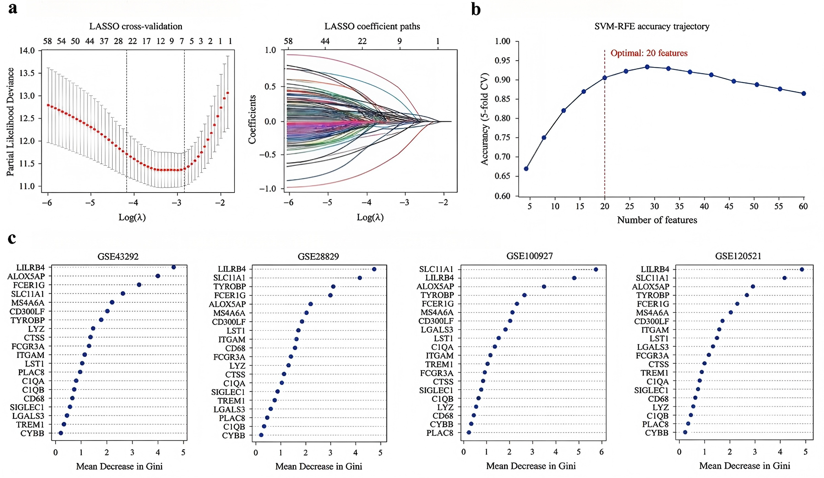
Figure S1. Detailed results of machine learning-based feature selection. (a) LASSO cross-validation plot and coefficient paths. (b) SVM-RFE recursive feature elimination accuracy trajectory. (c) Random forest variable importance plot (mean decrease in Gini) for the top 20 features from each GEO dataset.

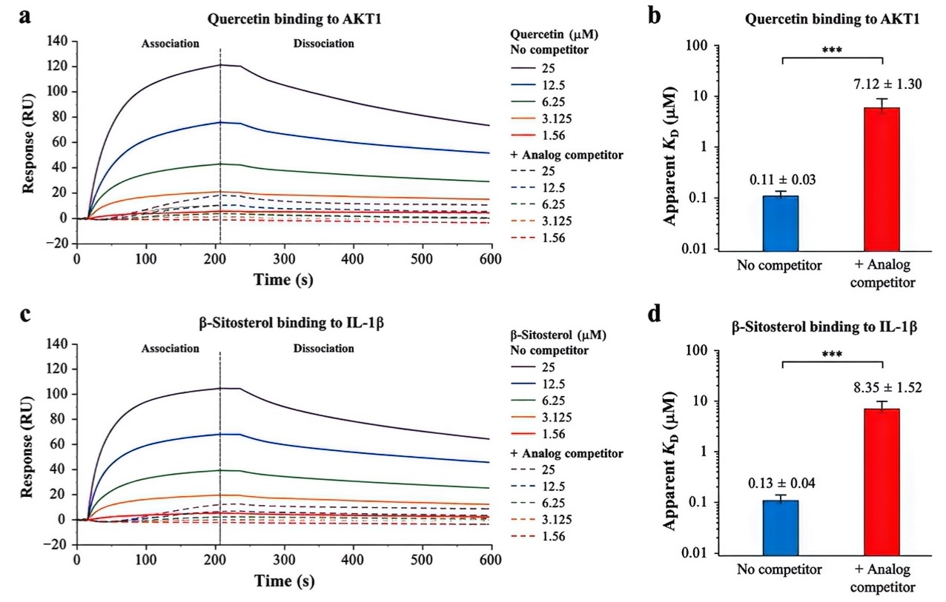
Figure S2. Competitive SPR binding assays confirming target engagement specificity. Pre-incubation of immobilized proteins with excess structural analogs (100 μM) significantly reduces quercetin binding to AKT1 and β-sitosterol binding to IL-1β.

Table S1. Physicochemical and surface chemical properties of GO and cGO. (n=3)
Parameter | GO | cGO | Method
Lateral size (nm) | 520±160 | 540±170 | AFM
Thickness (nm) | 1.05±0.18 | 1.02±0.16 | AFM
Hydrodynamic diameter (nm) | 612±96 | 638±101 | DLS
Polydispersity index (PDI) | 0.23±0.04 | 0.24±0.04 | DLS
Zeta potential (mV) | -39.6±3.2 | -38.1±3.1 | ELS
C/O atomic ratio | 2.31±0.10 | 2.28±0.09 | XPS
Raman ID/IG ratio | 1.02±0.05 | 1.01±0.05 | Raman(532 nm)
Endotoxin level (EU mg⁻¹) | 0.18±0.06 | 0.17±0.05 | LAL assay(562 nm)
Fe³⁺-to Fe²⁺ reduction rate at pH6.5 (min⁻¹) | 0.215±0.018 | 0.086±0.010 | UV-Vis(562 nm)
Fe³⁺-to Fe²⁺ reduction rate at pH7.4 (min⁻¹) | 0.091±0.009 | 0.034±0.005 | UV-Vis(562 nm)

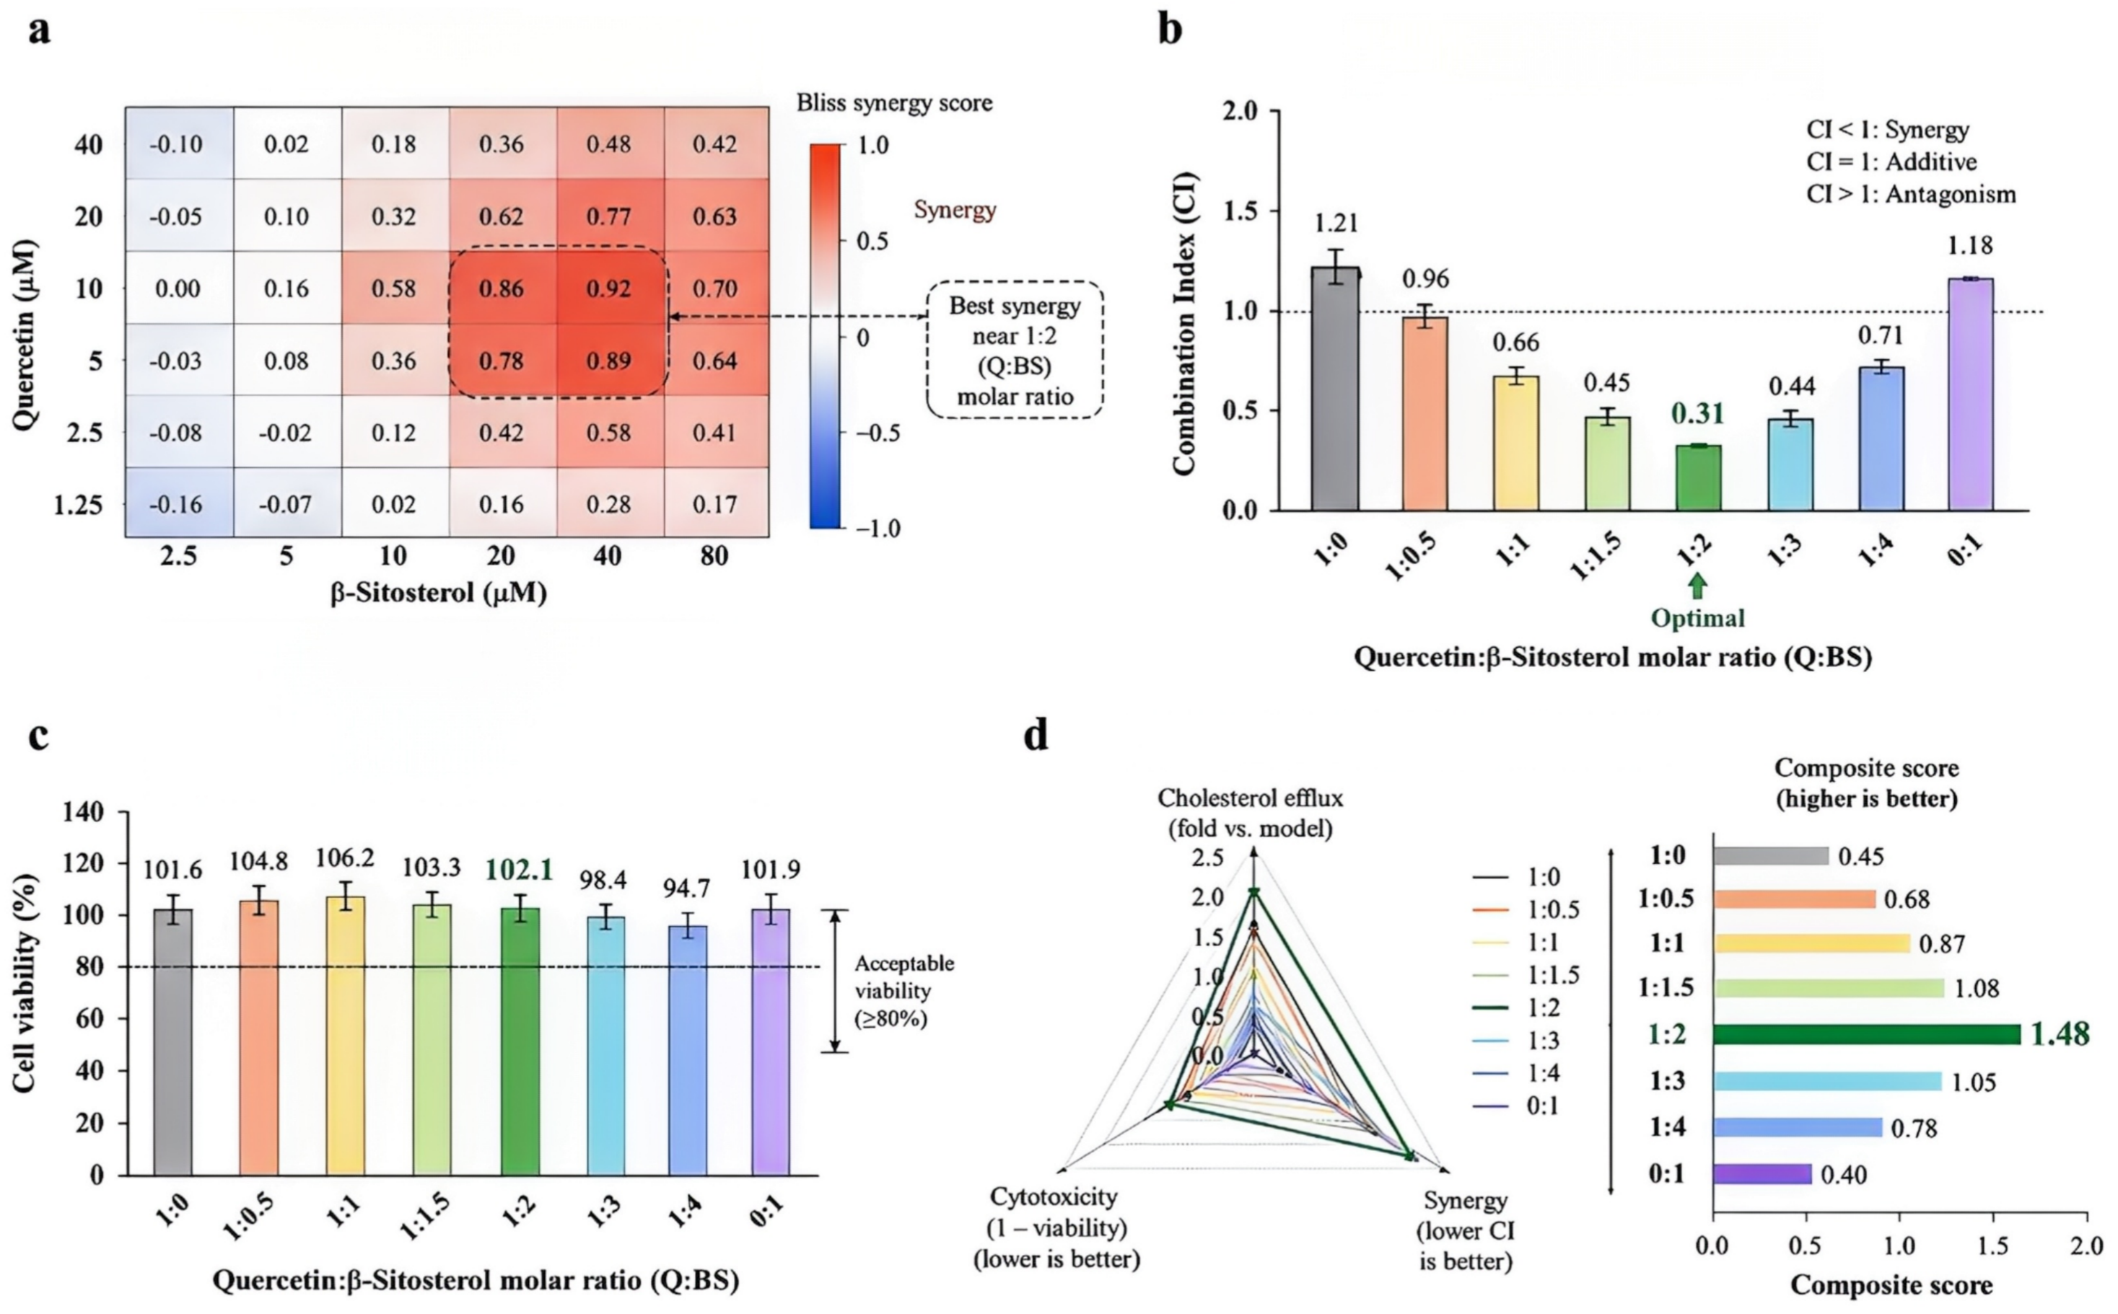
Figure S3. Synergy analysis and cytotoxicity screening for drug ratio optimization.
Table S2. Drug loading content,encapsulation efficiency, and release characteristics of GO@Drug and cGO@Drug.
Formulation | Drug | Loading content  (wt%) | Encapsulation efficiency(%) | Release at pH 7.4 at 48h(%) | Release at pH 6.5 at 48h(%) | Notes
GO@Drug | quercetin | 18.7±1.4 | 83.6±3.2 | 28.4±2.1 | 72.6±3.7 | pH-reponsive release
GO@Drug | β-sitosterol | 32.1±2.1 | 89.2±3.6 | 21.7±1.8 | 68.9±3.4 | pH-reponsive release
cGO@Drug | quercetin | 21.3±1.6 | 88.9±3.1 | 33.1±2.4 | 81.2±3.9 | Enhanced loading and release
cGO@Drug | β-sitosterol | 35.4±2.2 | 92.7±3.4 | 24.6±1.9 | 74.8±3.6 | Enhanced loading and release
Loading and release parameters of the pH-responsive GO-based co-delivery system. Date are mean±s.d. from n=3 independent experiments
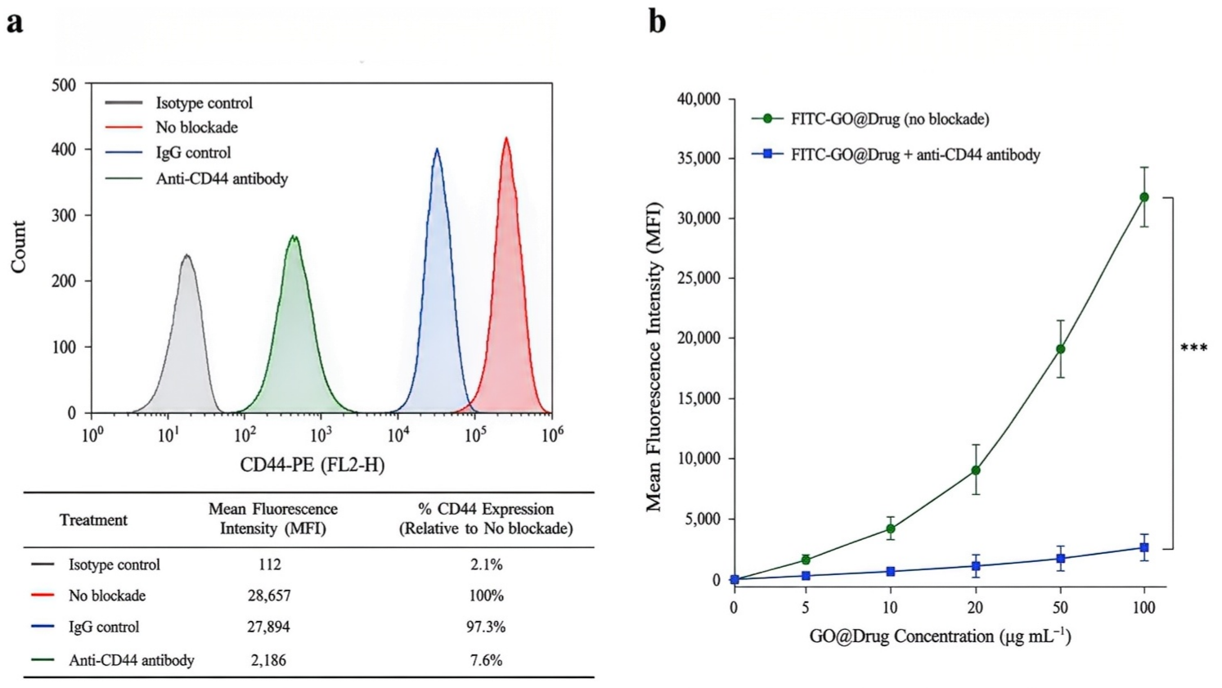
Figure S4. CD44 blockade efficiency and dose-dependent uptake of FITC-GO@Drug. (a) Flow cytometry histogram showing CD44 surface expression before and after antibody blockade. (b) Mean fluorescence intensity as a function of GO@Drug concentration.

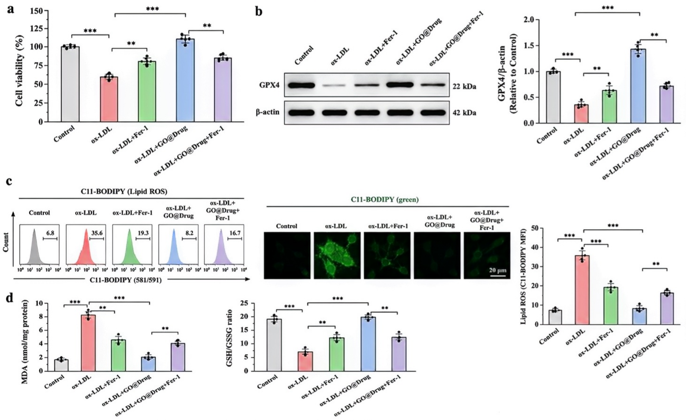
Figure S5. Ferrostatin-1 (Fer-1) control experiments confirming ferroptosis pathway dependence.

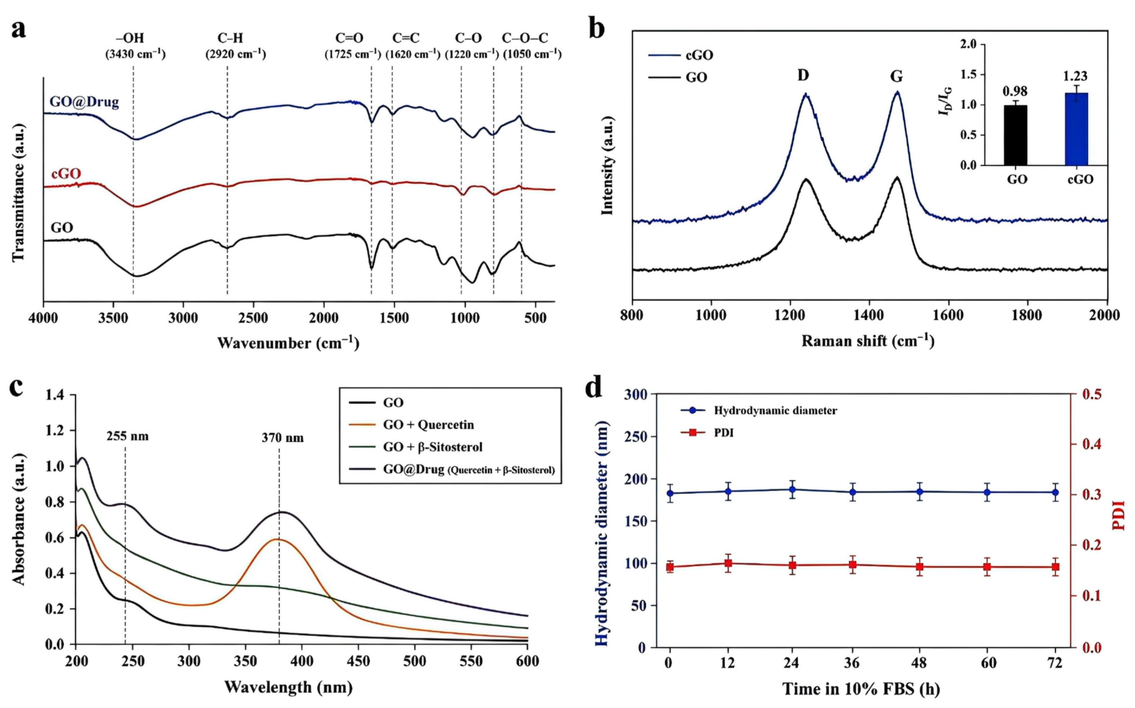
Figure S6. Expand physicochemical characterization confirming successful drug loading and stable colloidal behavior of GO@Drug.

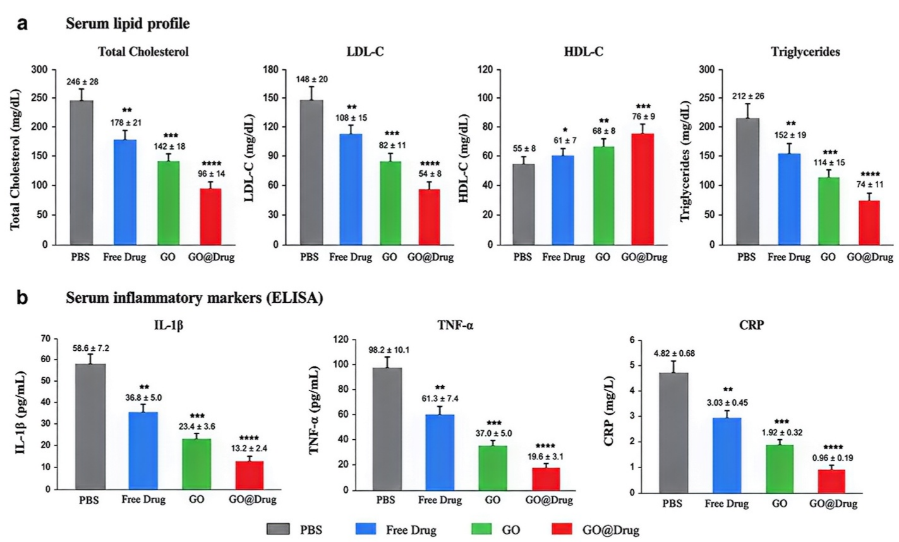
Figure S7. Systemic metabolic and inflammatory profiles in ApoE^{-/-}mice after 8-week treatment. (a) Serum total cholesterol, LDL-C, HDL-C, and triglycerides. (b) Serum IL-1β, TNF-α, and CRP levels measured by ELISA.
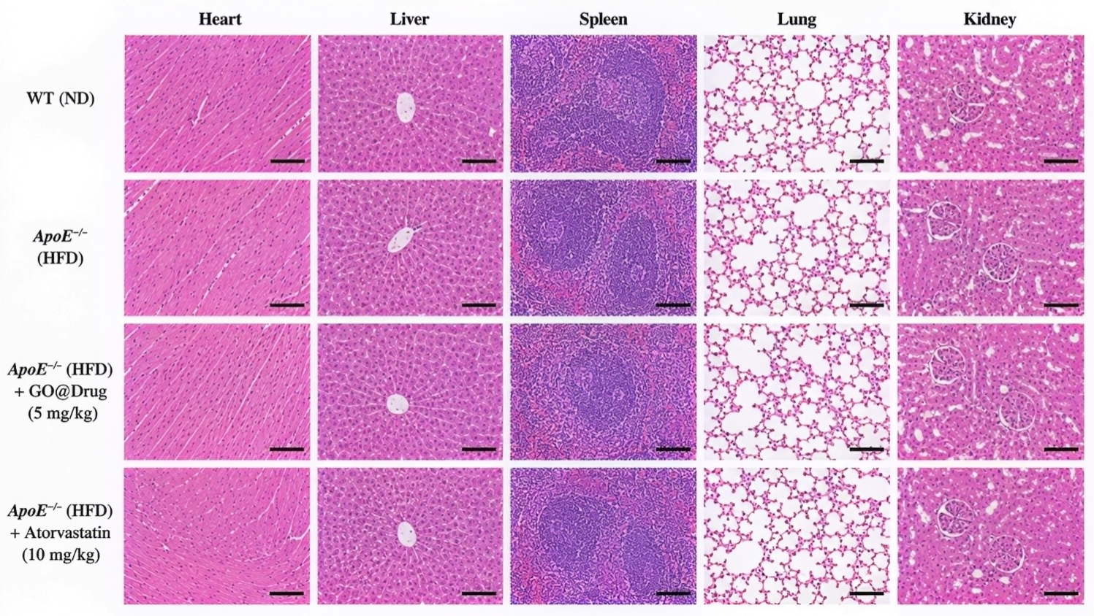
Figure S8. H&E staining of major organs (heart, liver, spleen, lung, kidney) from all treatment groups, showing normal histology without evidence of toxicity. Scale bar, 100 μm.

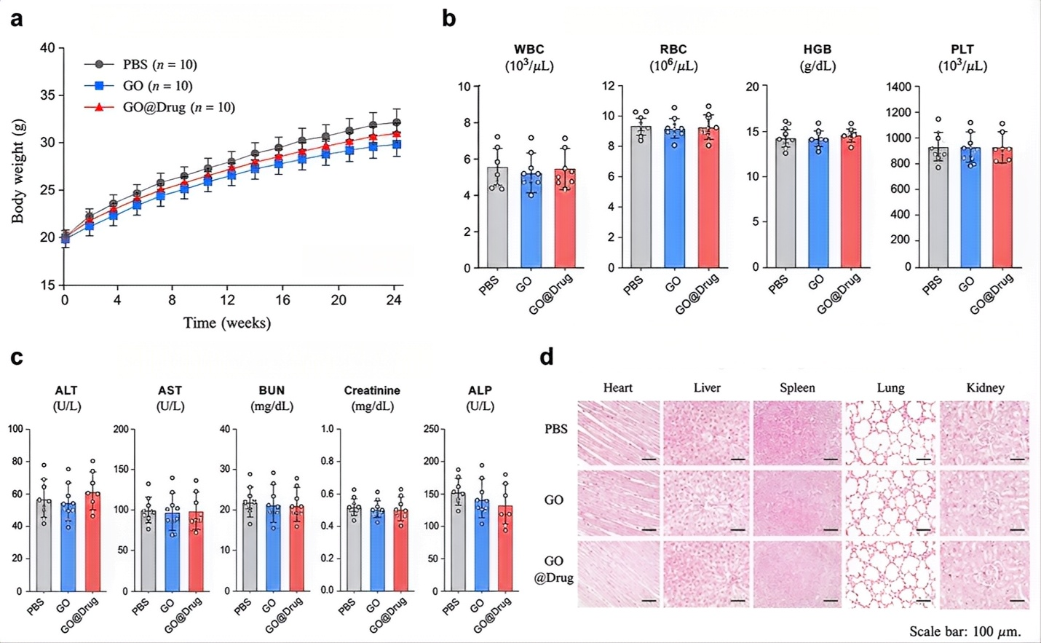
Figure S9. Long-term (6-month) safety assessment. (a) Body weight curves. (b) Complete blood counts at sacrifice. (c) Serum biochemistry panel. (d) Prussian Blue staining of major organs showing no abnormal iron deposition.
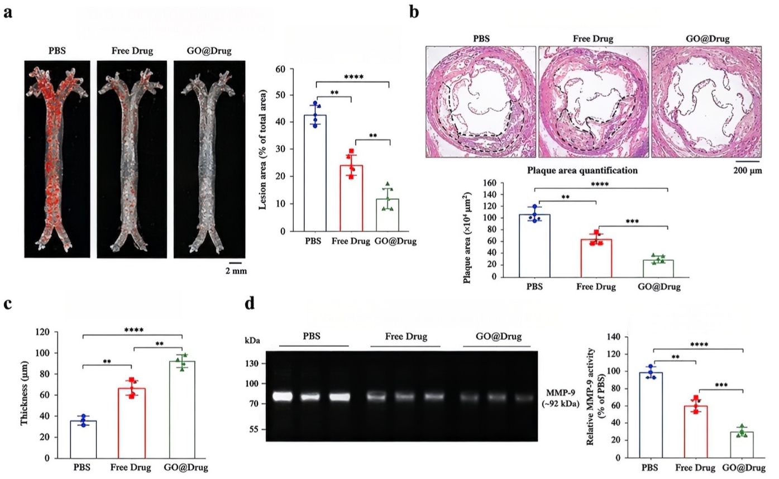
Figure S10. Advanced lesion intervention model (20-week HFD before treatment initiation). (a) En face Oil Red O and lesion area quantification. (b) H&E-stained aortic root sections. (c) Fibrous cap thickness measurement. (d) Gelatin zymography for MMP-9 activity in aortic extracts.

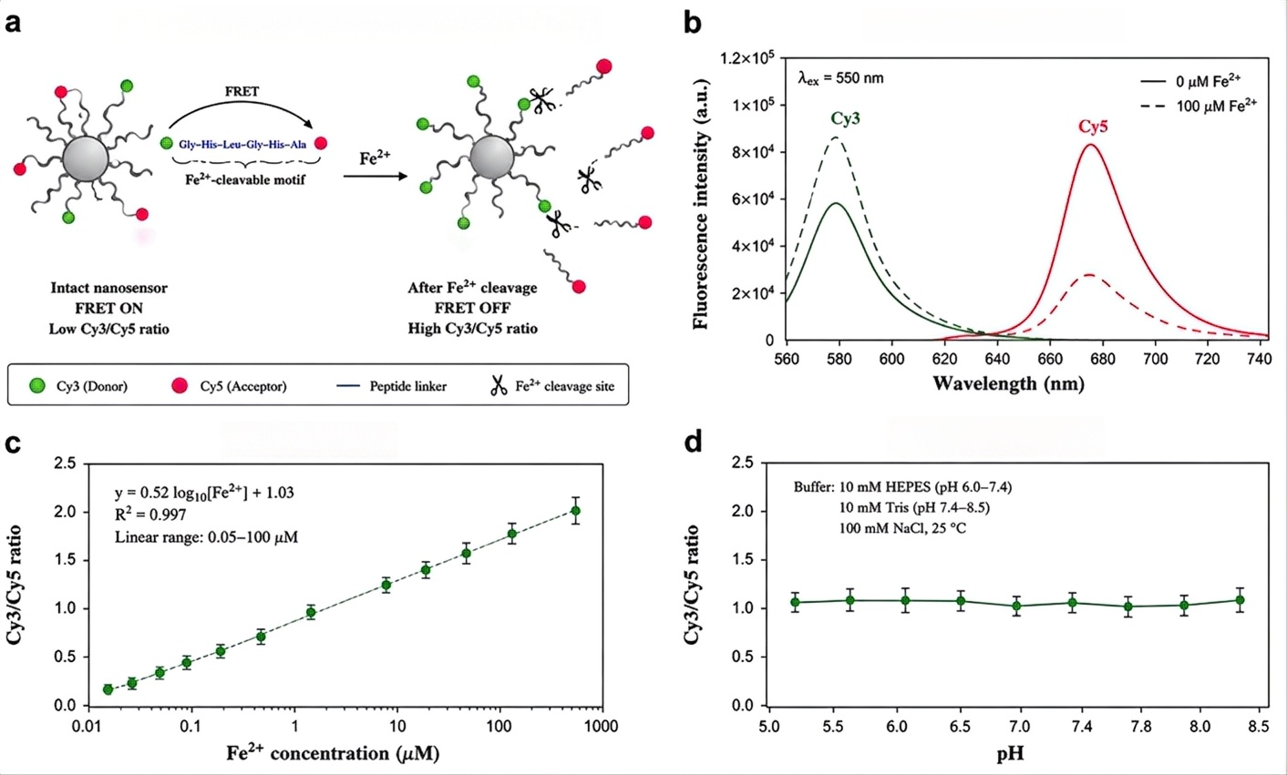
Figure S11. Characterization of the FRET-based Fe²⁺ nanosensor. (a) Schematic of Fe²⁺-dependent peptide cleavage and FRET disruption mechanism. (b) Fluorescence emission spectra before and after Fe²⁺ exposure, showing increased Cy3/Cy5 ratio. (c) Calibration curve of FRET ratio versus Fe²⁺ concentration. (d) pH stability profile of the sensor.
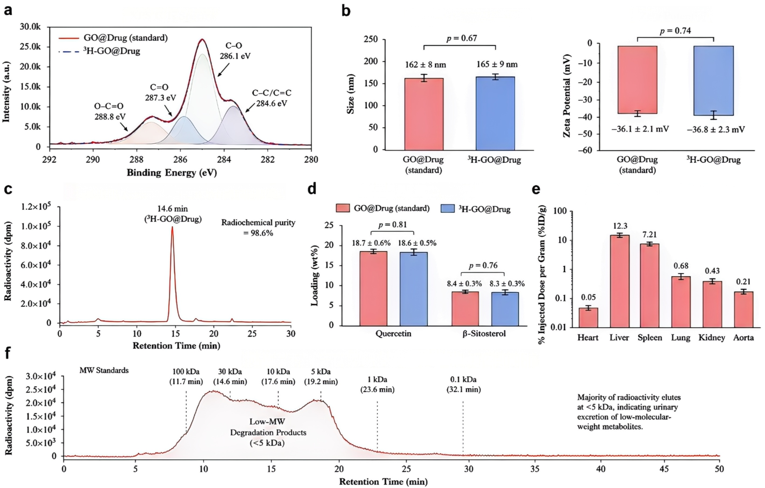
Figure S12. Characterization and pharmacokinetics of ³H-labeled GO@Drug. (a) XPS C 1s spectra of 3H-GO@Drug confirming identical surface chemistry to standard GO. (b) Hydrodynamic size and zeta potential comparison. (c) Radiochemical purity by SEC-HPLC. (d) Drug loading equivalency. (e) Organ biodistribution of ³H-GO@Drug at 24 h post-injection. (f) Size-exclusion chromatography of urinary ³H fractions at day 28 showing low-molecular-weight degradation products (<5 kDa).

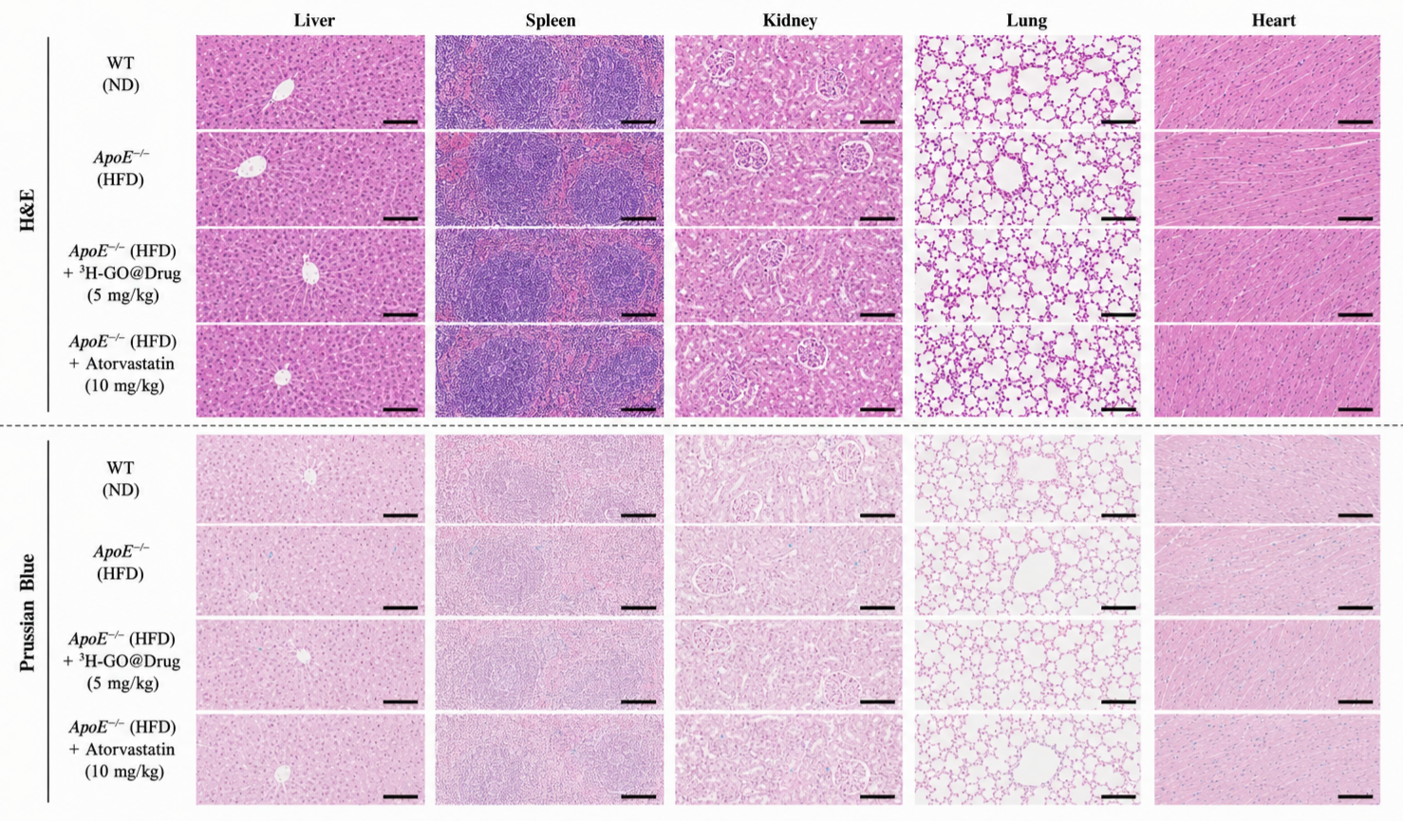
Figure S13. Long-term histopathological safety at 180 days post-treatment. H&E and Prussian Blue staining of liver, spleen, kidney, lung, and heart from 3H-GO@Drug-treated ApoE^{-/-}mice, showing no evidence of necrosis, fibrosis, steatosis, or iron overload. Scale bar, 100 μm.

