Supplemental Material for
“Analysis of tropospheric noise at small spatial scales based on GNSS ZTD and Numerical Weather Prediction models”

Adeyinka Olaseinde, 201 7th Ave. Tuscaloosa, AL 35487, aoolaseinde@crimson.ua.edu
Jeremy Maurer, 1400 N Bishop, Rolla, MO. 65409, jmaurer@mst.edu

File Contents
Supplement Text S1
Supplemental Figures S1 – S8
Supplemental Tables S1 – S6

Supplemental Text
Supplemental Text S1. GNSS data collection in Rolla, MO
GNSS observations were conducted at four benchmark stations in Rolla, Missouri (Figure S6): ROL1, ROL2, ROL3, and ROL4. Data were acquired using post-processed static surveying techniques, which involve collecting GNSS observations at fixed benchmark locations (Figure S7) followed by post-processing to improve positional accuracy. At each station, a GNSS antenna was mounted on a tripod equipped with dual clamps to ensure precise centering above the geodetic benchmark (Figure S8), typically identified by a survey monument marked with a small triangular symbol. The tripod legs were adjusted to establish a stable and level setup, thereby minimizing positioning errors associated with instrument tilt. A compact integrated GNSS system, consisting of an antenna, receiver, and data logger, was mounted on the tripod for data acquisition. Observation sessions ranged from 30 minutes to 2 hours at each station, providing sufficient data for high-accuracy static positioning, Between June 2024 and March 2025, GNSS observations were acquired from four permanent benchmark locations in Rolla, Missouri, using dual-frequency Emlid Reach receivers installed over established survey monuments. Observation files were recorded in Receiver Independent Exchange (RINEX) format and subsequently analyzed to generate Zenith Total Delay (ZTD) estimates for evaluation against numerical weather prediction (NWP) model-derived delays. The monitoring network consisted of four benchmark sites designated as ROL1, ROL2, ROL3, and ROL4.
Measurement campaigns were performed periodically throughout the study, generally at intervals of two to four weeks, depending on weather conditions and equipment availability. Observations were primarily collected during the early morning (~08:00 UTC) or late afternoon (~18:00 UTC) to correspond to InSAR acquisition times. Field deployments utilized three or four receivers operating concurrently, allowing simultaneous observations across the study area and improving spatial representation of atmospheric conditions. Instrument heights were carefully documented during each deployment. Following collection, all datasets were processed by submitting the raw RINEX 3.0 observations to the Canadian Spatial Reference System (CSRS) processing website (https://webapp.csrs-scrs.nrcan-rncan.gc.ca/geod/tools-outils/ppp.php). CSRS provides the troposphere ZTD as an output from the processing step, which is then used in our analysis.
Supplemental Figures
Figure S1. Frequency distributions of ERA5 residuals across ten study regions: (a) Australia, (b) Japan-1, (c) Germany, (d) Alaska, (e) Japan-2, (f) near Rome, Italy, (g) Chile, (h) Guadeloupe, (i) Rolla, Missouri, and (j) Mineral, California. Each subplot shows station-level histograms for the corresponding region.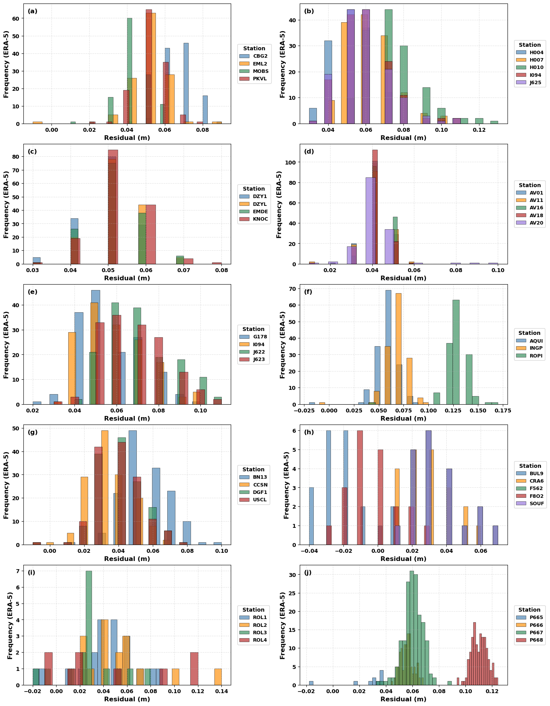
Figure S2. ERA5 residuals as a function of station elevation for GNSS sites grouped by region: (a) Australia, (b) Japan-1, (c) Germany, (d) Alaska, (e) Japan-2, (f) near Rome, Italy, (g) Chile, (h) Guadeloupe, (i) Rolla, Missouri, and (j) Mineral, California. Each station forms a vertical cluster at its characteristic elevation.
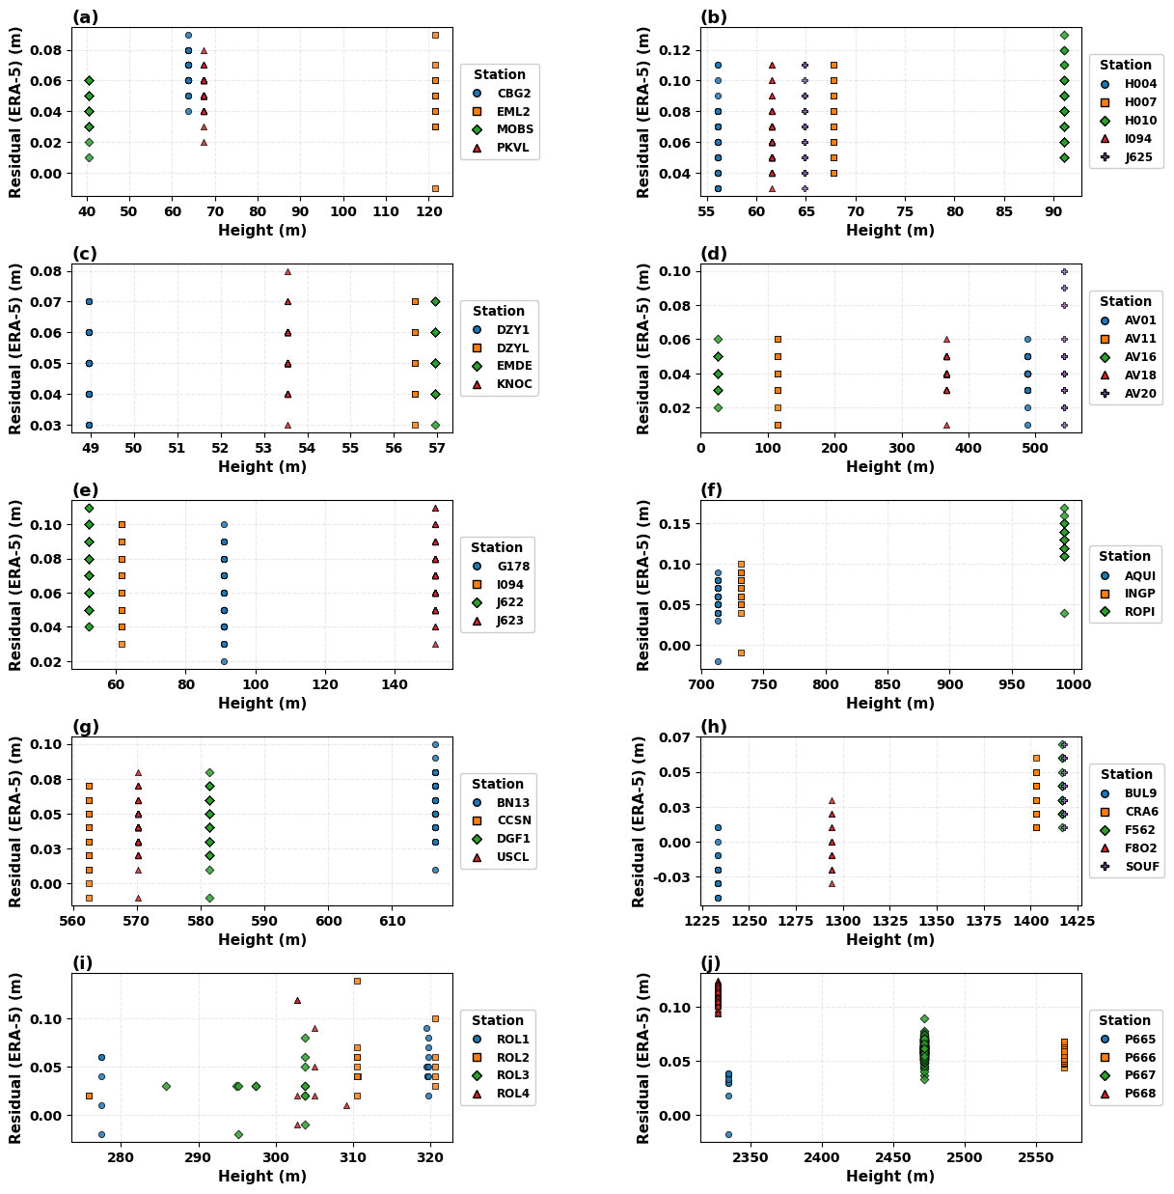

Figure S3. Frequency distributions of HRRR residuals for (a) Rolla, Missouri, (b) Mineral, California, and (c) Salt Lake City, Utah. Station-level distributions with varying degrees of overlap and spread are visible at all three sites.
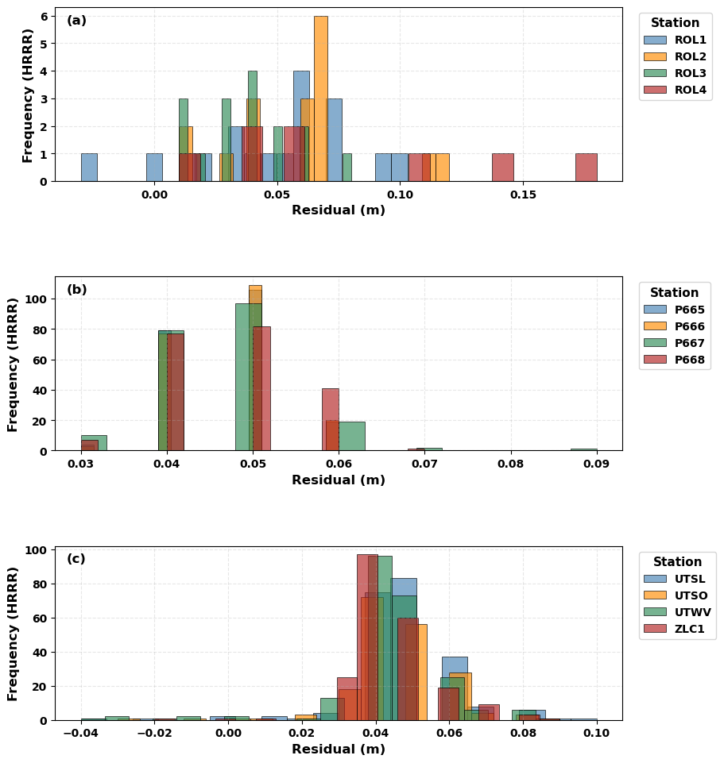

Figure S4. Elevation-dependent variation of HRRR residuals for GNSS stations at (a) Rolla, Missouri, (b) Mineral, California, and (c) Salt Lake City, Utah. Each panel relates residual magnitude to station height, allowing comparison of model discrepancies across elevation within each site.
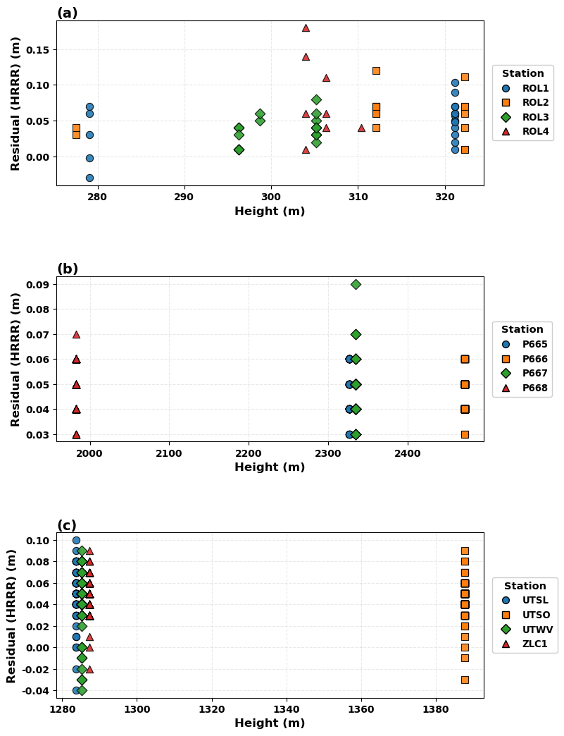

Figure S5. Results from fitting the model (Equation 6 in the main text) to the data in Table S5. Top left: Predicted versus observed $σ^{sp}$. Top right: $σ^{sp}$ versus latitude, with points colored by elevation. Bottom left: $σ^{sp}$ versus latitude, with points colored by latitude. Bottom right: Residual versus $σ^{sp}$.
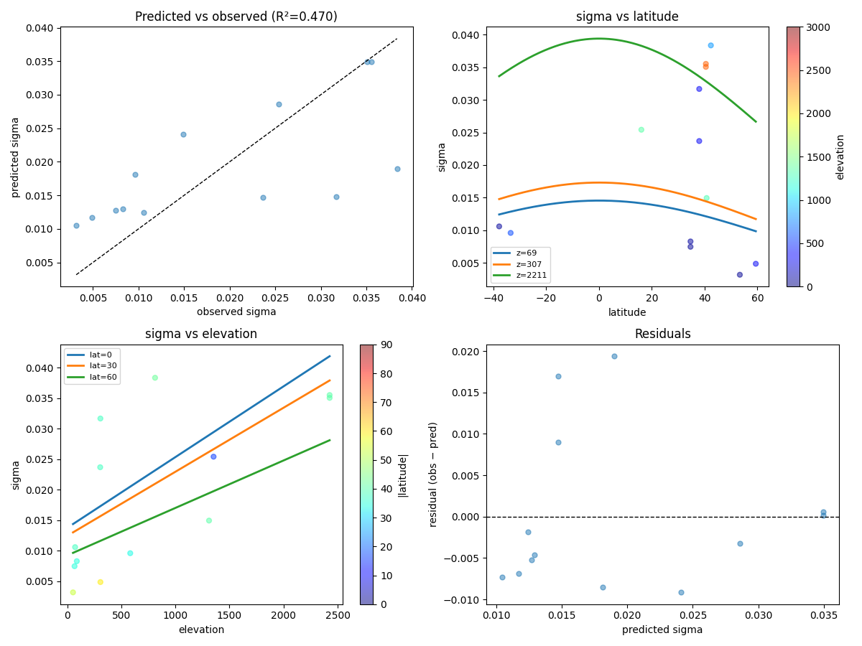

Figure S6. Locations of GNSS base stations within the Rolla, Missouri study area used for tropospheric delay monitoring.

Figure S7. Photos of data collection using the tripod-Mounted Emlid Reach RS2+ GNSS Receiver at three of the stations in Rolla, Missouri.
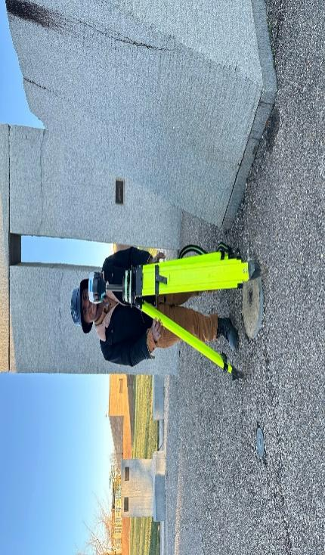
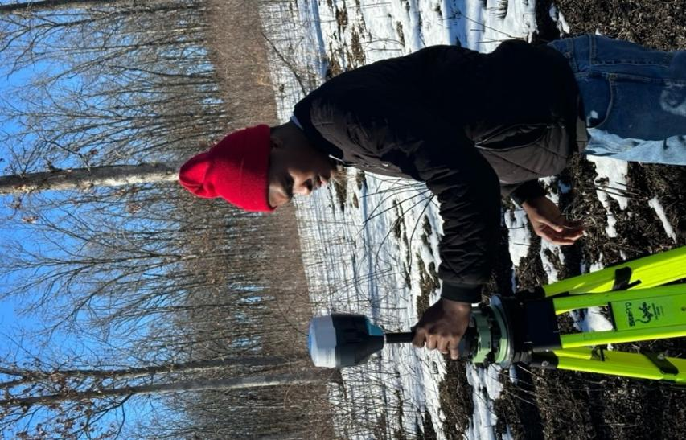
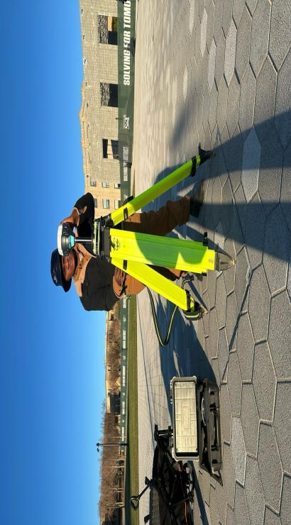

Figure S8. Three of the benchmark used in Rolla, Missouri.
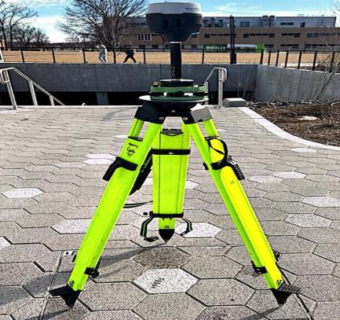
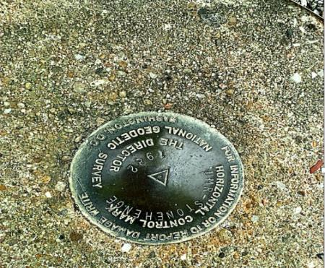
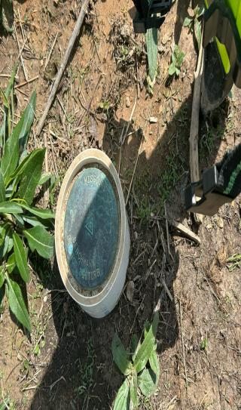
ROL1
ROL4
ROL2

Supplemental Tables
Table S1. GNSS stations used in this analysis. Highlighted stations at the end are for HRRR.
Site | ID | Lat | Lon | Elev (m) | Start Date | End Date | N_Obs
Alaska | AV01 | 59.359 | -153.461 | 487.2 | 1/1/20 | 1/10/25 | 153
Alaska | AV11 | 59.371 | -153.355 | 114.9 | 1/25/20 | 1/10/25 | 149
Alaska | AV16 | 59.386 | -153.535 | 25.4 | 1/1/20 | 1/10/25 | 152
Alaska | AV18 | 59.38 | -153.437 | 367.2 | 1/1/20 | 1/10/25 | 152
Alaska | AV20 | 59.347 | -153.428 | 542.2 | 1/1/20 | 1/10/25 | 143
Australia | CBG2 | -37.739 | 144.974 | 63.7 | 10/27/20 | 1/10/25 | 110
Australia | EML2 | -37.809 | 144.974 | 121.5 | 10/3/20 | 1/10/25 | 125
Australia | MOBS | -37.829 | 144.975 | 40.6 | 10/3/20 | 1/10/25 | 116
Australia | PKVL | -37.8 | 144.961 | 67.4 | 10/3/20 | 1/10/25 | 127
California | P665 | 40.456 | -121.526 | 2326.8 | 1/1/20 | 1/10/20 | 10
California | P666 | 40.456 | -121.515 | 2471.5 | 1/1/20 | 4/21/20 | 112
California | P667 | 40.466 | -121.467 | 2334.1 | 1/1/20 | 10/10/20 | 179
California | P668 | 40.509 | -121.463 | 1982.5 | 1/1/20 | 10/10/20 | 143
Chile | BN13 | -33.443 | -70.646 | 616.8 | 1/1/20 | 9/24/24 | 145
Chile | CCSN | -33.463 | -70.664 | 562.5 | 1/1/20 | 9/24/24 | 145
Chile | DGF1 | -33.457 | -70.662 | 581.4 | 1/1/20 | 9/24/24 | 145
Chile | USCL | -33.45 | -70.681 | 570.2 | 1/1/20 | 9/24/24 | 145
Europe | DZY1 | 53.323 | 6.936 | 49 | 1/1/20 | 1/10/25 | 152
Europe | DZYL | 53.32 | 6.94 | 56.5 | 1/1/20 | 1/10/25 | 148
Europe | EMDE | 53.337 | 7.028 | 57 | 1/1/20 | 1/10/25 | 146
Europe | KNOC | 53.327 | 7.031 | 53.5 | 1/1/20 | 1/10/25 | 154
Guadeloupe | BUL9 | 16.04 | -61.663 | 1233.3 | 1/4/24 | 8/19/24 | 20
Guadeloupe | CRA6 | 16.043 | -61.662 | 1402.8 | 1/4/24 | 8/19/24 | 20
Guadeloupe | F562 | 16.044 | -61.663 | 1416.5 | 1/4/24 | 8/19/24 | 20
Guadeloupe | F8O2 | 16.041 | -61.663 | 1293.8 | 1/4/24 | 8/19/24 | 20
Guadeloupe | SOUF | 16.045 | -61.663 | 1417.6 | 1/4/24 | 8/19/24 | 20
Italy | AQUI | 42.368 | 13.35 | 713.1 | 1/1/20 | 9/24/24 | 145
Italy | INGP | 42.382 | 13.316 | 731.8 | 1/1/20 | 9/24/24 | 145
Italy | ROPI | 42.332 | 13.337 | 991.9 | 1/1/20 | 9/24/24 | 145
Japan2 | G178 | 34.603 | 138.215 | 90.9 | 1/1/20 | 1/10/25 | 154
Japan2 | I094 | 34.643 | 138.129 | 61.6 | 1/1/20 | 1/10/25 | 154
Japan2 | J622 | 34.68 | 138.098 | 52.3 | 1/1/20 | 1/10/25 | 154
Japan2 | J623 | 34.678 | 138.183 | 151.7 | 1/1/20 | 1/10/25 | 153
Japan | H004 | 34.632 | 138.19 | 56.1 | 1/1/20 | 9/24/24 | 145
Japan | H007 | 34.655 | 138.166 | 67.8 | 1/1/20 | 9/24/24 | 145
Japan | H010 | 34.67 | 138.136 | 91 | 1/1/20 | 9/24/24 | 145
Japan | I094 | 34.643 | 138.129 | 61.6 | 1/1/20 | 9/24/24 | 145
Japan | J625 | 34.635 | 138.159 | 64.9 | 1/1/20 | 9/24/24 | 145
Missouri | ROL1 | 37.956 | -91.777 | 319.6 | 6/11/24 | 3/7/25 | 28
Missouri | ROL2 | 37.954 | -91.775 | 310.5 | 6/11/24 | 3/7/25 | 28
Missouri | ROL3 | 37.926 | -91.747 | 303.8 | 6/11/24 | 3/7/25 | 28
Missouri | ROL4 | 37.964 | -91.78 | 302.7 | 6/11/24 | 3/7/25 | 28
California | P665 | 40.456 | -121.526 | 2326.8 | 1/2/19 | 12/27/22 | 208
California | P666 | 40.456 | -121.515 | 2471.5 | 1/2/19 | 12/27/22 | 209
California | P667 | 40.466 | -121.467 | 2334.1 | 1/2/19 | 12/27/22 | 208
California | P668 | 40.509 | -121.463 | 1982.5 | 1/2/19 | 12/27/22 | 208
Missouri | ROL1 | 37.956 | -91.777 | 321.2 | 6/11/24 | 3/7/25 | 28
Missouri | ROL2 | 37.954 | -91.775 | 312.1 | 6/11/24 | 3/7/25 | 28
Missouri | ROL3 | 37.926 | -91.747 | 305.2 | 6/11/24 | 3/7/25 | 28
Missouri | ROL4 | 37.964 | -91.78 | 304 | 6/11/24 | 3/7/25 | 28
Utah | UTSL | 40.737 | -111.895 | 1283.7 | 1/1/19 | 12/29/22 | 222
Utah | UTSO | 40.779 | -111.888 | 1387.7 | 1/1/19 | 4/3/22 | 189
Utah | UTWV | 40.71 | -111.978 | 1285.2 | 1/1/19 | 12/29/22 | 229
Utah | ZLC1 | 40.786 | -111.952 | 1287.3 | 1/1/19 | 12/29/22 | 217

Table S2. ERA5 station-level bias, MAE, and temporal standard deviation.
Dataset | Region | Station | N | Lat. (°) | Elev. (m) | Bias (mm) | MAE (mm) | σ^{t} (mm)
ERA5 | Australia | CBG2 | 110 | -37.74 | 63.67 | 66.91 | 66.91 | 8.21
ERA5 | Australia | EML2 | 125 | -37.81 | 121.55 | 49.36 | 49.52 | 10.22
ERA5 | Australia | MOBS | 116 | -37.83 | 40.61 | 42.59 | 42.59 | 8.96
ERA5 | Australia | PKVL | 127 | -37.8 | 67.39 | 51.89 | 51.89 | 8.52
ERA5 | Japan-1 | H004 | 145 | 34.63 | 56.06 | 54.69 | 54.69 | 14.72
ERA5 | Japan-1 | H007 | 145 | 34.66 | 67.76 | 62.41 | 62.41 | 14.01
ERA5 | Japan-1 | H010 | 145 | 34.67 | 91.05 | 73.03 | 73.03 | 14.92
ERA5 | Japan-1 | I094 | 145 | 34.64 | 61.59 | 59.38 | 59.38 | 14.1
ERA5 | Japan-1 | J625 | 145 | 34.64 | 64.9 | 58.55 | 58.55 | 13.94
ERA5 | Germany | DZY1 | 152 | 53.32 | 48.97 | 49.54 | 49.54 | 8.08
ERA5 | Germany | DZYL | 148 | 53.32 | 56.49 | 52.16 | 52.16 | 7.43
ERA5 | Germany | EMDE | 146 | 53.34 | 56.95 | 51.51 | 51.51 | 7.82
ERA5 | Germany | KNOC | 154 | 53.33 | 53.54 | 52.21 | 52.21 | 7.43
ERA5 | Alaska | AV01 | 153 | 59.36 | 487.21 | 40.39 | 40.39 | 6.58
ERA5 | Alaska | AV11 | 149 | 59.37 | 114.9 | 40.74 | 40.74 | 7.45
ERA5 | Alaska | AV16 | 152 | 59.39 | 25.36 | 42.5 | 42.5 | 5.9
ERA5 | Alaska | AV18 | 152 | 59.38 | 367.19 | 40.33 | 40.33 | 5.8
ERA5 | Alaska | AV20 | 143 | 59.35 | 542.18 | 41.89 | 41.89 | 10.07
ERA5 | Japan-2 | G178 | 154 | 34.6 | 90.88 | 55.65 | 55.65 | 15.08
ERA5 | Japan-2 | I094 | 154 | 34.64 | 61.59 | 59.16 | 59.16 | 15.46
ERA5 | Japan-2 | J622 | 154 | 34.68 | 52.3 | 70.71 | 70.71 | 15.76
ERA5 | Japan-2 | J623 | 153 | 34.68 | 151.7 | 67.65 | 67.65 | 15.55
ERA5 | Italy | AQUI | 145 | 42.37 | 713.13 | 58.14 | 58.41 | 11.55
ERA5 | Italy | INGP | 145 | 42.38 | 731.85 | 68.41 | 68.55 | 11.47
ERA5 | Italy | ROPI | 145 | 42.33 | 991.87 | 129.1 | 129.1 | 12.36
ERA5 | Chile | BN13 | 145 | -33.44 | 616.82 | 55.66 | 55.66 | 13.63
ERA5 | Chile | CCSN | 145 | -33.46 | 562.52 | 33.86 | 34 | 13.6
ERA5 | Chile | DGF1 | 145 | -33.46 | 581.4 | 41.24 | 41.38 | 13.53
ERA5 | Chile | USCL | 145 | -33.45 | 570.19 | 40.21 | 40.34 | 13.41
ERA5 | Guadeloupe | BUL9 | 20 | 16.04 | 1233.3 | -21 | 23 | 14.83
ERA5 | Guadeloupe | CRA6 | 20 | 16.04 | 1402.82 | 28.5 | 28.5 | 14.61
ERA5 | Guadeloupe | F562 | 20 | 16.04 | 1416.48 | 34.5 | 34.5 | 15.72
ERA5 | Guadeloupe | F8O2 | 20 | 16.04 | 1293.81 | -3 | 12 | 15.25
ERA5 | Guadeloupe | SOUF | 20 | 16.05 | 1417.59 | 34.5 | 34.5 | 15.72
ERA5 | Missouri | ROL1 | 20 | 37.96 | 307.25 | 42 | 45 | 27.26
ERA5 | Missouri | ROL2 | 16 | 37.95 | 309.36 | 52.5 | 52.5 | 31.3
ERA5 | Missouri | ROL3 | 16 | 37.93 | 299.74 | 28.75 | 32.5 | 23.91
ERA5 | Missouri | ROL4 | 9 | 37.96 | 304.42 | 45.56 | 50 | 52.23
ERA5 | California | P665 | 10 | 40.47 | 2334.06 | 27.16 | 30.72 | 16.91
ERA5 | California | P666 | 112 | 40.47 | 2569.13 | 55.62 | 55.62 | 4.9
ERA5 | California | P667 | 179 | 40.47 | 2471.54 | 60.27 | 60.27 | 7.57
ERA5 | California | P668 | 143 | 40.46 | 2326.8 | 110.3 | 110.3 | 6.08

Table S3. HRRR station-level bias, MAE, and temporal standard deviation.
Station | N | Lat. (°) | Elev. (m) | Bias (mm) | MAE (mm) | σ^{t} (mm) | Site
ROL1 | 18 | 37.96 | 309.49 | 46.44 | 50.0 | 32.75 | Missouri
ROL2 | 17 | 37.95 | 312.23 | 58.88 | 58.88 | 29.45 | Missouri
ROL3 | 16 | 37.93 | 301.01 | 37.5 | 37.5 | 19.83 | Missouri
ROL4 | 8 | 37.96 | 305.65 | 80.0 | 80.0 | 57.82 | Missouri
P665 | 10 | 40.47 | 2334.06 | 46.9 | 46.9 | 11.79 | California
P666 | 112 | 40.47 | 2569.13 | 72.42 | 72.42 | 4.66 | California
P667 | 179 | 40.47 | 2471.54 | 78.83 | 78.83 | 6.74 | California
P668 | 143 | 40.46 | 2326.8 | 130.97 | 130.97 | 5.77 | California
UTSL | 33 | 40.74 | 1283.67 | 21.85 | 28.76 | 27.84 | Utah
UTSO | 33 | 40.78 | 1387.7 | 22.67 | 27.76 | 25.55 | Utah
UTWV | 47 | 40.71 | 1285.19 | 46.26 | 46.26 | 3.27 | Utah
ZLC1 | 45 | 40.79 | 1287.34 | 43.13 | 43.13 | 7.15 | Utah

Table S4. Overall ERA5 and HRRR comparison.
Dataset | Overall Bias (mm) | Overall MAE (mm) | Overall σ^{t} (mm)
ERA5 | 50.13 | 51.91 | 13.62
HRRR | 49.48 | 49.97 | 18.85

Table S5. Site summary of spatial residual standard deviation (σ^{sp}). The Latitude and Elevation represent the mean for each site that is shown in Figures 6 and 7 in the main manuscript. “N” is the number of observations used to calculate σ^{sp}.
Model | Site | Lat | Elev (m) | N | Mean σ^{sp} (mm) | Min σ^{sp} (mm) | Max σ^{sp} (mm)
ERA5 | Alaska | 59.3686 | 307 | 153 | 4.8 | 0.0 | 26.8
ERA5 | Australia | -37.7943 | 73 | 124 | 10.6 | 0.0 | 32.1
ERA5 | California | 40.4650 | 2425 | 13 | 35.1 | 30.6 | 49.7
ERA5 | Chile | -33.4532 | 583 | 145 | 9.6 | 8.2 | 12.6
ERA5 | Germany | 53.3268 | 54 | 151 | 3.2 | 0.0 | 9.6
ERA5 | Guadeloupe | 16.0426 | 1353 | 20 | 25.4 | 23.0 | 28.3
ERA5 | Italy | 42.3607 | 812 | 145 | 38.4 | 32.1 | 43.6
ERA5 | Japan-1 | 34.6470 | 68 | 145 | 7.5 | 4.5 | 11.4
ERA5 | Japan-2 | 34.6510 | 89 | 154 | 8.3 | 0.0 | 24.5
ERA5 | Missouri | 37.9502 | 305 | 7 | 23.7 | 10.0 | 41.6
HRRR | California | 40.4718 | 2279 | 209 | 3.0 | 0.0 | 14.1
HRRR | Missouri | 37.9502 | 307 | 11 | 31.7 | 5.8 | 90.7
HRRR | Utah | 40.7530 | 1311 | 219 | 5.8 | 0.0 | 51.9

Table S6 Maximum inter-station separation at each site. For every site the table lists the number of GNSS stations, the most widely separated station pair, and the corresponding maximum separation distance.
Site | N Stations | Farthest Station Pair | Max Separation (km)
Alaska | 5 | AV11–AV16 | 10.33
Australia | 4 | CBG2–MOBS | 10.01
California | 4 | P665–P668 | 4.52
Chile | 4 | BN13–USCL | 3.34
Germany | 4 | DZY1–KNOC | 6.32
Guadeloupe | 5 | BUL9–SOUF | 0.56
Italy | 3 | INGP–ROPI | 5.82
Japan-1 | 5 | H004–H010 | 6.50
Japan-2 | 4 | G178–J622 | 13.71
Missouri | 4 | ROL3–ROL4 | 5.17
Utah | 4 | UTSO–UTWV | 10.79

