Dimethyl fumarate improves imiquimod-induced psoriasiform inflammation and melanogenesis.

Ho Yong Hyun ^{a†}, Joon Min Jung ^{b†}, Myoung Eun Choi ^{b}, Youngsup Song ^{c*}, Sung Eun Chang ^{b*}

Supplementary Table 1. Individual patient data and clinical characteristics.
Patient | Demographics |  |  | DMF Treatment |  | Baseline |  | Week 16 |  |  | Outcome
Patient ID | Sex | Age  (yrs) | BMI  (kg/m²) | Disease  duration (mo) | Dose  (mg) | Baseline  PASI | Baseline  BSA (%) | Baseline  IGA | Wk16  PASI | Wk16  BSA (%) | Wk16  IGA
P01 | M | 52 | 24 | 72 | 120 | 1 | 1 | 1 (almost clear) | 1 | 1 | 1 (almost clear)
P02 | M | 55 | 28.4 | 60 | 120 | 7 | 10 | 3 (moderate) | 1 | 1 | 2 (mild)
P03 | F | 33 | 32.8 | 168 | 240 | 2 | 2 | 2 (mild) | 0.4 | 1 | 1 (almost clear)
P04 | F | 56 | 22.3 | 60 | 240 | 0.8 | 1 | 2 (mild) | 0 | 0 | 0 (clear)
P05 | F | 50 | 31.6 | 132 | 240 | 6 | 5 | 3 (moderate) | 1.5 | 2 | 2 (mild)
P06 | M | 68 | 26.7 | 228 | 240 | 8 | 3 | 3 (moderate) | 2 | 2 | 2 (mild)
P07 | F | 44 | 26.9 | 180 | 240 | 3 | 3 | 3 (moderate) | 1.5 | 2 | 2 (mild)
P08 | M | 40 | 24.4 | 48 | 240 | 4 | 5 | 3 (moderate) | 4 | 4 | 3 (moderate)
P09 | F | 53 | 25.7 | 180 | 240 | 5 | 2 | 2 (mild) | 2 | 2 | 2 (mild)
P10 | M | 46 | 26.4 | 120 | 240 | 5 | 4 | 3 (moderate) | 8 | 4 | 3 (moderate)
P11 | M | 45 | 29 | 60 | 240 | 1 | 1 | 1 (almost clear) | 2 | 1 | 1 (almost clear)
P12 | M | 74 | 21.5 | 72 | 240 | 6 | 2 | 3 (moderate) | 4 | 4 | 3 (moderate)
P13 | F | 34 | 19 | 96 | 240 | 5 | 4 | 3 (moderate) | 3 | 1 | 2 (mild)
P14 | M | 40 | 23.4 | 132 | 360 | 5 | 4 | 3 (moderate) | 5 | 4 | 3 (moderate)
P15 | M | 65 | 27.1 | 204 | 360 | 3 | 5 | 3 (moderate) | 0 | 0 | 0 (clear)
P16 | F | 34 | 21.2 | 72 | 360 | 1.5 | 1 | 2 (mild) | 0.5 | 1 | 1 (almost clear)
P17 | M | 57 | 27.7 | 96 | 360 | 1 | 1 | 2 (mild) | 1.5 | 1 | 2 (mild)
P18 | M | 36 | 26.2 | 204 | 360 | 2 | 2 | 1 (almost clear) | 1 | 1 | 1 (almost clear)
P19 | F | 24 | 20.5 | 160 | 360 | 6.2 | 5 | 3 (moderate) | 6 | 5 | 3 (moderate)
P20 | F | 45 | 23.7 | 360 | 360 | 3 | 4 | 3 (moderate) | 1 | 1 | 1 (almost clear)
P21 | F | 36 | 34.6 | 72 | 360 | 6.4 | 5 | 3 (moderate) | 4 | 4 | 3 (moderate)
P22 | F | 37 | 20.7 | 96 | 360 | 1.2 | 1 | 2 (mild) | 0 | 1 | 1 (almost clear)
P23 | F | 45 | 34.7 | 48 | 360 | 0.2 | 1 | 2 (mild) | 0.2 | 1 | 2 (mild)
P24 | M | 53 | 29.3 | 144 | 480 | 7 | 6 | 3 (moderate) | 2 | 4 | 2 (mild)
P25 | M | 38 | 29.6 | 132 | 480 | 6.5 | 2 | 3 (moderate) | 1 | 1 | 1 (almost clear)
P26 | M | 56 | 26.4 | 370 | 480 | 7 | 5 | 2 (mild) | 3.5 | 5 | 2 (mild)
P27 | M | 39 | 27.4 | 72 | 480 | 4 | 4 | 3 (moderate) | 2.5 | 2.5 | 2 (mild)
P28 | M | 52 | 25.8 | 96 | 480 | 10.7 | 11 | 4 (severe) | 3 | 3 | 2 (mild)
P29 | M | 31 | 38.5 | 192 | 480 | 3.2 | 4 | 3 (moderate) | 1 | 1 | 1 (almost clear)
P30 | M | 29 | 27.1 | 150 | 480 | 12 | 7 | 3 (moderate) | 8 | 6 | 3 (moderate)
P31 | F | 61 | 28.9 | 336 | 480 | 5 | 5 | 3 (moderate) | 5 | 5 | 3 (moderate)
P32 | M | 54 | N/A | 300 | 480 | 1 | 1 | 1 (almost clear) | 1 | 1 | 1 (almost clear)
P33 | F | 37 | 22 | 108 | 480 | 4 | 5 | 3 (moderate) | 2 | 4 | 2 (mild)
P34 | M | 42 | 33.5 | 144 | 600 | 15.5 | 13 | 4 (severe) | 10 | 12 | 4 (severe)
P35 | M | 52 | 31.1 | 120 | 600 | 2 | 3 | 2 (mild) | 0.4 | 2 | 2 (mild)
P36 | M | 55 | 25.6 | 96 | 600 | 7.8 | 20 | 4 (severe) | 4 | 4 | 2 (mild)
P37 | M | 41 | 30.1 | 370 | 600 | 5 | 3 | 3 (moderate) | 1 | 1 | 1 (almost clear)
P38 | M | 39 | 22.5 | 108 | 600 | 5 | 8 | 3 (moderate) | 11 | 15 | 4 (severe)
P39 | M | 36 | 27.3 | 36 | 600 | 0.5 | 0 | 1 (almost clear) | 2 | 1 | 1 (almost clear)
P40 | M | 52 | 24.6 | 204 | 600 | 4 | 4 | 3 (moderate) | 2 | 4 | 2 (mild)
P41 | M | 36 | 29.1 | 156 | 720 | 2 | 2 | 2 (mild) | 0.1 | 1 | 1 (almost clear)
P42 | F | 46 | 24.7 | 276 | 720 | 2.4 | 2 | 2 (mild) | 2 | 2 | 2 (mild)
P43 | M | 46 | 29.1 | 120 | 720 | 19 | 10 | 4 (severe) | 20.4 | 10 | 4 (severe)
IGA: 0=clear, 1=almost clear, 2=mild, 3=moderate, 4=severe ; N/A: not available.

Supplementary Table 2. Primer sequences used for quantitative real-time PCR (qPCR) analysis.
Primer sequences
mGAPDH-F | 5′-CAT CAC TGC CAC CCA GAA GAC TG-3′
mGAPDH-R | 5′-ATG CCA GTG AGC TTC CCG TTC AG-3′
mMITF-F | 5′-GGG ATG CCT TGT TTA TGG TG-3′
mMITF-R | 5′-CAC CGC AGA CCA CTT AGT CC-3′
mTyrosinase-F | 5′-TTA TGC GAT GGA ACA CCT GA-3′
mTyrosinase-R | 5′-GAG CGG TAT GAA AGG AAC CA-3′
mIL-1α-F | 5′-ACG GCT GAG TTT CAG TGA GAC C-3′
mIL-1α-R | 5′-CAC TCT GGT AGG TGT AAG GTG C-3′
mIL-1β-F | 5′-TGG ACC TTC CAG GAT GAG GAC A-3′
mIL-1β-R | 5′-GTT CAT CTC GGA GCC TGT AGT G-3′
mIL-6-F | 5′-TAC CAC TTC ACA AGT CGG AGG C-3′
mIL-6-R | 5′-CTG CAA GTG CAT CAT CGT TGT TC-3′
mCCL20-F | 5′-GTG GGT TTC ACA AGA CAG ATG GC-3′
mCCL20-R | 5′-CCA GTT CTG CTT TGG ATC AGC G-3′
mTNF-α-F | 5′-AGT TCT ATG GCC CAG ACC CT-3′
mTNF-α-R | 5′-GTC TTT GAG ATC CAT GCC GT-3′
mS100A8-F | 5′-CAA GGA AAT CAC CAT GCC CTC TA-3′
mS100A8-R | 5′-ACC ATC GCA AGG AAC TCC TCG A-3′
mS100A9-F | 5′-TGG TGG AAG CAC AGT TGG CAA C-3′
mS100A9-R | 5′-CAG CAT CAT ACA CTC CTC AAA GC-3′
mIL-17c-F | 5′-AGG TGC TGG AAG CTG ACA CTC A-3′
mIL-17c-R | 5′-TCC ACG ACA CAA GCA TTC TGC C-3′
mIL-17f-F | 5′-AAC CAG GGC ATT TCT GTC CCA C-3′
mIL-17f-R | 5′-GGCATTGATGCAGCCTGAGTGT-3′
hGAPDH-F | 5′-GTC TCC TCT GAC TTC AAC AGC G-3′
hGAPDH-R | 5′-ACC ACC CTG TTG CTG TAG CCA A-3′
hMITF-F | 5′-GGC TTG ATG GAT CCT GCT TTG C-3′
hMITF-R | 5′-GAA GGT TGG CTG GAC AGG AGT T-3′
hTyrosinase-F | 5′-GCA CAG ATG AGT ACA TGG GAG G-3′
hTyrosinase-R | 5′-CTG ATG GCT GTT GTA CTC CTC C-3′
hIL-6-F | 5′-AGA CAG CCA CTC ACC TCT TCA G-3′
hIL-6-R | 5′-TTC TGC CAG TGC CTC TTT GCT G-3′
hIL-8-F | 5′-AAC CCT CTG CAC CCA GTT TT-3′
hIL-8-R | 5′-ACT GAG AGT GAT TGA GAG TG-3′
hIL-22-F | 5′-GTT CCA GCC TTA TAT GCA GGA GG-3′
hIL-22-R | 5′-GCA CAT TCC TCT GGA TAT GCA GG-3′
hCCL20-F | 5′-AAG TTG TCT GTG TGC GCA AAT CC-3′
hCCL20-R | 5′-CCA TTC CAG AAA AGC CAC AGT TTT-3′
hTNF-α-F | 5′-CTC TTC TGC CTG CTG CAC TTT G-3′
hTNF-α-R | 5′-ATG GGC TAC AGG CTT GTC ACT C-3′
hIL-17c-F | 5′-GCC CTC AGC TAC GAC CCA GTG-3′
hIL-17c-R | 5′-AGC TTC TGT GGA TAG CGG TCC T-3′
hIL-36γ-F | 5′-GAA ACC CTT CCT TTT CTA CCG TG-3′
hIL-36γ-R | 5′-GCT GGT CTC TCT TGG AGG AG-3′
hDEFB4A-F | 5′-ATA GGC GAT CCT GTT ACC TGC C-3′
hDEFB4A-R | 5′-CAT CAG CCA CAG CAG CTT CTT G-3′
hS100A7-F | 5′-AGA AGC CAA GCC TGC TGA CGA T-3′
hS100A7-R | 5′-GTC CTT TTT CTC AAA GAC ATC GGC-3′
hS100A8-F | 5′-ATG CCG TCT ACA GGG ATG ACC T-3′
hS100A8-R | 5′-AGA ATG AGG AAC TCC TGG AAG TTA-3′
hS100A9-F | 5′-GCA CCC AGA CAC CCT GAA CCA-3′
hS100A9-R | 5′-TGT GTC CAG GTC CTC CAT GAT G-3′

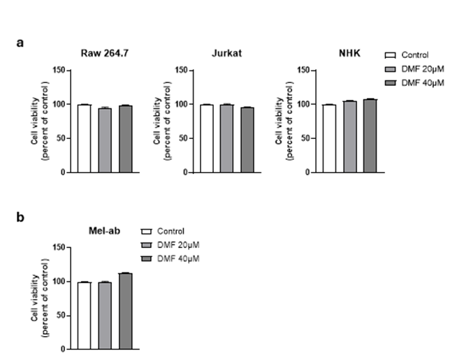
Supplementary Figure 1. Cytotoxic effects of DMF on various cell lines. Cell viability was determined using the MTT assay. (a) RAW 264.7, Jurkat, and NHK cells were treated with DMF (20 and 40 μM) for 24 h. (b) Mel-ab cells were treated with the same concentrations for 72 h. Cell viability is expressed as a percentage relative to the untreated control group. Data represent the mean ± SEM of three independent experiments
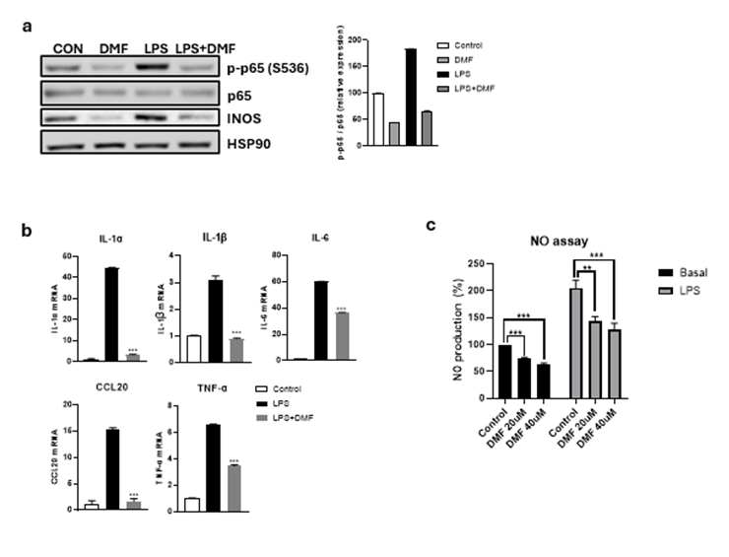
Supplementary Figure 2. Effects of DMF treatment on LPS-stimulated RAW 264.7 macrophages. (a) Western blot analysis of phosphorylated p65 (p-p65) expression in RAW 264.7 cells stimulated with LPS for 1 h in the presence or absence of DMF. (b) qPCR analysis of **Il1a, **Il1b, **Il6, **Ccl20, and Tnfa mRNA expression levels in RAW 264.7 cells stimulated with LPS for 4 h in the presence or absence of DMF (c) Nitric oxide (NO) production measured by Griess assay in RAW 264.7 cells stimulated with LPS for 24 h with or without DMF.
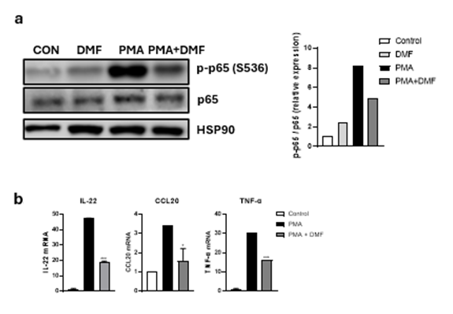
Supplementary Figure 3. Effects of DMF treatment on PMA-stimulated Jurkat T cells.
(a) Western blot analysis of phosphorylated p65 (p-p65) protein expression in Jurkat cells stimulated with PMA for 30 minutes in the presence or absence of DMF. (b) mRNA expression levels of IL22, CCL20, and TNFA assessed by qPCR in Jurkat cells stimulated with PMA for 4 hours in the presence or absence of DMF.

Supplementary Information: Full-length blots.

