Simulated Light Schedules for Sleep-Wake Adjustments: Exploring the Incorporation of Reinforcement Learning
Ming-yi Seah^{1, 2}, Joanne Mun Yee Lim¹, Shiuan-Ni Liang¹, Yatinesh Kumari³, Vineetha Kalavally^{1, 2, *}
¹ Department of Electrical and Robotics Engineering, Monash University Malaysia, Subang Jaya, Malaysia.
² Intelligent Lighting Laboratory, Monash University Malaysia, Subang Jaya, Malaysia.
³ Neurological Disorder and Aging Research Group (NDA), Neuroscience Research Strength (NRS), Jeffrey Cheah School of Medicine and Health Sciences, Monash University Malaysia, Subang Jaya, Malaysia.
*Correspondence: Vineetha Kalavally (vineetha@monash.edu)

Supplementary Material 1.0 Example Actigraphy Data Obtained from GENEActiv Actiwatch and GENEActiv’s R Markdown Tool
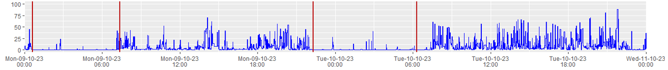
Fig. S1.1 Example plot of actigraphy data (blue) collected using GENEActiv Actiwatch across a period of two days. Red vertical lines indicate the sleep-wake times identified by GENEActiv’s complementary R markdown tool.
Table S1 Sleep-wake parameters identified by GENEActiv for the collected data across two days.
Night Starting | Sleep Onset Time | Rise Time | Total Elapsed Bedtime | Total Sleep Time | Total Wake Time | Sleep Efficiency
08-10-2023 | 00:38 | 07:21 | 06:41 | 05:10 | 01:30 | 77.4%
09-10-2023 | 22:17 | 06:17 | 07:57 | 05:16 | 02:40 | 66.3%

Supplementary Material 2.0 Minima and Maxima used to Standardized Sleep-Wake Metric Values
Table S2 Minimum and maximum values used for standardizations of collected participant sleep-wake metrics.
Sleep-Wake Metric | Minimum | Maximum
Sleep Onset (SO) | 22:00 | 06:00
Wake time (WT) | 06:00 | 12:00
Mid-Sleep (MS) | 02:00 | 09:00
Total Sleep Time (TST) | 3 hours | 8 hours
Sleep Efficiency (SE) | 50% | 100%

Supplementary Material 3.0 Visualization of Data Augmentation and Deep Deterministic Policy Gradient (DDPG) Light Schedule Modification Algorithm
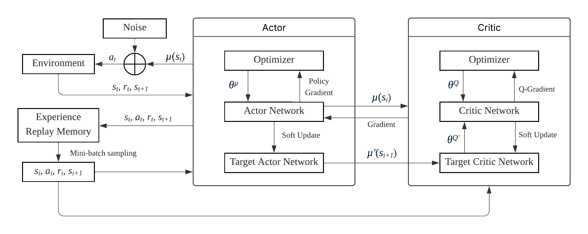
Fig. S3.1 Framework structure of deep deterministic gradient policy (DDPG) algorithm.

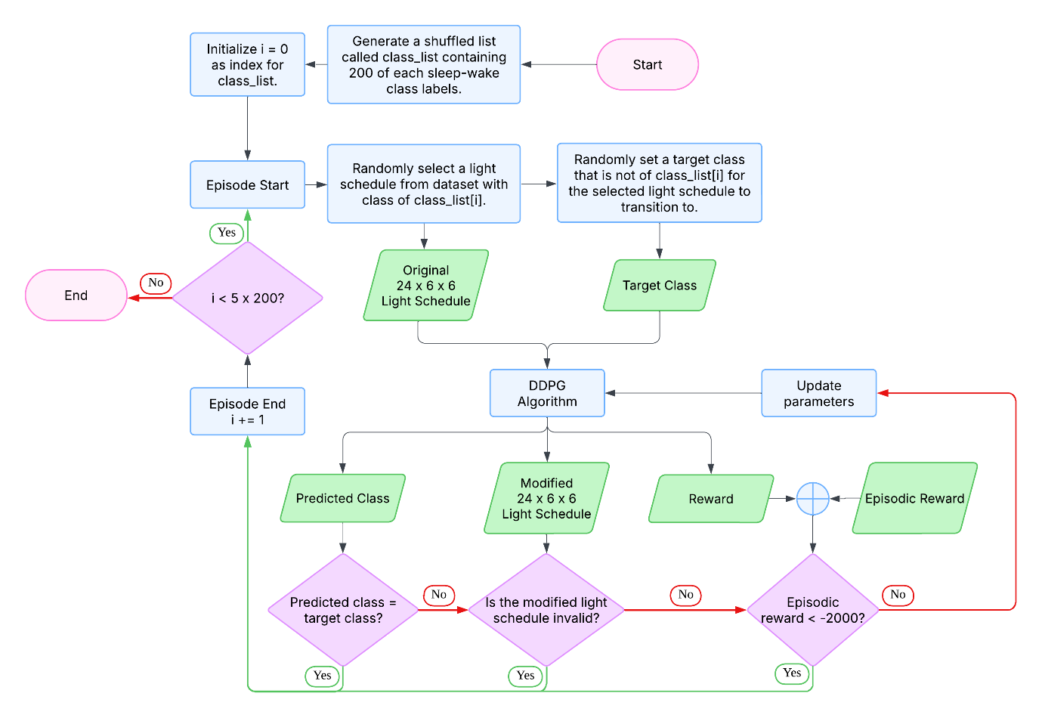
Fig. S3.2 Flowchart of the training process of deep deterministic policy gradient (DDPG) algorithm.

Supplementary Material 4.0 Correlation between Simulated DLMO and Sleep-Wake Parameters
Table S3 Correlation coefficients (r) between DLMOs simulated from experimental schedules using a physiological model and sleep-wake parameters.
Sleep-Wake Parameter | Correlation Coefficient (r) with DLMO
Sleep Onset (SO) | 0.4935
Wake Time (WT) | 0.5683
Mid-Sleep (MS) | 0.5609
Total Sleep Time (TST) | 0.1143
Sleep Efficiency (SE) | 0.0205

