Supplementary information
High-performance and hysteresis-free perovskite transistors with anion engineering
Huihui Zhu^{1, 7}, Ao Liu^{1, 7}, Kyu In Shim², Haksoon Jung¹, Taoyu Zou¹, Youjin Reo¹, Hyunjun Kim¹, Jeong Woo Han², Yimu Chen³, Hye Yong Chu⁴, Jun Hyung Lim⁴, Hyung-Jun Kim⁴, Sai Bai^{5, 6}*, Yong-Young Noh¹*
¹Department of Chemical Engineering, Pohang University of Science and Technology, 77 Cheongam-Ro, Nam-Gu, Pohang 37673, Republic of Korea
²Department of Chemical Engineering and School of Interdisciplinary Bioscience and Bioengineering, Pohang University of Science and Technology, 77 Cheongam-Ro, Nam-Gu, Pohang 37673, Republic of Korea
³Ministry of Industry and Information Technology Key Lab of Micro-Nano Optoelectronic Information System, Harbin Institute of Technology, Shenzhen, 518055, China
⁴R&D Center, Samsung Display Inc., Yongin 17113, Republic of Korea
⁵Institute of Fundamental and Frontier Sciences, University of Electronic Science and Technology of China, Chengdu, 611731, China
⁶Department of Physics, Chemistry and Biology (IFM), Linköping University, Linköping SE-58183, Sweden
⁷These authors contributed equally to this work.
*Corresponding to authors: Y. Y. Noh (yynoh@postech.ac.kr) and S. B (sai.bai@liu.se)

Methods
Chemicals. N,N-dimethylformamide (DMF, anhydrous, 99.8%, Sigma-Aldrich), dimethyl sulfoxide (DMSO, anhydrous, ≥99.9%, Sigma-Aldrich), methylammonium iodide (MAI, ≥99.5%, Xi’an Polymer Light Technology Corp), tin(II) iodide (SnI₂, anhydrous, beads, 99.99% trace metals basis, Sigma-Aldrich), lead(II) iodide (PbI₂, 99.9985% metals basis, Alfa Aesar), tin(II) fluoride (SnF₂, 99%, Sigma-Aldrich), lead(II) bromide (PbBr₂, 99.99% trace metals basis, Sigma-Aldrich), lead(II) chloride (PbCl₂, >99.99%, Xi’an Polymer Light Technology Corp), tin(II) chloride (SnCl₂, 99.99% trace metals basis, Sigma-Aldrich) and chlorobenze (anhydrous, 99.8%, Sigma-Aldrich) were used as received without further purification.
Precursor and device preparation. The precursor solutions were prepared by mixing MAX and SnX₂ (X = I, Cl, Br) in DMF/DMSO binary solvents at a volume ratio of 4/1. The ratio of different composition is expressed as MASn(I_{1-y}X_{y})₃, X = Cl or Br, and y=0~0.08. The precursor concentration was around 0.15 M. For example, to prepare the MASnI₃ precursor, 102 mg of MAI, 216 mg of SnI₂, 17 mg of PbI₂, and 8.4 mg of SnF₂ were dissolved in 4 mL of mixed solvent (3.2 mL of DMF and 0.8 mL of DMSO). The others were made similarly. Same amounts of SnF₂ (8 mol% with respect to the Sn source) and lead substitution (6 mol%) were added in each precursor as anti-oxidation and stabilizer additives. Each precursor was stir-heated at 60 ºC for 2h before use. Dielectric layers were the reliable 40-nm HfO₂ on Si substrates with capacitance of 270 nF cm⁻² grown by the mature atomic layer deposition (ALD) in National Institute for Nanomaterials Techanology, Pohang. For the perovskite film deposition, the HfO₂/Si substrates (1.5×1.5 cm²) were first treated with UV ozone for 30 mins, then the precursor solutions were dropped on the substrates and spin-coated at the speed of 4000 rpm for 25 s with 60 uL of chlorobenzene dripping after ~10 s from the beginning. Afterwards, the films were annealed at 70 ºC for 10 mins. All precursor solutions and films were prepared in an N₂-filled glove box (O₂ and H₂O levels: 1–2 ppm). Then thermal evaporation and a shadow mask were used for the Au source/drain electrode deposition. The channel width and length of the TFTs are 1000 and 150 um, respectively. For the complementary inverter integration, we used design-patterned indium tin oxide (ITO, 10 Ω/□) glass by photolithography as the bottom gate, ALD HfO₂ as the dielectric layer, solution-processed self-patterned¹ triple-halide perovskite as the p-channel and IGZO as the n-channel, and evaporated gold through a bespoke shadow mask as electrodes.

Film and device characterizations. The film XRD patterns were recorded using a Rigaku D/MAX 2600 V with Cu Kα (λ = 1.5406 Å) radiation. SEM images were obtained using a field-emission scanning electron microscope (Hitachi S4800). AFM height profile data were collected using an atomic force microscopy (Nanosurf Nanite AFM). XPS characterizations were conducted using a VersaProbe Scanning Microprobe under vacuum (10⁻⁸ Torr). The Hall measurements were performed using the van der Pauw method, using a 0.51T magnet and a bespoke sample holder in an N₂-filled glove box at room temperature. The electrical signal during the Hall measurement was obtained using a Keithley 4200-SCS and probe station (MST-4000A, MS TECH, Korea). Transistor transfer characteristics were measured using a semiconductor parameter analyser (Keithley 4200-SCS) in an N₂-filled glove box at room temperature in continuous mode. The saturation TFT mobility was calculated as²:
${μ_{sat}=\frac{2L}{WC_{i}}\left(\frac{∂\sqrt{I_{DS}}}{∂V_{GS}}\right)}^{2}$,
where L, W, and C_{i} are the channel length and width and dielectric areal capacitance, respectively.

DFT calculations. All density functional theory (DFT) calculations were performed using the Vienna ab Initio Simulation Package (VASP)³. The Perdew-Burke-Ernzerhof (PBE) functional of the generalized gradient approximation (GGA) was used for the exchange-correlation energies^{4, 5}. Bulk MASnI₃ tetragonal crystal structure was initially optimized to have the parameters of a = 6.230 Å, b = 6.230 Å, and c = 6.232 Å. Based on this, (5 × 3 × 1) MASnI₃ slab structures were constructed with 6 layer thickness and ~15 Å vacuum spacing in the direction normal to the surface. Br-doped slab model, MASn(I/Br)₃, was also created with same parameters. The energy cutoff for the plane-wave basis set was set to be 600 eV, and Monkhorst-Pack 1 × 1 × 1 k-point meshes were used⁶. Moreover, the DFT-D3 method was employed to introduce the van der Waals interaction⁷. For the structural optimization, the bottom three layers were fixed, but rest of atoms were relaxed using a conjugate-gradient algorithm until the difference in the total force was < 0.03 eV/Å, and spin-polarization was taken into considerations⁸. VESTA package was used for structural visualization⁹. For the calculation of binding affinity towards I vacancy site, two slab models of pure MASnI₃ and Br-doped MASn(I/Br)₃ were employed. For each slab model, I vacancy site was created on the surface, and different halides (X = I⁻, Br⁻, Cl⁻) were placed at the I vacancy site. Affinity towards I vacancy site depending on different halides was calculated using below equations,
$E_{affinity}=E_{halide passivated }-E_{I_{vac}}-n*\frac{1}{2}E_{halogen\left(g\right)}$,
where $E_{affinity}$ is the adsorption energy of halide to the I vacancy site on the surface, $E_{halide passivated }$ is the total energy of halide passivated at the I vacancy site on the surface, $n$ is the number of halides being passivated, $E_{anion\left(g\right)}$ is the total energy of halogen gas. For MASn(I/Br)₃ model, above equation was also applied using total energy of passivated at the I vacancy site of MASn(I/Br)₃ slab instead of MASnI₃ slab. In order to simulate the randomness of Br passivation, Br was doped at random locations within the slab layers at Br to I ratio of 0.05.

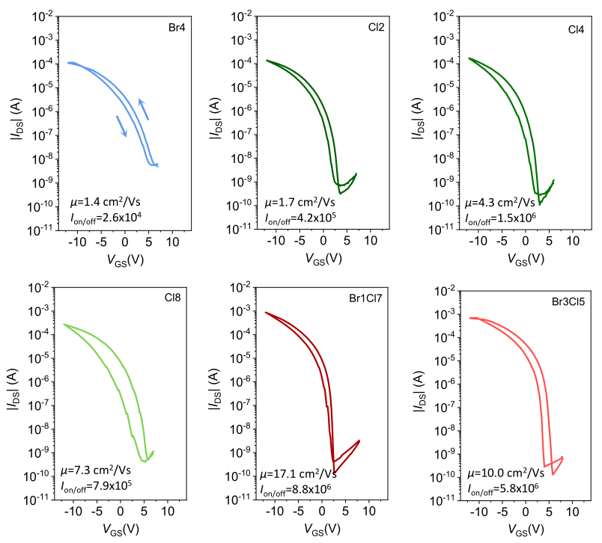
Supplementary Fig. 1. The optimizations of halide composition for MASnX₃ based perovskite TFTs. Br4, Cl2, Cl4, Cl8, Br1Cl7, and Br3Cl5 denote the devices based on channel films processed from precursors of MASn(I_{0.96}Br_{0.04})₃, MASn(I_{0.98}Cl_{0.02})₃, MASn(I_{0.96}Cl_{0.04})₃, MASn(I_{0.92}Cl_{0.08})₃, MASn(I_{0.92}Br_{0.01}Cl_{0.07})₃, and MASn(I_{0.92}Br_{0.03}Cl_{0.05})₃, respectively.

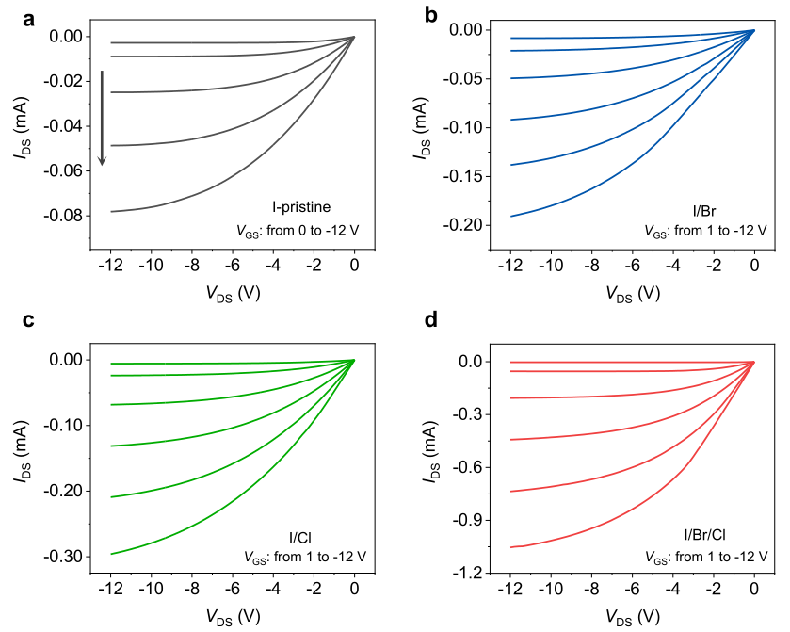
Supplementary Fig. 2. Output characteristics of the (a) I-pristine, (b) I/Br, (c) I/Cl and (d) I/Br/Cl perovskite TFTs. I-pristine, I/Br, I/Cl, and I/Br/Cl denote the devices based on channel films processed from precursors of MASnI₃, MASn(I_{0.98}Br_{0.02})₃, MASn(I_{0.94}Cl_{0.06})₃ and MASn(I_{0.92}Br_{0.02}Cl_{0.06})₃, respectively.

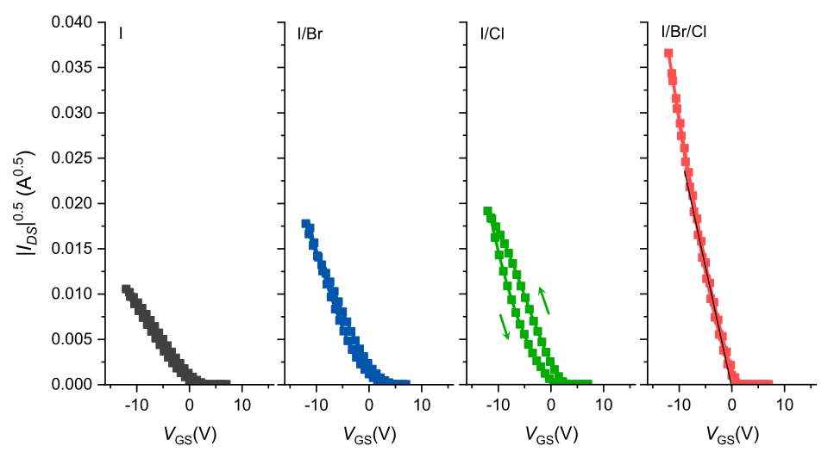
Supplementary Fig. 3. |I_{DS}|^{1/2} of the perovskite TFTs with the I-pristine, I/Br, I/Cl and I/Br/Cl channel films, respectively.

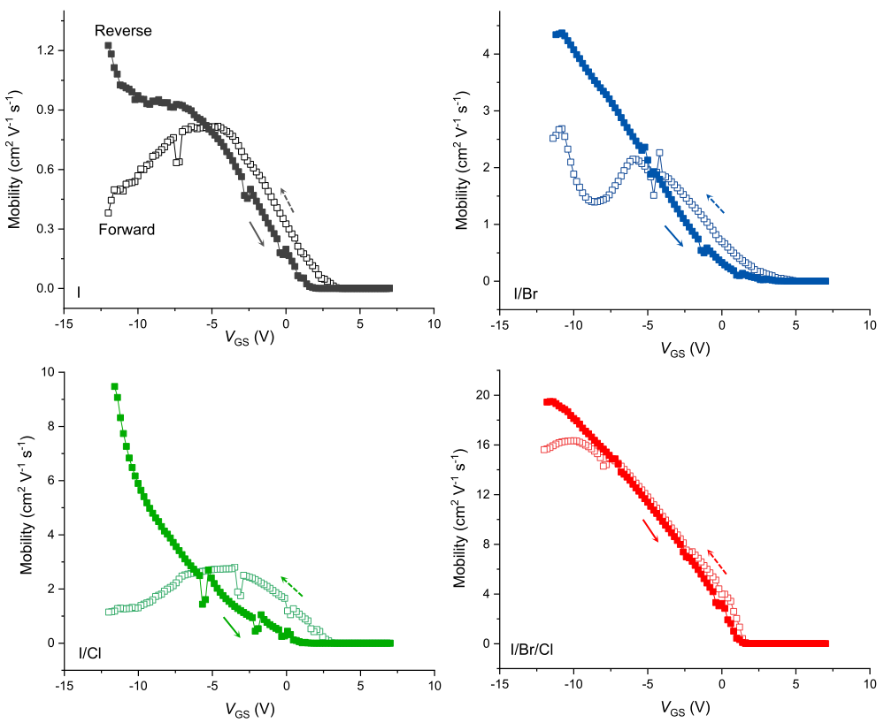
Supplementary Fig. 4. Dual-sweep mobilities of the perovskite TFTs with the I-pristine, I/Br, I/Cl and I/Br/Cl channel films, respectively. The maximum values were extraced from reverse and forward sweeps for per device, respectively.

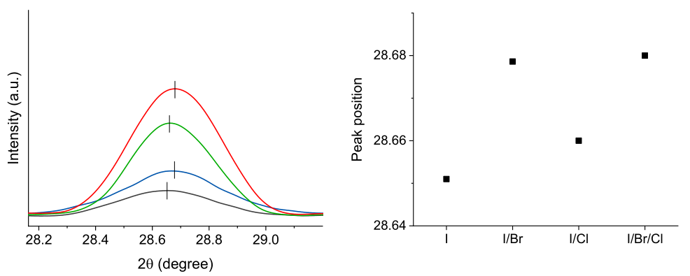
Supplementary Fig. 5. XRD peak shift of the perovskite TFTs with the I-pristine, I/Br, I/Cl and I/Br/Cl channel films, respectively.

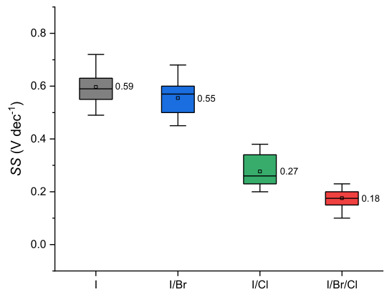
Supplementary Fig. 6. Subthreshold swing (SS) statistics from ten individual TFTs with the I, I/Br, I/Cl and I/Br/Cl channel films, respectively. The mean values are labelled.
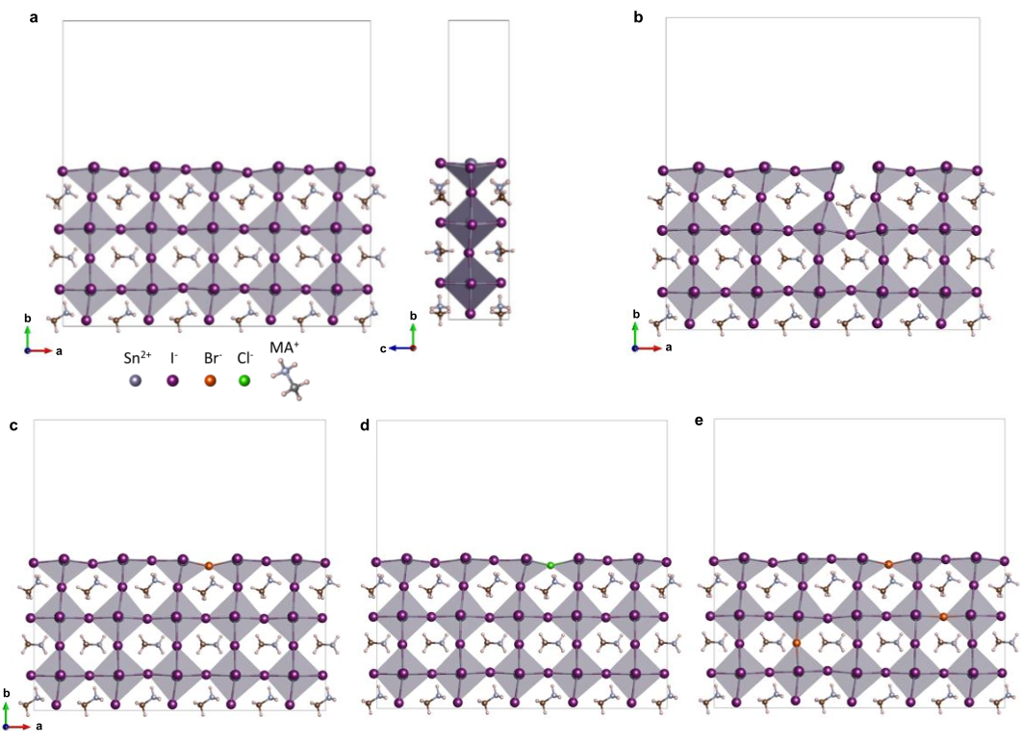
Supplementary Fig. 7. DFT slab models of (a) basic MASnI₃, (b) MASnI₃ with an iodine vacancy (V_{I}). Illustrations of V_{I} passivation by (c) Br or (d) Cl anions in MASnI₃, and (e) illustrations of V_{I} passivation by a Br anion in MASn(I/Br)₃ case.

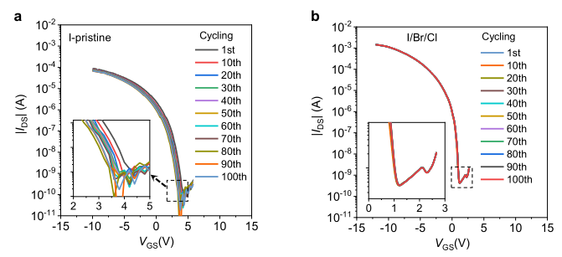
Supplementary Fig. 8. Transfer characteristics of (a) I-pristine and (b) I/Br/Cl TFTs under cycling test (V_{DS}=-12 V).

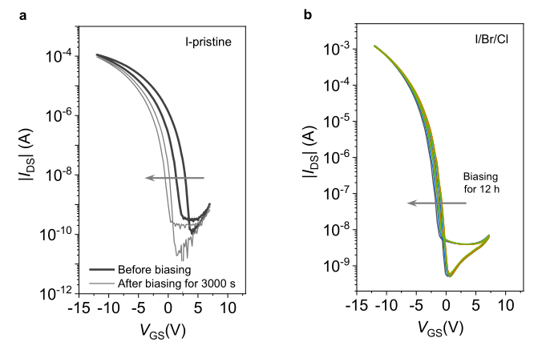
Supplementary Fig. 9. Transfer characteristics of (a) I-pristine and (b) I/Br/Cl TFTs under bias (V_{GS}=V_{DS}=-12 V).

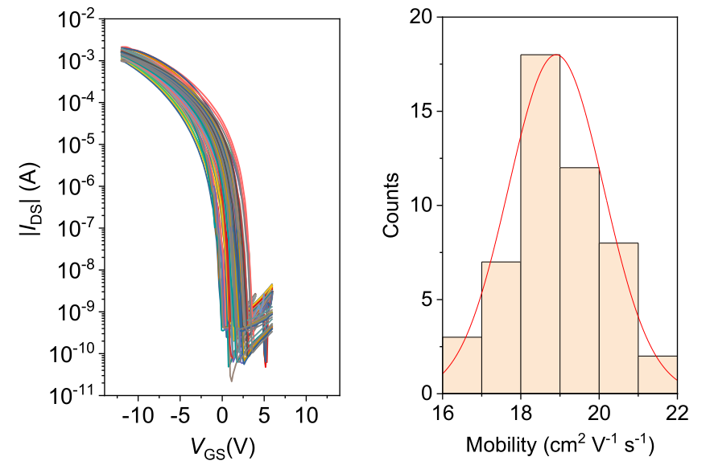
Supplementary Fig. 10. Transfer characteristics and mobility statistics of 50 individual I/Br/Cl TFTs. The average mobility extracted from reverse scans is 19±1.2 cm² V⁻¹ s⁻¹.

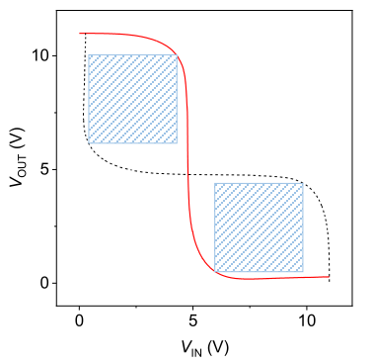
Supplementary Fig. 11. The butterfly voltage transfer curves plot of the integrated perovskite/IGZO complementary inverter. The black-dash curve was plotted in mirror. The noise margin can be estimated by nesting the largest possible rectangular area inside the butterfly plot, following the maximum equal criterion method¹⁰.

Supplementary Table 1. Performance parameters of Pb-and Sn-based perovskite transistors.
 | Perovskite Channel | Interlayer/  Processing* | Operation Temp. | Mobility (cm² V⁻¹ s⁻¹) |  | On/off ratio | Year |  | Ref.
 |  |  |  | μ_{h} | μ_{e} | On/off ratio |  |  | Ref.
3D Pb-based perovskites | MAPbI₃ | / | 78 K | 2.1 × 10⁻² | 7.2 × 10⁻² | ~10⁵ | 2015 |  | ¹¹
3D Pb-based perovskites | MAPbI₃ | / | 180 K | / | 1 × 10⁻² | ~10⁴ | 2015 |  | ¹²
3D Pb-based perovskites | MAPbI₃ | PEIE | 300 K | / | 0.5 | ~10⁴ | 2017 |  | ¹³
3D Pb-based perovskites | MAPbI₃ | Microplate | 200 K | / | 0.3 | ~10⁵ | 2016 |  | ¹⁴
3D Pb-based perovskites | MAPbI₃ | Microplate, Gra modified | 77 K | / | ~4 | ~10⁵ | 2017 |  | ¹⁵
3D Pb-based perovskites | MAPbI₃ | Surface cleaning | RT | 1.8 | 3.0 | ~10⁵ | 2020 |  | ¹⁶
3D Pb-based perovskites | MAPbI_{3−x}Cl_{x} | TTFB-SAM | RT | 1.3 | 1.0 | ~10³ | 2015 |  | ¹⁷
3D Pb-based perovskites | MAPbI_{3−x}Cl_{x} | Protein treated | RT | 0.11 | / | ~10⁴ | 2017 |  | ¹⁸
3D Pb-based perovskites | Cs_{x}(MA_{0.17}FA_{0.83})_{1−x}Pb(Br_{0.17}I_{0.83})₃ | DTS | RT | 2.1 | 2.5 | ~10⁴ | 2017 |  | ¹⁹
3D Pb-based perovskites | RbCsFAMAPbI₃ | Sol. treated | RT | / | 1.2 | ~10⁴ | 2020 |  | ²⁰
3D Pb-based perovskites | MAPbX₃,  X = Cl, Br, I | Single crystal | RT | 4.7 | 1.5 | ~10⁵ | 2018 |  | ²¹
2D Sn-based perovskites | (PEA)₂SnI₄ | / | RT | 0.6 | / | 10⁴ | 1999 |  | ²²
2D Sn-based perovskites | (PEA)₂SnI₄ | Melt  processed | RT | 2.6 | / | ~10⁶ | 2002 |  | ²³
2D Sn-based perovskites | (PEA)₂SnI₄ | MoO_{x}, NH₃I-SAM | RT | 12 | / | ~10⁶ | 2016 | ²⁴
2D Sn-based perovskites | (PEA)₂SnI₄ | Semi-CNTs hybrid | RT | 1.5 | / | ~10⁵ | 2019 |  | ²⁵
2D Sn-based perovskites | (PEA)₂SnI₄ | Precursor- film-FET optimization | RT | 3.5 | / | ~10⁶ | 2020 |  | ²⁶
2D Sn-based perovskites | (PEA)₂SnI₄ | Binary sol. | RT | 3.8 | / | ~10⁶ | 2020 |  | ²⁷
2D Sn-based perovskites | (PEA)₂SnI₄ | Urea | RT | 4.2 | / | ~10⁵ | 2021 |  | ²⁸
2D Sn-based perovskites | (m-FPEA)₂SnI₄  m=2, 3, 4 | / | RT | 0.2~0.6 | / | ~10⁵ | 2001 |  | ²⁹
2D Sn-based perovskites | (4Tm)₂SnI₄ | / | RT | 2.32 | / | ~10⁶ | 2019 |  | ³⁰
2D Sn-based perovskites | (TT)₂SnI₄ | / | RT | 9.35 | / | ~10⁶ | 2021 |  | ³¹
2D/3D Sn-based perovskite | (FA/PEA)SnI_{x} | / | RT | 0.21 | / | ~10⁴ | 2021 |  | ³²
3D Sn-based perovskites | MASn(I)₃ | / | RT | 1.3 | / | 10⁶ | This work
3D Sn-based perovskites | MASn(I/Br/Cl)₃ | Halide engineering | RT | 19.6 | / | 3×10⁷
Note: The perovskite FETs based on mature dielectrics with uncontested capacitance, e.g. SiO₂, Cytop, PMMA, were summarized here.³³ *Thin-film channel layers were solution-processed unless otherwise noted. Research on perovskite-based FETs is still at a relatively early stage,^{34, 35} and device test and mobility calculation vary in a wide range from lab to lab.³⁶⁻⁴⁰ It is suggested: i) drain current should be very distinguishable from gate leakage current; ii) capacitance of dielectric layer should be verified; iii) contact resistance between channel layer and source-drain electrodes should be small enough for precise mobility extraction; iv) if dual-sweep hysteresis exists, detailed mobility extraction should be provided; v) device reproducibility should be reasonable.

References
(1) Park, W.-T.; Noh, Y.-Y., A Self-Aligned High Resolution Patterning Process for Large Area Printed Electronics. J. Mater. Chem. C 5, 6467-6470 (2017).
(2) Wang, Z.; Nayak, P. K.; Caraveo-Frescas, J. A.; Alshareef, H. N., Recent Developments in P-Type Oxide Semiconductor Materials and Devices. Adv. Mater. 28, 3831-3892 (2016).
(3) Kresse, G.; Furthmüller, J., Efficient Iterative Schemes for Ab Initio Total-Energy Calculations Using a Plane-Wave Basis Set. Phys. Rev. B 54, 11169-11186 (1996).
(4) Grimme, S., Semiempirical Gga-Type Density Functional Constructed with a Long-Range Dispersion Correction. J. Comput. Chem. 27, 1787-1799 (2006).
(5) Sholl, D.; Steckel, J. A., Density Functional Theory: A Practical Introduction. John Wiley & Sons: 2011.
(6) Monkhorst, H. J.; Pack, J. D. J. P. r. B., Special Points for Brillouin-Zone Integrations. 13, 5188 (1976).
(7) Grimme, S.; Antony, J.; Ehrlich, S.; Krieg, H., A Consistent and Accurate Ab Initio Parametrization of Density Functional Dispersion Correction (Dft-D) for the 94 Elements H-Pu. J. Chem. Phys. 132, 154104 (2010).
(8) Press, W. H.; Flannery, B. P.; Teukolsky, S. A.; Vetterling, W. T. J. C.; New York, C. U. P., , 839, Numerical Recipes: The Art of Scientific Computing. (1986).
(9) Momma, K.; Izumi, F., Vesta 3 for Three-Dimensional Visualization of Crystal, Volumetric and Morphology Data. J. Appl. Crystallogr. 44, 1272-1276 (2011).
(10) Hauser, J. R., Noise Margin Criteria for Digital Logic-Circuits. Ieee. T. Educ. 36, 363-368 (1993).
(11) Chin, X. Y.; Cortecchia, D.; Yin, J.; Bruno, A.; Soci, C., Lead Iodide Perovskite Light-Emitting Field-Effect Transistor. Nat. Commun. 6, 7383 (2015).
(12) Labram, J. G.; Fabini, D. H.; Perry, E. E.; Lehner, A. J.; Wang, H.; Glaudell, A. M.; Wu, G.; Evans, H.; Buck, D.; Cotta, R.; Echegoyen, L.; Wudl, F.; Seshadri, R.; Chabinyc, M. L., Temperature-Dependent Polarization in Field-Effect Transport and Photovoltaic Measurements of Methylammonium Lead Iodide. J. Phys. Chem. Lett. 6, 3565-3571 (2015).
(13) Senanayak, S. P.; Yang, B.; Thomas, T. H.; Giesbrecht, N.; Huang, W.; Gann, E.; Nair, B.; Goedel, K.; Guha, S.; Moya, X., Understanding Charge Transport in Lead Iodide Perovskite Thin-Film Field-Effect Transistors. Sci. Adv. 3, e1601935 (2017).
(14) Li, D.; Wang, G.; Cheng, H.-C.; Chen, C.-Y.; Wu, H.; Liu, Y.; Huang, Y.; Duan, X., Size-Dependent Phase Transition in Methylammonium Lead Iodide Perovskite Microplate Crystals. Nat. Commun. 7, 11330 (2016).
(15) Li, D.; Cheng, H.-C.; Wang, Y.; Zhao, Z.; Wang, G.; Wu, H.; He, Q.; Huang, Y.; Duan, X., The Effect of Thermal Annealing on Charge Transport in Organolead Halide Perovskite Microplate Field-Effect Transistors. Adv. Mater. 29, 1601959 (2017).
(16) She, X. J.; Chen, C.; Divitini, G.; Zhao, B. D.; Li, Y.; Wang, J. Z.; Orri, J. F.; Cui, L. S.; Xu, W. D.; Peng, J.; Wang, S.; Sadhanala, A.; Sirringhaus, H., A Solvent-Based Surface Cleaning and Passivation Technique for Suppressing Ionic Defects in High-Mobility Perovskite Field-Effect Transistors. Nat. Electron. 3, 694-703 (2020).
(17) Mei, Y.; Zhang, C.; Vardeny, Z.; Jurchescu, O., Electrostatic Gating of Hybrid Halide Perovskite Field-Effect Transistors: Balanced Ambipolar Transport at Room-Temperature. MRS Commun. 5, 297-301 (2015).
(18) Ward, J. W.; Smith, H. L.; Zeidell, A.; Diemer, P. J.; Baker, S. R.; Lee, H.; Payne, M. M.; Anthony, J. E.; Guthold, M.; Jurchescu, O. D., Solution-Processed Organic and Halide Perovskite Transistors on Hydrophobic Surfaces. ACS Appl. Mater. Interfaces 9, 18120-18126 (2017).
(19) Yusoff, A. R. b. M.; Kim, H. P.; Li, X.; Kim, J.; Jang, J.; Nazeeruddin, M. K., Ambipolar Triple Cation Perovskite Field Effect Transistors and Inverters. Adv. Mater. 29, 1602940 (2017).
(20) Senanayak, S. P.; Abdi-Jalebi, M.; Kamboj, V. S.; Carey, R.; Shivanna, R.; Tian, T.; Schweicher, G.; Wang, J.; Giesbrecht, N.; Di Nuzzo, D.; Beere, H. E.; Docampo, P.; Ritchie, D. A.; Fairen-Jimenez, D.; Friend, R. H.; Sirringhaus, H., A General Approach for Hysteresis-Free, Operationally Stable Metal Halide Perovskite Field-Effect Transistors. Sci. Adv. 6, eaaz4948 (2020).
(21) Yu, W.; Li, F.; Yu, L.; Niazi, M. R.; Zou, Y.; Corzo, D.; Basu, A.; Ma, C.; Dey, S.; Tietze, M. L., Single Crystal Hybrid Perovskite Field-Effect Transistors. Nat. Commun. 9, 5354 (2018).
(22) Kagan, C.; Mitzi, D.; Dimitrakopoulos, C., Organic-Inorganic Hybrid Materials as Semiconducting Channels in Thin-Film Field-Effect Transistors. Science 286, 945-947 (1999).
(23) Mitzi, D. B.; Dimitrakopoulos, C. D.; Rosner, J.; Medeiros, D. R.; Xu, Z.; Noyan, C., Hybrid Field‐Effect Transistor Based on a Low‐Temperature Melt‐Processed Channel Layer. Adv. Mater. 14, 1772-1776 (2002).
(24) Matsushima, T.; Hwang, S.; Sandanayaka, A. S.; Qin, C.; Terakawa, S.; Fujihara, T.; Yahiro, M.; Adachi, C., Solution‐Processed Organic–Inorganic Perovskite Field‐Effect Transistors with High Hole Mobilities. Adv. Mater. 28, 10275-10281 (2016).
(25) Zhu, H.; Liu, A.; Luque, H. L.; Sun, H.; Ji, D.; Noh, Y.-Y., Perovskite and Conjugated Polymer Wrapped Semiconducting Carbon Nanotube Hybrid Films for High-Performance Transistors and Phototransistors. ACS Nano 13, 3971-3981 (2019).
(26) Zhu, H.; Liu, A.; Shim, K. I.; Hong, J.; Han, J. W.; Noh, Y.-Y., High-Performance and Reliable Lead-Free Layered-Perovskite Transistors. Adv. Mater. 32, 2002717 (2020).
(27) Zhu, H.; Liu, A.; Kim, H.; Hong, J.; Go, J.-Y.; Noh, Y.-Y., High-Performance Layered Perovskite Transistors and Phototransistors by Binary Solvent Engineering. Chem. Mater. 33, 1174-1181 (2021).
(28) Zhu, H.; Liu, A.; Zou, T.; Jung, H.; Heo, S.; Noh, Y. Y., A Lewis Base and Boundary Passivation Bifunctional Additive for High Performance Lead-Free Layered-Perovskite Transistors and Phototransistors. Mater. Today Energy 21, 100722 (2021).
(29) Mitzi, D. B.; Dimitrakopoulos, C. D.; Kosbar, L. L., Structurally Tailored Organic−Inorganic Perovskites: Optical Properties and Solution-Processed Channel Materials for Thin-Film Transistors. Chem. Mater. 13, 3728-3740 (2001).
(30) Gao, Y.; Wei, Z.; Yoo, P.; Shi, E.; Zeller, M.; Zhu, C.; Liao, P.; Dou, L. J. J. o. t. A. C. S., Highly Stable Lead-Free Perovskite Field-Effect Transistors Incorporating Linear Π-Conjugated Organic Ligands. J. Am. Chem. Soc. 141, 15577-15585 (2019).
(31) Liang, A.; Gao, Y.; Asadpour, R.; Wei, Z.; Finkenauer, B. P.; Jin, L.; Yang, J.; Wang, K.; Chen, K.; Liao, P.; Zhu, C.; Huang, L.; Boudouris, B. W.; Alam, M. A.; Dou, L., Ligand-Driven Grain Engineering of High Mobility Two-Dimensional Perovskite Thin-Film Transistors. J. Am. Chem. Soc. 143, 15215-15223 (2021).
(32) Shao, S.; Talsma, W.; Pitaro, M.; Dong, J.; Kahmann, S.; Rommens, A. J.; Portale, G.; Loi, M. A., Field‐Effect Transistors Based on Formamidinium Tin Triiodide Perovskite. Adv. Funct. Mater. 31, 2008478 (2021).
(33) Yang, T.; Wu, Q.; Dai, F.; Huang, K.; Xu, H.; Liu, C.; Chen, C.; Hu, S.; Liang, X.; Liu, X.; Noh, Y.-Y.; Liu, C., Understanding, Optimizing, and Utilizing Nonideal Transistors Based on Organic or Organic Hybrid Semiconductors. Adv. Funct. Mater. 30, 1903889 (2020).
(34) Shining a Light on Perovskite Devices. Nat. Electron. 3, 657-657 (2020).
(35) Zhu, H.; Liu, A.; Noh, Y.-Y., Perovskite Transistors Clean up Their Act. Nat. Electron. 3, 662-663 (2020).
(36) Paulus, F.; Tyznik, C.; Jurchescu, O. D.; Vaynzof, Y., Switched-On: Progress, Challenges, and Opportunities in Metal Halide Perovskite Transistors. Adv. Funct. Mater. 31, 2101029 (2021).
(37) Zhu, H.; Shin, E.-S.; Liu, A.; Ji, D.; Xu, Y.; Noh, Y.-Y., Printable Semiconductors for Backplane Tfts of Flexible Oled Displays. Adv. Funct. Mater. 30, 1904588 (2020).
(38) Zhu, H.; Liu, A.; Noh, Y.-Y., Recent Progress on Metal Halide Perovskite Field-Effect Transistors. Journal of Information Display, 1-12 (2021).
(39) Liu, X.; Yu, D.; Song, X.; Zeng, H., Metal Halide Perovskites: Synthesis, Ion Migration, and Application in Field‐Effect Transistors. Small 14, 1801460 (2018).
(40) Lin, Y.-H.; Pattanasattayavong, P.; Anthopoulos, T. D., Metal-Halide Perovskite Transistors for Printed Electronics: Challenges and Opportunities. Adv. Mater. 29, 1702838 (2017).

