Supplementary Materials for
Visibility Graph Analysis Identifies Informative Spectral Regions in Fiber Evanescent Wave Spectra of Synovial Fluid for Knee Osteoarthritis Diagnosis
Bohdan Mahlovanyi¹*, Rafał Rak¹, Paweł Jakubczyk¹, Yaroslav Shpotyuk^{1,2} , Jarosław Jabłoński^{3,4}, Sławomir Snela^{3,4}, Józef Cebulski¹

¹Institute of Physics, Faculty of Exact and Technical Sciences, University of Rzeszów, Rzeszów, Poland.
²Department of Sensor and Semiconductor Electronics, Ivan Franko National University of Lviv, Lviv, Ukraine
³Department of Orthopedics and Traumatology, Faculty of Medicine, University of Rzeszów, Rzeszów , Poland
⁴Clinical Provincial Hospital No. 2 in Rzeszów, Department of Orthopedics and Traumatology of Children and Adults. Rzeszów, Poland

*Corresponding author:
Bohdan Mahlovanyi: bmahlovanyi@ur.edu.pl

Raw IR absorption spectra
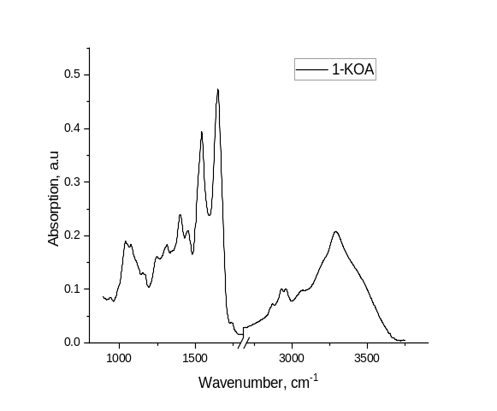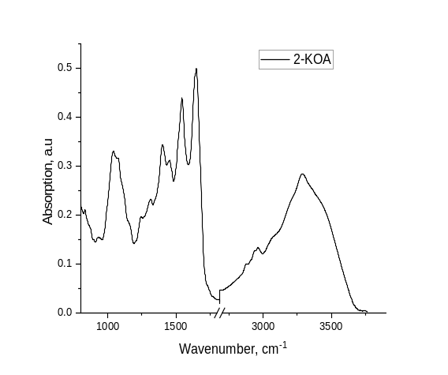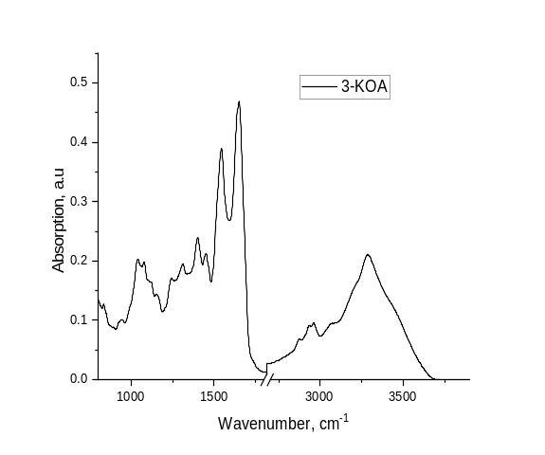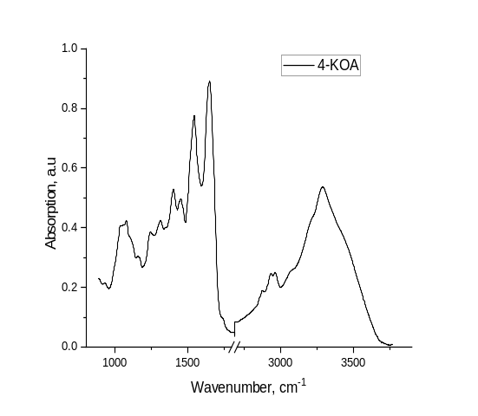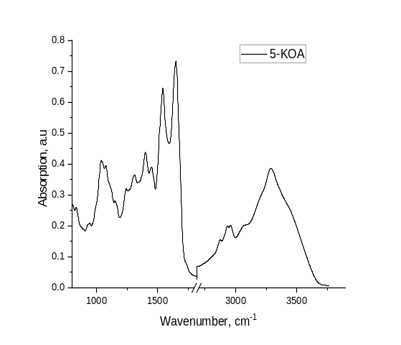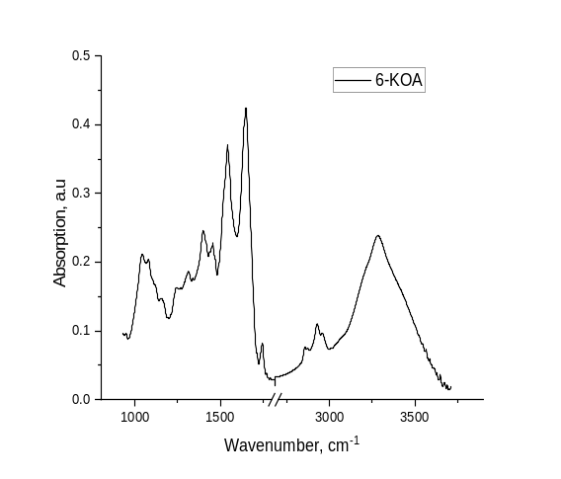

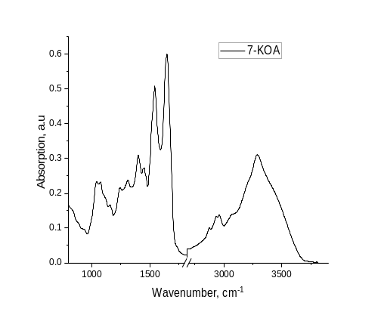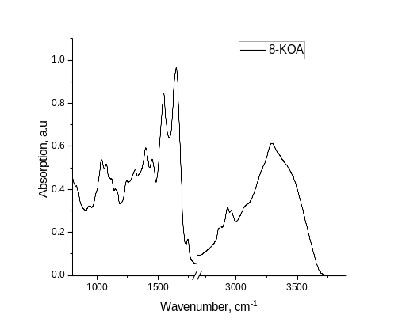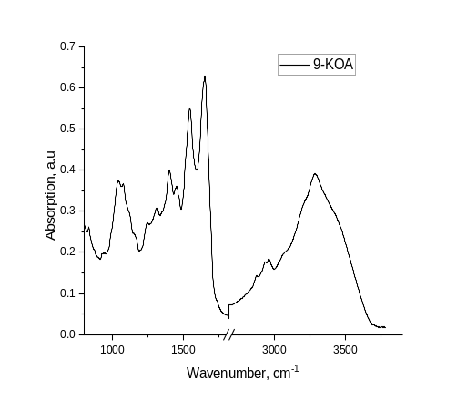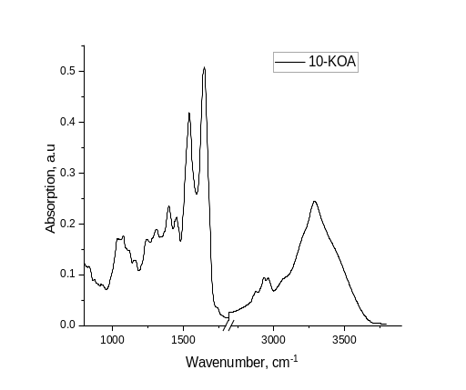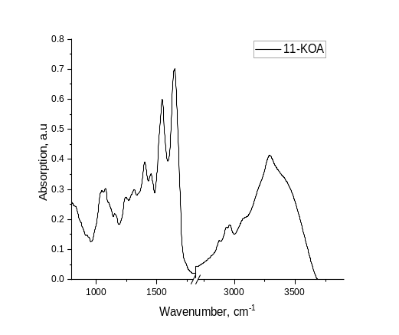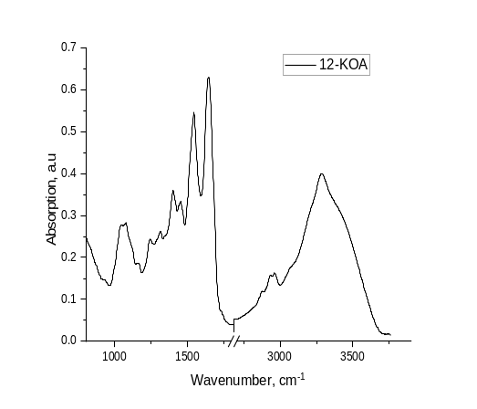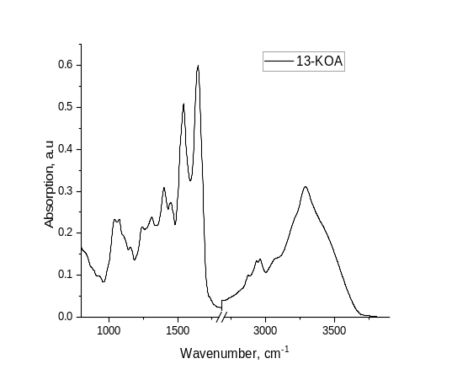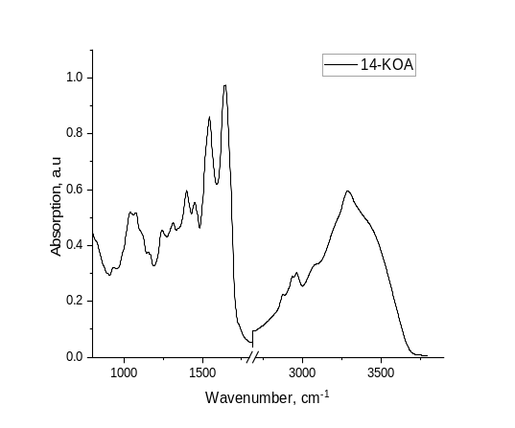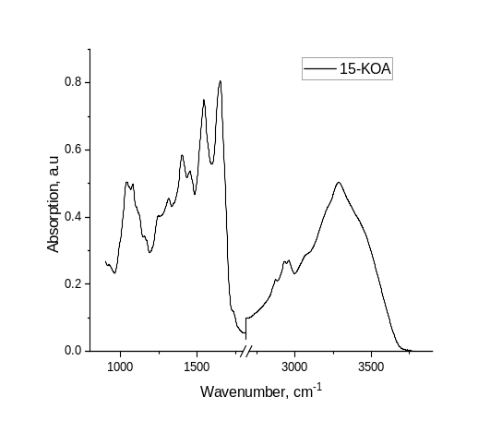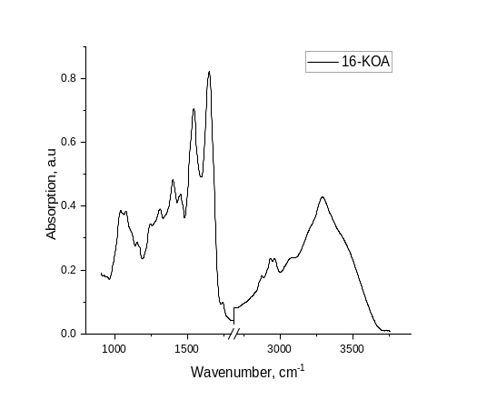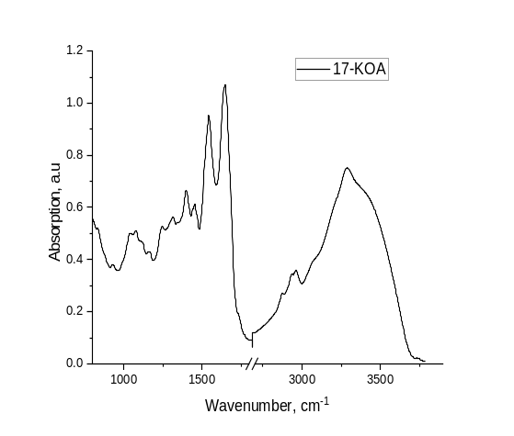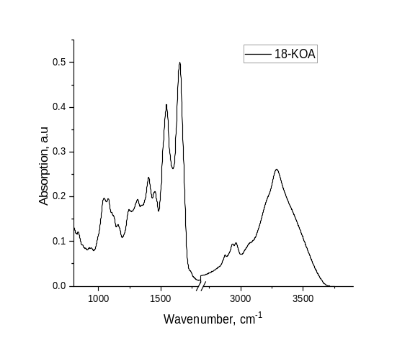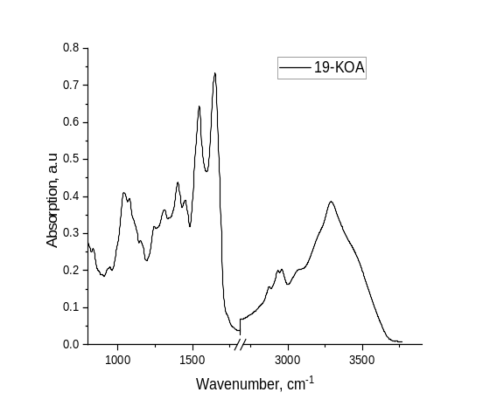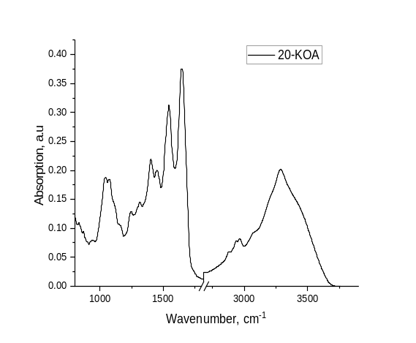
Fig. S1. IR absorption spectra of dried synovial fluid affected by knee osteoarthritis samples measured by the FEWS method.
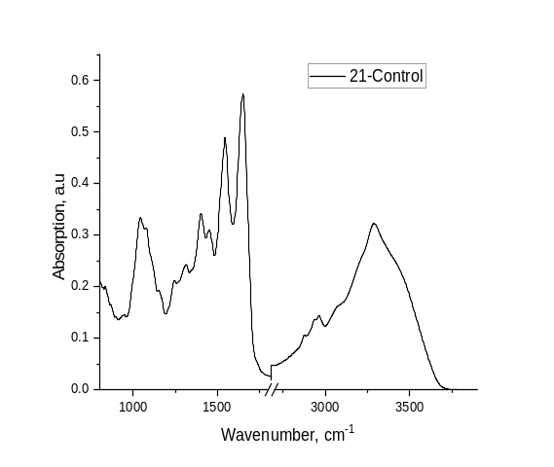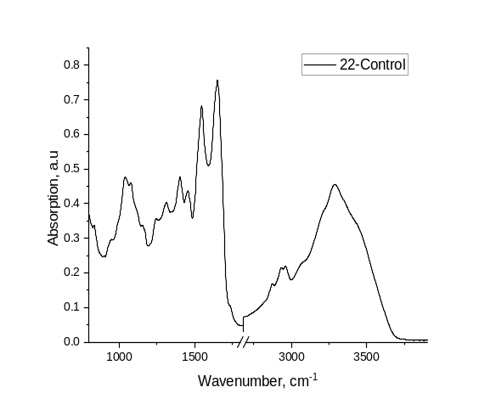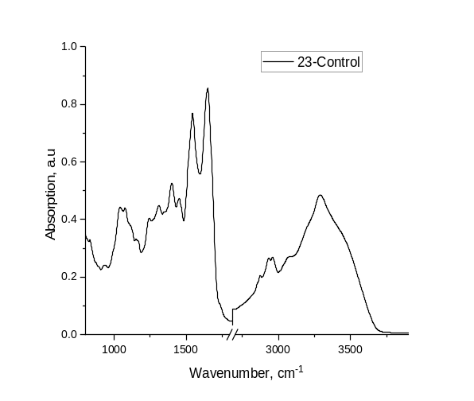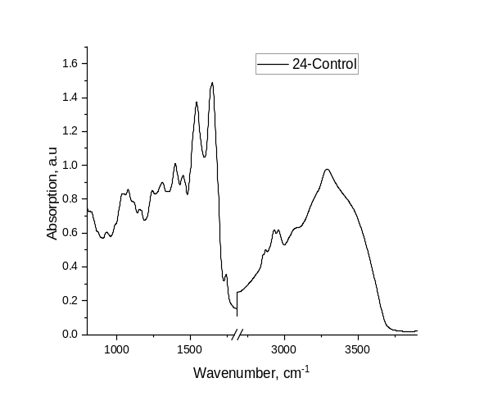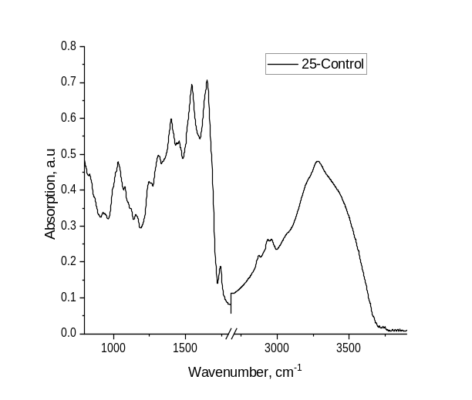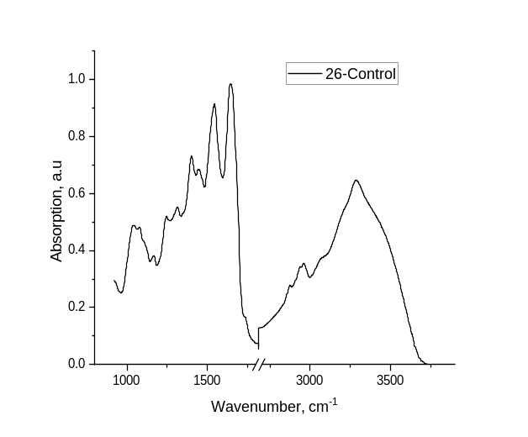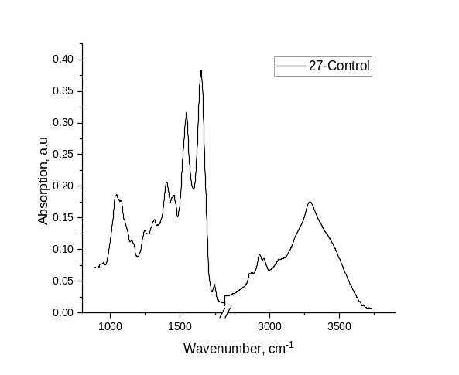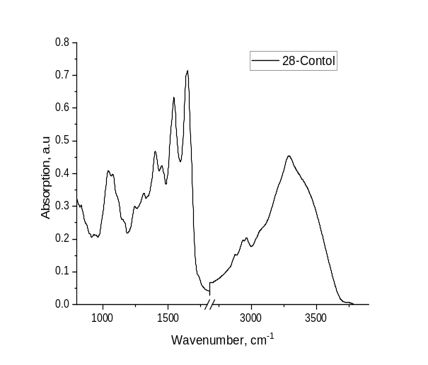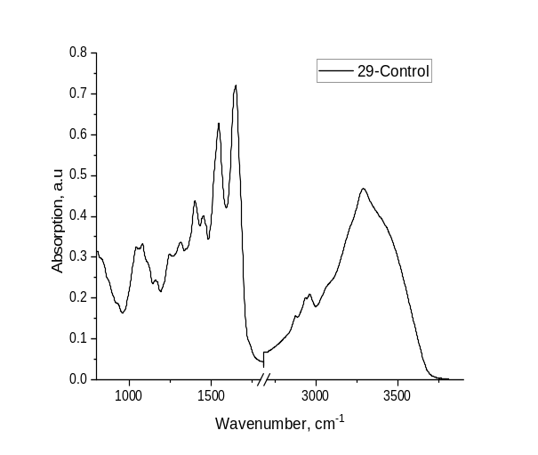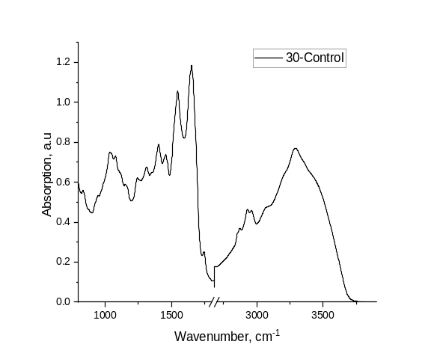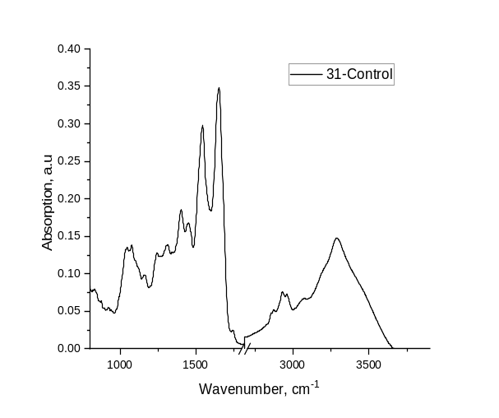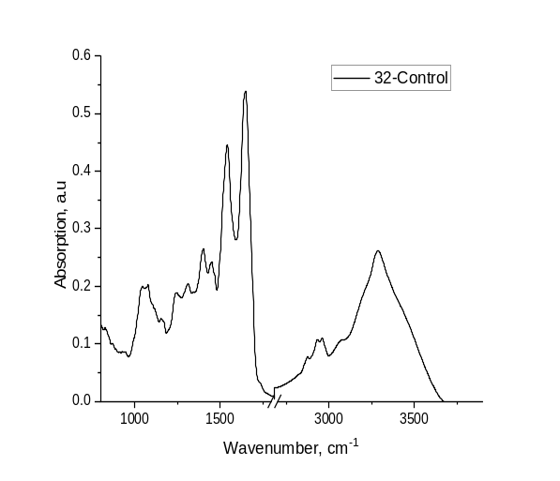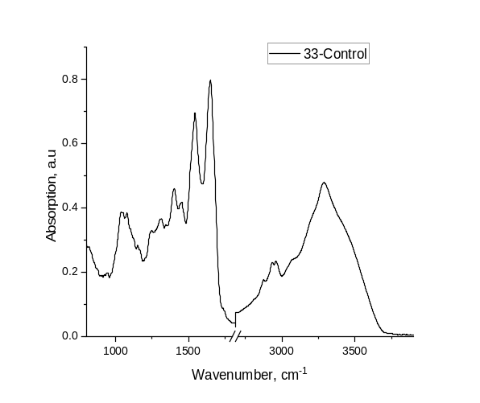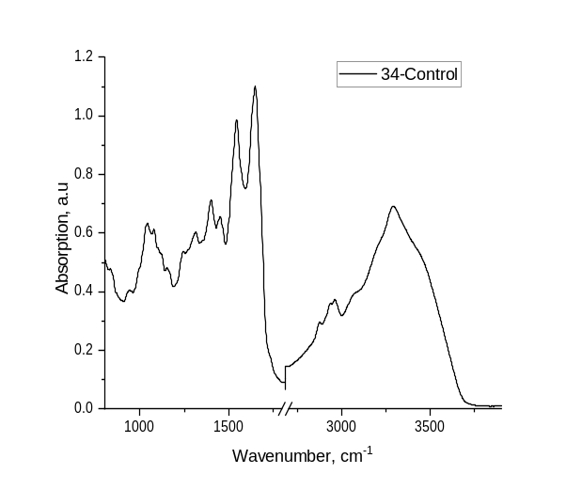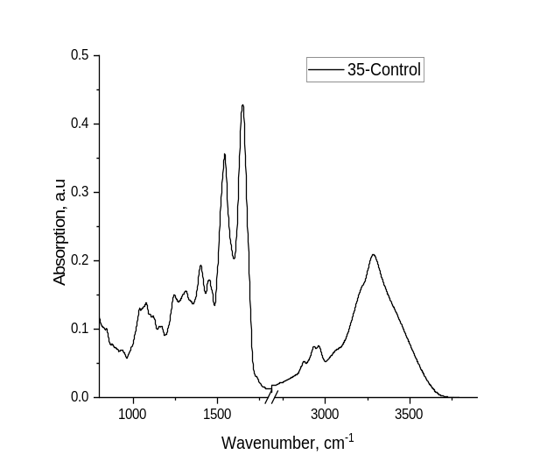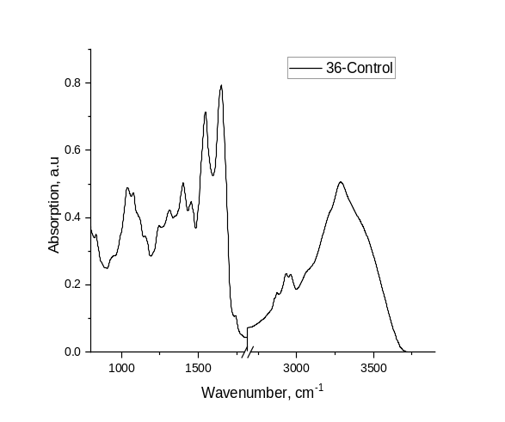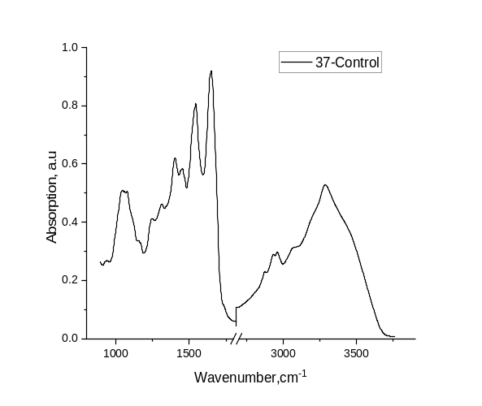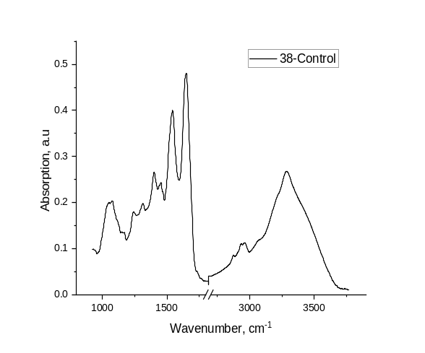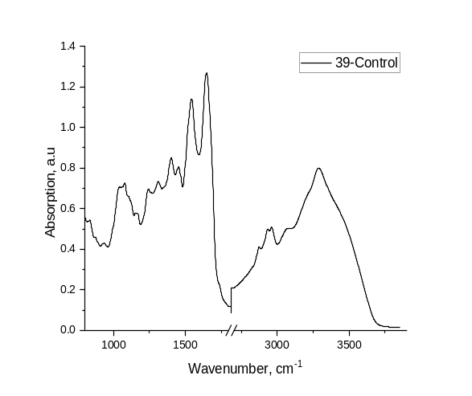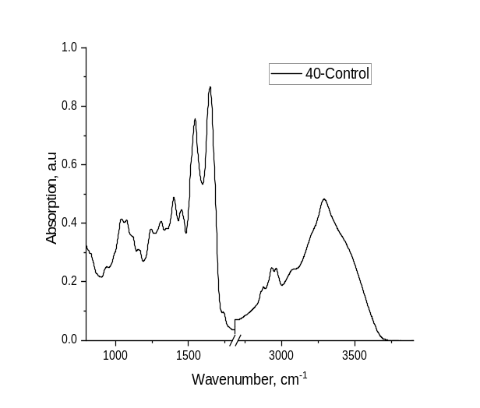
Fig. S2. IR absorption spectra of dried synovial fluid of the Control group measured by the FEWS method.

Conventional Machine Learning analysis
Comparison of Classification Models
Nine machine learning models were compared:
- logistic regression with LASSO regularization (fitclinear, logistic learner),
- linear SVM,
- SVM with an RBF kernel,
- kNN with k = 5,
- linear discriminant analysis (LDA),
- naive Bayes classifier,
- a single decision tree with a minimum leaf size of 2,
- an ensemble of bagged trees (200 iterations),
- a LogitBoost ensemble (200 iterations).
The use of class weights was included in the analysis; however, due to the perfectly balanced dataset, their impact on the results was limited. The main evaluation scheme was 12-fold outer cross-validation. Predictions from all folds were subsequently aggregated to calculate pooled outer-CV performance metrics. Three performance measures were assessed: accuracy, balanced accuracy, and ROC AUC. Final model selection was based on the AUC value.
Final Model Training and Feature-Importance Analysis
After the best-performing model had been identified, it was retrained on the entire dataset using the same preprocessing and PCA scheme. Subsequently, permutation importance analysis was performed for individual wavenumbers. In this procedure, the decrease in model performance after random permutation of the values of a single feature was assessed. Feature importance was quantified as the decrease in AUC, estimated using five permutation repeats for each feature. In addition, two types of feature-reduction analysis were performed. First, the minimum number of wavenumbers required to achieve 95% cumulative importance was determined. Second, the minimum number of features required to preserve at least 95% of the performance of the best model, as measured by outer-CV AUC, was evaluated. Figure S3 illustrates the outer cross-validation AUC of the best-performing model as a function of the number of selected top-ranked wavenumbers.
Fig. S3. Outer cross-validation AUC of the best-performing model as a function of the number of selected top-ranked wavenumbers (m). The dashed horizontal line indicates the baseline AUC, whereas the dotted line denotes the 95% performance threshold. The plot shows that preserving at least 95% of baseline performance required retaining 848 wavenumbers.

Extended results of conventional Machine learning analysis
The best-performing model was logistic regression with LASSO regularization. It achieved accuracy = 0.675, balanced accuracy = 0.675, and pooled AUC = 0.6725. The second-best model was naive Bayes, with balanced accuracy = 0.625 and AUC = 0.665. The remaining models achieved lower performance, most often close to the random level or only slightly above it.
The ranking of models according to AUC was as follows:
- logistic regression with LASSO: AUC = 0.6725,
- naive Bayes: AUC = 0.6650,
- LogitBoost: AUC = 0.6250,
- bagged trees: AUC = 0.6125,
- LDA: AUC = 0.6100,
- decision tree: AUC = 0.5800,
- SVM with RBF kernel: AUC = 0.5475,
- linear SVM: AUC = 0.5225,
- kNN: AUC = 0.4325.
These results indicate that among the evaluated methods, a linear model with sparse regularization performed best, although its advantage over the second-best model was small. The confusion matrix for the best model showed 13 correctly classified control samples and 14 correctly classified KOA samples. At the same time, 7 control samples were misclassified as KOA, and 6 KOA samples were misclassified as control. Figure S4 shows the confusion matrix for the best-performing model, logistic regression with LASSO regularization.
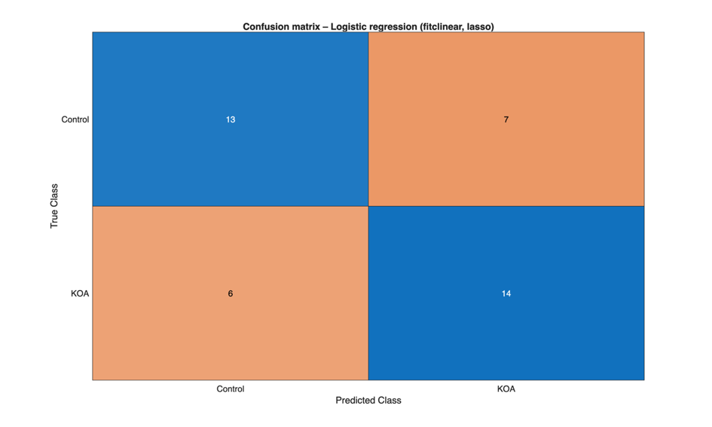
Fig. S4. Confusion matrix for the best-performing classification model, logistic regression with LASSO regularization. The model correctly classified 13 Control samples and 14 KOA samples, while 7 control samples were misclassified as KOA and 6 KOA samples were misclassified as Control.
This corresponds to a specificity of 13/20 = 0.65 and a sensitivity of 14/20 = 0.70. Thus, the balanced accuracy of 0.675 is consistent with the error distribution observed in the confusion matrix. From a practical perspective, this means that the model demonstrates some discriminatory ability, but still commits a substantial number of errors, which limits its readiness for decision-making applications.

