Supplementary Figure S1. Monthly rainfall climatology from CHIRPS and GMet for Sunyani and Wenchi during 2000–2024.
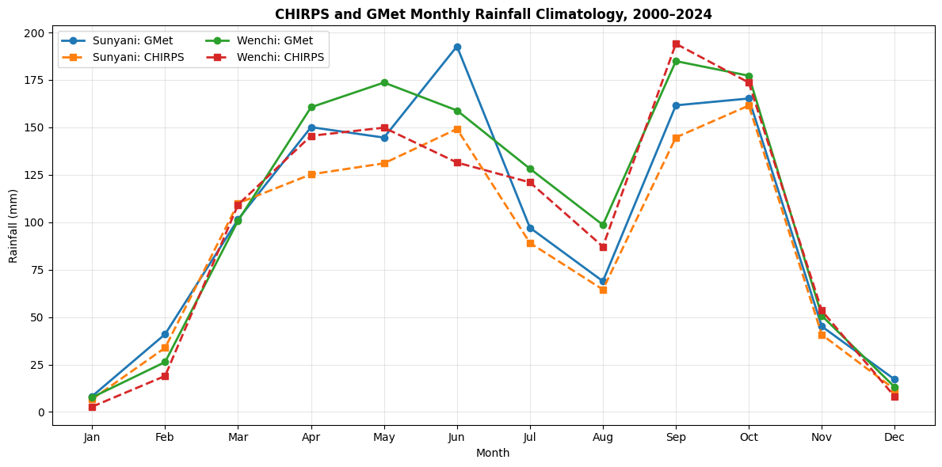

Supplementary Figure S2. Pooled CHIRPS–GMet town-level seasonal rainfall-climatology agreement for Sunyani and Wenchi during 2000–2024.
