Supplementary Information
for

Cost and Carbon Implications of Battery-Grade Iron Phosphate Production from Wastewater Sludge

Xuan Wang^{1,2,†}, Jianan Feng^{2,†}, Xiao-yan Li¹, Lin Lin¹*, Jeremy S. Guest²*
¹ Institute of Environment and Ecology, Tsinghua Shenzhen International Graduate School, Tsinghua University, Shenzhen 518055, China
² The Grainger College of Engineering, Department of Civil and Environmental Engineering, University of Illinois Urbana-Champaign, Urbana, IL 61801, United States
† Indicates equal contribution
*Corresponding author: linlin00@sz.tsinghua.edu.cn (L.L.); jsguest@illinois.edu (J.S.G.)
This Supplementary Information contains 23 pages, 17 tables, and 6 figures.
S1. Feedstock Characterization
Fe-enhanced primary sedimentation sludge (Fe-CEPS) and rice-rich food waste were used as the feedstocks in this study. They were characterized to support interpretation of the fermentation results and parameterization of the process model (Table S1). Measured physicochemical properties include total solids (TS), volatile solids (VS), total iron (TFe), total phosphorus (TP), total chemical oxygen demand (TCOD), and pH. These parameters were selected because they directly influence fermentation performance, Fe and P mobilization, and the subsequent formation of FePO₄. In particular, the VS content provides an indication of biodegradable organic matter availability, whereas TCOD represents the overall organic substrate available for microbial conversion to volatile fatty acids (VFAs). Total Fe and TP determine the theoretical resource recovery potential of the sludge and establish the elemental inventory available for downstream FePO₄ production.

Table S1. Physicochemical properties of the Fe-enhanced primary sedimentation sludge (Fe-CEPS) and rice-rich food waste used as feedstocks in this study. Values are reported as mean ± standard deviations from 3 replicate measurements.
feedstock | unit | TS | VS | TCOD | TFe | TP | pH
Fe-CEPS | mg·L⁻¹ | 10750±330 | 6000±105 | 6850±105 | 330±3 | 181±0 | 6.85
food waste | mg·g⁻¹ | 886±4 | 881±4 | 4720±18 | N/A | 6.1±0.2 | 6.45

S2. Acidogenic Fermentation Experimental Methods
Prior to fermentation, rice-rich food waste was homogenized using a blender to ensure uniform particle size and composition. The homogenized material was stored at 4 °C and used within a short storage period to minimize degradation. Batch acidogenic fermentation experiments were conducted under anaerobic conditions at 37 °C using Fe-CEPS as the primary substrate (Fig. S1). The initial sludge concentration was adjusted to 6 g VS·L⁻¹ in all reactors. Food waste was added on a volatile solids (VS) basis at food waste:sludge ratios of 0:3, 1:3, 2:3, and 3:3. After feedstock addition, reactor headspaces were purged with high-purity N₂ gas for 8 min to establish anaerobic conditions and subsequently sealed using rubber stoppers. Fermentation experiments were conducted for up to 132 h, with samples collected at every 12 h to characterize fermentation performance, VFA production, and Fe/P mobilization dynamics. A detailed summary of the experimental design is provided in Table S2.

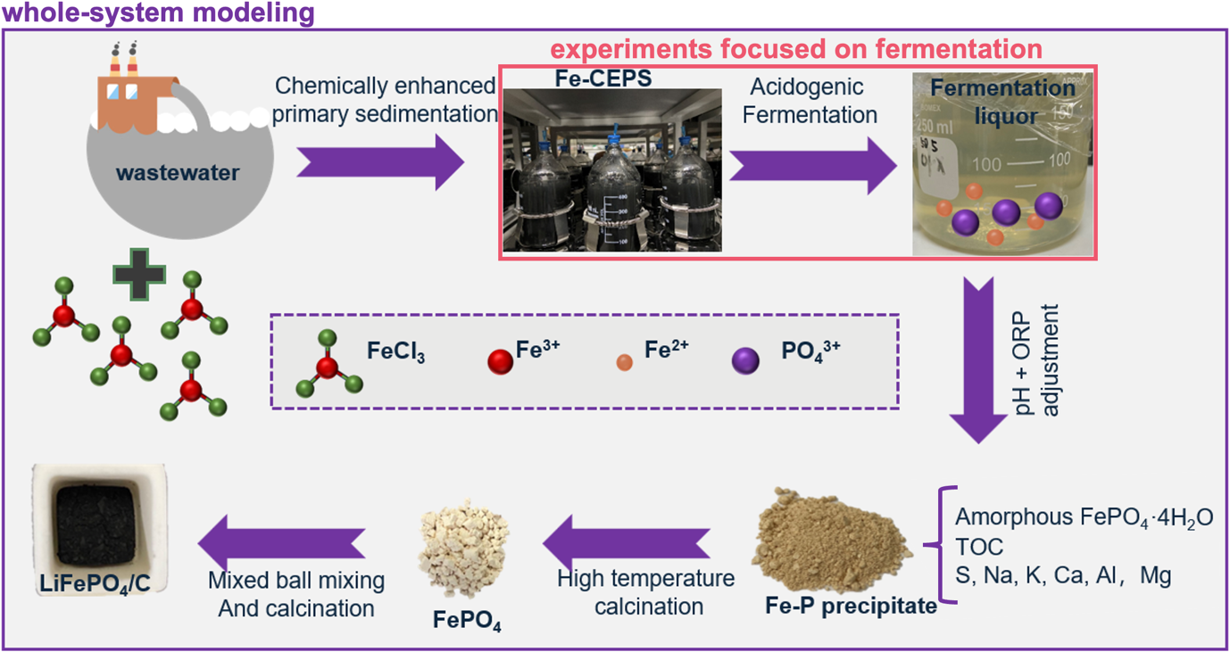
Fig. S1. System boundary for battery-grade FePO₄ production from Fe-enhanced primary sedimentation sludge (Fe-CEPS) through an acidogenic fermentation-based process.

Table S2. Experimental design and key operating parameters for acidogenic fermentation.
parameter | value
reactor type | batch serum bottle
working volume | 500 mL
initial VS | 6 g VS·L⁻¹
temperature | 37 °C
anaerobic condition | N₂ purging for 8 min
food waste:sludge ratios | 0:3, 1:3, 2:3, 3:3
fermentation time | 132 h
sampling interval | every 12 h
replicates | 3
At each sampling point, fermentation slurry was withdrawn and centrifuged at 5,000 rpm for 10 min to separate liquid and solid phases. The resulting supernatant was filtered through 0.45 μm membrane filters prior to analysis. Liquid-phase samples were analyzed for pH, VFAs, soluble chemical oxygen demand (sCOD), phosphate (PO₄³⁻-P), dissolved iron, and ammonium (NH₄⁺-N). pH was measured using a calibrated pH meter. VFAs were quantified using ICP-OES. Dissolved phosphate, ammonium, and iron concentrations were determined using standard colorimetric methods. Total phosphorus and total iron contents in sludge and residual solids were measured following acid digestion. The liquid-phase Fe:P molar ratio was calculated from measured dissolved Fe and phosphate concentrations and was used to evaluate the suitability of fermentation conditions for downstream FePO₄ precipitation.

Phosphorus and iron release efficiencies from Fe-CEPS during fermentation were calculated as:

$$\text{P release efficiency }\left(\text{\%}\right)\text{ = }\frac{{\text{m}}_{\text{p,liquid}}}{{\text{m}}_{\text{p,initail sludge}}}\text{×100\%}$$
$$\text{Fe release efficiency }\left(\text{\%}\right)\text{ = }\frac{{\text{m}}_{\text{Fe,liquid}}}{{\text{m}}_{\text{Fe,initail sludge}}}\text{×100\%}$$
where ${\text{m}}_{\text{p,liquid}}$ and ${\text{m}}_{\text{Fe,liquid}}$ represent the masses of dissolved P and Fe in the fermentation liquor, respectively, and ${\text{m}}_{\text{p,initial sludge}}$ and ${\text{m}}_{\text{Fe,initial sludge}}$ represent the total phosphorus and iron initially present in Fe-CEPS.
S3. Process Modeling and System Simulation
S3.1. Overview
The proposed system configuration was based on Wang et al. The Fe-rich sludge was introduced into the acidogenic fermentation unit with food waste as an external carbon source. After fermentation, the slurry was separated into a VFA-rich supernatant and residual solids. Dissolved Fe and P in the supernatant were recovered through selective precipitation with sulfuric acid addition for pH adjustment and hydrogen peroxide addition for Fe²⁺ oxidation. The recovered FePO₄·2H₂O precipitate was further processed through moisture removal and thermal treatment to obtain the final FePO₄ product. The process modeling was implemented in QSDsan using the phos_rec branch (updated as of Jun 30, 2026). All the units were coded using python 3.12 and can be publicly accessed through GitHub-Quantitative Sustainable Design (QSD) Group-repositories. Detailed unit design assumptions and methods can be found in the following sections. Units not discussed below (e.g., centrifuge, heat exchanger) were inherited from previous work in QSDsan.PA

S3.2. Acidogenic fermentation
The acidogenic fermentation unit was developed to simulate the co-fermentation of Fe-CEPS and food waste under anaerobic conditions. The unit receives sludge and food waste as inputs and generates two output streams: (i) a fermentation liquor containing dissolved nutrients, fermentation products, and residual solids and (ii) a gas stream primarily composed of carbon dioxide. The composition of simulated Fe-CEPS (Table S3) was developed based on the laboratory measurement (Table S1). The moisture content of food waste was assumed to be 74%. The reactor was maintained at 37°C.

Table S3. Composition of simulated Fe-rich sludge feedstock.
component | unit | concentration
organic matter | mg VS·L⁻¹ | 5000
PO₄³⁻-P | mg·L⁻¹ | 300
Fe³⁺ | mg·L⁻¹ | 180
Ca²⁺ | mg·L⁻¹ | 150
Mg²⁺ | mg·L⁻¹ | 100
inert solids | mg·L⁻¹ | 1000
Note: VS represents volatile solids.

Organic matter conversion during fermentation was represented through four pathways: gas production, VFA formation, ethanol formation, and residual solids generation. A small fraction (i.e., 5%) of the biodegradable organic matter was converted to CO₂, while the majority (i.e., 65%) was converted to VFAs. Individual VFAs were represented as acetic acid, propionic acid, butyric acid, valeric acid, and lactic acid according to experimentally informed composition ratios (Table S4). A smaller fraction (i.e., 2%) of organics was converted to ethanol, while the remaining fraction was retained as residual solids or unconverted organic matter. Mass balances were enforced to ensure conservation of carbon throughout the fermentation process.
Table S4. Composition of volatile fatty acids produced during acidogenic fermentation.
volatile fatty acid | ratio
acetic acid | 0.5
propionic acid | 0.24
butyric acid | 0.23
valeric acid | 0.02
lactic acid | 0.01

In addition to organic matter conversion, the model explicitly represented Fe reduction and nutrient mobilization during fermentation. Ninety-eight percent (98%) of ferric iron (Fe³⁺) was reduced to ferrous iron (Fe²⁺) under the reducing conditions generated by acidogenic fermentation. The release of Fe and P from sludge solids into the liquid phase was determined using experimentally measured release efficiencies under different food waste:sludge ratios and fermentation times (Table S5). The unreleased fractions of Fe and P were assigned to the residual stream. This approach allowed the model to directly capture experimentally observed relationships among fermentation intensity, Fe dissolution, phosphorus mobilization, and solution-phase Fe:P stoichiometry.

Table S5. Measured iron and phosphorus release efficiencies under different food waste:sludge ratios and fermentation times.
food waste:sludge ratio | fermentation time | P release ratio | Fe release ratio
0:3 | 0 | 0.0839 | 0.00739
0:3 | 12 | 0.138 | 0.00754
0:3 | 24 | 0.148 | 0.00623
0:3 | 36 | 0.160 | 0.00440
0:3 | 48 | 0.162 | 0.00580
0:3 | 60 | 0.0934 | 0.00460
0:3 | 72 | 0.0994 | 0.00604
0:3 | 84 | 0.108 | 0.00771
0:3 | 96 | 0.112 | 0.00667
0:3 | 108 | 0.114 | 0.00484
0:3 | 120 | 0.111 | 0.00397
0:3 | 132 | 0.111 | 0.0212
1:3 | 0 | 0.0839 | 0.00739
1:3 | 12 | 0.248 | 0.105
1:3 | 24 | 0.412 | 0.140
1:3 | 36 | 0.460 | 0.164
1:3 | 48 | 0.502 | 0.176
1:3 | 60 | 0.494 | 0.180
1:3 | 72 | 0.516 | 0.190
1:3 | 84 | 0.515 | 0.187
1:3 | 96 | 0.528 | 0.197
1:3 | 108 | 0.523 | 0.173
Table S5. (cont.)
1:3 | 120 | 0.513 | 0.149
1:3 | 132 | 0.443 | 0.211
2:3 | 0 | 0.0839 | 0.00739
2:3 | 12 | 0.284 | 0.149
2:3 | 24 | 0.544 | 0.291
2:3 | 36 | 0.635 | 0.362
2:3 | 48 | 0.613 | 0.401
2:3 | 60 | 0.623 | 0.427
2:3 | 72 | 0.651 | 0.444
2:3 | 84 | 0.650 | 0.476
2:3 | 96 | 0.668 | 0.488
2:3 | 108 | 0.656 | 0.510
2:3 | 120 | 0.694 | 0.515
2:3 | 132 | 0.712 | 0.607
3:3 | 0 | 0.0839 | 0.00739
3:3 | 12 | 0.299 | 0.175
3:3 | 24 | 0.576 | 0.358
3:3 | 36 | 0.628 | 0.455
3:3 | 48 | 0.656 | 0.485
3:3 | 60 | 0.672 | 0.517
3:3 | 72 | 0.706 | 0.578
3:3 | 84 | 0.700 | 0.627
3:3 | 96 | 0.736 | 0.671
3:3 | 108 | 0.741 | 0.729
3:3 | 120 | 0.797 | 0.772
3:3 | 132 | 0.823 | 0.831
4:3 | 132 | 0.830 | 0.850

The acidogenic fermentation unit was modeled as a batch reactor operated under cyclic conditions. A cleaning and unloading period of 3 h was included following each fermentation cycle to account for reactor turnaround time. To maintain continuous system operation, two parallel fermenters were assumed. Reactor sizing was based on a working volume corresponding to 90% of the total reactor volume, with the remaining capacity reserved for headspace and operational flexibility. Owing to the acidic conditions generated during fermentation, all major process equipment was assumed to be constructed from 316 stainless steel.

S3.3. Selective precipitation
The selective precipitation unit was developed to produce FePO₄·2H₂O from the fermentation liquor following solid-liquid separation. The unit receives fermentation supernatant, sulfuric acid (H₂SO₄), and hydrogen peroxide (H₂O₂) as inputs and generates a slurry stream containing precipitated FePO₄. The reactor was maintained at 40 °C.
Sulfuric acid was added to adjust solution chemistry and facilitate FePO₄ precipitation. The acid dosage was assumed to be 0.003 kg H₂SO₄ per kg fermentation supernatant. Hydrogen peroxide was subsequently added to oxidize dissolved ferrous iron (Fe²⁺) generated during acidogenic fermentation. The oxidation reaction was represented as:

H₂O₂ + 2Fe²⁺ + 2H⁺ → 2Fe³⁺ + 2H₂O

To ensure complete oxidation, H₂O₂ was supplied at twice the stoichiometric requirement. Following oxidation, all dissolved Fe²⁺ was converted to Fe³⁺ and made available for downstream precipitation. FePO₄·2H₂O formation was subsequently calculated based on the dissolved Fe and P available in the fermentation liquor after solid-liquid separation. Any excess dissolved Fe or P remaining after precipitation was retained in the liquid phase and transferred to downstream processing. The FePO₄·2H₂O production was calculated as:

$${\text{n}}_{{\text{FePO}}_{\text{4}}\text{·2}{\text{H}}_{\text{2}}\text{O}}\text{ = min(}{\text{n}}_{\text{Fe,liq}}\text{, }{\text{n}}_{\text{P,liq}}\text{)}$$
$${\text{m}}_{{\text{FePO}}_{\text{4}}\text{·2}{\text{H}}_{\text{2}}\text{O}}\text{ = }{\text{n}}_{{\text{FePO}}_{\text{4}}\text{·2}{\text{H}}_{\text{2}}\text{O}}\text{×}{\text{MW}}_{{\text{FePO}}_{\text{4}}\text{·2}{\text{H}}_{\text{2}}\text{O}}$$

where ${\text{n}}_{{\text{FePO}}_{\text{4}}\text{·2}{\text{H}}_{\text{2}}\text{O}}$ is the molar quantities of precipitated FePO₄·2H₂O, ${\text{n}}_{\text{Fe,liq}}$ and ${\text{n}}_{\text{P,liq}}$ are the molar quantities of dissolved Fe and P in the fermentation liquor, respectively, and ${\text{MW}}_{{\text{FePO}}_{\text{4}}\text{·2}{\text{H}}_{\text{2}}\text{O}}$ is the molecular weight of FePO₄·2H₂O.

The selective precipitation unit was modeled as a batch reactor operated under cyclic conditions. A reaction time of 6 h was assumed for FePO₄·2H₂O precipitation, followed by 1 h for cleaning and unloading. Two parallel precipitation reactors were included to maintain continuous operation. Reactor sizing was based on a working volume corresponding to 90% of the total reactor volume. Owing to the acidic and oxidative operating conditions, all major process equipment was assumed to be constructed from 316 stainless steel.

S3.4. Thermal treatment
The moisture removal and thermal treatment units were developed to convert the FePO₄-containing precipitate into battery-grade FePO₄ product. The thermal treatment process consisted of two sequential steps: heat drying and sintering. The heat drying unit receives FePO₄·2H₂O slurry from the selective precipitation unit and generates dried solids and vapor streams. The sintering unit subsequently receives the dried solids and converts FePO₄·2H₂O into FePO₄ through thermal dehydration and organic matter removal.

During heat drying, water and volatile organic compounds (including VFAs and ethanol) were assumed to be completely evaporated from the slurry. The drying temperature was assumed to be 105 °C. Natural gas was used as the heat source, and consumption was calculated based on the amount of water removed, a unit heat demand of 4.5 GJ·tonne⁻¹ water evaporated, and a natural gas higher heating value (HHV) of 39 MJ·m⁻³. Electricity demand was estimated using a specific consumption of 214 kWh per tonne of dry solids.

The dried solids were subsequently routed to the sintering unit. Sintering was modeled using a rotary kiln operated at 700 °C to remove bound water. Air was supplied as needed to satisfy oxygen demand. Natural gas was used as the primary heating source, with a combustion efficiency of 80%. Electricity demand was assumed to be 30 kWh·tonne⁻¹ feed.
S4. Techno-Economic Assessment (TEA)
Economic performance was evaluated from two complementary perspectives: a sludge management perspective and a FePO₄ production perspective. Under the sludge management perspective, the system was treated as a wastewater solids management pathway, and the primary economic metric was sludge management cost. Revenue generated from FePO₄ production was treated as a credit that offsets sludge management costs. Under the FePO₄ production perspective, the system was treated as a battery precursor manufacturing pathway, and the primary economic metric was the minimum selling price (MSP) of FePO₄. In this case, avoided sludge management costs associated with diverting solids from conventional disposal pathways were treated as credits that offset FePO₄ production costs. Together, these two perspectives provide complementary insights into the economic viability of integrating battery-grade FePO₄ production into wastewater resource recovery systems.

For both perspectives, TEA was conducted using discounted cash flow analysis under nth-of-a-kind (NOAK) assumptions, representing a commercially mature deployment stage in which process design, equipment manufacturing, and supply-chain development have been largely optimized through prior deployment. Consequently, the reported costs should be interpreted as long-term deployment estimates rather than first-of-a-kind demonstration costs. All costs were reported in 2023 U.S. dollars and adjusted using the Chemical Engineering Plant Cost Index (CEPCI) where appropriate.

Capital costs were estimated using equipment sizing results generated from process simulation. For the acidogenic fermentation, selective precipitation, and thermal treatment units, purchase cost (P) and installed cost (I) were estimated using the following equations and parameters summarized in Table S6. For unit operations adopted directly from QSDsan, embedded design and costing algorithms were used without further modification.

$$\text{P}\text{ = }\text{N}\text{×}{\text{P}}_{\text{0}}\text{×(}\frac{\text{S}}{{\text{S}}_{\text{0}}}{\text{)}}^{\text{n}}\text{×}\frac{{\text{CE}}_{\text{2023}}}{{\text{CE}}_{\text{0}}}$$
I = P×BM

where N is the number of equipment units required, P₀ is the reference purchase cost, S₀ and S are the reference and scaled design parameters (e.g., flow rate, reactor volume), respectively, n is the scaling exponent, CE₀ and CE₂₀₂₃ are the CEPCI values corresponding to the reference year and 2023 (CE₂₀₂₃= 797.9), respectively, and BM is the bare module factor used to estimate installed costs.
Table S6. Equipment cost parameters and scaling assumptions used for capital cost estimation of the FePO₄ production system.
unit | equipment | N | scale stream | S₀ | S₀ unit | P₀ | CE₀ | n | BM | reference
acidogenic fermentation | reactor | 2 | reactor volume | 3785 | m³ | 1042588 | 521.9 | 0.5 | 1.5 | ¹
acidogenic fermentation | cleaning in place | 1 | reactor volume | 3785 | m³ | 520059 | 521.9 | 0.6 | 1.8 | ¹
acidogenic fermentation | agitator | 2 | reactor volume | 3785 | m³ | 64853 | 521.9 | 0.5 | 1.5 | ¹
acidogenic fermentation | recirculation pump | 2 | recirculation flow rate | 77 | m³·h⁻¹ | 47200 | 522 | 0.8 | 2.3 | ¹
acidogenic fermentation | heat exchanger | 2 | reactor duty | 20920000 | kJ·h⁻¹ | 29524 | 522 | 0.7 | 2.2 | ¹
selective precipitation | reactor | 2 | reactor volume | 3785 | m³ | 1042588 | 521.9 | 0.5 | 1.5 | ¹
selective precipitation | cleaning in place | 1 | reactor volume | 3785 | m³ | 520059 | 521.9 | 0.6 | 1.8 | ¹
selective precipitation | agitator | 2 | reactor volume | 3785 | m³ | 64853 | 521.9 | 0.5 | 1.5 | ¹
selective precipitation | recirculation pump | 2 | recirculation flow rate | 77 | m³·h⁻¹ | 47200 | 522 | 0.8 | 2.3 | ¹
selective precipitation | heat exchanger | 2 | reactor duty | 20920000 | kJ·h⁻¹ | 29524 | 522 | 0.7 | 2.2 | ¹
thermal treatment | dryer | 2 | dry solids flow rate | 80 | tonne·day⁻¹ | 2776025 | 603.1 | 0.7 | 3.17 | ²
thermal treatment | rotary kiln | 1 | product flow rate | 441 | tonne·day⁻¹ | 1250000ª | 798 | 0.6 | 1 | ³
ª Installed cost of rotary kiln.
In addition to capital costs, operating costs associated with chemicals, utilities, and residual solids management were estimated from process simulation outputs. The unit prices used for operating cost, revenue, and credit calculations are summarized in Table S7.

Table S7. Unit prices and economic parameters used in operating cost and credit calculations.
item | unit | price | reference
sludge management (baseline) | $·dry tonne⁻¹ | 300 | Peccia and Westerhoff⁴
food waste management | $·dry tonne⁻¹ | 0ª | -
fermentation gas | $·kg⁻¹ | 0^{b} | -
H₂SO₄ | $·kg⁻¹ | 0.08 | EverBatt 2023⁵
H₂O₂ | $·kg⁻¹ | 1.46 | EverBatt 2023⁵
FePO₄ | $·kg⁻¹ | 2.14 | Wang et al.⁶
landfill disposal | $·tonne⁻¹ | 68.7 | EREF⁷
electricity | $·kWh⁻¹ | 0.0782 | BioSTEAM⁸
steam for heating | $·kmol⁻¹ | 0.238 | BioSTEAM⁸
natural gas | $·kmol⁻¹ | 3.50 | BioSTEAM⁸
ª Food waste was assumed to enter the system burden-free and was assigned no burden or credit.
^{b} CO₂ was assumed to be the dominant component of the fermentation gas and was assigned no burden or credit.

Financial assumptions used in the discounted cash flow analysis, including project lifetime, discount rate, depreciation, taxation, and operating schedule, are summarized in Table S8.
Table S8. Financial assumptions applied in the discounted cash flow analysis.
parameter | value
internal rate of return | 3% (sludge management perspective), 10% (FePO₄ production perspective)
project lifetime | 30 years
income tax | 30%
yearly operating days | 365
construction schedule | 3 years (8% 1st year, 60% 2nd year, 32% 3rd year)
startup month | 6
startup fixed operating cost fraction | 1
startup sales fraction | 0.5
startup volatile operating cost fraction | 0.75
working capital over fixed capital investment (FCI) | 5%
finance interest | 3% (sludge management perspective), 8% (FePO₄ production perspective)
finance years | 10
finance fraction | 0.6
warehouse | 4% of installed equipment cost
site development | 9% of inside battery limits (ISBL)
additional piping | 4.5% of ISBL
proratable costs | 10% of total direct cost (TDC)
field expenses | 10% of TDC
home office and construction | 20% of TDC
project Contingency | 10% of TDC
other indirect costs | 10% of TDC
labor cost | 0 (integrated within existing water resource recovery facility operations)
labor burden | 90%
property insurance and taxes | 0.7% of FCI
maintenance | 3% of total indirect cost (TIC)
steam power depreciation | modified accelerated cost recovery system (MACRS) 20-year depreciation schedule

S5. Life Cycle Assessment (LCA)
LCA was conducted to quantify the greenhouse gas emissions associated with battery-grade FePO₄ production from wastewater sludge. The analysis focused on global warming potential (GWP) over a 100-year time horizon and reported results as carbon intensity (CI). Two complementary functional units were used to align with the system perspectives evaluated in this work: 1 dry tonne of sludge managed for the sludge management perspective and 1 kg of recovered FePO₄ for the FePO₄ production perspective.

Life cycle inventories for material and energy consumption were obtained directly from process simulation outputs. Background life cycle inventory data for chemicals, electricity, fuels, and waste management processes were obtained from the Ecoinvent v3.11 database⁹. Life cycle impact assessment was performed using the IPCC 2021 GWP100 method, excluding biogenic CO₂ emissions. Detailed inventory data are provided in Table S9.
Table S9. Life cycle assessment inventory data.
item | unit | geography | CI | reference
sludge management (baseline) | kg CO₂e·dry tonne⁻¹ | - | 1000 | Huang et al.¹⁰
food waste management | kg CO₂e·dry tonne⁻¹ | - | 0ª | -
fermentation gas | kg CO₂e·kg⁻¹ | - | 0^{b} | -
H₂SO₄ | kg CO₂e·kg⁻¹ | Europe | proprietary | Ecoinvent
H₂O₂ | kg CO₂e·kg⁻¹ | Europe | proprietary | Ecoinvent
FePO₄ | kg CO₂e·kg⁻¹ | - | 4 | Xu et al.¹¹
landfill disposal | kg CO₂e·kg⁻¹ | rest of world | proprietary | Ecoinvent
electricity | kg CO₂e·kWh⁻¹ | US | proprietary | Ecoinvent
steam for heating | kg CO₂e·MJ⁻¹ | Europe | proprietary | Ecoinvent
natural gas | kg CO₂e·m⁻³ CH₄ | US | proprietary | Ecoinvent
ª Food waste was assumed to enter the system burden-free and was assigned no burden or credit.
^{b} CO₂ was assumed to be the dominant component of the fermentation gas, and as a biogenic emission, was assigned no burden or credit.
S6. Uncertainty Analysis
The criteria for the selection of uncertainty distributions followed guidance by previous studies^{12–17} with modifications.

- For parameters directly measured in this study:
  - If more than 20 experimental observations were available, we selected triangular distributions and used 5th, 50th, and 95th percentiles from the experimental values as the minimum, most probable, and maximum values, respectively.
  - If 5 to 20 experimental observations were available, we selected triangular distributions and used minimum, mean, and maximum of the experimental values as the minimum, most probable, and maximum values, respectively.
  - If less than 5 experimental observations were available, we selected uniform distributions and used 80%, 100%, and 120% of the mean experimental values as lower bound, baseline, and upper bounds, respectively.
- For parameters not measured in this study and for which distributions can be found in literature, we used the same distribution as the literature.
- For parameters not measured in this study and for which only the ranges can be found in literature, we chose a uniform distribution with the minimum and maximum limits as the lower and upper bounds of the distribution and the mean value of the minimum and maximum limits as the baseline.
- For parameters not measured in this study and for which only a single value can be found in the literature and is based on empirical formulae, this value was assigned as the baseline and uniform distributions were set from 90% to 110% of the baseline value.
- For parameters not measured in this study and with no known distribution in the literature:
  - If more than 20 data points were found in the literature, we selected triangular distributions and used 5th, 50th, and 95th percentiles from the literature values as the minimum, most probable, and maximum values.
  - If 5 to 20 data points were found in the literature, we selected triangular distributions and used minimum, mean, and maximum of the literature value as the minimum, most probable, and maximum values.
  - If less than 5 data points can be found in the literature, we selected uniform distributions and used 80%, 100%, and 120% of the mean value as lower bound, baseline, and upper bounds.

A complete list of distributions assigned to model parameters is provided in Table S10.
Table S10. List of parameters included in the uncertainty analysis. Abbreviations: criterion (crit.), distribution (dist.), volatile fatty acids (VFAs).
model parameter | explanation | unit | crit. | dist. | lower | baseline | upper
acidogenic fermentation
all Fe and P release ratios in Table S5ª |  | - | #1.3 | uniform | 0.8*X | 1*X | 1.2*X
food_waste_moisture | food waste moisture content | - | #1.3 | uniform | 0.592 | 0.74 | 0.888
org_unconverted^{b} | unconverted organics | - | #1.3 | uniform | 0.024 | 0.03 | 0.036
org_to_gas^{b} | organics conversion to biogas | - | #1.3 | uniform | 0.04 | 0.05 | 0.06
org_to_vfa^{b} | organics conversion to VFAs | - | #1.3 | uniform | 0.52 | 0.65 | 0.78
org_to_ethanol^{b} | organics conversion to ethanol | - | #1.3 | uniform | 0.016 | 0.02 | 0.024
org_to_residue^{b} | organics conversion to residual solids | - | #1.3 | uniform | 0.20 | 0.25 | 0.30
Fe_reduction | Fe³⁺ reduction efficiency | - | #1.2 | triangular | 0.95 | 0.98 | 1
selective precipitation
acid_dose | sulfuric acid dosage | - | #1.3 | uniform | 0.0024 | 0.003 | 0.0036
oxidant_excess | hydrogen peroxide excess ratio | - | #1.3 | triangular | 1.6 | 2 | 2.4
thermal treatment
unit_heat | heat demand for heat drying | - | #5.3 | uniform | 3.6 | 4.5 | 5.4
combustion_eff_HD | combustion efficiency for heat drying | - | #5.3 | uniform | 0.64 | 0.8 | 0.96
unit_electricity_HD | electricity demand for heat drying | $·kWh⁻¹ | #5.3 | uniform | 171 | 214 | 257
combustion_eff_SI | combustion efficiency for sintering | - | #5.3 | uniform | 0.64 | 0.8 | 0.96
unit_electricity_SI | electricity demand for sintering | $·kWh⁻¹ | #5.3 | uniform | 24 | 30 | 36
TEA
landfill disposal cost |  | $·tonne⁻¹ | #5.3 | uniform | 54.9 | 68.7 | 82.4
H₂SO₄ price |  | $·L⁻¹ | #5.3 | uniform | 0.064 | 0.08 | 0.096
H₂O₂ price |  | $·L⁻¹ | #5.3 | uniform | 1.17 | 1.46 | 1.75
FePO₄ price |  | $·kg⁻¹ | #5.3 | uniform | 1.71 | 2.14 | 2.57
electricity price |  | $·kWh⁻¹ | #5.3 | uniform | 0.0626 | 0.0782 | 0.0938
low-pressure steam price |  | $·kWh⁻¹ | #5.3 | uniform | 0.190 | 0.238 | 0.285
medium-pressure steam price |  | $·kWh⁻¹ | #5.3 | uniform | 0.220 | 0.276 | 0.331
Table S10. (cont.)
high-pressure steam price |  | $·kWh⁻¹ | #5.3 | uniform | 0.254 | 0.317 | 0.381
natural gas price |  | $·kg⁻¹ | #5.3 | uniform | 0.175 | 0.219 | 0.262
IRR | internal rate of return (sludge) | $·kg⁻¹ | #2 | triangular | 0 | 0.03 | 0.05
IRR | internal rate of return (FePO₄) | $·kg⁻¹ | #2 | triangular | 0.05 | 0.10 | 0.15
LCA
carbon intensity for all impact items listed in Table S9 |  |  | #4 | uniform | 0.9*X | 1*X | 1.1*X
ª Release ratios are capped at 1.
^{b} These parameters are normalized such that their sum equals 1.
S7. Supplementary results
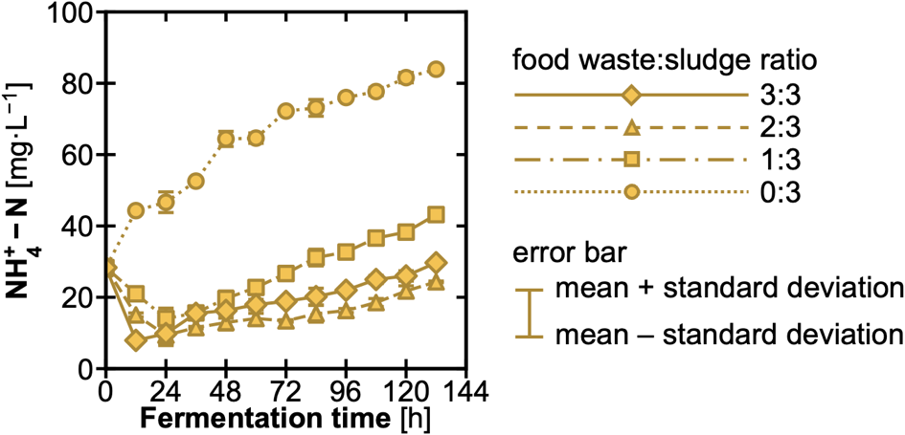
Fig. S2. Effect of food waste:sludge ratio and fermentation time on nitrogen transformation during acidogenic fermentation. Food waste:sludge ratios (based on volatile solids) are represented by different patterns: 0:3 (dotted line with circles), 1:3 (dash-dot line with squares), 2:3 (dashed line with triangles), and 3:3 (solid line with diamonds). Error bars represent mean ± standard deviation (n = 3).

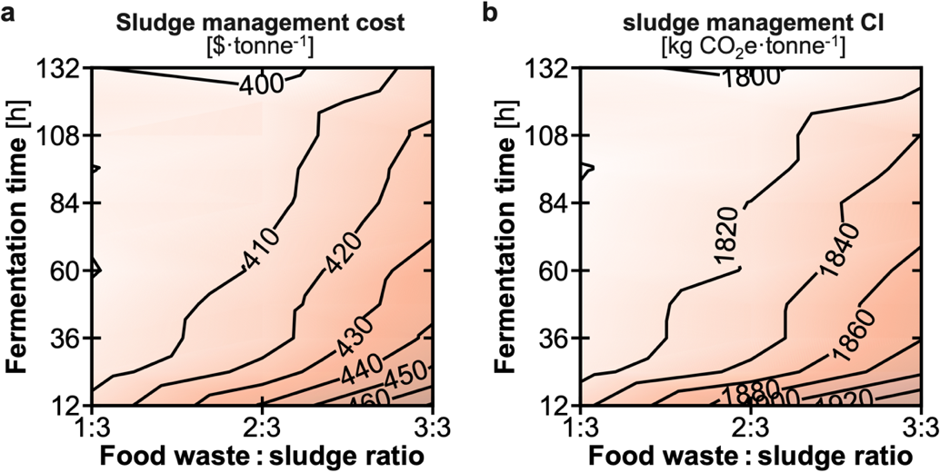
Fig. S3. Influence of key process parameters on sludge management cost and carbon intensity (CI). Contour plots of (a) sludge management cost and (b) sludge management CI as functions of food waste:sludge ratio and fermentation time. Median results from Monte Carlo simulations are shown.

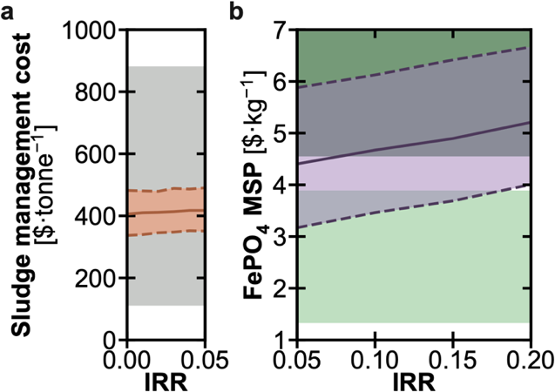
Fig. S4. Influence of internal rate of return (IRR) on economic performance. Results are shown from (a) the sludge management perspective and (b) the FePO₄ production perspective. Solid lines denote 50th percentile value, while the orange and purple bands represent the interquartile ranges (25th to 75th percentiles). Gray shaded region in (a) represents reported ranges for conventional sludge management cost. Dark and light green bands in (b) represent the reported minimum selling price (MSP) range for recovered FePO₄ and the price range for commercial FePO₄, respectively.

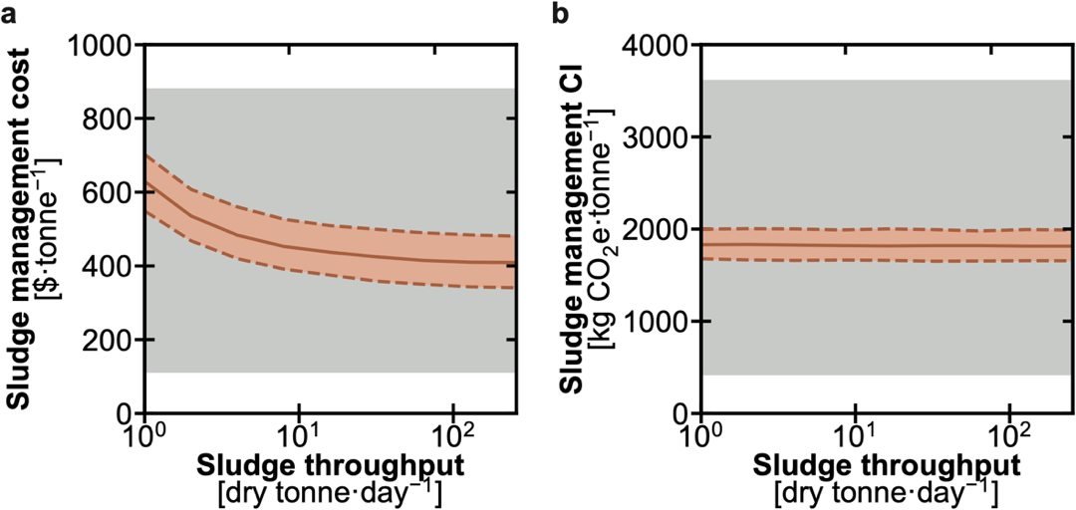
Fig. S5. Influence of sludge throughput from the sludge management perspective. Results are shown for (a) sludge management cost and (b) sludge management carbon intensity (CI). Solid lines denote 50th percentile value, while the orange bands represent the interquartile ranges (25th to 75th percentiles). Gray shaded regions in (a) and (b) represent reported ranges of conventional sludge management cost and CI, respectively.

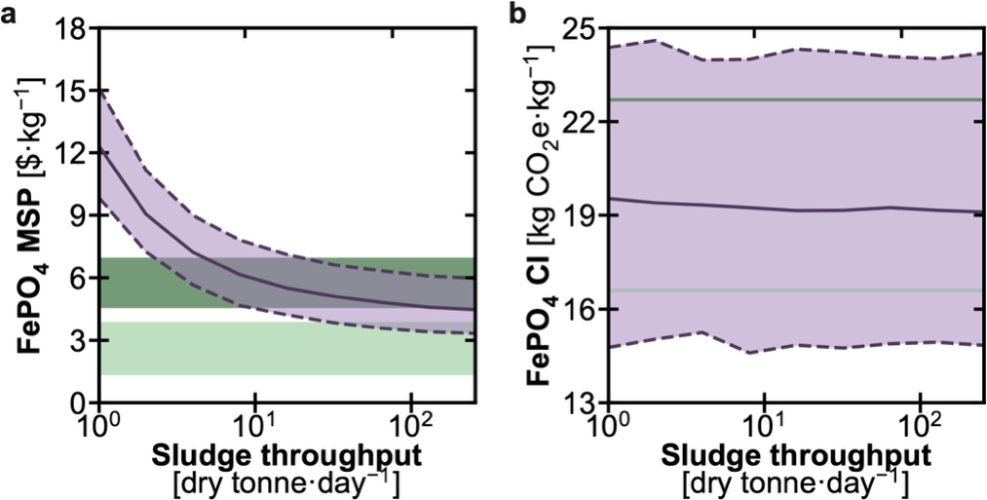
Fig. S6. Influence of sludge throughput from the FePO₄ production perspective. Results are shown for (a) FePO₄ minimum selling price (MSP) and (b) FePO₄ carbon intensity (CI). Solid lines denote 50th percentile value, while the purple bands represent the interquartile ranges (25th to 75th percentiles). Dark and light green bands in (a) represent the reported minimum selling price (MSP) range for recovered FePO₄ and the price range for commercial FePO₄, respectively. The dark and light green lines in (b) represent the reported CI values for recovered and commercial FePO₄, respectively.

Table S11. Baseline results from the sludge management perspective obtained using different numbers of Monte Carlo simulations, with 1000 simulations selected for uncertainty analyses.
percentage | number of Monte Carlo simulations
percentage | 100 | 200 | 500 | 1000 | 2000
sludge management cost [$·dry tonne⁻¹]
5th | 358 | 343 | 348 | 348 | 347
50th | 406 | 413 | 410 | 413 | 413
95th | 487 | 493 | 488 | 486 | 486
sludge management carbon intensity [kg CO₂e·dry tonne⁻¹]
5th | 1660 | 1660 | 1650 | 1650 | 1650
50th | 1820 | 1820 | 1820 | 1820 | 1820
95th | 1970 | 1990 | 2000 | 1990 | 1990

Table S12. Baseline results from the FePO₄ production perspective obtained using different numbers of Monte Carlo simulations, with 1000 simulations selected for uncertainty analyses.
percentage | number of Monte Carlo simulations
percentage | 100 | 200 | 500 | 1000 | 2000
FePO₄ minimum selling price [$·kg⁻¹]
5th | 3.51 | 3.46 | 3.42 | 3.46 | 3.42
50th | 4.64 | 4.71 | 4.70 | 4.65 | 4.68
95th | 6.05 | 5.93 | 6.10 | 6.15 | 6.17
FePO₄ carbon intensity [kg CO₂e·kg⁻¹]
5th | 15.53 | 14.59 | 14.57 | 14.92 | 14.90
50th | 19.17 | 19.18 | 19.30 | 19.15 | 19.11
95th | 23.99 | 24.17 | 24.09 | 23.96 | 23.88

Table S13. Breakdown of installed capital cost and annual utility cost for each unit in the system. Median results from Monte Carlo simulations are reported.
unit | installed capital cost [$] | utility cost [$·year⁻¹]
acidogenic fermentation | 1.52E6 | 2.70E6
selective precipitation | 1.34E6 | 8.47E5
thermal treatment | 2.67E6 | 7.80E5
others (e.g., pump, centrifuge) | 6.46E5 | 1.26E6
total | 6.17E6 | 5.61E6

Table S14. Breakdown of annual material cost for each stream in the system. Median results from Monte Carlo simulations are reported. FePO₄ need to be excluded when evaluating the sludge management perspective, whereas the avoided management of Fe-enhanced primary sedimentation sludge (Fe-CEPS; assuming a baseline value of 300 $·dry tonne⁻¹) need to be excluded when evaluating the FePO₄ production perspective.
stream | material cost [$·year⁻¹]
Fe-CEPS (avoided management) | -1.09E7
fermentation residue | 8.93E6
Table S 14 (cont.)
H₂SO₄ | 1.99E6
H₂O₂ | 1.76E6
FePO₄ | -4.22E6
total | -7.16E6

Table S15. Breakdown of utility carbon intensity (CI) for each unit in the system. Median results from Monte Carlo simulations are reported.
unit | utility CI [kg CO₂e]
acidogenic fermentation | 1.39E9
selective precipitation | 3.92E8
thermal treatment | 9.57E7
others (e.g., pump, centrifuge) | 2.35E8
total | 2.12E9

Table S16. Breakdown of material carbon intensity (CI) for each stream in the system. Median results from Monte Carlo simulations are reported. FePO₄ need to be excluded when evaluating the sludge management perspective, whereas the avoided management of Fe-enhanced primary sedimentation sludge (Fe-CEPS; assuming a baseline value of 1000 kg CO₂e·dry tonne⁻¹) need to be excluded when evaluating the FePO₄ production perspective.
stream | material CI [kg CO₂e]
Fe-CEPS | -1.10E9
fermentation residue | 2.29E7
H₂SO₄ | 5.97E7
H₂O₂ | 2.45E7
FePO₄ | -2.34E8
total | -1.22E9

Table S17. Spearman correlation results for contextual parameters that have a statistically significant (i.e., |ρ|>0.2 and p<0.05,) impact on the minimum selling price (MSP) of FePO₄ when evaluating the system from the FePO₄ production perspective.
contextual parameter | ρ | p
residual disposal cost | -0.638 | 1.4E-115

References
1. Humbird, D. et al. Process Design and Economics for Biochemical Conversion of Lignocellulosic Biomass to Ethanol: Dilute-Acid Pretreatment and Enzymatic Hydrolysis of Corn Stover. NREL/TP-5100-47764, 1013269 http://www.osti.gov/servlets/purl/1013269/ (2011) doi:10.2172/1013269.
2. Hao, X., Chen, Q., van Loosdrecht, M. C. M., Li, J. & Jiang, H. Sustainable disposal of excess sludge: Incineration without anaerobic digestion. Water Research 170, 115298 (2020).
3. Vertical kiln vs. Rotary Kiln: A Cost Analysis. https://www.cementequipments.com/info/vertical-kiln-vs-rotary-kiln-a-cost-analysis-103128381.html.
4. Peccia, J. & Westerhoff, P. We Should Expect More out of Our Sewage Sludge. Environ. Sci. Technol. 49, 8271–8276 (2015).
5. EverBatt. Argonne National Laboratory https://www.anl.gov/amd/everbatt.
6. Wang, X. et al. Sustainable production of high-purity crystalline FePO₄ from sludge for battery electrodes. Water Res. 289, 124885 (2026).
7. Environmental Research & Education Foundation. Analysis of MSW Landfill Tipping Fees — 2024. (2025).
8. BioSTEAM Development Group. https://github.com/BioSTEAMDevelopmentGroup.
9. Ecoinvent v3.11 Database. Swiss Centre for Life Cycle Inventories.
10. Huang, D. et al. Life cycle assessment of sewage sludge treatment and disposal technologies based on carbon emissions and environmental impacts. Environmental Technology 46, 477–493 (2025).
11. Xu, Y. et al. A novel way to prepare battery-grade FePO4 2H2O from copper slag and life cycle assessment. Sep. Purif. Technol. 339, 126686 (2024).
12. Feng, J., Li, Y., Strathmann, T. J. & Guest, J. S. Characterizing the opportunity space for sustainable hydrothermal valorization of wet organic wastes. Environ. Sci. Technol. 58, 2528–2541 (2024).
13. Li, Y. et al. Sustainable Lactic Acid Production from Lignocellulosic Biomass. ACS Sustainable Chem. Eng. 9, 1341–1351 (2021).
14. Feng, J., Strathmann, T. J. & Guest, J. S. Hydrothermal-based wastewater solids management for targeted resource recovery and decarbonization in the contiguous U.S. Environ. Sci. Technol. 59, 20389–20400 (2025).
15. El Abbadi, S. H. et al. Benchmarking greenhouse gas emissions from US wastewater treatment for targeted reduction. Nat. Water 3, 1133–1143 (2025).
16. Wang, Z. et al. The potential of thermomechanical and thermochemical processes to enable sustainable household sanitation. Environ. Sci. Technol. 60, 6227–6238 (2026).
17. Feng, J. & Guest, J. S. Thermochemical Treatment of Wastewater Residual Solids for Global Mitigation of Emerging Contaminants. Nat Commun https://doi.org/10.1038/s41467-026-74242-2 (2026) doi:10.1038/s41467-026-74242-2.

