Supplementary Material
Table of Contents
Figure S1. Leave-one-out analysis for all-cause mortality
Figure S2. Leave-one-out analysis for cardiac mortality
Figure S3. Leave-one-out analysis for myocardial infarction
Figure S4. Leave-one-out analysis for stent thrombosis
Figure S5. Leave-one-out analysis for target vessel revascularization
Figure S6. Critical appraisal of individual studies (risk of bias)
Figure S7. Summary of risk of bias
Figure S8. Funnel plot assessing publication bias among the included studies

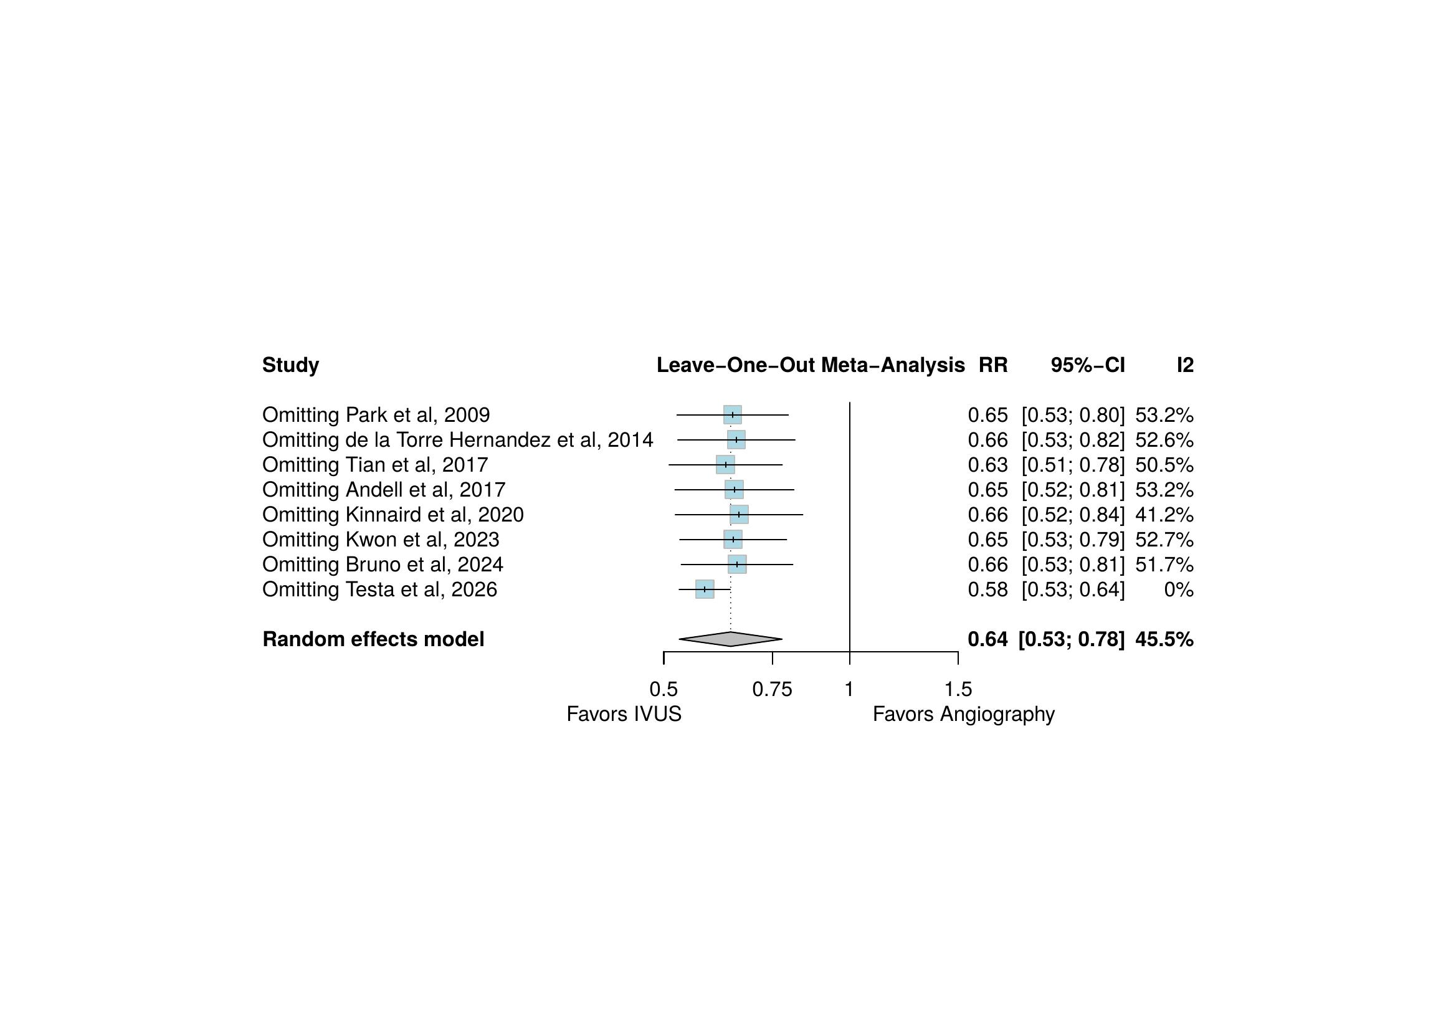
Figure S1. Leave-one-out sensitivity analysis for all-cause mortality.

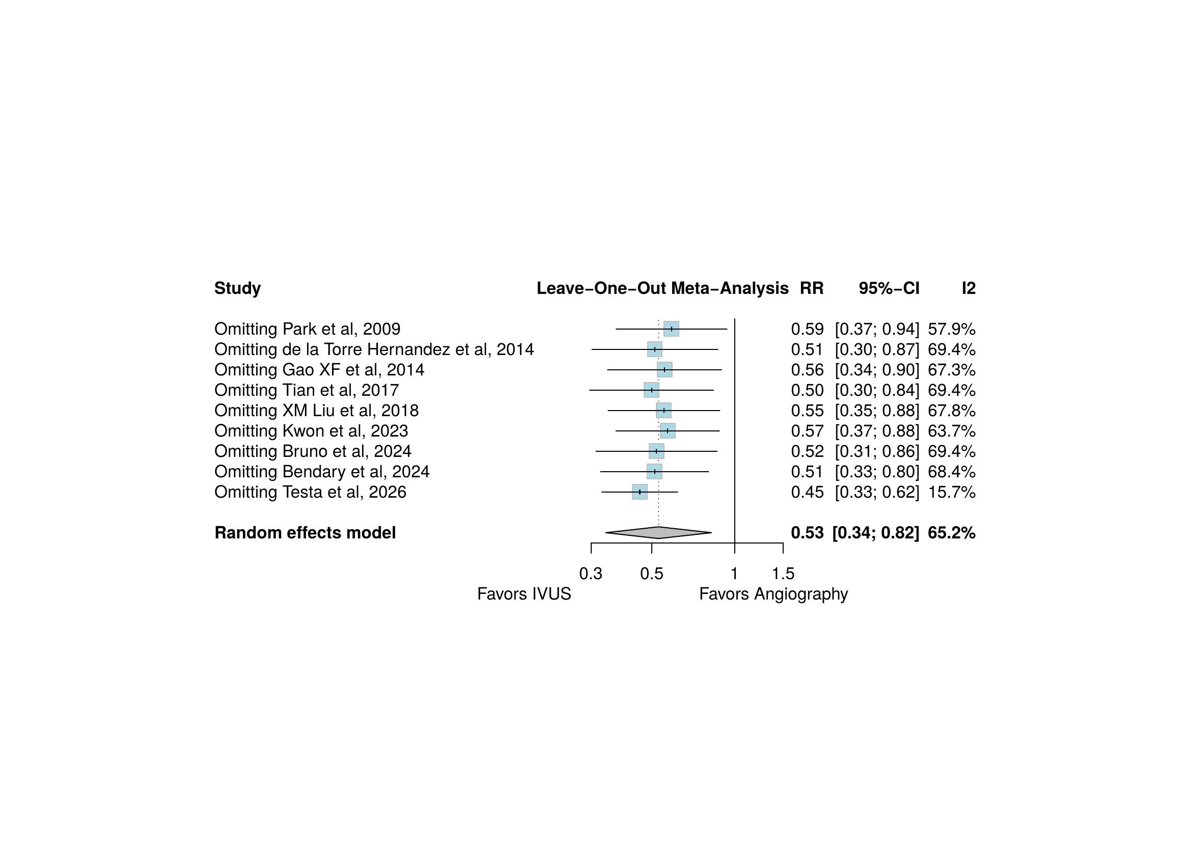
Figure S2. Leave-one-out sensitivity analysis for cardiac mortality.

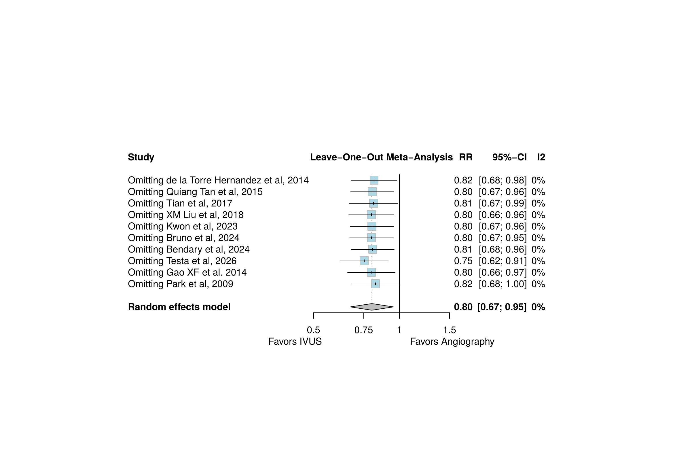
Figure S3. Leave-one-out sensitivity analysis for myocardial infarction.

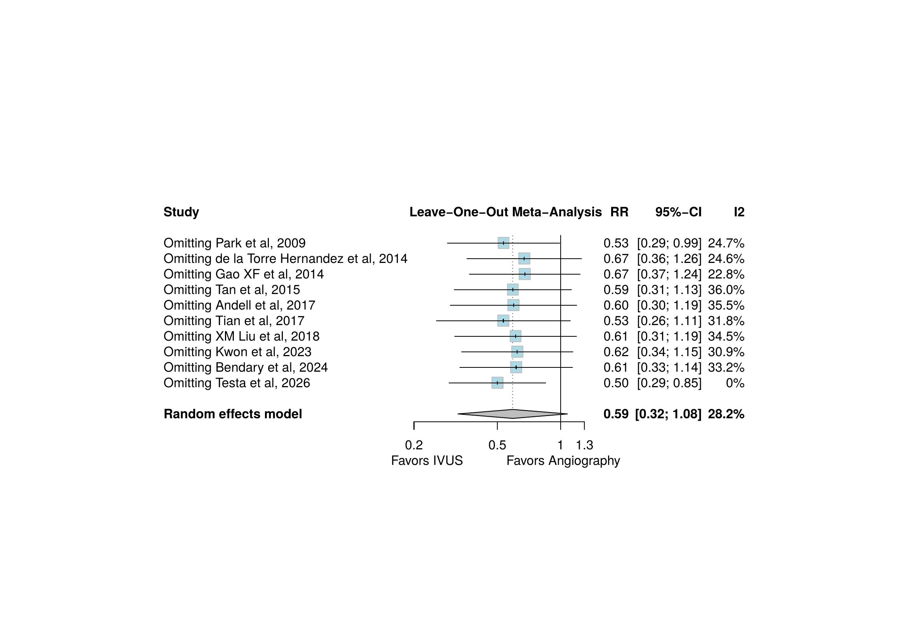
Figure S4. Leave-one-out sensitivity analysis for stent thrombosis.

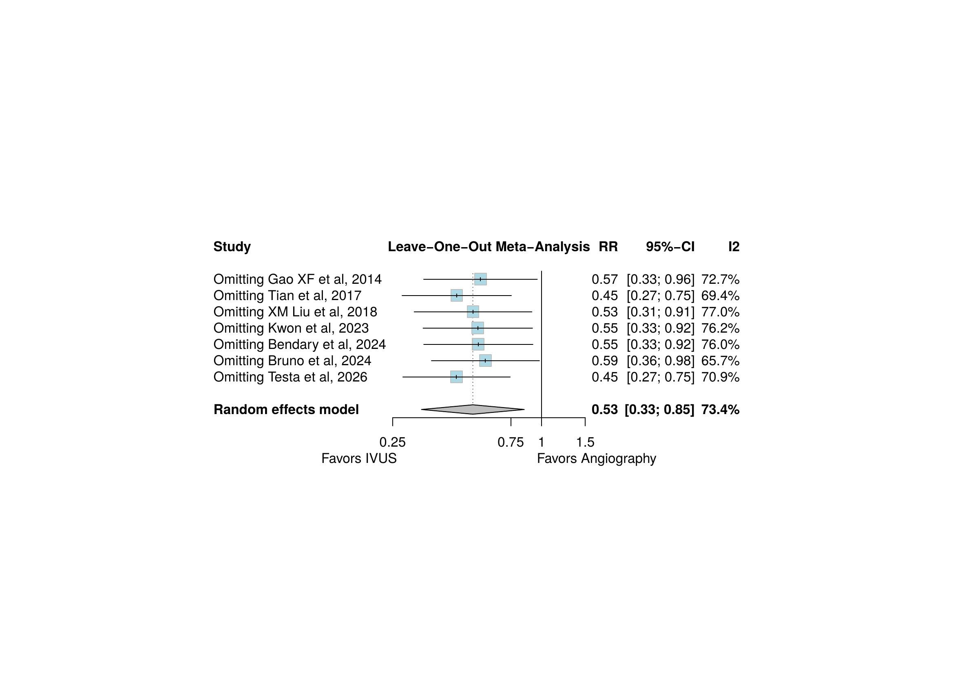
Figure S5. Leave-one-out sensitivity analysis for target vessel revascularization.

Figure S6. Critical appraisal of individual studies according to the Cochrane risk-of-bias tools for (A) randomized and (B) non-randomized studies.
A.
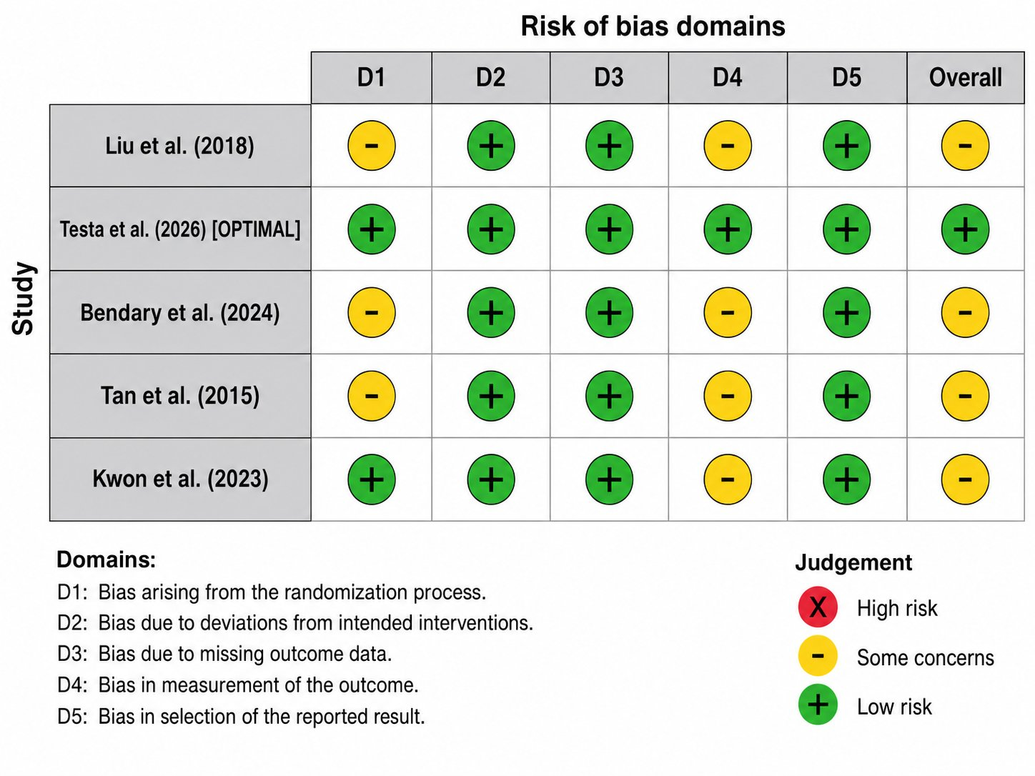

B.
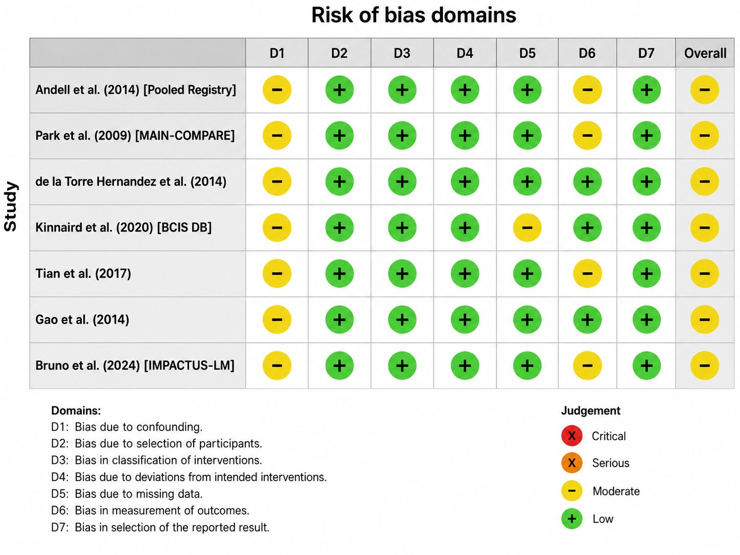

Figure S7. Summary of risk of bias for (A) randomized and (B) non-randomized studies.
A.
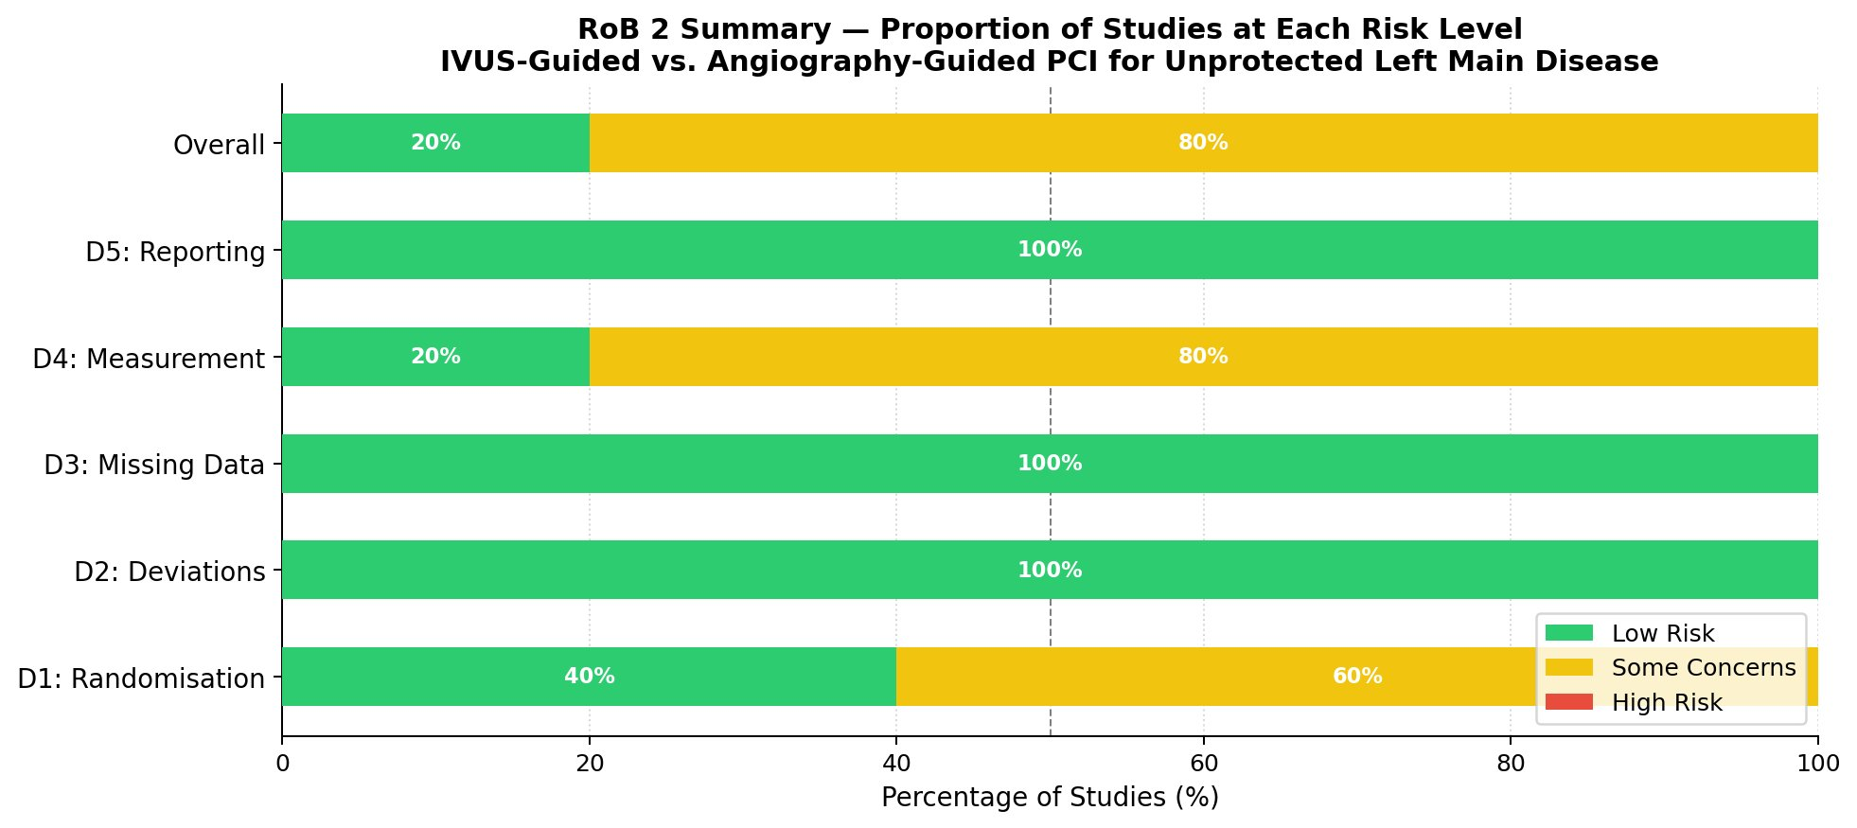
B.
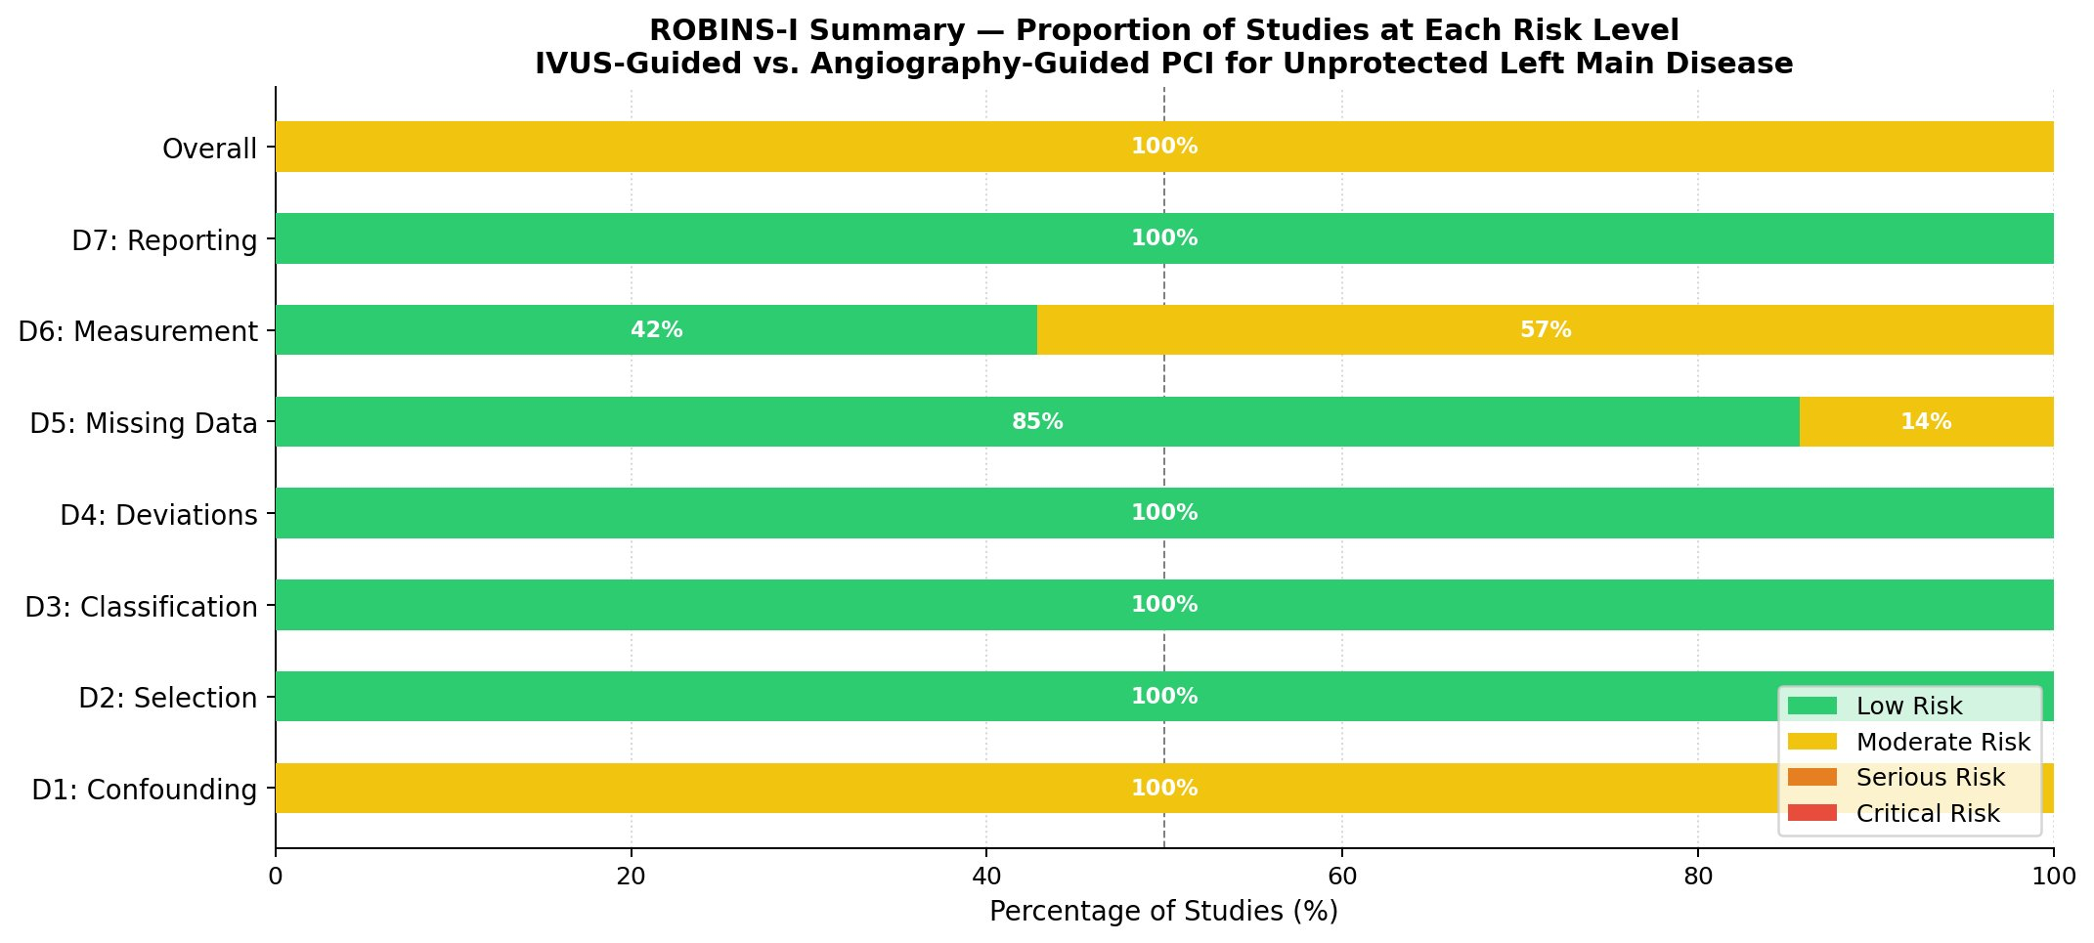

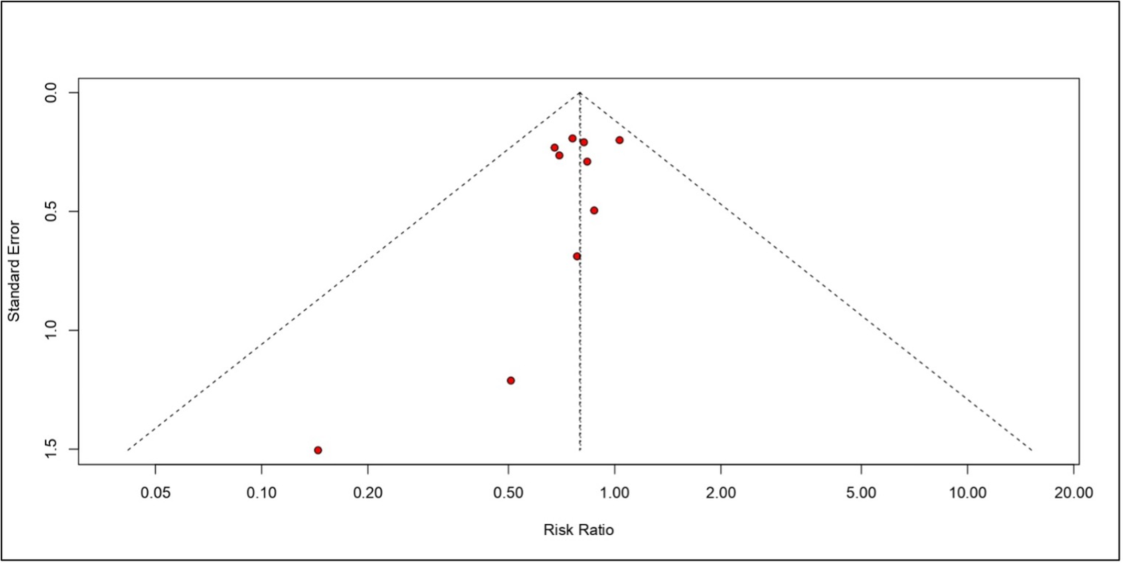
Figure S8. Funnel plot assessing publication bias among the included studies. Egger's regression test: t = −1.50, df = 8, p = 0.173.

