Taxonomic composition shifts with StressType and soil texture
Differential abundance analyses revealed clear but taxon-specific bacterial differences between mesic and xeric soils (Supplementary Figs. 3A-C). LEfSe identified 291 differentially abundant taxa and ANCOM-BC2 detected 139, with 85 shared (Supplementary Fig. 3A). For visualization, only the top 10 mesic-enriched and top 10 xeric-enriched taxa were plotted (Supplementary Fig. 3B). Mesic soils were enriched in taxa such as Latescibacterota, Devosia, Pseudolabrys, Geobacteraceae, etc., whereas xeric soils showed elevated abundances of Craurococcus-Caldivatus, Acidipila, Acidiphilium, Crossiella, etc. ANCOM-BC2 plots likewise display only the 10 highest positive and negative LFC values (Supplementary Fig. 3C), again highlighting mesic enrichment of groups such as Ktedonobacterales, Salinivibrio, Crossiella, etc., and xeric enrichment of Caldilineaceae, Arenimonas, Nannocystis, etc. These responses were not uniformly conserved across textures, indicating that moisture-associated taxonomic shifts are context-dependent.
Fungal ITS datasets showed analogous StressType-specific patterns (Supplementary Fig. 3D-F). LEfSe identified 64 fungal taxa and ANCOM-BC2 identified 61, with 29 shared (Supplementary Fig. 3D). Only the top 10 mesic- and top 10 xeric-enriched taxa were plotted (Supplementary Fig. 3E), with mesic soils enriched in Tomentella, Chloridium, Thelephora, Tuber, etc., and xeric soils enriched in Geminibasidium, Cenococcum, Glutinomyces, Parateratosphaeria, etc. ANCOM-BC2 fungal results similarly show only the strongest positive and negative LFC responses (Supplementary Fig. 3F), highlighting mesic enrichment of Phylloporopsis, Paratritirachium, Coprinellus, etc., and xeric enrichment of Lecythophora, Neobulgaria, Paracremonium, Tuber, etc., indicating that fungal responses to moisture stress are more limited and less consistent across taxa than bacterial communities.
Across StressTexture groups, multiple bacterial taxa exhibited significant shifts in relative abundance. KW-Dunn identified 594 differentially varying bacterial taxa, and ALDEx2 detected 83, with 73 shared between methods (Supplementary Fig. 3E). Bacterial genus-level dominance varied across StressTexture groups (Supplementary Fig. 4). Mesic sandy loam contained the highest number of dominant genera (28), including Devosia, Duganella, Flavobacterium, Paenibacillus, Rhizobacter, and Arenimonas. Xeric sand contained 17 dominant genera, including Acidibacter, Acidiphilium, Acidipila, Arthrobacter, Bryocella, and Actinomadura. Xeric sandy loam contained 9 dominant genera, including Acidothermus, Bryobacter, Conexibacter, Crossiella, and Kutzneria. Mesic loamy sand and mesic sand each contained 5 dominant genera; Mesic loamy sand was characterized by Bacillus, Citrifermentans, and Lysinibacillus, whereas mesic sand included Amycolatopsis, Nevskia, and Vermiphilaceae. Xeric loamy sand contained a single dominant genus, Mycobacterium. These patterns indicate strong texture-dependent bacterial responses to moisture regime, particularly within sandy loam and xeric sand soils.
Fungal ITS datasets showed parallel StressTexture-dependent patterns. KW-Dunn identified 470 varying fungal taxa, and ALDEx2 detected 37, with 32 shared between methods (Supplementary Fig. 3F). Fungal genus-level dominance also varied across StressTexture groups (Supplementary Fig. 5). Mesic sandy loam contained the highest number of dominant genera (12), including Coniochaeta, Trichoderma, Fusarium, and Chloridium. Mesic sand contained 6 dominant genera, including Archaeorhizomyces, Penicillium, Talaromyces, and Tomentella. Mesic loamy sand contained 5 dominant genera, including Amphinema, Cortinarius, Inocybe, and Lactarius. Xeric sandy loam and xeric sand each contained 4 dominant genera; xeric sandy loam included Cenococcum, Glutinomyces, Tylopilus, and Umbelopsis, whereas xeric sand included Coprinellus, Geminibasidium, Pseudophialophora, and Russula. Xeric loamy sand contained a single dominant genus, Clavulina. Overall, fungal responses to moisture regime were more limited and taxon-specific than bacterial responses, with fewer dominant genera differing consistently across textures.

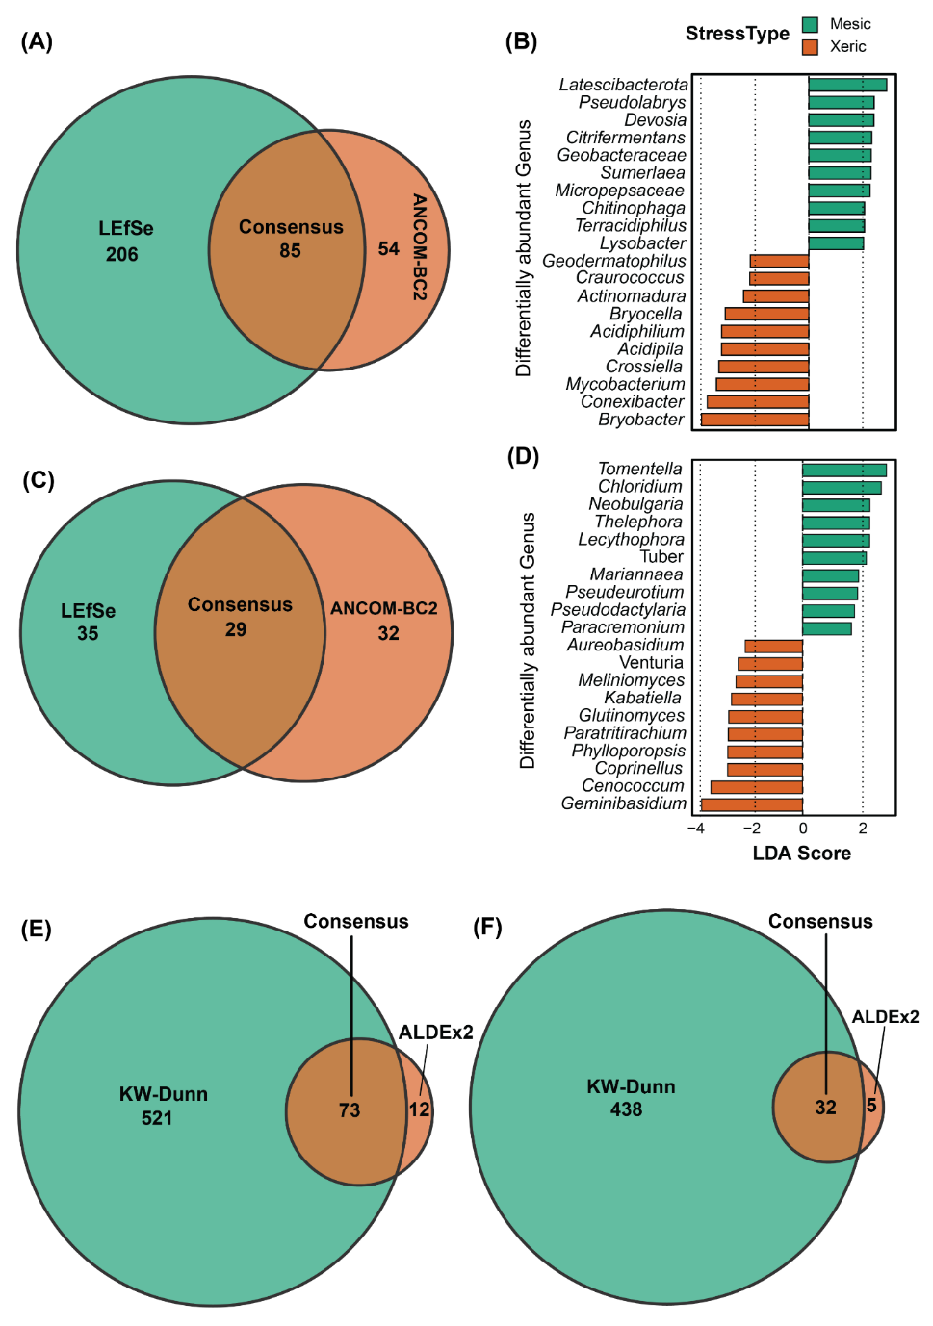
Supplementary Figure 3. Differentially abundant bacterial and fungal taxa across stress type and stresstexture groups.
(A) Bacterial Venn diagram. (B) Bacterial LEfSe plot. (C) Fungal Venn. (D) Fungal LEfSe plot. Bacterial (E) and fungal (F) Venn diagrams show the overlap of differentially abundant taxa identified by LEFSe and ANCOM-BC2 across stress type groups and KW-Dunn and ALDEx2 across stress texture groups. LEfSe plots taxa enriched in mesic or xeric conditions; bar length indicates the strength of the discriminatory signal.

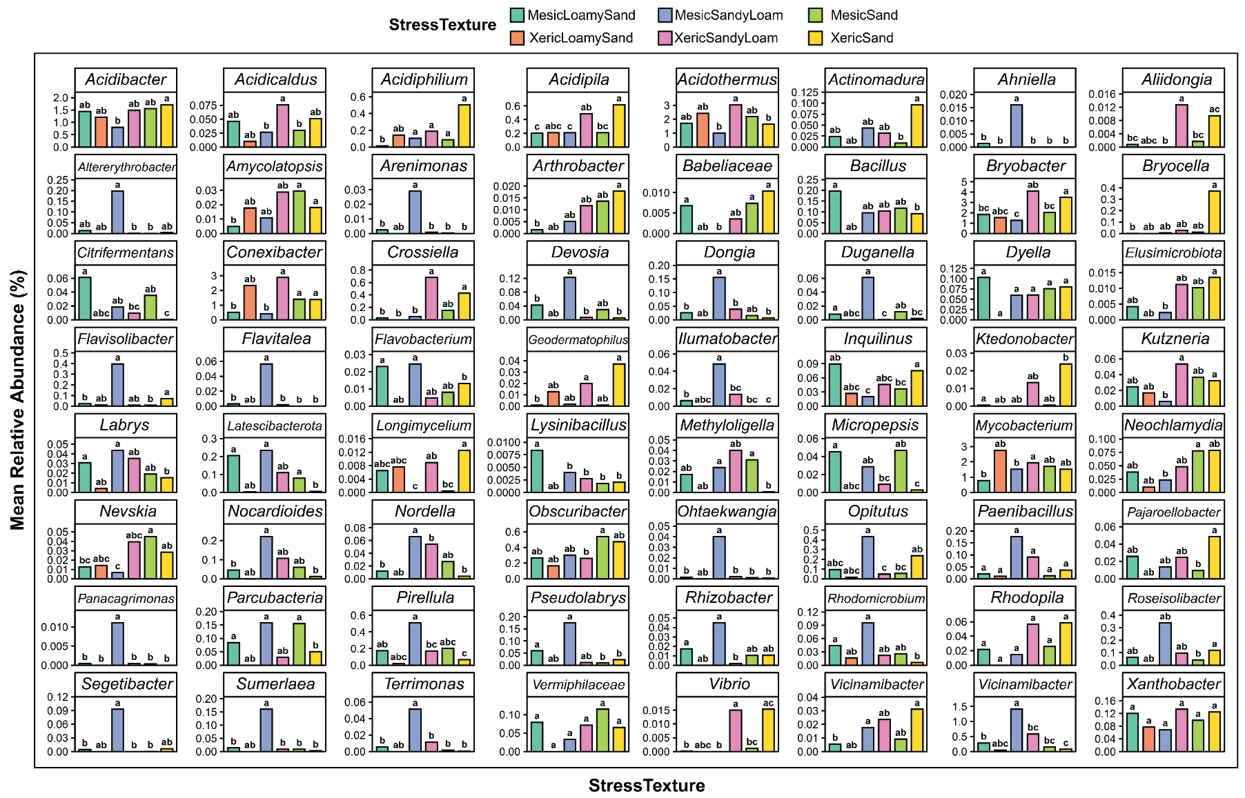
Supplementary Figure 4. Differentially abundant bacterial genera across stress texture groups.
Bars show mean relative abundance (%) of genera differing significantly among mesic loamy sand, xeric loamy sand, mesic sandy loam, xeric sandy loam, mesic sand, and xeric sand soils. Letters above bars indicate significant differences among treatments based on post hoc multiple-comparison testing (P < 0.05). Colors denote stress texture groups. Only consensus genera identified as significantly different by KW–Dunn and ALDEx2 across stress texture groups are shown.

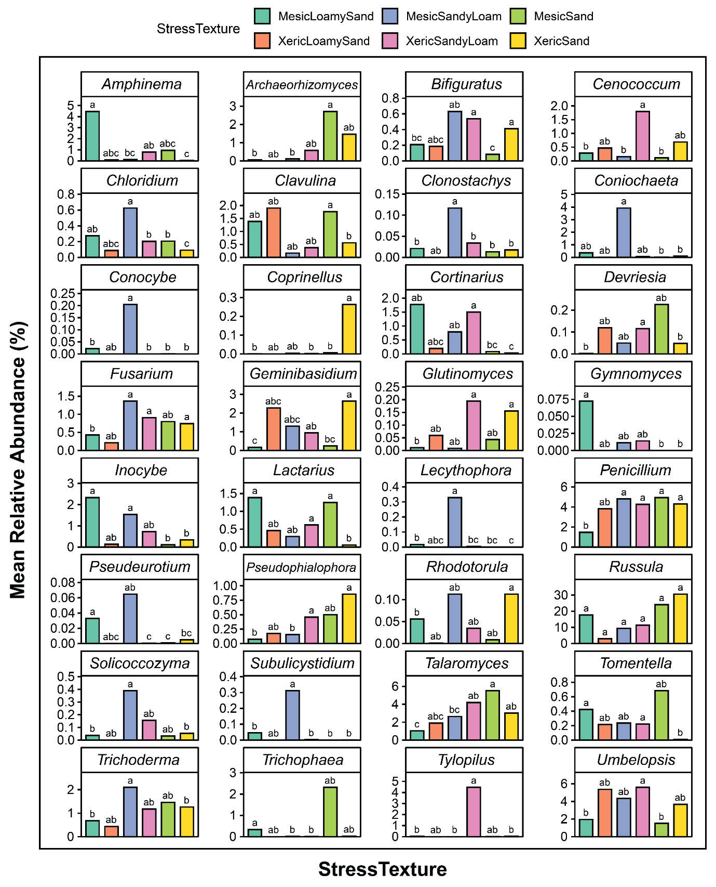
Supplementary Figure 5. Differentially abundant fungal genera across stress texture groups.
Bars show mean relative abundance (%) of genera differing significantly among mesic loamy sand, xeric loamy sand, mesic sandy loam, xeric sandy loam, mesic sand, and xeric sand soils. Letters above bars indicate significant differences among treatments based on post hoc multiple-comparison testing (P < 0.05). Colors denote stress texture groups. Only consensus genera identified as significantly different by KW-Dunn and ALDEx2 across stress texture groups are shown.

