Supplementary Table 1. Baseline Demographics and Clinical Characteristics of the Enrolled Patients
Characteristic | Cilostazol/Rosuvastatin combination therapy  (N=130) | Rosuvastatin  monotherapy  (N=130) | P value
Age, years | 69.6 ± 8.4 | 68.9 ± 10.1 | 0.528
Male | 117 (90.0) | 114 (87.7) | 0.694
BMI, kg/m² | 24.5 ± 3.4 | 24.1 ± 3.4 | 0.295
Hypertension | 98 (75.4) | 93 (71.5) | 0.574
Diabetes mellitus | 70 (53.8) | 72 (55.4) | 0.901
Coronary artery disease | 30 (23.1) | 35 (26.9) | 0.567
Atrial fibrillation | 9 (6.9) | 6 (4.6) | 0.595
Cerebrovascular disease | 12 (9.2) | 6 (4.6) | 0.222
Chronic kidney disease | 13 (10.0) | 9 (6.9) | 0.504
COPD | 5 (3.8) | 6 (4.6) | 1.000
PAD presentation  Rutherford 2  Rutherford 3 | 62 (47.7)  68 (52.3) | 68 (52.3)  62 (47.7) | 0.457
PAD duration, years | 3.9 ± 4.2 | 4.3 ± 4.7 | 0.445
Medications
Prior statin therapy  Rosuvastatin  Atorvastatin  Others | 46 (35.4)  46 (35.4)  40 (30.8) | 43 (33.1)  43 (33.1)  47 (36.2) | 0.639
Assigned rosuvastatin dose
10 mg | 75 (57.7) | 74 (56.9) | 1.000
20 mg | 55 (42.3) | 56 (43.1)
Antiplatelet agent | 84 (64.6) | 92 (70.8) | 0.289
Values are mean ± SD or number (%). P values were obtained by using the independent t-test for continuous variables and the chi-square test (or Fisher's exact test where applicable) for categorical variables.
BMI, body mass index; COPD, chronic obstructive pulmonary disease; PAD, peripheral artery disease.

Supplementary Table 2. KPAQ Domain Scores at Baseline and Week 24
 | Cilostazol/Rosuvastatin  combination therapy  (n = 114) | Rosuvastatin  monotherapy  (n = 118) | LS Mean Difference  (95% CI) | P value ª
Physical Function (0-100)
Baseline | 41.1 ± 18.1 | 39.3 ± 16.4
Week 24 | 55.0 ± 20.5 | 47.3 ± 21.2
Change from baseline | 13.9 ± 18.1 | 8.0 ± 21.3 | 6.8 (2.0 to 11.6) | 0.048
Symptom (0-100)
Baseline | 51.0 ± 16.6 | 50.4 ± 18.5
Week 24 | 67.4 ± 19.1 | 63.2 ± 18.6
Change from baseline | 16.5 ± 19.0 | 12.8 ± 17.8 | 3.9 (−0.3 to 8.2) | 0.094
Quality of Life (0-100)
Baseline | 43.2 ± 14.6 | 40.8 ± 16.0
Week 24 | 57.3 ± 16.3 | 49.3 ± 18.5
Change from baseline | 14.1 ± 16.5 | 8.5 ± 15.1 | 6.5 (2.7 to 10.4) | 0.002
Social Limitation (0-100)
Baseline | 55.0 ± 22.4 | 52.1 ± 21.4
Week 24 | 70.0 ± 21.4 | 64.7 ± 23.1
Change from baseline | 15.0 ± 22.9 | 12.7 ± 23.3 | 4.0 (−1.4 to 9.5) | 0.273
Symptom Stability (0-100)
Baseline | 49.6 ± 11.5 | 51.5 ± 10.5
Week 24 | 64.0 ± 17.9 | 63.3 ± 20.6
Change from baseline | 14.5 ± 21.3 | 11.9 ± 22.3 | 0.9 (−4.1 to 6.0) | 0.926
Treatment Satisfaction (0-100)
Baseline | 49.3 ± 14.3 | 52.4 ± 18.8
Week 24 | 66.0 ± 20.1 | 61.2 ± 20.1
Change from baseline | 16.7 ± 19.9 | 8.8 ± 19.9 | 6.4 (1.7 to 11.2) | 0.012
Values are mean ± SD. Change from baseline indicates absolute change in scores from baseline at Week 24.
ª LS Mean Difference (95% CI) and P value from Rank-ANCOVA, adjusted for rosuvastatin dose and baseline value.
KPAQ, Korean Peripheral Artery Questionnaire; LS, least squares mean; CI, confidence interval.

Supplementary Table 3. KPAQ Summary Scores Change from Baseline Over Time
 | Cilostazol/Rosuvastatin  combination therapy  (n = 114) | Rosuvastatin  monotherapy  (n = 118) | P value ª
Week 4
Change from baseline | +6.8 ± 11.0 | +4.6 ± 10.8 | 0.169
Week 8
Change from baseline | +9.2 ± 10.8 | +7.7 ± 12.3 | 0.174
Week 12
Change from baseline | +12.6 ± 12.8 | +8.1 ± 14.3 | 0.017
Week 24
Change from baseline | +15.4 ± 14.4 | +10.6 ± 14.7
LS Mean change ± SE | 15.5 ± 1.3 | 10.2 ± 1.3 | 0.003
Values are mean ± SD. LS Mean change is model-estimated ± SE. Change from baseline indicates change in score from baseline at follow-up.
ª P values from Rank-ANCOVA (Weeks 4, 8, 12) or ANCOVA (Week 24), adjusted for rosuvastatin dose and baseline KPAQ summary score.
KPAQ, Korean Peripheral Artery Questionnaire; LS, least squares mean; SE, standard error.

Supplementary Table 4. Adverse events
 | Cilostazol/Rosuvastatin combination therapy (N=130) | Rosuvastatin  monotherapy  (N=130) | P valueª
Any TEAE | 62 (47.7) | 48 (36.9) | 0.079
Any ADR | 36 (27.7) | 23 (17.7) | 0.054
Serious AE | 8 (6.2) | 7 (5.4) | 0.790
AE leading to discontinuation | 8 (6.2) | 5 (3.8) | 0.393
Death | 0 | 1 (0.8) | 1.000
Common TEAEs (≥2 patients in either group)
Diarrhea | 8 (6.2) | 1 (0.8) | 0.036
Headache | 7 (5.4) | 1 (0.8) | 0.066
Dizziness | 6 (4.6) | 3 (2.3) | 0.500
Pain in extremity | 1 (0.8) | 5 (3.8) | 0.213
Back pain | 4 (3.1) | 1 (0.8) | 0.370
Edema peripheral | 3 (2.3) | 1 (0.8) | 0.622
Dyspepsia | 1 (0.8) | 3 (2.3) | 0.622
Urinary tract infection | 0 | 3 (2.3) | 0.247
Palpitations | 2 (1.5) | 0 | 0.498
Liver enzyme elevation | 2 (1.5) | 0 | 0.498
Hypoesthesia | 0 | 2 (1.5) | 0.498
Values are number (%).
ᵃ P values were obtained by using the chi-square test (or Fisher's exact test where applicable) for between-group comparisons.
TEAE, treatment-emergent adverse event; ADR, adverse drug reaction; AE, adverse event.

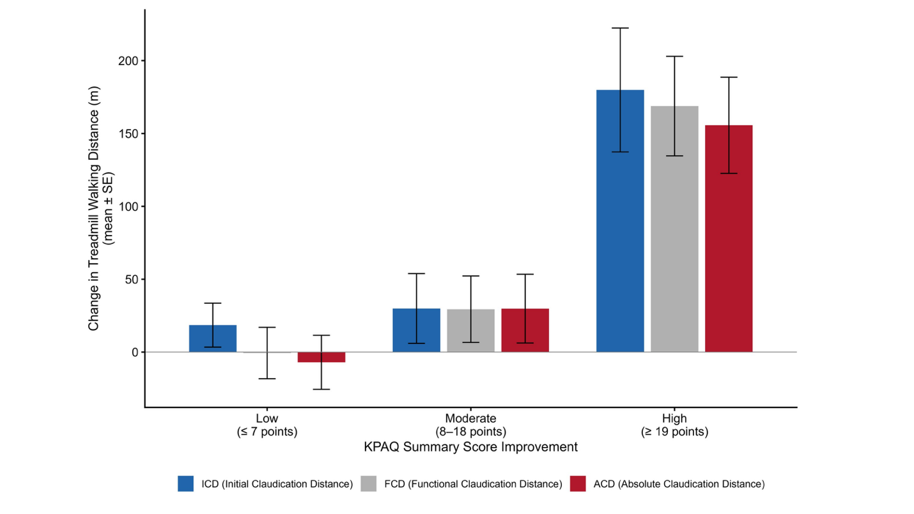
Suppl. Fig. 1 Association Between KPAQ Summary Score Improvement and Treadmill Walking Distance at Week 24. Patients with available KPAQ and treadmill data at week 24 were divided into tertiles based on change in KPAQ summary score from baseline. Bars represent mean ± SE change from baseline in treadmill walking distance.
Abbreviations: : ICD, initial claudication distance; FCD; functional claudication distance; ACD, absolute claudication distance; KPAQ, Korean Peripheral Artery Questionnaire; SE, standard error.

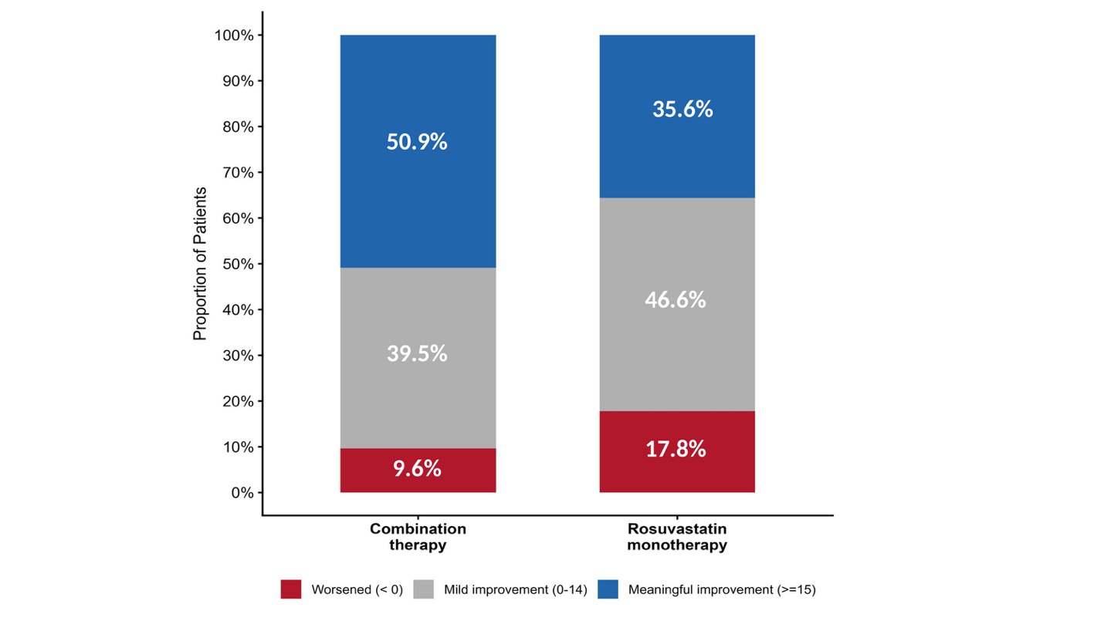
Suppl. Fig. 2 Distribution of Individual KPAQ Summary Score Changes at Week 24. Patients were categorized into three groups based on change in KPAQ summary score from baseline: meaningful improvement (≥15 points), mild improvement (0-14 points), and worsened (<0 points).
Abbreviations: KPAQ, Korean Peripheral Artery Questionnaire

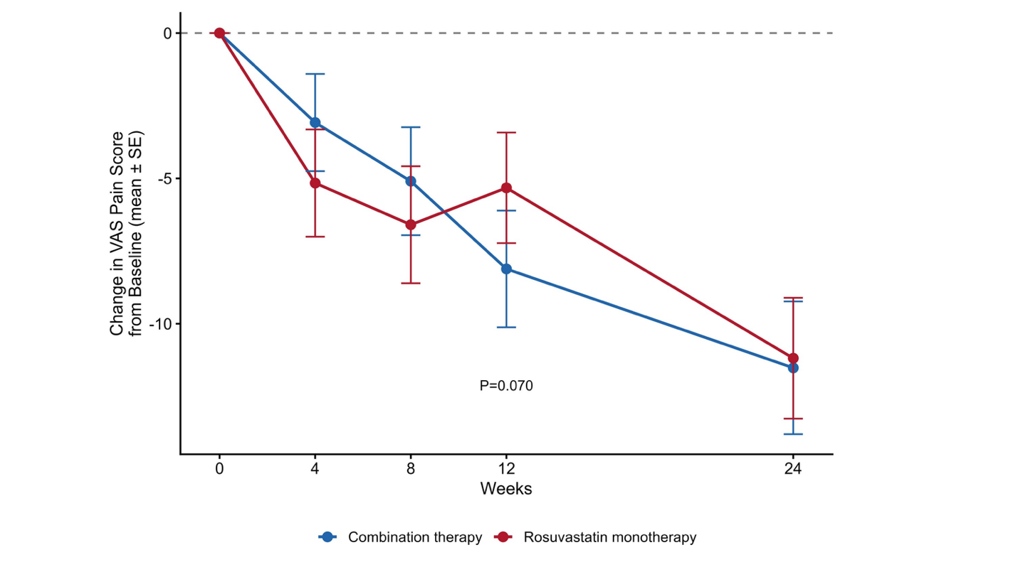Suppl. Fig. 3 Change of VAS Pain Score from Baseline Over 24 Weeks. Data are presented as mean ± SE. P-values indicate between-group differences at each timepoint. N at each timepoint: Week 4 (126/129), week 8 (122/126), Week 12 (117/122), Week 24 (115/118).
Abbreviations: : VAS, visual analogue scale; SE, standard error

