Fig. S1. Geographic accessibility to neonatal intensive care services and identification of priority expansion areas.
Spatial distribution of population-level access to neonatal intensive care based on travel-time modeling. Areas shaded from white to blue represent the existing service network, with white indicating optimal access and progressively darker blue indicating suboptimal access. Polygons located outside these zones denote regions with limited or no effective access and are identified as priority areas for targeted expansion of neonatal critical care capacity.

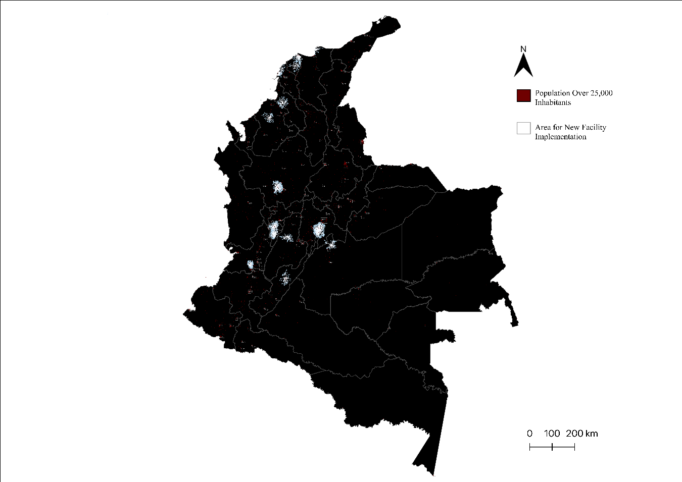

Fig. S2. Geographic accessibility to pediatric intensive care services and identification of priority expansion areas.
Spatial distribution of population-level access to pediatric intensive care based on travel-time modeling. Areas shaded from white to blue represent the existing service network, with white indicating optimal access and progressively darker blue indicating suboptimal access. Polygons located outside these zones denote regions with limited or no effective access and are identified as priority areas for targeted expansion of pediatric critical care capacity.

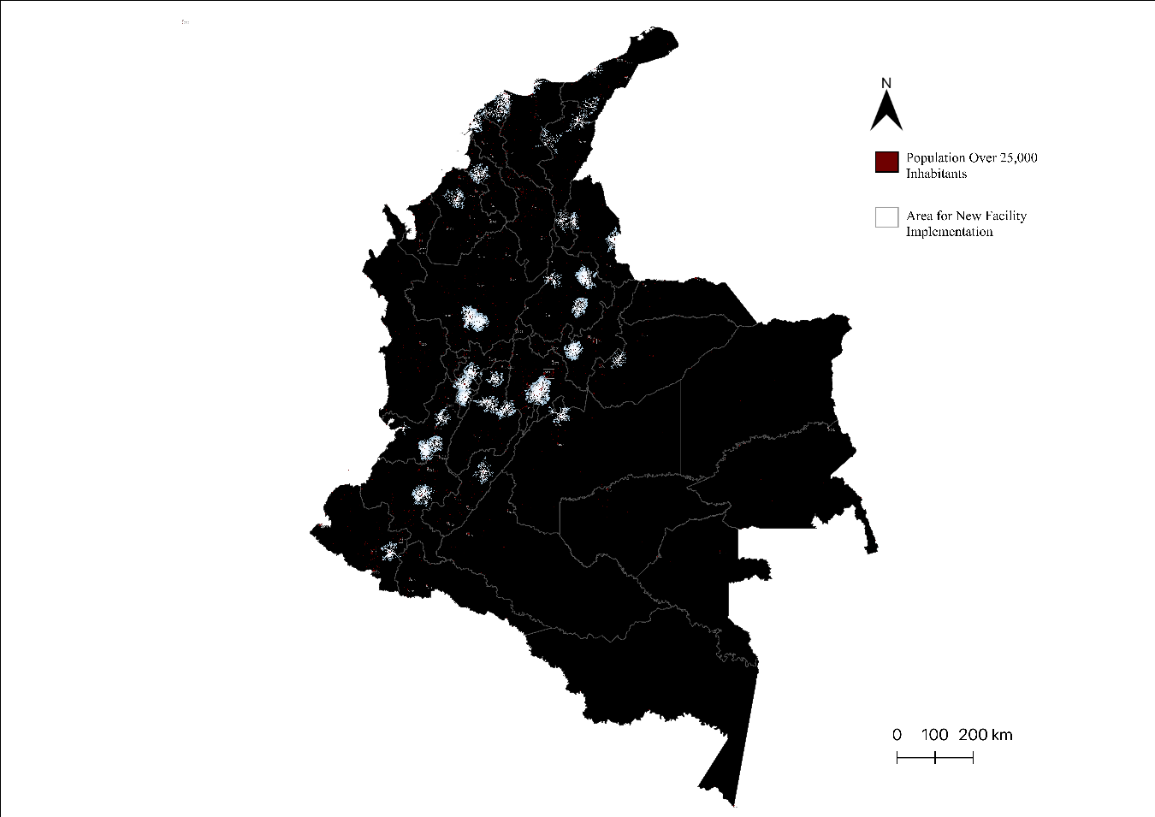

Fig. S3. Geographic accessibility to adult intensive care services and identification of priority expansion areas.
Spatial distribution of population-level access to adult intensive care based on travel-time modeling. Areas shaded from white to blue represent the existing service network, with white indicating optimal access and progressively darker blue indicating suboptimal access. Polygons located outside these zones denote regions with limited or no effective access and are identified as priority areas for targeted expansion of adult critical care capacity.

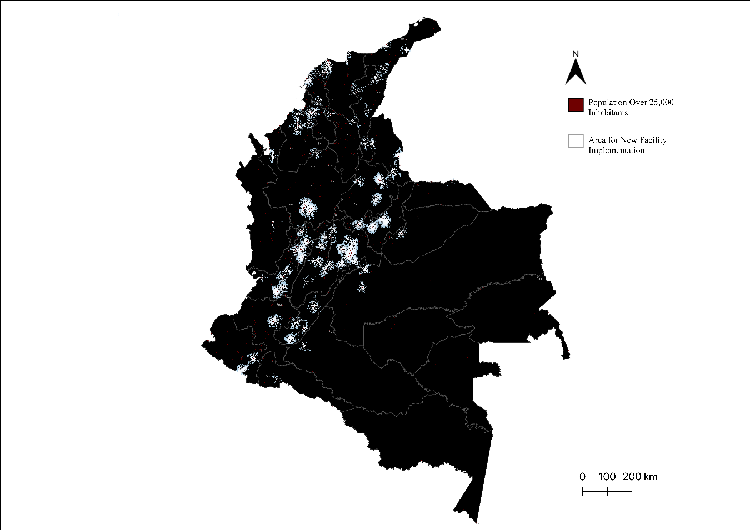

Fig. S4. Geographic accessibility to pediatric burn care services and identification of priority expansion areas.
Spatial distribution of population-level access to pediatric burn care based on travel-time modeling. Areas shaded from white to blue represent the existing service network, with white indicating optimal access and progressively darker blue indicating suboptimal access. Polygons located outside these zones denote regions with limited or no effective access and are identified as priority areas for targeted expansion of pediatric burn care capacity.

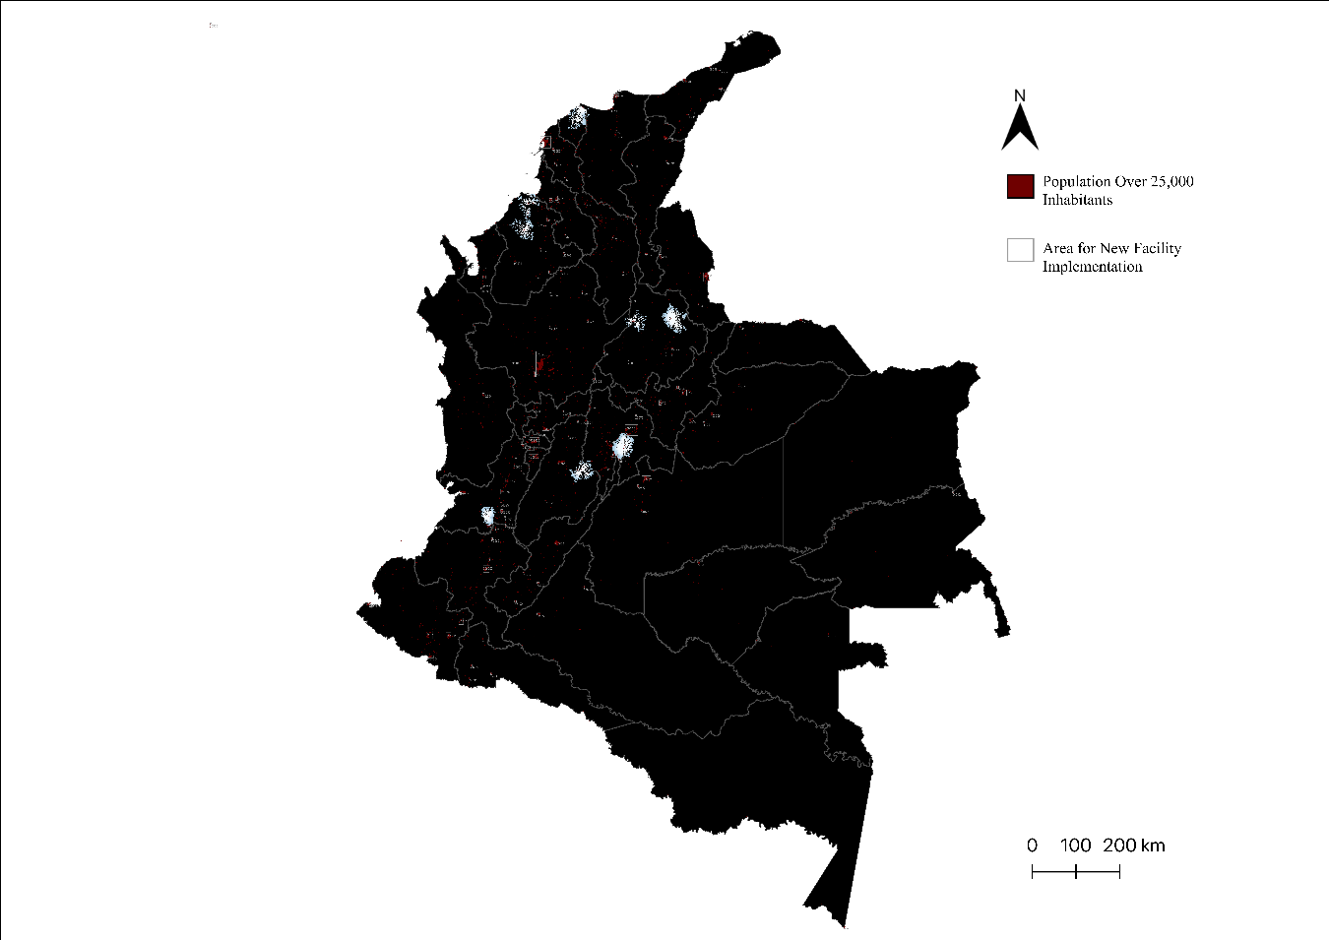

Fig. S5. Geographic accessibility to adult burn care services and identification of priority expansion areas.
Spatial distribution of population-level access to adult burn care based on travel-time modeling. Areas shaded from white to blue represent the existing service network, with white indicating optimal access and progressively darker blue indicating suboptimal access. Polygons located outside these zones denote regions with limited or no effective access and are identified as priority areas for targeted expansion of adult burn care capacity.

