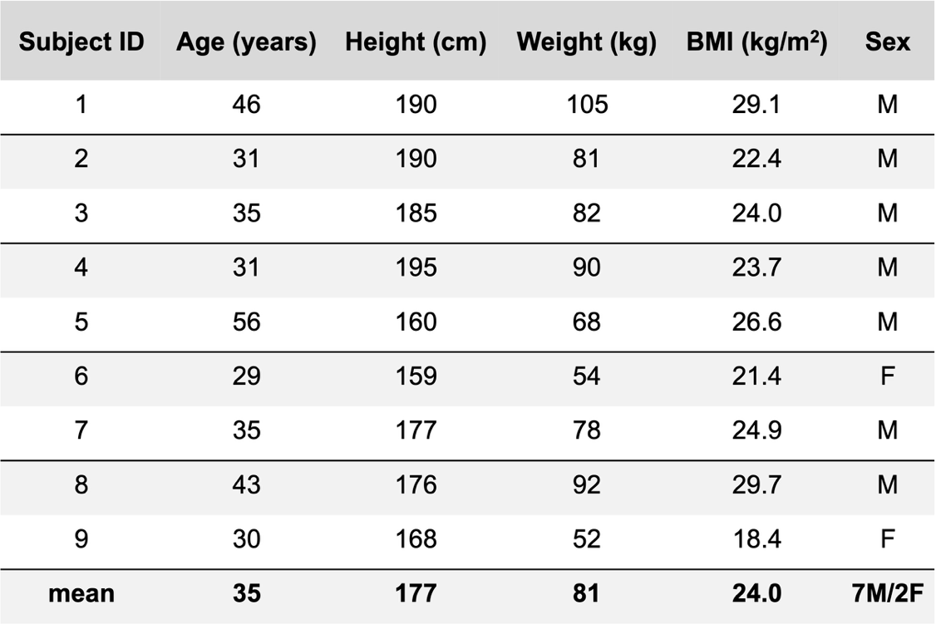
Table 1: Baseline characteristics of the study participants

