Supplements

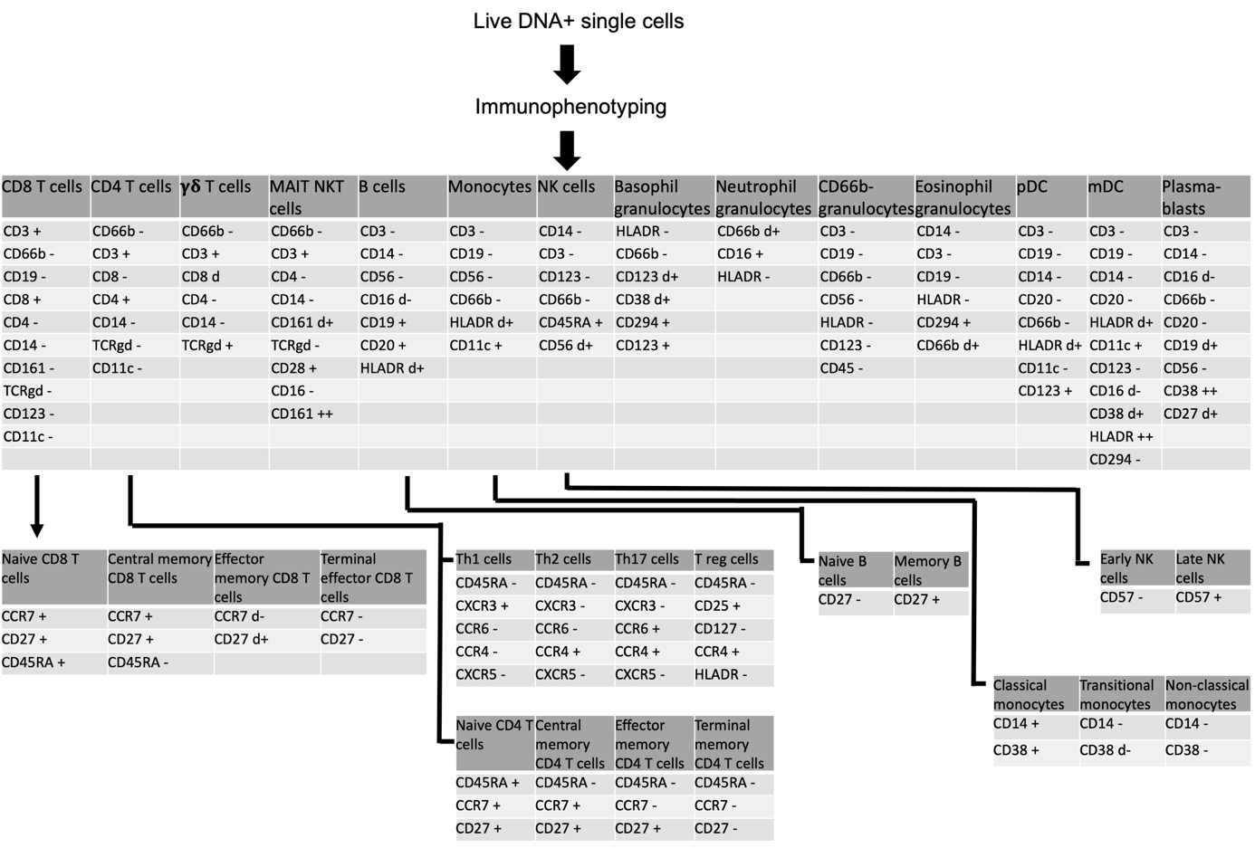
Supplemental Figure 1: Gating strategy Maxpar Pathsetter™

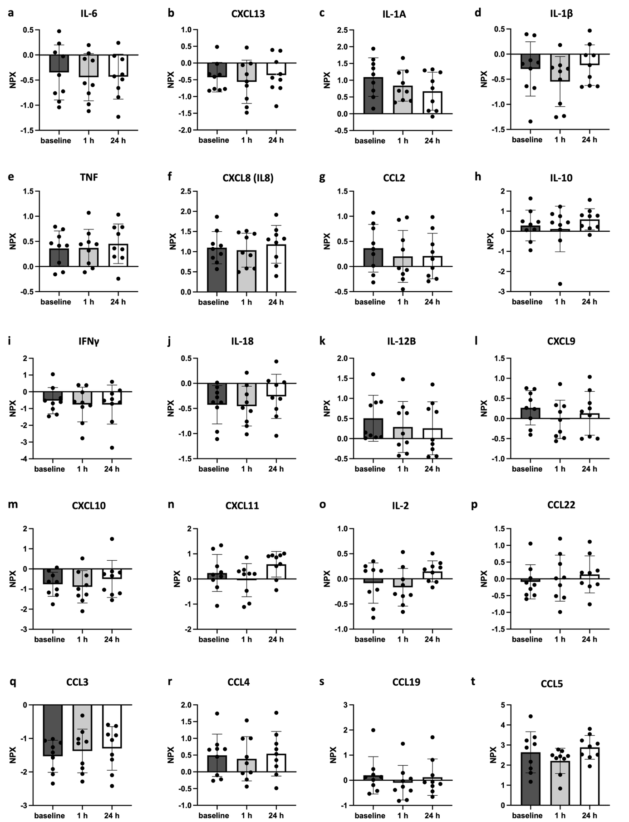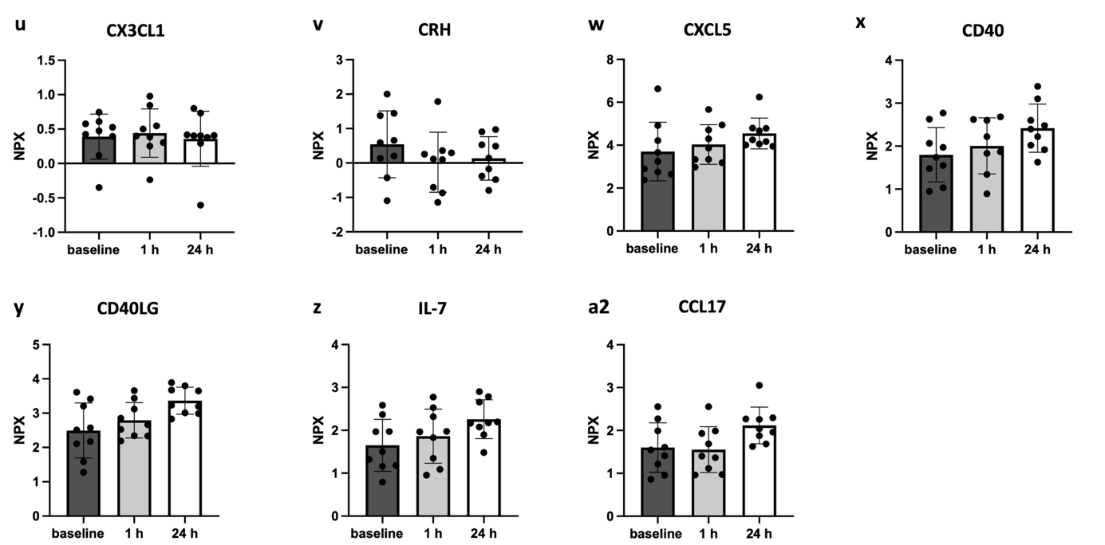
Supplemental Figure 2: Proximity extension assay of 26 immune-modulatory proteins before and after parabolic flight.
Proximity extension assay (PEA; Olink®) performed on blood samples at baseline, and 1 h and 24 h after parabolic flight and evaluated regarding levels of 26 immune-modulatory proteins. Protein abundance is indicated as NPX-value (Normalized Protein eXpression), an arbitrary logarithmic unit by Olink®.. Statistical analyses were performed with the one-way ANOVA test and Tukey’s multiple comparisons.

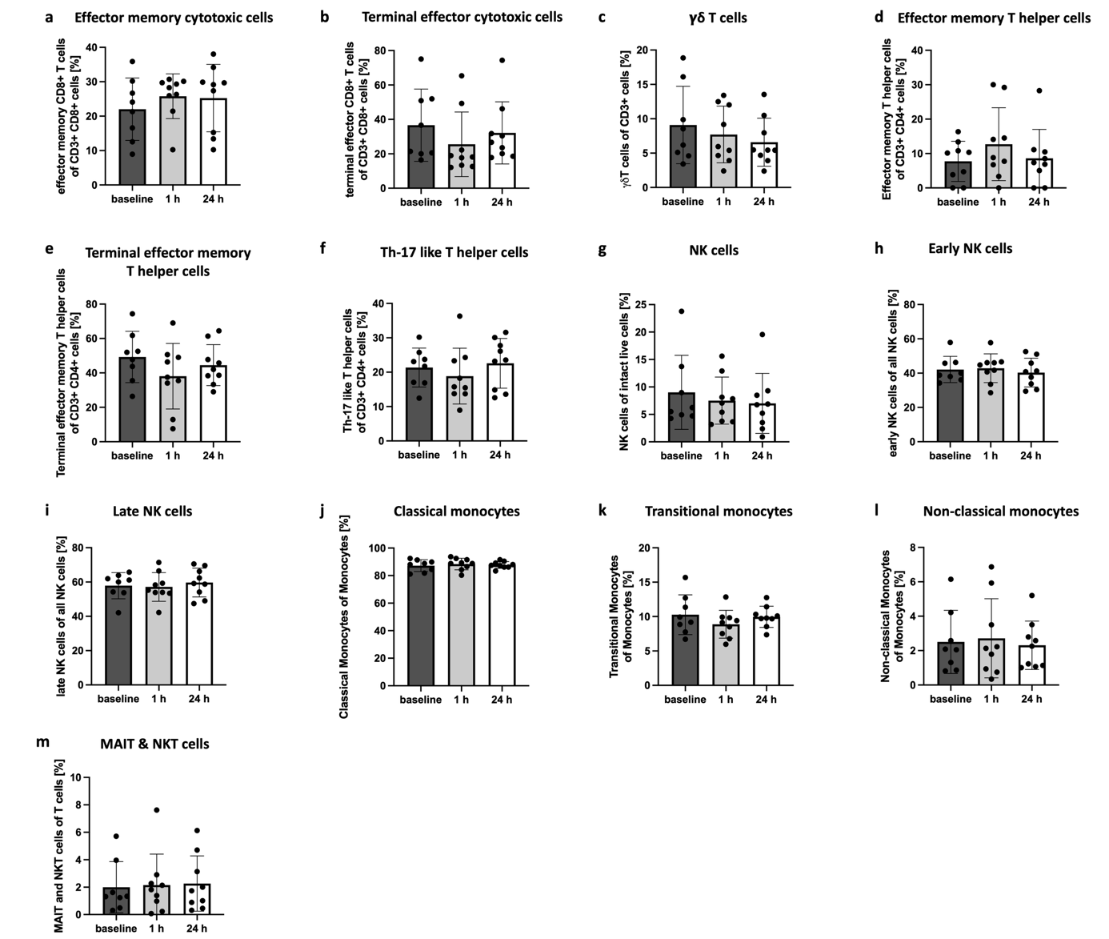
Supplemental Figure 3: Circulating immune cells before and after parabolic flight
CyTOF analysis performed on PBMCs at baseline and 1 h and 24 h after parabolic flight and analyzed regarding the relative count of (a) Effector memory CD8⁺ T cells (CD27^{dim+} CCR7^{dim-} CD3⁺ CD8⁺ cells), (b) Terminal effector CD8⁺ T cells (CD27⁻ CCR7⁻ CD3⁺ CD8⁺ cells), (c) γδT cells (TCRγδ⁺ CD8^{dim+} CD3⁺ cells), (d) Effector memory T helper cells (CD27⁺ CCR7^{dim-} CD45RA⁻ CD4⁺ CD3⁺ cells), (e) Terminal effector memory T helper cells (CD45RA⁻ CR7⁻ CD27⁻ CD4⁺ CD3⁺ cells), (f) Th-17 like T helper cells (CCR4⁺ CCR6⁺ CXCR3⁻ CXCR5⁻ CD45RA⁻ cells), (g) NK cells (CD56^{dim+} CD45RA⁺ CD66b⁻ CD123⁻ CD3⁻ CD14⁻ cells), (h) early NK cells (CD57⁻ CD56^{dim+} CD45RA⁺ CD66b⁻ CD123⁻ CD3⁻ CD14⁻ cells), (i) late NK cells (CD57⁺ cells of CD56^{dim+} CD45RA⁺ CD66b⁻ CD123⁻ CD3⁻ CD14⁻ cells), (j) Classical monocytes (CD38⁺ CD14⁺ CD11c⁺ HLADR^{dim+} CD66b⁻ CD56⁻ CD19⁻ CD3⁻ cells), (k) Transitional Monocytes (CD38⁻ CD14^{dim-} CD11c⁺ HLADR^{dim+} CD66b⁻ CD56⁻ CD19⁻ CD3⁻ cells), (l) Non-classical Monocytes (CD38⁻ CD14⁻ CD11c⁺ HLADR^{dim+} CD66b⁻ CD56⁻ CD19⁻ CD3⁻ cells), (m) MAIT and NKT cells (CD161^{dim+} CD28⁺ TCRγδ⁻ CD16⁻ CD14⁻ CD66b⁻ CD3⁺ cells). Statistical analyses were performed with the one-way ANOVA test and Tukey’s multiple comparisons.

