Supplementary Material
Contents
Supplementary Note S1. Relation-layer composition of the STS knowledge graph
Supplementary Note S2. Detailed KG-anchored literature retrieval analysis
Supplementary Note S3. Automated answer-context consistency: implementation details
Supplementary Note S4. Task-category breakdown of expert scores
Supplementary Note S5. Failure-mode case analyses (Q17, Q2, Q9)
Supplementary Note S6. PubMed corpus retrieval for the STS knowledge graph
Supplementary Note S7. LLM-based relation-extraction agent

Supplementary Figure S1. Content composition of the STS knowledge graph
Supplementary Figure S2.ICC (Pre - post adjudication reliability)
Supplementary Table S1. Inter-rater reliability across the five evaluation dimensions
Supplementary Table S2. Per-dimension descriptive and inferential statistics for the three architectures.
Supplementary Table S3. Composite expert score by clinical task category
Supplementary Table S4. The 20 clinical scenarios used in the blinded expert evaluation, in the order referenced as Q1–Q20.
Supplementary Note S1. Relation-layer composition of the STS knowledge graph
Across all retained edges, the relation distribution was dominated by RELATED_TO (21,101 edges; 91.66%), which represents the exploratory association layer of the KG and captures any co-occurrence-based association between two entities supported by the source literature. To characterize the semantically specified relation layer, relation composition was reassessed after excluding RELATED_TO. In this reduced view (n = 1,921 edges; Fig. S1b), the most frequent typed relations were HAS_SYNONYM (25.40%), MAY_OCCUR_IN (17.70%), TREATMENT_MAY_LEAD_TO_OUTCOME (16.97%), and HAS_TREATMENT_OPTIONS (10.15%), together accounting for over 70% of typed relations. The semantically specified component of the KG therefore primarily captures subtype naming and normalization, anatomical occurrence patterns, and clinically relevant treatment-outcome structure, categories aligned with the decision-relevant facts that drive multidisciplinary sarcoma board discussions.
Supplementary Note S2. Detailed KG-anchored literature retrieval analysis
Eligibility. Of the 20 evaluated questions, 14 (70%) were eligible for KG-anchoring analysis because they contained at least one KG-supported silver PMID target.
Primary retrieval metrics. Within this evaluable subset, mean reciprocal rank improved from 0.774 (KG-ablated) to 0.929 (full hybrid pipeline); recall@1 increased from 0.238 to 0.440; and hit@1 increased from 0.643 to 0.929. The mean best rank of the highest-ranked silver PMID also improved from 1.38 under ablation to 1.00 under hybrid retrieval.
Deeper-rank metrics. No corresponding differences were observed for recall@3, hit@3, or the analogous metrics at k = 5 and k = 10. This indicates that KG anchoring primarily affected early-rank promotion rather than deeper-list recall.
Statistical assessment. Bootstrap 95% confidence intervals for the paired differences in MRR, recall@1, and hit@1 were entirely positive, but paired permutation tests did not reach conventional significance thresholds (p = 0.125 for all three metrics). For hit@1, exact McNemar testing likewise yielded p = 0.125. These findings provide supportive but not definitive evidence that KG anchoring improved the top-rank surfacing of question-relevant KG-supported literature within the abstract retrieval stage, with the statistical power of the test limited by the modest evaluable sample.
Secondary diagnostics. Additional retrieval diagnostics including penetration@k, rank-biased overlap (RBO)[1], and per-question rank-shift summaries were consistent with the primary-metric interpretation. Across questions with comparable silver PMIDs, the rank-shift summary showed that 34.6% of questions improved in rank, 65.4% were unchanged, and none worsened.
Computation. For evaluable questions, abstract evidence items were extracted from the final context and ranked according to their final retrieval scores. PMID-level ranked lists were then constructed for both the hybrid and KG-ablated conditions, and metrics were computed at k = 1, 3, 5, and 10. Best rank was defined as the highest position at which any silver PMID appeared in the ranked list.
Metric definitions. Reciprocal rank was the inverse of the best rank, set to zero when no silver PMID was retrieved. Recall@k was the proportion of silver PMIDs appearing within the top-k ranked abstract PMIDs; hit@k was a binary indicator of whether at least one silver PMID appeared within the top-k list; and penetration@k was the proportion of top-k retrieved PMIDs that belonged to the silver target set, quantifying how densely the head of the ranked list was populated by silver PMIDs. Rank-biased overlap (RBO; p = 0.9) was used to quantify top-weighted overlap between the hybrid and ablation PMID rankings, giving greater weight to agreement near the head of the list and allowing comparison of incomplete, non-identical rankings. For silver PMIDs present in both rankings, delta rank was defined as ablation rank minus hybrid rank, so positive values indicated upward movement under the hybrid condition; rank-shift summaries comprised mean and median delta rank together with the proportions of improved, unchanged, and worsened ranks. This panel of measures was designed to test the intended retriever-side role of the KG component, namely anchoring and promotion of question-relevant literature through KG-supported PMID signals, rather than autonomous symbolic reasoning.
Supplementary Note S3. Automated answer-context consistency: implementation details
AlignScore was run using the RoBERTa-base AlignScore checkpoint in its NLI-style scoring mode. SummaCConv was applied at sentence granularity with mean aggregation. Scores were computed separately for each evaluated variant. The assembled retrieval context was treated as the supporting source document and the generated answer as the claim or summary-like text whose statements should be supported by that context. Paired mean differences between Hybrid KG-RAG and Guideline-only RAG were summarized using non-parametric bootstrap 95% confidence intervals with 10,000 resamples; statistical significance was assessed using two-sided paired permutation tests with 10,000 permutations. The paired effect size dz was computed as the mean of the paired differences divided by the standard deviation of the paired differences.
Summary statistics. For each evaluated variant, AlignScore and SummaCConv distributions were further summarized using means, standard deviations, minima, and maxima. Any effect of the KG on answer-context consistency was expected to arise primarily through retrieval support and context shaping rather than through direct graph-based reasoning.
Supplementary Note S4. Task-category breakdown of expert scores
The 20 clinical scenarios were grouped into five task categories: diagnostic biopsy (Q1, Q12, Q20; n = 3), surgical management (Q2, Q4, Q5, Q7, Q8, Q13; n = 6), systemic and advanced-disease therapy (Q3, Q11, Q15, Q16; n = 4), radiotherapy (Q9, Q14, Q17; n = 3), and GIST-specific decisions (Q6, Q10, Q18, Q19; n = 4). Per-category composite expert scores (median [IQR]) and paired incremental gains over Zero-shot LLM and Guideline-only RAG are summarized in Supplementary Table S3 and visualised in Figure 2c.
The increment of Hybrid KG-RAG over Guideline-only RAG was largest in diagnostic biopsy (Δ median = +5.3), reflecting the dependence of biopsy-strategy questions on subtype-specific evidence that the KG retrieval layer was best positioned to surface. Increments were intermediate for systemic and advanced-disease therapy (Δ +2.5), GIST-specific decisions (Δ +2.3), and surgical management (Δ +1.8), where Guideline-only RAG already approached ceiling on guideline-based recommendations. The radiotherapy category showed a nominal decrement (Δ −1.7) driven entirely by a single failure case (Q17, detailed in Supplementary Note S5); the other two radiotherapy questions both showed positive Hybrid KG-RAG gains. Given the modest sample size per category (n = 3–6), these category-level differences are reported descriptively and were not subjected to formal significance testing.
Supplementary Note S5. Failure-mode case analyses (Q17, Q2, Q9)
Three questions diverged from the dominant performance pattern and were examined qualitatively to characterize the failure modes of the current pipeline.
Q17 — Anchoring miscalibration. On the question of optimal post-operative radiotherapy timing in extremity STS, Zero-shot LLM (composite score 20.3) and Guideline-only RAG (25.0) produced the guideline-concordant answer of 3–6 weeks, whereas Hybrid KG-RAG (6.3) retrieved a topically related but question-misaligned PubMed publication on the effect of surgery-to-radiotherapy delay on local control, anchored on this evidence, and concluded that the optimal interval was "not explicitly specified." This case illustrates a KG-anchoring miscalibration in which a correctly retrieved publication addressed a sibling sub-question rather than the target question, and the generator preferred the KG-anchored evidence over the directly applicable guideline excerpt.
Q2 — Indication-level retrieval miss. In a case where an uncontrolled local recurrence coexisted with a new resectable pulmonary metastasis, both retrieval-augmented conditions (Guideline-only RAG 5.3; Hybrid KG-RAG 6.7) retrieved technique-focused evidence on thoracoscopic versus open metastasectomy and produced incorrect indication-level answers, while Zero-shot LLM (12.7) gave a safer, vague case-by-case multidisciplinary deferral. This pattern reflects an inherent limitation of evidence retrieval in encoding case-specific clinical prerequisites such as the requirement for adequate local control prior to pulmonary metastasectomy.
Q9 — Inverse failure (retrieval grounding prevents unsafe confabulation). On the question of whether post-operative radiotherapy could substitute for definitive re-resection, Zero-shot LLM (5.0) generated a permissive and clinically unsafe affirmative response, whereas both Guideline-only RAG (21.3) and Hybrid KG-RAG (19.7) correctly stated that the guidelines do not support such substitution. This case illustrates the inverse failure mode in which retrieval grounding prevented a potentially dangerous hallucination from the underlying language model.
Mapping to pipeline stages. These three cases delineate three distinct failure mechanisms, namely anchoring on topically related but question-misaligned literature, retrieval miss on indication-level questions requiring case-specific clinical context, and inverse failure in which retrieval grounding prevents unsafe LLM confabulation. These mechanisms map onto different stages of the retrieval-augmented generation pipeline and motivate future work on retrieval-confidence gating, case-context-aware re-ranking, and explicit clinical prerequisite checking.
Supplementary Figure S1. Content composition of the STS knowledge graph
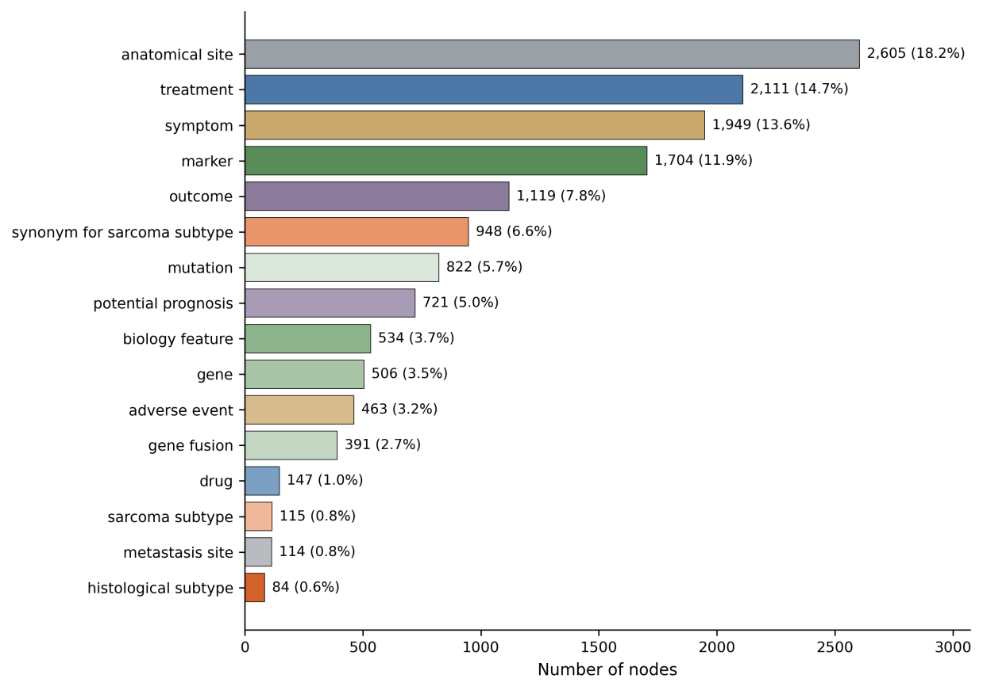
Figure S1a. Node type composition. Number of nodes per node type. Bars are colored by semantic class family (subtypes in coral, treatments in blue, markers and biology in green, anatomical and metastasis sites in grey, symptoms and adverse events in gold, outcomes and prognosis in purple).
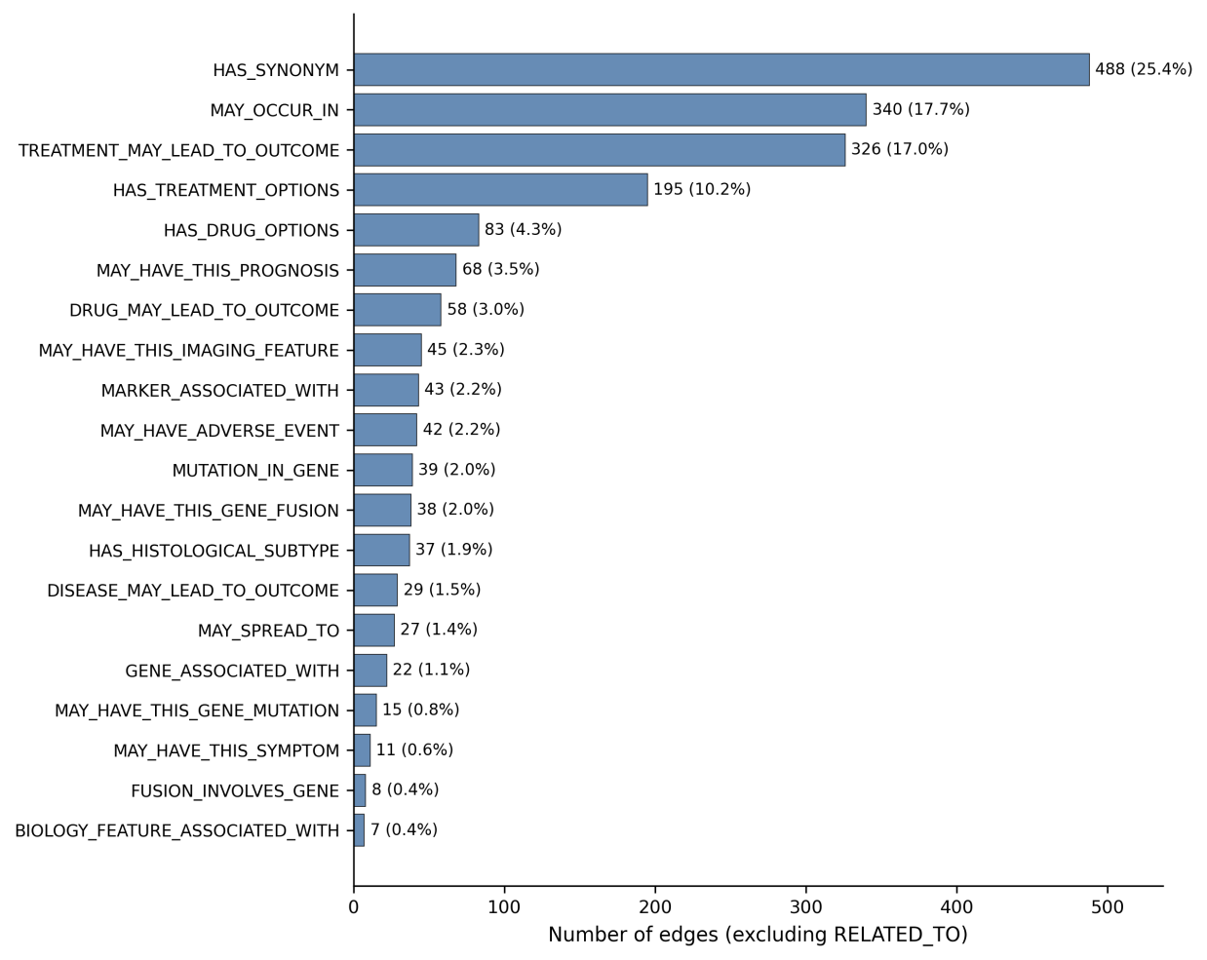
Figure S1b. Typed relation composition (excluding RELATED_TO). Number of edges per typed relation. Percentage shares are computed within the typed relation layer (n = 1,921 edges).
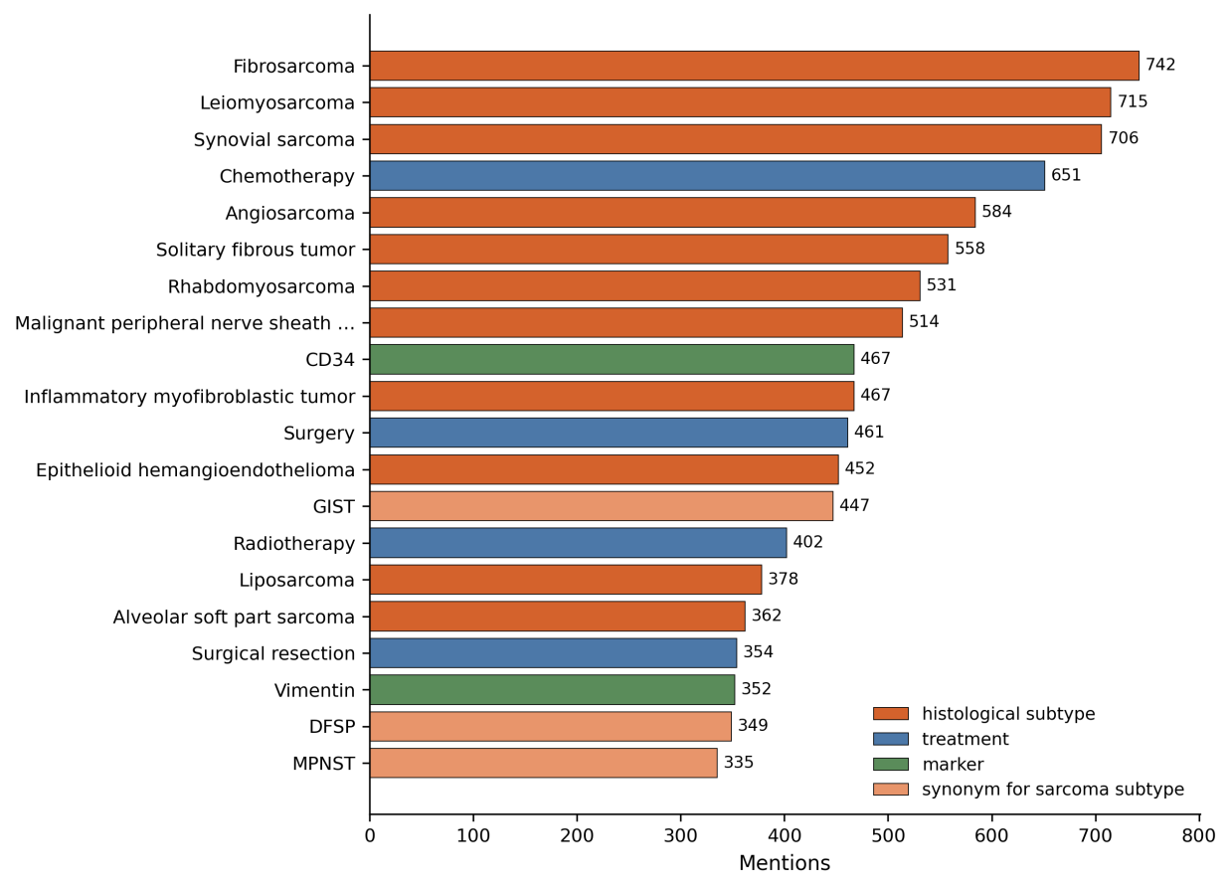
Figure S1c. Top 20 nodes by mention frequency in the source corpus. Bar color indicates node type.
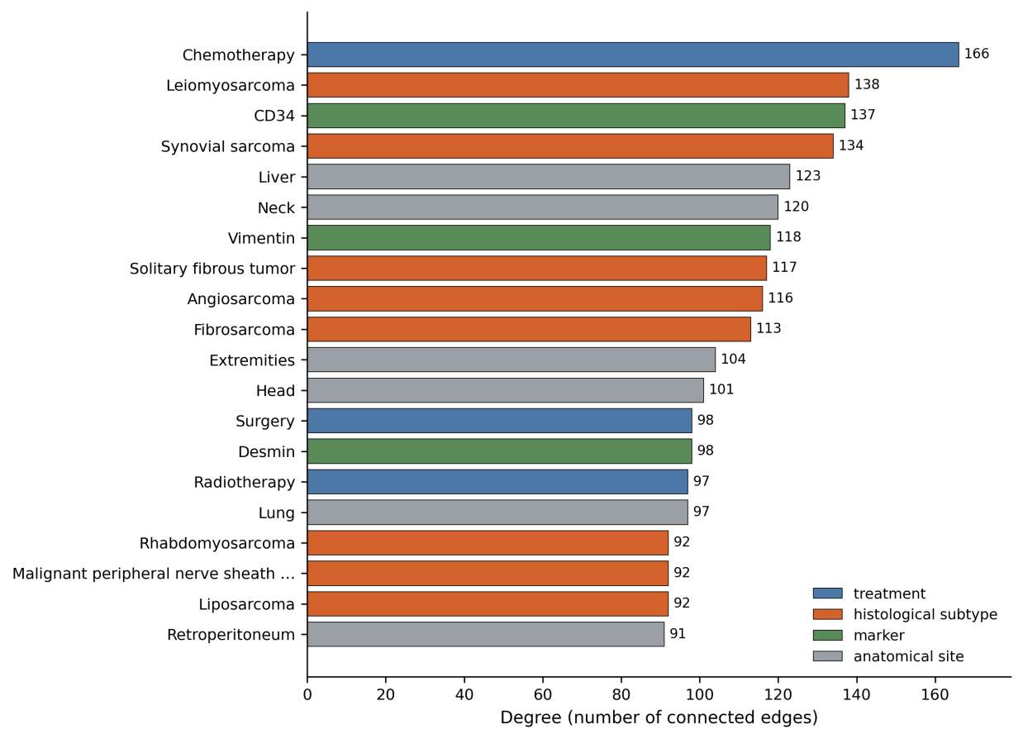
Figure S1d. Top 20 nodes by degree (number of distinct neighboring nodes in the graph). Bar color indicates node type. Anatomical-site nodes appear among the top-degree nodes despite not appearing in the top-mention list (panel c), reflecting their role as cross-topic relational hubs rather than topic-defining concepts.
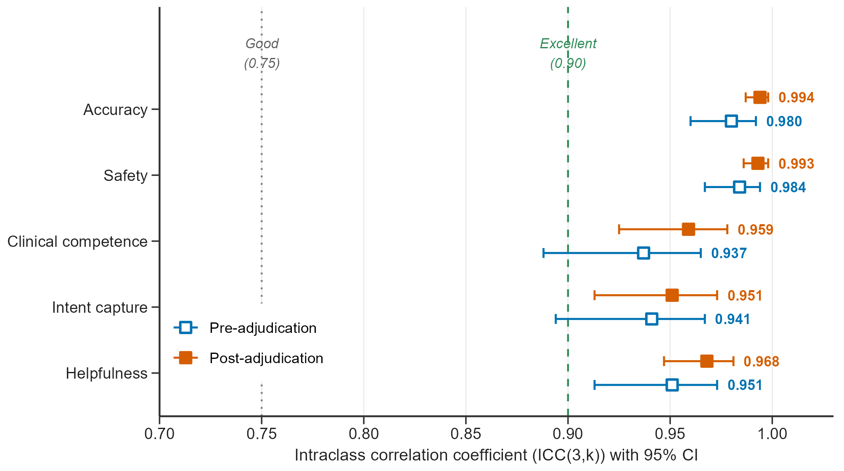
Figure S2: Pre - post adjudication reliability
Inter-rater reliability before and after consensus adjudication. Intraclass correlation coefficient (ICC(3,k); two-way mixed-effects model, average measures, absolute agreement) across the three blinded sarcoma surgeons for each of the five evaluation dimensions. Open blue squares indicate pre-adjudication estimates; filled orange squares indicate post-adjudication estimates. Error bars show non-parametric 95% bootstrap confidence intervals. Numerical values (pre- and post-adjudication point estimates with confidence intervals) are reported in Supplementary Table S1.

Supplementary Table S1. Inter-rater reliability across the five evaluation dimensions
Evaluation dimension | Pre-adjudication ICC(3,k) [95% CI] | Post-adjudication ICC(3,k) [95% CI]
Accuracy | 0.980 [0.960–0.992] | 0.994 [0.987–0.998]
Safety | 0.984 [0.967–0.994] | 0.993 [0.986–0.998]
Miller's Pyramid clinical competence | 0.937 [0.888–0.965] | 0.959 [0.925–0.978]
Intent capture | 0.941 [0.894–0.967] | 0.951 [0.913–0.973]
Helpfulness | 0.951 [0.913–0.973] | 0.968 [0.947–0.981]
Intraclass correlation coefficients ICC(3,k) were computed using a two-way mixed-effects model with average measures and absolute agreement formulation. Each ICC was estimated by pooling all (question × architecture) units as subjects within the respective dimension. 95% confidence intervals were obtained by non-parametric bootstrap with 10,000 resamples of subjects. All point estimates exceed the 0.90 threshold conventionally interpreted as excellent reliability (Koo & Li 2016), with lower confidence-interval bounds also exceeding 0.85 across all dimensions both before and after consensus adjudication.

Supplementary Table S2. Per-dimension descriptive and inferential statistics for the three architectures.
Dimension | Median [IQR] |  |  | Friedman omnibus | Pairwise Wilcoxon (Bonferroni-corrected p; matched-pairs r)
 | Zero-shot LLM (V1) | Guideline-only RAG (V2) | Hybrid KG-RAG (V3) | χ²(2), p, W | V3 vs V1 | V3 vs V2 | V2 vs V1
Accuracy | 3.00 [1.00–5.00] | 5.00 [4.33–5.00] | 5.00 [5.00–5.00] | 12.39, 0.002, 0.31 | p = 0.029; r = 0.57 | p = 1.000; r = 0.19 | p = 0.082; r = 0.48
Safety | 3.17 [1.00–4.50] | 5.00 [4.83–5.00] | 5.00 [5.00–5.00] | 13.19, 0.001, 0.33 | p = 0.012; r = 0.64 | p = 1.000; r = 0.19 | p = 0.063; r = 0.51
Miller's Pyramid clinical competence | 2.00 [1.00–3.33] | 4.00 [3.33–4.08] | 4.67 [3.33–4.67] | 18.75, <0.001, 0.47 | p = 0.004; r = 0.71 | p = 0.172; r = 0.42 | p = 0.022; r = 0.60
Intent capture | 2.17 [1.33–3.33] | 4.17 [3.33–4.33] | 4.67 [4.25–5.00] | 20.90, <0.001, 0.52 | p < 0.001; r = 0.81 | p = 0.064; r = 0.51 | p = 0.017; r = 0.62
Helpfulness | 2.17 [1.00–3.33] | 4.00 [3.25–4.08] | 4.67 [3.58–5.00] | 19.50, <0.001, 0.49 | p = 0.003; r = 0.74 | p = 0.093; r = 0.48 | p = 0.022; r = 0.60
Composite (5–25) | 12.50 [5.33–20.33] | 21.50 [19.92–22.58] | 23.83 [21.83–24.42] | 22.13, <0.001, 0.55 | p = 0.004; r = 0.71 | p = 0.085; r = 0.49 | p = 0.016; r = 0.62
Median and interquartile range (IQR) are computed across the 20 expert-rated questions using the post-adjudication consensus score (mean across three raters). The Friedman omnibus test was run within each dimension on the matched three-architecture vector per question. Pairwise comparisons used the Wilcoxon signed-rank test with Bonferroni correction for the three contrasts within each dimension (corrected p-values are reported). The matched-pairs effect size is r = |Z| / √N, with conventional thresholds 0.10 (small), 0.30 (medium), 0.50 (large). The composite score (5–25) is the per-question sum of the five Likert scores.

Supplementary Table S3. Composite expert score by clinical task category
Task category | Question IDs | n | Composite score, median [IQR] |  |  | Δ median (V3 − V1) | Δ median (V3 − V2) | Note
 |  |  | Zero-shot LLM (V1) | Guideline-only RAG (V2) | Hybrid KG-RAG (V3)
Diagnostic biopsy | Q1, Q12, Q20 | 3 | 5.3 [5.2–11.5] | 18.7 [13.3–21.3] | 23.7 [20.7–23.8] | +12.7 | +5.3 | —
Surgical management | Q2, Q4, Q5, Q7, Q8, Q13 | 6 | 15.8 [12.4–20.0] | 22.3 [20.8–23.1] | 24.3 [23.8–24.6] | +4.5 | +1.8 | V2 near ceiling
Systemic / advanced-disease therapy | Q3, Q11, Q15, Q16 | 4 | 5.5 [5.2–9.5] | 22.0 [17.6–22.3] | 23.3 [21.8–24.4] | +16.8 | +2.5 | —
Radiotherapy | Q9, Q14, Q17 | 3 | 20.3 [12.7–20.5] | 21.3 [21.2–23.2] | 19.7 [13.0–22.0] | +3.7 | −1.7 | Q17 failure (Note S5)
GIST-specific decisions | Q6, Q10, Q18, Q19 | 4 | 10.5 [5.3–16.8] | 21.3 [17.2–21.9] | 24.0 [23.1–24.8] | +13.0 | +2.3 | —
Composite expert score is the per-question sum of the five Likert dimensions (Accuracy, Safety, Miller’s Pyramid clinical competence, Intent capture, Helpfulness), with theoretical range 5–25. Median and interquartile range (IQR) are computed across the post-adjudication consensus scores (mean of three raters) for the questions in each task category. Δ median values reflect the median of the per-question paired differences within each category.

1. Webber, W., A. Moffat, and J. Zobel, A similarity measure for indefinite rankings. ACM Transactions on Information Systems (TOIS), 2010. 28(4): p. 1-38.

Supplementary Table S4. The 20 clinical scenarios used in the blinded expert evaluation, in the order referenced as Q1–Q20.
ID | Clinical question
Q1 | A 20-year-old man presented with a painless superficial mass, 2.5 cm in diameter, adjacent to the right knee. The surgeon recommended excisional biopsy and intraoperative frozen section pathology to confirm the tumor subtype. Is this treatment correct? If not, please explain the reason for the error.
Q2 | A 40-year-old patient with myxoid liposarcoma of the right lower extremity experienced a local recurrence following surgery, which was deemed unresectable by the MDT. The local recurrence was assessed as progressive disease, along with a new resectable metastatic lesion of approximately 2 cm in the left lung, identified after multiple lines of chemotherapy. Could this patient undergo thoracoscopic pulmonary metastasectomy to control the lung metastasis?
Q3 | A 45-year-old patient with retroperitoneal dedifferentiated liposarcoma, who underwent R0 resection three years ago, was diagnosed with unresectable local recurrence. The patient received first-line chemotherapy with a doxorubicin and ifosfamide regimen, but disease progression was noted after three months. Can the patient be switched to a pazopanib regimen to continue treatment?
Q4 | A 46-year-old man underwent R0 resection for a G1 retroperitoneal well-differentiated liposarcoma. What is the optimal follow-up interval for this patient in the first two years after resection?
Q5 | A 50-year-old woman has been diagnosed with right retroperitoneal well-differentiated liposarcoma. After an MDT discussion, the decision was made to proceed with surgical resection, including resection of the right kidney. What preoperative tests are required to assess the risk of postoperative renal failure?
Q6 | A 55-year-old woman was diagnosed with duodenal GIST with unresectable liver metastases. Molecular analysis revealed that the tumor harbors a D842V mutation in the PDGFRA gene. What is the most effective first-line treatment for this patient?
Q7 | A 56-year-old woman with leiomyosarcoma confined to the uterus requires surgery. Can the specimen be morcellated in a bag for removal through the port site?
Q8 | A 70-year-old patient underwent multivisceral resection for a retroperitoneal dedifferentiated liposarcoma. Postoperative pathology revealed an R1 resection. Should the patient undergo re-resection?
Q9 | A 71-year-old male with de-differentiated liposarcoma of the left lower extremity underwent en-bloc resection. Postoperative pathology and CT imaging revealed residual disease. The patient tolerated the initial surgery well and is eligible for re-resection. Could postoperative radiotherapy serve as an alternative to definitive re-resection in this case?
Q10 | A 74-year-old woman presented with an abdominal mass with imaging findings of a 7 × 6 cm soft tissue mass lateral to the lesser curvature of the stomach, without distant metastases. Gastroscopic biopsy revealed a GIST, and molecular analysis showed the presence of a KIT exon 11 mutation in the tumor. The surgeon assessed that the operation may require removal of a large portion of the stomach, leading to significant changes in the patient's gastrointestinal function. Does the patient require neoadjuvant imatinib therapy first?
Q11 | Can you provide guidance on which drugs can be used in combination with gemcitabine as a second-line treatment for patients with advanced sarcoma who have previously received chemotherapy with doxorubicin and ifosfamide?
Q12 | Could excisional biopsy be considered for superficial soft tissue tumors larger than 2 cm in diameter?
Q13 | For a patient with a metastasis-free femoral sarcoma and preoperative imaging indicating tumor invasion of the femoral artery, how should the affected artery be managed during surgery?
Q14 | For patients with G2 soft tissue sarcomas of the extremities or trunk who underwent an unplanned incomplete resection and did not receive preoperative radiotherapy before re-resection, should they receive radiotherapy after the re-resection?
Q15 | Should neoadjuvant chemotherapy be recommended for a patient with a 6 cm G1 well-differentiated liposarcoma located in the retroperitoneum?
Q16 | Systemic whole-body hyperthermia can be used regularly in patients with locally advanced sarcoma. Is this statement correct? If not, please explain the reason for the error.
Q17 | What is the optimal time interval between resection and the initiation of postoperative percutaneous radiation therapy for patients with soft tissue sarcomas of the extremities who are candidates for postoperative radiotherapy?
Q18 | Which type of GIST does not require immediate surgery and can be monitored regularly with endoscopic ultrasound?
Q19 | Which type of GIST may have regional lymph node metastases and therefore may require intraoperative lymph node dissection?
Q20 | Would you recommend using a 18G coaxial needle to perform an image-guided biopsy to confirm the pathological diagnosis of retroperitoneal sarcoma?

Supplementary Note S6. PubMed corpus retrieval for the STS knowledge graph
Query construction. The soft-tissue-sarcoma abstract corpus was retrieved from PubMed via the NCBI Entrez E-utilities. For each combination of a sarcoma-subtype synonym (Supplementary Table S5) and a publication year between 2003 and 2024, the following query was issued: "<synonym>"[Title/Abstract] AND <year>[PDAT] AND english[lang] AND Humans[MeSH Terms]. Each synonym was matched as a phrase in the title or abstract, restricted to English-language entries indexed under the Humans MeSH term, with the publication year constrained by the [PDAT] field. Up to ~47 records were retrieved per (subtype × year) cell to balance the corpus across subtypes and years.
Post-retrieval filtering. Retrieved abstracts were de-duplicated by PMID, and a whole-word, case-insensitive regular-expression filter on subtype synonyms was applied to the title and abstract text, retaining only abstracts that explicitly mentioned at least one subtype synonym. This corpus is then being filtered again and the final filtered set constituted the final corpus of 9,594 abstracts used for downstream knowledge-graph construction.
Supplementary Table S5. Sarcoma-subtype synonyms used in the PubMed corpus retrieval.
Canonical subtype | Query synonyms
Gastrointestinal stromal tumor | gastrointestinal stromal tumor; GIST
Liposarcoma | liposarcoma
Leiomyosarcoma | leiomyosarcoma
Undifferentiated pleomorphic sarcoma | undifferentiated pleomorphic sarcoma; UPS; pleomorphic sarcoma; malignant fibrous histiocytoma; myxofibrosarcoma
Synovial sarcoma | synovial sarcoma
Malignant peripheral nerve sheath tumor | malignant peripheral nerve sheath tumor; MPNST
Solitary fibrous tumor | solitary fibrous tumor; hemangiopericytoma
Fibrosarcoma | fibrosarcoma
Angiosarcoma | angiosarcoma
Epithelioid sarcoma | epithelioid sarcoma
Alveolar soft part sarcoma | alveolar soft part sarcoma; alveolar soft tissue sarcoma; ASPS
Clear cell sarcoma | clear cell sarcoma; melanoma of soft parts
Extraskeletal myxoid chondrosarcoma | extraskeletal myxoid chondrosarcoma; EMC
Dermatofibrosarcoma protuberans | dermatofibrosarcoma; DFSP
Rhabdomyosarcoma | rhabdomyosarcoma
Chondrosarcoma | chondrosarcoma
Tenosynovial giant cell tumor | tenosynovial giant cell tumor
Undifferentiated spindle cell sarcoma | undifferentiated spindle cell sarcoma
Undifferentiated round cell sarcoma | undifferentiated round cell sarcoma
Undifferentiated epithelioid sarcoma | undifferentiated epithelioid sarcoma
Inflammatory myofibroblastic tumor | inflammatory myofibroblastic tumor
PEComa | tumor of perivascular epithelioid cells; PEComa
Epithelioid hemangioendothelioma | epithelioid hemangioendothelioma; EHE
Embryonal sarcoma of the liver | embryonal sarcoma of the liver

Supplementary Note S7. LLM-based relation-extraction agent
Within each abstract, validated entities were paired exhaustively to form candidate (head, tail) pairs, which were then routed to an LLM-based validation agent running Llama 3 70B Instruct via Ollama.
Inputs to the LLM. For each candidate pair, the agent received a five-sentence context window centered on the earlier of the two mention sentences (the sentence itself plus the two preceding and two following sentences), the two entity mention strings and their entity types, and a schema-filtered list of allowed relation types; only relations compatible with the head and tail types under the relation ontology were exposed.
Pre-LLM filtering. Pairs were excluded before prompting if the abstract text could not be located for the source PMID, if mention spans did not match the abstract text after a light, case-insensitive repair step, if mention metadata was missing, or if the head and tail mentions were not in the same sentence or in adjacent sentences (two-sentence sliding window).
Output validation and retries. The agent was instructed to return a JSON object with two keys, relation (one of the allowed labels or NONE) and score (confidence in [0, 1]), using the verbatim prompt below. Outputs were validated for JSON validity and for membership of the returned label in the allowed set; non-conforming outputs triggered up to three retries before the candidate was logged as a prediction failure and excluded. Pairs returning NONE were not added to the graph.
Run-level statistics. Counts of total pairs processed, valid relations, span issues, prediction issues, and NONE responses, together with the mean, minimum, and maximum confidence score across valid relations and the total runtime, were saved alongside the validated triples.
Verbatim prompt template (curly-brace tokens are populated per candidate pair):
You are an information extraction model.
Given the context from a sarcoma paper and two highlighted entities,
decide which relation best describes their biomedical relationship.

Context:
"{context}"

Head: "{h_text}" (type: {h_type})
Tail: "{t_text}" (type: {t_type})

Allowed relation types:
{rel_list}
Additionally, you may answer "NONE" if no relation is supported.

Respond ONLY in JSON with keys:
- relation: one of the allowed relation types or "NONE"
- score: a number between 0 and 1 indicating confidence.

