Supplementary material
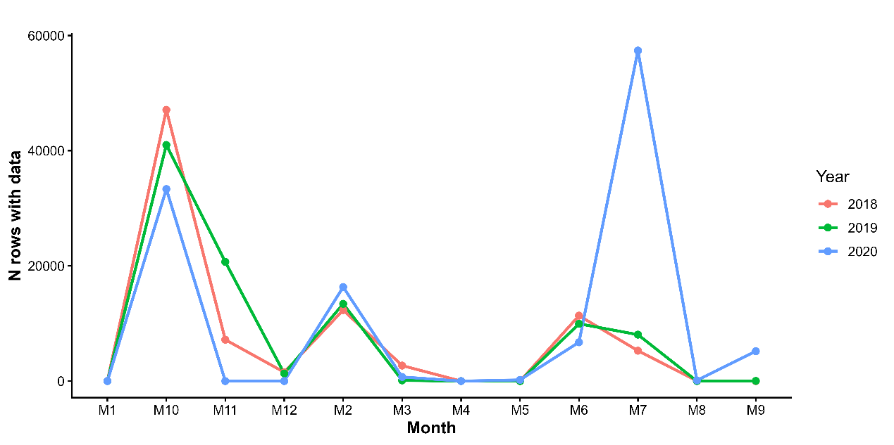
Figure 1. Monthly distribution of sampling effort (number of observations) across the study period (2018-2020).

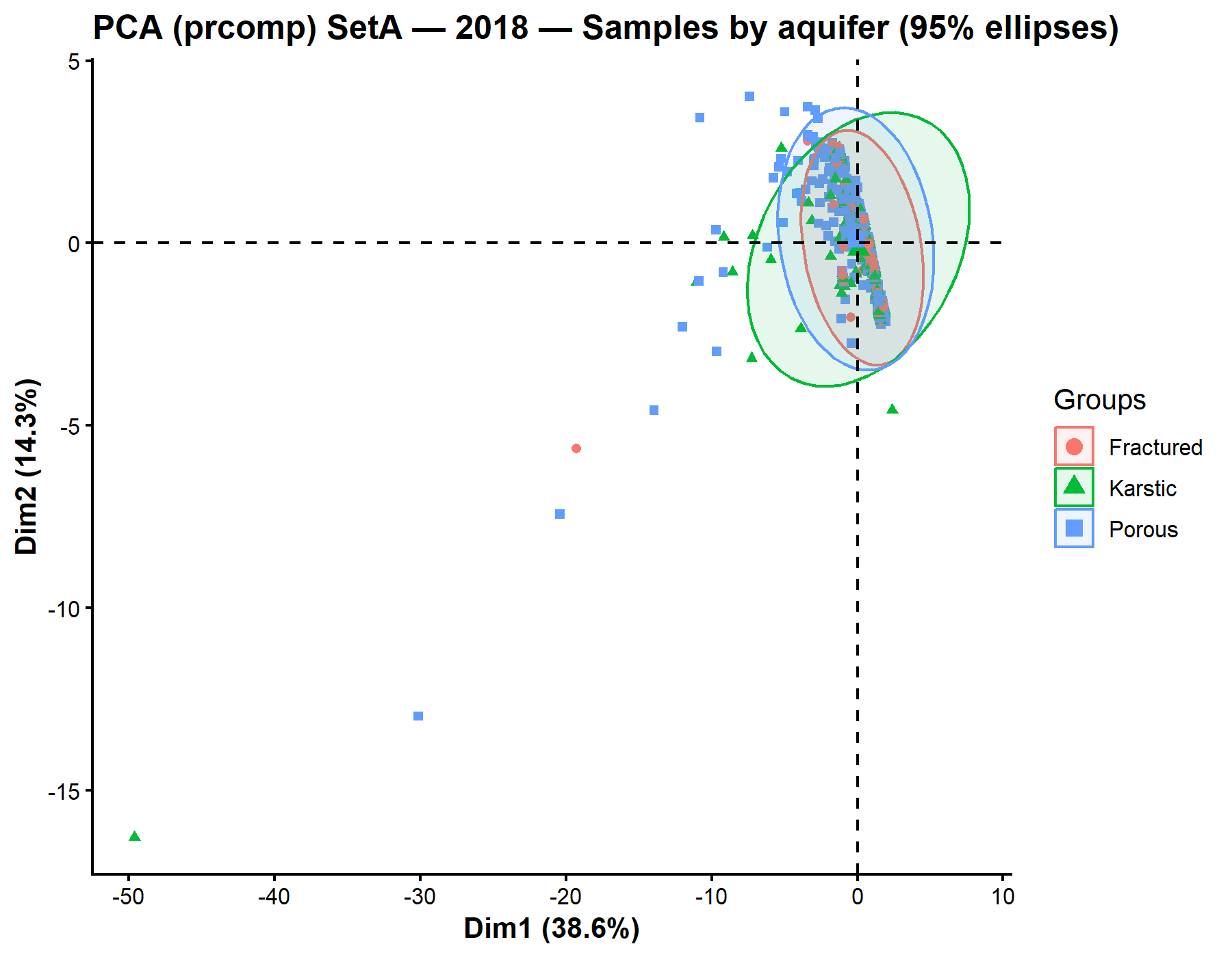

Figure 2. PCA score plot showing sample distribution by aquifer type with 95% confidence ellipses for 2018.
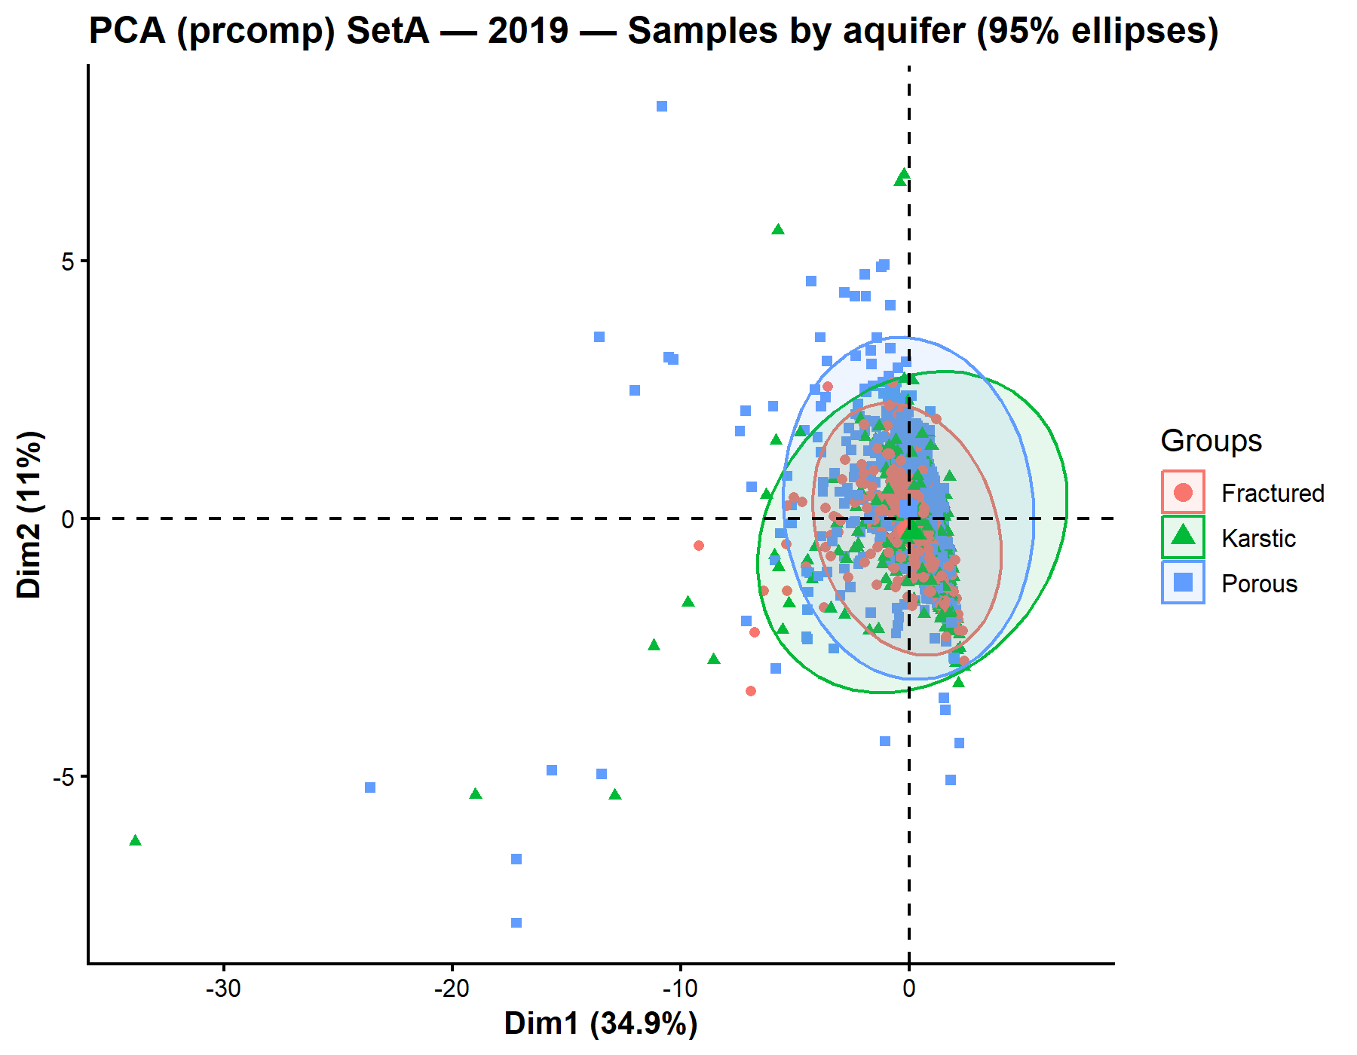
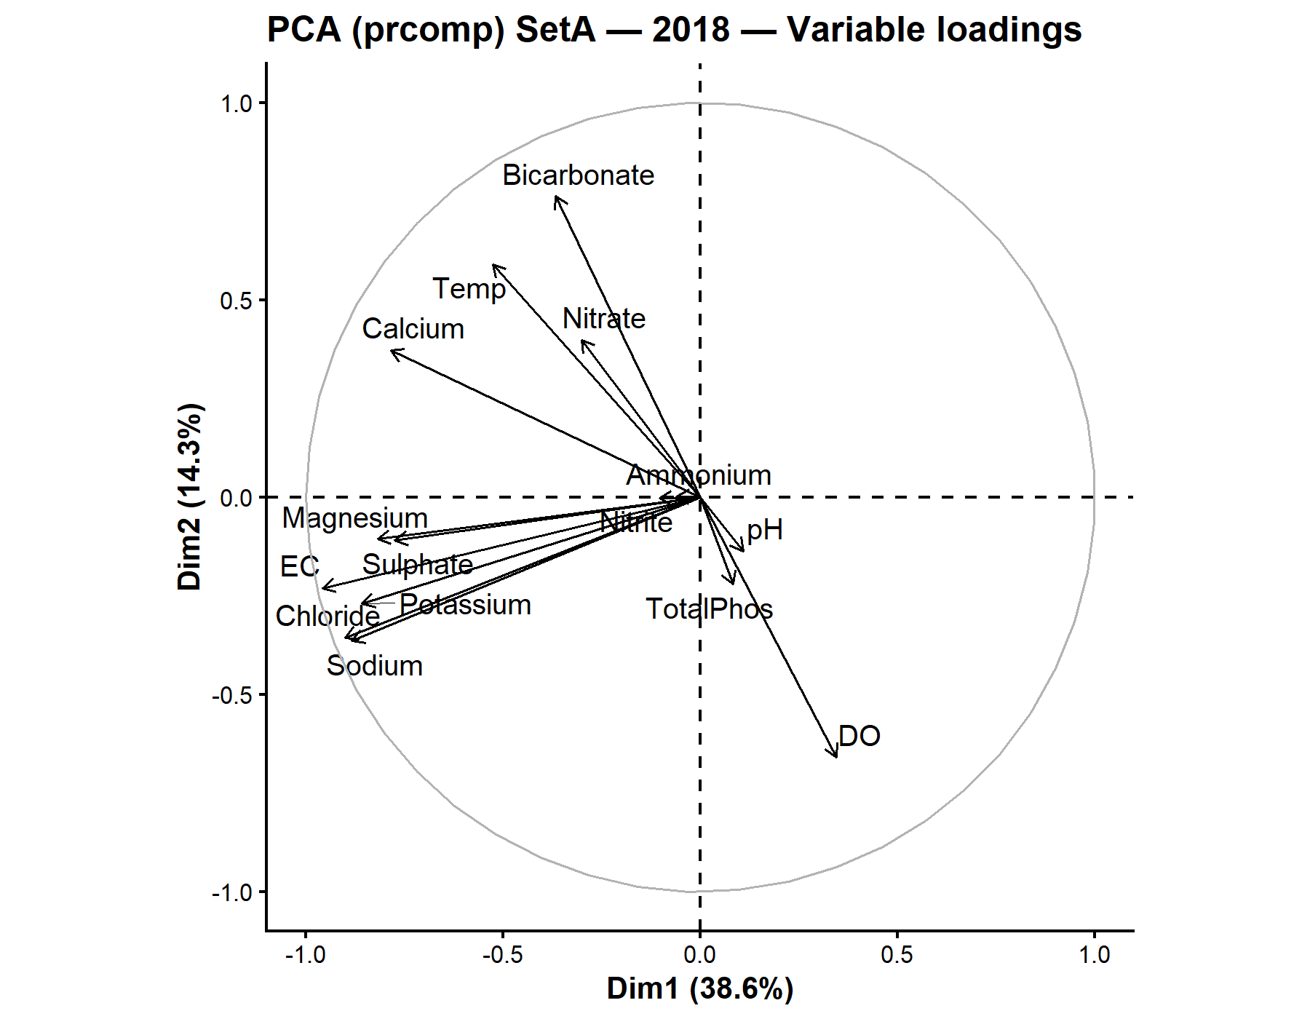
Figure 3. PCA variable loadings for 2018 showing the contribution of major ions and physicochemical parameters to the first two principal components.
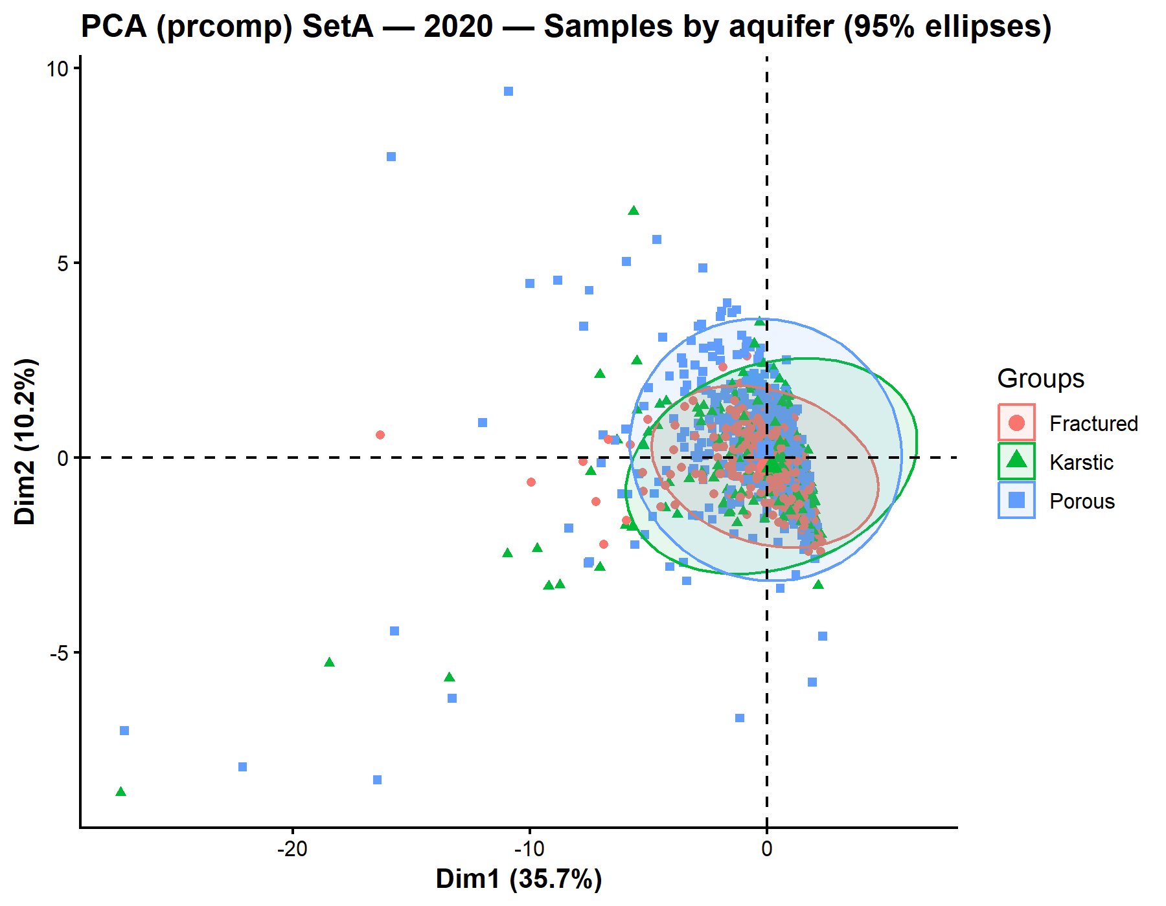
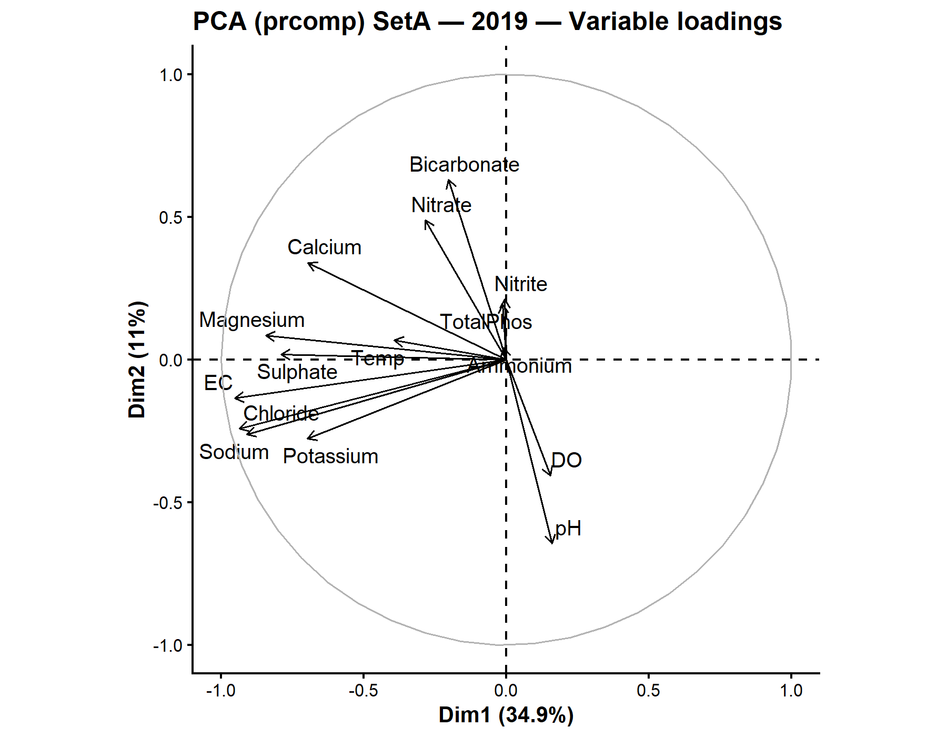
Figure 4. PCA score plot showing sample distribution by aquifer type with 95% confidence ellipses for 2019.
Figure 5. PCA variable loadings for 2019 showing the contribution of major ions and physicochemical parameters to the first two principal components
Figure 6. PCA score plot showing sample distribution by aquifer type with 95% confidence ellipses for 2020.
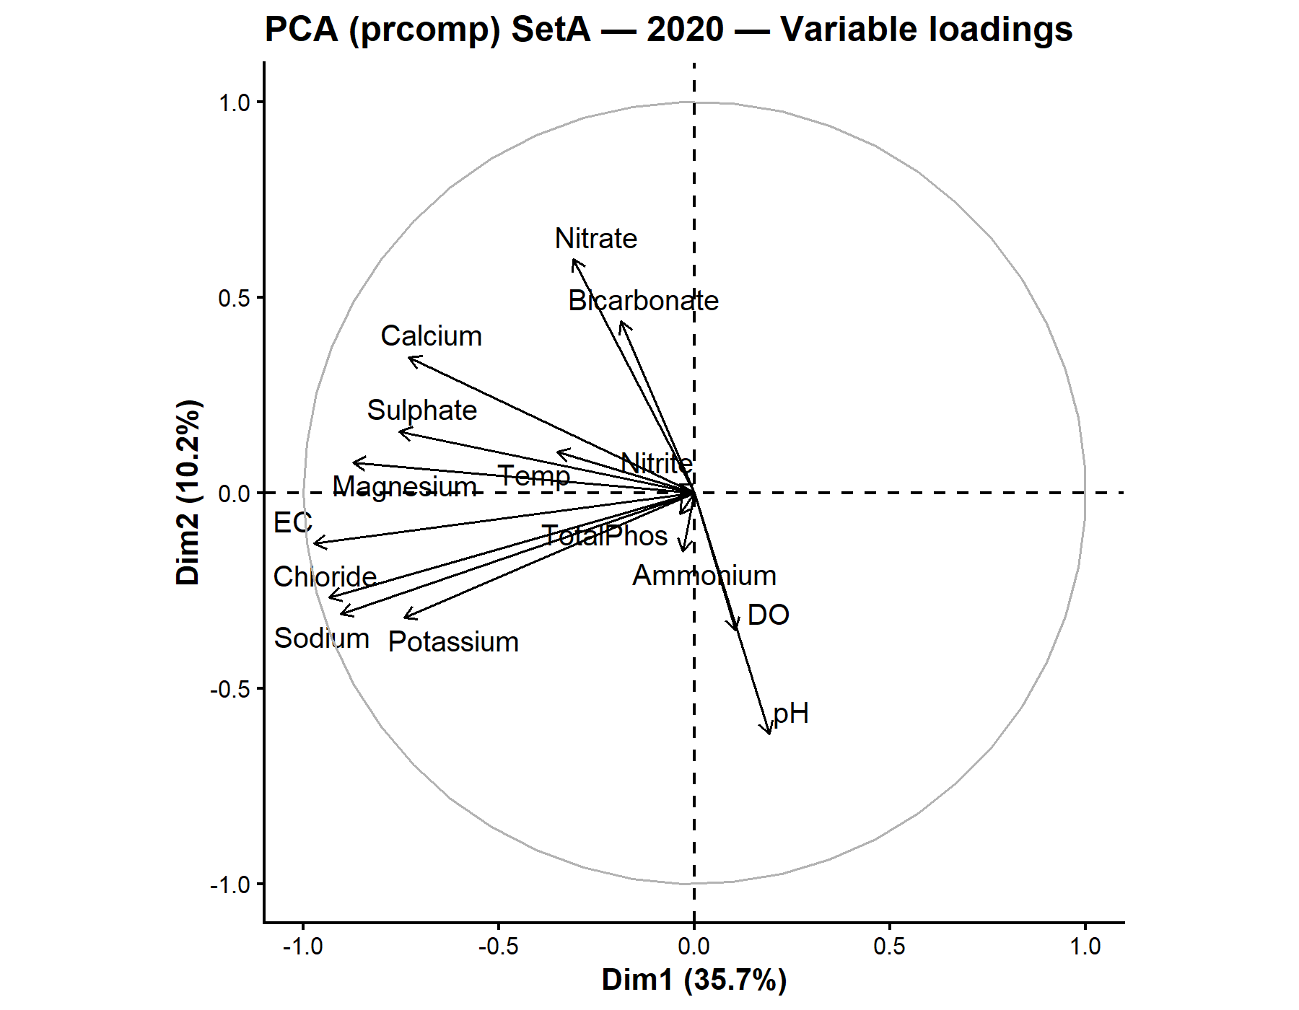
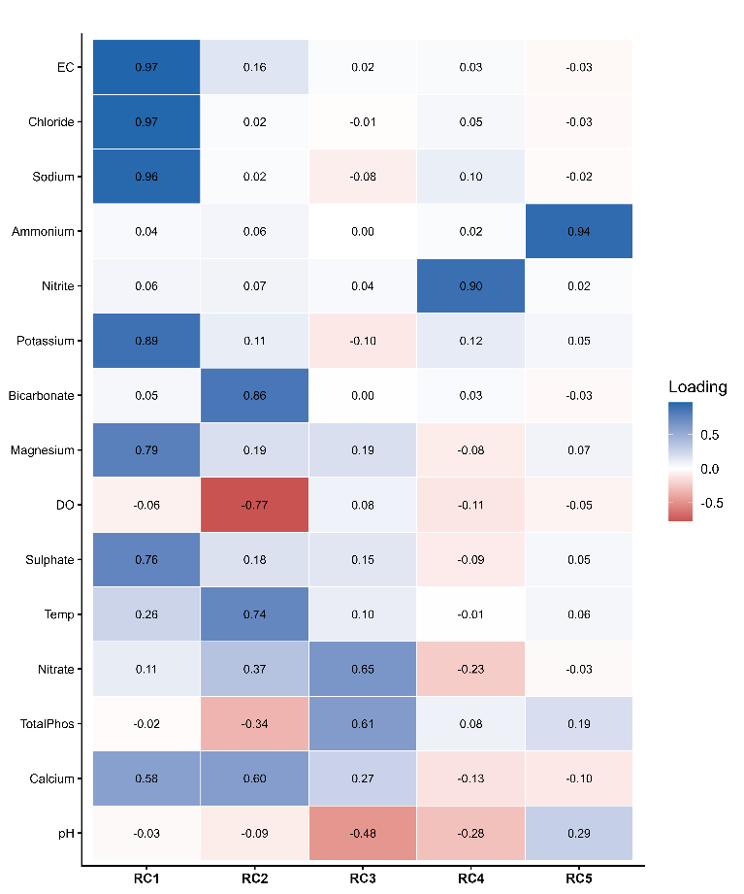
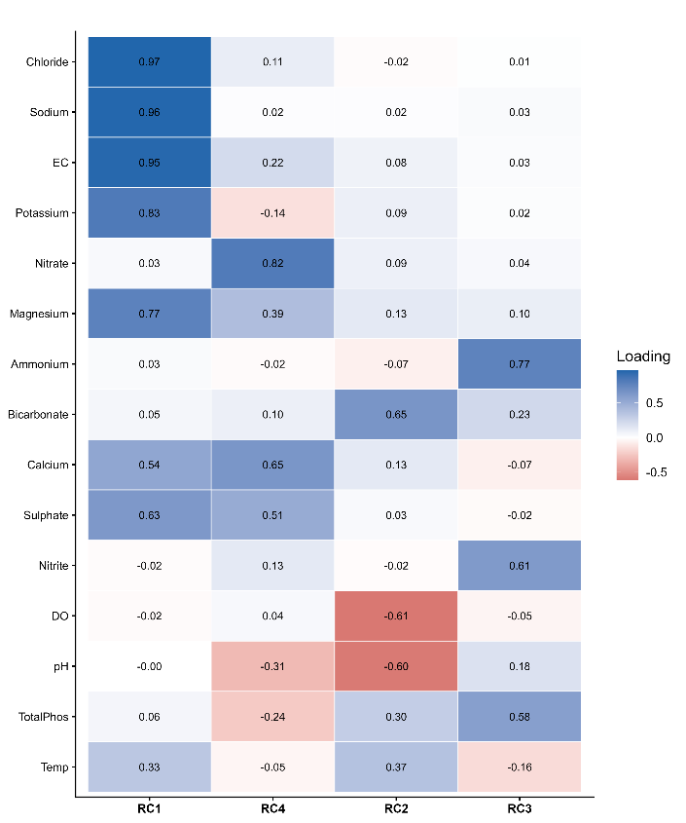
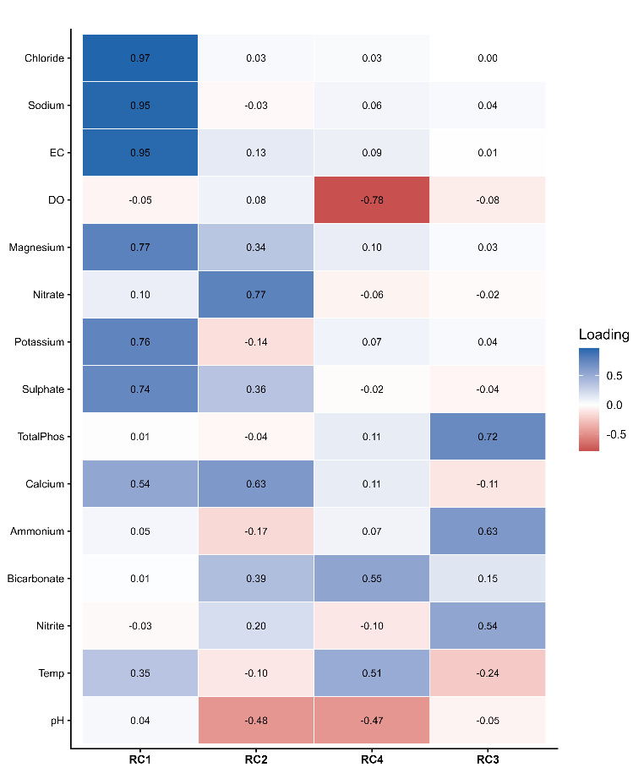
Figure 9. Rotated component matrix for the 2018 SetA dataset (major ions and physicochemical parameters). Only loadings with absolute values ≥ 0.40 are displayed to facilitate interpretation.
Figure 7. PCA variable loadings for 2020 showing the contribution of major ions and physicochemical parameters to the first two principal components.
Figure 11. Rotated component matrix for the 2020 SetA dataset (major ions and physicochemical parameters). Only loadings with absolute values ≥ 0.40 are displayed to facilitate interpretation.
Figure 10. Rotated component matrix for the 2019 SetA dataset (major ions and physicochemical parameters). Only loadings with absolute values ≥ 0.40 are displayed to facilitate interpretation.
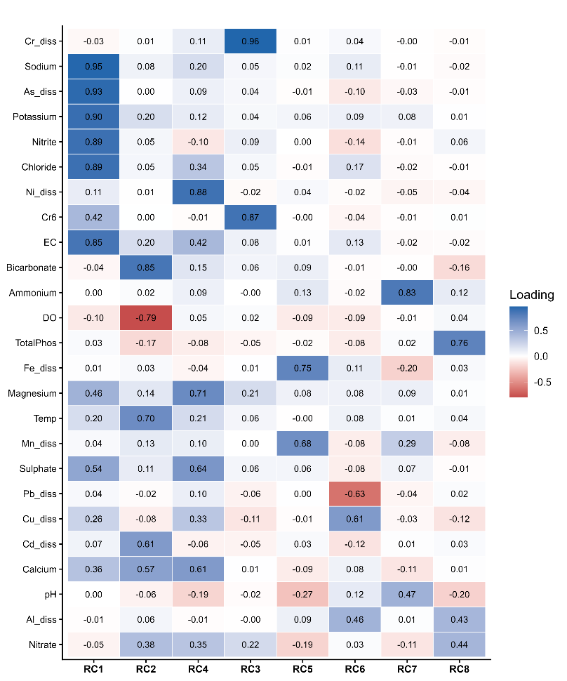
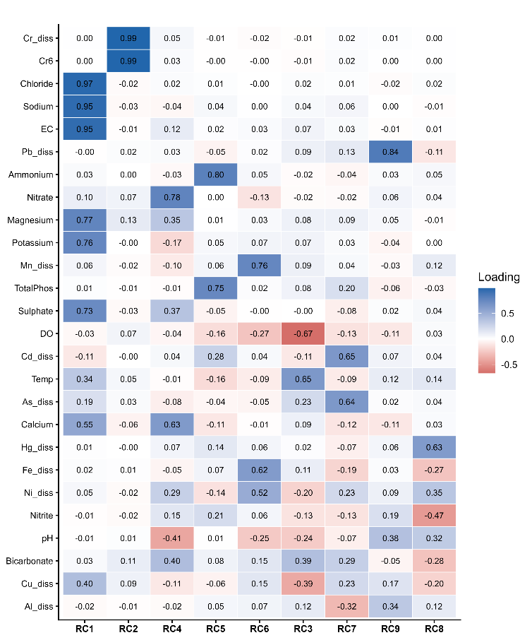
Figure 13. Rotated component matrix for the 2019 SetB dataset (major ions and physicochemical parameters). Only loadings with absolute values ≥ 0.40 are displayed to facilitate interpretation.
Figure 12. Rotated component matrix for the 2018 SetB dataset (major ions and physicochemical parameters). Only loadings with absolute values ≥ 0.40 are displayed to facilitate interpretation.
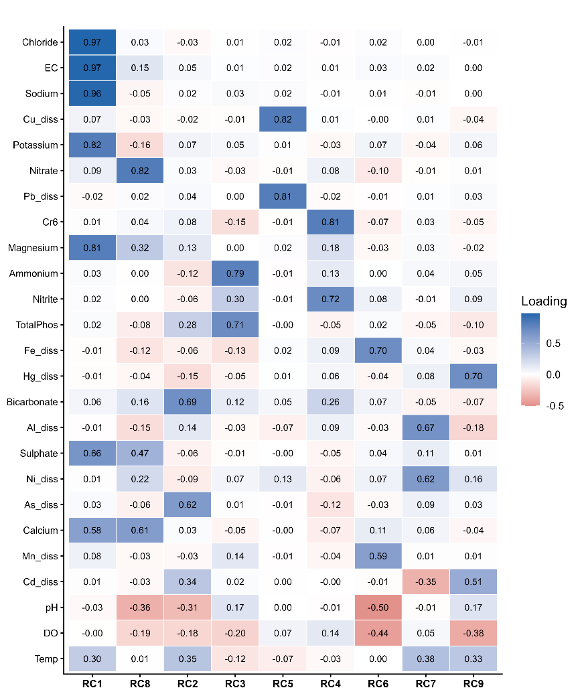
Figure 14. Rotated component matrix for the 2020 SetB dataset (major ions and physicochemical parameters). Only loadings with absolute values ≥ 0.40 are displayed to facilitate interpretation.

