Supplementary Tables：
Table S1. Baseline demographics of the study population.
Characteristics | Healthy Donors (n = 26) | IPF Patients (n = 22)
Age (years), Mean ± SD | 54.9 ± 5.8 | 60.0 ± 9.1
Gender (Male/Female), n (%) | 17 (65.4%) / 9 (34.6%) | 17 (77.3%) / 5 (22.7%)
Smoking Status, n (%)
Never smoker | 10 (54.5%) | 9 (40.9%)
Ever smoker | 16 (61.5%) | 13 (59.1%)
Lung Function ª
FVC (% predicted) | N/A | 57.7 ± 15.3
DLCO (% predicted) | N/A | 42.1 ± 13.6
Abbreviations: IPF, idiopathic pulmonary fibrosis; SD, standard deviation; FVC, forced vital capacity; DLCO, diffusing capacity of the lung for carbon monoxide; N/A, not applicable.
Note: Lung function parameters were not available for the healthy donor group, as these individuals underwent localized resections for benign lung nodules, and comprehensive pulmonary function testing was not clinically indicated.

Table S2. Target sequences of shRNAs targeting human c-Myc used in this study
shRNA Name | Target Sequence (5'–3')
c-Myc shRNA 1 | CCAAGGTAGTGATCCTCAATTCAAGAGATTGAGGATCACTACCTTGGTTTTTT
c-Myc shRNA 2 | CCACTCACCAGCACAACTATTCAAGAGATAGTTGTGCTGGTGAGTGGTTTTTT
c-Myc shRNA 3 | GGAGATGATGACCGAGTTATTCAAGAGATAACTCGGTCATCATCTCCTTTTTT
Abbreviations: shRNA, short hairpin RNA.

Table S3. Primers used for quantitative real-time PCR
Species | Gene | Forward primer sequence  (5' to 3') | Reverse primer sequence  (5' to 3')
Human | c-Myc | GGCTCCTGGCAAAAGGTCA | CTGCGTAGTTGTGCTGATGT
 | Collagen I | GAGGGCCAAGACGAAGACATC | CAGATCACGTCATCGCACAAC
 | Fibronectin | CGGTGGCTGTCAGTCAAAG | AAACCTCGGCTTCCTCCATAA
 | p53 | CAGCACATGACGGAGGTTGT | TCATCCAAATACTCCACACGC
 | p21 | CTCTCCCGAAAAGCAGTCCC | GCGAGAACGAGCCAACCTT
 | p16 | GATCCAGGTGGGTAGAAGGT | CCCCCTGCAAACTTCGTCCT
 | 18S | GCAATTATTCCCCATGAACG | GGCCTCACTAAACCATCCAA
Mouse | Myc | ATGCCCCTCAACGTGAACTTC | GTCGCAGATGAAATAGGGCTG
 | Col1a1 | GCTCCTCTTAGGGGCCACT | ATTGGGGACCCTTAGGCCAT
 | Fn1 | ATGTGGACCCCTCCTGATAGT | GCCCAGTGATTTCAGCAAAGG
 | 18S | CGGACACGGACAGGATTGAC | TGCCAGAGTCTCGTTCGTTATC
Abbreviations: PCR, polymerase chain reaction.
Note: 18S ribosomal RNA (18S) was utilized as the endogenous reference control for the normalization of target gene expression across all samples.

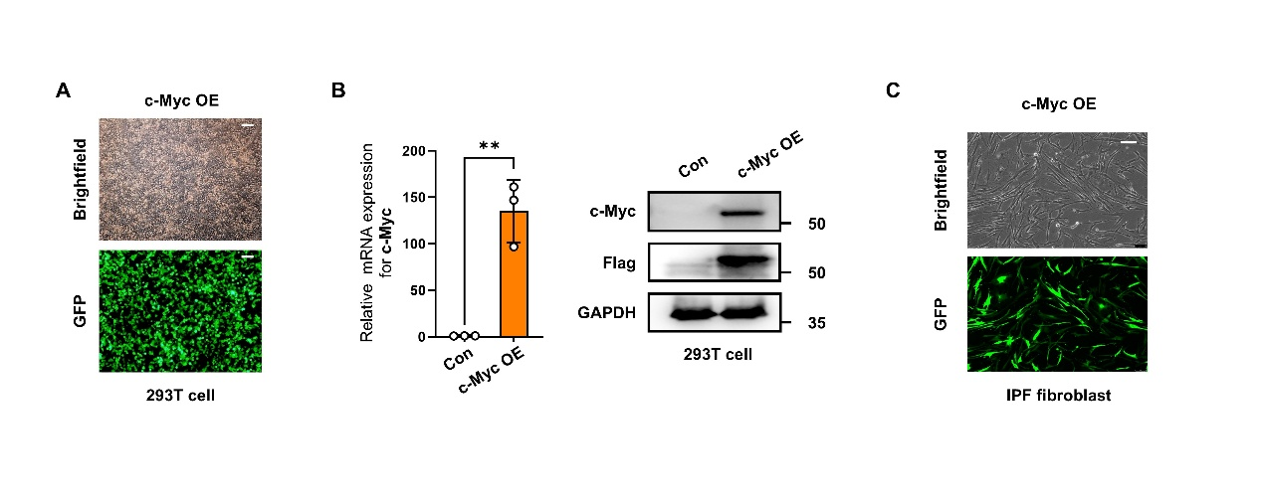Fig. S1. Validation of the lentiviral c-Myc overexpression system in 293T cells and primary IPF fibroblasts. (A) Representative brightfield and fluorescence images of 293T cells transduced with the lentiviral c-Myc overexpression (c-Myc OE) vector. Green fluorescence (GFP) indicates the expression of the viral reporter. (B) qRT-PCR analysis of c-Myc mRNA levels (left) and western blot analysis of c-Myc and Flag-tag protein expression (right) in 293T cells transduced with control (Con) or c-Myc OE vectors. GAPDH was used as the loading control. (C) Representative brightfield and fluorescence images of primary IPF fibroblasts following transduction with the lentiviral c-Myc OE vector. Data are presented as mean ± SEM. Statistical significance was determined using Student’s t-test (**p < 0.01).
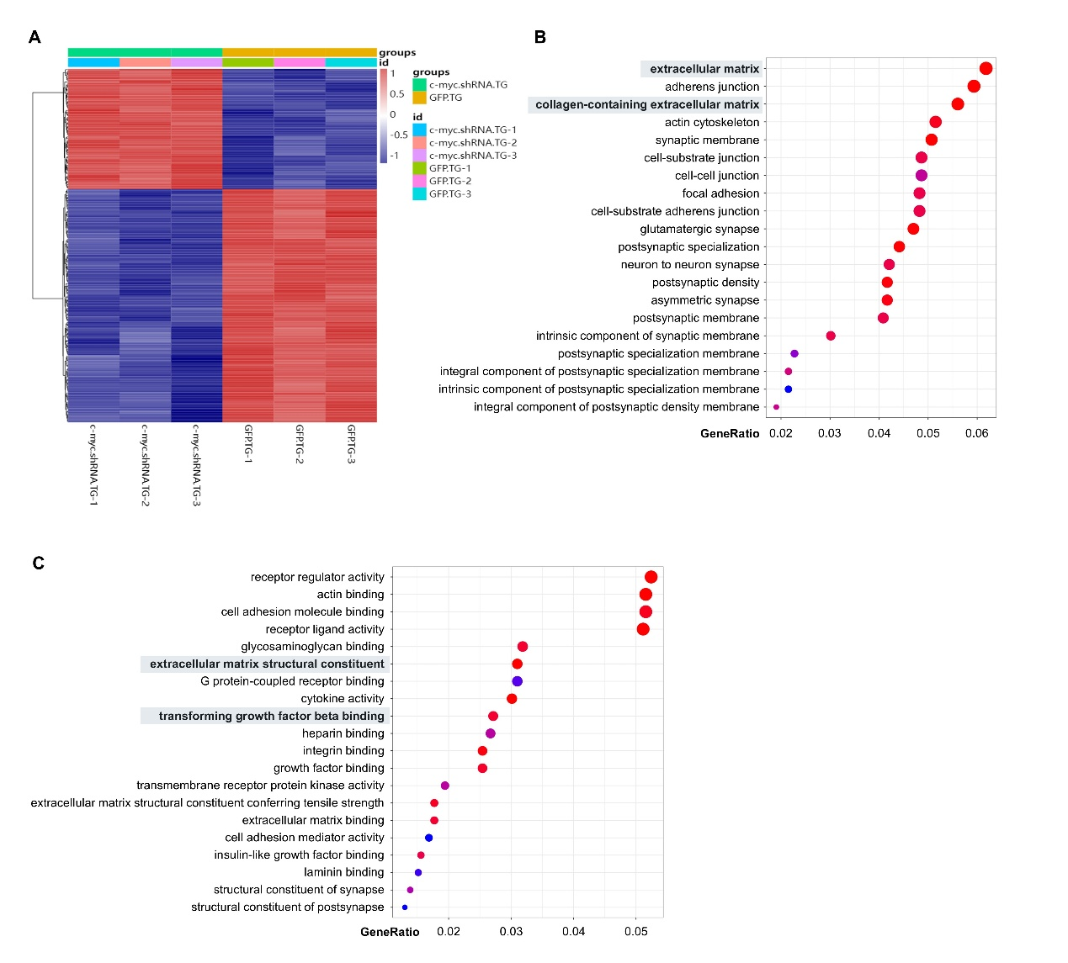 Fig. S2. Transcriptomic analysis of TGF-β1-treated IPF fibroblasts following c-Myc knockdown. (A) Heatmap of differentially expressed genes between control (GFPTG) and c-Myc shRNA (c-myc.shRNA.TG) IPF fibroblasts under TGF-β1 stimulation. (B and C) Gene Ontology (GO) enrichment analysis of cellular components (B) and molecular functions (C) showing downregulated categories following c-Myc knockdown.

