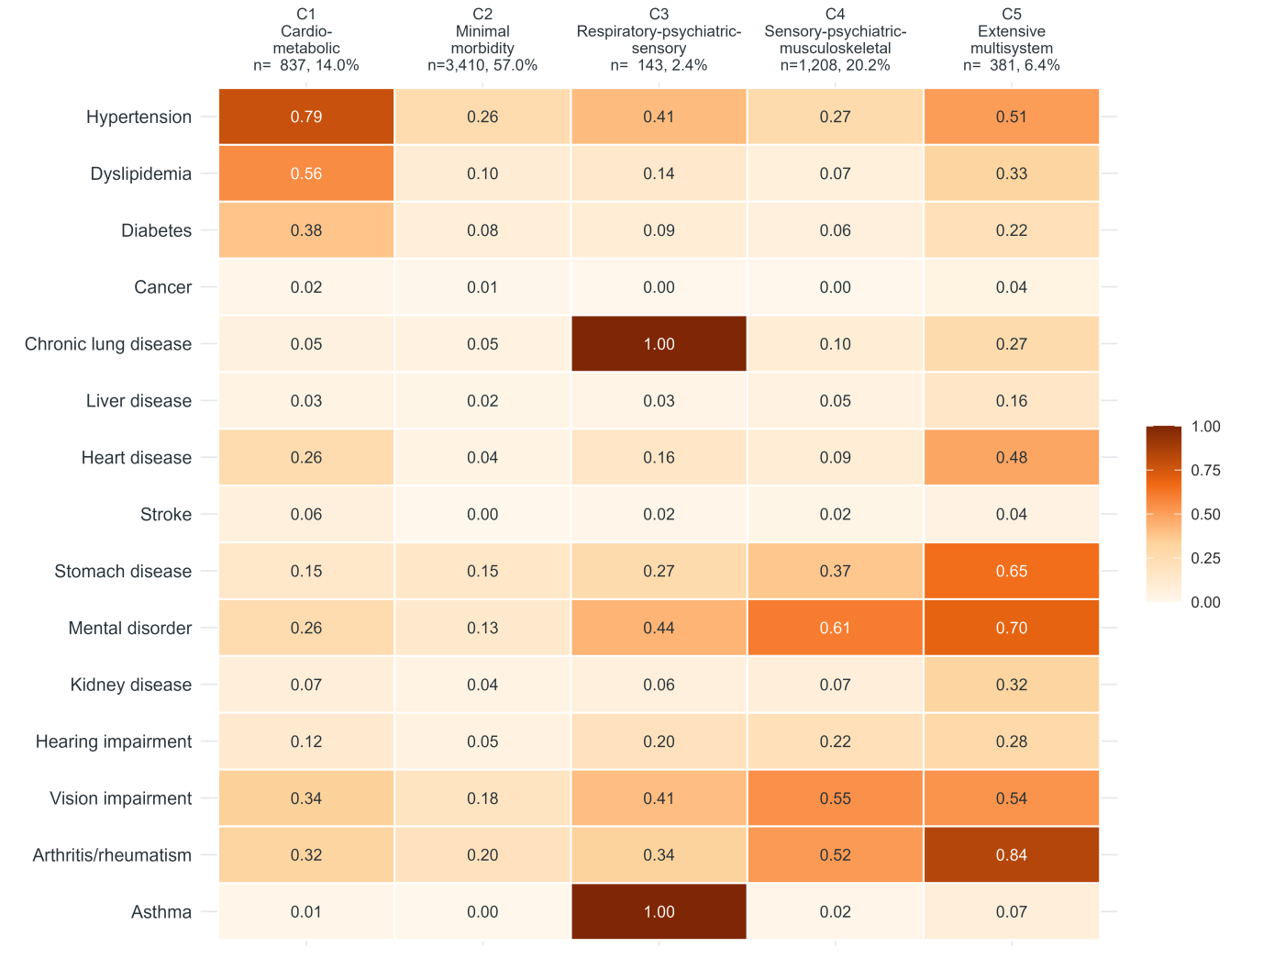

Figure S1. Conditional probability heatmap of the five-class latent class analysis (LCA) model.
Rows represent individual chronic conditions and rows represent the five identified multimorbidity profiles (C1–C5). The colour intensity indicates the conditional probability (range 0–1) of endorsing a given condition within each class. C1, Cardiometabolic; C2, Minimal morbidity; C3, Respiratory–PSS; C4, Sensory–PMM; C5, Extensive multisystem. Class prevalence and sample size are shown in the column headers.

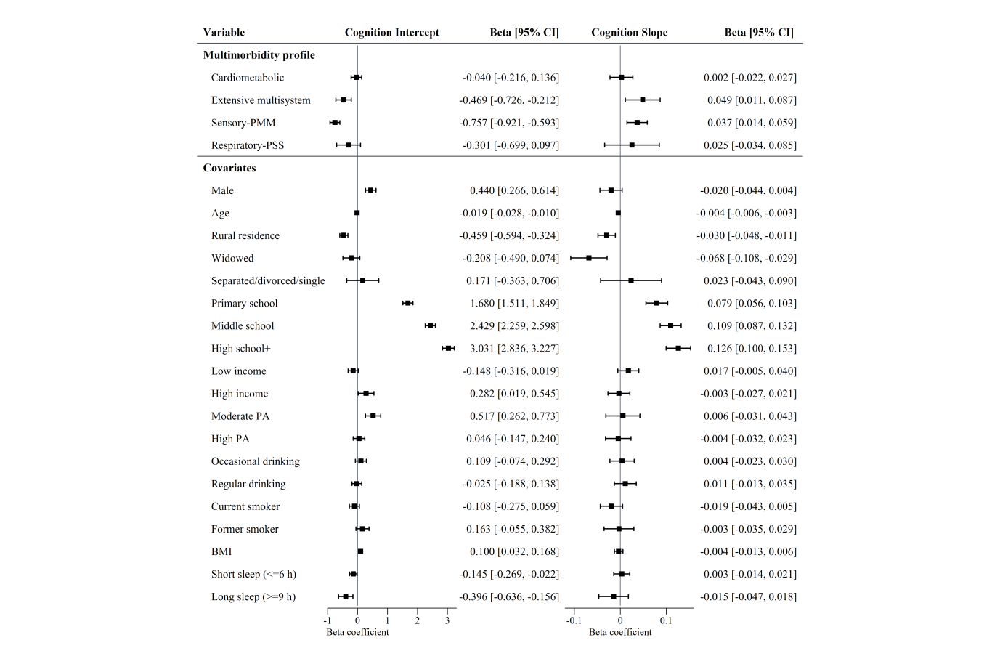
Figure S2. Forest plot of fully adjusted latent growth curve model (Model 3) estimates for cognitive intercept and slope.
Squares denote unstandardized beta coefficients and horizontal lines represent 95% confidence intervals. The reference line at zero indicates no effect. Estimates are adjusted for all covariates listed and are pooled across 20 multiply imputed datasets. PA, physical activity; BMI, body mass index. Multimorbidity profiles are referenced against Minimal morbidity.

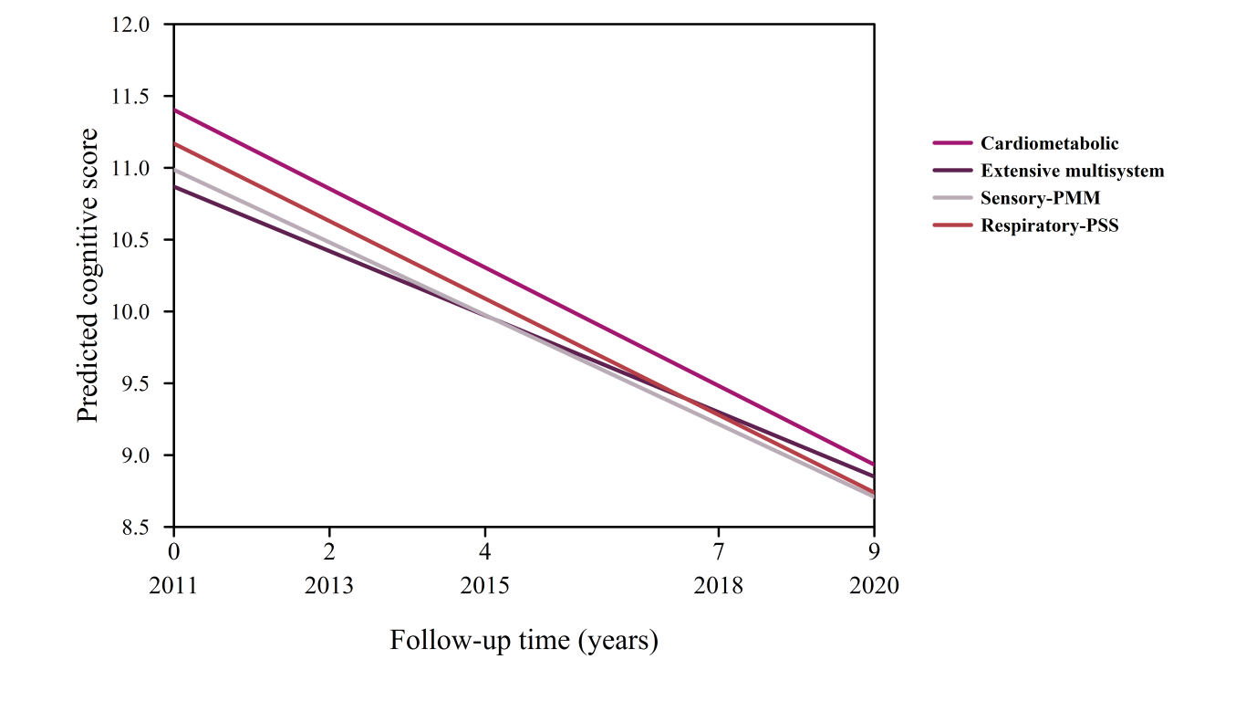
Figure S3. Predicted cognitive trajectories by time-varying multimorbidity profiles from the linear mixed-effects model (LMM).
Lines represent estimated marginal means of cognitive scores over the 9-year follow-up period (2011–2020), with the x-axis indicating years since baseline. The four multimorbidity profiles are contrasted against the Minimal morbidity reference group. Predictions are derived from the fully adjusted LMM (Model 3), with all covariates held at their mean or reference values. Estimates are pooled across 20 multiply imputed datasets.

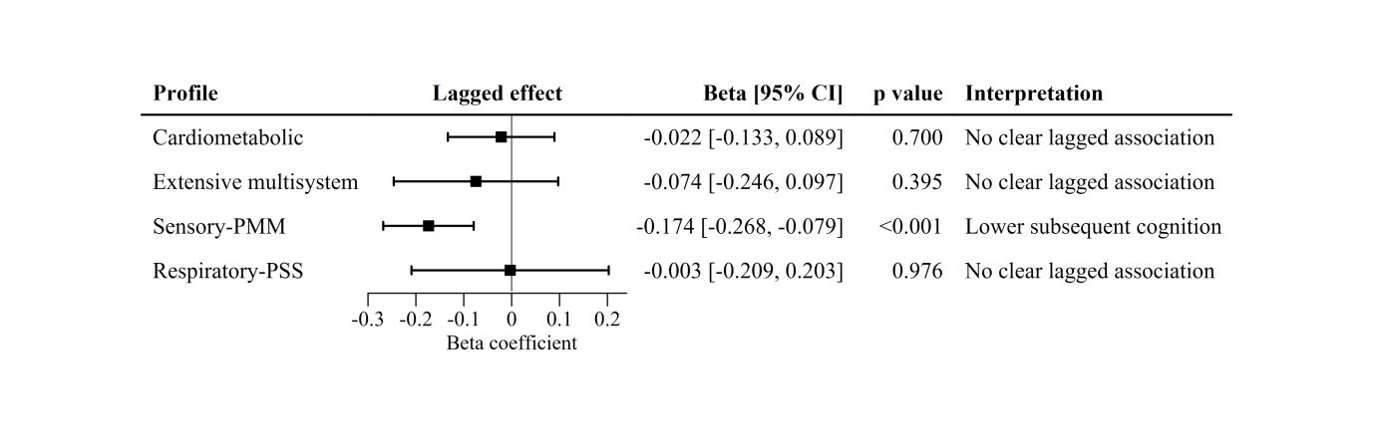
Figure S4. Lagged associations between time-varying multimorbidity profiles and subsequent cognitive score from the linear mixed-effects model.
Squares denote unstandardized beta coefficients and horizontal lines represent 95% confidence intervals for the effect of multimorbidity profile at one wave on cognitive score at the next wave (lagged by approximately 2 years). The reference line at zero indicates no effect. Multimorbidity profiles are referenced against Minimal morbidity. Estimates are adjusted for all covariates and are pooled across 20 multiply imputed datasets.

Supplementary Table 1 Fit statistics for latent class analysis models with one through six classes at baseline (2011, N = 5,979).
Class | AIC | BIC | aBIC | cAIC | Entropy | Avepp
1 | 69149.95 | 69250.39 | 69202.72 | 69265.39 | 1.000 | 1.000
2 | 67584.55 | 67792.92 | 67693.61 | 67823.92 | 0.517 | 0.856
3 | 67073.21 | 67387.63 | 67238.57 | 67434.63 | 0.583 | 0.819
4 | 66711.09 | 67132.94 | 66932.74 | 67195.94 | 0.680 | 0.826
5* | 66605.06 | 67134.04 | 66883.00 | 67213.04 | 0.602 | 0.752
6 | 66558.03 | 67194.15 | 66892.27 | 67289.15 | 0.604 | 0.732
*Final model selected based on cross-wave consistency, clinical interpretability, and split-sample validation. Bold indicates the minimum BIC. AIC: Akaike's information criterion; BIC: Bayesian information criterion; aBIC: adjusted Bayesian information criterion; cAIC: consistent Akaike's information criterion; Avepp: Average posterior probability.

Supplementary Table 2 LCA Class Profiles and Longitudinal Distribution (N = 5,979)
Panel A. Baseline (2011) Conditional Probabilities of Disease Endorsement by LCA Class
Disease | Class 1 (Sensory-PMM) | Class 2 (Minimal) | Class 3 (Cardiometabolic) | Class 4 (Respiratory-PSS) | Class 5 (Extensive)
Arthritis/rheumatism | 0.518 | 0.198 | 0.319 | 0.335 | 0.838
Asthma | 0.017 | 0.004 | 0.013 | 1.000 | 0.074
Cancer | 0.002 | 0.006 | 0.018 | <0.001 | 0.041
Chronic lung disease | 0.097 | 0.046 | 0.055 | 1.000 | 0.268
Diabetes | 0.063 | 0.084 | 0.384 | 0.092 | 0.216
Dyslipidemia | 0.067 | 0.100 | 0.564 | 0.138 | 0.326
Hearing impairment | 0.221 | 0.050 | 0.119 | 0.202 | 0.280
Heart disease | 0.093 | 0.036 | 0.259 | 0.162 | 0.480
Hypertension | 0.269 | 0.259 | 0.786 | 0.413 | 0.513
Kidney disease | 0.075 | 0.037 | 0.074 | 0.062 | 0.322
Liver disease | 0.046 | 0.021 | 0.033 | 0.025 | 0.158
Mental disorder | 0.609 | 0.130 | 0.260 | 0.436 | 0.696
Stomach disease | 0.375 | 0.152 | 0.147 | 0.266 | 0.653
Stroke | 0.021 | <0.001 | 0.065 | 0.015 | 0.044
Vision impairment | 0.546 | 0.180 | 0.344 | 0.407 | 0.541
Panel B. Longitudinal Stability of Conditional Probabilities Across Five Waves (2011–2020)
Disease | Aligned Pattern | Mean | CV | Range (Min–Max) | Stability
Arthritis/rheumatism | Minimal | 0.260 | 0.236 | 0.198–0.326 | Low
Arthritis/rheumatism | Sensory-PMM | 0.652 | 0.135 | 0.518–0.744 | Low
Arthritis/rheumatism | Cardiometabolic | 0.381 | 0.149 | 0.319–0.465 | Low
Arthritis/rheumatism | Respiratory-PSS | 0.456 | 0.216 | 0.335–0.556 | Low
Arthritis/rheumatism | Extensive | 0.862 | 0.035 | 0.823–0.892 | Low
Asthma | Minimal | 0.005 | 0.359 | 0.004–0.009 | Low
Asthma | Sensory-PMM | 0.021 | 0.173 | 0.017–0.025 | Low
Asthma | Cardiometabolic | 0.009 | 0.479 | 0.003–0.013 | Low
Asthma | Respiratory-PSS | 0.738 | 0.212 | 0.633–1.000 | Low
Asthma | Extensive | 0.157 | 0.540 | 0.074–0.286 | Moderate
Cancer | Minimal | 0.011 | 0.685 | 0.006–0.023 | Moderate
Cancer | Sensory-PMM | 0.015 | 0.859 | 0.002–0.033 | Moderate
Cancer | Cardiometabolic | 0.024 | 0.359 | 0.015–0.037 | Low
Cancer | Respiratory-PSS | 0.005 | 1.572 | <0.001–0.019 | High
Cancer | Extensive | 0.075 | 0.270 | 0.041–0.092 | Low
Chronic lung disease | Minimal | 0.058 | 0.291 | 0.040–0.079 | Low
Chronic lung disease | Sensory-PMM | 0.145 | 0.413 | 0.097–0.245 | Low
Chronic lung disease | Cardiometabolic | 0.072 | 0.357 | 0.050–0.112 | Low
Chronic lung disease | Respiratory-PSS | 0.994 | 0.014 | 0.969–1.000 | Low
Chronic lung disease | Extensive | 0.450 | 0.315 | 0.268–0.652 | Low
Diabetes | Minimal | 0.122 | 0.355 | 0.070–0.172 | Low
Diabetes | Sensory-PMM | 0.120 | 0.453 | 0.060–0.176 | Low
Diabetes | Cardiometabolic | 0.476 | 0.196 | 0.366–0.561 | Low
Diabetes | Respiratory-PSS | 0.170 | 0.400 | 0.092–0.231 | Low
Diabetes | Extensive | 0.406 | 0.308 | 0.216–0.539 | Low
Dyslipidemia | Minimal | 0.135 | 0.364 | 0.080–0.205 | Low
Dyslipidemia | Sensory-PMM | 0.169 | 0.439 | 0.067–0.238 | Low
Dyslipidemia | Cardiometabolic | 0.663 | 0.177 | 0.532–0.810 | Low
Dyslipidemia | Respiratory-PSS | 0.243 | 0.369 | 0.138–0.345 | Low
Dyslipidemia | Extensive | 0.576 | 0.318 | 0.326–0.781 | Low
Hearing impairment | Minimal | 0.048 | 0.277 | 0.031–0.067 | Low
Hearing impairment | Sensory-PMM | 0.252 | 0.090 | 0.221–0.276 | Low
Hearing impairment | Cardiometabolic | 0.120 | 0.118 | 0.100–0.139 | Low
Hearing impairment | Respiratory-PSS | 0.194 | 0.147 | 0.159–0.221 | Low
Hearing impairment | Extensive | 0.340 | 0.121 | 0.280–0.382 | Low
Heart disease | Minimal | 0.053 | 0.343 | 0.032–0.072 | Low
Heart disease | Sensory-PMM | 0.171 | 0.360 | 0.093–0.252 | Low
Heart disease | Cardiometabolic | 0.328 | 0.249 | 0.249–0.438 | Low
Heart disease | Respiratory-PSS | 0.304 | 0.352 | 0.162–0.425 | Low
Heart disease | Extensive | 0.617 | 0.171 | 0.480–0.749 | Low
Hypertension | Minimal | 0.374 | 0.214 | 0.259–0.452 | Low
Hypertension | Sensory-PMM | 0.405 | 0.220 | 0.269–0.477 | Low
Hypertension | Cardiometabolic | 0.838 | 0.056 | 0.786–0.887 | Low
Hypertension | Respiratory-PSS | 0.543 | 0.151 | 0.413–0.632 | Low
Hypertension | Extensive | 0.685 | 0.154 | 0.513–0.785 | Low
Kidney disease | Minimal | 0.063 | 0.375 | 0.037–0.087 | Low
Kidney disease | Sensory-PMM | 0.145 | 0.370 | 0.075–0.218 | Low
Kidney disease | Cardiometabolic | 0.135 | 0.404 | 0.074–0.198 | Low
Kidney disease | Respiratory-PSS | 0.141 | 0.441 | 0.062–0.200 | Low
Kidney disease | Extensive | 0.469 | 0.200 | 0.322–0.553 | Low
Liver disease | Minimal | 0.037 | 0.405 | 0.021–0.054 | Low
Liver disease | Sensory-PMM | 0.078 | 0.416 | 0.046–0.129 | Low
Liver disease | Cardiometabolic | 0.070 | 0.454 | 0.033–0.114 | Low
Liver disease | Respiratory-PSS | 0.095 | 0.520 | 0.025–0.143 | Moderate
Liver disease | Extensive | 0.295 | 0.354 | 0.158–0.401 | Low
Mental disorder | Minimal | 0.147 | 0.216 | 0.120–0.192 | Low
Mental disorder | Sensory-PMM | 0.552 | 0.105 | 0.495–0.617 | Low
Mental disorder | Cardiometabolic | 0.260 | 0.193 | 0.202–0.333 | Low
Mental disorder | Respiratory-PSS | 0.412 | 0.075 | 0.381–0.450 | Low
Mental disorder | Extensive | 0.653 | 0.075 | 0.595–0.696 | Low
Stomach disease | Minimal | 0.194 | 0.198 | 0.152–0.237 | Low
Stomach disease | Sensory-PMM | 0.479 | 0.146 | 0.375–0.562 | Low
Stomach disease | Cardiometabolic | 0.238 | 0.326 | 0.147–0.345 | Low
Stomach disease | Respiratory-PSS | 0.342 | 0.196 | 0.266–0.416 | Low
Stomach disease | Extensive | 0.748 | 0.084 | 0.653–0.799 | Low
Stroke | Minimal | 0.010 | 0.962 | <0.001–0.022 | Moderate
Stroke | Sensory-PMM | 0.038 | 0.730 | 0.012–0.074 | Moderate
Stroke | Cardiometabolic | 0.115 | 0.531 | 0.065–0.187 | Moderate
Stroke | Respiratory-PSS | 0.041 | 0.538 | 0.015–0.068 | Moderate
Stroke | Extensive | 0.151 | 0.682 | 0.044–0.285 | Moderate
Vision impairment | Minimal | 0.159 | 0.198 | 0.129–0.204 | Low
Vision impairment | Sensory-PMM | 0.528 | 0.050 | 0.499–0.563 | Low
Vision impairment | Cardiometabolic | 0.292 | 0.121 | 0.253–0.344 | Low
Vision impairment | Respiratory-PSS | 0.345 | 0.121 | 0.300–0.407 | Low
Vision impairment | Extensive | 0.584 | 0.094 | 0.541–0.680 | Low
Panel C. LCA Class Distribution by Wave
Year | Class | N | Percentage (%) | AvePP
2011 | Class 1 (Sensory-PMM) | 1208 | 20.21 | 0.662
 | Class 2 (Minimal) | 3410 | 57.03 | 0.794
 | Class 3 (Cardiometabolic) | 837 | 14.00 | 0.697
 | Class 4 (Respiratory-PSS) | 143 | 2.39 | 0.929
 | Class 5 (Extensive) | 381 | 6.37 | 0.701
2013 | Class 1 (Minimal) | 3001 | 50.19 | 0.757
 | Class 2 (Sensory-PMM) | 1374 | 22.98 | 0.666
 | Class 3 (Extensive) | 241 | 4.03 | 0.743
 | Class 4 (Cardiometabolic) | 1180 | 19.74 | 0.725
 | Class 5 (Respiratory-PSS) | 183 | 3.06 | 0.855
2015 | Class 1 (Cardiometabolic) | 1117 | 18.68 | 0.688
 | Class 2 (Sensory-PMM) | 1689 | 28.25 | 0.684
 | Class 3 (Extensive) | 332 | 5.55 | 0.705
 | Class 4 (Respiratory-PSS) | 281 | 4.70 | 0.811
 | Class 5 (Minimal) | 2560 | 42.82 | 0.760
2018 | Class 1 (Respiratory-PSS) | 412 | 6.89 | 0.783
 | Class 2 (Minimal) | 2678 | 44.79 | 0.776
 | Class 3 (Cardiometabolic) | 1137 | 19.02 | 0.715
 | Class 4 (Sensory-PMM) | 1302 | 21.78 | 0.684
 | Class 5 (Extensive) | 450 | 7.53 | 0.731
2020 | Class 1 (Respiratory-PSS) | 334 | 5.59 | 0.858
 | Class 2 (Cardiometabolic) | 1325 | 22.16 | 0.726
 | Class 3 (Minimal) | 2422 | 40.51 | 0.784
 | Class 4 (Extensive) | 511 | 8.55 | 0.761
 | Class 5 (Sensory-PMM) | 1387 | 23.20 | 0.665
Note. LCA = Latent Class Analysis. Panel A shows conditional probabilities (range 0–1) of endorsing each disease within each latent class at baseline. Minimal-Morbidity-Profile is the reference class (not shown). Panel B: CV = coefficient of variation (SD/mean); Range = minimum to maximum probability across 5 waves. Stability classification: High (CV > 1.0), Moderate (CV 0.5–1.0), Low (CV < 0.5). Panel C: N = class size; % = percentage of total sample; AvePP = average posterior probability.

Supplementary Table 3 Model fit indices, unconditional parameters, and R² summary
A. Model Fit Indices
Model | χ² | df | p-value | CFI | TLI | RMSEA | SRMR | AIC | BIC | npar
Unconditional | 651.35 | 10 | <0.001 | 0.955 | 0.955 | 0.104 [0.097–0.110] | 0.058 | 137121.7 | 137188.7 | 10
Model 1 (LCA only) | 685.42 | 28 | <0.001 | 0.956 | 0.937 | 0.063 [0.059–0.067] | 0.030 | 136346.3 | 136493.6 | 22
Model 2 (LCA + demographics) | 757.19 | 52 | <0.001 | 0.959 | 0.937 | 0.048 [0.045–0.051] | 0.020 | 134126.7 | 134381.2 | 38
Model 3 (Fully adjusted) | 788.80 | 79 | <0.001 | 0.959 | 0.935 | 0.039 [0.036–0.041] | 0.014 | 134086.8 | 134461.7 | 56
Quadratic Model 3 | 636.72 | 52 | <0.001 | 0.966 | 0.919 | 0.043 [0.040–0.046] | 0.011 | 133988.7 | 134544.4 | 83
B. Unconditional Model Parameters
Parameter | Estimate (SE) [95% CI], P-value
Intercept mean | 12.87 (0.036) [12.80, 12.95], <0.001
Slope mean | −0.247 (0.004) [−0.26, −0.24], <0.001
Intercept variance | 5.310 (0.141) [5.02, 5.60], <0.001
Slope variance | 0.032 (0.003) [0.03, 0.04], <0.001
Intercept–slope covariance | 0.126 (0.014) [0.10, 0.16], <0.001
Intercept–slope correlation | 0.307
C. R² Summary
Model | Intercept R² | Slope R²
Model 1 (LCA only) | 0.1330 | 0.0810
Model 2 (LCA + demographics) | 0.4333 | 0.2064
Model 3 (Fully adjusted) | 0.4426 | 0.2118
Note. All models were estimated across 20 multiply imputed datasets and pooled using Rubin's rules. RMSEA = root mean square error of approximation; CFI = comparative fit index; TLI = Tucker-Lewis index; SRMR = standardized root mean square residual; AIC = Akaike information criterion; BIC = Bayesian information criterion.

Supplementary Table 4 Full covariate effects from the fully adjusted latent growth curve model (Model 3)
Covariate | Intercept | Slope
Male | 0.440 (0.089) [0.27, 0.61], <0.001 | −0.020 (0.012) [−0.04, 0.00], 0.100
Age | −0.019 (0.004) [−0.03, −0.01], <0.001 | −0.004 (0.001) [−0.01, −0.00], <0.001
Rural residence | −0.459 (0.069) [−0.59, −0.32], <0.001 | −0.030 (0.010) [−0.05, −0.01], 0.002
Widowed | −0.208 (0.144) [−0.49, 0.07], 0.148 | −0.068 (0.020) [−0.11, −0.03], <0.001
Separated/divorced/single | 0.171 (0.273) [−0.36, 0.71], 0.530 | 0.023 (0.034) [−0.04, 0.09], 0.488
Primary school | 1.680 (0.086) [1.51, 1.85], <0.001 | 0.079 (0.012) [0.06, 0.10], <0.001
Middle school | 2.429 (0.086) [2.26, 2.60], <0.001 | 0.109 (0.012) [0.09, 0.13], <0.001
High school+ | 3.031 (0.100) [2.84, 3.23], <0.001 | 0.126 (0.014) [0.10, 0.15], <0.001
Low income | −0.148 (0.085) [−0.32, 0.02], 0.082 | 0.017 (0.012) [−0.01, 0.04], 0.134
High income | 0.282 (0.131) [0.02, 0.55], 0.036 | −0.003 (0.012) [−0.03, 0.02], 0.804
Moderate PA | 0.518 (0.130) [0.26, 0.77], <0.001 | 0.006 (0.019) [−0.03, 0.04], 0.766
High PA | 0.046 (0.099) [−0.15, 0.24], 0.639 | −0.004 (0.014) [−0.03, 0.02], 0.750
Occasional drinking | 0.109 (0.094) [−0.07, 0.29], 0.243 | 0.004 (0.014) [−0.02, 0.03], 0.778
Regular drinking | −0.025 (0.083) [−0.19, 0.14], 0.763 | 0.011 (0.012) [−0.01, 0.03], 0.377
Current smoker | −0.108 (0.085) [−0.27, 0.06], 0.207 | −0.019 (0.012) [−0.04, 0.01], 0.120
Former smoker | 0.163 (0.112) [−0.06, 0.38], 0.143 | −0.003 (0.016) [−0.04, 0.03], 0.860
BMI | 0.100 (0.035) [0.03, 0.17], 0.004 | −0.004 (0.005) [−0.01, 0.01], 0.437
Short sleep (≤6 h) | −0.146 (0.063) [−0.27, −0.02], 0.021 | 0.003 (0.009) [−0.01, 0.02], 0.718
Long sleep (≥9 h) | −0.396 (0.122) [−0.64, −0.16], 0.001 | −0.015 (0.016) [−0.05, 0.02], 0.372
Note. Values are estimate (SE) [95% CI], P-value. PA = physical activity. Reference categories: female (for male), urban residence, married/cohabiting, no formal education, middle income, no physical activity, never/former drinking, never smoking, normal sleep duration (7–8 h). Minimal-morbidity profile is the reference class for comorbidity patterns (see Table 2).

Supplementary Table 5 Results from the time-varying linear mixed-effects model predicting global cognitive scores (2011-2020, N = 5,979).
Variable | Estimate (β) | SE | 95% CI | z | p
Multimorbidity pattern (ref: Minimal)
Cardiometabolic | 0.140 | 0.071 | 0.000 to 0.279 | 1.961 | 0.050
Extensive | -0.395 | 0.110 | -0.611 to -0.179 | -3.592 | <0.001
Sensory-PMM | -0.277 | 0.060 | -0.395 to -0.158 | -4.577 | <0.001
Respiratory-PSS | -0.095 | 0.155 | -0.400 to 0.210 | -0.611 | 0.541
Year (continuous) | -0.246 | 0.006 | -0.259 to -0.234 | -38.702 | <0.001
Demographics
Age, years (centered) | -0.033 | 0.004 | -0.041 to -0.025 | -8.148 | <0.001
Male (ref: female) | 0.418 | 0.083 | 0.256 to 0.581 | 5.041 | <0.001
Rural residence (ref: urban) | -0.541 | 0.063 | -0.666 to -0.417 | -8.533 | <0.001
Widowed (ref: married/partnered) | -0.393 | 0.119 | -0.626 to -0.159 | -3.296 | <0.001
Separated/divorced/single (ref: married/partnered) | 0.195 | 0.252 | -0.298 to 0.689 | 0.776 | 0.438
Education (ref: illiterate)
Primary school | 1.919 | 0.075 | 1.772 to 2.065 | 25.629 | <0.001
Middle school | 2.756 | 0.078 | 2.604 to 2.908 | 35.474 | <0.001
High school and above | 3.422 | 0.096 | 3.234 to 3.611 | 35.584 | <0.001
Household income (ref: moderate)
Low | -0.129 | 0.077 | -0.281 to 0.023 | -1.667 | 0.097
High | 0.300 | 0.129 | 0.030 to 0.570 | 2.323 | 0.031
Smoking (ref: never)
Current smoker | -0.181 | 0.082 | -0.341 to -0.020 | -2.211 | 0.027
Former smoker | 0.124 | 0.113 | -0.097 to 0.346 | 1.100 | 0.271
Drinking (ref: none)
Occasional | 0.118 | 0.089 | -0.056 to 0.292 | 1.327 | 0.185
Regular | 0.023 | 0.082 | -0.137 to 0.184 | 0.285 | 0.775
Physical activity (ref: low)
Moderate | 0.544 | 0.127 | 0.295 to 0.793 | 4.277 | <0.001
High | 0.009 | 0.092 | -0.172 to 0.190 | 0.099 | 0.921
Health indicators
BMI, kg/m² (centered) | 0.102 | 0.030 | 0.043 to 0.162 | 3.380 | <0.001
Multimorbidity × Year interaction
Cardiometabolic× Year | -0.028 | 0.012 | -0.052 to -0.005 | -2.346 | 0.019
Extensive × Year | 0.022 | 0.018 | -0.012 to 0.056 | 1.251 | 0.211
Sensory-PMM × Year | -0.007 | 0.011 | -0.029 to 0.015 | -0.604 | 0.546
Respiratory-PSS× Year | -0.024 | 0.023 | -0.069 to 0.021 | -1.033 | 0.301
Note. Bold indicates statistically significant results (p < 0.05). SE = standard error; CI = confidence interval; ref = reference category. BMI = body mass index. The model included random intercepts for participants.

Supplementary Table 6 Sensitivity Analyses of the Association Between Multimorbidity Patterns and Cognitive Trajectories Using Latent Growth Curve Models
Panel A. Model Fit Indices
Analysis | Model | CFI | TLI | RMSEA (95% CI) | SRMR | R² (Int. / Slp.) | AIC | BIC
4-class LCA | Unconditional | 0.955 | 0.955 | 0.104 (0.097–0.110) | 0.058 | — | 137121.7 | 137188.7
 | Model 3 | 0.959 | 0.935 | 0.039 (0.037–0.042) | 0.014 | 0.435 / 0.209 | 134129.7 | 134491.3
Complete-case | Unconditional | 0.955 | 0.955 | 0.103 (0.096–0.111) | 0.057 | — | 114505.8 | 114571.0
 | Model 3 | 0.960 | 0.937 | 0.042 (0.039–0.045) | 0.016 | 0.428 / 0.231 | 112052.5 | 112365.3
Panel B. Parameter Estimates from Model 3 (Fully Adjusted Model)
Variable | 4-class: Intercept β (95% CI); p | 4-class: Slope β (95% CI); p | CC: Intercept β (95% CI); p | CC: Slope β (95% CI); p
Multimorbidity pattern (ref: Minimal-Morbidity-Profile)
Cardiometabolic-Multimorbidity | 0.037 (-0.150 to 0.224); 0.697 | 0.004 (-0.023 to 0.030); 0.779 | 0.023 (-0.163 to 0.209); 0.805 | 0.003 (-0.024 to 0.030); 0.826
Extensive-Multisystem-Multimorbidity | — | — | -0.607 (-0.892 to -0.321); <0.001 | 0.060 (0.019 to 0.100); 0.004
Psychiatric-Sensory-Musculoskeletal-Multimorbidity | -0.540 (-0.698 to -0.381); <0.001 | 0.036 (0.015 to 0.058); <0.001 | -0.845 (-1.021 to -0.669); <0.001 | 0.045 (0.021 to 0.068); <0.001
Respiratory-Psychiatric-Sensory-Multimorbidity | 0.233 (-0.166 to 0.631); 0.252 | -0.010 (-0.069 to 0.050); 0.754 | -0.348 (-0.771 to 0.076); 0.108 | 0.041 (-0.020 to 0.101); 0.188
Demographics
Age, years (centered) | -0.019 (-0.028 to -0.011); <0.001 | -0.005 (-0.006 to -0.003); <0.001 | -0.023 (-0.033 to -0.014); <0.001 | -0.004 (-0.005 to -0.002); <0.001
Male (ref: female) | 0.465 (0.291 to 0.640); <0.001 | -0.021 (-0.045 to 0.003); 0.081 | 0.388 (0.197 to 0.580); <0.001 | -0.017 (-0.044 to 0.009); 0.195
Rural residence (ref: urban) | -0.465 (-0.601 to -0.330); <0.001 | -0.029 (-0.048 to -0.010); 0.002 | -0.600 (-0.739 to -0.461); <0.001 | -0.021 (-0.040 to -0.001); 0.038
Widowed (ref: married/partnered) | -0.209 (-0.491 to 0.072); 0.145 | -0.068 (-0.107 to -0.028); <0.001 | -0.317 (-0.617 to -0.018); 0.038 | -0.071 (-0.112 to -0.029); <0.001
Separated/divorced/single (ref: married/partnered) | 0.150 (-0.386 to 0.686); 0.583 | 0.027 (-0.040 to 0.093); 0.430 | 0.053 (-0.578 to 0.683); 0.870 | 0.030 (-0.050 to 0.109); 0.460
Education (ref: illiterate)
Primary school | 1.685 (1.516 to 1.854); <0.001 | 0.079 (0.055 to 0.103); <0.001 | 1.691 (1.509 to 1.872); <0.001 | 0.083 (0.057 to 0.108); <0.001
Middle school | 2.419 (2.248 to 2.589); <0.001 | 0.110 (0.087 to 0.133); <0.001 | 2.455 (2.271 to 2.639); <0.001 | 0.115 (0.090 to 0.140); <0.001
High school and above | 3.037 (2.841 to 3.233); <0.001 | 0.126 (0.100 to 0.153); <0.001 | 3.171 (2.964 to 3.379); <0.001 | 0.136 (0.107 to 0.164); <0.001
Household income (ref: moderate; 4-class only)
Low | -0.166 (-0.334 to 0.001); 0.052 | 0.018 (-0.005 to 0.041); 0.116 | — | —
High | 0.302 (0.038 to 0.566); 0.026 | -0.004 (-0.028 to 0.020); 0.758 | — | —
Smoking (ref: never)
Current smoker | -0.123 (-0.290 to 0.044); 0.148 | -0.019 (-0.043 to 0.006); 0.134 | -0.107 (-0.294 to 0.080); 0.261 | -0.024 (-0.051 to 0.003); 0.080
Former smoker | 0.156 (-0.062 to 0.375); 0.160 | -0.003 (-0.036 to 0.029); 0.847 | 0.240 (-0.002 to 0.482); 0.052 | -0.016 (-0.051 to 0.020); 0.380
Drinking (ref: none)
Occasional | 0.103 (-0.080 to 0.285); 0.271 | 0.004 (-0.023 to 0.030); 0.777 | 0.113 (-0.085 to 0.310); 0.263 | 0.002 (-0.027 to 0.030); 0.914
Regular | -0.014 (-0.177 to 0.150); 0.870 | 0.010 (-0.014 to 0.034); 0.412 | -0.012 (-0.191 to 0.168); 0.900 | 0.014 (-0.011 to 0.040); 0.277
Physical activity (ref: low; 4-class only)
Moderate | 0.504 (0.248 to 0.759); <0.001 | 0.007 (-0.030 to 0.044); 0.713 | — | —
High | 0.030 (-0.164 to 0.224); 0.761 | -0.003 (-0.031 to 0.024); 0.814 | — | —
Health indicators
BMI, kg/m² (centered) | 0.116 (0.048 to 0.184); <0.001 | -0.004 (-0.013 to 0.005); 0.365 | -0.010 (-0.027 to 0.008); 0.272 | 0.002 (0.000 to 0.004); 0.013
Short sleep duration, ≤6 h | -0.167 (-0.292 to -0.043); 0.008 | 0.004 (-0.013 to 0.021); 0.648 | -0.145 (-0.281 to -0.010); 0.036 | -0.001 (-0.020 to 0.018); 0.946
Long sleep duration, ≥9 h | -0.410 (-0.649 to -0.170); <0.001 | -0.015 (-0.047 to 0.018); 0.376 | -0.399 (-0.664 to -0.134); 0.003 | -0.019 (-0.055 to 0.016); 0.285
Note. LGCM = latent growth curve model. CFI = comparative fit index; TLI = Tucker-Lewis index; RMSEA = root mean square error of approximation; CI = confidence interval; SRMR = standardized root mean square residual; AIC = Akaike information criterion; BIC = Bayesian information criterion; BMI = body mass index; PA = physical activity; CC = complete-case. Bold indicates statistically significant results (p < 0.05). Reference groups: multimorbidity pattern = Minimal-Morbidity-Profile; sex = female; marital status = married/partnered; education = illiterate; household income = moderate; smoking = never; drinking = none; physical activity = low; sleep duration = 7–8 hours. Intercept β (95% CI); p = unstandardized regression coefficient with 95% confidence interval and p-value. — = not applicable.

Supplementary Table 7 Moderation Effects of Lifetime Environmental Quality (LEQ) and Adverse Childhood Experiences (ACE) on the Association Between Multimorbidity Patterns and Cognitive Trajectories
Panel A. LEQ Moderation (Independent Model)
Parameter | Intercept β (95% CI); p | Slope β (95% CI); p
LEQ main effect (ref: high)
Medium LEQ | -0.225 (-0.504 to 0.054); 0.108 | -0.029 (-0.084 to 0.025); 0.276
Poor LEQ | -0.463 (-0.959 to 0.033); 0.065 | -0.020 (-0.110 to 0.070); 0.645
Rural residence × LEQ interaction
Rural × Medium LEQ | 0.075 (-0.347 to 0.496); 0.715 | 0.011 (-0.069 to 0.091); 0.782
Rural × Poor LEQ | -0.057 (-0.616 to 0.502); 0.834 | -0.028 (-0.135 to 0.078); 0.587
Multimorbidity class × LEQ on intercept
Class 1 (Cardiometabolic) × Medium | -0.017 (-0.468 to 0.434); 0.939 | —
Class 2 (Sensory-PMM) × Medium | -0.917 (-1.767 to -0.066); 0.036 | —
Class 3 (Respiratory-PSS) × Medium | 0.354 (-0.187 to 0.895); 0.187 | —
Class 4 (Extensive) × Medium | 0.487 (-1.008 to 1.983); 0.503 | —
Class 1 (Cardiometabolic) × Poor | -0.156 (-0.723 to 0.412); 0.573 | —
Class 2 (Sensory-PMM) × Poor | -0.449 (-1.341 to 0.443); 0.306 | —
Class 3 (Respiratory-PSS) × Poor | 0.418 (-0.163 to 0.999); 0.148 | —
Class 4 (Extensive) × Poor | 0.608 (-0.929 to 2.145); 0.418 | —
Multimorbidity class × LEQ on slope
Class 1 (Cardiometabolic) × Medium | — | 0.042 (-0.044 to 0.129); 0.318
Class 2 (Sensory-PMM) × Medium | — | 0.098 (-0.054 to 0.251); 0.194
Class 3 (Respiratory-PSS) × Medium | — | 0.099 (-0.012 to 0.210); 0.077
Class 4 (Extensive) × Medium | — | -0.068 (-0.311 to 0.175); 0.565
Class 1 (Cardiometabolic)× Poor | — | -0.014 (-0.118 to 0.091); 0.789
Class 2 (Sensory-PMM) × Poor | — | 0.119 (-0.047 to 0.286); 0.150
Class 3 (Respiratory-PSS) × Poor | — | 0.101 (-0.017 to 0.220); 0.090
Class 4 (Extensive) × Poor | — | -0.135 (-0.374 to 0.104); 0.251
Panel B. ACE Moderation (Independent Model)
Parameter | Intercept β (95% CI); p | Slope β (95% CI); p
ACE main effect (continuous, standardized)
ACE | 0.062 (-0.068 to 0.192); 0.333 | 0.017 (-0.007 to 0.041); 0.155
Rural residence × ACE interaction
Rural × ACE | -0.030 (-0.181 to 0.121); 0.682 | -0.017 (-0.044 to 0.010); 0.211
Multimorbidity class × ACE on intercept
Class 1 (Cardiometabolic) × ACE | -0.057 (-0.275 to 0.162); 0.594 | —
Class 2 (Sensory-PMM) × ACE | 0.075 (-0.236 to 0.386); 0.621 | —
Class 3 (Respiratory-PSS) × ACE | -0.007 (-0.213 to 0.200); 0.948 | —
Class 4 (Extensive) × ACE | -0.366 (-0.910 to 0.177); 0.175 | —
Multimorbidity class × ACE on slope
Class 1 (Cardiometabolic) × ACE | — | 0.017 (-0.023 to 0.056); 0.395
Class 2 (Sensory-PMM) × ACE | — | -0.006 (-0.066 to 0.053); 0.827
Class 3 (Respiratory-PSS) × ACE | — | -0.010 (-0.046 to 0.026); 0.575
Class 4 (Extensive) × ACE | — | 0.033 (-0.075 to 0.141); 0.525
Panel C. Joint LEQ and ACE Moderation (Simultaneous Model)
Parameter | Intercept β (95% CI); p | Slope β (95% CI); p
LEQ main effect (ref: high)
Medium LEQ | -0.227 (-0.505 to 0.051); 0.103 | -0.030 (-0.085 to 0.025); 0.263
Poor LEQ | -0.455 (-0.953 to 0.043); 0.071 | -0.022 (-0.111 to 0.068); 0.619
ACE main effect (continuous, standardized)
ACE | 0.043 (-0.123 to 0.209); 0.596 | 0.016 (-0.016 to 0.047); 0.310
LEQ × ACE three-way interaction
Medium LEQ × ACE | 0.038 (-0.162 to 0.239); 0.693 | 0.005 (-0.032 to 0.042); 0.774
Poor LEQ × ACE | 0.071 (-0.175 to 0.317); 0.555 | 0.002 (-0.043 to 0.048); 0.915
Rural residence interactions
Rural × Medium LEQ | 0.072 (-0.347 to 0.492); 0.722 | 0.012 (-0.069 to 0.092); 0.764
Rural × Poor LEQ | -0.070 (-0.630 to 0.491); 0.798 | -0.027 (-0.133 to 0.080); 0.608
Rural × ACE | -0.060 (-0.234 to 0.114); 0.477 | -0.020 (-0.051 to 0.011); 0.195
Multimorbidity class × LEQ on intercept
Class 1 (Cardiometabolic) × Medium | -0.013 (-0.465 to 0.439); 0.953 | —
Class 2 (Sensory-PMM) × Medium | -0.898 (-1.755 to -0.041); 0.041 | —
Class 3 (Respiratory-PSS) × Medium | 0.358 (-0.185 to 0.901); 0.184 | —
Class 4 (Extensive) × Medium | 0.474 (-1.018 to 1.966); 0.514 | —
Class 1 (Cardiometabolic) × Poor | -0.157 (-0.725 to 0.411); 0.570 | —
Class 2 (Sensory-PMM) × Poor | -0.452 (-1.348 to 0.443); 0.303 | —
Class 3 (Respiratory-PSS) × Poor | 0.420 (-0.163 to 1.003); 0.148 | —
Class 4 (Extensive) × Poor | 0.640 (-0.906 to 2.186); 0.397 | —
Multimorbidity class × LEQ on slope
Class 1 (Cardiometabolic) × Medium | — | 0.041 (-0.046 to 0.127); 0.336
Class 2 (Sensory-PMM) × Medium | — | 0.100 (-0.053 to 0.254); 0.187
Class 3 (Respiratory-PSS) × Medium | — | 0.102 (-0.010 to 0.213); 0.072
Class 4 (Extensive) × Medium | — | -0.069 (-0.310 to 0.173); 0.559
Class 1 (Cardiometabolic) × Poor | — | -0.016 (-0.121 to 0.089); 0.753
Class 2 (Sensory-PMM) × Poor | — | 0.124 (-0.043 to 0.290); 0.137
Class 3 (Respiratory-PSS) × Poor | — | 0.104 (-0.015 to 0.223); 0.082
Class 4 (Extensive) × Poor | — | -0.141 (-0.380 to 0.098); 0.231
Multimorbidity class × ACE on intercept
Class 1 (Cardiometabolic) × ACE | -0.059 (-0.275 to 0.157); 0.575 | —
Class 2 (Sensory-PMM) × ACE | 0.038 (-0.269 to 0.345); 0.800 | —
Class 3 (Respiratory-PSS) × ACE | -0.017 (-0.224 to 0.190); 0.865 | —
Class 4 (Extensive) × ACE | -0.376 (-0.920 to 0.167); 0.163 | —
Multimorbidity class × ACE on slope
Class 1 (Cardiometabolic) × ACE | — | 0.016 (-0.024 to 0.056); 0.413
Class 2 (Sensory-PMM) × ACE | — | -0.004 (-0.063 to 0.055); 0.885
Class 3 (Respiratory-PSS) × ACE | — | -0.010 (-0.047 to 0.026); 0.556
Class 4 (Extensive) × ACE | — | 0.038 (-0.066 to 0.141); 0.454
Panel D. Variance Inflation Factors (Joint Model)
Variable | VIF | Assessment
LEQ_medium | 4.37 | Acceptable
LEQ_poor | 6.60 | Attention needed
ACE (standardized) | 6.06 | Attention needed
LEQ_medium × ACE | 3.51 | Acceptable
LEQ_poor × ACE | 2.81 | Acceptable
Rural residence | 5.14 | Attention needed
Rural × LEQ_medium | 6.40 | Attention needed
Rural × LEQ_poor | 7.99 | Attention needed
Rural × ACE | 3.01 | Acceptable
Multimorbidity Class 1 (Cardiometabolic) | 4.27 | Acceptable
Multimorbidity Class 2 (Sensory-PMM) | 7.30 | Attention needed
Multimorbidity Class 3 (Respiratory-PSS) | 6.74 | Attention needed
Multimorbidity Class 4 (Extensive) | 6.08 | Attention needed
Class 1(Cardiometabolic) × LEQ_medium | 3.32 | Acceptable
Class 2(Sensory-PMM) × LEQ_medium | 4.48 | Acceptable
Class 3(Respiratory-PSS) × LEQ_medium | 4.74 | Acceptable
Class 4(Extensive) × LEQ_medium | 3.47 | Acceptable
Class 1(Cardiometabolic) × ACE | 1.27 | Acceptable
Class 2(Sensory-PMM) × ACE | 1.17 | Acceptable
Class 3(Respiratory-PSS) × ACE | 1.45 | Acceptable
Class 4 (Extensive)× ACE | 1.14 | Acceptable
Note. LEQ = Lifetime Environmental Quality; ACE = Adverse Childhood Experiences; β = unstandardized regression coefficient; SE = standard error; CI = confidence interval. VIF = Variance Inflation Factor. Bold indicates statistically significant results (p < 0.05). Multimorbidity classes are from 4-class LCA: Class 1 = Cardiometabolic-Multimorbidity; Class 2 = Psychiatric-Sensory-Musculoskeletal-Multimorbidity; Class 3 = Respiratory-Psychiatric-Sensory-Multimorbidity; Class 4 = Extensive-Multisystem-Multimorbidity. Reference group = Minimal-Morbidity-Profile. LEQ reference = high quality; ACE is standardized continuous.

Supplementary Table 8. Definition of life environment factors
Component | score | Measurement | Definition
Building type
One-story building | 0 | "Is the building one story or multi-level building, how many stories?" | No
Multi-story building | 1 |  | Yes
Household water source
Non-tap water use | 0 | "Does your residence have running water?" | No
Tap water use | 1 | "Does your residence have running water?" | Yes
Household fuel types
All solid fuel | 0 | "What is the main heating energy source?"  "What is the main source of cooking fuel?" | Natural gas, biogas, liquefied petroleum gas, and electricity for cooking; and natural gas, liquefied petroleum gas, solar energy, electricity, and municipal heating for heating
Mixed-fuel use | 1 |  | Use of solid fuels for either cooking or heating
All clean fuel | 2 |  | Coal, crop residues, wood, and charcoal for cooking; and crop residues, coal, wood, and charcoal for heating
Room temperature
Unfavorable | 0 | "How is the temperature in this household？" | Very hot, hot, cold, or very cold
Suitable | 1 | "How is the temperature in this household？" | Bearable
Ambient concentration of PM2.5
Polluted | 0 | Measured by NASA Earth Observing System Distributed Information System | ≥35ug/m3
Good | 1 |  | ＜35ug/m3
Living environment quality
unfavorable | 4-6 | Sum up 5 items above
moderate | 2-3
favorable | 0-1

Supplementary Table 9. Questionnaire Items and Prevalence of Each ACE Indicator
Types ofACE | Domain | Questionnaire Items
Conventional ACEs | Physical abuse | When you were growing up, did your female/male guardian ever hit you? (oftenª, sometimesª, rarely, or never)
 | Emotional neglect | How much love and affection did your female guardian give you while you were growing up? (often, sometimes, rarelyª, or neverª)
 |  | How much effort did your female guardian put into watching over you? (a lot, some, a littleª, or not at allª)
 | Household  substance abuse | During the years you were growing up, did your female/male guardian ever have alcoholism or drug? (yesª or no)
 | Household mental illness | Did your female/male guardian have abnormality of mind when you were young? (yesª or no)
 |  | During the years you were growing up, had your female/male guardian often showed continued signs of sadness or depression? (during allª, mostª, some, or only a little of the childhood)
 | Domestic violence | Have your father/mother ever beat up your mother/father? (oftenª, sometimesª, not very often, or never)
 | Incarcerated  household member | During the years you were growing up, have your female/male guardian ever been arrested or sent to prison? (yesª or no)
 | Parental separation or divorce | Were your biological parents divorced (including long separation due to emotional problems) before you were 17 years? (yesª or no)
Expanded ACEs | Unsafe  neighborhood | Was it safe being out alone at night in the neighborhood where you lived as a child? (very safe, somewhat safe, not very safeª, or not safe at allª)
 | Bullying | When you were a child, how often were you picked on or bullied by kids in your neighborhood? (oftenª, sometimesª, not very often, or never)
 |  | When you were a child, how often were you picked on or bullied by kids in your school? (oftenª, sometimesª, not very often, or never)
Abbreviation: ACEs: adverse childhood experiences.
a Answers indicate thresholds for ACEs.
b Calculated based on dates of birth and their parental death.
c Calculated based on dates of birth and their sibling's death.

