Supplementary Information

Polarity-Registered Nuclear Mapping Reveals Discrete Topological Classes of Chromosome Organization

Luca Messina, Carlo F. Natale, Paolo A. Netti*

Materials and methods
Homologs classification algorithm
Step 1 — Input Data Definition
Let $I=\{I_{i}\}_{i=1}^{N}$ be a dataset of $N$ nuclear microscopy images, where each $I_{i}$ represents a distinct nucleus. For each image $I_{i}∈I$, with $i ∈\{1, …, N\}$, the center-of-mass coordinates of the chromosomal territories (CTs) are extracted and expressed in the normalized nuclear reference frame. We denote the centroid of homolog $h∈\{', ''\}$ of chromosome $k∈\{CT6, CT12\}$ in image $i$ by:
$$C_{k^{h}}^{i}=\left(x_{k^{h}}^{i},y_{k^{h}}^{i}\right)$$
where:
- $i$ indexes the image,
- $k$ indicates the chromosome $\left(CT6\text{,} CT12\right)$,
- $h$ identify the two homologs ($'$, $''$)
- $x$ and $y$ are center of mass coordinates expressed in the normalized reference frame defined on the unit circle
Note that at this stage, the labels $'$ and $''$ are arbitrarily assigned, as homolog identity is not yet determined. These spatial data constitute the input library for subsequent processing steps.
Step 2 — Homolog Classification via Similarity-Based Image Ordering
The algorithm computes a similarity-based ordering of nuclei to enable homolog classification. For each image $I_{i}∈I$, with $i ∈\{1, …, N\}$, we define a path $P_{i}∈P=\{P_{i}\}_{i=1}^{N}$, representing an ordered sequence of images constructed by ranking all other images in $I$ based on their spatial similarity to the reference nucleus $I_{i}$. For every $C_{k^{h}}^{i}$ the arbitrary homolog labels $'$ and $''$ are reclassified into $α$ and $β$, according to positional coherence along the trajectory $P_{i}$. Specifically, given a starting image $I_{i}∈I$, we define the similarity path $P_{i}∈P$ through the following iterative procedure:
2.1 Initialize the path with a starting frame $f_{0}=I_{i}$, where $f_{0}$ denotes the first element of the path.
2.2 Define and set the reference image $I_{r}=f_{0}$.
2.3 Define:
- $F$ the set of images already assigned to the current path (initialized as $F=\{f_{0}\}$)
- $C$ the set of candidate images available for comparison, defined as $C=I∖F$
2.4 Select a candidate image $I_{c}∈C$ to compare with the current reference image $I_{r}$.
2.5 Compute a dissimilarity (or distance) score $S\left(I_{r},I_{c}\right)$ between the reference image $I_{r}$ and the candidate image $I_{c}$.
To compare the two images, we assess how similar their chromosomal features are by measuring the spatial distance between corresponding chromosomes. Since each image contains two homologs for each chromosome (e.g., chromosome 6 and chromosome 12), and we do not yet know which homolog corresponds to which, we consider both possible pairings between them. For each chromosome, we compute the total distance between homologs under both pairing options, and we retain the one that gives the lowest total distance. Let $C_{j}^{\text{ref}}=\left(x_{j}^{\text{ref}},y_{j}^{\text{ref}}\right)$ and $C_{j}^{c}=\left(x_{j}^{c},y_{j}^{c}\right)$ be the coordinates of CT $j∈\{6^{'},6^{''},{12}^{'},{12}^{''}\}$ in $I_{\text{ref}}$ and $I_{c}$, respectively. We denote by $Π$ the set of all bijective mappings between homolog labels $h∈\{^{'}, ^{''}\}$:
$$Π=\left\{π:\{^{'},{}_{ }^{''}\}→\{^{'},{}_{ }^{''}\} | π\text{ is bijective}\right\}$$
For each chromosome, we evaluate the two possible pairings between the homologs in $I_{\text{ref}}$ and those in $I_{c}$ by applying each $π∈Π$. For example, if $π$ maps $'$ to $''$, then $C_{6^{'}}^{\text{ref}}$ is compared with $C_{6^{''}}^{c}$ while $C_{6^{''}}^{\text{ref}}$ with $C_{6^{'}}^{c}$.
For chromosome $k ∈\{6, 12\}$, we compute the total pairing Euclidean distance as:
$$D^{\left(k\right)}\left(π\right)=\sum_{h∈\{^{'},{}_{ }^{''}\}}{\left.||C_{k^{h}}^{\text{ref}}-C_{k^{π\left(h\right)}}^{c}\right.||}$$
Then, we define the minimal pairing distance for each chromosome as:
$$D_{\text{min}}^{\left(k\right)}=\min_{π∈Π}{D^{\left(k\right)}}\left(π\right)$$
This ensures that only the most spatially coherent pairing is selected. The total dissimilarity index between the two images is defined as the sum of minimal pairing distances over the two chromosomes:
$$S\left(I_{\text{ref}},I_{c}\right)=D_{\text{min}}^{\left(6\right)}+D_{\text{min}}^{\left(12\right)}$$
2.6 Repeat the dissimilarity computation for all $I_{c}∈C$.
2.7 Identify the most similar image as:
$$I^{*}=\arg{\min_{I_{c}}{S}}\left(I_{r},I_{c}\right)$$
2.8 Set $f_{k+1}=I^{*}$
2.9 Update the reference image as $I_{r}=I^{*}$.
2.10 Add $I^{*}$ to $F$ and remove it from $C$.
2.11 Repeat steps 2.4-2.10 until all images have been added to the path.
2.12 The final path is the ordered sequence:
$$P_{i}=\left(f_{0}, f_{1}, …, f_{N-1} \right)$$
2.13 Once the similarity path $P_{i}$is constructed, we resolve the arbitrary $'/{''}$ labeling by assigning consistent homolog identities $α/β$ to chromosomal features by propagating a label correspondence along the path. The process begins by arbitrarily assigning the labels $α$ and $β$ to the two homologs in the initial frame $f_{0}$:
$$C_{6^{'}}^{f_{0}}→C_{6_{α}}^{f_{0}} C_{6^{''}}^{f_{0}}→C_{6_{β}}^{f_{0}}$$
(and analogously for chromosome 12).
We then propagate this assignment to all subsequent frames in $P_{i}$, using the pairwise image pairings that were already computed during path construction. Once the initial labels are set at $f_{0}$, all subsequent frames inherit the classification coherently, based on the same spatial relationships that were used to order the path in the first place. In this way, the $α/β$ identity of each homolog in each frame is determined directly from its proximity to the homologs already labeled in the preceding frame. At the end of this process, the path $P_{i}$ contains the same ordered sequence of images, but with a fully resolved homolog classification.
2.14 The steps 2.1-2.13 are repeated for each possible starting frame $f_{0}=I_{i}$ obtaining the full set of possible ordered path $P=\{P_{i}\}_{i=1}^{N}$
Step 3 — Path Energy Computation
To quantify the spatial position coherence of homologous along a similarity path and select the optimal path, we define a stepwise energy measure based on squared Euclidean distances. For each similarity path $P_{i} ∈ P$, the algorithm computes the total virtual energy associated with the path, denoted $E_{P_{i}}$. This energy quantifies the global coherence of all chromosomal positioning across the ordered nuclei in $P_{i}$.
Let $P_{i}=\left(f_{0},f_{1},…,f_{N-1}\right)∈P$ be a path, where $i ∈\{1, …, N\}$ indexes the path and $l∈\{0, …, N-1\}$ indexes the frames in the ordered sequence. Let $j∈\{6_{α},6_{β},{12}_{α},{12}_{β}\}$ denote the classified CT of interest.
3.1 For each consecutive pair of frames $f_{l-1},f_{l}$, we define and compute the local energy variation $Δe_{j}^{i}\left(f_{l}\right)$ associated with the chromosome position $C_{j}^{i}$ as:
- For $l= 0$, we set:

$$Δe_{j}^{i}\left(l=0\right)=0 (by definition, since there is no preceding frame)$$

- For $l≥1$, we compute:

$$Δe_{j}^{i}\left(f_{l}\right)=\left.||C_{j}^{i}\left(f_{l}\right)-C_{j}^{i}\left(f_{l-1}\right)\right.{||}^{2}$$

where $C_{j}^{i}\left(f_{l}\right)$ is the coordinate of CT $j$ in frame $f_{l}$.
3.2 Repeat step 4.1 for all consecutive frame pairs in the path.
3.3 Compute the total energy of feature $C_{j}^{i}$ over the entire path:
$$E_{j}^{i}=\sum_{l=0}^{N-1}{Δe_{j}^{i}\left(f_{l}\right)}$$
3.4 Repeat step 4.1-4.3 for all features $j∈\{6_{α},6_{β},{12}_{α},{12}_{β}\}$.
3.5 Define the total energy of path $P_{i}$ as the sum over all CT-specific energies:
$$E_{P_{i}}=\sum_{j∈\{6_{α},6_{β},{12}_{α},{12}_{β}\}}{E_{j}^{i}}$$
3.6 Repeat the steps 4.1-4.5 for all path $P_{i} ∈ P$. The complete set of energies is therefore:
$$E=\{E_{P_{i}}\}_{i=1}^{N}$$

Step 4 — Optimal Path Selection and Final Homolog Classification
Among all computed paths $\{P_{i}\}_{i=1}^{N}∈P$ and their associated energies $\{E_{P_{i}}\}_{i=1}^{N}∈E$, we identify the optimal path $P^{*}$ as the one with minimal total energy:
$$P^{*}=\arg{\min_{P_{i}∈P}{E_{P_{i}}}}$$
The corresponding minimum energy is:
$$E_{P^{*}}=\min_{i}{E_{P_{i}}}$$
The final homolog classification is then defined according to the $α/β$ labels assigned along the optimal path $P^{*}$.

Supplementary Figures
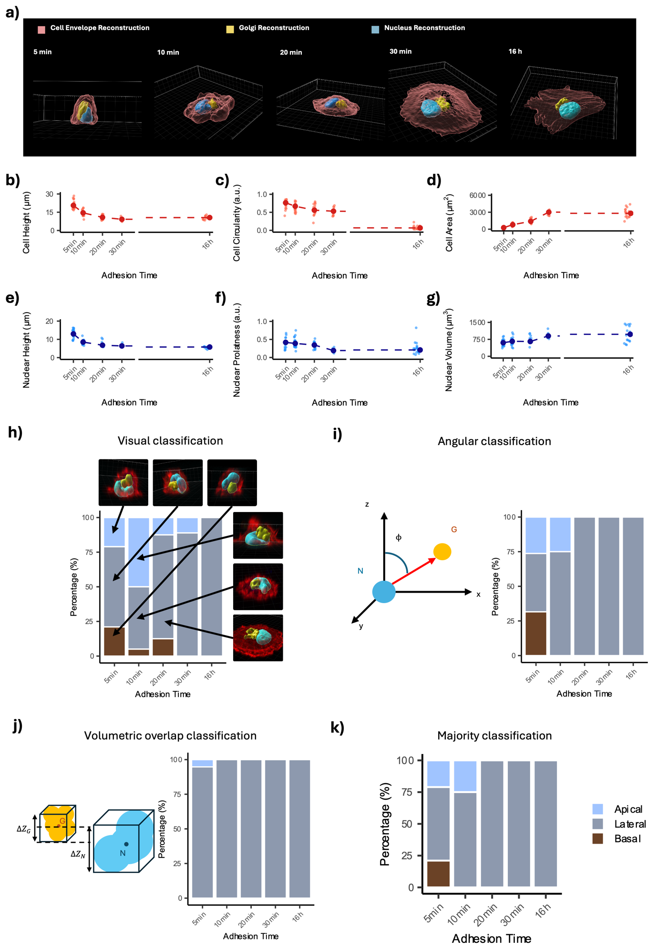
Supplementary Fig. 1 Stable lateral nucleus–Golgi polarity during adhesion. Representative three-dimensional surface reconstructions from confocal z-stacks showing the cellular envelope (red), nucleus (blue), and Golgi apparatus (yellow) at progressive stages of adhesion (5, 10, 20, and 30 min; 16 h after seeding). Scatter plots showing cellular height (b), circularity (c), and projected area (d), as well as nuclear height (e), prolateness (f), and volume (g), across the five adhesion time points (5, 10, 20, and 30 min; 16 h). Each dot represents a single cell; the larger filled point indicates the median value for each condition. (h) Visual classification based on direct inspection of 3D z-stack reconstructions of hMSCs fixed at five adhesion time points (5, 10, 20, and 30 min; 16 h). Cells were assigned to three categories: Basal (Golgi positioned below the nucleus), Lateral (Golgi positioned laterally), or Apical (Golgi positioned above the nucleus). (i) Angular classification. The angle (ϕ) between the nucleus-to-Golgi vector and the z-axis was computed. Cells were classified as Apical (0°≤ ϕ ≤ 60°), Lateral (60° < ϕ ≤ 120°) or Basal (120° < ϕ ≤ 180°). (j) Volumetric overlap classification. Three-dimensional bounding volumes enclosing the nucleus and Golgi were generated and centered on their respective centroids. Cells were classified as Lateral when vertical overlap was ≥50%; otherwise, classification as Apical or Basal was determined based on relative centroid position along the z-axis. (k) Majority classification. The final category for each cell was assigned by majority agreement across the three independent classification methods. n > 20 cells per condition.

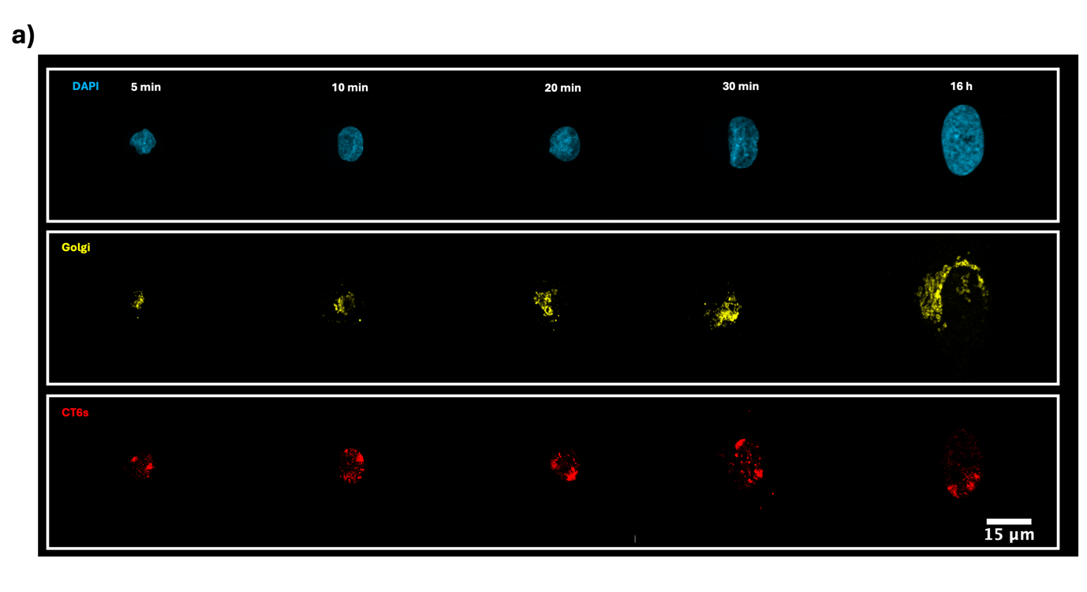
Supplementary Fig. 2 Stable CT6 radial positioning during adhesion. Representative confocal microscopy images of hMSCs showing the nucleus (DAPI, blue), Golgi apparatus (yellow), and CT6 (red) at progressive adhesion stages (5, 10, 20, and 30 min; 16 h). Each column shows a representative cell at the indicated adhesion time point. Scale bar, 15 µm.

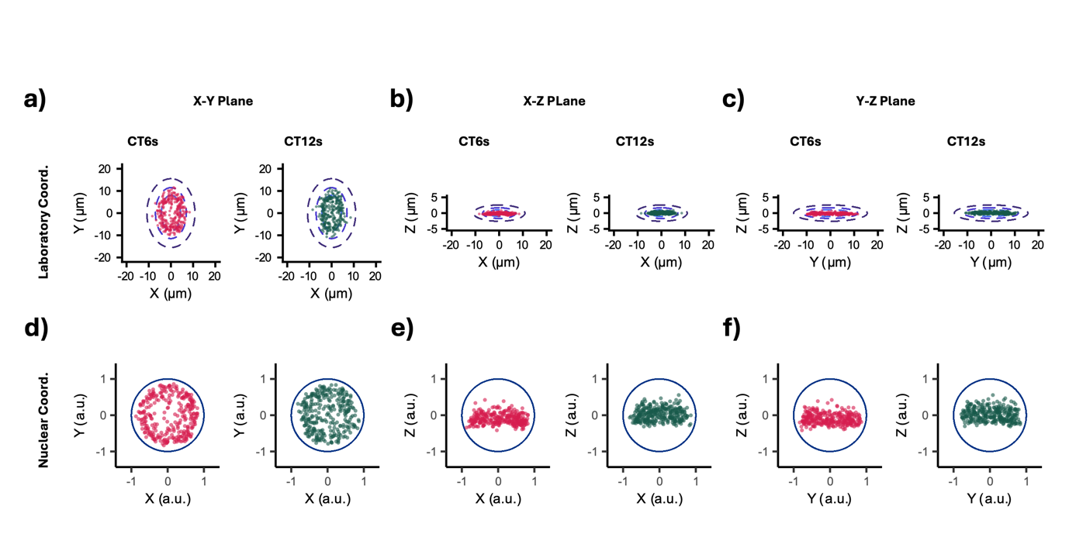
Supplementary Fig. 3 Centroid distributions in laboratory and normalized reference frames. Scatter plots of CT6 (red) and CT12 (green) centroid positions expressed in laboratory coordinates and projected onto the (a) x–y, (b) x–z, and (c) y–z planes. Dashed blue contours indicate the fitted nuclear boundaries corresponding to each projection plane. Corresponding centroid distributions after affine normalization are projected onto the (d) x–y, (e) x–z, and (f) y–z planes. Solid blue contours denote the normalized nuclear boundary (unit circle). n = 150 cells from three independent experiments.

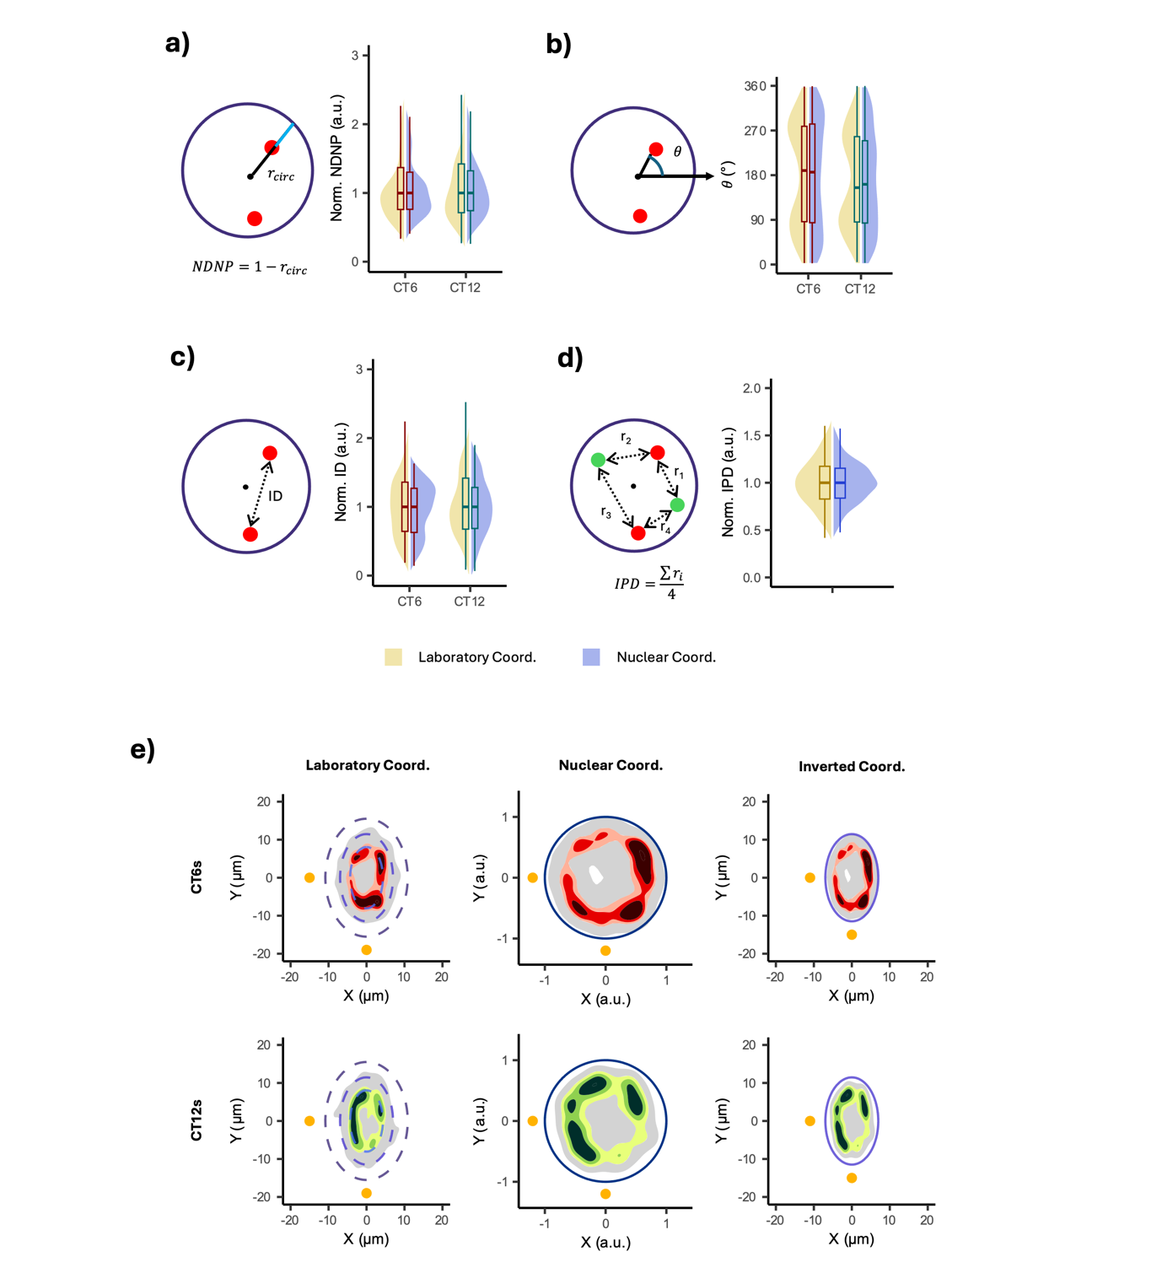
Supplementary Fig. 4 Affine normalization preserves population-level chromosomal topology. (a) Impact of nuclear normalization on radial chromosome positioning. (Left) Schematic representation of NDNP computation in normalized circular coordinates. (Right) Violin–box plots comparing NDNP distributions for CT6 and CT12 in laboratory (yellow) and normalized (blue) coordinates. To enable comparison across coordinate systems with different absolute scales, each distribution was median-normalized (values divided by their respective medians). (b) Impact of nuclear normalization on angular chromosome positioning. (Left) Schematic representation of the in-plane angular coordinate (θ), (Right) Violin–box plots comparing the distributions of θ for CT6 and CT12 in laboratory (yellow) and normalized (blue) coordinates. Because θ is scale-independent, no additional rescaling was required for comparison. (c) Impact of nuclear normalization on inter-homolog distance (ID). (Left) Schematic representation of ID calculation, (Right) Violin–box plots comparing ID distributions for CT6 and CT12 in laboratory (yellow) and normalized (blue) coordinates. Each distribution was median-normalized. (d) Impact of nuclear normalization on inter-chromosomal physical distance (IPD). (Left) Schematic representation of IPD calculation, (Right) Violin–box plots comparing IPD distributions in laboratory (yellow) and normalized (blue) coordinates. Each distribution was median-normalized. Statistical comparison of distribution shapes was performed using the Cramér test for the two-sample problem. (e) Assessment of coordinate normalization invertibility. KDE maps of CT6 (top row) and CT12 (bottom row) centroid distributions shown in laboratory coordinates (left), normalized nuclear coordinates (center), and laboratory coordinates reconstructed after back-transformation using the population-median nuclear semi-axes (right). Global differences between spatial probability maps were assessed using a kernel density–based global two-sample test applied to the corresponding spatial probability distributions. n = 150 cells from three independent experiments.

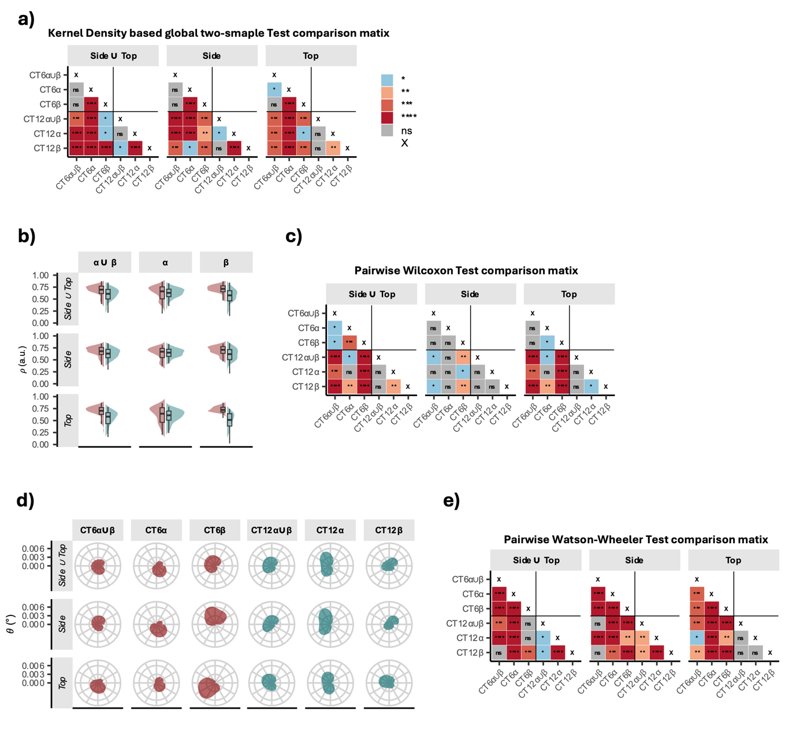
Supplementary Fig. 5 Intra-condition homolog-specific distributions are statistically distinct. (a) Intra-population comparison of homolog-resolved spatial probability maps. Matrix representation of pairwise statistical comparisons between homolog-specific CT KDE maps. Each matrix entry reports the p-value derived from a kernel density–based global two-sample test applied to the corresponding 2D spatial probability distributions. (b) Homolog-specific radial positioning across polarity states. Violin–box plots of the normalized radial coordinate (ρ) for CT6 (red) and CT12 (green) in the normalized reference frame. (c) Matrix representation of pairwise statistical comparisons between homolog-specific CT radial distributions (ρ). Each matrix entry reports the P-value derived from the pairwise Wilcoxon tests applied to the corresponding distributions. (d) Angular positioning of homolog-resolved chromosome territories. Radial plots of the in-plane angular coordinate (θ) in the normalized reference frame for CT6 (red) and CT12 (green). (e) Matrix representation of pairwise statistical comparisons between homolog-specific angular distributions. Data are grouped by polarity state (Side ∪ Top, Side, Top) and homolog class (α ∪ β, α, β). Each matrix entry reports the p-value derived from the Watson–Wheeler test for circular data applied to the corresponding θ distributions. Color intensity encodes p-value magnitude, with statistical significance indicated as follows: *(P < 0.05); **(P < 0.01); ***(P < 0.001); ****(P < 0.0001); ns, not significant. n = 150 cells total (Side, n = 83; Top, n = 67) from three independent experiments.

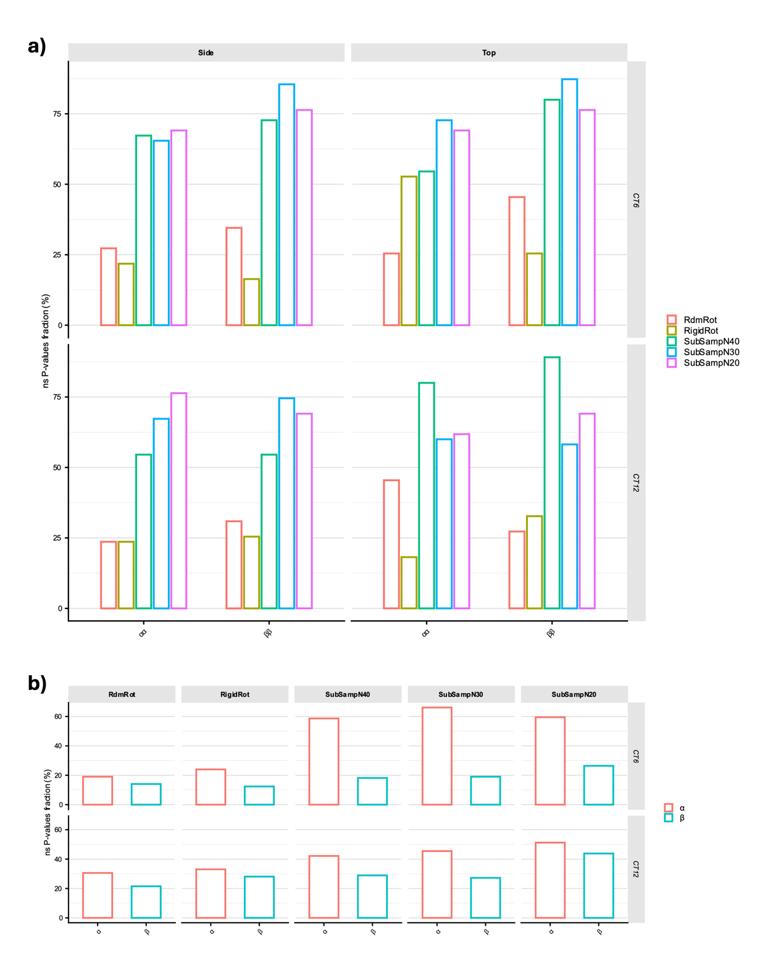
Supplementary Fig. 6 Stability analysis of homolog-specific chromosome maps under angular randomization and subsampling perturbations. (a) Percentage of non-significant (P > 0.05) pairwise comparisons, obtained with the kernel-density–based global two-sample test, among homolog-specific maps (α vs α and β vs β) reconstructed from synthetic datasets generated by random rotation (RdmRot), rigid nuclear rotation (RigidRot), or subsampling of 40, 30, or 20 observations from the original dataset (SubSampN40, SubSampN30, and SubSampN20). For each condition, 10 synthetic datasets plus the original dataset were analyzed. (b) Percentage of ns pairwise comparisons between Side and Top homolog-specific maps. For each perturbation strategy, comparisons were performed between α maps from Side and Top datasets and, separately, between β maps from Side and Top datasets.

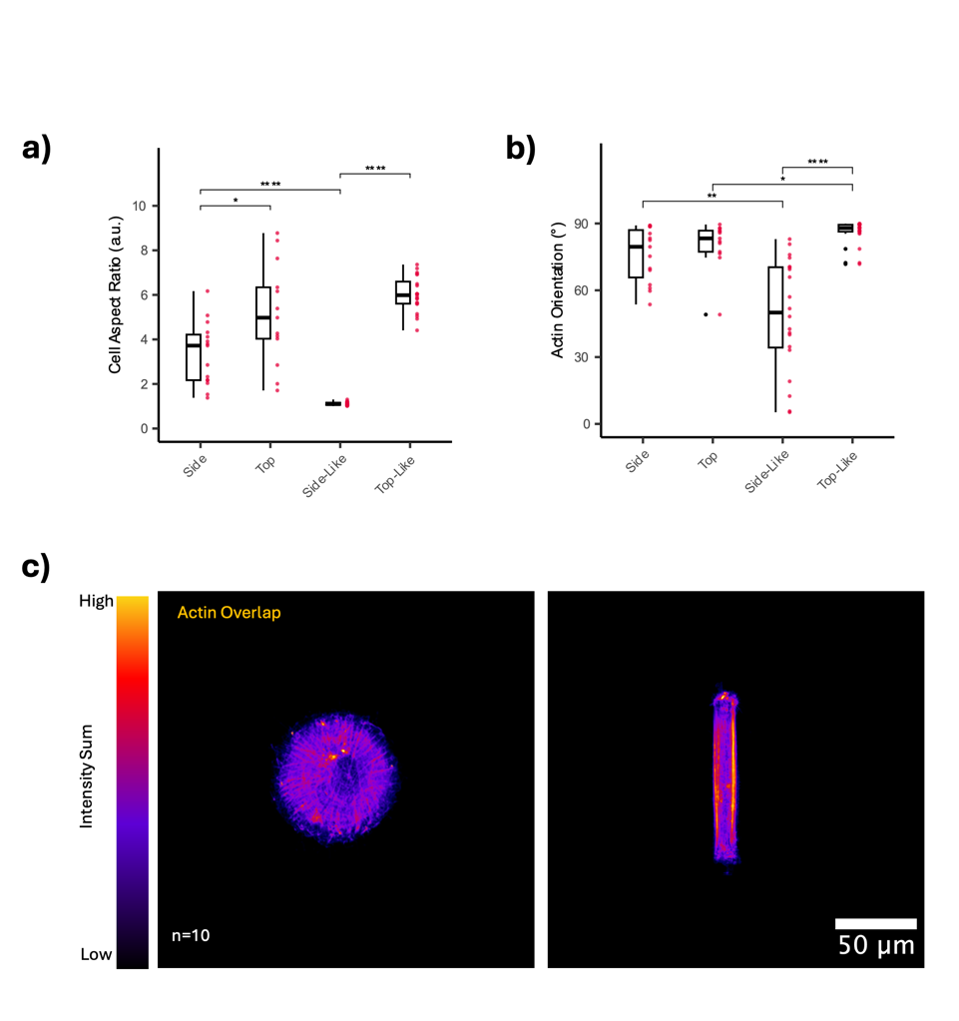

Supplementary Fig. 7 Geometric confinement shapes cell morphology and actin cytoskeleton. Box-and-jitter plots showing (a) the cell aspect ratio and (b) the angular distribution of actin fibers relative to the x-axis across Side, Top, Side-Like (circular micropattern), and Top-Like (rectangular micropattern) hMSC conditions. n ≥ 20 cells per condition. Statistical significance between pairwise groups was assessed using the pairwise Wilcoxon test. (c) Sum-intensity z-stack projection overlays of F-actin in circular (left) and rectangular (right) micropatterned hMSCs. Each overlay includes n = 10 cells.

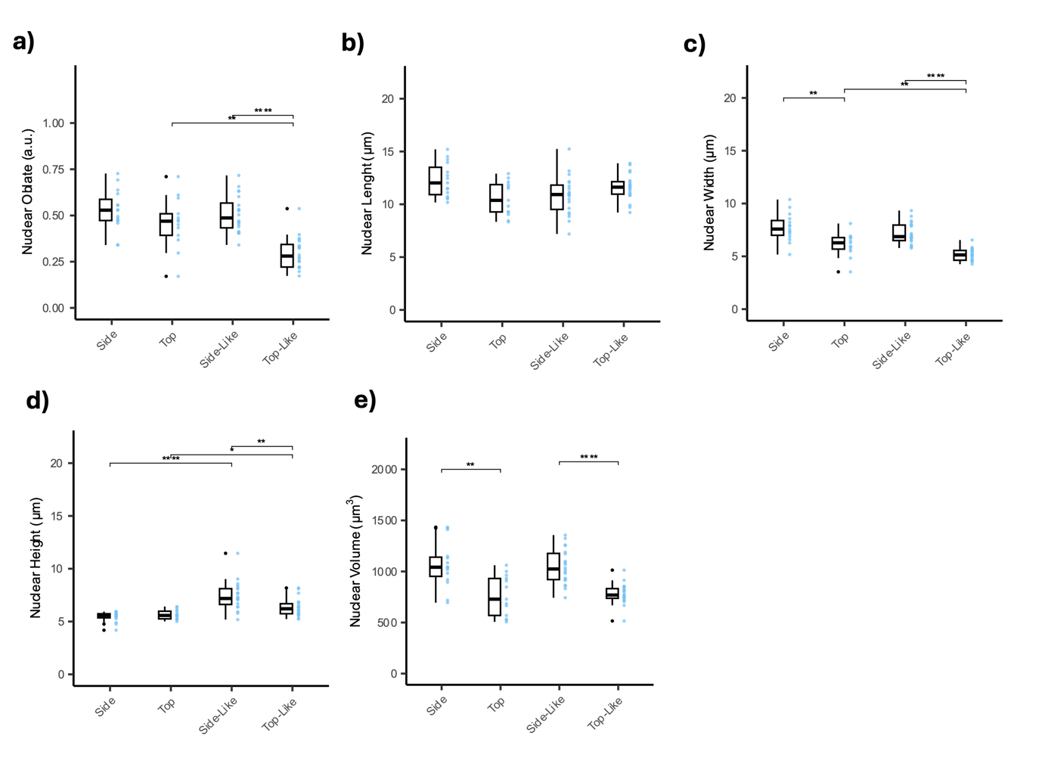
Supplementary Fig. 8 Geometric confinement shapes nuclear morphology. Box-and-violin plots showing (a) oblateness; (b) height; (c) width; (d) length and (e) volume of the hMSC nuclei for all conditions. n > 20 cells per condition. Statistical significance between pairwise groups was assessed using the pairwise Wilcoxon test.

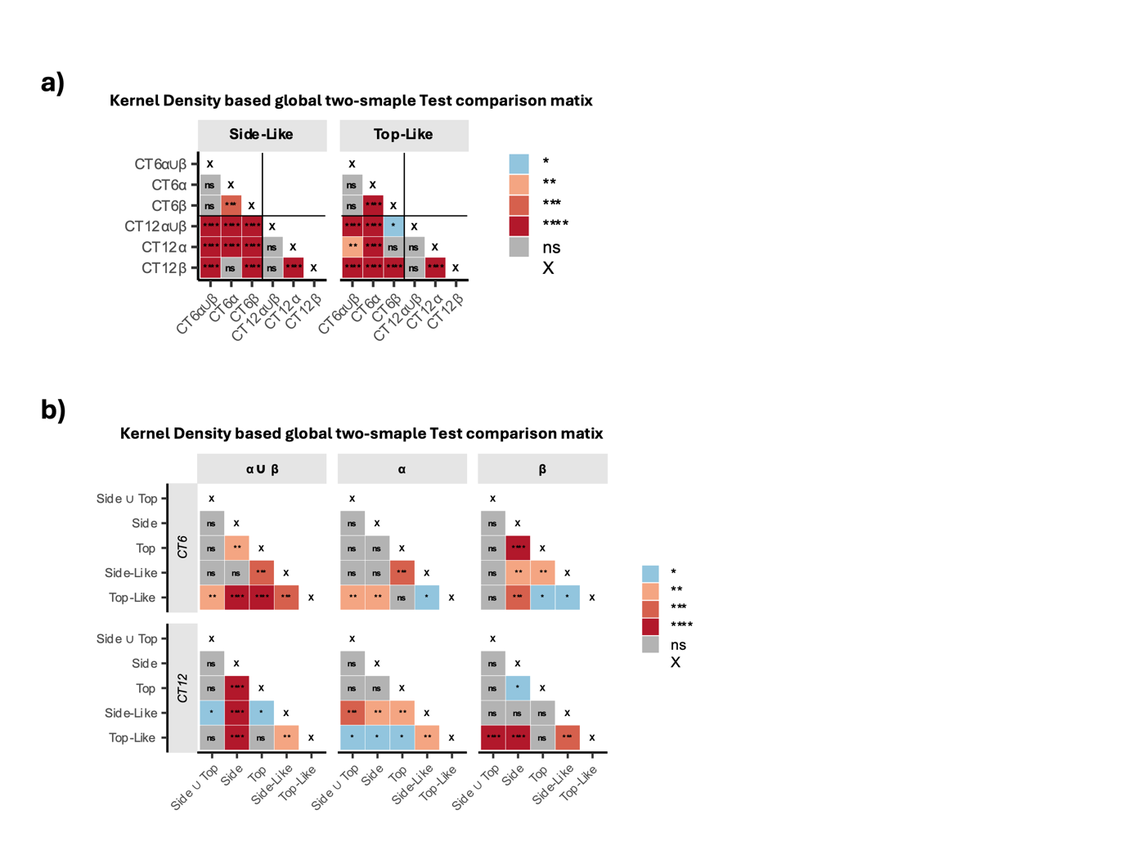
Supplementary Fig. 9 Micropatterned hMSCs recapitulate nuclear topological classes observed in unconfined cells. (a) Intra-population comparison of homolog-resolved spatial probability maps. Matrix representation of pairwise statistical comparisons between homolog-specific CT KDE maps. (b) Inter-population comparison of homolog-resolved spatial probability maps. Matrix representation of pairwise statistical comparisons between homolog-specific CT KDE maps. Each matrix entry reports the p-value derived from a kernel density–based global two-sample test applied to the corresponding 2D spatial probability distributions. Color intensity encodes p-value magnitude, with statistical significance indicated as follows: *(P < 0.05); **(P < 0.01); ***(P < 0.001); ****(P < 0.0001); ns, not significant, not significant. n > 50 cells (Side, n = 83; Top, n = 67; Side-Like, n = 100; Top-Like, n = 150) from three independent experiments per condition.

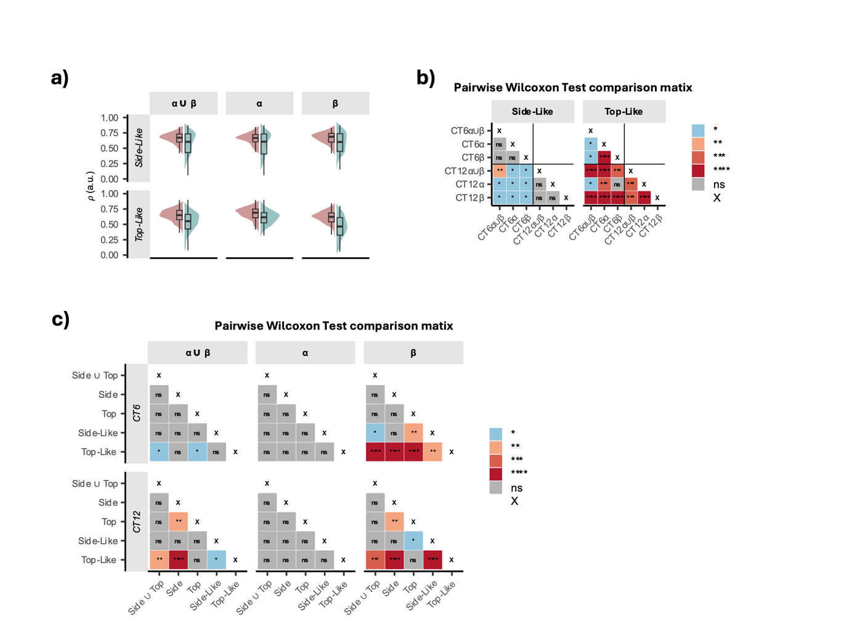
Supplementary Fig. 10 Homolog-specific radial distributions distinguish topological states and geometric conditions. (a) Homolog-specific radial positioning across polarity states. Violin–box plots of the normalized radial coordinate (ρ) for CT6 (red) and CT12 (green) in the normalized reference frame. Data are grouped by polarity state and homolog class (α ∪ β, α, β). (b) Matrix representation of intra-population pairwise statistical comparisons between homolog-specific CT radial distributions (ρ). Each matrix entry reports the p-value derived from the pairwise Wilcoxon tests applied to the corresponding distributions. (c) Matrix representation of inter-population pairwise statistical comparisons between homolog-specific CT radial distributions (ρ). Each matrix entry reports the p-value derived from the pairwise Wilcoxon tests applied to the corresponding distributions. Color intensity encodes p-value magnitude, with statistical significance indicated as follows: *(P < 0.05); **(P < 0.01); ***(P < 0.001); ****(P < 0.0001); ns, not significant. n > 50 cells (Side, n = 83; Top, n = 67; Side-Like, n = 100; Top-Like, n = 150) from three independent experiments per condition.

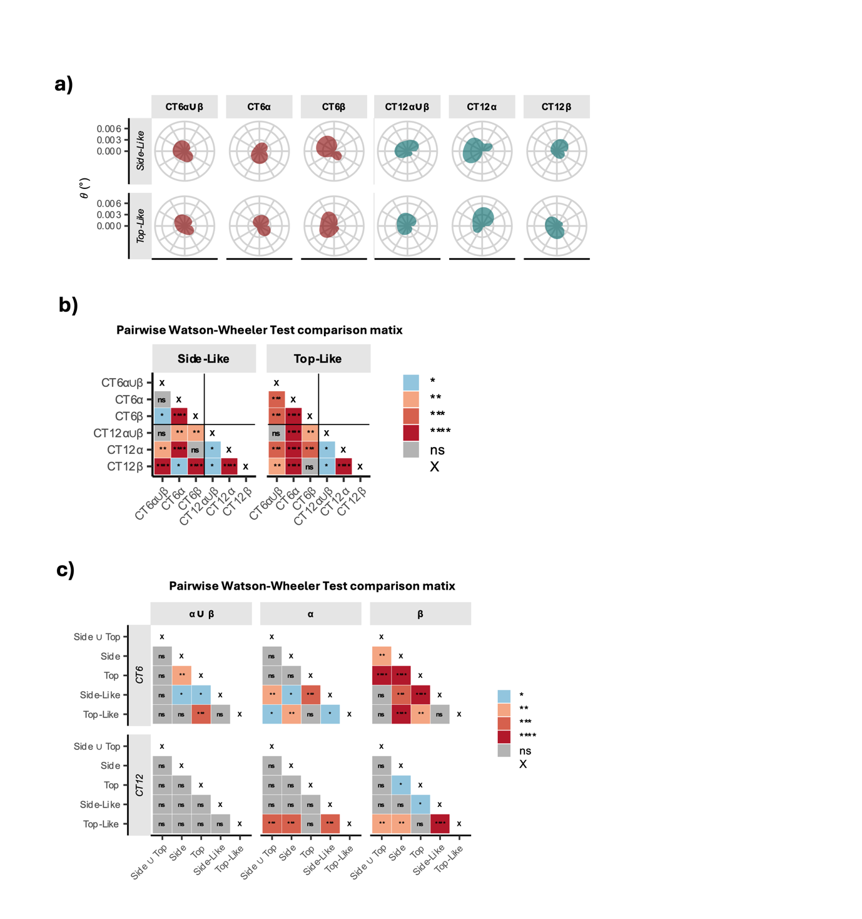
Supplementary Fig. 11 Homolog-specific angular distributions distinguish topological states and geometric conditions. (a) Homolog-specific angular positioning across polarity states. Radial plots of the in-plane angular coordinate (θ) in the normalized reference frame for CT6 (red) and CT12 (green). Data are grouped by polarity state and homolog class (α ∪ β, α, β). (b) Matrix representation of intra-population pairwise statistical comparisons between homolog-specific CT angular distributions (θ). Each matrix entry reports the p-value derived from Watson–Wheeler tests applied to the corresponding distributions. (c) Matrix representation of inter-population pairwise statistical comparisons between homolog-specific CT angular distributions (θ). Each matrix entry reports the p-value derived from Watson–Wheeler tests applied to the corresponding distributions. Color intensity encodes p-value magnitude, with statistical significance indicated as follows: *(P < 0.05); **(P < 0.01); ***(P < 0.001); ****(P < 0.0001); ns, not significant. n > 50 cells (Side, n = 83; Top, n = 67; Side-Like, n = 100; Top-Like, n = 150) from three independent experiments per condition.

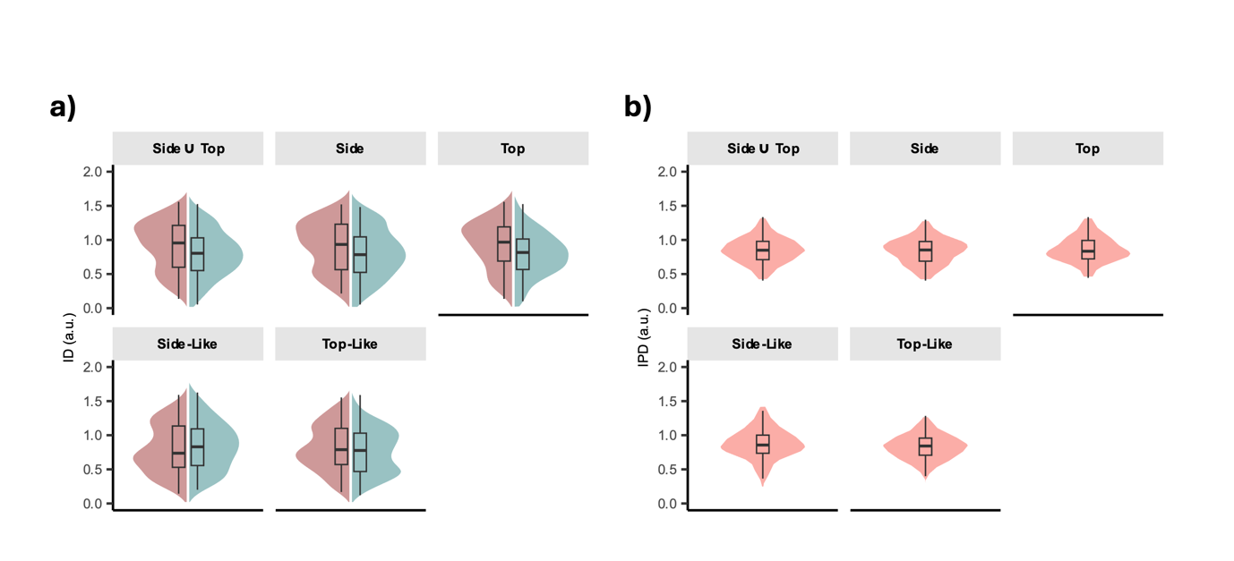
Supplementary Fig. 12 Inter-homolog and inter-physical distances are invariant across polarity and geometric conditions. (a) Violin–box plots of inter-homolog distance (ID) distributions in the normalized reference frame for CT6 (red) and CT12 (green). (b) Violin–box plots of interphysical distance (IPD) between CT6 and CT12 in the normalized reference frame. Statistical significance for all pairwise group comparisons was assessed using the pairwise Wilcoxon test. n > 50 cells (Side, n = 83; Top, n = 67; Side-Like, n = 100; Top-Like, n = 150) from three independent experiments per condition.

