Supplementary Materials
Table S1. Full Mann-Kendall, Sen’s slope, Pettitt, Buishand results for all 14 variables
Variable | PRCPTOT | PRCPTOT_Winter | PRCPTOT_Pre-Monsoon | PRCPTOT_Monsoon | PRCPTOT_Post-Monsoon | Rx1day | Rx5day | R95p | R99p | R95pFrac | R99pFrac | CDD | CWD | SDII
MK_Tau | 0.0831 | -0.1265 | -0.0844 | 0.1894 | 0.1133 | 0.0945 | 0.0787 | 0.0991 | 0.1085 | 0.0957 | 0.1037 | 0.0325 | 0.0735 | 0.1084
MK_Z | 1.3722 | -2.0892 | -1.3935 | 3.1306 | 1.8715 | 1.56 | 1.2996 | 1.6368 | 1.754 | 1.5813 | 1.6766 | 0.5296 | 1.2061 | 1.7905
MK_Pval | 0.17 | 0.03669 | 0.1635 | 0.001744 | 0.06127 | 0.1188 | 0.1937 | 0.1017 | 0.07944 | 0.1138 | 0.09362 | 0.5964 | 0.2278 | 0.07338
Sens_Slope | 1.2139 | -0.1415 | -0.5434 | 1.7685 | 0.3858 | 0.08 | 0.1501 | 0.8997 | 0.344 | 0.0322 | 0.0152 | 0.0133 | 0.0654 | 0.0064
Sens_LCL | -0.5531 | -0.2909 | -1.433 | 0.6634 | -0.017 | -0.0199 | -0.0809 | -0.1936 | 0 | -0.0083 | 0 | -0.0476 | -0.0435 | -0.0007
Sens_UCL | 3.0226 | -0.0092 | 0.2608 | 2.8791 | 0.7859 | 0.178 | 0.3833 | 2.068 | 1.0672 | 0.0748 | 0.044 | 0.0805 | 0.1667 | 0.0138
Trend_Dir | Increasing | Decreasing | Decreasing | Increasing | Increasing | Increasing | Increasing | Increasing | Increasing | Increasing | Increasing | Increasing | Increasing | Increasing
MMK_HR_Z | 1.2514 | -2.0892 | -1.4111 | 2.3769 | 1.8715 | 2.204 | 1.2996 | 2.5905 | 2.1159 | 1.6948 | 2.012 | 0.5087 | 0.656 | 1.998
MMK_HR_Pval | 0.2108 | 0.03669 | 0.1582 | 0.01746 | 0.06127 | 0.02752 | 0.1937 | 0.009584 | 0.03436 | 0.09011 | 0.04422 | 0.6109 | 0.5118 | 0.04572
TFPW_Z | 1.0259 | -2.3002 | -1.6306 | 3.1425 | 1.7991 | 1.5874 | 1.1641 | 1.3067 | 1.743 | 1.3067 | 1.73 | 0.2657 | 1.0993 | 1.5788
TFPW_Pval | 0.8122 | -0.155 | -0.6683 | 1.638 | 0.3626 | 0.07916 | 0.1304 | 0.7337 | 0.4157 | 0.0276 | 0.01723 | 0.009997 | 0.05976 | 0.005423
Pettitt_Pval | 0.07594 | 0.09265 | 0.1992 | 0.004362 | 0.09611 | 0.01444 | 0.2526 | 0.09152 | 0.02934 | 0.09728 | 0.04226 | 0.2858 | 0.001052 | 0.03312
Pettitt_Year | 1922 | 1998 | 1959 | 1937 | 1944 | 1975 | 1975 | 1975 | 1975 | 1975 | 1975 | 2007 | 1937 | 1975
SNHT_Year | NA | NA | NA | NA | NA | NA | NA | NA | NA | NA | NA | NA | NA | NA
Buishand_Year | 1975 | 1995 | 2005 | 1975 | 1945 | 1975 | 1975 | 1975 | 1975 | 1975 | 1975 | 2007 | 1937 | 1975

Table S2. Quantile regression results for all seasons
Season | Quantile | Slope | Pval
Annual | Q10 | 0 | NA
Annual | Q50 | -0.000394099 | 0.885481061
Annual | Q90 | 0.058460657 | 0.000695905
Annual | Q95 | 0.086014485 | 0.069647666
Annual | Q99 | 0.107275479 | 0.023081433
Winter | Q10 | 0 | NA
Winter | Q50 | 0 | NA
Winter | Q90 | -0.046789453 | 1.13653E-05
Winter | Q95 | -0.052500288 | 0.604297853
Winter | Q99 | 0.399401799 | 0.417861638
Pre-Monsoon | Q10 | 0 | NA
Pre-Monsoon | Q50 | -0.007033193 | 0.133562483
Pre-Monsoon | Q90 | 0.00403811 | 0.935430626
Pre-Monsoon | Q95 | 0.015359698 | 0.919016602
Pre-Monsoon | Q99 | 0.03149629 | 0.916325978
Monsoon | Q10 | 0.001974763 | 0.488976464
Monsoon | Q50 | 0.01003878 | 0.064487552
Monsoon | Q90 | 0.033666124 | 0.287632704
Monsoon | Q95 | 0.078816239 | 0.152722439
Monsoon | Q99 | 0.142490647 | 0.266453952
Post-Monsoon | Q10 | 0 | NA
Post-Monsoon | Q50 | 0 | NA
Post-Monsoon | Q90 | 0.039993449 | 0.032192323
Post-Monsoon | Q95 | 0.016939106 | 0.821821974
Post-Monsoon | Q99 | -0.209309599 | 0.234645235

Table S3. Hurst exponents for all variables
Variable | H | Flag
PRCPTOT | 0.595 | Long-memory detected
PRCPTOT_Winter | 0.56 | Long-memory detected
PRCPTOT_Pre-Monsoon | 0.549 | Long-memory detected
PRCPTOT_Monsoon | 0.629 | Long-memory detected
PRCPTOT_Post-Monsoon | 0.547 | Long-memory detected
Rx1day | 0.586 | Long-memory detected
Rx5day | 0.518 | Long-memory detected
R95p | 0.603 | Long-memory detected
R99p | 0.588 | Long-memory detected
R95pFrac | 0.592 | Long-memory detected
R99pFrac | 0.569 | Long-memory detected
CDD | 0.605 | Long-memory detected
CWD | 0.683 | Long-memory detected
SDII | 0.631 | Long-memory detected

Figure S1. Seasonal rainfall time series (winter, pre-monsoon, monsoon, post-monsoon) showing the contrasting trends.

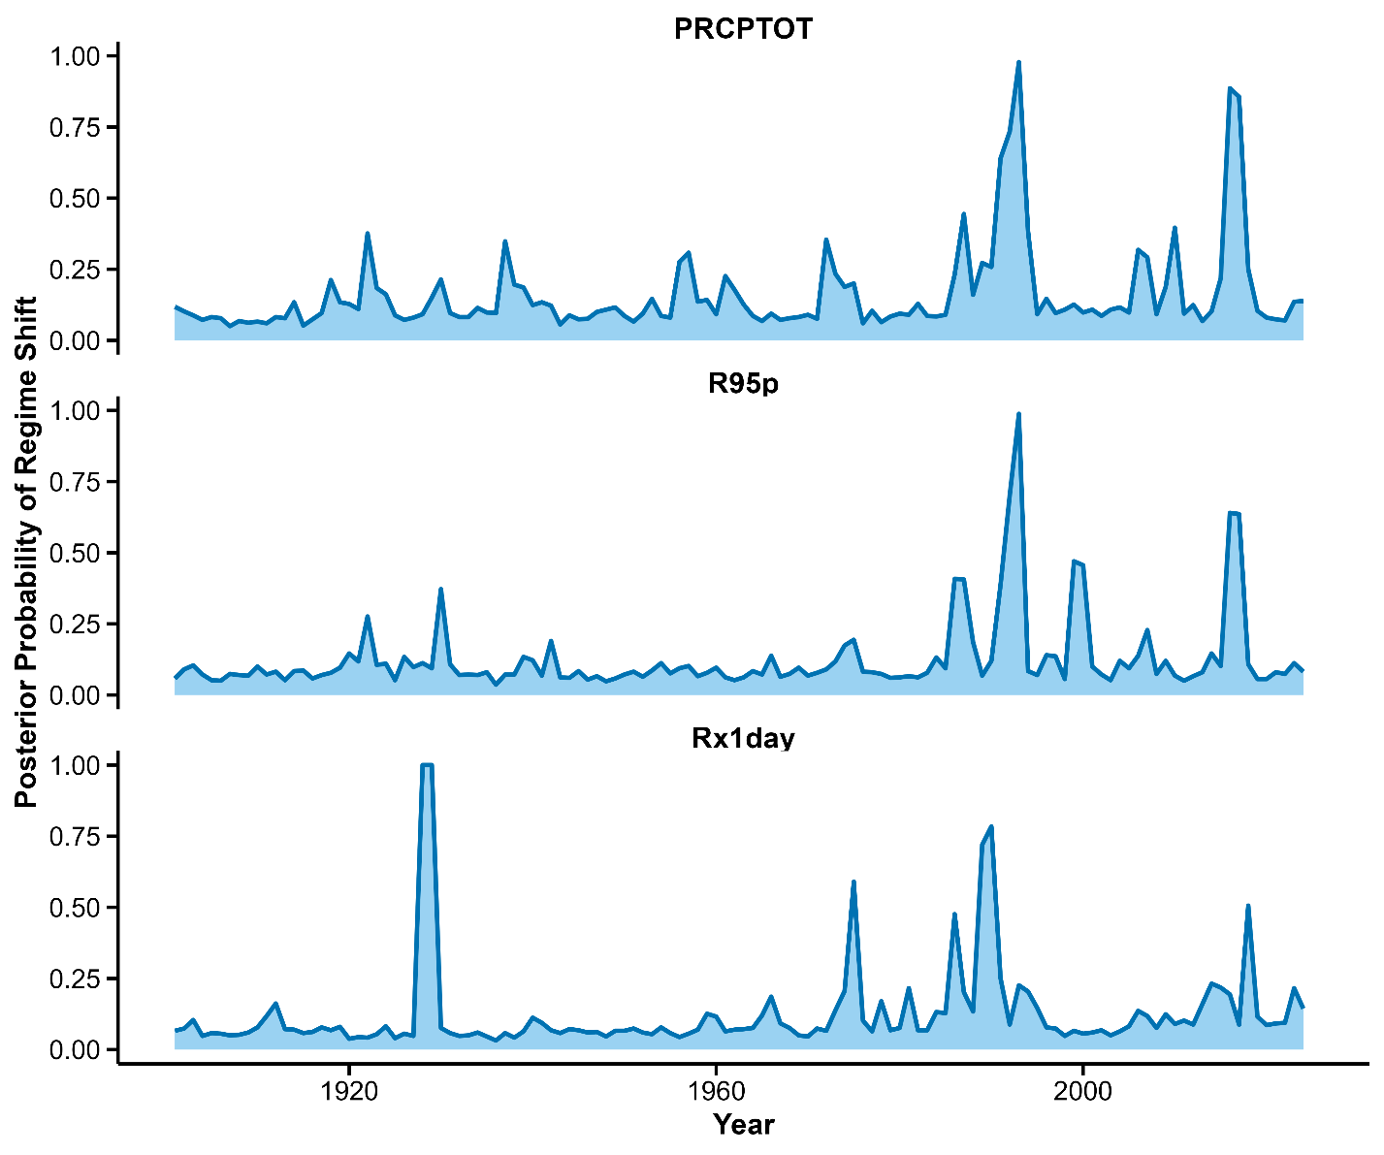

Figure S2. Bayesian change-point posterior probabilities for PRCPTOT, Rx1day, R95p
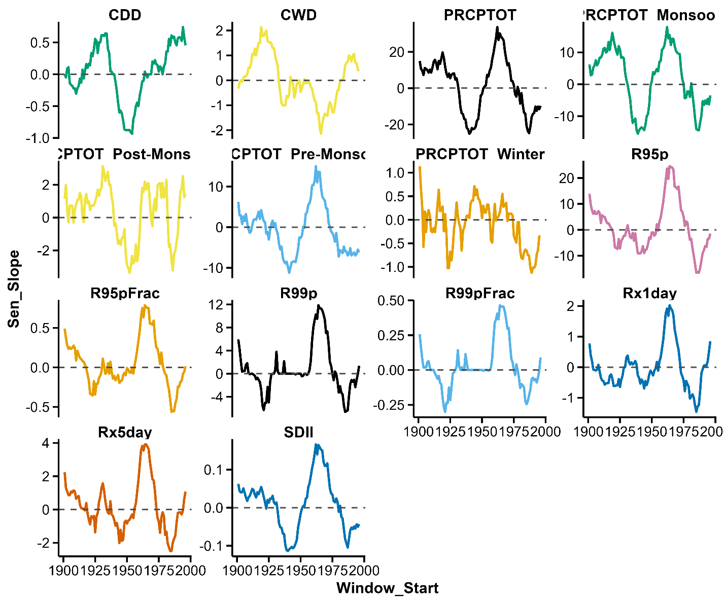

Figure S3: Temporal evolution and 30-year moving-window Sen's slope of precipitation and precipitation extreme indices over Mizoram (1901–2024). Upper panels show annual values, LOESS smoothing (95% CI), overall linear trend, and detected regime shifts (where applicable); lower panels show the 30-year moving-window Sen's slope. Panels: (1) CDD, (2) CWD, (3) PRCPTOT_Monsoon, (4) PRCPTOT, (5) PRCPTOT_Post-Monsoon, (6) PRCPTOT_Pre-Monsoon, (7) PRCPTOT_Winter, (8) R95p, (9) R95pFrac, (10) R99p, (11) R99pFrac, (12) Rx1day, (13) Rx5day, and (14) SDII.

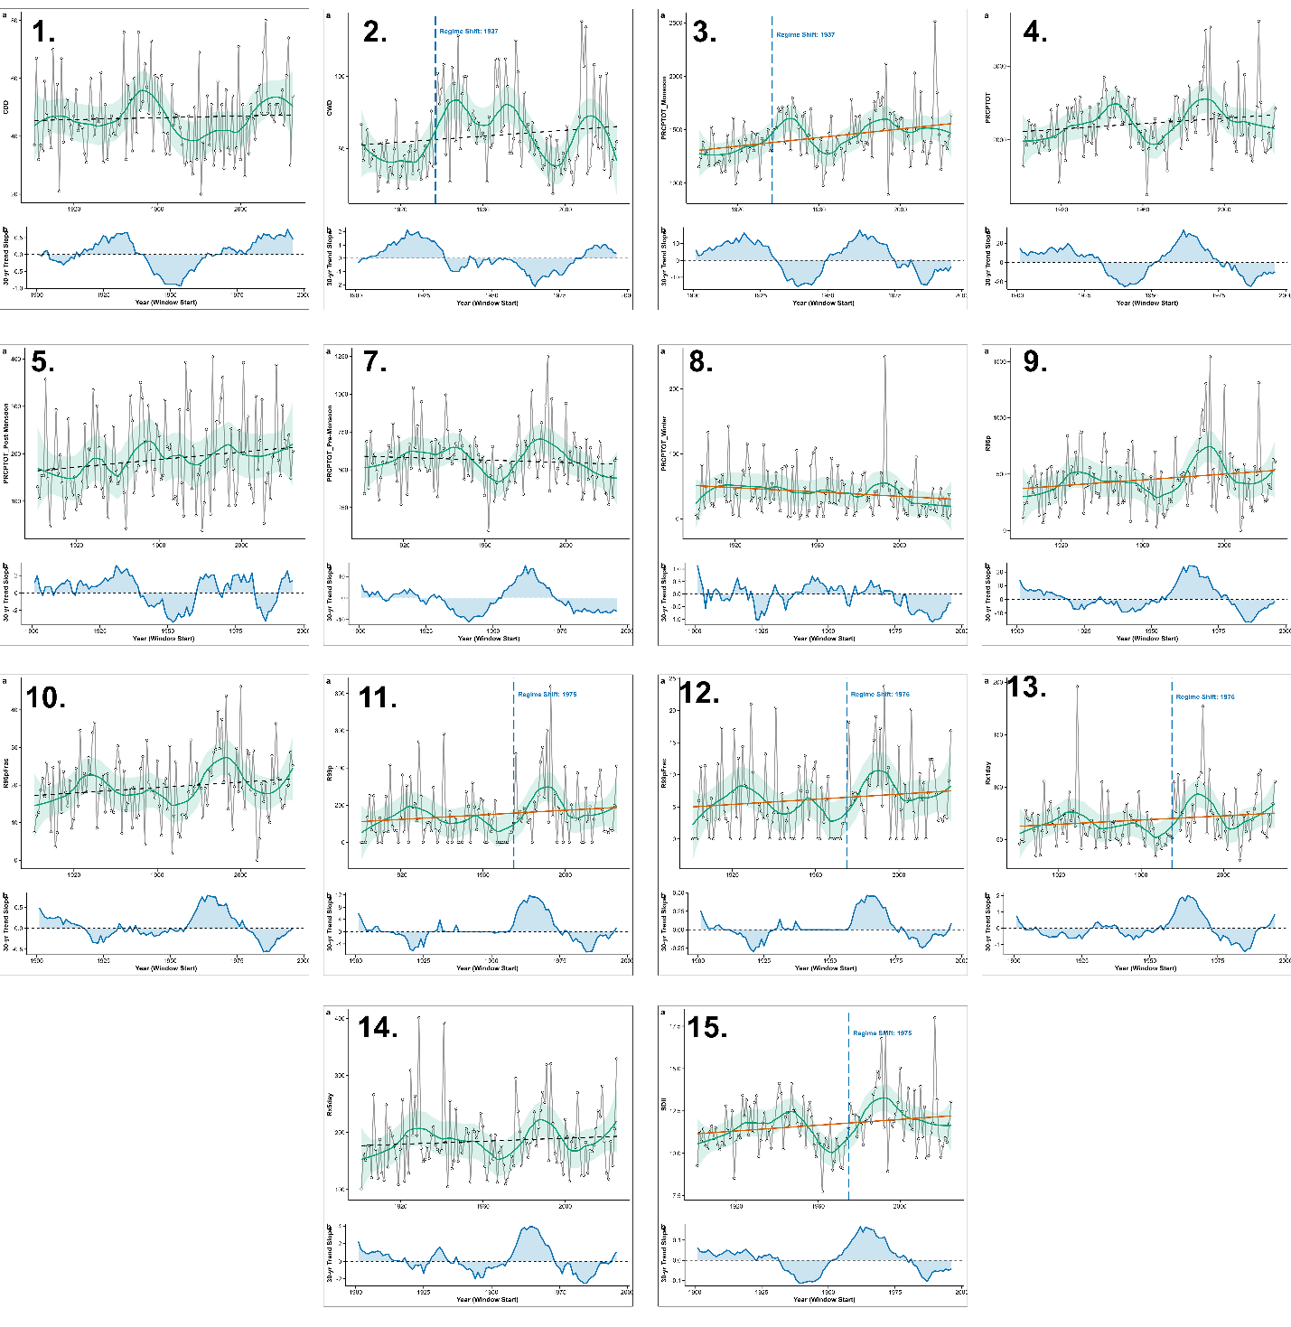

Figure S4. Stationary vs. non-stationary GEV return level plot
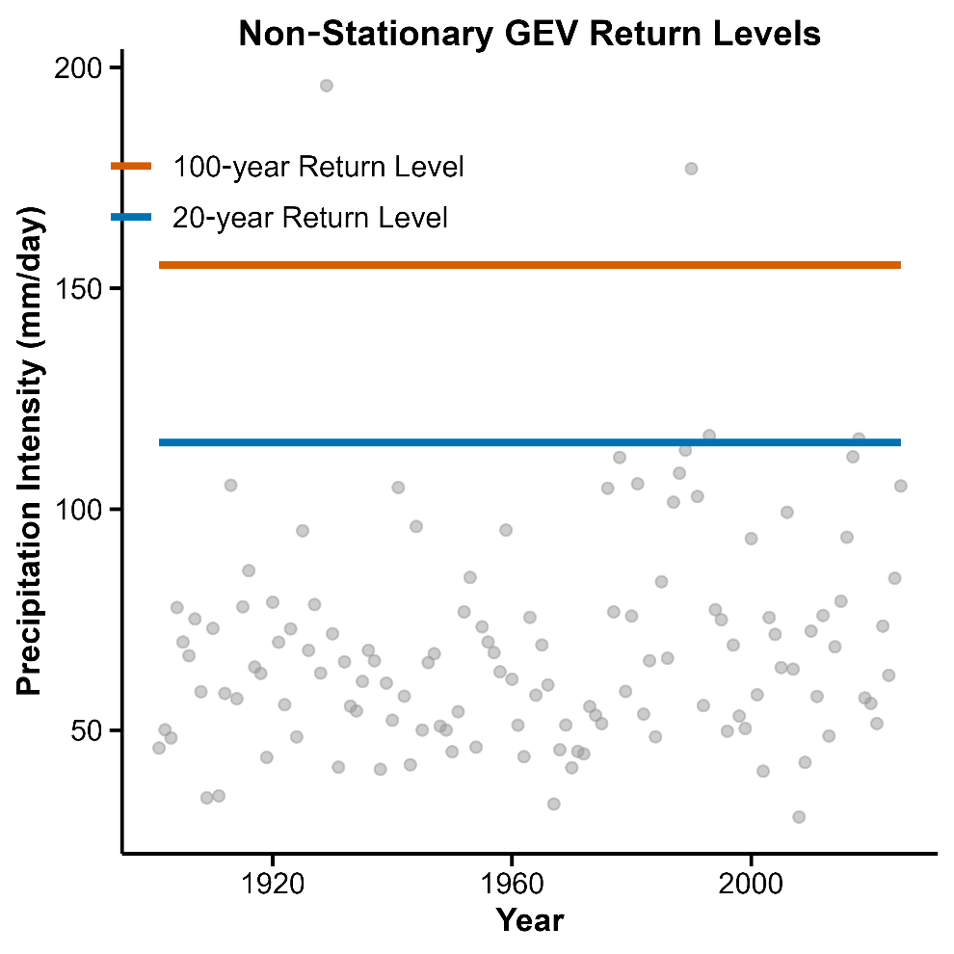
Figure S5. SPI-based drought frequency bar chart.
