East Asian-Specific Variants in LINC00251 and DEK in Suicidal and Non-Suicidal Major Depressive Disorder: A Discovery GWAS
Yu-Tien Chang¹, Chih-Chung Huang², Kuo-Sheng Hung³, Yu-Lung Chiu¹, Ya-Ting Yang¹, Su-Wen Chuang¹, Chia-Chao Wu⁴, Chia-Jung Hsu⁵, Chih-Hsiung Hsu⁶, Chien-Ho Lin⁷*, Hsin-An Chang^{2,8}*
1 College of Public Health, National Defense Medical University, Taipei City, Taiwan
2 Department of Psychiatry, Tri-Service General Hospital, National Defense Medical University, Taipei City, Taiwan
3 Center for Precision Medicine and Genomics, Tri-Service General Hospital, National Defense Medical University, Taipei City, Taiwan
4 Division of Nephrology, Department of Medicine, Tri-Service General Hospital, National Defense Medical University, Taipei City, Taiwan
5 Information Management Center, Tri-Service General Hospital, National Defense Medical University, Taipei City, Taiwan
6 Administration Office, Taoyuan Armed Forces General Hospital Hsinchu Branch, Hsinchu City, Taiwan
7 Department of Psychiatry, Chi Mei Medical Center, Tainan, Taiwan
8 Department of Psychiatry, School of Medicine, College of Medicine, National Defense Medical University, Taipei City, Taiwan
*Corresponding authors (equal contribution):
Chien-Ho Lin, M.D. — Department of Psychiatry, Chi Mei Medical Center, Tainan, Taiwan. Email: alholin@gmail.com
Hsin-An Chang, M.D. — Department of Psychiatry, Tri-Service General Hospital, No. 325, Cheng-Kung Road, Sec. 2, Nei-Hu District, Taipei, 114, Taiwan. Email: chang.ha@mail.ndmutsgh.edu.tw

Supplementary Materials

Supplementary Figures
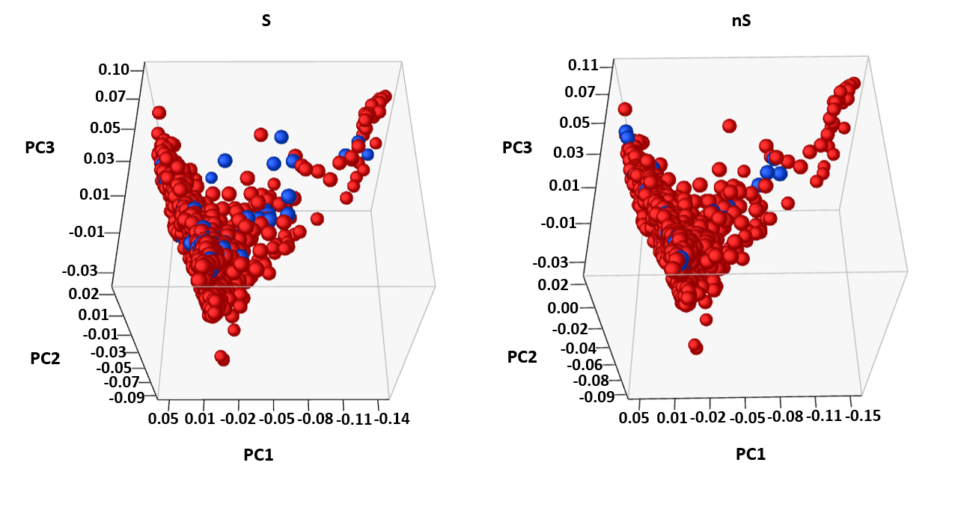
Figure S1. Principal component analysis of genotyping data stratified by suicide status. PCA was performed using genome-wide genotyping data to evaluate potential population structure among study participants. The suicide and non-suicide groups showed broadly comparable clustering across PC1, PC2, and PC3, supporting the absence of marked ancestry-related separation between groups. Minor dispersed points were observed but did not indicate a distinct subgroup pattern.
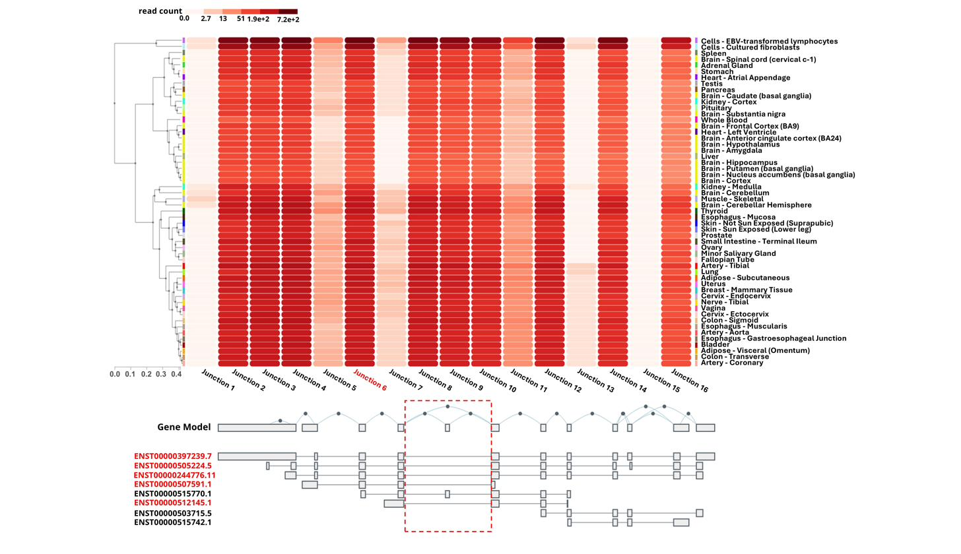
Figure S2. Expression of DEK splice junction 6 across tissues from GTEx. Heatmap of RNA-seq junction-level read counts across 50+ tissues (GTEx v8). Junction 6 (red dashed box) — the region overlapping rs184634961 — exhibits high expression across virtually all tissues (>51 read counts), with particularly elevated levels in the cerebral hemisphere (>7.2 × 10² read counts). Five transcript isoforms share this junction region (labelled in red).

Supplementary Tables
Table S1. Full phenome-wide association study (PheWAS) results for rs184634961 and rs78287434.
Variant | atlas ID | PMID | Year | Domain | Trait | P-value | N | EA | NEA
rs184634961 | 4166 | 30108127 | 2018 | Metabolic | Body Mass Index | 0.002 | 334487 | T | A
rs184634961 | 3896 | 27863252 | 2016 | Immunological | Neutrophil percentage of white cells (three-way meta) | 0.002 | 171542 | A | T
rs78287434 | 1002 | 27989323 | 2017 | Immunological | Monokine induced by interferon-gamma (CXCL9) | 0.001 | 3685 | G | T
rs78287434 | 4197 | 31217584 | 2019 | Metabolic | Waist-hip ratio | 0.002 | 33904 | T | G
EA = Effect Allele. NEA = Non-Effect Allele.
Table S2. Predicted LINC00251 interaction partners from LncRRIsearch.
Rank | Target Gene | Description | Sum Energy (kcal/mol) | Min Energy (kcal/mol) | MDD/Suicidality Relevance
1 | HRG-AS1 | HRG And FETUB Antisense RNA 1 | −785.93 | −21.35 | No published link
2 | RPGR | Retinitis Pigmentosa GTPase Regulator | −640.13 | −23.61 | No published link
3 | FAM98B | Family With Sequence Similarity 98 Member B | −578.31 | −27.54 | No published link
4 | SNX8 | Sorting Nexin 8 | −484.63 | −24.56 | No published link
5 | UCN3 ★ | Urocortin 3 | −237.79 | −25.16 | HPA axis, MDD biomarker (Waters et al. 2015)
6 | EMC10 | ER Membrane Protein Complex Subunit 10 | −224.31 | −22.25 | No published link
7 | CCDC85C | Coiled-Coil Domain Containing 85C | −205.09 | −22.17 | No published link
Seven predicted interaction partners ranked by summed base-pairing energy (LncRRIsearch; Fukunaga et al. 2019). UCN3 (★) was selected for biological follow-up based on its established HPA axis and MDD relevance; the four higher-ranked targets lack reported associations with MDD or suicidal behavior.

