Supplementary Information for
Prokaryotic (6-4) photolyases depend on a one-way bridge for blue-light triggered electron transfer

Christian Joshua Rosner^{[a],#}, Florian Trunk^{[b],#}, Elisa Seiler^{[a]}, Andrea Bologna^{[c]}, Valeri Fuchs^{[a]}, Hans-Joachim Emmerich^{[a]}, Marco Samir Kamel Bekhit^{[a]} Yazan Ibrahim^{[a]}, Josef Wachtveitl^{[b],}*, Po-Hsun Wang^{[a], [d],}* and Lars-Oliver Essen^{[a],}*

[a] Department of Chemistry
Philipps University Marburg
Hans-Meerwein Strasse 4, Marburg 35032, Germany
[b] Institute of Physical Chemistry
University of Frankfurt am Main
Max von Laue-Straße 7, 60438 Frankfurt am Main, Germany
[c] Department of Science and Technology
University of Sannio
Via Francesco de Sanctis, snc, 82100, Benevento, Italy
[d] Institute for Biological Chemistry
Academia Sinica
No. 128, Sect. 2, Academia Rd, Nangang District, Taipei City 115, Taiwan

#C.J.R and F.T. contributed equally to this work.
*Corresponding authors. Email: essen@chemie.uni-marburg.de (L.O.E.); nigel4069@as.edu.tw (P.H.W.); wveitl@theochem.uni-frankfurt.de (J.W.)

This PDF file includes:
Supplementary Information: Figures S1 to S11
Supplementary Information: Methods with Figures S12 to S20
Supplementary Information: Tables S1 to S5
Supplementary Information: References

Supplementary Figures
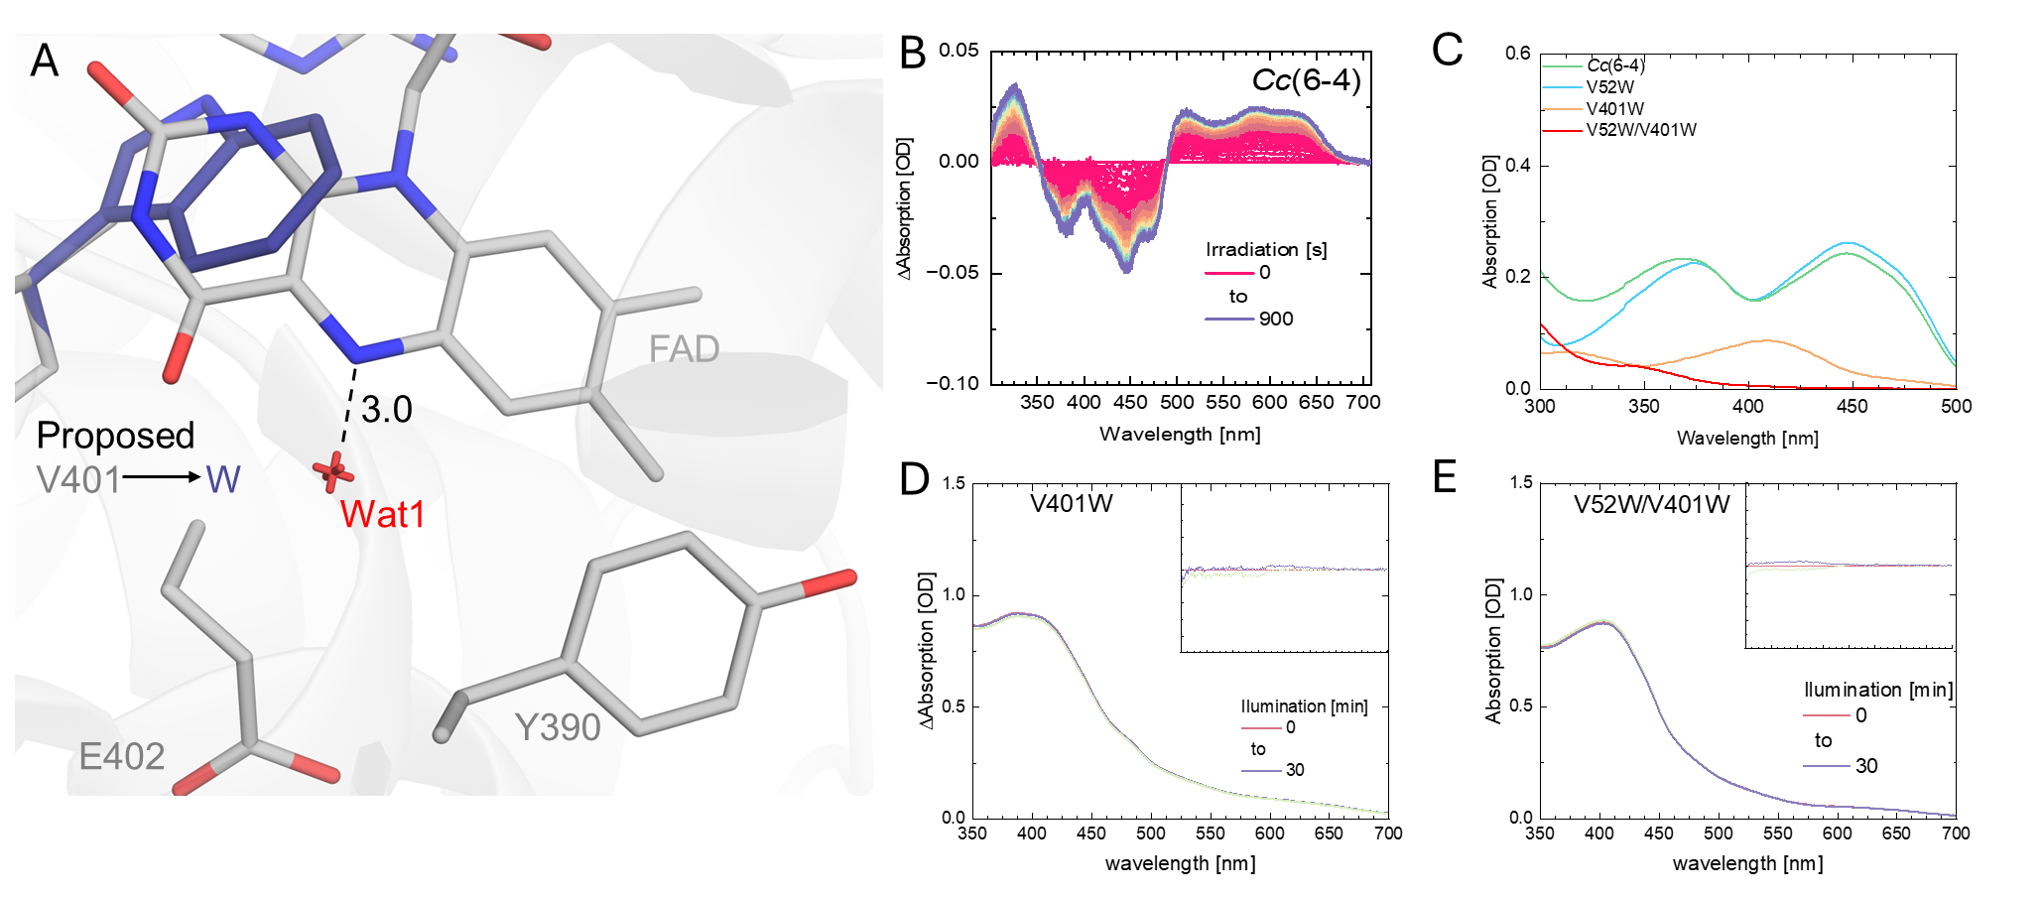
Figure S1. (A) Comparison between the crystal structure of Cc(6-4) PL and the modelled Cc(6-4)-V401W mutant. The V401W mutant is predicted to abolish FAD binding due to steric clashes. (B) In vitro photoreduction of Cc(6-4) PL using a 455 nm LED (1W, ThorLabs) at 350 mA. Cofactor extracts (C) obtained by heat denaturation of Cc(6-4) PL and therefrom derived mutants after 30 min at 95 °C and filtration. While the WT (green) and the antenna-free V52W mutant (blue) show the typical spectrum for free FAD, the FAD-depleted mutant V401W (yellow) shows only a peak at 410 nm which is characteristic of DLZ (1). For comparison the double mutant V52W/V401W (red) without both cofactors shows residual absorption which may be attributed to the FeS-content. Absorption spectra of the FAD-free mutants Cc(6-4) V401W (D) and V52W/V401W (E). Blue light illumination at 455 nm causes no significant spectral changes (upper inlays).

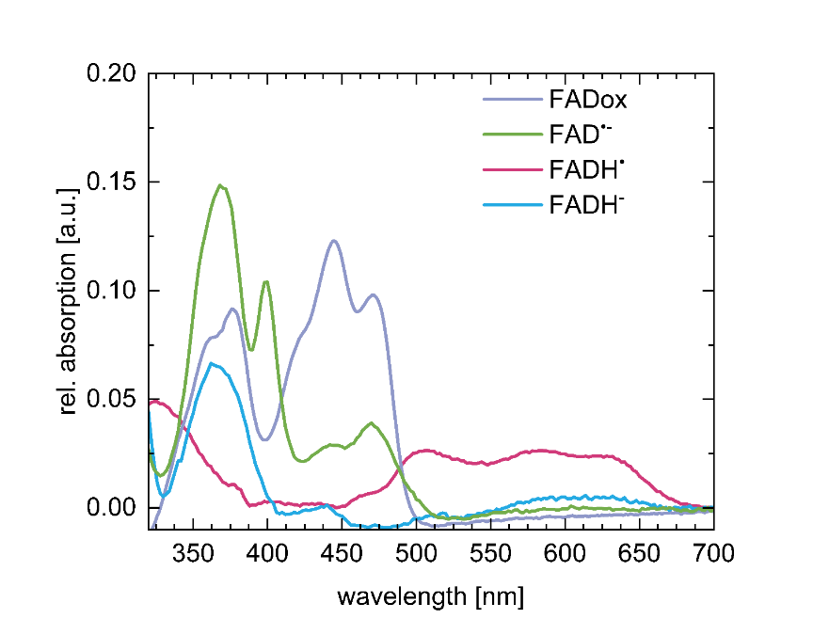 | 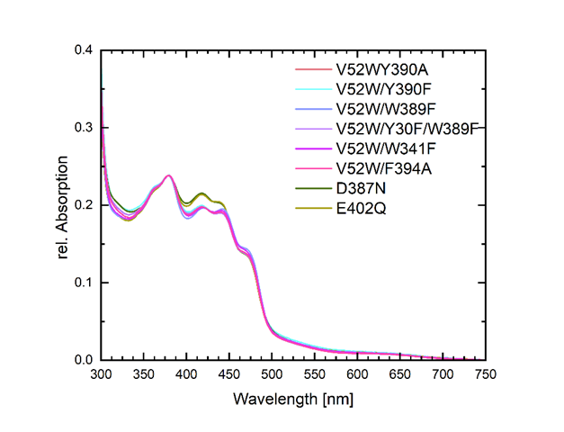
Figure S2. Absorption spectra of Cc(6-4) mutants and redox states. Left, FAD in its four Cc(6-4)-bound redox-/protonation-states. These spectra were derived from difference spectra between Cc(6-4) PL and the V401W mutant lacking the FAD cofactor (FAD_{ox}) and, after illumination (455 nm), with DTT for FADH– and without DTT for FADH•. For the FAD•– redox state, the V401W spectrum was subtracted from the illuminated TPP mutant E402Q. Notably, this state displays minor contamination by the FAD_{ox} and FADH• states. Right, absorption spectra of Cc(6-4) ET pathway variants V52W/Y390F, V52W/Y390A V52W/W389F, V52W/Y390F/W389F, V52W/W341F and V52W/F394A which show a lack of DLZ absorption unlike the TPP mutations D387N and E402Q. The absorption spectra were normalized to a protein concentration of 8 mg/mL.
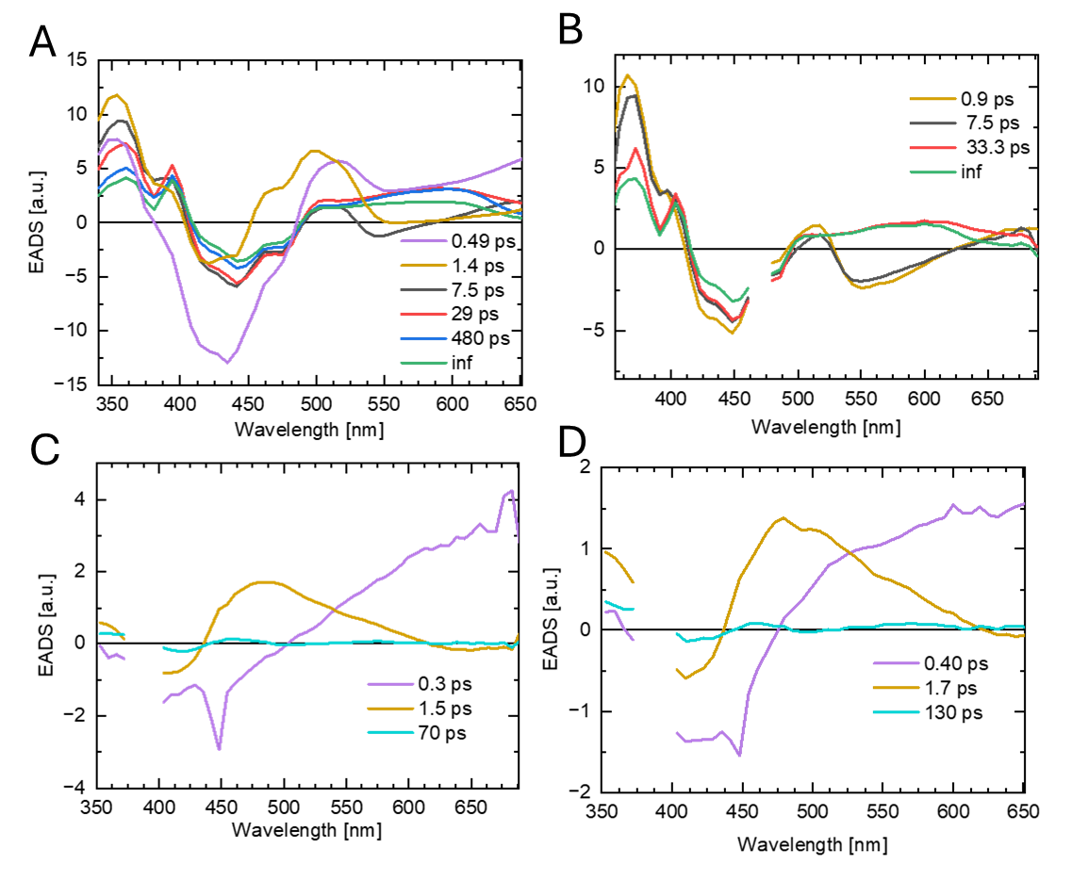
Figure S3. Evolution-associated decay spectra (EADS) for Cc(6-4) PL excited at 388 nm (A) and 470 nm (B). EADS spectra for the FAD-free V401W (C) and FAD-/DLZ-free V52W/V401W (D) mutants were obtained by excitation at 388 nm.
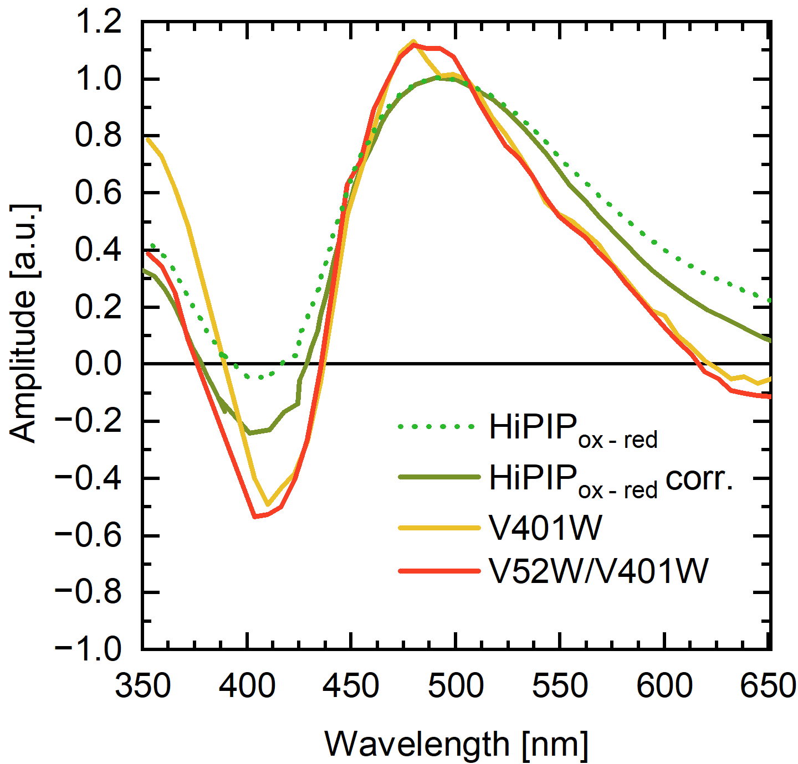
Figure S4. Spectral comparison of redox-induced changes in HiPIP and the light-induced
changes of Cc(6-4) V401 and V52W/V401W. The spectra of the Cc(6-4) constructs were obtained as EADS from kinetic analyses (1.5 ps and 1.7 ps) and normalized to 500 nm. The spectra of HiPIP (5) were digitized, and either directly normalized (dotted line) or baseline corrected at 700 nm before normalization (green line).

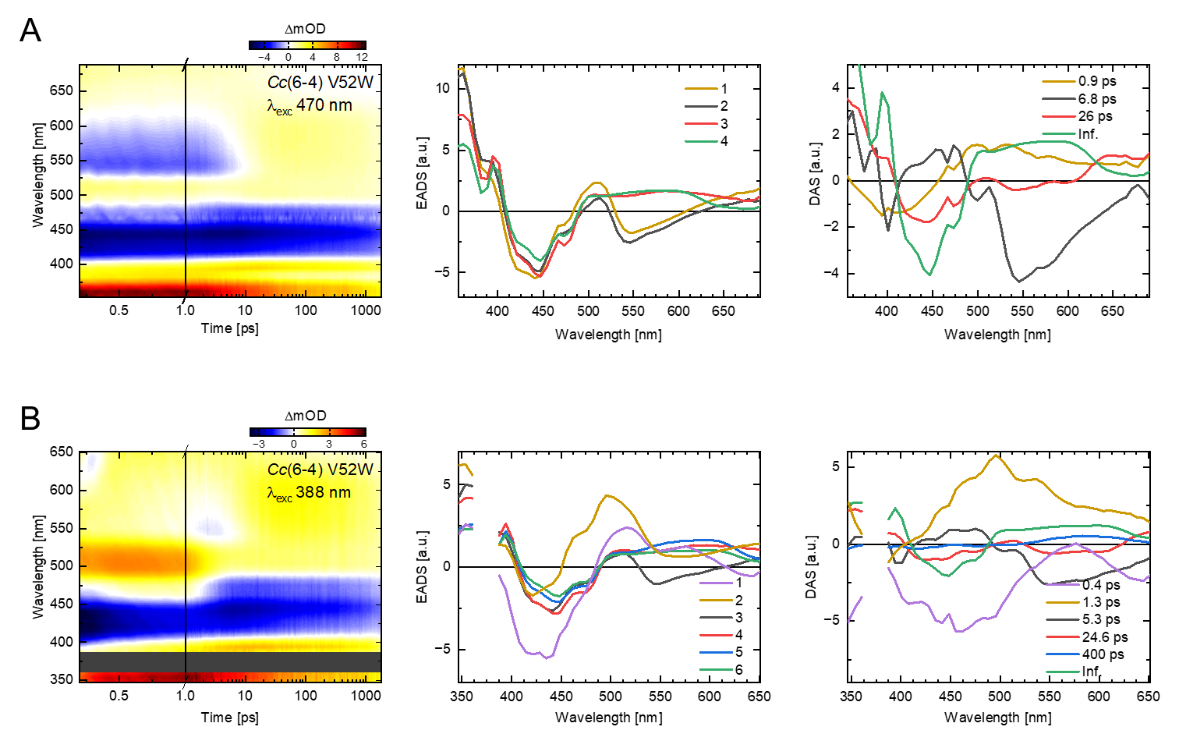
Figure S4. Ultrafast TA spectroscopy data and kinetic analyses. Using a sequential scheme for the DLZ-free mutant Cc(6-4) V52W and excitation wavelengths of 470 nm (A) and 388 nm (B), the panels show from left to right the transient map as well as the EADS and DAS obtained by kinetic analysis. Due to excitation scattering, the gray bars show the regions masked out from global analysis.
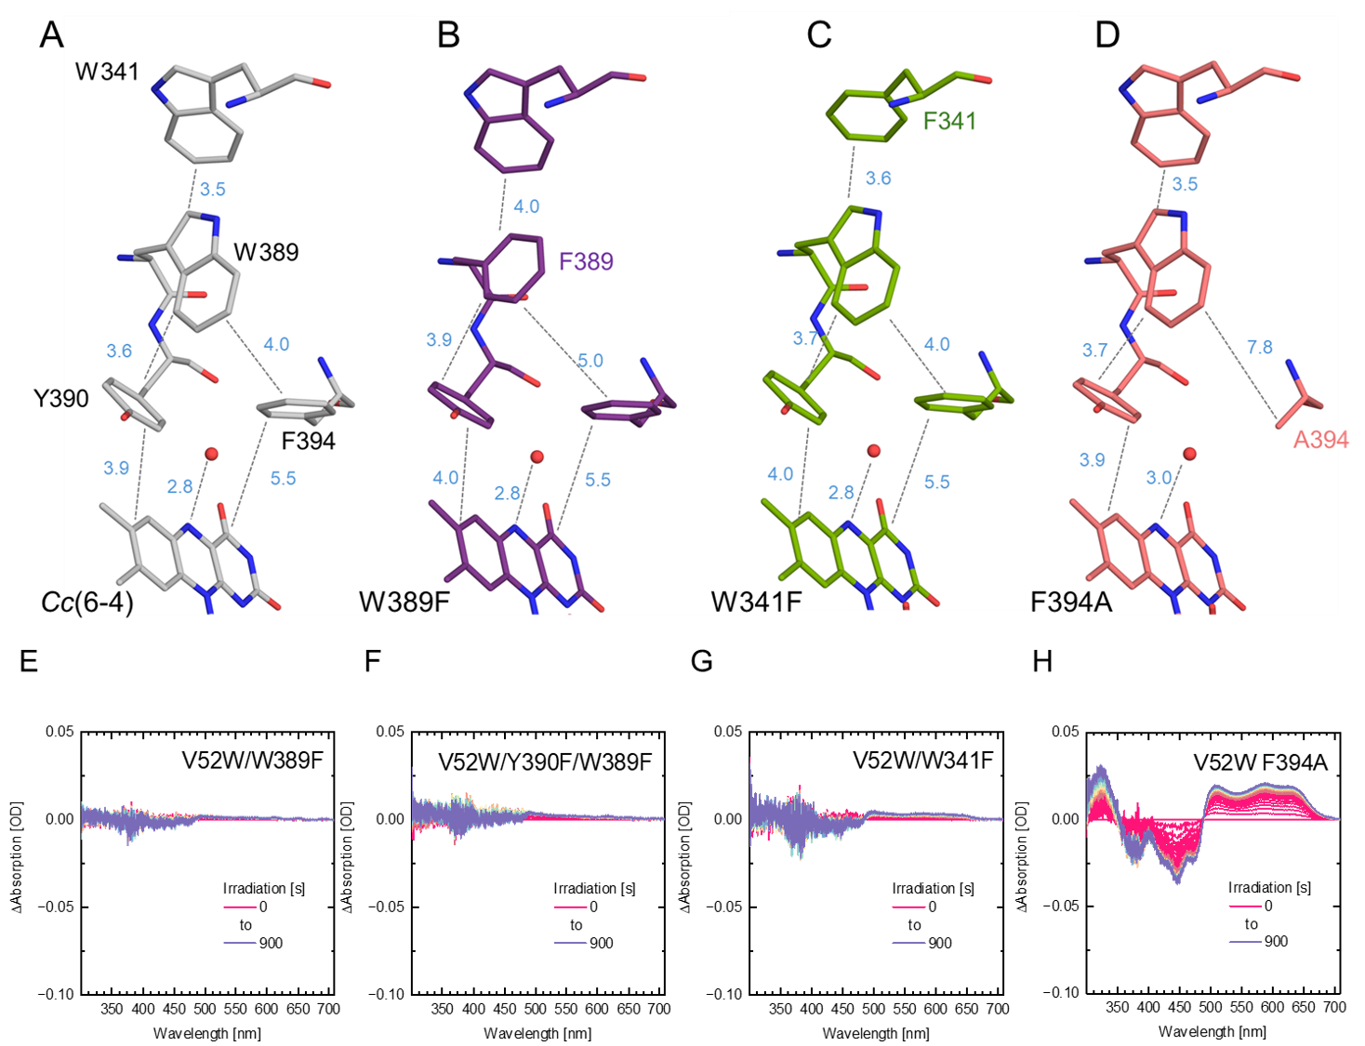
Figure S6. (A-D) Comparison of crystal structures of ET pathway variants without DLZ antenna due to V52W mutation. Edge-to-edge distances are marked in blue; statistics for (A-D) are found in Supplementary Table S1. The first (proximal) aromatic residue in the ET pathway of Cc(6-4) is Y390. To study the role of the second (medial) aromatic residue, W389, we analyzed steady-state photoreduction of the W389F (B, E) and Y390F/W389F (F) mutants. The last (distal) aromatic residue in the ET pathway is W341 and was characterized by the W341F mutant (C, G). Being a potential alternative to Y390, the F394A mutant of Cc(6-4) was found (D,H) of not being involved in the ET pathway. Accordingly, W389 and W341 are essential for FADH• formation upon illumination. The Y390F and F394A mutant still form FADH• like WT, while the Y390A mutant exhibits diminished FADH• accumulation (Fig. 3C). Difference spectra (E-H) for the in vitro photoreduction of Cc(6-4) via the ET pathway used a 455 nm LED (1W, ThorLabs) at 200 mA.

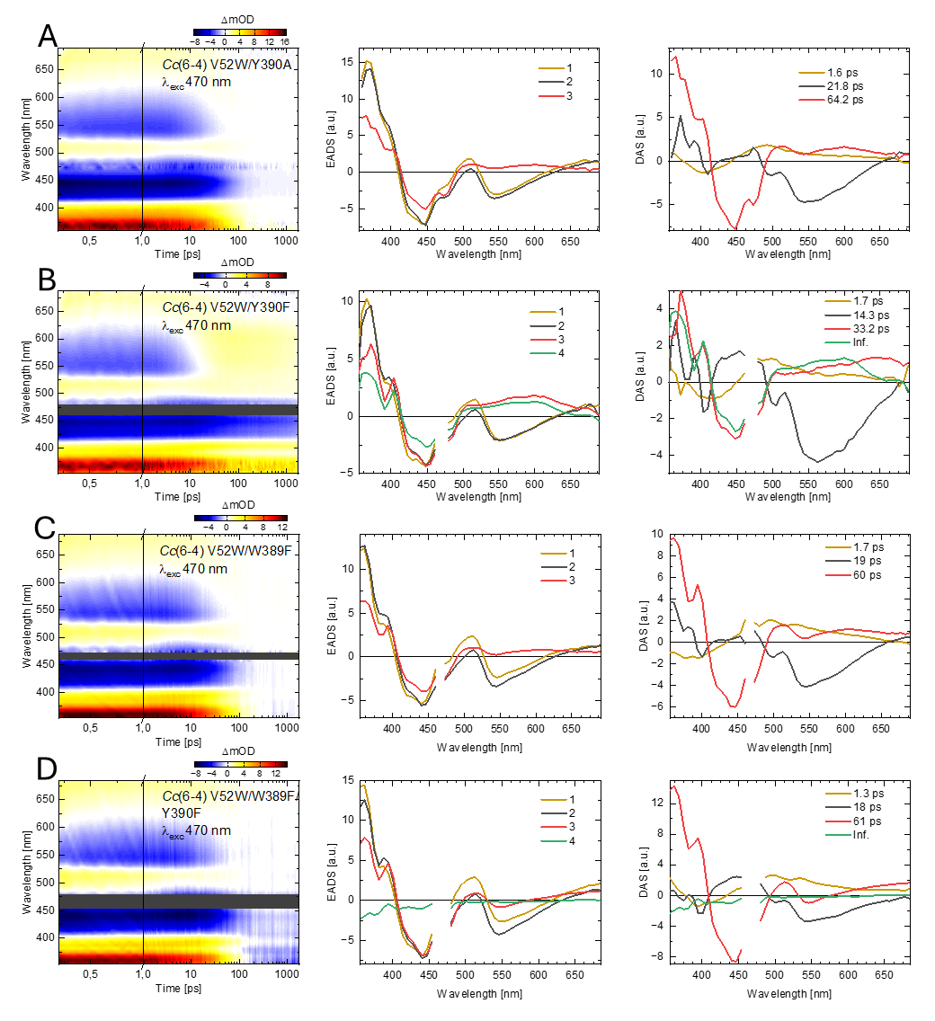
Figure S7. Ultrafast TA data and therefrom derived kinetic analyses of ET pathway variants of Cc(6-4) for the proximal Y390 (A-B) and medial W389 (C-D) positions at an excitation wavelength at 470 nm. From left to right, the panels show the transient map and therefrom derived EADS and DAS using a sequential kinetic scheme for global analysis. No residual components (Inf) were observed for the W389F and Y390A mutants, due to complete RP recombination after intramolecular reduction of the FAD.
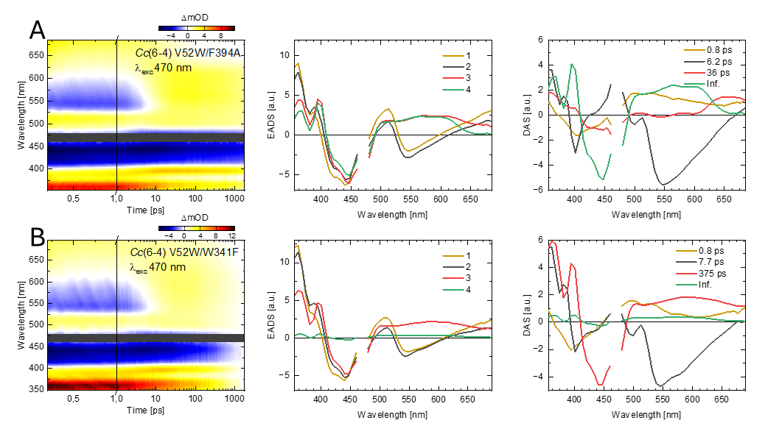
Figure S8. Ultrafast TA data and therefrom derived kinetic analyses of ET pathway variants of Cc(6-4) for the F394 (A) and the distal W341 (B) positions at an excitation wavelength at 470 nm. The V52W/F394A addressing the second aromatic residue (A) of the Yx₃F motif shows only minor effects compared to WT, whereas the V52W/W341F indicates a trapped RP.
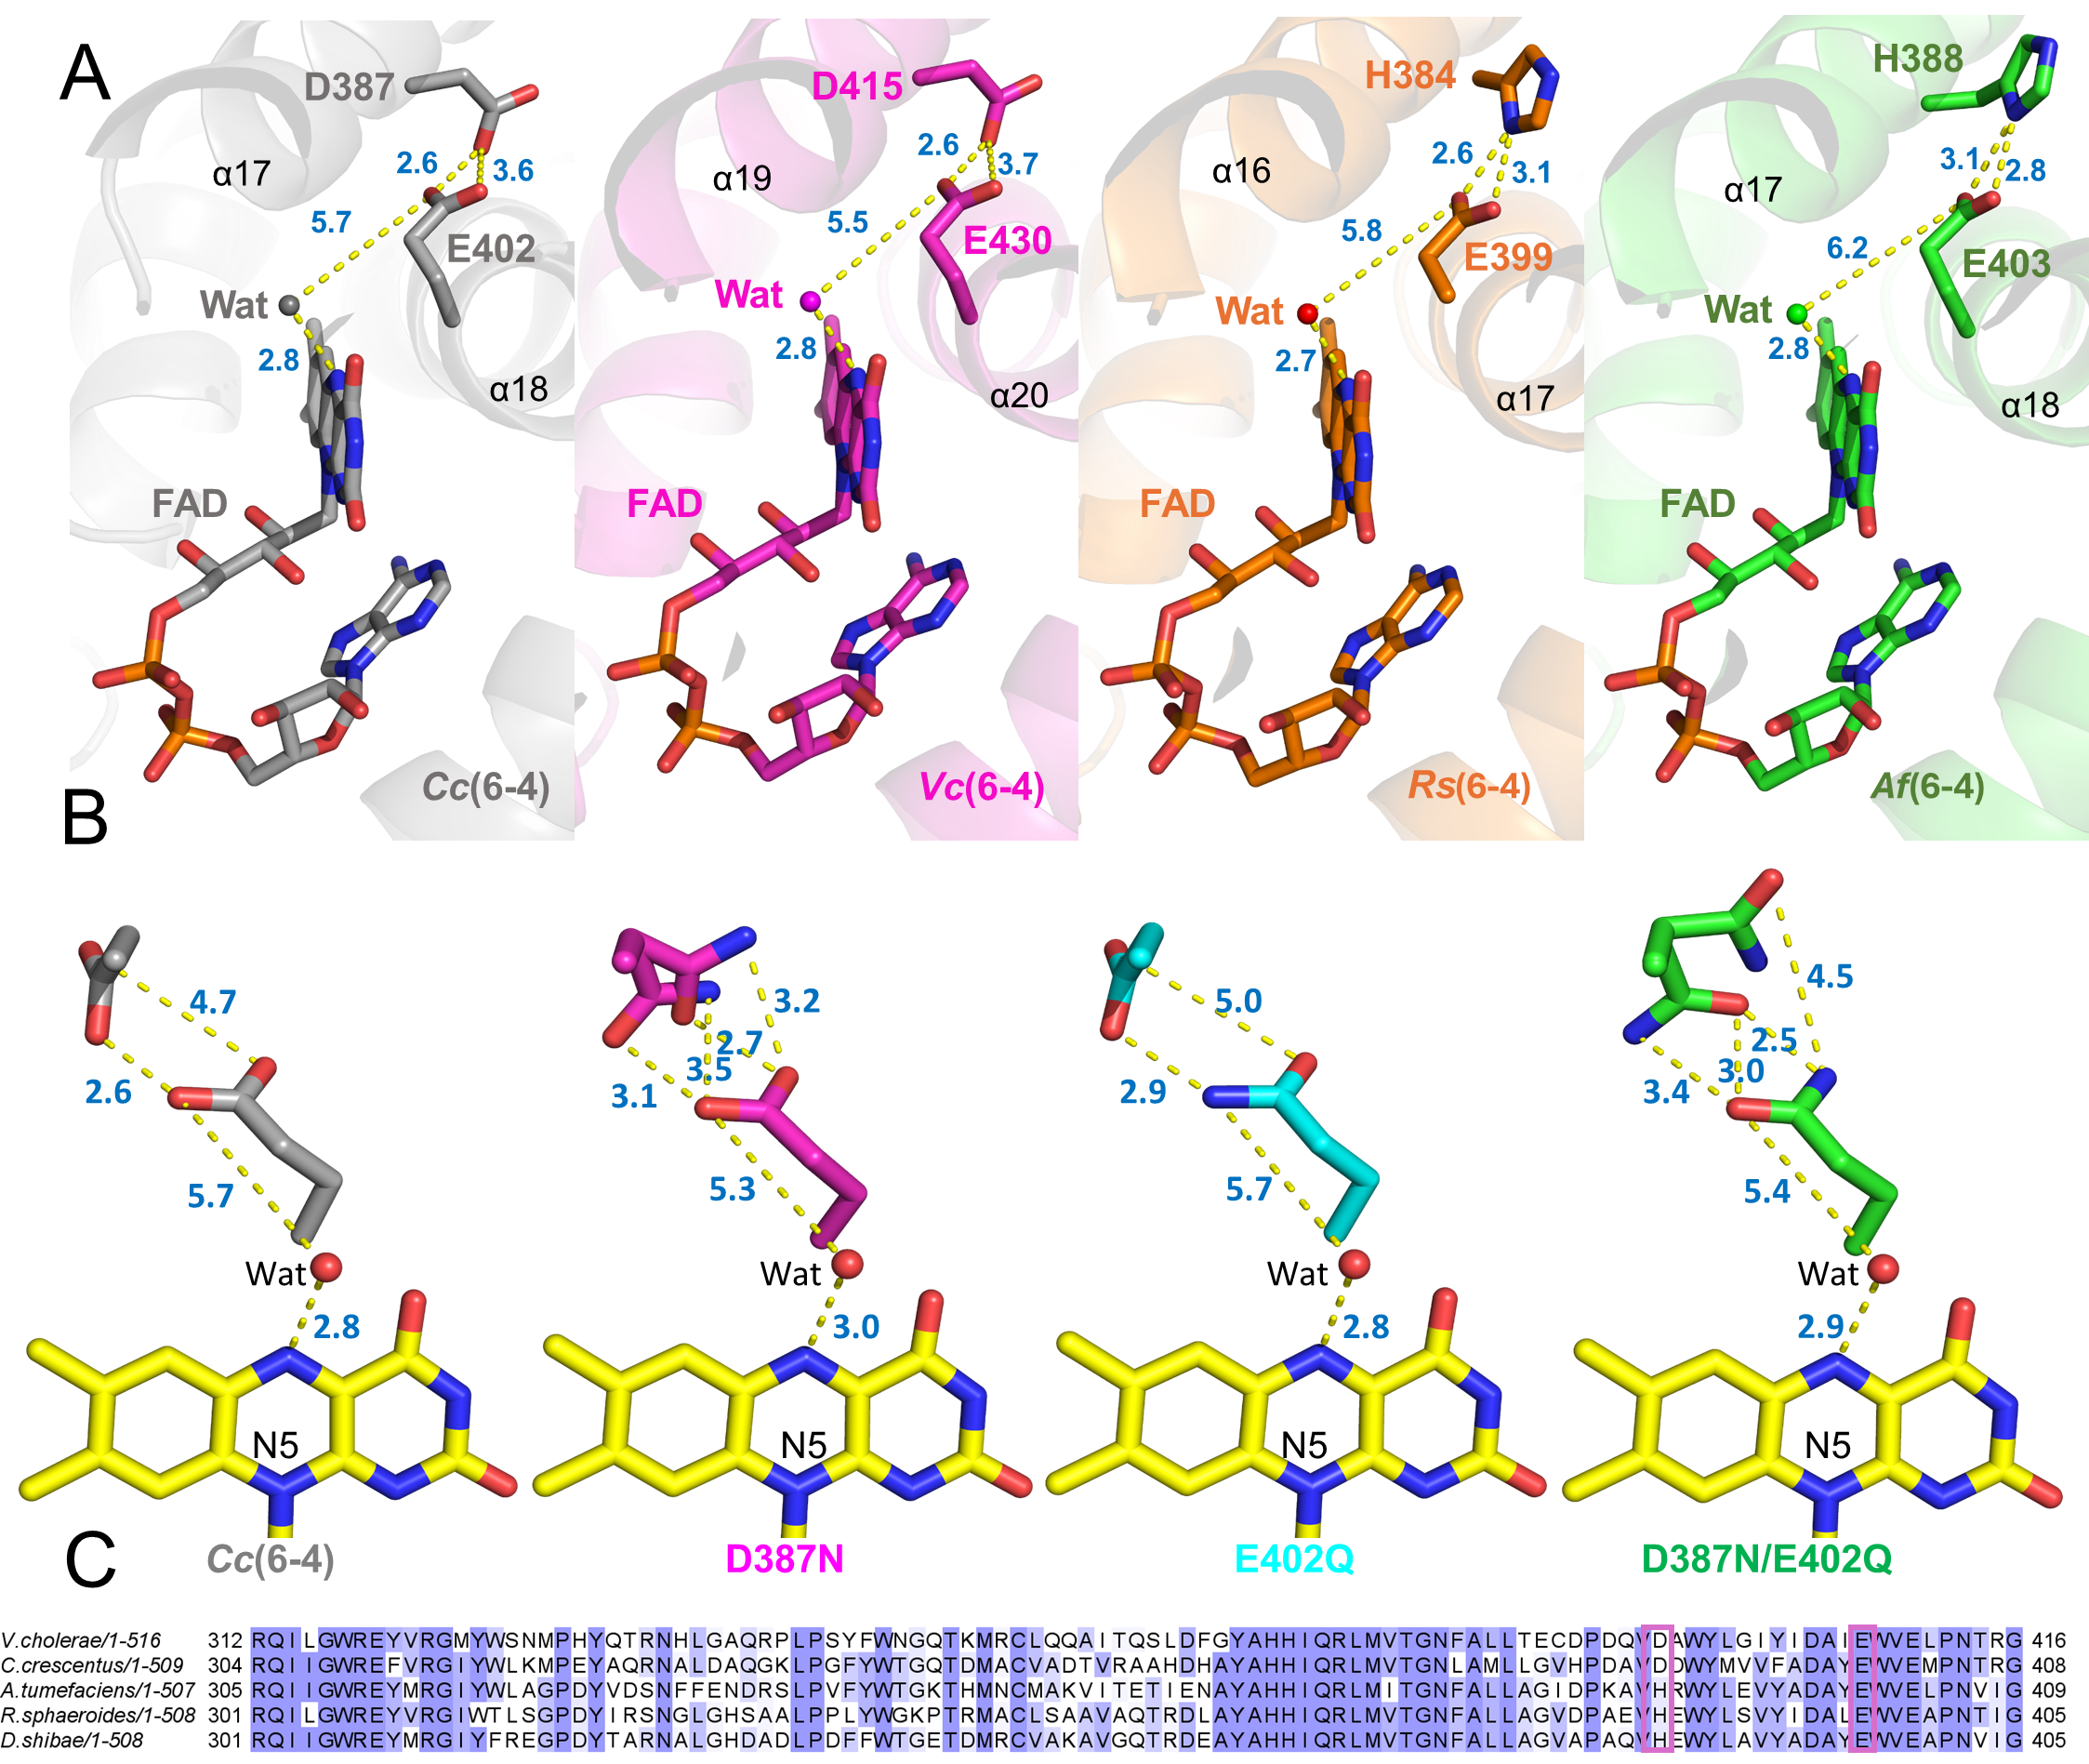
Figure S9 Structural details of the transient protonation pathways in prokaryotic (6-4) photolyases (A). The relative residues were shown by stick models. The Cc(6-4) was colored in grey, Vc(6-4)(2) (PDB entry: 8A1H, magenta), Rs(6-4) (PDB entry: 3ZXS, orange)(3) and At(6-4) (PDB entry: 4DJA, green)(4). The yellow lines indicated the distances in Å.(B) Structure comparison between Cc(6-4)-WT and its mutants within a protonation pathway.(C) Multiple sequence alignment for members of the prokaryotic (6-4)PLs with the TPP residues marked by magenta.

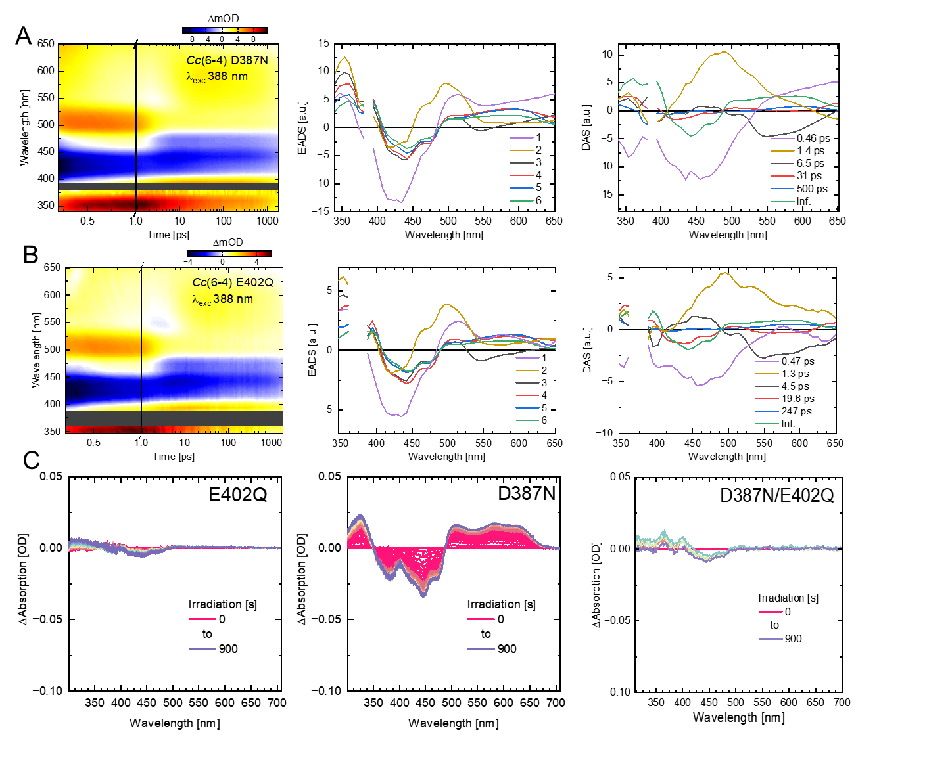
Figure S10. Ultrafast TA data and kinetic analysis of TPP variants (A) The D387N and (B) E402Q mutants were excited at 388 nm. From left to right the panels show first the transient map, EADS and DAS obtained from kinetic analysis using a sequential scheme. (C) In vitro photoreduction of E302Q, D387N and D387N/E402Q mutants using a 455 nm LED.

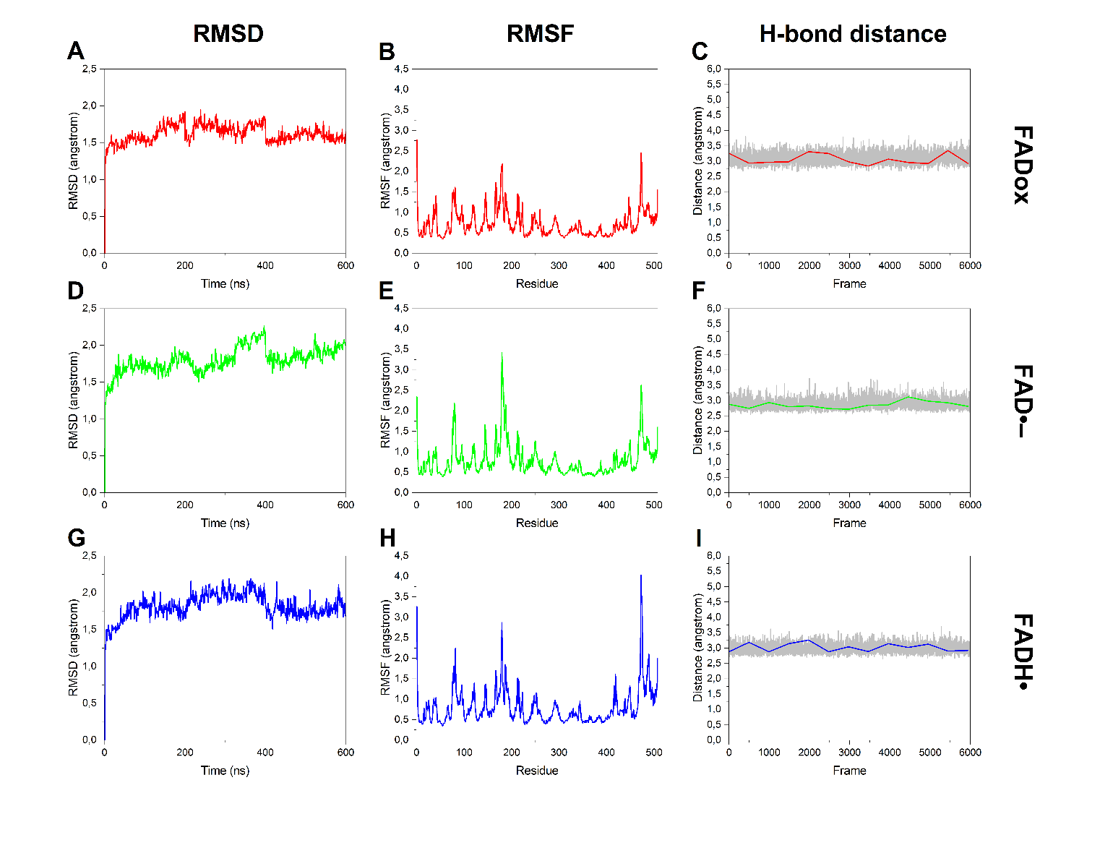
Figure S11. Conformational and dynamic analysis of hydrogen interactions in the three redox states of the FAD cofactor (FAD_{ox}, FAD^{•−}, FADH•) in 200 ns MD trajectories. (A-C) oxidized state (FAD_{ox}); (D-F) anionic semiquinoid state (FAD^{•−}); (G-I) neutral semiquinoid state (FADH•). Left column (A, D, G): root mean square deviation (RMSD) calculated from the initial structure after minimization and equilibration, indicating that all three systems reach a stable conformational plateau after 50–100 ns, with RMSD values between 1.2 and 1.6 Å. Middle column (B, E, H): root mean square fluctuation (RMSF) per residue, showing increased flexibility in N- and C-terminal regions (residues 1–10 and 500–508), and redox-dependent fluctuations in specific loop regions. In FAD_{ox}, enhanced mobility is observed at residues 179–181 (AEN) and 472–474 (GNG); in FAD^{•−}, this extends to 78–80 (PDN), 179–184 (AENRRK), and 472–475 (GDGR); in FADH•, fluctuations are more limited but still appreciable at residues 80 (G), 179–181 (AEN), and 472–475 (GDGR). Right column (C, F, I): time evolution of the dynamic distance between the N5 atom of FAD and a conserved water molecule (Water1) over the 6000 frames per trajectory. The gray line represents the global frame-by-frame trend, while the superimposed colored line shows the moving average over time windows of 495 frames, adopted to highlight significant redox-dependent interactions. Suppl. Table S2 shows the MD parameters.

Supplementary Methods

Guide for intermediate assignments in UV/Vis spectra of a prokaryotic (6-4) photolyase
References from literature: To discuss and evaluate our time-resolved results and identify the photoproducts, we analyzed the EADS from the global analysis. Evolution-associated difference spectra (EADS) contain the spectral information of each observed intermediate while assuming a sequential scheme (S1→S2→ S3 …). Decay-associated spectra (DAS) describe spectral changes observed during transitions between species; e.g., DAS1 shows the differences between S1 and S2, whereas S1 and S2 can be reconstructed from the contributions of the involved intermediates.
To obtain reference spectra from literature (Fig. 12A) figures were digitized by automeris (https://automeris.io) and interpolated with a 1 nm step-size using OriginLab 2024. For comparing the reference spectra to our data, we calculated difference spectra by combining the spectra of possible radical pairs and subtracting the bleach contribution from FAD_{ox} (Fig.12B). Based on these differences potential marker bands for the following assignment can be visually identified, e.g.: a double shoulder located at 380 nm and 400 nm when FAD_{ox} is reduced to FAD^{•-} (Fig.12B, green line). Additionally, we see that formation of FADH• from FAD_{ox} exhibits different characteristics in the region below 400 nm when compared to the FAD^{•-} /TrpH^{•+} RP (compare Fig. 12B, red vs blue lines).

A
B
Figure S12. Reference spectra for species assignment. (A) Reference spectra from literature are shown for FAD^{•-}(6),FAD_{OX} (7), FADH•(8) ,TrpH^{•+}(9), TyrO•(10), Trp•(9), TyrOH^{•+}(11). (B) Difference spectra calculated from (A) for assigning signals in time-resolved and steady-state spectroscopy.
Furthermore, transient radical pairs (RP) have been identified in other FAD-binding proteins as well, e.g. the FAD^{•-}/TyrOH^{•+} radical pair in a light-excited ferredoxin-NADP⁺ oxidoreductase, BsFNR (11). These serve as additional references and enable an assessment of deviations between reference and experimental data (Fig.S13).

A
B
Figure S13 Literature data (11) for BsFNR and its light-triggered FAD^{•-}/YOH^{•+} radical pair. (A) Experimentally obtained absorption spectra (solid lines) of the radical pairs FAD^{•-}/YOH^{•+} of BsFNR wild type and FAD^{•-}/WH^{•+} of its Y50W mutant. (B) EAS of picosecond phases as obtained from global analysis of the wild type with FAD and a proximal, isolated tyrosine, Y50, and the Y50W mutant from BsFNR as obtained by Zhuang et al.(11). The corresponding simulated spectra, generated from reference spectra of Fig. 12, are shown as dotted lines.

Spectral assignments in EADS obtained from fs-TA data: No additional scaling was performed and molar extinctions were used, unless otherwise stated. Based on our analysis, when exciting Cc(6-4) at 470 nm, the [4Fe-4S]²⁺ cluster is co-excited. This results in the observed dynamics within the first two ps. To focus on the FAD_{ox}-related dynamics we compare EADS after rapid decay of the [4Fe-4S]²⁺-related dynamics by excluding EADS1.
A direct comparison is provided for four selected Cc(6-4) mutants in the subsequent sections (i) to (v), as all other measurements contain the same spectral intermediates and can thus be analyzed by direct comparison to the spectra shown below. First, the DLZ-free V52W mutant is assessed as an example for a functional Y-W-W ET pathway. Secondly, the V52W/Y390A mutant highlights the effects of a missing proximal aromatic bridge, creating an A-W-W ET pathway that is interrupted at the proximal position. Thirdly, the V52W/W389F mutant is expected to stop the ET pathway after initial ET, creating a Y-F-W ET path. This blockage would be a candidate for accumulating a transiently formed TyrOH^{•+} species, as observed before in light-excited BsFNR (11), and could thus be an indicator for a hopping mechanism, i.e. direct ET from the proximal aromatic residue in Cc(6-4). Lastly, EADS3 of the V52W/W341F mutant is compared to EADS3 and EADS4 of V52W to identify spectral differences between W389H^{•+} at its medial position and W341H^{•+} at the distal, solvent-exposed position.
In all ET pathway variants EADS1 and EADS2 (Fig. S14A, S14B) are both dominated by contributions of the FAD_{ox} excited state (ES) and ground state bleach (GSB). The GSB is located at the FAD_{ox} absorption at 450 nm, while the population of the ES can be identified by the negative signal corresponding to the stimulated emission (SE) centered at 550 nm and the two excited state absorption (ESA) bands below 400 nm (ESA1) and above 620 nm (ESA2), as commonly described in literature.(7, 11, 12) The combination of GSB at 450 nm and SE at 550 nm can be used to determine whether the FAD_{ox} is present in the ES. A combined loss of the SE and GSB occurs when FAD directly decays from the ES back to the ground state (GS), without photochemical reactions. This also implies that no further spectral evolution takes place and no observation of any other EADS shape than that of EADS2 is detectable. Residual differences between EADS1 and EADS2 can be assigned to the [4Fe-4S] cluster. Photoinduced oxidation of the [4Fe-4S]²⁺ cluster in Cc(6-4) wild type (Fig. 2B, Fig. S4) contributes to absorption changes at ~415 nm and 500 nm in EADS1 throughout all Cc(6-4) variants, which are decayed in EADS2. As illustrated by the three Cc(6-4) mutants V52W, V52W/Y390A, and V52W/W389F, EADS3 differs significantly from EADS2 (Fig. S14C). This indicates that a photoreaction occurs during the decay of the FAD_{ox} ES in all three ET pathway variants. By comparing normalized EADS, we can assign all intermediates of the photoreaction and disregard recombination events, as the latter only result in amplitude losses in difference spectra. To assign the intermediates present in EADS3 and EADS4 of all ET pathway variants, subsections (i)-(v), we refer to the reference spectra as presented in Fig S12B.
A
B
C
Figure S14. Normalized EADS1 (A),EADS2 (B) and EADS3 (C) of the Cc(6-4) mutants V52W, V52W/Y390A and V52W/W389F from global analysis of time-resolved UV/Vis spectra when using an excitation at 470 nm (conditions also used for Suppl. Fig. S15-S19).

(i) Transient intermediates of the functional ET pathway in Cc(6-4), Y-W-W: The V52W mutant shows the same kinetic behavior as the WT when FAD_{ox} is excited. Its global analysis required four lifetimes, resulting in one additional EADS due to the formation of a stable radical pair (RP) existing beyond the observed timescale of 1.8 ns. A comparison of the resulting EADS to the simulated intermediate spectra is shown in Fig. S15 and Fig. S16.
A
B
C
Figure S15. Comparison of EADS3 from Cc(6-4) V52W normalized to 447 nm to potentially observed intermediate species. A) compares EADS3 to a formation of RP FAD^{•-} /TrpH^{•+}, B) compares EADS3 to FAD^{•-} formation without any additional cation being considered, and C) compares EADS3 to a formation of RP FAD^{•-} /TyrOH^{•-}. From the appearance alone, all simulated spectra do not exactly match the observed EADS, yet the RP FAD^{•-} /TrpH^{•+} shows the least deviations across all wavelengths.

The transition from EADS3 to EADS4 includes a sharpening of the positive signature ~600 nm, a change in absorption that is associated with cooling/hopping, and the environment of the TrpH^{•+}. Due to the spectral shape and kinetic analysis, the RP FAD^{•-} and TrpH^{•+} is formed with the decay of the ES and present in EADS3. Comparing EADS3 to the experimental reference shown in Fig. S13B, shows how the contributions from the RP TrpH^{•+} are less pronounced and stretched up to 700 nm. Propagation/cooling of EADS then results in a spectrally similar EADS4 that also represents FAD^{•-} and TrpH^{•+}, matching the simulated spectrum much better. For further assignment of the spectral sharpening to the two tryptophans W389 and W341 refer to (iv).
A
B
C
Figure S16. Comparison of EADS4 from Cc(6-4) V52W normalized to 447 nm to potentially observed intermediate species. A) compares EADS4 to a formation of RP FAD^{•-} /TrpH^{•+}, B) compares EADS4 to FAD^{•-} formation without any additional cation being considered and C) compares EADS4 to a formation of RP FAD^{•-} /TyrOH^{•-}. The RP FAD^{•-} /TrpH^{•+} shows the least deviations across all wavelengths and nicely describes the observed difference signal without any spectral adjustments.

(ii) Transient intermediates of a proximally interrupted ET pathway, A-W-W: The V52W/Y390A mutant exhibits kinetic and spectral deviations in the fs-TA data when compared to the functional Y-W-W ET pathway. Its global analysis required three lifetimes, resulting in a complete decay of difference signals on the observed timescale of 1.8 ns. As EADS2 represented the ES of FAD_{ox} the only observed RP is present in EADS3. Fig. S17 compares EADS3 to possible RP combinations.
EADS3 of V52W/Y390A shows the signature at ~400 nm that indicates FAD reduction to FAD^{•-}. Given that none of the possible RP combinations shown in Fig. S17 exactly matches the observed differences, the simple FAD^{•-} + FAD_{ox} apparently describes better the observed signals. Notably, no accumulation of TrpH^{•+}, e.g. by W389, is observed when the aromatic side chain of Y390 is missing. This indicates that Y390 is essential for efficient and long-lived charge separation. For explanation of the now apparently missing electron donor refer to section (v).

A
B
C
Figure S17. Comparison of EADS3 from Cc(6-4) V52W Y390A normalized to 447 nm to potentially observe intermediate species. A) compares EADS3 to a formation of RP FAD^{•-} /TrpH^{•+}, B) compares EADS3 to FAD^{•-} formation without any additional cation being considered and C) compares EADS3 to a formation of RP FAD^{•-} /TyrOH^{•-}. The formation of FAD^{•-} (B) shows the least deviations across all wavelengths and misses additional absorptions below 390 nm and around 600 nm.

(iii) Transient intermediates of a medially interrupted ET chain, Y-F-W: The V52W/W389F mutant allows us to construct a Y-F-W ET chain. This, in theory, allows us to block the chain after the initial ET from Y390 to investigate the formation of TyrOH^{•+}. This ET pathway variant exhibits kinetic and spectral deviations in the fs-TA data when compared to a functional ET chain. Its global analysis required three lifetimes and shows a complete decay of difference signals on the observed timescale of 1.8 ns. As EADS2 represented the ES of FAD_{ox} the only observed RP is present in EADS3. Fig. S18 compares EADS3 to possible RP combinations.
Comparing the V52W/W389F mutant to possible intermediates, again the best description of EADS3 is obtained by the reduction of the FAD to FAD^{•-} like for the Y390A mutant. Again, no Y390^{•+} can be observed in this ET pathway variant. However, the spectral intermediates and lifetimes are identical to those observed in the V52W/Y390A mutant. Accordingly, a common electron donor explaining the remaining positive differences at ~600 nm and below 380 nm must be present in both variants, see (v).
Figure S18. Comparison of EADS3 of the Cc(6-4) V52W/W389F mutant, normalized to 447 nm, to potentially observed intermediate species. (A) compares EADS3 to formation of an FAD^{•-} /TrpH^{•+} RP, whereas (B) compares EADS3 to FAD^{•-} formation without an additional aromatic cation radical. (C) compares EADS3 to formation of RP FAD^{•-} /TyrOH^{•-} that would be an indicator of a hopping mechanism However, formation of FAD^{•-} (B) shows the least deviations across all wavelengths and misses additional absorptions below 390 nm and around 600 nm.
A
B
C

(iv) Transient intermediates of a distally interrupted ET pathway, Y-W-F: To prove the contribution of the distal Trp W341 to the ET pathway of Cc(6-4) we compare the ultrafast dynamics of the V52W and the V52W/W341F mutants. The comparison of the TA data presented above reveals that the signal decayed by ~95%, as illustrated by EADS4 of V52W/W341F, which exhibits only very small amplitudes (Fig. S8B). This can be rationalized by a lack of further separation of the FAD^{•-}/TrpH^{•+} RP from the medial position W389, as the distal W341, and thus a pathway to the protein surface, is now missing. This results in a slow but nearly complete recombination within 1.8 ns after excitation. By comparing EADS3 of the V52W/W341F mutant to the functional ET pathway of V52W, we obtain spectral indicators that allow us to identify spectral differences between the W389H^{•+} and W341H^{•+} species (Fig. S19). Here, the medial W389H^{•+} that is protected from solvent access exhibits a slightly red-shifted, broader absorption than the distal and solvent-exposed W341H^{•+}.
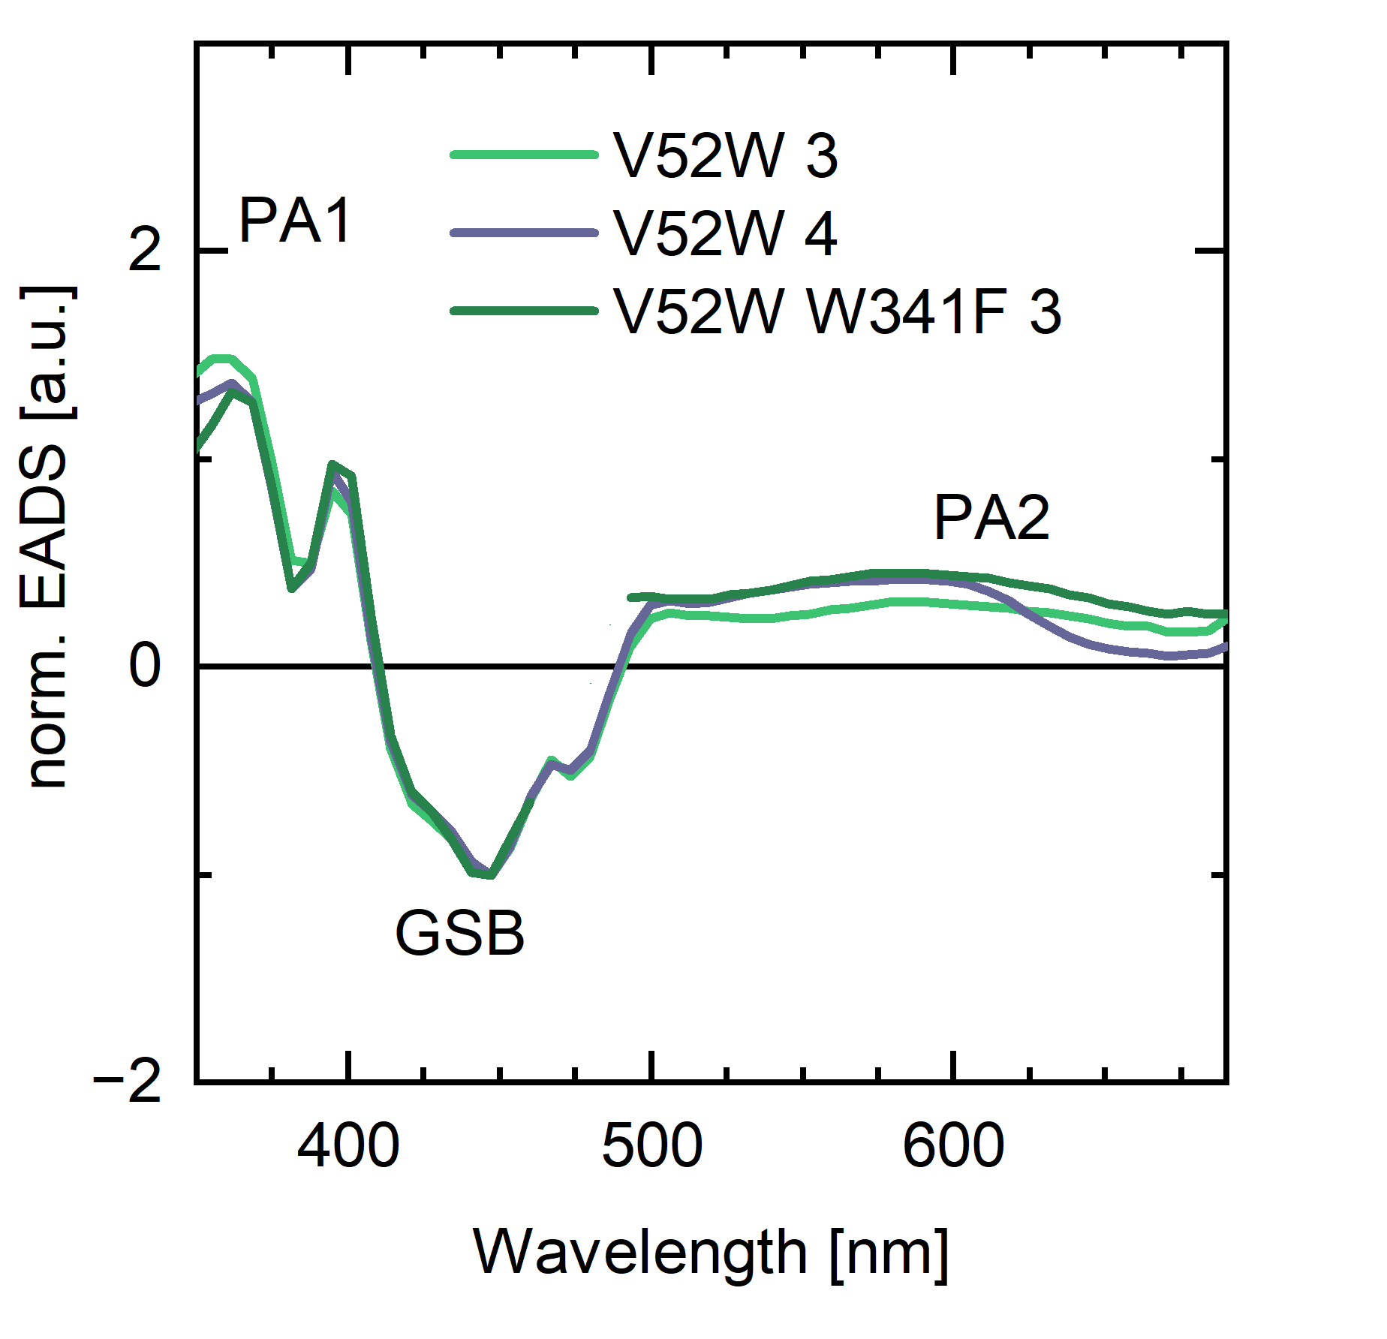
Figure S19. Comparison of EADS3 and EADS4 of Cc(6-4) V52W and EADS3 of the V52W/W341F mutant normalized to 447 nm to highlight spectral differences between ET pathways consisting of the Y-W-W triad and a Y-W dyad, respectively. The data around 470 nm for V52W/W341F were masked due to excitation scattering. Notably, spectral differences above 600 nm indicate that W389H^{•+} (medial) exhibits a red shift compared to W341H^{•+} (distal).

(v) Transient intermediates with blocked intra-protein ET pathways, formation of the internal FAD RP: The remaining EADS3 signals of the V52W/Y390A and V52W/W389F mutants at ~600 nm and below 380 nm can be explained by ET within the FAD chromophore. The characteristic FAD^{•-} spectrum as described above is only caused by reduction of the isoalloxazine moiety. When the adenosine moiety gets concomitantly oxidized to its radical cation (Ade^{•+}), it exhibits a distinct spectral signature as shown in Fig. S20A . Accordingly, the difference spectrum between an FAD species with internal ET from its adenine to isoalloxazine moiety and FAD_{ox} corresponds to the sum of the FAD•– – FAD_{ox} difference spectra and the Ade^{•+} spectrum. Indeed, EADS3 of V52W/Y390A and V52W/W389F (Fig. 20B) correspond closely to such an FAD species with internal RP, especially below 400 nm and at 600 nm for the Ade^{•+} species, while the simple FAD•– – FAD_{ox} difference spectrum without Ade⁺ contribution fails to account for the observed differences. Likewise, neither TyrOH^{•+} nor TrpH^{•+} explain the observed differences (Fig. S17, S18). Taking these spectral indicators with the previously reported lifetimes reported by Liu et al (12) into account, we can assign the EADS3 phases of the proximally and medially blocked ET pathway variants to transient RP formation within the FAD chromophore.
A
B
Figure S20. (A) Comparison of two different Ade^{•+} spectra from literature, Ade^{•+} (13) and Ade^{•+} II (14). To obtain Ade^{•+} II_{scaled,} we subtracted 0.6x10³ and scaled by a factor of 0.33, to obtain similar extinctions while not overestimating the contributions at ~450 nm. (B) Comparison of EADS3 from the V52W/Y390A and V52W/W389F mutants to the simulated spectrum of the RP FAD^{•-} + Ade^{•+}. Notably, the reference spectra are measured in solution, while the U-shaped FAD is confined in Cc(6-4) with charges both on the nearby isoalloxazine and adenine moieties.

Supplementary Tables
Table S1. Synchrotron data and refinement statistics for structures of Cc(6-4)PL mutants.
Structures | WT | D387N | E402Q | D387N  E402Q | V52W | V52W  Y390F | V52W  Y390A | V52W  W341F | V52W  F394A | V52W  W389F
PDB code | 9T7Y | 9T7Z | 9T80 | 9T81 | 9T82 | 9T83 | 9T84 | 9T85 | 9T86 | 9T87
Beamline | ID30A-3, ESRF | ID30A-3, ESRF | P13, EMBL | ID30A-3, ESRF | ID23-2, ESRF | ID23-2, ESRF | ID23-2, ESRF | ID30A-3, ESRF | ID30A-3, ESRF | P13  EMBL
Wavelength (Å) | 0.968 | 0.968 | 0.976 | 0.968 | 0.873 | 0.873 | 0.873 | 0.968 | 0.968 | 0.976
Space group | P2₁2₁2₁ |  |  |  |  |  |  |  |  | C222₁
Unit cell (a, b, c)* | 49.35, 102.65, 103.04 | 49.38, 102.70, 103.09 | 49.20, 102.45, 102.44 | 46.78, 102.60, 104.27 | 46.60, 101.96, 104.24 | 46.58, 102.35, 103.99 | 48.94, 102.85, 103.28 | 49.27, 102.6, 103.73 | 47.86, 102.18, 104.40 | 85.68, 160.15, 94.92
Processing statistics
Completeness (%) | 97.16 (94.13) | 95.19 (70.10) | 99.76 (99.60) | 99.14 (94.06) | 98.43 (97.17) | 97.50 (82.43) | 99.84 (98.96) | 97.95 (99.64) | 98.21 (87.36) | 99.96 (99.98)
Total reflections | 1124155  (114224) | 573683  (36774) | 1020346  (97162) | 387158  (23801) | 557676  (54807) | 388965  (34408) | 523090  (42114) | 111877 (11530) | 144091 (10668) | 605540 (61818)
Unique reflections | 82671 (8072) | 44958 (4067) | 75787 (7464) | 46951 (4371) | 46692 (4542) | 29535 (2681) | 49091 (4784) | 30833 (3074) | 20328 (1760) | 44442 (4382)
Multiplicity | 13.6 (14.2) | 12.8 (9.0) | 13.5 (13.0) | 8.2 (5.4) | 11.9 (12.1) | 13.2 (12.8) | 10.7 (8.8) | 3.6 (3.8) | 7.1 (6.1) | 13.6 (14.1)
CC1/2 | 0.999 (0.955) | 0.994 (0.681) | 0.997 (0.677) | 0.998 (0.589) | 0.999 (0.802) | 0.999 (0.949) | 0.998 (0.351) | 0.992 (0.879) | 0.993 (0.714) | 0.998 (0.807)
I/σ | 23.96 (5.61) | 15.09 (0.63) | 10.71 (1.57) | 11.86 (1.64) | 17.72 (1.72) | 22.67 (3.31) | 13.53 (1.72) | 10.36 (4.11) | 8.56 (1.33) | 13.04 (1.61)
R_{merge} | 0.088 (1.884) | 0.200 (1.957) | 0.178 (1.399) | 0.131 (1.124) | 0.148 (11.740) | 0.115 (8.229) | 0.117 (1.450) | 0.111 (0.391) | 0.212 (1.335) | 0.118 (1.291)
Wilson B-factor | 11.33 | 17.32 | 16.62 | 24.31 | 22.59 | 25.45 | 26.90 | 18.42 | 38.06 | 40.44
Refinement statistics
Resolution range (Å) | 46.05-1.50  (1.55- 1.50) | 40.86-1.85  (1.92 - 1.85) | 45.82-1.55  (1.61-1.55) | 46.03-1.80  (1.86-1.80) | 46.41-1.80  (1.86-1.80) | 45.92-2.10  (2.18-2.10) | 44.23-1.80  (1.86-1.80) | 44.51-2.10 (2.18-2.10) | 46.49-2.40 (2.49-2.40) | 47.46 -2.0 (2.07-2.0)
Unique reflections | 82137 (7829) | 43383 (3139) | 75737 (7458) | 46944 (4370) | 46130 (4492) | 29055 (2406) | 49075 (4780) | 30833 (3074) | 20316 (1756) | 44430 (4381)
R-work | 0.1411 (0.2192) | 0.1850 (0.4343) | 0.1695 (0.2298) | 0.1809 (0.2743) | 0.1794 (0.2580) | 0.1782 (0.3573) | 0.1759 (0.2881) | 0.1662 (0.1855) | 0.2006 (0.2930) | 0.1941 (0.3207)
R-free | 0.1638 (0.2422) | 0.2011 (0.4285) | 0.1901 (0.2560) | 0.2081 (0.3305) | 0.2122 (0.3176) | 0.2157 (0.4112) | 0.2053 (0.3047) | 0.2120 (0.2510) | 0.2360 (0.3408) | 0.2237 (0.3545)
Ramachandran outliers (%) | 0 | 0 | 0 | 0 | 0 | 0 | 0 | 0 | 0 | 0
Number of non-H atoms | 5019 | 4799 | 4708 | 4620 | 4571 | 4561 | 4399 | 4528 | 4214 | 4378
RMS (bonds, Å) | 0.006 | 0.004 | 0.013 | 0.009 | 0.010 | 0.002 | 0.016 | 0.002 | 0.002 | 0.006
RMS (angles, deg) | 0.97 | 0.80 | 1.25 | 1.09 | 1.16 | 0.54 | 1.44 | 0.55 | 0.55 | 0.81
Average B factor | 16.47 | 20.56 | 21.75 | 30.07 | 27.90 | 28.62 | 34.58 | 20.17 | 45.77 | 48.39
*α=β=γ=90°
Numbers in parenthesis describe the highest resolution shell. V52W/W389F crystallizes in space group C222₁ as its crystals were obtained in 15 % PEG3350 (v/v) rather than 25 %.
Table S2 System setup for MD simulations of Cc(6-4) PL
Parameter | Value/Description
Software | AMBER24
Force Field | ff19SB (protein), SF4, GAFF (non-standard residues)
System | Cc(6-4)PL (PDB: 9HNM and 9HNN, Uniprot entry Q9AAF5), SF4, FAD cofactor (FAD_{ox} or FAD^{•−} or FADH•),  DLZ, protein-bound waters
Non-standard Residues | SF4, FAD cofactor (FAD_{ox} or FAD^{•−} or FADH•), DLZ
pH | 7.0
Bonds | Cys-SF4 bonds
Preprocessing | Residue renaming: PDB 9HNM, Wat866 in Wat1; PDB 9HNN, Wat745 in Wat1;  ASP to ASH; GLU to GLH with proton addition (HD2, HE2); HIS264 with proton addition (HD2, HE2)
Solvent | Cubic water box (OPC model), 10 Å buffer
Ions | Na+ and Cl- in stoichiometric quantities to neutralize the system
Topology (post-solvation) | - Cc(6-4) + FAD_{ox}: 75732 atoms, 17495 residues, 16987 mols  - Cc(6-4) + FAD^{•−}: 76906 atoms, 17801 residues, 17293 mols  - Cc(6-4) + FADH•: 79500 atoms, 18450 residues, 17942 mols
Boundary Conditions | Periodic cubic (PBC)
Cutoff | 10 Å for unbound (Van der Waals and direct electrostatic) interactions
Electrostatic Algorithm | PME (Particle Mesh Ewald), with grid size calculated as factors  nfft1=84, nfft2=84, nfft3=112
Energy Minimization | - Multi-step with imin=1, maxcyc=5000, ncyc=500  - Position constraints (ntr=1) decreasing (from 500 to 5 kcal/mol∙Å²)  - Last step without constraints
Equilibration and post-equilibration | - Initial phase of 350 ps (NVT) at 0 K to 300 K (ntb=1, ntp=0)  - Next phase of 3 ns (NPT) at 1 atm (ntb=2, ntp=1), barostat (taup=2.0)  - Time step 0.5 fs  - Slight constraints on CA (5 kcal/mol∙Å²) and then gradual removal  - Post-equilibration of 18 ns (NPT, 300 K, 1 atm, dt=0.002) with attainment of temperature target
Simulation Duration | 200 ns, time step 2 fs (nstlim=100000000, dt=0.002)
Thermostat | Berendsen (ntt=1)
Temperature | 300 K reference standard
Pressure | 1 atm (pres0=1.0)
Barostat | Monte Carlo Barostat (barostat=2) ntp=1, taup=2.0, barostat=2
Constraints | SHAKE on hydrogen bonds (ntc=2 and ntf=2, integration step = 2 fs)
Output Frequency | - ntpr (energy output): typically, every 1000-10000 steps  - ntwx (trajectory): every 1000-10000 steps  - Longer frequencies for extended output
Restart Frequency | Increasing value from equilibration to production with ntwr: 5000 to 50000 steps
Random Seed Algorithm | ig=-1, to initialize speeds with a random seed based on the system clock
Independent simulations | 3 replications for each redox condition
Frames | 2000 frames per simulation: 6000 frames per condition (output every 100 ps)

Table S3. Hydrogen bond geometry and frequency between WAT1 and N5 of FAD.
Redox State | H-bond frequency (%) | Avg distance (Å) ± SD | Avg angle (°) ± SD
FAD_{ox} | 10.2 | 2.96 ± 0.12 | 145.47 ± 8.28
FAD^{•−} | 91.2 | 2.86 ± 0.12 | 158.03 ± 10.06
FADH• | 0.0 | - | -
Hydrogen bond geometries and frequencies were calculated between the N5 atom of FAD and the oxygen WAT1 for all frames of the molecular dynamics trajectories in the three redox states FAD_{ox}, FAD^{•−}, FADH•. Filtering for hydrogen-bonding used donor-acceptor distances < 3.2 Å and D-H--A angles > 135° as criteria.(15, 16)

Table S4. Overview of time constants and edge-to-edge distances of PCSf members
 | ET pathway type | FAD-WA  (ps /Å/ °) | FAD-WB  (ps/Å/°) | WA-WB  (ps/Å/°) | WB-WC  (ps/Å/°)
Cc(6-4) wt | prokaryotic (6-4) PL | n.a./3.6/41.1 | 7.5/7.7/87.8 | n.a. /3.5/87.4 | 30/3.6/68.1
Cc(6-4) Y390F | prokaryotic (6-4) PL | n.a./3.6/45.6 | 14/7.7/86.8 | n.a./3.5/89.8 | 30/ 3.6/62.9
Cc(6-4) Y390A | prokaryotic (6-4) PL | n.a./n.a./n.a. | n.a./6.6/84.1 | n.a./n.a./n.a. | n.a./3.9/72.4
CraCRY | canonical | 0.4/4.0/66.3 | n.a./9.3/87.7 | 4.0/4.8/23.0 | 50/3.8/81.9
ErCRY4a* | canonical | 0.4/3.8/67.3 | n.a./9.3/88.5 | 30/3.9/23.7 | 141/4.1/84.1
Ot(6-4)* | canonical | 0.4/4.2/66.9 | n.a./9.3/88.68 | 10/4.4/23.6 | 125/4.6/83.4
Xl(6-4)* | canonical | 0.5/4.0/66.8 | n.a./9.3/88.9 | 10/4.8/25.0 | 40/3.7/81.6
EcCPDI | canonical | 0.8/4.2/77.6 | n.a./9.9/78.3 | 70/5.2/24.4 | 150/3.9/76.7
MmCPDII | class II CPD | 9.2/5.3/59.1 | n.a./10.8/67.1 | 29/3.3/10.3 | 230/4.1/61.9
AtCPDII* | class II CPD | 22/5.6/60.4 | n.a./10.8/64.4 | 156/3.3/9.6 | 17/3.5/68.8

Kinetic & structural data for Cc(6-4)PL and its Y390F and Y390A mutants and data reported for other PCSf subfamilies.(7, 17–22) Geometric data like edge-edge distances (Å) and interplanar angles (°) between aromatic groups are calculated by the ETCalcPyMOL toolbox, v0.1 (https://github.com/loessen/ETCalcPyMOL).
* Structure predicted by AF3, other structural data are taken from the RCSB protein database.

Table S5. Oligonucleotides Used for site directed Mutations on Cc(6-4)
Oligodeoxynucleotides | Sequence 5‘ -> 3‘
D387N-fwd | CATCCGGATGCCGTGAATGATTGGTATATGGTG
D387N-rev | TGCAAAAACCACCATATACCAATCATTCACGGCATCCGG
E402Q-fwd | GAATGGGTTCAAATGCCGAATACCCGC
E402Q-rev | GCGGGTATTCGGCATTTGAACCCATTC
V401W-fwd | GCAGATGCATATGAATGGTGGGAAATGCCGAATACC
V401W-rev | GGTATTCGGCATTTCCCACCATTCATATGCATCTGC
V52W-fwd | CAGAAACTGGTTCTGTGGTGGAGCGCCATGCGTC
V52W-rev | GACGCATGGCGCTCCACCACAGAACCAGTTTCTG
Y390A-fwd | GCCGTGGATGATTGGGCTATGGTGGTTTTTGCAGATGC
Y390A-rev | TGCATCTGCAAAAACCACCATAGCCCAATCATCCACGGC
Y390F-fwd | GCCGTGGATGATTGGGCTATGGTGGTTTTTGCAGATGC
Y390-rev | GCATCTGCAAAAACCACCATAGCCCAATCATCCACGGC
F394A-fwd | GATTGGTATATGGTGGTTGCAGCAGATGCATATGAATG
F394A-rev | CATT CATATGCATCTGCTGCAACCACCATATACCAATC
W389F-fwd | GCCGTGGATGATT TCTTCATGGTGGTTTTTGC
W389F-rev | GCAAAAACCACCATGAAGAAATCATCCACGGC
W389F/Y390F-fwd | GCCGTGGATGATTTTTTCATGGTGGTTTTTGC
W389F/Y390F-rev | GCAAAAACCACCATGAAAAAATCATCCACGGC
W341F-fwd | GCCGGGCTTTTATTTCACCGGCCAGACC
W341F-rev | GGTCTGGCCGGTGAAATAAAAGCCCGGC

Supplementary References
1. A. Von Zadow, et al., Rhodobacter sphaeroides CryB is a bacterial cryptochrome with (6-4) photolyase activity. https://doi.org/10.1111/febs.13924.
2. H.-J. Emmerich, L. Schneider, L.-O. Essen, Structural and Functional Analysis of a Prokaryotic (6-4) Photolyase from the Aquatic Pathogen Vibrio Cholerae †. Photochem. Photobiol. 99, 1248–1257 (2023).
3. Y. Geisselbrecht, et al., CryB from Rhodobacter sphaeroides: A unique class of cryptochromes with new cofactors. EMBO Rep. 13, 223–229 (2012).
4. F. Zhang, P. Scheerer, I. Oberpichler, T. Lamparter, N. Krauß, Crystal structure of a prokaryotic (6-4) photolyase with an Fe-S cluster and a 6,7-dimethyl-8-ribityllumazine antenna chromophore. Proc. Natl. Acad. Sci. U. S. A. 110, 7217–7222 (2013).
5. A. Hochkoeppler, P. Kofod, G. Ferro, S. Ciurli, Isolation, characterization, and functional role of the high-potential iron-sulfur protein (HiPIP) from Rhodoferax fermentans. Arch. Biochem. Biophys. 322, 313–318 (1995).
6. A. Berndt, et al., A novel photoreaction mechanism for the circadian blue light photoreceptor Drosophila cryptochrome. Journal of Biological Chemistry 282, 13011–13021 (2007).
7. F. Lacombat, et al., Ultrafast Oxidation of a Tyrosine by Proton-Coupled Electron Transfer Promotes Light Activation of an Animal-like Cryptochrome. J. Am. Chem. Soc. 141, 13394–13409 (2019).
8. E. Schleicher, et al., Electron nuclear double resonance differentiates complementary roles for active site histidines in (6-4) photolyase. Journal of Biological Chemistry 282, 4738–4747 (2007).
9. S. Solar, N. Getoff, P. S. Surdhar, D. A. Armstrong, A. Singh, Oxidation of Tryptophan and Af-Methyllndole by N3\ Br2*", and (SCN)2-Radicals In Light-and Heavy-Water Solutions: A Pulse Radlolysls Study. J. Phys. Chem 95, 3639–3643 (1991).
10. C. Aubert, P. Mathis, A. P. M. Eker, K. Brettel, Intraprotein electron transfer between tyrosine and tryptophan in DNA photolyase from Anacystis nidulans. Proc. Natl. Acad. Sci. U. S. A. 96, 5423–5427 (1999).
11. B. Zhuang, D. Seo, A. Aleksandrov, M. H. Vos, Characterization of light-induced, short-lived interacting radicals in the active site of flavoprotein ferredoxin-NADP+ oxidoreductase. J. Am. Chem. Soc. 143, 2757–2768 (2021).
12. Z. Liu, et al., Determining complete electron flow in the cofactor photoreduction of oxidized photolyase. Proc. Natl. Acad. Sci. U. S. A. 110, 12966–12971 (2013).
13. S. V Jovanovicf, M. G. Simic, One-Electron Redox Potentials of Purines and Pyrimidines. J. Phys. Chem 90, 974–978 (1986).
14. T. Ito, S. Kuno, T. Uchida, S. I. Fujita, S. I. Nishimoto, Properties and reactivity of the adenosine radical generated by radiation-induced oxidation in aqueous solution. Journal of Physical Chemistry B 113, 389–394 (2009).
15. I. K. McDonald, J. M. Thornton, Satisfying Hydrogen Bonding Potential in Proteins. J. Mol. Biol. 238, 777–793 (1994).
16. E. N. Baker, R. E. Htjabardt, HYDROGEN BONDING IN GLOBULAR PROTEINS. Prog Biophys. molec. Biol 44, 97–179 (1984).
17. P. Müller, E. Ignatz, S. Kiontke, K. Brettel, L. O. Essen, Sub-nanosecond tryptophan radical deprotonation mediated by a protein-bound water cluster in class II DNA photolyases. Chem. Sci. 9, 1200–1212 (2018).
18. A. Usman, et al., Spectroscopic characterization of a (6-4) photolyase from the green alga Ostreococcus tauri. J. Photochem. Photobiol. B 96, 38–48 (2009).
19. E. Schleicher, et al., Light-induced reactions of Escherichia coli DNA photolyase monitored by Fourier transform infrared spectroscopy. FEBS J. 272, 1855–1866 (2005).
20. D. Timmer, et al., Tracking the Electron Transfer Cascade in European Robin Cryptochrome 4 Mutants. Cite This: J. Am. Chem. Soc 145, 11566–11578 (2023).
21. Z. Zhou, et al., Elucidation of a distinct photoreduction pathway in class II Arabidopsis thaliana photolyase. Proc. Natl. Acad. Sci. U. S. A. 122, e2416284121 (2024).
22. F. Cailliez, P. Müller, T. Firmino, P. Pernot, A. De La Lande, Energetics of Photoinduced Charge Migration within the Tryptophan Tetrad of an Animal (6-4) Photolyase. J. Am. Chem. Soc. 138, 1904–1915 (2016).

