Supplementary Tables

Table S1. Regression and advanced model frameworks relating stump diameter to DBH and stem biomass, including linear, ln–ln, polynomial, mixed-effects, and machine learning approaches.
Model | Equation / Framework | Notes
D1 | DBH(cm) = β₀ + β₁ × (Stump Diameter(cm)) | Simple linear regression
D2 | ln(DBH(cm)) = β₀ + β₁ × ln(Stump Diameter(cm)) | ln–ln regression; high accuracy baseline
D3 | ln(DBH(cm)) = β₀ + β₁ × (Stump Diameter(cm)) + β₂ × (Stump Diameter(cm))² | Polynomial regression
D4 (Mixed-Effects) | ln(DBH(cm)) = β₀ + β₁ × ln(Stump Diameter(cm)) + u_{i} | Random effect for site/species; reduces bias
SB1 | ln(Stem Biomass(kg)) = β₀ + β₁ × DBH(cm) | Linear DBH-based
SB2 | ln(Stem Biomass(kg)) = β₀ + β₁ × ln(DBH(cm)) | ln–ln DBH-based
SB3 | ln(Stem Biomass(kg)) = β₀ + β₁ × DBH(cm) + β₂ × (DBH(cm))² | Polynomial DBH-based
SB4 (Mixed-Effects) | ln(Stem Biomass(kg)) = β₀ + β₁ × ln(DBH(cm)) + u_{i} | Random effect for site/species
SB5 | ln(Stem Biomass(kg)) = β₀ + β₁ × (Stump Diameter(cm)) | Linear stump-based
SB6 | ln(Stem Biomass(kg)) = β₀ + β₁ × ln(Stump Diameter(cm)) | ln–ln stump-based; parsimonious best-fit
SB7 | ln(Stem Biomass(kg)) = β₀ + β₁ × (Stump Diameter(cm)) + β₂ × (Stump Diameter(cm))² | Polynomial stump-based
SB8 (Mixed-Effects) | ln(Stem Biomass(kg)) = β₀ + β₁ × ln(Stump Diameter(cm)) + u_{i} | Random effect for site/species; reduces bias
Random Forest | Ensemble of regression trees using stump diameter, DBH, stem height, and wood density; predictions averaged across trees | Captures nonlinearities; stump diameter emerges as dominant predictor
Gradient Boosting | Sequential ensemble of regression trees minimizing prediction error; stump diameter primary, stem height and wood density secondary | High apparent accuracy but risk of overfitting

Table S2. Combined species regression results for DBH and stem biomass models (estimated coefficients, RMSE, adjusted R², AIC, average deviation, correction factor and Durbin–Watson values).
Model | Estimated coefficients |  |  | RMSE | F | Adjusted  R² | AIC | Average  deviation (%) | CF | DW
Model | β₀ | β₁ | β₂
D1 | 1.044** | 0.450*** |  | 0.109 | 5550 | 0.9463 | -569.63 | 2.483 | 1.0302 | 1.402
D2 | 2.746*** | 0.002*** |  | 0.107 | 3951 | 0.9851 | -884.42 | 2.417 | 1.0019 | 1.542
D3 | 2.479*** | 0.006*** | 0.0005*** | 0.129 | 2985 | 0.9288 | -751.12 | 3.369 | 1.0020 | 1.157
D4 | -0.275*** | 1.032*** |  | 0.122 | 3417 | 0.9812 | -854.76 | 2.754 | 1.0055 | 1.419
SB1 | 2.651*** | 0.080*** |  | 0.316 | 4470 | 0.9118 | 327.62 | 5.661 | 1.0507 | 0.679
SB2 | -1.932*** | 2.101*** |  | 0.213 | 10550 | 0.9663 | -145.31 | 3.692 | 1.0230 | 1.682
SB3 | 1.383*** | 0.181*** | -0.0017*** | 0.222 | 4847 | 0.9518 | -96.33 | 3.884 | 1.0250 | 1.393
SB4 | -2.644*** | 2.208*** |  | 0.218 | 6382 | 0.9532 | -138.60 | 3.803 | 1.0240 | 1.591
SB5 | 2.614*** | 0.069*** |  | 0.347 | 3610 | 0.9076 | 439.13 | 6.221 | 1.0187 | 0.765
SB6 | -2.355*** | 2.123*** |  | 0.269 | 6435 | 0.9548 | 131.00 | 4.102 | 1.0018 | 1.556
SB7 | 1.332*** | 0.156*** | -0.0012*** | 0.271 | 3156 | 0.9333 | 142.73 | 4.758 | 1.0069 | 1.435
SB8 | 1.311*** | 2.154*** |  | 0.278 | 5381 | 0.9475 | 137.66 | 4.305 | 1.0031 | 1.501
* P < 0.01, ** P <0.001, *** P <0.0001

Supplementary Figures

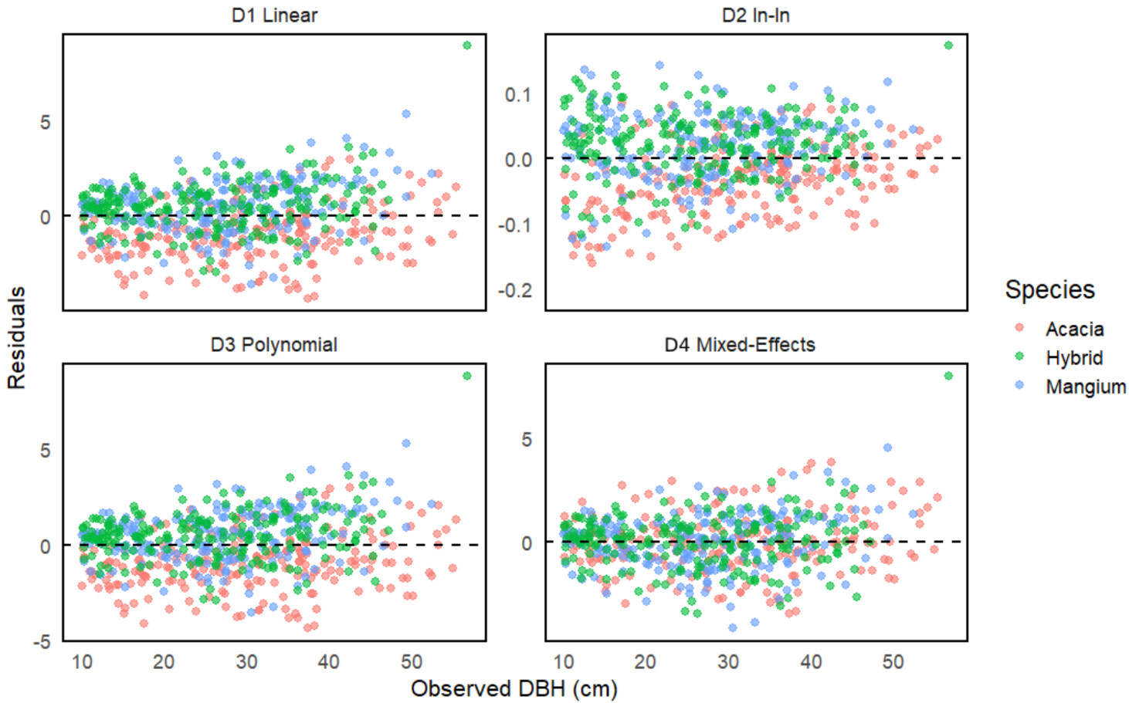

Figure S1. Residual plots for regression and mixed effects DBH models (D1–D4) illustrating reduction in bias with inclusion of species level random effects.

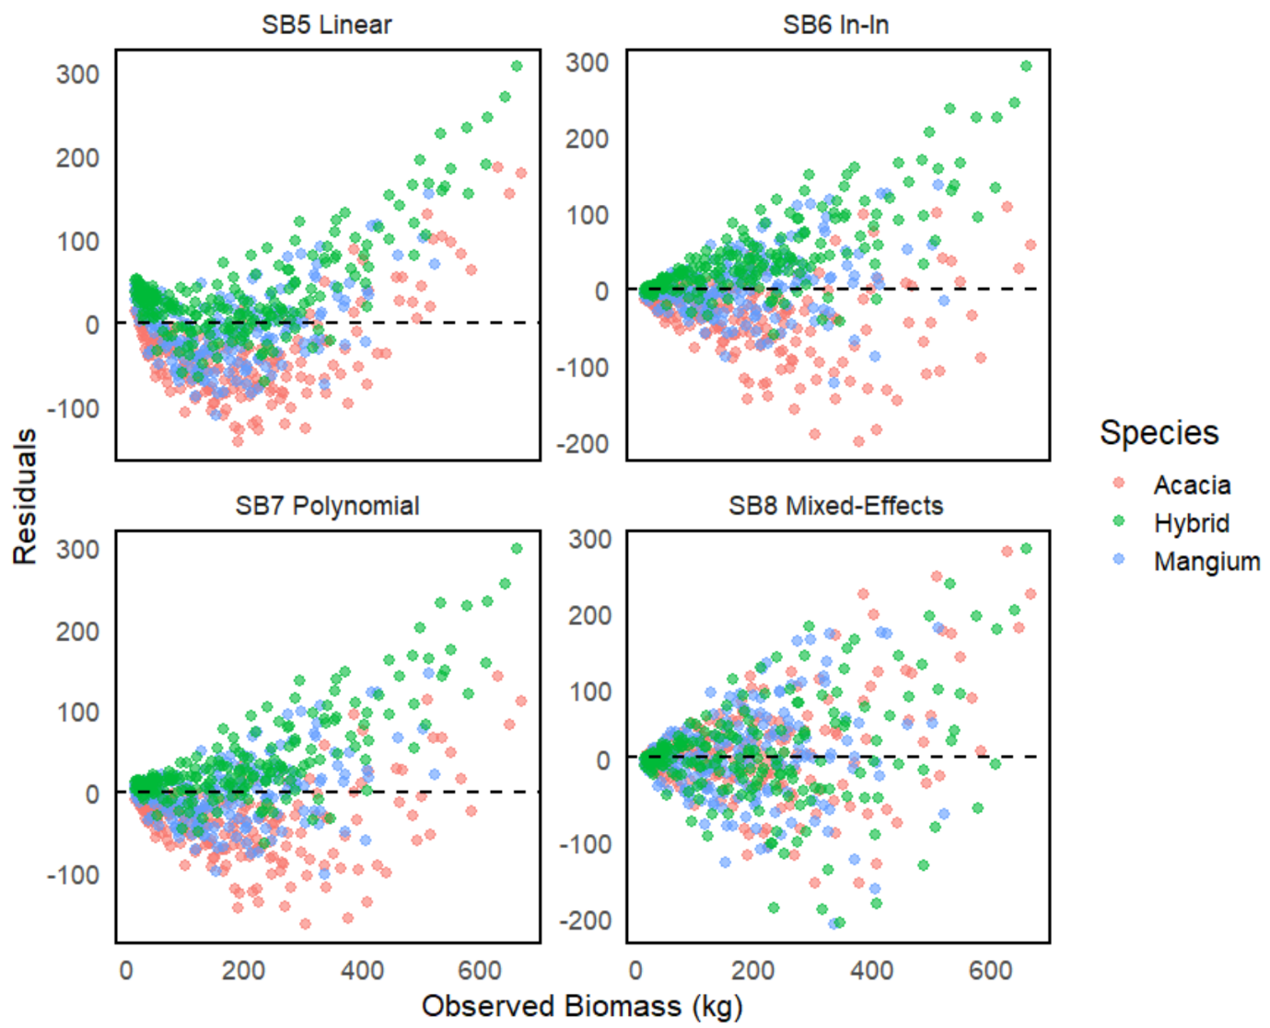

Figure S2. Residual plots of stump-based biomass models, clustering around zero.

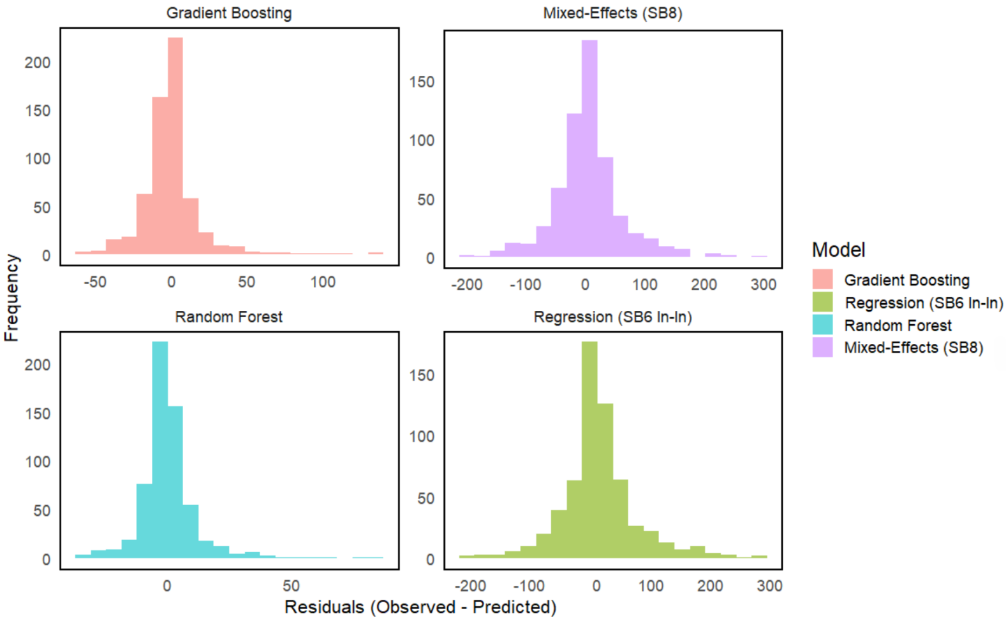

Figure S3. Histograms of the residual distribution for the regression, mixed effects and standard ML models confirming that the residuals are balanced.

