SUPPLEMENTARY MATERIAL
The following figure S1 contains the data of the leading and trail leg for the healthy athletes. There were no significant differences in any of the variables for the two groups.
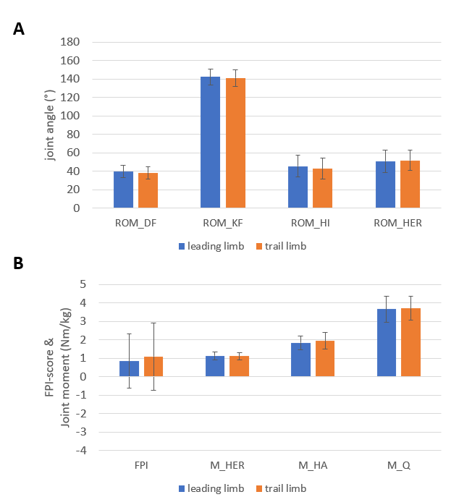
Fig. S1. Mean and standard deviation of leading and trail leg of the healthy group. There were no significant differences between groups.

The following figure S2 contains the data of the healthy legs and the contralateral uninjured leg of unilateral injured athletes. In none of the given variables there was a significant differences between the two groups. 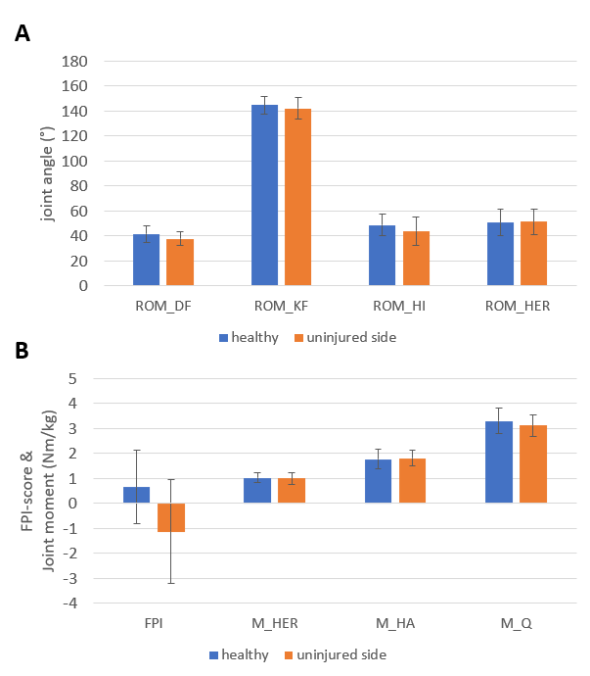
Fig. S2. Mean and standard deviation of healthy legs and the contralateral uninjured leg of the unilateral injured group. There were no significant differences between groups.

