Multimedia Appendix 1
Supplementary tables and figures for the BMC Geriatrics submission.

Supplementary Material
Supplementary Table A. Missingness in analysis variables
Variable | Nonmissing, n | Missing, n | Missing, %
Mobile phone use | 684 | 36 | 5
Age | 720 | 0 | 0
Sex | 720 | 0 | 0
Education | 719 | 1 | 0.1
Pension level | 642 | 78 | 10.8
Comorbidity burden | 652 | 68 | 9.4
CMMS total score | 652 | 68 | 9.4
Cognitive impairment | 652 | 68 | 9.4
6-m gait speed | 672 | 48 | 6.7
Maximum grip strength | 711 | 9 | 1.2
Five-chair-stand time | 613 | 107 | 14.9
Neurofunctional reserve score | 558 | 162 | 22.5
Barthel ADL total score | 684 | 36 | 5
IADL total score | 652 | 68 | 9.4
Worse-ear hearing score | 719 | 1 | 0.1
Worse-eye vision score | 715 | 5 | 0.7
Note. The neurofunctional reserve score required complete data on all seven component measures.
Supplementary Table B. Participant characteristics by neurofunctional reserve complete-case status
Characteristic | NFR complete cases (n=558) | NFR incomplete cases (n=162) | P value
Mobile phone use, n (%) | 418 (74.9%) | 89 (70.6%) | 0.380
Age, mean ± SD | 85.93 ± 5.01 | 85.04 ± 6.38 | 0.102
Female sex, n (%) | 382 (68.5%) | 108 (66.7%) | 0.738
CMMS total score, mean ± SD | 25.77 ± 4.68 | 24.45 ± 5.68 | 0.034
6-m gait speed, m/s, mean ± SD | 0.89 ± 0.28 | 0.57 ± 0.22 | <0.001
Maximum grip strength, kg, mean ± SD | 19.45 ± 7.66 | 16.64 ± 7.08 | <0.001
Barthel ADL total score, mean ± SD | 96.45 ± 5.87 | 92.30 ± 10.61 | <0.001
IADL total score, mean ± SD | 6.73 ± 1.40 | 6.01 ± 1.64 | <0.001
Note. NFR complete cases were residents with nonmissing data on all seven NFR component measures.
Supplementary Table C. Outcome-wide screen with false-discovery-rate adjustment
Outcome | Domain | Analytic N | Events, n | Estimate (95% CI) | Raw P | FDR q | FDR significant
CMMS total score | Cognition | 641 | — | Beta 3.32 (2.34, 4.30) | <0.001 | <0.001 | Yes
Neurofunctional reserve score | Composite reserve | 548 | — | Beta 0.29 (0.21, 0.38) | <0.001 | <0.001 | Yes
Cognitive impairment | Cognition | 641 | 145 | OR 0.26 (0.17, 0.40) | <0.001 | <0.001 | Yes
6-m gait speed, m/s | Physical performance | 596 | — | Beta 0.11 (0.06, 0.17) | <0.001 | <0.001 | Yes
Chair-stand abnormality | Physical performance | 550 | 161 | OR 0.44 (0.28, 0.68) | <0.001 | 0.001 | Yes
Maximum grip strength, kg | Physical performance | 634 | — | Beta 2.09 (0.91, 3.27) | <0.001 | 0.003 | Yes
Possible sarcopenia | Physical performance | 636 | 515 | OR 0.32 (0.17, 0.61) | <0.001 | 0.003 | Yes
Slow gait | Physical performance | 596 | 396 | OR 0.44 (0.27, 0.70) | <0.001 | 0.003 | Yes
SF-36 physical-function score | Quality of life | 641 | — | Beta 1.04 (0.42, 1.65) | <0.001 | 0.003 | Yes
Low grip strength | Physical performance | 634 | 409 | OR 0.51 (0.33, 0.79) | 0.003 | 0.008 | Yes
SARC-F total score | Physical performance | 641 | — | Beta -0.51 (-0.86, -0.17) | 0.004 | 0.011 | Yes
SF-36 mental-health score | Quality of life | 641 | — | Beta 1.05 (0.32, 1.77) | 0.005 | 0.013 | Yes
Health-information access | Participation / information | 641 | — | Beta 0.23 (0.06, 0.39) | 0.008 | 0.020 | Yes
SARC-F risk | Physical performance | 641 | 174 | OR 0.58 (0.38, 0.88) | 0.011 | 0.025 | Yes
Nursing-home activity participation | Participation / information | 641 | — | Beta 0.27 (0.05, 0.48) | 0.014 | 0.030 | Yes
GDS-15 total score | Mood | 641 | — | Beta -0.55 (-0.98, -0.11) | 0.014 | 0.030 | Yes
Five-chair-stand time, s | Physical performance | 550 | — | Beta -1.33 (-2.41, -0.25) | 0.016 | 0.031 | Yes
Barthel ADL total score | Daily function | 641 | — | Beta 1.68 (0.12, 3.24) | 0.035 | 0.064 | No
ADL dependence | Daily function | 641 | 266 | OR 0.67 (0.46, 0.98) | 0.037 | 0.064 | No
Depressive symptoms | Mood | 641 | 80 | OR 0.56 (0.32, 0.97) | 0.039 | 0.065 | No
Moderate-to-high fall risk | Physical performance | 600 | 233 | OR 0.67 (0.45, 1.00) | 0.051 | 0.080 | No
Morse fall score | Physical performance | 600 | — | Beta -3.66 (-7.46, 0.14) | 0.059 | 0.089 | No
Poor sleep quality | Sleep | 641 | 343 | OR 1.37 (0.93, 2.00) | 0.107 | 0.154 | No
Anxiety symptoms | Mood | 641 | 37 | OR 0.56 (0.26, 1.22) | 0.146 | 0.200 | No
MNA-SF first-5-item score | Nutrition | 641 | — | Beta 0.15 (-0.10, 0.41) | 0.236 | 0.311 | No
GAD-7 total score | Mood | 641 | — | Beta -0.19 (-0.57, 0.19) | 0.326 | 0.413 | No
Skeletal muscle index | Muscle mass / sarcopenia | 588 | — | Beta 0.06 (-0.08, 0.21) | 0.389 | 0.476 | No
Visceral fat area, cm² | Body composition | 588 | — | Beta 2.69 (-4.57, 9.95) | 0.468 | 0.552 | No
Low skeletal muscle index | Muscle mass / sarcopenia | 588 | 303 | OR 1.12 (0.76, 1.66) | 0.574 | 0.653 | No
SF-36 social-function score | Quality of life | 641 | — | Beta 0.07 (-0.31, 0.45) | 0.704 | 0.750 | No
Body fat percentage, % | Body composition | 588 | — | Beta 0.27 (-1.11, 1.64) | 0.705 | 0.750 | No
AWGS sarcopenia | Muscle mass / sarcopenia | 588 | 255 | OR 0.94 (0.63, 1.40) | 0.745 | 0.768 | No
PSQI total score | Sleep | 641 | — | Beta 0.00 (-0.68, 0.69) | 0.997 | 0.997 | No
Note. Linear regression was used for continuous outcomes and logistic regression for binary outcomes. FDR adjustment used the Benjamini-Hochberg method.
Supplementary Table D. Principal component analysis construction of the reserve score
Panel A. PC1 loadings for direction-aligned reserve components.
Reserve component | Alignment before PCA | PC1 loading
CMMS total score | Original direction | 0.362
6-m gait speed, m/s | Original direction | 0.471
Maximum grip strength, kg | Original direction | 0.35
Five-chair-stand time, s | Reversed so higher indicates better performance | 0.362
GDS-15 total score | Reversed so higher indicates fewer depressive symptoms | 0.368
SF-36 physical-function score | Original direction | 0.396
SF-36 mental-health score | Original direction | 0.32
Panel B. Explained variance and analytic sample.
Statistic | Value
PC1 explained variance, % | 31.1
Complete-case N | 558
Note. Five-chair-stand time and GDS-15 score were reversed before PCA so that higher aligned values indicated better performance or fewer depressive symptoms.
Supplementary Table E. Latent-class model selection and classification quality
Panel A. Model-fit indices for 1- to 5-class solutions.
Number of classes | BIC | AIC | Smallest class proportion
1 | 3918.1 | 3880.0 | 1.000
2 | 3801.2 | 3720.9 | 0.415
3 | 3822.9 | 3700.2 | 0.078
4 | 3852.4 | 3687.5 | 0.089
5 | 3890.7 | 3683.5 | 0.037
Panel B. Classification quality for the selected two-class solution.
Assigned class | Assigned N | Model class proportion | Mean posterior probability | Median posterior probability | Overall entropy
Low-engagement communication | 181 | 0.415 | 0.901 | 0.866 | 0.581
High-engagement multifunctional | 326 | 0.585 | 0.855 | 0.928 | 0.581
Note. Latent classes were estimated among mobile phone users. BIC was used for class selection; higher entropy indicates clearer class separation.
Supplementary Table F. Sensitivity analyses for latent-class outcome associations
Outcome | Hard-classification estimate (95% CI) | Posterior-draw pooled estimate (95% CI) | Posterior-draw pooled P value | Mean analytic N across draws
CMMS total score | Beta 1.14 (0.42, 1.86) | Beta 1.04 (0.23, 1.86) | 0.012 | 481
Neurofunctional reserve score | Beta 0.10 (0.02, 0.19) | Beta 0.09 (0.00, 0.18) | 0.039 | 412
6-m gait speed, m/s | Beta 0.04 (-0.01, 0.10) | Beta 0.05 (-0.01, 0.11) | 0.116 | 449
Cognitive impairment | OR 0.73 (0.43, 1.23) | OR 0.74 (0.40, 1.38) | 0.342 | 481
Note. Posterior-draw analyses used 200 draws from each resident’s latent-class posterior probabilities.
Supplementary Table G. Sensitivity analyses with additional sensory and functional adjustment
Outcome | Adjustment set | Analytic N | Estimate (95% CI) | P value
CMMS total score | Primary adjustment set | 641 | Beta 3.32 (2.34, 4.30) | <0.001
CMMS total score | Primary set + sensory scores | 637 | Beta 3.33 (2.34, 4.32) | <0.001
CMMS total score | Primary set + ADL/IADL | 641 | Beta 2.83 (1.84, 3.82) | <0.001
CMMS total score | Primary set + sensory scores + ADL/IADL | 637 | Beta 2.85 (1.86, 3.85) | <0.001
Neurofunctional reserve score | Primary adjustment set | 548 | Beta 0.29 (0.21, 0.38) | <0.001
Neurofunctional reserve score | Primary set + sensory scores | 544 | Beta 0.30 (0.21, 0.39) | <0.001
Neurofunctional reserve score | Primary set + ADL/IADL | 548 | Beta 0.22 (0.14, 0.30) | <0.001
Neurofunctional reserve score | Primary set + sensory scores + ADL/IADL | 544 | Beta 0.23 (0.14, 0.31) | <0.001
Cognitive impairment | Primary adjustment set | 641 | OR 0.26 (0.17, 0.40) | <0.001
Cognitive impairment | Primary set + sensory scores | 637 | OR 0.26 (0.17, 0.39) | <0.001
Cognitive impairment | Primary set + ADL/IADL | 641 | OR 0.31 (0.20, 0.48) | <0.001
Cognitive impairment | Primary set + sensory scores + ADL/IADL | 637 | OR 0.31 (0.20, 0.48) | <0.001
6-m gait speed, m/s | Primary adjustment set | 596 | Beta 0.11 (0.06, 0.17) | <0.001
6-m gait speed, m/s | Primary set + sensory scores | 592 | Beta 0.12 (0.07, 0.17) | <0.001
6-m gait speed, m/s | Primary set + ADL/IADL | 596 | Beta 0.08 (0.03, 0.13) | 0.002
6-m gait speed, m/s | Primary set + sensory scores + ADL/IADL | 592 | Beta 0.09 (0.04, 0.14) | <0.001
Note. Sensory variables were worse-ear hearing and worse-eye vision scores; functional variables were Barthel ADL and IADL total scores.
Supplementary Table H. Multiple-imputation sensitivity analyses for CMMS and gait speed
Outcome | Analysis | Complete-case N | Complete-case estimate (95% CI) | MI pooled N | MI pooled estimate (95% CI) | MI pooled P value | Imputations
CMMS total score | Adjusted | 641 | Beta 3.32 (2.34, 4.30) | 720 | Beta 3.34 (2.36, 4.32) | <0.001 | 20
6-m gait speed, m/s | Adjusted | 596 | Beta 0.11 (0.06, 0.17) | 720 | Beta 0.12 (0.06, 0.17) | <0.001 | 20
CMMS total score | Overlap weighted | 641 | Beta 3.25 (2.21, 4.28) | 720 | Beta 3.29 (2.27, 4.31) | <0.001 | 20
6-m gait speed, m/s | Overlap weighted | 596 | Beta 0.11 (0.06, 0.17) | 720 | Beta 0.12 (0.06, 0.17) | <0.001 | 20
Note. Multiple imputation used 20 posterior draws from an iterative Bayesian-ridge imputer.
Supplementary Table I. Specification dimensions for the multiverse analyses
Dimension | Level | Definition
Sample restriction | Full analytic sample | All residents with nonmissing exposure and model-specific complete data
Sample restriction | Exclude memory-related disease history | Exclude residents with memory-related disease history
Sample restriction | Exclude CMMS <= 10 | Exclude residents with CMMS <= 10
Covariate set | Demographic set | Age, sex, education
Covariate set | Demographic + socioeconomic set | Age, sex, education, marital status, pension
Covariate set | Primary adjustment set | Age, sex, education, marital status, pension, comorbidity burden
Covariate set | Primary set + institutional/social context | Primary set + co-living, cohabitant type, children visit frequency, confidant support, nursing-home activities
Covariate set | Primary set + institutional/social context + health-information access | Primary set + institutional/social context + health-information access
Note. The multiverse crossed 3 sample restrictions with 5 covariate sets, yielding 15 specifications for each outcome.
Supplementary Table J. Full results of the multiverse analyses
Outcome group | Outcome type | Outcome | Sample restriction | Covariate set | Analytic N | Estimate (95% CI) | P value
Positive control | Binary | Cognitive impairment | Full analytic sample | Demographic set: age, sex, education | 651 | OR 0.26 (0.17, 0.39) | <0.001
Positive control | Continuous | CMMS total score | Full analytic sample | Demographic set: age, sex, education | 651 | Beta 0.69 (0.50, 0.89) | <0.001
Positive control | Continuous | Neurofunctional reserve score | Full analytic sample | Demographic set: age, sex, education | 557 | Beta 0.61 (0.42, 0.80) | <0.001
Positive control | Continuous | PCA-derived reserve score | Full analytic sample | Demographic set: age, sex, education | 557 | Beta 0.61 (0.42, 0.81) | <0.001
Positive control | Binary | Slow gait | Full analytic sample | Demographic set: age, sex, education | 636 | OR 0.44 (0.28, 0.70) | <0.001
Positive control | Continuous | 6-m gait speed, m/s | Full analytic sample | Demographic set: age, sex, education | 636 | Beta 0.37 (0.20, 0.54) | <0.001
Positive control | Continuous | Maximum grip strength, kg | Full analytic sample | Demographic set: age, sex, education | 676 | Beta 0.27 (0.13, 0.41) | <0.001
Negative control | Continuous | PSQI total score | Full analytic sample | Demographic set: age, sex, education | 651 | Beta 0.01 (-0.18, 0.20) | 0.911
Negative control | Continuous | Skeletal muscle index | Full analytic sample | Demographic set: age, sex, education | 627 | Beta 0.06 (-0.09, 0.22) | 0.403
Negative control | Continuous | Visceral fat area, cm² | Full analytic sample | Demographic set: age, sex, education | 627 | Beta 0.11 (-0.08, 0.29) | 0.251
Negative control | Continuous | Body fat percentage, % | Full analytic sample | Demographic set: age, sex, education | 627 | Beta 0.08 (-0.10, 0.25) | 0.388
Positive control | Binary | Cognitive impairment | Full analytic sample | Demographic + socioeconomic set | 641 | OR 0.26 (0.17, 0.39) | <0.001
Positive control | Continuous | CMMS total score | Full analytic sample | Demographic + socioeconomic set | 641 | Beta 0.69 (0.49, 0.90) | <0.001
Positive control | Continuous | Neurofunctional reserve score | Full analytic sample | Demographic + socioeconomic set | 548 | Beta 0.59 (0.39, 0.78) | <0.001
Positive control | Continuous | PCA-derived reserve score | Full analytic sample | Demographic + socioeconomic set | 548 | Beta 0.59 (0.39, 0.78) | <0.001
Positive control | Binary | Slow gait | Full analytic sample | Demographic + socioeconomic set | 596 | OR 0.45 (0.28, 0.73) | 0.001
Positive control | Continuous | 6-m gait speed, m/s | Full analytic sample | Demographic + socioeconomic set | 596 | Beta 0.36 (0.18, 0.55) | <0.001
Positive control | Continuous | Maximum grip strength, kg | Full analytic sample | Demographic + socioeconomic set | 634 | Beta 0.27 (0.12, 0.42) | <0.001
Negative control | Continuous | PSQI total score | Full analytic sample | Demographic + socioeconomic set | 641 | Beta 0.04 (-0.15, 0.23) | 0.712
Negative control | Continuous | Skeletal muscle index | Full analytic sample | Demographic + socioeconomic set | 588 | Beta 0.08 (-0.08, 0.23) | 0.344
Negative control | Continuous | Visceral fat area, cm² | Full analytic sample | Demographic + socioeconomic set | 588 | Beta 0.08 (-0.12, 0.28) | 0.422
Negative control | Continuous | Body fat percentage, % | Full analytic sample | Demographic + socioeconomic set | 588 | Beta 0.04 (-0.15, 0.23) | 0.664
Positive control | Binary | Cognitive impairment | Full analytic sample | Primary adjustment set | 641 | OR 0.26 (0.17, 0.40) | <0.001
Positive control | Continuous | CMMS total score | Full analytic sample | Primary adjustment set | 641 | Beta 0.69 (0.49, 0.89) | <0.001
Positive control | Continuous | Neurofunctional reserve score | Full analytic sample | Primary adjustment set | 548 | Beta 0.63 (0.44, 0.82) | <0.001
Positive control | Continuous | PCA-derived reserve score | Full analytic sample | Primary adjustment set | 548 | Beta 0.64 (0.45, 0.83) | <0.001
Positive control | Binary | Slow gait | Full analytic sample | Primary adjustment set | 596 | OR 0.44 (0.27, 0.70) | <0.001
Positive control | Continuous | 6-m gait speed, m/s | Full analytic sample | Primary adjustment set | 596 | Beta 0.39 (0.21, 0.57) | <0.001
Positive control | Continuous | Maximum grip strength, kg | Full analytic sample | Primary adjustment set | 634 | Beta 0.27 (0.12, 0.43) | <0.001
Negative control | Continuous | PSQI total score | Full analytic sample | Primary adjustment set | 641 | Beta 0.00 (-0.18, 0.19) | 0.997
Negative control | Continuous | Skeletal muscle index | Full analytic sample | Primary adjustment set | 588 | Beta 0.07 (-0.09, 0.23) | 0.389
Negative control | Continuous | Visceral fat area, cm² | Full analytic sample | Primary adjustment set | 588 | Beta 0.07 (-0.12, 0.27) | 0.468
Negative control | Continuous | Body fat percentage, % | Full analytic sample | Primary adjustment set | 588 | Beta 0.04 (-0.15, 0.23) | 0.705
Positive control | Binary | Cognitive impairment | Full analytic sample | Primary set + institutional/social context | 641 | OR 0.26 (0.17, 0.40) | <0.001
Positive control | Continuous | CMMS total score | Full analytic sample | Primary set + institutional/social context | 641 | Beta 0.65 (0.45, 0.85) | <0.001
Positive control | Continuous | Neurofunctional reserve score | Full analytic sample | Primary set + institutional/social context | 548 | Beta 0.59 (0.42, 0.77) | <0.001
Positive control | Continuous | PCA-derived reserve score | Full analytic sample | Primary set + institutional/social context | 548 | Beta 0.60 (0.42, 0.79) | <0.001
Positive control | Binary | Slow gait | Full analytic sample | Primary set + institutional/social context | 596 | OR 0.46 (0.29, 0.75) | 0.002
Positive control | Continuous | 6-m gait speed, m/s | Full analytic sample | Primary set + institutional/social context | 596 | Beta 0.35 (0.17, 0.52) | <0.001
Positive control | Continuous | Maximum grip strength, kg | Full analytic sample | Primary set + institutional/social context | 634 | Beta 0.24 (0.09, 0.39) | 0.002
Negative control | Continuous | PSQI total score | Full analytic sample | Primary set + institutional/social context | 641 | Beta -0.00 (-0.19, 0.18) | 0.979
Negative control | Continuous | Skeletal muscle index | Full analytic sample | Primary set + institutional/social context | 588 | Beta 0.05 (-0.10, 0.21) | 0.513
Negative control | Continuous | Visceral fat area, cm² | Full analytic sample | Primary set + institutional/social context | 588 | Beta 0.08 (-0.11, 0.28) | 0.401
Negative control | Continuous | Body fat percentage, % | Full analytic sample | Primary set + institutional/social context | 588 | Beta 0.04 (-0.15, 0.24) | 0.648
Positive control | Binary | Cognitive impairment | Full analytic sample | Primary set + institutional/social context + health-information access | 641 | OR 0.27 (0.18, 0.42) | <0.001
Positive control | Continuous | CMMS total score | Full analytic sample | Primary set + institutional/social context + health-information access | 641 | Beta 0.62 (0.42, 0.82) | <0.001
Positive control | Continuous | Neurofunctional reserve score | Full analytic sample | Primary set + institutional/social context + health-information access | 548 | Beta 0.59 (0.41, 0.77) | <0.001
Positive control | Continuous | PCA-derived reserve score | Full analytic sample | Primary set + institutional/social context + health-information access | 548 | Beta 0.60 (0.42, 0.78) | <0.001
Positive control | Binary | Slow gait | Full analytic sample | Primary set + institutional/social context + health-information access | 596 | OR 0.46 (0.29, 0.76) | 0.002
Positive control | Continuous | 6-m gait speed, m/s | Full analytic sample | Primary set + institutional/social context + health-information access | 596 | Beta 0.35 (0.17, 0.52) | <0.001
Positive control | Continuous | Maximum grip strength, kg | Full analytic sample | Primary set + institutional/social context + health-information access | 634 | Beta 0.24 (0.09, 0.38) | 0.002
Negative control | Continuous | PSQI total score | Full analytic sample | Primary set + institutional/social context + health-information access | 641 | Beta -0.02 (-0.20, 0.17) | 0.866
Negative control | Continuous | Skeletal muscle index | Full analytic sample | Primary set + institutional/social context + health-information access | 588 | Beta 0.05 (-0.11, 0.20) | 0.557
Negative control | Continuous | Visceral fat area, cm² | Full analytic sample | Primary set + institutional/social context + health-information access | 588 | Beta 0.09 (-0.11, 0.28) | 0.388
Negative control | Continuous | Body fat percentage, % | Full analytic sample | Primary set + institutional/social context + health-information access | 588 | Beta 0.05 (-0.14, 0.24) | 0.619
Positive control | Binary | Cognitive impairment | Exclude memory-related disease history | Demographic set: age, sex, education | 638 | OR 0.25 (0.17, 0.38) | <0.001
Positive control | Continuous | CMMS total score | Exclude memory-related disease history | Demographic set: age, sex, education | 638 | Beta 0.72 (0.52, 0.92) | <0.001
Positive control | Continuous | Neurofunctional reserve score | Exclude memory-related disease history | Demographic set: age, sex, education | 546 | Beta 0.62 (0.44, 0.81) | <0.001
Positive control | Continuous | PCA-derived reserve score | Exclude memory-related disease history | Demographic set: age, sex, education | 546 | Beta 0.63 (0.44, 0.82) | <0.001
Positive control | Binary | Slow gait | Exclude memory-related disease history | Demographic set: age, sex, education | 623 | OR 0.43 (0.27, 0.69) | <0.001
Positive control | Continuous | 6-m gait speed, m/s | Exclude memory-related disease history | Demographic set: age, sex, education | 623 | Beta 0.38 (0.21, 0.55) | <0.001
Positive control | Continuous | Maximum grip strength, kg | Exclude memory-related disease history | Demographic set: age, sex, education | 663 | Beta 0.26 (0.12, 0.41) | <0.001
Negative control | Continuous | PSQI total score | Exclude memory-related disease history | Demographic set: age, sex, education | 638 | Beta -0.01 (-0.20, 0.18) | 0.948
Negative control | Continuous | Skeletal muscle index | Exclude memory-related disease history | Demographic set: age, sex, education | 616 | Beta 0.07 (-0.08, 0.22) | 0.364
Negative control | Continuous | Visceral fat area, cm² | Exclude memory-related disease history | Demographic set: age, sex, education | 616 | Beta 0.11 (-0.07, 0.29) | 0.246
Negative control | Continuous | Body fat percentage, % | Exclude memory-related disease history | Demographic set: age, sex, education | 616 | Beta 0.08 (-0.09, 0.26) | 0.351
Positive control | Binary | Cognitive impairment | Exclude memory-related disease history | Demographic + socioeconomic set | 628 | OR 0.25 (0.16, 0.38) | <0.001
Positive control | Continuous | CMMS total score | Exclude memory-related disease history | Demographic + socioeconomic set | 628 | Beta 0.72 (0.51, 0.92) | <0.001
Positive control | Continuous | Neurofunctional reserve score | Exclude memory-related disease history | Demographic + socioeconomic set | 537 | Beta 0.60 (0.41, 0.79) | <0.001
Positive control | Continuous | PCA-derived reserve score | Exclude memory-related disease history | Demographic + socioeconomic set | 537 | Beta 0.60 (0.40, 0.80) | <0.001
Positive control | Binary | Slow gait | Exclude memory-related disease history | Demographic + socioeconomic set | 583 | OR 0.45 (0.28, 0.72) | <0.001
Positive control | Continuous | 6-m gait speed, m/s | Exclude memory-related disease history | Demographic + socioeconomic set | 583 | Beta 0.37 (0.19, 0.56) | <0.001
Positive control | Continuous | Maximum grip strength, kg | Exclude memory-related disease history | Demographic + socioeconomic set | 621 | Beta 0.26 (0.11, 0.41) | <0.001
Negative control | Continuous | PSQI total score | Exclude memory-related disease history | Demographic + socioeconomic set | 628 | Beta 0.02 (-0.17, 0.21) | 0.846
Negative control | Continuous | Skeletal muscle index | Exclude memory-related disease history | Demographic + socioeconomic set | 577 | Beta 0.08 (-0.08, 0.25) | 0.302
Negative control | Continuous | Visceral fat area, cm² | Exclude memory-related disease history | Demographic + socioeconomic set | 577 | Beta 0.08 (-0.11, 0.28) | 0.406
Negative control | Continuous | Body fat percentage, % | Exclude memory-related disease history | Demographic + socioeconomic set | 577 | Beta 0.05 (-0.14, 0.24) | 0.606
Positive control | Binary | Cognitive impairment | Exclude memory-related disease history | Primary adjustment set | 628 | OR 0.25 (0.17, 0.39) | <0.001
Positive control | Continuous | CMMS total score | Exclude memory-related disease history | Primary adjustment set | 628 | Beta 0.71 (0.51, 0.92) | <0.001
Positive control | Continuous | Neurofunctional reserve score | Exclude memory-related disease history | Primary adjustment set | 537 | Beta 0.64 (0.45, 0.83) | <0.001
Positive control | Continuous | PCA-derived reserve score | Exclude memory-related disease history | Primary adjustment set | 537 | Beta 0.65 (0.46, 0.84) | <0.001
Positive control | Binary | Slow gait | Exclude memory-related disease history | Primary adjustment set | 583 | OR 0.43 (0.27, 0.70) | <0.001
Positive control | Continuous | 6-m gait speed, m/s | Exclude memory-related disease history | Primary adjustment set | 583 | Beta 0.39 (0.21, 0.58) | <0.001
Positive control | Continuous | Maximum grip strength, kg | Exclude memory-related disease history | Primary adjustment set | 621 | Beta 0.27 (0.11, 0.42) | <0.001
Negative control | Continuous | PSQI total score | Exclude memory-related disease history | Primary adjustment set | 628 | Beta -0.01 (-0.20, 0.17) | 0.900
Negative control | Continuous | Skeletal muscle index | Exclude memory-related disease history | Primary adjustment set | 577 | Beta 0.08 (-0.08, 0.24) | 0.337
Negative control | Continuous | Visceral fat area, cm² | Exclude memory-related disease history | Primary adjustment set | 577 | Beta 0.08 (-0.12, 0.27) | 0.441
Negative control | Continuous | Body fat percentage, % | Exclude memory-related disease history | Primary adjustment set | 577 | Beta 0.05 (-0.14, 0.24) | 0.633
Positive control | Binary | Cognitive impairment | Exclude memory-related disease history | Primary set + institutional/social context | 628 | OR 0.25 (0.16, 0.39) | <0.001
Positive control | Continuous | CMMS total score | Exclude memory-related disease history | Primary set + institutional/social context | 628 | Beta 0.67 (0.47, 0.88) | <0.001
Positive control | Continuous | Neurofunctional reserve score | Exclude memory-related disease history | Primary set + institutional/social context | 537 | Beta 0.60 (0.42, 0.78) | <0.001
Positive control | Continuous | PCA-derived reserve score | Exclude memory-related disease history | Primary set + institutional/social context | 537 | Beta 0.61 (0.43, 0.80) | <0.001
Positive control | Binary | Slow gait | Exclude memory-related disease history | Primary set + institutional/social context | 583 | OR 0.46 (0.28, 0.75) | 0.002
Positive control | Continuous | 6-m gait speed, m/s | Exclude memory-related disease history | Primary set + institutional/social context | 583 | Beta 0.35 (0.17, 0.53) | <0.001
Positive control | Continuous | Maximum grip strength, kg | Exclude memory-related disease history | Primary set + institutional/social context | 621 | Beta 0.23 (0.08, 0.39) | 0.003
Negative control | Continuous | PSQI total score | Exclude memory-related disease history | Primary set + institutional/social context | 628 | Beta -0.01 (-0.20, 0.17) | 0.894
Negative control | Continuous | Skeletal muscle index | Exclude memory-related disease history | Primary set + institutional/social context | 577 | Beta 0.06 (-0.10, 0.22) | 0.437
Negative control | Continuous | Visceral fat area, cm² | Exclude memory-related disease history | Primary set + institutional/social context | 577 | Beta 0.09 (-0.11, 0.29) | 0.357
Negative control | Continuous | Body fat percentage, % | Exclude memory-related disease history | Primary set + institutional/social context | 577 | Beta 0.06 (-0.13, 0.25) | 0.553
Positive control | Binary | Cognitive impairment | Exclude memory-related disease history | Primary set + institutional/social context + health-information access | 628 | OR 0.27 (0.17, 0.41) | <0.001
Positive control | Continuous | CMMS total score | Exclude memory-related disease history | Primary set + institutional/social context + health-information access | 628 | Beta 0.64 (0.44, 0.85) | <0.001
Positive control | Continuous | Neurofunctional reserve score | Exclude memory-related disease history | Primary set + institutional/social context + health-information access | 537 | Beta 0.60 (0.42, 0.78) | <0.001
Positive control | Continuous | PCA-derived reserve score | Exclude memory-related disease history | Primary set + institutional/social context + health-information access | 537 | Beta 0.61 (0.42, 0.79) | <0.001
Positive control | Binary | Slow gait | Exclude memory-related disease history | Primary set + institutional/social context + health-information access | 583 | OR 0.46 (0.28, 0.75) | 0.002
Positive control | Continuous | 6-m gait speed, m/s | Exclude memory-related disease history | Primary set + institutional/social context + health-information access | 583 | Beta 0.35 (0.18, 0.53) | <0.001
Positive control | Continuous | Maximum grip strength, kg | Exclude memory-related disease history | Primary set + institutional/social context + health-information access | 621 | Beta 0.22 (0.07, 0.37) | 0.003
Negative control | Continuous | PSQI total score | Exclude memory-related disease history | Primary set + institutional/social context + health-information access | 628 | Beta -0.03 (-0.21, 0.16) | 0.754
Negative control | Continuous | Skeletal muscle index | Exclude memory-related disease history | Primary set + institutional/social context + health-information access | 577 | Beta 0.06 (-0.10, 0.22) | 0.487
Negative control | Continuous | Visceral fat area, cm² | Exclude memory-related disease history | Primary set + institutional/social context + health-information access | 577 | Beta 0.10 (-0.10, 0.30) | 0.347
Negative control | Continuous | Body fat percentage, % | Exclude memory-related disease history | Primary set + institutional/social context + health-information access | 577 | Beta 0.06 (-0.13, 0.26) | 0.528
Positive control | Binary | Cognitive impairment | Exclude CMMS <= 10 | Demographic set: age, sex, education | 639 | OR 0.28 (0.18, 0.43) | <0.001
Positive control | Continuous | CMMS total score | Exclude CMMS <= 10 | Demographic set: age, sex, education | 639 | Beta 0.65 (0.44, 0.85) | <0.001
Positive control | Continuous | Neurofunctional reserve score | Exclude CMMS <= 10 | Demographic set: age, sex, education | 547 | Beta 0.57 (0.39, 0.76) | <0.001
Positive control | Continuous | PCA-derived reserve score | Exclude CMMS <= 10 | Demographic set: age, sex, education | 547 | Beta 0.58 (0.39, 0.78) | <0.001
Positive control | Binary | Slow gait | Exclude CMMS <= 10 | Demographic set: age, sex, education | 624 | OR 0.46 (0.29, 0.74) | 0.001
Positive control | Continuous | 6-m gait speed, m/s | Exclude CMMS <= 10 | Demographic set: age, sex, education | 624 | Beta 0.33 (0.16, 0.51) | <0.001
Positive control | Continuous | Maximum grip strength, kg | Exclude CMMS <= 10 | Demographic set: age, sex, education | 664 | Beta 0.26 (0.12, 0.41) | <0.001
Negative control | Continuous | PSQI total score | Exclude CMMS <= 10 | Demographic set: age, sex, education | 639 | Beta 0.03 (-0.16, 0.22) | 0.745
Negative control | Continuous | Skeletal muscle index | Exclude CMMS <= 10 | Demographic set: age, sex, education | 616 | Beta 0.06 (-0.10, 0.21) | 0.475
Negative control | Continuous | Visceral fat area, cm² | Exclude CMMS <= 10 | Demographic set: age, sex, education | 616 | Beta 0.09 (-0.10, 0.28) | 0.339
Negative control | Continuous | Body fat percentage, % | Exclude CMMS <= 10 | Demographic set: age, sex, education | 616 | Beta 0.06 (-0.12, 0.24) | 0.497
Positive control | Binary | Cognitive impairment | Exclude CMMS <= 10 | Demographic + socioeconomic set | 630 | OR 0.27 (0.18, 0.42) | <0.001
Positive control | Continuous | CMMS total score | Exclude CMMS <= 10 | Demographic + socioeconomic set | 630 | Beta 0.65 (0.44, 0.86) | <0.001
Positive control | Continuous | Neurofunctional reserve score | Exclude CMMS <= 10 | Demographic + socioeconomic set | 538 | Beta 0.55 (0.36, 0.74) | <0.001
Positive control | Continuous | PCA-derived reserve score | Exclude CMMS <= 10 | Demographic + socioeconomic set | 538 | Beta 0.55 (0.35, 0.75) | <0.001
Positive control | Binary | Slow gait | Exclude CMMS <= 10 | Demographic + socioeconomic set | 585 | OR 0.48 (0.29, 0.77) | 0.002
Positive control | Continuous | 6-m gait speed, m/s | Exclude CMMS <= 10 | Demographic + socioeconomic set | 585 | Beta 0.33 (0.14, 0.52) | <0.001
Positive control | Continuous | Maximum grip strength, kg | Exclude CMMS <= 10 | Demographic + socioeconomic set | 623 | Beta 0.27 (0.11, 0.42) | <0.001
Negative control | Continuous | PSQI total score | Exclude CMMS <= 10 | Demographic + socioeconomic set | 630 | Beta 0.06 (-0.13, 0.25) | 0.535
Negative control | Continuous | Skeletal muscle index | Exclude CMMS <= 10 | Demographic + socioeconomic set | 578 | Beta 0.06 (-0.10, 0.22) | 0.460
Negative control | Continuous | Visceral fat area, cm² | Exclude CMMS <= 10 | Demographic + socioeconomic set | 578 | Beta 0.07 (-0.13, 0.27) | 0.492
Negative control | Continuous | Body fat percentage, % | Exclude CMMS <= 10 | Demographic + socioeconomic set | 578 | Beta 0.03 (-0.16, 0.22) | 0.759
Positive control | Binary | Cognitive impairment | Exclude CMMS <= 10 | Primary adjustment set | 630 | OR 0.28 (0.18, 0.43) | <0.001
Positive control | Continuous | CMMS total score | Exclude CMMS <= 10 | Primary adjustment set | 630 | Beta 0.65 (0.44, 0.86) | <0.001
Positive control | Continuous | Neurofunctional reserve score | Exclude CMMS <= 10 | Primary adjustment set | 538 | Beta 0.60 (0.41, 0.79) | <0.001
Positive control | Continuous | PCA-derived reserve score | Exclude CMMS <= 10 | Primary adjustment set | 538 | Beta 0.61 (0.41, 0.80) | <0.001
Positive control | Binary | Slow gait | Exclude CMMS <= 10 | Primary adjustment set | 585 | OR 0.46 (0.29, 0.74) | 0.002
Positive control | Continuous | 6-m gait speed, m/s | Exclude CMMS <= 10 | Primary adjustment set | 585 | Beta 0.35 (0.17, 0.54) | <0.001
Positive control | Continuous | Maximum grip strength, kg | Exclude CMMS <= 10 | Primary adjustment set | 623 | Beta 0.27 (0.11, 0.43) | <0.001
Negative control | Continuous | PSQI total score | Exclude CMMS <= 10 | Primary adjustment set | 630 | Beta 0.03 (-0.16, 0.21) | 0.793
Negative control | Continuous | Skeletal muscle index | Exclude CMMS <= 10 | Primary adjustment set | 578 | Beta 0.05 (-0.11, 0.22) | 0.512
Negative control | Continuous | Visceral fat area, cm² | Exclude CMMS <= 10 | Primary adjustment set | 578 | Beta 0.06 (-0.14, 0.26) | 0.537
Negative control | Continuous | Body fat percentage, % | Exclude CMMS <= 10 | Primary adjustment set | 578 | Beta 0.03 (-0.17, 0.22) | 0.792
Positive control | Binary | Cognitive impairment | Exclude CMMS <= 10 | Primary set + institutional/social context | 630 | OR 0.27 (0.18, 0.43) | <0.001
Positive control | Continuous | CMMS total score | Exclude CMMS <= 10 | Primary set + institutional/social context | 630 | Beta 0.62 (0.41, 0.82) | <0.001
Positive control | Continuous | Neurofunctional reserve score | Exclude CMMS <= 10 | Primary set + institutional/social context | 538 | Beta 0.56 (0.38, 0.75) | <0.001
Positive control | Continuous | PCA-derived reserve score | Exclude CMMS <= 10 | Primary set + institutional/social context | 538 | Beta 0.58 (0.39, 0.76) | <0.001
Positive control | Binary | Slow gait | Exclude CMMS <= 10 | Primary set + institutional/social context | 585 | OR 0.49 (0.30, 0.79) | 0.004
Positive control | Continuous | 6-m gait speed, m/s | Exclude CMMS <= 10 | Primary set + institutional/social context | 585 | Beta 0.32 (0.14, 0.50) | <0.001
Positive control | Continuous | Maximum grip strength, kg | Exclude CMMS <= 10 | Primary set + institutional/social context | 623 | Beta 0.24 (0.09, 0.39) | 0.002
Negative control | Continuous | PSQI total score | Exclude CMMS <= 10 | Primary set + institutional/social context | 630 | Beta 0.02 (-0.17, 0.21) | 0.835
Negative control | Continuous | Skeletal muscle index | Exclude CMMS <= 10 | Primary set + institutional/social context | 578 | Beta 0.04 (-0.12, 0.20) | 0.611
Negative control | Continuous | Visceral fat area, cm² | Exclude CMMS <= 10 | Primary set + institutional/social context | 578 | Beta 0.08 (-0.12, 0.28) | 0.444
Negative control | Continuous | Body fat percentage, % | Exclude CMMS <= 10 | Primary set + institutional/social context | 578 | Beta 0.04 (-0.16, 0.23) | 0.719
Positive control | Binary | Cognitive impairment | Exclude CMMS <= 10 | Primary set + institutional/social context + health-information access | 630 | OR 0.29 (0.19, 0.45) | <0.001
Positive control | Continuous | CMMS total score | Exclude CMMS <= 10 | Primary set + institutional/social context + health-information access | 630 | Beta 0.58 (0.38, 0.78) | <0.001
Positive control | Continuous | Neurofunctional reserve score | Exclude CMMS <= 10 | Primary set + institutional/social context + health-information access | 538 | Beta 0.56 (0.37, 0.74) | <0.001
Positive control | Continuous | PCA-derived reserve score | Exclude CMMS <= 10 | Primary set + institutional/social context + health-information access | 538 | Beta 0.57 (0.38, 0.76) | <0.001
Positive control | Binary | Slow gait | Exclude CMMS <= 10 | Primary set + institutional/social context + health-information access | 585 | OR 0.49 (0.30, 0.79) | 0.004
Positive control | Continuous | 6-m gait speed, m/s | Exclude CMMS <= 10 | Primary set + institutional/social context + health-information access | 585 | Beta 0.32 (0.14, 0.50) | <0.001
Positive control | Continuous | Maximum grip strength, kg | Exclude CMMS <= 10 | Primary set + institutional/social context + health-information access | 623 | Beta 0.23 (0.08, 0.38) | 0.003
Negative control | Continuous | PSQI total score | Exclude CMMS <= 10 | Primary set + institutional/social context + health-information access | 630 | Beta 0.01 (-0.18, 0.19) | 0.957
Negative control | Continuous | Skeletal muscle index | Exclude CMMS <= 10 | Primary set + institutional/social context + health-information access | 578 | Beta 0.04 (-0.12, 0.20) | 0.650
Negative control | Continuous | Visceral fat area, cm² | Exclude CMMS <= 10 | Primary set + institutional/social context + health-information access | 578 | Beta 0.08 (-0.12, 0.28) | 0.425
Negative control | Continuous | Body fat percentage, % | Exclude CMMS <= 10 | Primary set + institutional/social context + health-information access | 578 | Beta 0.04 (-0.16, 0.23) | 0.688
Note. Continuous outcomes were standardized within each specification; binary outcomes are shown as odds ratios.
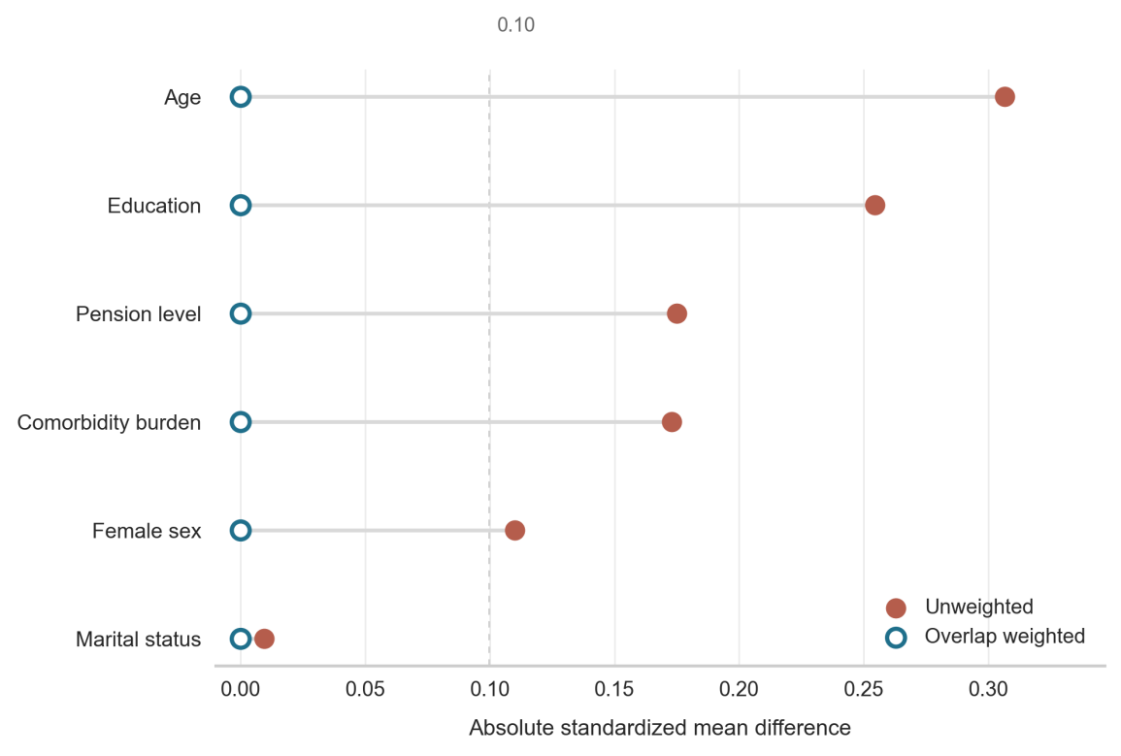
Supplementary Figure S1. Covariate balance before and after overlap weighting
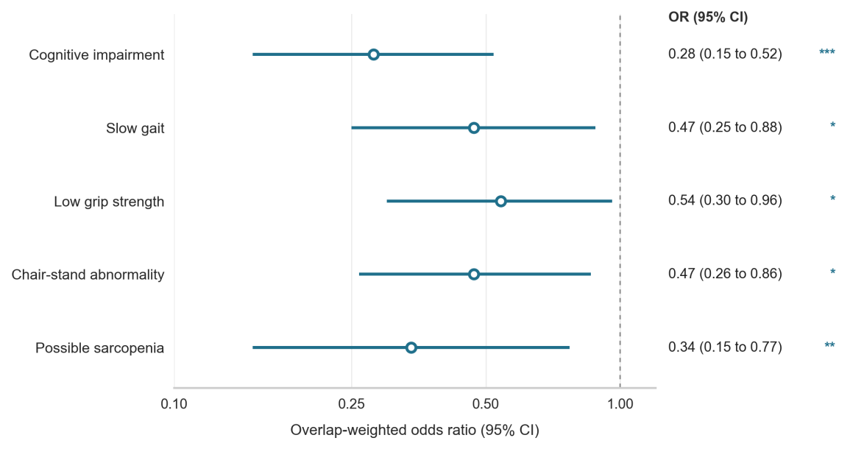
Supplementary Figure S2. Mobile phone use and binary outcomes
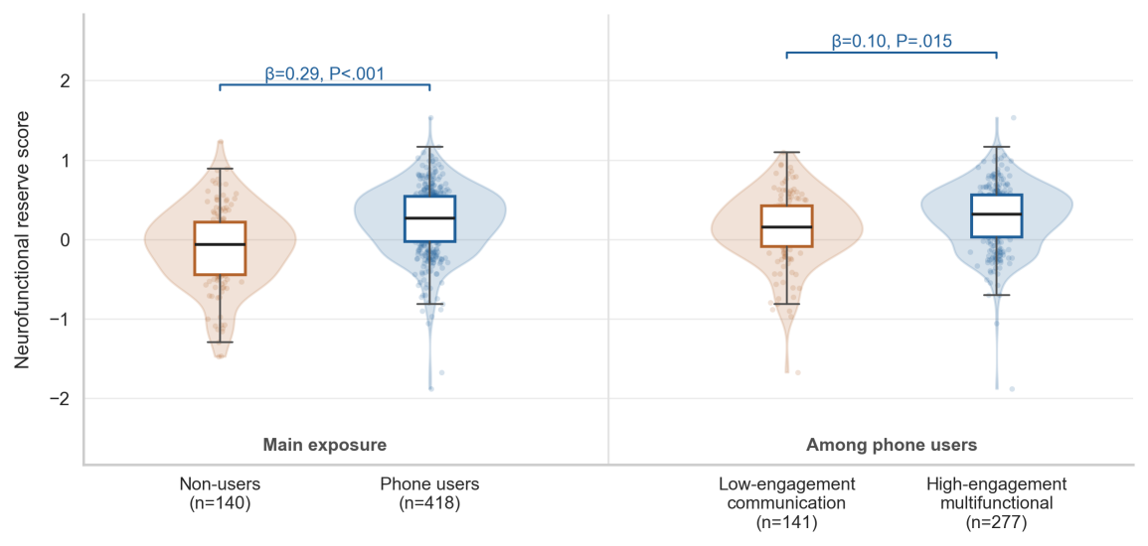
Supplementary Figure S3. Distribution of NFR score by phone-use status and engagement class
Note. Brackets show adjusted model estimates.
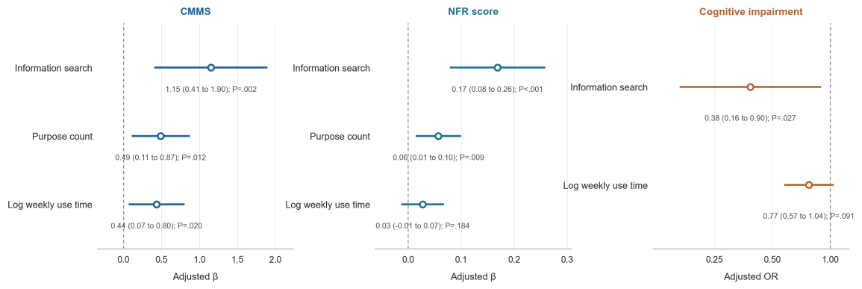
Supplementary Figure S4. Phone behaviors and reserve-related outcomes among phone users
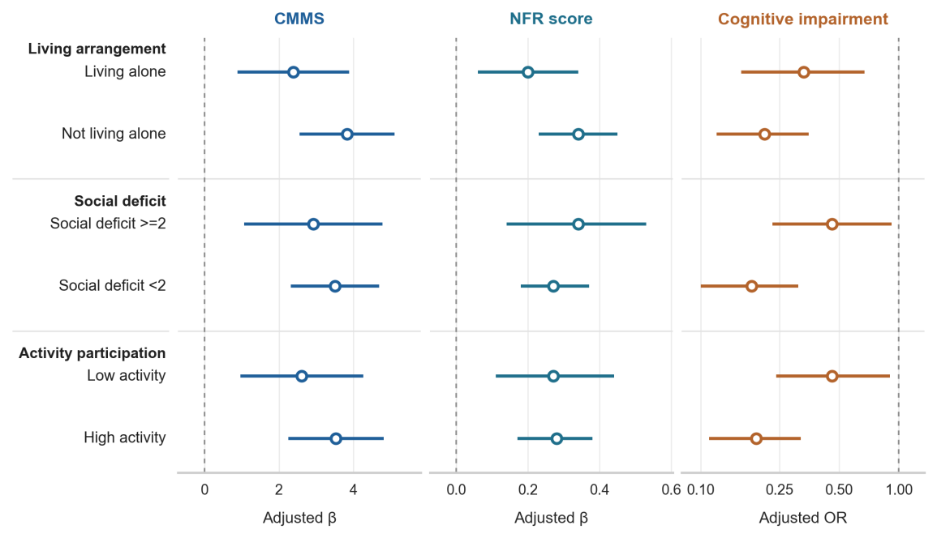
Supplementary Figure S5. Social-context variation in mobile phone-use associations

