Additional File 3
Irradiation pretreatment enhances the therapeutic efficacy of platelet-membrane-
camouflaged antitumor nanoparticles
Yin Chen^{1#}, Xue Shen^{2#}, Songling Han¹, Tao Wang¹, Jianqi Zhao¹ , Yongwu He^{1, 3}, Shilei Chen¹, Shengqi Deng², Cheng Wang^{1*} and Junping Wang^{1*}
¹ State Key Laboratory of Trauma, Burns and Combined Injury, Institute of Combined Injury
of PLA, Chongqing Engineering Research Center for Nanomedicine, College of Preventive
Medicine, Third Military Medical University, Chongqing, 400038, China
² Sichuan Industrial Institute of Antibiotics, Chengdu University, Chengdu, 610106, China
³ College of Materials Science and Engineering, Hebei University of Engineering, Handan,
056038, China
# These authors contributed equally to this work.
* Corresponding authors.
Junping Wang, wangjunping@tmmu.edu.cn; Cheng Wang, wangctmmu@126.com.
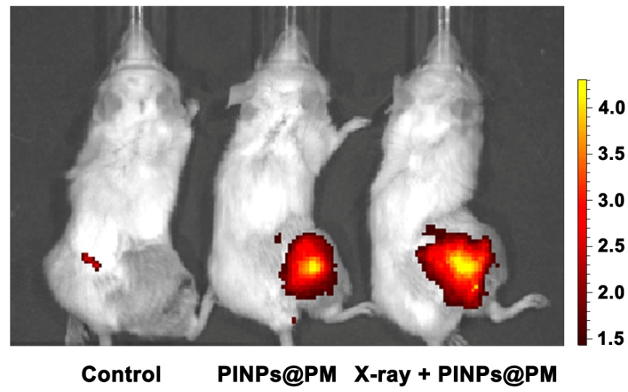
Additional File 3. In vivo imaging of tumor-bearing mice at 12 h post injection of PINPs@PM. Female 8-week-old BALB/c mice were subcutaneously injected with 2 × 10⁹ CFU 4T1 cells in the right hind leg. A 4-Gy X-ray local irradiation was performed when the tumor reached approximately 75 mm³. PINPs@PM (60 μg, based on the content of ICG) was intravenously administered 6 h later. The accumulation of PINPs@PM in the tumor-bearing mice was observed with an IVIS spectrum in vivo imaging system (Perkin Elmer, Shanghai, CHN) at 12 h post-treatment.

