Cross-Tissue WGCNA Reveals Conserved Brain-Blood Transcriptomic Signatures and Potential Biomarkers for Asymptomatic Alzheimer's Disease Diagnosis.

Efe Jennifer Jaiyeoba-Ojigho¹^{,2}, Taye Motunrayo Ilesanmi*^{1,3}, Chris-Ozoko Ebele Lilian², Oluwaseyi Abraham Olawale¹, Sefi Omole Ijeboi^{1,4}, Ikechukwu Emmanuel Okolie⁵

1. Bioinformatics and Genomics Research Unit, Genomac Institute, Ogbomosho 210213, Nigeria
2. Department of Human Anatomy, Delta State University, Abraka, Nigeria
3. Department of Biochemistry, University of Ilorin, Ilorin 240003, Nigeria
4. Department of Plant Biology and Biotechnology, University of Benin, Edo State, Nigeria
5. Department of Nursing and Midwifery, University of Central Lancashire, Preston, England
​*Correspondence: motunrayoilesanmi85@gmail.com

SUPPLEMENTARY MATERIALS

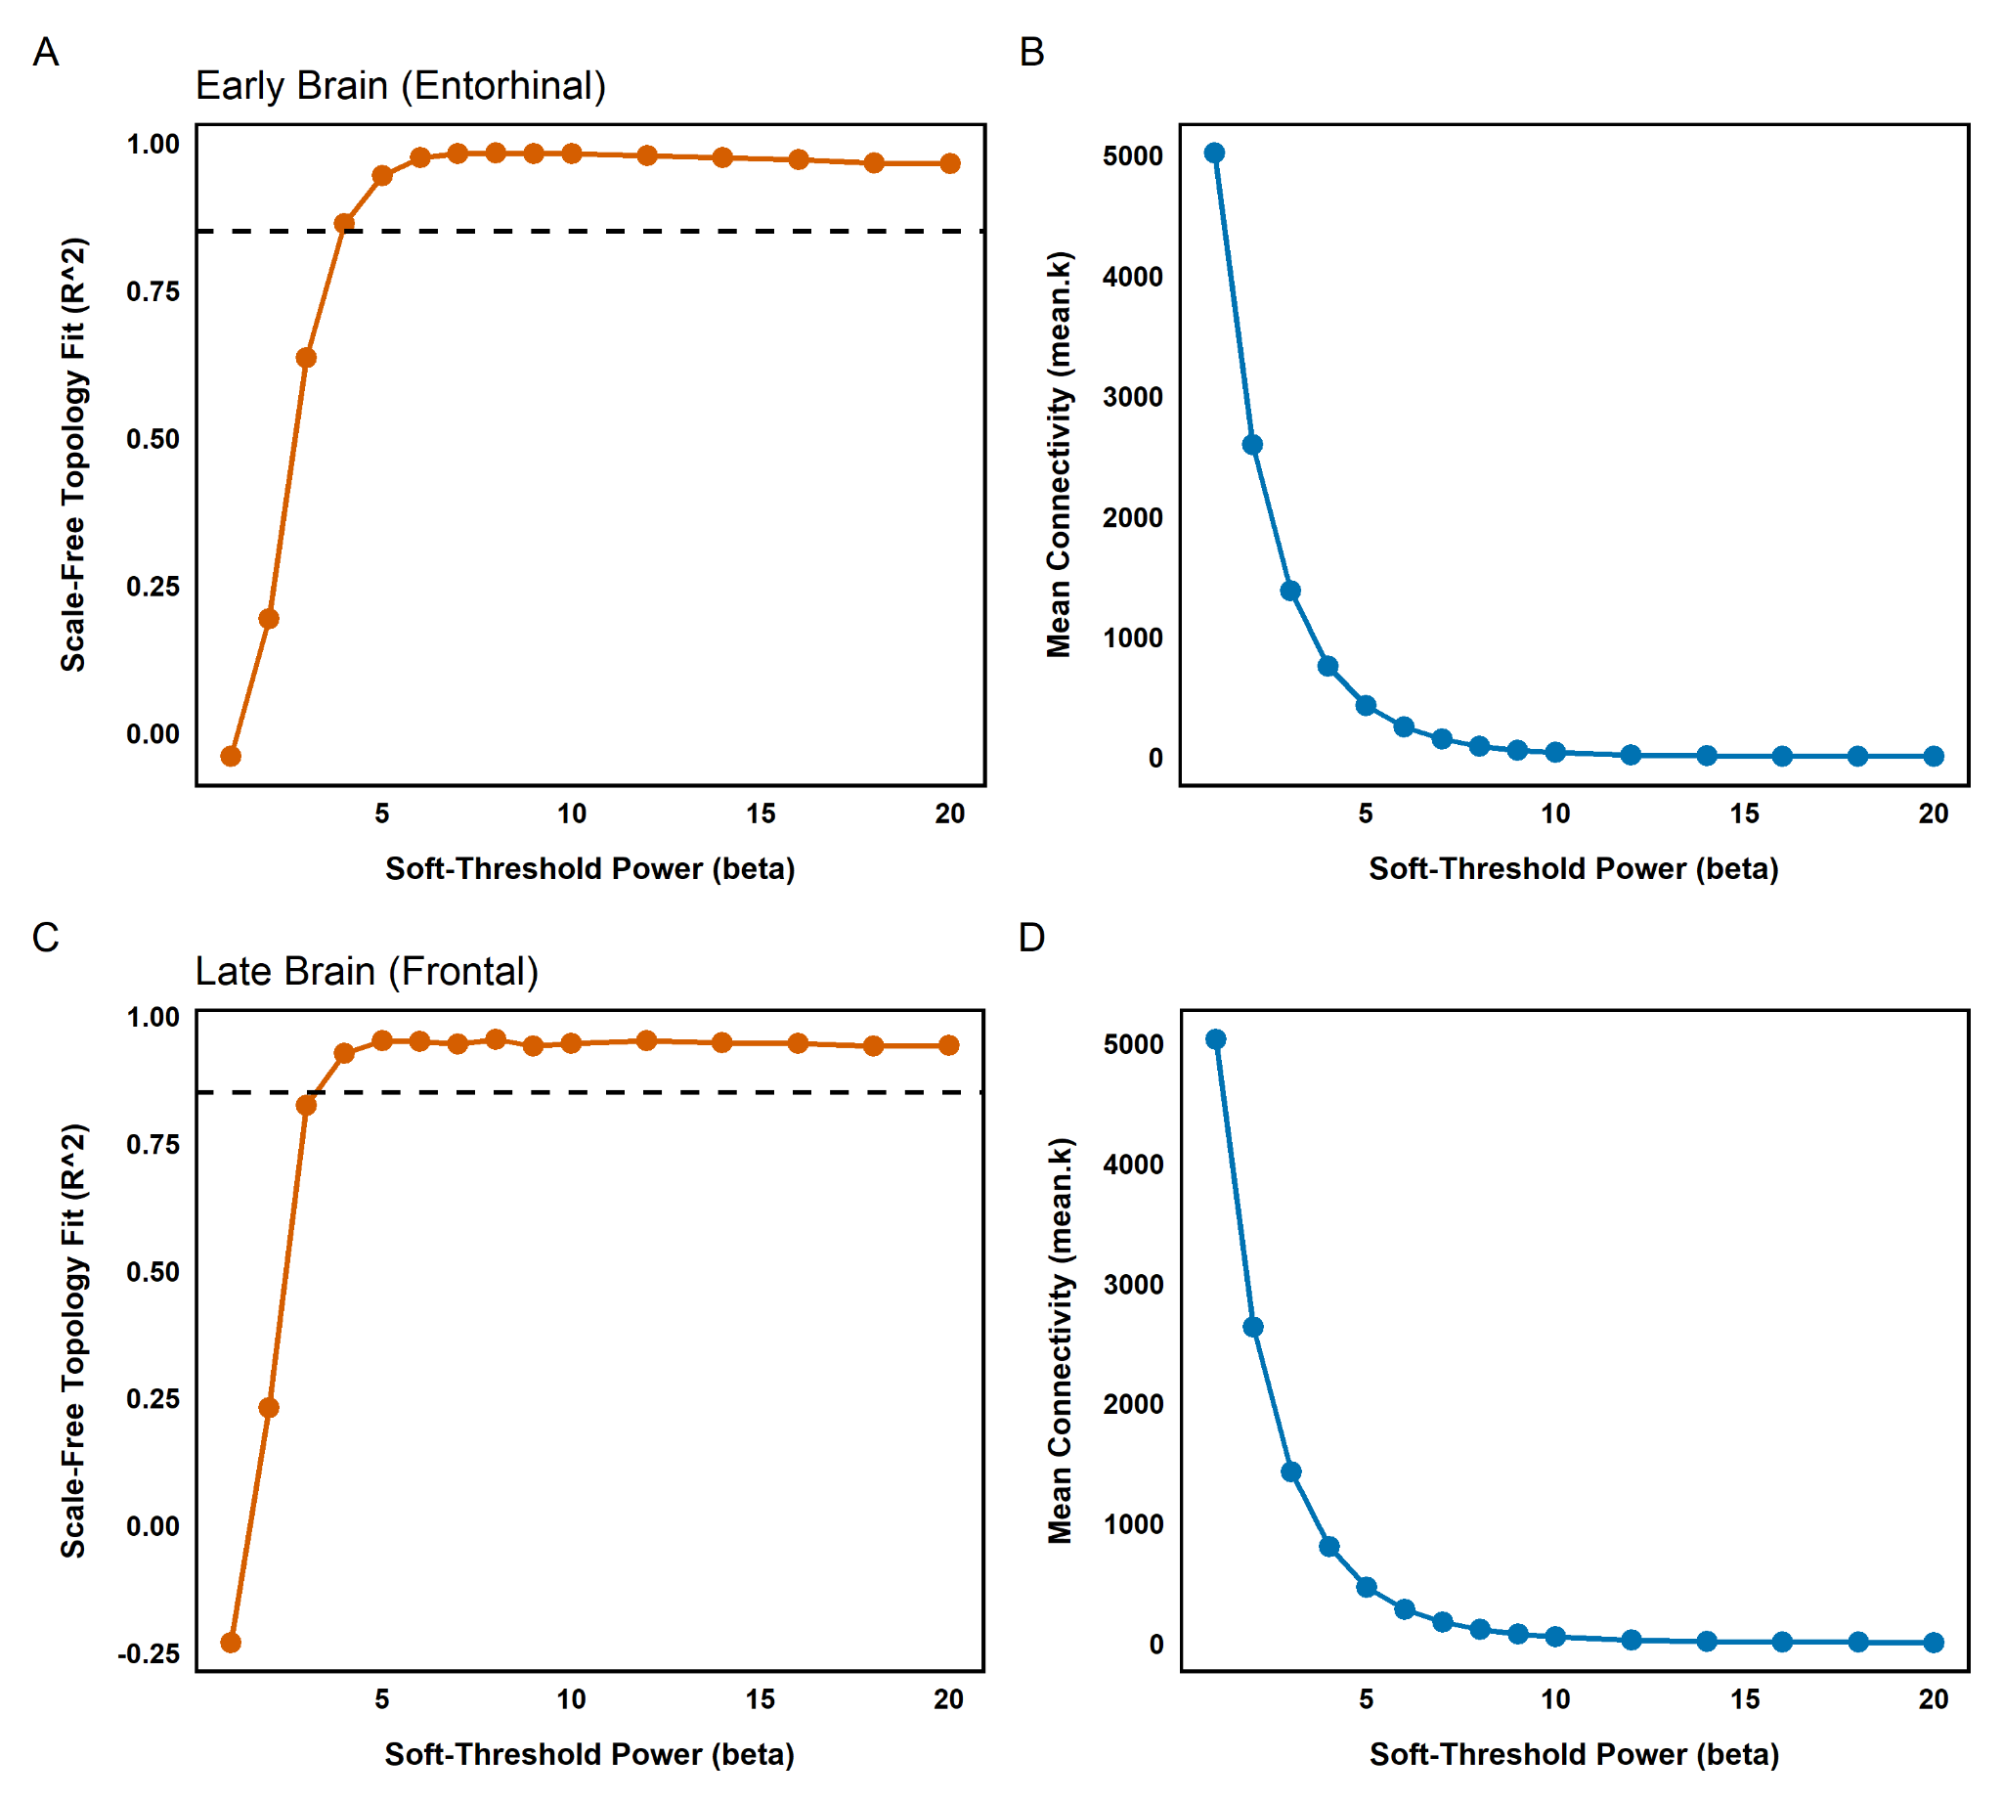

Figure S1: (A, C) The scale-free topology fit index (R2) is plotted as a function of soft-thresholding power (β) for the early disease (entorhinal cortex) and late disease (frontal cortex) cohorts, respectively. The dashed horizontal line marks the targeted R2 threshold of 0.85, which is necessary to ensure that the networks approximate a scale-free topology. (B, D) The mean connectivity is shown as a function of soft-thresholding power for the corresponding brain regions, illustrating the characteristic exponential decay in mean network connectivity as β increases. Accordingly, a soft-thresholding power of β = 5 was chosen for the entorhinal cortex network, and β = 4 for the frontal cortex network. These values represent the optimal thresholds at which each network robustly meets the scale-free fit criteria while preserving sufficient mean connectivity for downstream analysis.

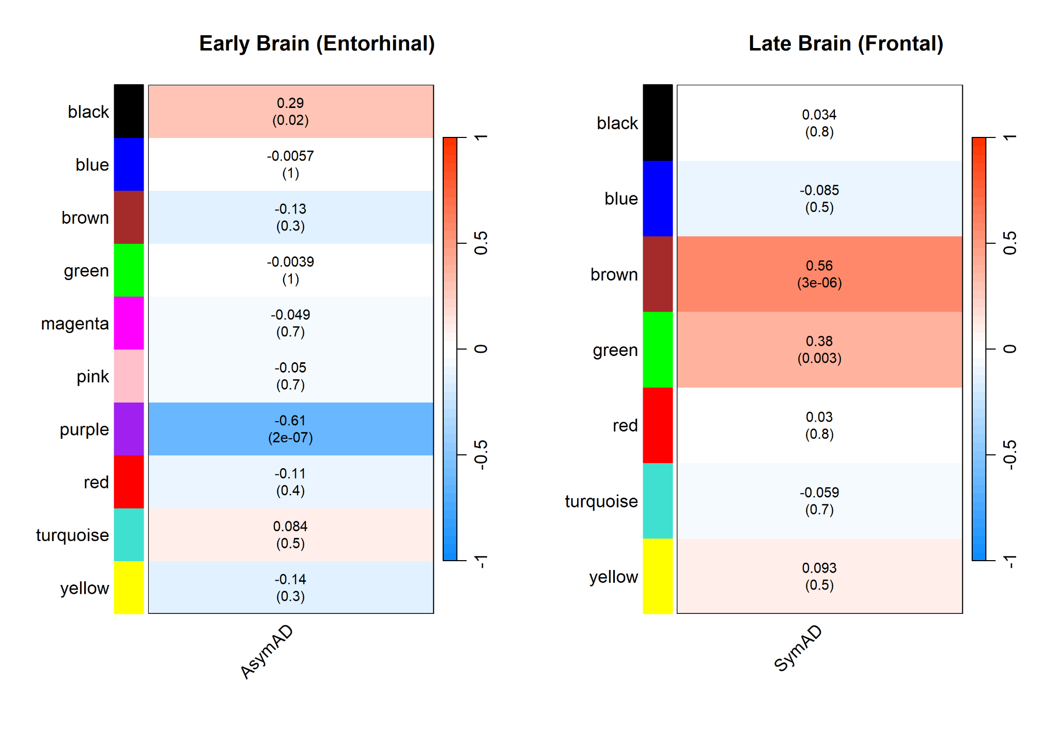

Figure S2: The heatmaps display the associations between module eigengenes and clinical diagnostic traits in the early-stage entorhinal cortex cohort (left: asymptomatic (AsymAD) versus healthy controls) and the late-stage frontal cortex cohort (right: symptomatic (SymAD) versus healthy controls). Each row represents a distinct co-expression module, identified by its assigned colour. Each cell presents the Pearson correlation coefficient between the global module eigengene and the clinical trait (top value), with the corresponding p-value in parentheses. The adjacent colour bars reflect the magnitude and direction of the correlation, ranging from red (positive correlation) to blue (negative correlation). In the early-stage asymptomatic network, the purple module shows a significant negative correlation with the disease trait (r = -0.61, p = 2 × 10-7), while the black module displays a moderate positive correlation (r = 0.29, p = 0.02). In contrast, in the late-stage symptomatic network, the brown and green modules exhibit significant positive correlations with clinical diagnosis (r = 0.56, p = 3 × 10-6 and r = 0.38, p = 0.003, respectively).

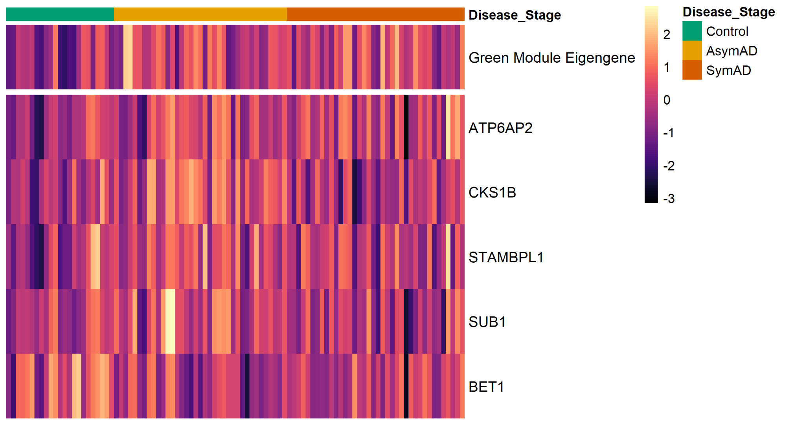
Figure S3: Heatmap illustrating the standardised expression profiles of the global Green module eigengene (top panel) and the five identified hub genes (ATP6AP2, CKS1B, STAMBPL1, SUB1, and BET1; bottom panel) across three clinical stages: healthy controls, asymptomatic Alzheimer's disease (AsymAD), and symptomatic Alzheimer's disease (SymAD). Columns correspond to individual patient samples organised by clinical diagnosis, as indicated by the top annotation bar. The adjacent colour scale represents relative expression levels (Z-scores), ranging from pronounced downregulation (dark purple/black) to marked upregulation (light yellow/white). This visualisation demonstrates the progressive transcriptional changes of the module and its core genes as pathology advances from a healthy baseline through prodromal and late-symptomatic phases.

Table 1: Supplementary Table S1
Cross-Tissue Network Preservation Analysis of Brain-Derived Modules in Peripheral Blood
Network Module | Entorinal Cortex (Z-summary) | Frontal Cortex (Z-summary)
green | 15.25 | 10.59
yellow | 4.47 | 2.10
blue | 2.36 | 0.75
magenta | 2.32 | -
gold | 1.80 | 3.51
turquoise | 0.49 | 7.81
brown | 0.36 | 2.02
purple | 0.09 | -
red | -0.13 | -0.96
black | -0.45 | 1.83
pink | -1.03 | -

