Appendix
Appendix 1. Mean cost differences after excluding individuals collecting JSA in the previous year
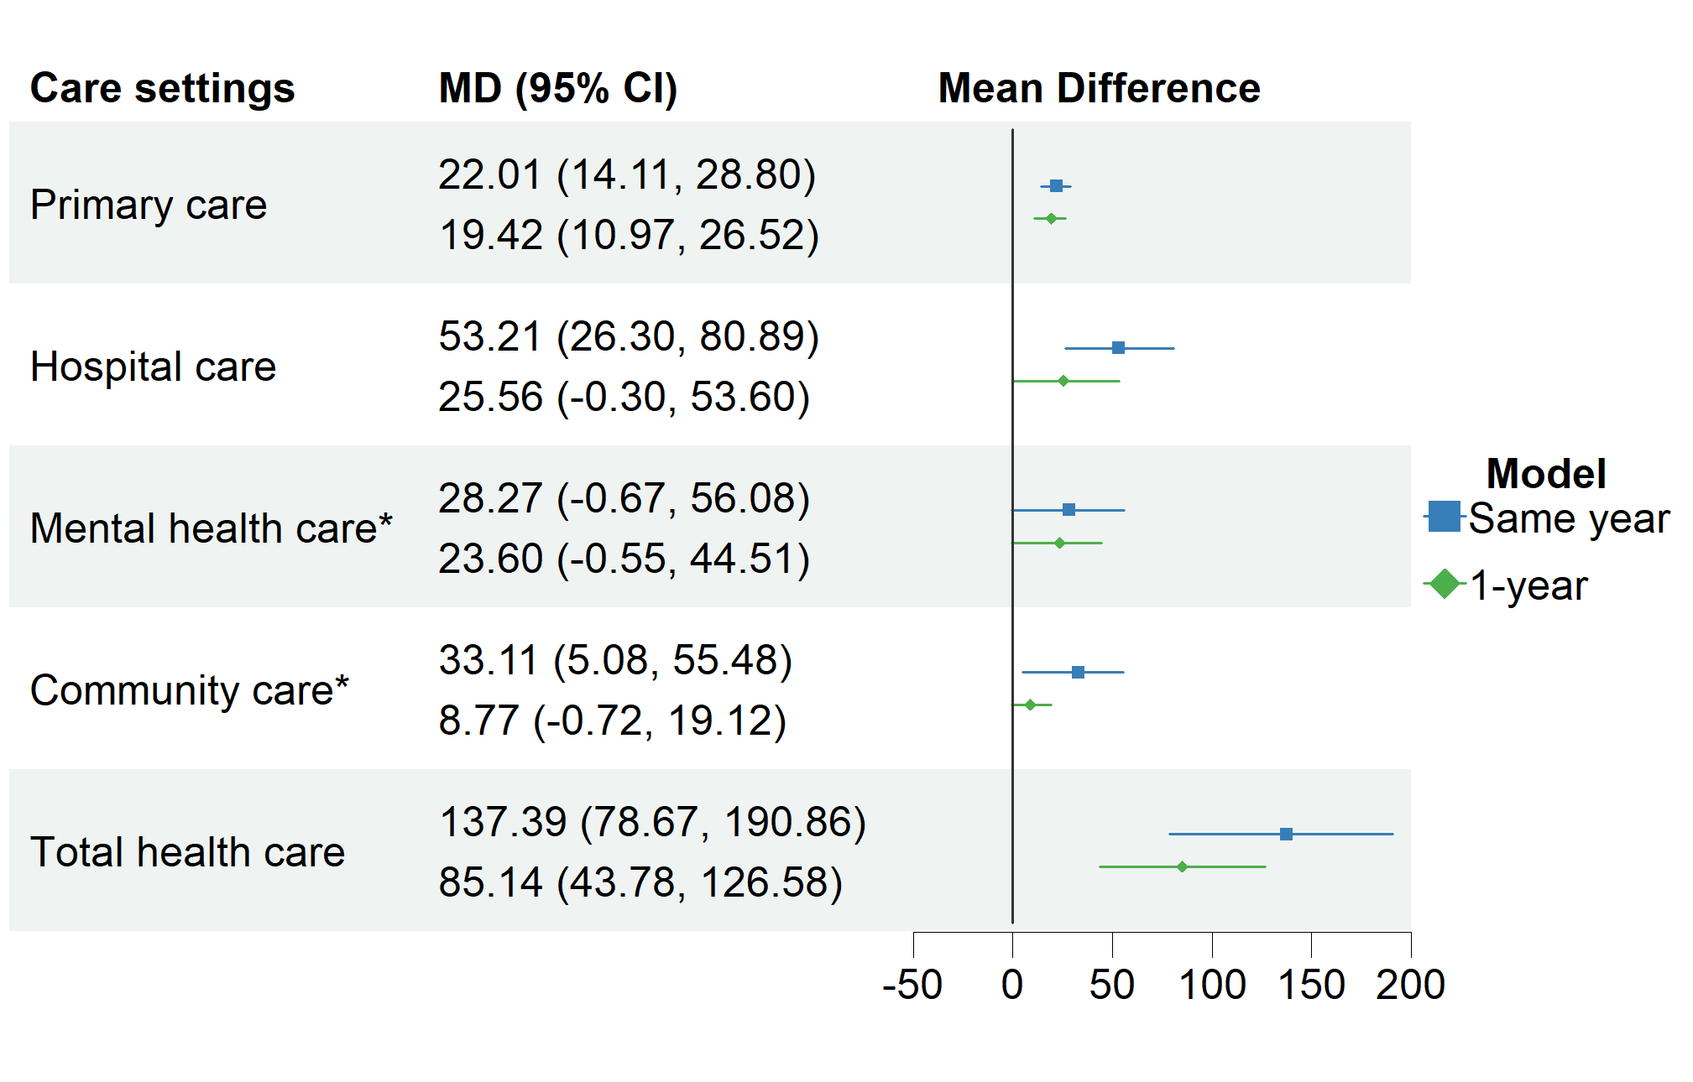

note: results in care settings with * were not bootstrapped due to convergence issues.

Appendix 2. Mean cost differences with gaussian distribution
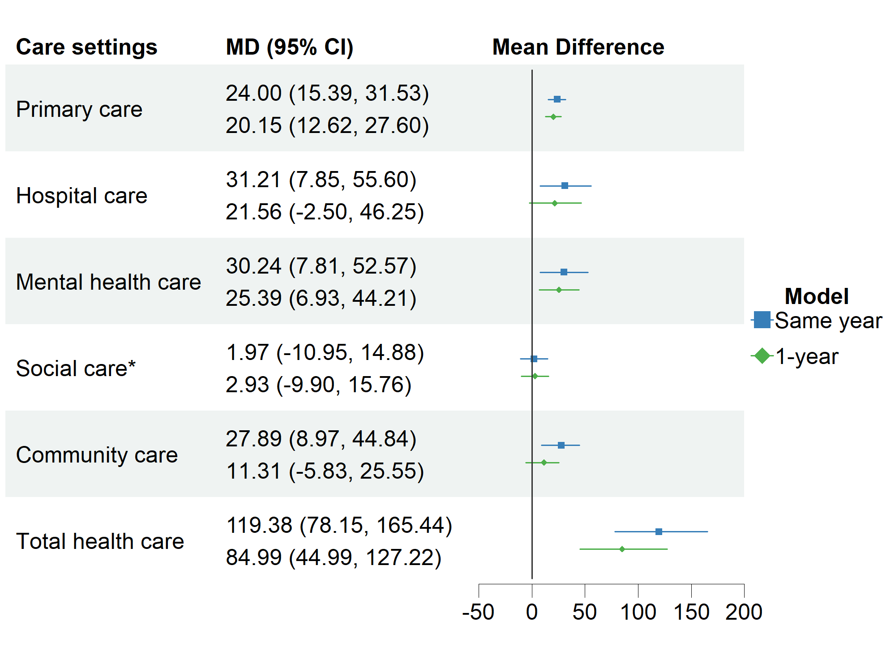

note: results in care settings with * were not bootstrapped due to convergence issues.
Appendix 3. Mean cost differences with 1:1 matching
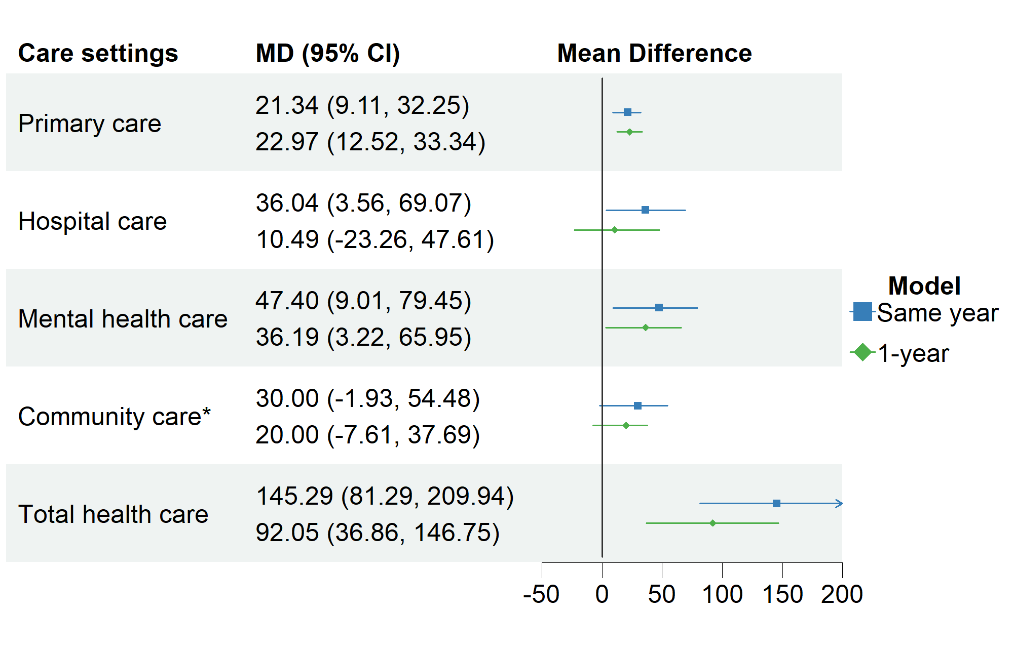

Note: The results of social care were not applicable in this context as no one in this sample have positive social care costs.

