Degradation exacerbates C and P limitations of soil microorganisms in the wetland ecosystems
Mingli Zhang¹, Yike Huang¹, Xinyu Li¹, Zhiwei Mao¹, Kexin Chen¹, Mei Liu², Yadong Xu³, Wenkai Chen⁴, Lin Wang⁵, Ming Dou¹, Junxiang Ding^{1*}
¹ Henan Funiu Mountain Biological and Ecological Environment Observatory, College of Ecology and Environment, Zhengzhou University, Zhengzhou, 450001, China
² Information office, Henan University of Technology, Zhengzhou, 450001, China
³ School of Agricultural Sciences, Zhengzhou University, Zhengzhou, 450001, China
⁴ Chengdu Botanical Garden, Chengdu, 610083, China
⁵ Institute of Natural Resources Monitoring and Comprehensive Land Improvement of Henan Province, Department of Natural Resources of Henan Province, Zhengzhou 450001, China
*Author for corresponding:
Junxiang Ding, E-mail: dingjunxiang@zzu.edu.cn, Tel: +86 13383827510

Table S1 Environmental characteristics of the nine sampling sites. Data are represented as means with standard errors (SE)
Site | Degradation  Degree | pH | EC | SWC (%) | SBD (g/cm³) | TC (g/kg) | TN (g/kg) | IN (mg/kg) | TP (g/kg) | AP (mg/kg)
1 | L | 8.24±0.03 | 194.40±41.81 | 37.16±6.65 | 1.33±0.04 | 28.03±4.25 | 0.98±0.23 | 62.62±3.22 | 0.58±0.05 | 22.7±2.30
2 | L | 8.28±0.03 | 223.30±52.50 | 32.96±8.23 | 1.40±0.02 | 26.12±2.07 | 0.84±0.03 | 57.41±4.52 | 0.61±0.02 | 16.84±3.78
3 | L | 8.28±0.03 | 251.00±19.00 | 36.69±5.94 | 1.42±0.02 | 24.53±3.94 | 0.83±0.04 | 61.33±2.09 | 0.59±0.03 | 13.28±2.85
4 | M | 8.36±0.08 | 268.80±24.99 | 24.38±6.35 | 1.56±0.03 | 24.20±0.96 | 0.59±0.07 | 53.36±7.29 | 0.54±0.07 | 13.33±4.24
5 | M | 8.39±0.05 | 325.33±28.92 | 24.30±4.44 | 1.55±0.02 | 18.58±0.66 | 0.52±0.02 | 46.49±1.62 | 0.56±0.01 | 8.75±2.43
6 | M | 8.52±0.04 | 347.67±71.49 | 17.40±7.05 | 1.56±0.06 | 18.53±1.41 | 0.53±0.13 | 50.55±7.31 | 0.58±0.06 | 7.93±2.49
7 | S | 8.40±0.01 | 333.67±23.46 | 15.37±9.59 | 1.59±0.03 | 16.05±0.69 | 0.47±0.05 | 43.57±5.49 | 0.58±0.05 | 8.43±3.75
8 | S | 8.53±0.05 | 357.00±57.47 | 20.81±3.19 | 1.60±0.01 | 16.07±1.45 | 0.38±0.03 | 47.77±6.35 | 0.62±0.01 | 10.91±2.70
9 | S | 8.52±0.05 | 399.33±20.13 | 17.88±7.89 | 1.64±0.03 | 16.47±1.03 | 0.34±0.09 | 42.53±2.29 | 0.64±0.04 | 8.37±3.39
Abbreviations are as follows: L, lightly degraded wetland; M, moderately degraded wetland; S, severely degraded wetland; pH, soil pH; EC, soil electrical conductivity; SWC, soil water content; SBD, soil bulk density; TC, soil total carbon; TN, soil total nitrogen; IN, soil inorganic nitrogen; TP, soil total phosphorus; AP, soil available phosphorus; C:N, the ratio of TC to TN; C:P, the ratio of TC to TP; N:P, the ratio of TN to TP.

Table S2 Community characteristics of the nine sampling sites. Data are represented as means with standard errors (SE)
Site | Degradation  Degree | PD (n/cm²) | AH (cm) | SR | CV (%) | AGB (g/m²)
1 | L | 297.00±41.00 | 123.95±33.01 | 4.56±0.84 | 78.89±10.78 | 868.89±215.67
2 | L | 332.33±73.23 | 88.64±8.22 | 5.22±0.84 | 61.22±9.34 | 624.44±99.57
3 | L | 226.11±13.46 | 82.68±9.10 | 5.56±1.02 | 54.44±5.36 | 411.82±80.65
4 | M | 179.33±22.43 | 71.55±15.34 | 6.89±1.64 | 45.00±4.41 | 356.97±141.38
5 | M | 144.33±19.55 | 62.42±15.39 | 4.78±1.07 | 34.11±8.00 | 195.67±32.62
6 | M | 112.44±17.43 | 55.15±10.78 | 6.89±1.95 | 32.56±2.50 | 136.02±22.5
7 | S | 106.44±10.00 | 48.16±3.42 | 5.00±0.33 | 21.11±4.19 | 123.47±51.91
8 | S | 119.33±23.67 | 27.11±2.42 | 5.89±2.34 | 23.33±2.89 | 77.09±11.95
9 | S | 98.44±23.87 | 42.84±6.65 | 3.44±0.77 | 17.00±4.06 | 91.24±6.84
Abbreviations are as follows: L, lightly degraded wetland; M, moderately degraded wetland; S, severely degraded wetland; PD, plant density; AH, average plant height; SR, species richness; CV, plant coverage; AGB, aboveground biomass.

Table S3 Substrates and functions of the four soil extracellular enzymes
Full Name | Abbreviation | Substrate | Function
β-1,4-glucosidase | BG | 4-methylumbelliferyl-β-D-glucopyranoside | Cleaves β-1,4-glycosidic bonds in cellulose and hemicellulose, releasing glucose.
N-acetyl-β-D-glucosaminidase | NAG | 4-methylumbelliferyl-glucosaminide | Cleaves β-1,4-glycosidic bonds in chitin and chitosan, releasing N-acetylglucosamine.
Leucine aminopeptidase | LAP | L-Leucine-7-amido-4-methylcoumarin hydrochloride | Cleaves peptide bonds in proteins, releasing amino acids.
Alkaline phosphatase | AKP | 4-methylumbelliferyl-phosphate | Cleaves phosphate ester bonds in organic phosphorus compounds, releasing inorganic phosphate.
References
DeForest JL (2009) The influence of time, storage temperature, and substrate age on potential soil enzyme activity in acidic forest soils using MUB-linked substrates and L-DOPA. Soil Biol. Biochem., 41(6), 1180-1186. http://dx.doi.org/10.1016/j.soilbio.2009.02.029.
German DP, Weintraub MN, Grandy AS, Lauber CL, Rinkes ZL, Allison SD (2011) Optimization of hydrolytic and oxidative enzyme methods for ecosystem studies. Soil Biol. Biochem., 43(7), 1387-1397. http://dx.doi.org/10.1016/j.soilbio.2011.03.017.
Han MG, Chen Y, Sun LJ, Yu M, Li R, Li SF, Su JR, Zhu B (2023) Linking rhizosphere soil microbial activity and plant resource acquisition strategy. J Ecol, 111(4), 875-888. http://dx.doi.org/10.1111/1365-2745.14067.
Sinsabaugh RL, Lauber CL, Weintraub MN, Ahmed B, Allison SD, Crenshaw C, Contosta AR, Cusack D, Frey S, Gallo ME, Gartner TB, Hobbie SE, Holland K, Keeler BL, Powers JS, Stursova M, Takacs-Vesbach C, Waldrop MP, Wallenstein MD, Zak DR, Zeglin LH (2008) Stoichiometry of soil enzyme activity at global scale. Ecol Lett, 11(11), 1252-1264. http://dx.doi.org/10.1111/j.1461-0248.2008.01245.x.

Table S4 Comparison of enzyme activities (nmol h⁻¹ g⁻¹ soil) in the study area with global and other ecosystem averages (mean ± SD)
Enzyme | Study Area (n=3) | Global Average (n=40) | Chinese Forest Ecosystem Average (n=181) | Desert Ecosystem (n=4) | Songnen Plain Wetland (n=4)
C-acquiring enzymes | 24.6 ± 4.5 | 414.1 ± 271.1 | 450.3 ± 285.6 | 306.4 ± 225.7 | 43.4 ± 5.4
N-acquiring enzymes | 10.4 ± 3.4 | 406.6 ± 255.3 | 268.2 ± 167.9 | 418.2 ± 50.4 | 118.8 ± 11.4
P-acquiring enzymes | 15.7 ± 4.5 | 708.6 ± 489.6 | 401.6 ± 272.5 | 129.0 ± 39.3 | 62.5 ± 6.8
Notes: n, number of ecosystem. C-acquiring enzyme activity represents β-1,4-glucosidase (BG) for all ecosystems except the desert ecosystem, where it represents the sum of BG and cellobiohydrolase (CBH) activities; N-acquiring enzyme activity represents the sum of N-acetyl-β-D-glucosaminidase (NAG) and leucine aminopeptidase (LAP) activities; P-acquiring enzyme activity represents acid or alkaline phosphatase. China average cited from Sinsabaugh et al. (2008); Chinese forest ecosystem average cited from Liu et al. (2023); desert ecosystem cited from Wang et al. (2023); Songnen plain wetland cited from Song et al. (2024).
References
Liu J, Fang L, Qiu T, Bing H, Cui Y, Sardans J, Du E, Chen J, Tan W, Delgado-Baquerizo M, Zhou G, Cui Q, Penuelas J (2023) Disconnection between plant–microbial nutrient limitation across forest biomes. Funct Ecol, 37(8), 2271-2281. http://dx.doi.org/10.1111/1365-2435.14361.
Sinsabaugh RL, Lauber CL, Weintraub MN, Ahmed B, Allison SD, Crenshaw C, Contosta AR, Cusack D, Frey S, Gallo ME, Gartner TB, Hobbie SE, Holland K, Keeler BL, Powers JS, Stursova M, Takacs-Vesbach C, Waldrop MP, Wallenstein MD, Zak DR, Zeglin LH (2008) Stoichiometry of soil enzyme activity at global scale. Ecol Lett, 11(11), 1252-1264. http://dx.doi.org/10.1111/j.1461-0248.2008.01245.x.
Song YZ, Song TJ, An Y, Shan LP, Su XS, Yu SD (2024) Soil ecoenzyme activities coupled with soil properties and plant biomass strongly influence the variation in soil organic carbon components in semi-arid degraded wetlands. Sci Total Environ, 922. http://dx.doi.org/10.1016/j.scitotenv.2024.171361.
Wang XY, Li YQ, Wang LL, Duan YL, Yao B, Chen Y, Cao WJ (2023) Soil extracellular enzyme stoichiometry reflects microbial metabolic limitations in different desert types of northwestern China. Sci Total Environ, 874. http://dx.doi.org/10.1016/j.scitotenv.2023.162504.

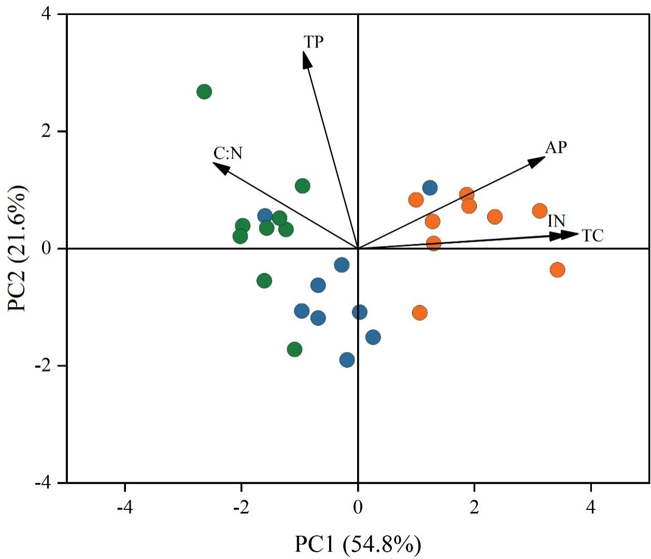
Fig. S1 Principal component analysis (PCA) of soil nutrient variables. TC, soil total carbon; IN, soil inorganic nitrogen; TP, soil total phosphorus; AP, soil available phosphorus; C:N, the ratio of TC to TN.
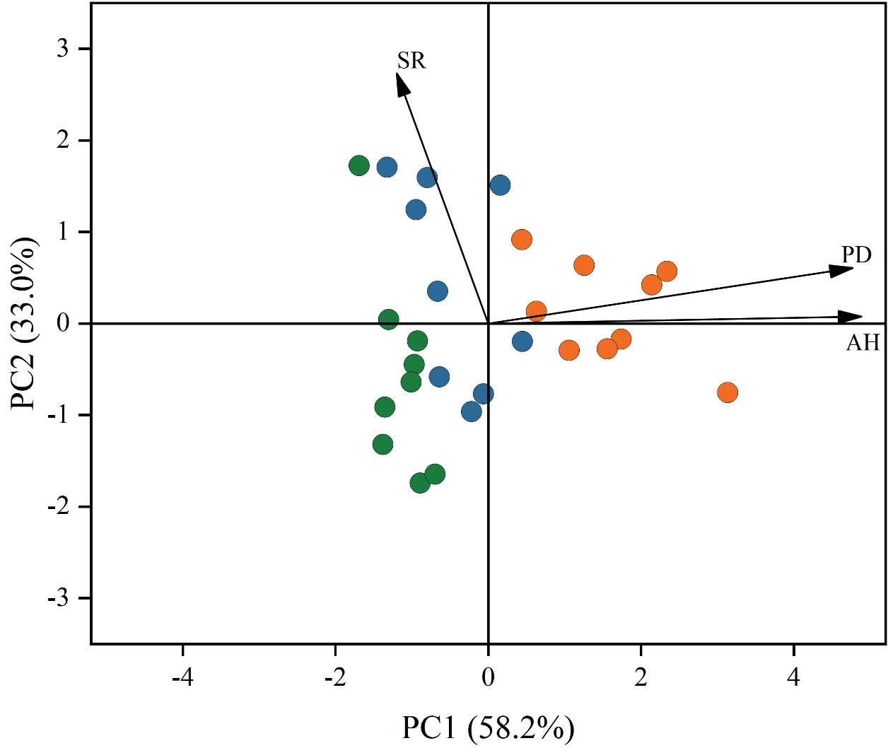
Fig. S2 Principal component analysis (PCA) of plant. PD, plant density; AH, average plant height; SR, species richness.
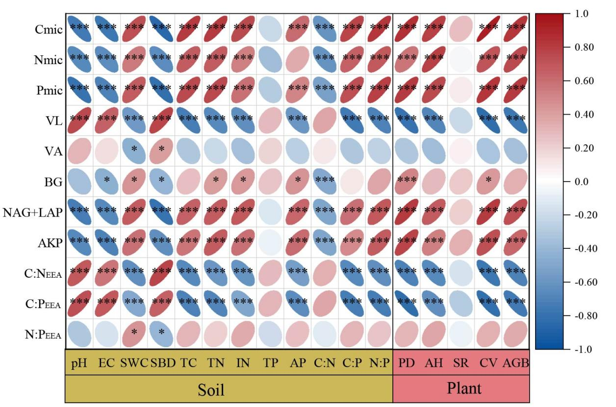
Fig. S3 Correlation analysis between soil enzyme activities and environmental factors along the wetland degradation gradient. * p ≤ 0.05; ** p ≤ 0.01; *** p ≤ 0.001. Narrower ellipses indicate stronger correlations. pH, soil pH; EC, soil electrical conductivity; SWC, soil water content; SBD, soil bulk density; TC, soil total carbon; TN, soil total nitrogen; IN, soil inorganic nitrogen; TP, soil total phosphorus; AP, soil available phosphorus; C:N, the ratio of TC to TN; C:P, the ratio of TC to TP; N:P, the ratio of TN to TP; PD, plant density; AH, average plant height; SR, species richness; CV, plant coverage; AGB, aboveground biomass; BG, β-1,4-glucosidase; NAG, N-acetyl-β-D-glucosaminidase; LAP, leucine aminopeptidase; AKP, alkaline phosphatase; C:N_{EEA}, the ratio of C- to N-acquiring enzyme activities; C:P_{EEA}, the ratio of C- to P-acquiring enzyme activities; N:P_{EEA}, the ratio of N- to P-acquiring enzyme activities; C_{mic}, microbial biomass carbon; N_{mic}, microbial biomass nitrogen; P_{mic}, microbial biomass phosphorus; VL, vector length; VA, vector angle.

