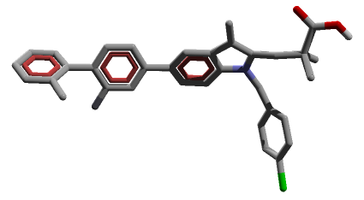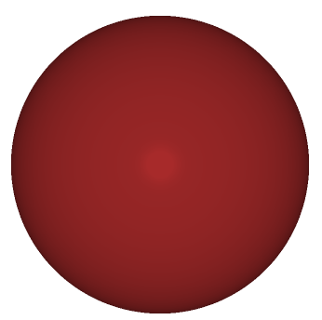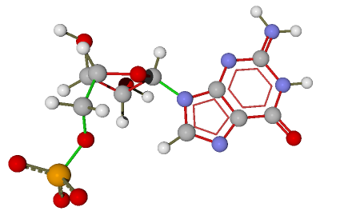
A] B] C]
Figure 1S: Binding poses of co crystal ligands to respective receptors: A] 3-[1-(4 chlorobenzyl)-5-(2-fluoro-2'-methylbiphenyl-4-yl)-3-methyl-1H-indol-2-yl]-2, 2 dimethylpropanoic acid (PDB: 4YK5) B] Zinc (2P1H) C] Guanosine-5'-monophosphate (2JBH)
Table 1S: Binding affinities of Co-crystal Ligands for docking validation
Sr. No. | Co crystal Ligand | RMSD | Binding affinity  Kcal/Mol
2P1H | Zinc | -- | -1.1
4YK5 | 3-[1-(4-chlorobenzyl)-5-(2-fluoro-2'-methylbiphenyl-4-yl)-3-methyl-1H-indol-2-yl]-2,2-dimethylpropanoic acid | 0 | -8.2
2JBH | Guanosine-5'-monophosphate | 0 | -7.8

