Supplementary Figure and Table

S1. Spatiotemporal Evolution of Primary School Teacher Allocation in China
Table S1 Raw Data of Student-Teacher Ratio (STR) and Class-Teacher Ratio (CTR) by Province in China (2004, 2010, 2016, 2023), stratified by total, urban, town, and rural area
Region |  | 2004  STR | 2010  STR | 2016  STR | 2023  STR | 2004  CTR | 2010  CTR | 2016  CTR | 2023  CTR
Beijing | Total | 10.5818 | 13.2024 | 14.0496 | 0.4343 | 0.4198 | 0.4180 | 0.4115 | 14.7289
Beijing | Urban | 11.5281 | 14.0918 | 14.6058 | 0.4388 | 0.4310 | 0.4226 | 0.4116 | 15.1608
Beijing | Towns | 10.9016 | 12.2760 | 13.1009 | 0.4185 | 0.3916 | 0.3990 | 0.4099 | 12.5498
Beijing | Rural | 8.2552 | 10.2827 | 10.4989 | 0.4482 | 0.3929 | 0.4003 | 0.4123 | 11.7073
Tianjin | Total | 13.1723 | 13.5567 | 15.1923 | 0.3916 | 0.3938 | 0.4202 | 0.4077 | 15.8956
Tianjin | Urban | 12.2120 | 12.3547 | 14.8394 | 0.3338 | 0.3635 | 0.3959 | 0.4074 | 16.8142
Tianjin | Towns | 13.2983 | 15.2377 | 17.3947 | 0.4122 | 0.3991 | 0.4731 | 0.4176 | 14.5255
Tianjin | Rural | 14.6325 | 12.9941 | 14.9389 | 0.4599 | 0.4370 | 0.4783 | 0.4016 | 11.0752
Hebei | Total | 16.8396 | 16.0355 | 17.6589 | 0.5416 | 0.4478 | 0.4526 | 0.4295 | 16.0999
Hebei | Urban | 17.8056 | 18.9664 | 19.0966 | 0.3800 | 0.3694 | 0.3839 | 0.4056 | 18.6268
Hebei | Towns | 17.3486 | 17.9580 | 18.8180 | 0.4446 | 0.3769 | 0.4259 | 0.4049 | 16.4514
Hebei | Rural | 16.5147 | 14.8656 | 15.9865 | 0.5992 | 0.4866 | 0.5082 | 0.4853 | 13.1753
Shanxi | Total | 18.7914 | 15.2757 | 13.2387 | 0.6527 | 0.4563 | 0.4248 | 0.4035 | 13.9576
Shanxi | Urban | 19.5546 | 18.8232 | 17.5651 | 0.4120 | 0.3564 | 0.3932 | 0.4189 | 17.4150
Shanxi | Towns | 20.6439 | 18.3229 | 14.7863 | 0.4165 | 0.3712 | 0.3814 | 0.3740 | 13.6036
Shanxi | Rural | 18.2559 | 13.1196 | 8.2161 | 0.7575 | 0.5167 | 0.4963 | 0.4336 | 7.1712
Inner Mongolia | Total | 13.3379 | 12.5986 | 13.4678 | 0.4847 | 0.3386 | 0.3705 | 0.3331 | 12.5691
Inner Mongolia | Urban | 18.3213 | 18.0681 | 16.9934 | 0.3949 | 0.3706 | 0.3983 | 0.3609 | 16.0950
Inner Mongolia | Towns | 15.6800 | 13.8707 | 13.2698 | 0.3803 | 0.3191 | 0.3539 | 0.3162 | 11.7729
Inner Mongolia | Rural | 10.8222 | 8.3840 | 8.5578 | 0.5527 | 0.3380 | 0.3678 | 0.3201 | 6.8461
Liaoning | Total | 16.7122 | 14.8550 | 14.1644 | 0.5249 | 0.4326 | 0.3964 | 0.3824 | 14.2875
Liaoning | Urban | 18.3652 | 17.1361 | 16.6702 | 0.4249 | 0.4031 | 0.3931 | 0.4233 | 17.8819
Liaoning | Towns | 17.5794 | 16.7850 | 13.0474 | 0.3838 | 0.3540 | 0.3417 | 0.3113 | 10.3728
Liaoning | Rural | 15.7756 | 13.2629 | 10.5685 | 0.5984 | 0.4609 | 0.4705 | 0.3573 | 7.6556
Jilin | Total | 12.3586 | 11.6033 | 11.5295 | 0.4692 | 0.4093 | 0.3757 | 0.3574 | 11.1477
Jilin | Urban | 16.5565 | 15.2411 | 14.7225 | 0.3802 | 0.3381 | 0.3586 | 0.3716 | 14.6644
Jilin | Towns | 14.9313 | 15.2593 | 12.6539 | 0.3826 | 0.3503 | 0.3417 | 0.3358 | 11.3645
Jilin | Rural | 10.2822 | 8.6086 | 7.5760 | 0.5255 | 0.4612 | 0.4228 | 0.3668 | 4.7035
Heilongjiang | Total | 13.2110 | 12.4194 | 12.0539 | 0.4758 | 0.3929 | 0.3553 | 0.3372 | 11.1553
Heilongjiang | Urban | 16.0833 | 14.9778 | 15.2692 | 0.3668 | 0.3447 | 0.3643 | 0.3756 | 14.4502
Heilongjiang | Towns | 15.9540 | 16.4157 | 12.8411 | 0.3579 | 0.3443 | 0.3396 | 0.3050 | 9.5660
Heilongjiang | Rural | 11.6892 | 10.0026 | 6.9788 | 0.5372 | 0.4277 | 0.3661 | 0.3050 | 4.7949
Shanghai | Total | 14.2452 | 15.5083 | 14.7918 | 0.4012 | 0.4181 | 0.3968 | 0.3718 | 13.9943
Shanghai | Urban | 14.2023 | 13.2276 | 14.9870 | 0.4324 | 0.4139 | 0.4016 | 0.3727 | 14.0622
Shanghai | Towns | 14.4532 | 17.1078 | 13.9281 | 0.3680 | 0.4191 | 0.3713 | 0.3649 | 13.5245
Shanghai | Rural | 12.2330 | 22.8168 | 14.3928 | 0.3652 | 0.4889 | 0.4014 | 0.3622 | 12.8189
Jiangsu | Total | 19.9372 | 15.9777 | 18.0566 | 0.4624 | 0.3706 | 0.4298 | 0.3890 | 16.1635
Jiangsu | Urban | 18.4964 | 16.7509 | 17.8775 | 0.4261 | 0.3884 | 0.4059 | 0.3866 | 16.5067
Jiangsu | Towns | 19.7846 | 16.7563 | 18.2252 | 0.4036 | 0.3535 | 0.4282 | 0.3889 | 16.0348
Jiangsu | Rural | 20.4711 | 14.8047 | 18.0946 | 0.4909 | 0.3747 | 0.5155 | 0.4142 | 13.4828
Zhejiang | Total | 21.5091 | 19.3899 | 17.7494 | 0.5226 | 0.4572 | 0.4604 | 0.4344 | 17.2519
Zhejiang | Urban | 21.6378 | 20.0600 | 18.1426 | 0.4838 | 0.4551 | 0.4532 | 0.4346 | 17.7968
Zhejiang | Towns | 21.5313 | 19.4762 | 18.0746 | 0.4873 | 0.4381 | 0.4586 | 0.4304 | 16.8870
Zhejiang | Rural | 21.3596 | 18.4425 | 15.8027 | 0.6094 | 0.4926 | 0.4862 | 0.4468 | 14.8101
Anhui | Total | 23.7579 | 18.7377 | 17.8951 | 0.6113 | 0.4996 | 0.5142 | 0.4760 | 17.6045
Anhui | Urban | 20.1533 | 19.7304 | 20.0717 | 0.4127 | 0.3934 | 0.4399 | 0.4514 | 19.7815
Anhui | Towns | 22.6596 | 20.8144 | 19.6230 | 0.4533 | 0.4000 | 0.4803 | 0.4699 | 18.6764
Anhui | Rural | 24.6461 | 17.8427 | 15.3220 | 0.6780 | 0.5556 | 0.5785 | 0.5192 | 12.8006
Fujian | Total | 16.7841 | 15.2548 | 18.0017 | 0.5435 | 0.4329 | 0.4557 | 0.4312 | 17.6925
Fujian | Urban | 19.6524 | 20.5352 | 21.0087 | 0.4423 | 0.4317 | 0.4373 | 0.4083 | 18.9163
Fujian | Towns | 17.4328 | 15.6512 | 18.3625 | 0.4126 | 0.3760 | 0.4175 | 0.4229 | 18.2119
Fujian | Rural | 15.7868 | 11.5263 | 13.7950 | 0.6210 | 0.4852 | 0.5305 | 0.5068 | 13.4927
Jiangxi | Total | 19.8692 | 20.9969 | 19.2900 | 0.5449 | 0.5475 | 0.5239 | 0.4647 | 15.7033
Jiangxi | Urban | 21.1819 | 21.9551 | 21.4636 | 0.4122 | 0.4141 | 0.4271 | 0.4323 | 18.2120
Jiangxi | Towns | 20.0784 | 23.5120 | 21.6161 | 0.5009 | 0.4332 | 0.4565 | 0.4321 | 16.5537
Jiangxi | Rural | 19.5610 | 20.1325 | 15.6541 | 0.5883 | 0.5968 | 0.6473 | 0.5771 | 10.3207
Shandong | Total | 16.5737 | 16.2406 | 16.9085 | 0.4438 | 0.3963 | 0.3966 | 0.4145 | 17.0105
Shandong | Urban | 17.6656 | 18.9368 | 18.2528 | 0.3865 | 0.3871 | 0.3823 | 0.4131 | 18.2459
Shandong | Towns | 16.4676 | 16.5383 | 17.0322 | 0.3731 | 0.3517 | 0.3761 | 0.4026 | 17.0679
Shandong | Rural | 16.2468 | 15.3640 | 15.3641 | 0.4849 | 0.4170 | 0.4365 | 0.4430 | 13.7298
Henan | Total | 21.1926 | 21.8292 | 19.0779 | 0.5476 | 0.5118 | 0.5100 | 0.4463 | 16.0210
Henan | Urban | 18.9197 | 21.9617 | 21.2796 | 0.3857 | 0.3821 | 0.4145 | 0.4109 | 19.0453
Henan | Towns | 20.9792 | 23.3882 | 20.8280 | 0.3943 | 0.4147 | 0.4704 | 0.4266 | 17.1565
Henan | Rural | 21.5526 | 21.4331 | 16.7889 | 0.5957 | 0.5566 | 0.5809 | 0.5011 | 12.0454
Hubei | Total | 21.4170 | 18.6432 | 17.1341 | 0.5356 | 0.4262 | 0.4356 | 0.4173 | 17.3649
Hubei | Urban | 18.8677 | 18.8390 | 19.3320 | 0.4458 | 0.3911 | 0.4149 | 0.4063 | 18.9377
Hubei | Towns | 19.8760 | 20.5143 | 17.8503 | 0.3485 | 0.3680 | 0.4150 | 0.4134 | 17.5728
Hubei | Rural | 22.8162 | 17.7738 | 13.7933 | 0.6108 | 0.4631 | 0.4841 | 0.4567 | 12.4279
Hunan | Total | 17.4175 | 19.1634 | 19.7783 | 0.5036 | 0.4442 | 0.4715 | 0.4304 | 16.7064
Hunan | Urban | 19.0075 | 22.0427 | 21.0371 | 0.3678 | 0.3905 | 0.4033 | 0.4025 | 18.7750
Hunan | Towns | 17.7098 | 19.7176 | 21.6893 | 0.3804 | 0.3642 | 0.4267 | 0.4135 | 17.3474
Hunan | Rural | 17.0049 | 18.2577 | 16.6552 | 0.5716 | 0.5026 | 0.5700 | 0.5210 | 11.4514
Guangdong | Total | 26.4731 | 19.7000 | 18.6038 | 0.6286 | 0.4898 | 0.4727 | 0.4645 | 18.1041
Guangdong | Urban | 26.6085 | 21.0835 | 20.1178 | 0.5384 | 0.4463 | 0.4454 | 0.4337 | 18.7203
Guangdong | Towns | 23.9362 | 19.8187 | 18.5344 | 0.4787 | 0.4119 | 0.4638 | 0.4748 | 18.7500
Guangdong | Rural | 27.3651 | 18.7591 | 15.1442 | 0.7283 | 0.5740 | 0.5464 | 0.5650 | 14.8286
Guangxi | Total | 23.4639 | 19.5319 | 19.4098 | 0.7825 | 0.5867 | 0.5352 | 0.4532 | 17.1274
Guangxi | Urban | 18.9519 | 22.2153 | 20.9305 | 0.4613 | 0.4490 | 0.4150 | 0.3949 | 19.1362
Guangxi | Towns | 18.3199 | 19.2232 | 20.5649 | 0.4383 | 0.4058 | 0.4526 | 0.4074 | 18.0579
Guangxi | Rural | 25.8184 | 19.3158 | 17.9614 | 0.9432 | 0.6779 | 0.6435 | 0.5504 | 14.4466
Hainan | Total | 19.9935 | 14.9941 | 16.1752 | 0.5909 | 0.4461 | 0.4332 | 0.3930 | 14.9740
Hainan | Urban | 22.1062 | 22.6069 | 22.4287 | 0.5100 | 0.4344 | 0.4384 | 0.3790 | 17.4333
Hainan | Towns | 19.7211 | 17.7511 | 16.4790 | 0.4112 | 0.3571 | 0.3745 | 0.3820 | 15.5141
Hainan | Rural | 19.6767 | 11.9685 | 10.3537 | 0.6773 | 0.4967 | 0.5058 | 0.4273 | 10.7399
Chongqing | Total | 23.8494 | 17.2278 | 17.0493 | 0.5900 | 0.4331 | 0.4239 | 0.3894 | 15.3074
Chongqing | Urban | 18.4642 | 17.9572 | 18.6966 | 0.3990 | 0.3972 | 0.4092 | 0.3977 | 17.7864
Chongqing | Towns | 24.5117 | 19.1469 | 18.1193 | 0.4237 | 0.3940 | 0.4015 | 0.3618 | 14.4377
Chongqing | Rural | 24.7929 | 15.2719 | 13.0273 | 0.6438 | 0.4784 | 0.4814 | 0.4213 | 8.7836
Sichuan | Total | 23.9194 | 19.3663 | 17.4781 | 0.6157 | 0.4635 | 0.4324 | 0.3820 | 15.5976
Sichuan | Urban | 22.5600 | 20.7574 | 19.3795 | 0.4436 | 0.4016 | 0.4036 | 0.3933 | 17.8847
Sichuan | Towns | 22.9403 | 19.2061 | 18.4797 | 0.4219 | 0.3647 | 0.3897 | 0.3573 | 15.0658
Sichuan | Rural | 24.3658 | 19.1255 | 14.9570 | 0.6905 | 0.5583 | 0.5071 | 0.4217 | 11.7836
Guizhou | Total | 26.5170 | 21.9034 | 17.9315 | 0.6993 | 0.5696 | 0.4792 | 0.4442 | 18.1343
Guizhou | Urban | 22.0346 | 24.6165 | 20.3460 | 0.4467 | 0.4472 | 0.4263 | 0.4188 | 20.0207
Guizhou | Towns | 22.0113 | 21.7678 | 19.6317 | 0.4695 | 0.4117 | 0.4239 | 0.4165 | 19.0750
Guizhou | Rural | 28.3352 | 21.6383 | 15.7400 | 0.7949 | 0.6373 | 0.5417 | 0.5150 | 14.6774
Yunnan | Total | 20.1238 | 18.3217 | 16.5876 | 0.6852 | 0.5280 | 0.4704 | 0.4614 | 16.6494
Yunnan | Urban | 21.1404 | 23.4272 | 20.1269 | 0.4429 | 0.4315 | 0.4082 | 0.4096 | 19.1306
Yunnan | Towns | 18.0574 | 17.9098 | 16.7797 | 0.4443 | 0.3861 | 0.3904 | 0.4218 | 17.5798
Yunnan | Rural | 20.4224 | 18.0401 | 15.6321 | 0.7455 | 0.5768 | 0.5228 | 0.5150 | 14.7446
Tibet | Total | 24.0229 | 15.8409 | 14.3660 | 0.8647 | 0.4753 | 0.4030 | 0.3738 | 14.4014
Tibet | Urban | 15.3605 | 15.7326 | 15.5475 | 0.3395 | 0.3231 | 0.3180 | 0.3274 | 15.9094
Tibet | Towns | 18.1904 | 14.2991 | 13.9088 | 0.5134 | 0.3385 | 0.3484 | 0.3485 | 14.1833
Tibet | Rural | 28.0064 | 16.4992 | 14.3441 | 1.1053 | 0.5540 | 0.4537 | 0.4040 | 13.9577
Shaanxi | Total | 19.7262 | 14.9006 | 15.4751 | 0.6690 | 0.4334 | 0.4201 | 0.4133 | 15.9018
Shaanxi | Urban | 21.2014 | 21.1178 | 19.3333 | 0.4378 | 0.4091 | 0.3904 | 0.4028 | 18.4063
Shaanxi | Towns | 20.3643 | 18.6555 | 15.7517 | 0.4210 | 0.3432 | 0.3907 | 0.3980 | 15.1175
Shaanxi | Rural | 19.4118 | 12.8933 | 10.4372 | 0.7378 | 0.4570 | 0.5127 | 0.5009 | 9.4208
Gansu | Total | 24.5138 | 16.8855 | 12.9090 | 0.7647 | 0.5823 | 0.5005 | 0.4435 | 13.4141
Gansu | Urban | 20.4120 | 20.6914 | 17.9967 | 0.4101 | 0.3789 | 0.3651 | 0.3830 | 18.0972
Gansu | Towns | 23.4137 | 17.6462 | 14.8751 | 0.5852 | 0.3962 | 0.3762 | 0.3839 | 14.7148
Gansu | Rural | 25.4516 | 16.0602 | 10.1182 | 0.8681 | 0.6718 | 0.6173 | 0.5693 | 8.2738
Qinghai | Total | 18.4171 | 19.5227 | 17.3392 | 0.6383 | 0.5428 | 0.4687 | 0.4277 | 17.3691
Qinghai | Urban | 21.7515 | 22.0487 | 19.0533 | 0.3958 | 0.4046 | 0.3577 | 0.3699 | 18.0533
Qinghai | Towns | 17.8593 | 20.3827 | 18.2657 | 0.4958 | 0.4208 | 0.4131 | 0.4139 | 18.4351
Qinghai | Rural | 17.9002 | 18.4183 | 15.3960 | 0.7580 | 0.6417 | 0.5902 | 0.4985 | 15.4610
Ningxia | Total | 19.9905 | 19.6817 | 17.0853 | 0.5897 | 0.5132 | 0.4524 | 0.4359 | 17.3192
Ningxia | Urban | 20.4255 | 21.1085 | 20.2807 | 0.3924 | 0.3781 | 0.3847 | 0.4195 | 20.2182
Ningxia | Towns | 19.4031 | 20.5010 | 17.9016 | 0.4614 | 0.3840 | 0.3898 | 0.4028 | 17.5177
Ningxia | Rural | 20.0904 | 18.7531 | 14.1196 | 0.6920 | 0.6245 | 0.5518 | 0.5072 | 12.4695
Xinjiang | Total | 16.4408 | 14.4502 | 14.7507 | 0.5156 | 0.4197 | 0.4114 | 0.4278 | 17.7004
Xinjiang | Urban | 18.0811 | 18.4457 | 18.1412 | 0.3975 | 0.3874 | 0.3972 | 0.4174 | 19.6306
Xinjiang | Towns | 15.6538 | 15.9041 | 14.4559 | 0.3795 | 0.3708 | 0.3778 | 0.4044 | 16.7345
Xinjiang | Rural | 16.1782 | 13.1084 | 13.5812 | 0.5669 | 0.4386 | 0.4359 | 0.4487 | 17.2750

Table S2. The proportion of bachelor-and-above teachers (PBAT) and the proportion of mid-to-senior title teachers (PMSTT) by Province in China (2004, 2010, 2016, 2023), stratified by total, urban, town, and rural area.
Region |  | 2004% PBAT | 2010% PBAT | 2016% PBAT | 2023% PBAT | 2004% PMSTT | 2010% PMSTT | 2016% PMSTT | 2023% PMSTT
Beijing | Total | 0.2216 | 0.7524 | 0.9051 | 0.9662 | 0.4799 | 0.5636 | 0.5106 | 0.5248
Beijing | Urban | 0.2760 | 0.7865 | 0.9139 | 0.9678 | 0.5556 | 0.5697 | 0.5183 | 0.5196
Beijing | Towns | 0.1891 | 0.6945 | 0.8758 | 0.9575 | 0.4277 | 0.5471 | 0.4599 | 0.5489
Beijing | Rural | 0.1615 | 0.6542 | 0.8631 | 0.9557 | 0.4058 | 0.5496 | 0.4985 | 0.5634
Tianjin | Total | 0.0608 | 0.4970 | 0.7650 | 0.9076 | 0.5798 | 0.8054 | 0.7030 | 0.6585
Tianjin | Urban | 0.1115 | 0.5258 | 0.7937 | 0.9146 | 0.6558 | 0.8054 | 0.6802 | 0.6424
Tianjin | Towns | 0.0279 | 0.5188 | 0.7159 | 0.8889 | 0.5251 | 0.7939 | 0.7672 | 0.7096
Tianjin | Rural | 0.0237 | 0.4144 | 0.6860 | 0.8773 | 0.5327 | 0.8233 | 0.7461 | 0.7209
Hebei | Total | 0.0476 | 0.2382 | 0.4789 | 0.7263 | 0.3755 | 0.5171 | 0.4683 | 0.4881
Hebei | Urban | 0.1263 | 0.4773 | 0.6516 | 0.8247 | 0.4957 | 0.5997 | 0.5393 | 0.4585
Hebei | Towns | 0.0582 | 0.2877 | 0.4812 | 0.7116 | 0.4414 | 0.5500 | 0.4510 | 0.4836
Hebei | Rural | 0.0294 | 0.1838 | 0.3940 | 0.6500 | 0.3344 | 0.4923 | 0.4488 | 0.5230
Shanxi | Total | 0.0397 | 0.2204 | 0.4938 | 0.7740 | 0.3116 | 0.3688 | 0.3793 | 0.3918
Shanxi | Urban | 0.1034 | 0.3891 | 0.6307 | 0.8028 | 0.3845 | 0.4166 | 0.4299 | 0.3709
Shanxi | Towns | 0.0540 | 0.2536 | 0.4963 | 0.7630 | 0.3259 | 0.3598 | 0.3651 | 0.4169
Shanxi | Rural | 0.0208 | 0.1549 | 0.3850 | 0.7347 | 0.2903 | 0.3563 | 0.3553 | 0.3834
Inner Mongolia | Total | 0.0584 | 0.3467 | 0.6075 | 0.8291 | 0.4621 | 0.6770 | 0.7175 | 0.6051
Inner Mongolia | Urban | 0.1449 | 0.5406 | 0.7507 | 0.8872 | 0.4645 | 0.6486 | 0.7015 | 0.5680
Inner Mongolia | Towns | 0.0609 | 0.3467 | 0.5743 | 0.8014 | 0.4951 | 0.6739 | 0.7440 | 0.6409
Inner Mongolia | Rural | 0.0286 | 0.2373 | 0.4678 | 0.7792 | 0.4492 | 0.6958 | 0.6792 | 0.5823
Liaoning | Total | 0.0438 | 0.2738 | 0.5179 | 0.7623 | 0.6595 | 0.7674 | 0.8150 | 0.7343
Liaoning | Urban | 0.1115 | 0.4478 | 0.6376 | 0.8295 | 0.6108 | 0.7562 | 0.8291 | 0.6971
Liaoning | Towns | 0.0335 | 0.2261 | 0.4250 | 0.6806 | 0.6569 | 0.7742 | 0.8197 | 0.8074
Liaoning | Rural | 0.0141 | 0.1807 | 0.3947 | 0.6542 | 0.6827 | 0.7729 | 0.7814 | 0.7411
Jilin | Total | 0.1450 | 0.3735 | 0.5962 | 0.8242 | 0.4720 | 0.5545 | 0.5850 | 0.6784
Jilin | Urban | 0.3696 | 0.6237 | 0.7391 | 0.8765 | 0.5007 | 0.5725 | 0.6386 | 0.6940
Jilin | Towns | 0.1694 | 0.4378 | 0.5918 | 0.8196 | 0.5191 | 0.5639 | 0.5793 | 0.6533
Jilin | Rural | 0.0772 | 0.2683 | 0.4699 | 0.7410 | 0.4466 | 0.5444 | 0.5413 | 0.6908
Heilongjiang | Total | 0.0705 | 0.2484 | 0.4677 | 0.7000 | 0.4976 | 0.5894 | 0.6519 | 0.6634
Heilongjiang | Urban | 0.1984 | 0.4902 | 0.6253 | 0.7688 | 0.5717 | 0.6612 | 0.7010 | 0.6571
Heilongjiang | Towns | 0.0788 | 0.2474 | 0.4244 | 0.6555 | 0.5354 | 0.6146 | 0.6409 | 0.6749
Heilongjiang | Rural | 0.0330 | 0.1726 | 0.3331 | 0.6011 | 0.4672 | 0.5567 | 0.6065 | 0.6495
Shanghai | Total | 0.0976 | 0.5770 | 0.7890 | 0.9178 | 0.5513 | 0.5600 | 0.4842 | 0.4951
Shanghai | Urban | 0.1177 | 0.6344 | 0.8114 | 0.9239 | 0.5386 | 0.6377 | 0.5002 | 0.4922
Shanghai | Towns | 0.0780 | 0.5440 | 0.6992 | 0.8636 | 0.5692 | 0.5098 | 0.4553 | 0.5254
Shanghai | Rural | 0.0500 | 0.1708 | 0.7127 | 0.8731 | 0.5108 | 0.1795 | 0.3140 | 0.4952
Jiangsu | Total | 0.0521 | 0.3952 | 0.7714 | 0.9595 | 0.4608 | 0.6394 | 0.6171 | 0.5413
Jiangsu | Urban | 0.0957 | 0.5526 | 0.8358 | 0.9674 | 0.4782 | 0.6615 | 0.6178 | 0.5108
Jiangsu | Towns | 0.0818 | 0.4262 | 0.7557 | 0.9513 | 0.4871 | 0.6473 | 0.6256 | 0.5821
Jiangsu | Rural | 0.0291 | 0.2700 | 0.6067 | 0.9337 | 0.4477 | 0.6185 | 0.5862 | 0.5749
Zhejiang | Total | 0.0690 | 0.4711 | 0.7438 | 0.9257 | 0.3997 | 0.5454 | 0.5509 | 0.5596
Zhejiang | Urban | 0.1461 | 0.5952 | 0.7860 | 0.9281 | 0.4401 | 0.5521 | 0.5559 | 0.5509
Zhejiang | Towns | 0.0528 | 0.4486 | 0.7164 | 0.9237 | 0.3942 | 0.5663 | 0.5717 | 0.5840
Zhejiang | Rural | 0.0227 | 0.3617 | 0.6804 | 0.9164 | 0.3711 | 0.5013 | 0.4874 | 0.5351
Anhui | Total | 0.0323 | 0.1694 | 0.4592 | 0.7569 | 0.3871 | 0.5983 | 0.5209 | 0.5312
Anhui | Urban | 0.0942 | 0.3393 | 0.5912 | 0.8343 | 0.5038 | 0.6272 | 0.5437 | 0.4866
Anhui | Towns | 0.0458 | 0.1911 | 0.4683 | 0.7440 | 0.4763 | 0.6034 | 0.5214 | 0.5565
Anhui | Rural | 0.0180 | 0.1247 | 0.3927 | 0.6810 | 0.3486 | 0.5903 | 0.5105 | 0.5419
Fujian | Total | 0.0132 | 0.1851 | 0.4637 | 0.7244 | 0.2839 | 0.5789 | 0.5828 | 0.4750
Fujian | Urban | 0.0427 | 0.3724 | 0.6611 | 0.8233 | 0.3518 | 0.5687 | 0.4956 | 0.4284
Fujian | Towns | 0.0144 | 0.1525 | 0.3925 | 0.6660 | 0.3393 | 0.5974 | 0.6416 | 0.5194
Fujian | Rural | 0.0052 | 0.0950 | 0.3169 | 0.5999 | 0.2446 | 0.5687 | 0.6105 | 0.4976
Jiangxi | Total | 0.0370 | 0.1738 | 0.4473 | 0.7050 | 0.3875 | 0.5082 | 0.5068 | 0.4594
Jiangxi | Urban | 0.1209 | 0.4230 | 0.6357 | 0.7429 | 0.5128 | 0.5009 | 0.5731 | 0.4935
Jiangxi | Towns | 0.0427 | 0.2497 | 0.4520 | 0.7156 | 0.4072 | 0.5510 | 0.5241 | 0.4701
Jiangxi | Rural | 0.0215 | 0.1232 | 0.3416 | 0.6281 | 0.3582 | 0.4962 | 0.4529 | 0.3880
Shandong | Total | 0.0636 | 0.3169 | 0.5878 | 0.9193 | 0.4768 | 0.5616 | 0.4549 | 0.4985
Shandong | Urban | 0.1679 | 0.6050 | 0.7709 | 0.9493 | 0.4597 | 0.5293 | 0.4455 | 0.4641
Shandong | Towns | 0.0725 | 0.3746 | 0.5590 | 0.9098 | 0.4493 | 0.5243 | 0.4454 | 0.5059
Shandong | Rural | 0.0265 | 0.2128 | 0.4330 | 0.8621 | 0.4911 | 0.5859 | 0.4760 | 0.5715
Henan | Total | 0.0364 | 0.1691 | 0.4399 | 0.7300 | 0.3401 | 0.4555 | 0.4667 | 0.4540
Henan | Urban | 0.1299 | 0.4052 | 0.6225 | 0.8209 | 0.4187 | 0.5264 | 0.5103 | 0.4265
Henan | Towns | 0.0520 | 0.1972 | 0.4398 | 0.7198 | 0.3677 | 0.4230 | 0.4417 | 0.4424
Henan | Rural | 0.0204 | 0.1233 | 0.3633 | 0.6677 | 0.3244 | 0.4516 | 0.4678 | 0.4918
Hubei | Total | 0.0685 | 0.1963 | 0.4327 | 0.7141 | 0.5559 | 0.6974 | 0.6400 | 0.5029
Hubei | Urban | 0.1575 | 0.4453 | 0.5761 | 0.7983 | 0.5473 | 0.6962 | 0.6577 | 0.4751
Hubei | Towns | 0.0750 | 0.2005 | 0.3965 | 0.6655 | 0.6014 | 0.7115 | 0.6518 | 0.5505
Hubei | Rural | 0.0288 | 0.1094 | 0.3164 | 0.5756 | 0.5507 | 0.6917 | 0.6058 | 0.4824
Hunan | Total | 0.0282 | 0.1755 | 0.4284 | 0.7796 | 0.5007 | 0.6622 | 0.5639 | 0.4919
Hunan | Urban | 0.1178 | 0.4479 | 0.6296 | 0.8255 | 0.5982 | 0.6714 | 0.5754 | 0.4576
Hunan | Towns | 0.0258 | 0.1738 | 0.3992 | 0.7702 | 0.5339 | 0.6573 | 0.5735 | 0.5250
Hunan | Rural | 0.0113 | 0.1220 | 0.3321 | 0.7190 | 0.4702 | 0.6632 | 0.5448 | 0.4749
Guangdong | Total | 0.0510 | 0.2347 | 0.5118 | 0.8442 | 0.3467 | 0.6003 | 0.5773 | 0.4879
Guangdong | Urban | 0.1318 | 0.4919 | 0.6396 | 0.8917 | 0.3735 | 0.5552 | 0.4987 | 0.4183
Guangdong | Towns | 0.0321 | 0.2034 | 0.4167 | 0.7884 | 0.4053 | 0.6372 | 0.6865 | 0.5911
Guangdong | Rural | 0.0195 | 0.0990 | 0.3204 | 0.7480 | 0.3117 | 0.6008 | 0.6381 | 0.5974
Guangxi | Total | 0.0107 | 0.1455 | 0.3768 | 0.6370 | 0.4064 | 0.5286 | 0.5972 | 0.5353
Guangxi | Urban | 0.0434 | 0.3853 | 0.5828 | 0.7987 | 0.4467 | 0.6142 | 0.5424 | 0.4445
Guangxi | Towns | 0.0108 | 0.1850 | 0.3931 | 0.6352 | 0.4945 | 0.6365 | 0.6661 | 0.5538
Guangxi | Rural | 0.0052 | 0.0989 | 0.2787 | 0.5008 | 0.3722 | 0.4738 | 0.5721 | 0.5937
Hainan | Total | 0.0255 | 0.0906 | 0.2564 | 0.5907 | 0.2932 | 0.4261 | 0.4917 | 0.4027
Hainan | Urban | 0.1282 | 0.3321 | 0.4068 | 0.6979 | 0.3441 | 0.3896 | 0.4493 | 0.3235
Hainan | Towns | 0.0140 | 0.0824 | 0.2375 | 0.5728 | 0.3633 | 0.4707 | 0.5472 | 0.4621
Hainan | Rural | 0.0094 | 0.0465 | 0.1507 | 0.4593 | 0.2557 | 0.4093 | 0.4557 | 0.4408
Chongqing | Total | 0.0472 | 0.2259 | 0.4890 | 0.7335 | 0.2937 | 0.3965 | 0.4758 | 0.5183
Chongqing | Urban | 0.1609 | 0.5800 | 0.6505 | 0.8344 | 0.4258 | 0.4494 | 0.4902 | 0.4728
Chongqing | Towns | 0.0657 | 0.2373 | 0.4254 | 0.6333 | 0.3855 | 0.4314 | 0.4895 | 0.5728
Chongqing | Rural | 0.0238 | 0.1237 | 0.3786 | 0.6079 | 0.2589 | 0.3508 | 0.4333 | 0.5549
Sichuan | Total | 0.0321 | 0.1624 | 0.3741 | 0.6817 | 0.3823 | 0.4591 | 0.4609 | 0.5194
Sichuan | Urban | 0.1455 | 0.4033 | 0.5584 | 0.8291 | 0.4711 | 0.5098 | 0.4936 | 0.4249
Sichuan | Towns | 0.0363 | 0.1648 | 0.3500 | 0.6066 | 0.4407 | 0.4990 | 0.4803 | 0.5859
Sichuan | Rural | 0.0151 | 0.0968 | 0.2906 | 0.5436 | 0.3546 | 0.4140 | 0.4146 | 0.5594
Guizhou | Total | 0.0109 | 0.1032 | 0.3805 | 0.7363 | 0.2026 | 0.3931 | 0.5434 | 0.5684
Guizhou | Urban | 0.0649 | 0.2756 | 0.5146 | 0.8015 | 0.3438 | 0.4590 | 0.4615 | 0.4660
Guizhou | Towns | 0.0104 | 0.1001 | 0.3689 | 0.7358 | 0.3246 | 0.5197 | 0.6015 | 0.6166
Guizhou | Rural | 0.0048 | 0.0844 | 0.3440 | 0.6701 | 0.1510 | 0.3425 | 0.5246 | 0.5957
Yunnan | Total | 0.0190 | 0.1743 | 0.4126 | 0.7436 | 0.3198 | 0.4681 | 0.5292 | 0.7303
Yunnan | Urban | 0.1275 | 0.4684 | 0.6398 | 0.8567 | 0.4588 | 0.5011 | 0.5491 | 0.5954
Yunnan | Towns | 0.0328 | 0.2312 | 0.4123 | 0.7242 | 0.4571 | 0.6013 | 0.6351 | 0.8360
Yunnan | Rural | 0.0089 | 0.1346 | 0.3570 | 0.6989 | 0.2854 | 0.4268 | 0.4751 | 0.7276
Tibet | Total | 0.0098 | 0.1121 | 0.4145 | 0.6434 | 0.0794 | 0.2251 | 0.3958 | 0.5263
Tibet | Urban | 0.0223 | 0.2355 | 0.5020 | 0.7296 | 0.2257 | 0.4617 | 0.5605 | 0.6426
Tibet | Towns | 0.0169 | 0.1195 | 0.4439 | 0.6417 | 0.1578 | 0.3547 | 0.4502 | 0.5873
Tibet | Rural | 0.0046 | 0.0915 | 0.3773 | 0.6126 | 0.0202 | 0.1374 | 0.3264 | 0.4518
Shaanxi | Total | 0.0295 | 0.2440 | 0.5895 | 0.8550 | 0.2327 | 0.3396 | 0.3858 | 0.4234
Shaanxi | Urban | 0.1216 | 0.4783 | 0.7263 | 0.8998 | 0.3751 | 0.4600 | 0.3881 | 0.3784
Shaanxi | Towns | 0.0339 | 0.2625 | 0.5785 | 0.8347 | 0.2853 | 0.3494 | 0.3880 | 0.4684
Shaanxi | Rural | 0.0145 | 0.1939 | 0.4522 | 0.7599 | 0.2036 | 0.3139 | 0.3788 | 0.4402
Gansu | Total | 0.0235 | 0.2073 | 0.5339 | 0.7891 | 0.3048 | 0.3806 | 0.3888 | 0.5657
Gansu | Urban | 0.0828 | 0.3761 | 0.6388 | 0.8400 | 0.4555 | 0.5388 | 0.5129 | 0.5796
Gansu | Towns | 0.0224 | 0.2275 | 0.5682 | 0.8051 | 0.3133 | 0.3973 | 0.3891 | 0.5842
Gansu | Rural | 0.0145 | 0.1749 | 0.4800 | 0.7308 | 0.2788 | 0.3509 | 0.3488 | 0.5302
Qinghai | Total | 0.0501 | 0.2756 | 0.5473 | 0.7330 | 0.3136 | 0.6522 | 0.6003 | 0.5561
Qinghai | Urban | 0.1232 | 0.4089 | 0.6821 | 0.8251 | 0.5172 | 0.6734 | 0.5366 | 0.4827
Qinghai | Towns | 0.0460 | 0.2791 | 0.5533 | 0.7269 | 0.3833 | 0.6955 | 0.6234 | 0.6106
Qinghai | Rural | 0.0351 | 0.2389 | 0.4618 | 0.6536 | 0.2355 | 0.6244 | 0.6147 | 0.5606
Ningxia | Total | 0.0519 | 0.2461 | 0.5443 | 0.7652 | 0.4157 | 0.5263 | 0.4309 | 0.5848
Ningxia | Urban | 0.1263 | 0.4675 | 0.6570 | 0.8532 | 0.5238 | 0.5999 | 0.4934 | 0.5276
Ningxia | Towns | 0.0589 | 0.2852 | 0.5485 | 0.7496 | 0.4190 | 0.5173 | 0.4371 | 0.6158
Ningxia | Rural | 0.0288 | 0.1419 | 0.4595 | 0.6478 | 0.3847 | 0.5016 | 0.3808 | 0.6327
Xinjiang | Total | 0.0603 | 0.2208 | 0.4134 | 0.6125 | 0.2761 | 0.4001 | 0.3728 | 0.3602
Xinjiang | Urban | 0.1352 | 0.4276 | 0.6336 | 0.7944 | 0.4392 | 0.5318 | 0.4428 | 0.4600
Xinjiang | Towns | 0.0714 | 0.2275 | 0.4515 | 0.6346 | 0.3744 | 0.4950 | 0.4481 | 0.4172
Xinjiang | Rural | 0.0403 | 0.1662 | 0.3055 | 0.4993 | 0.2204 | 0.3457 | 0.3032 | 0.2689

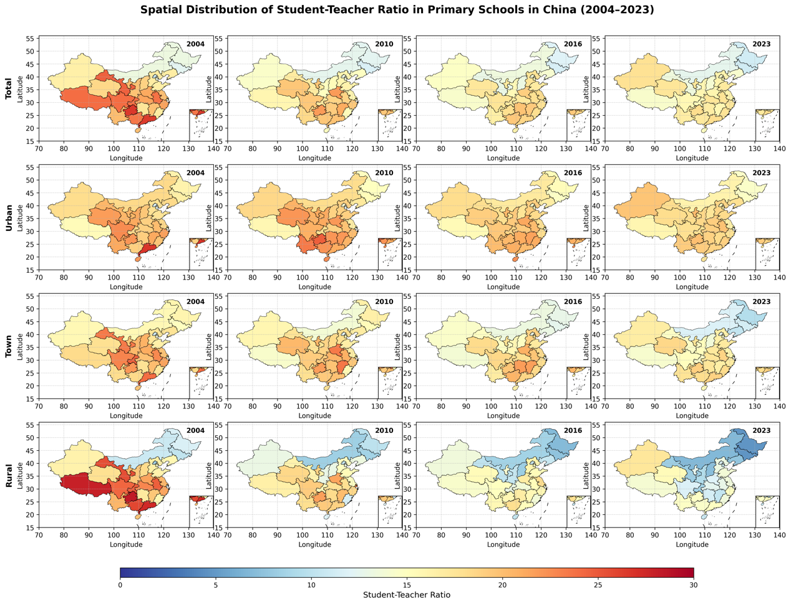
Figure S1. Spatial Distribution Characteristics of Provincial Student-Teacher Ratios in China (2004-2023), stratified by total, urban, town, and rural area.

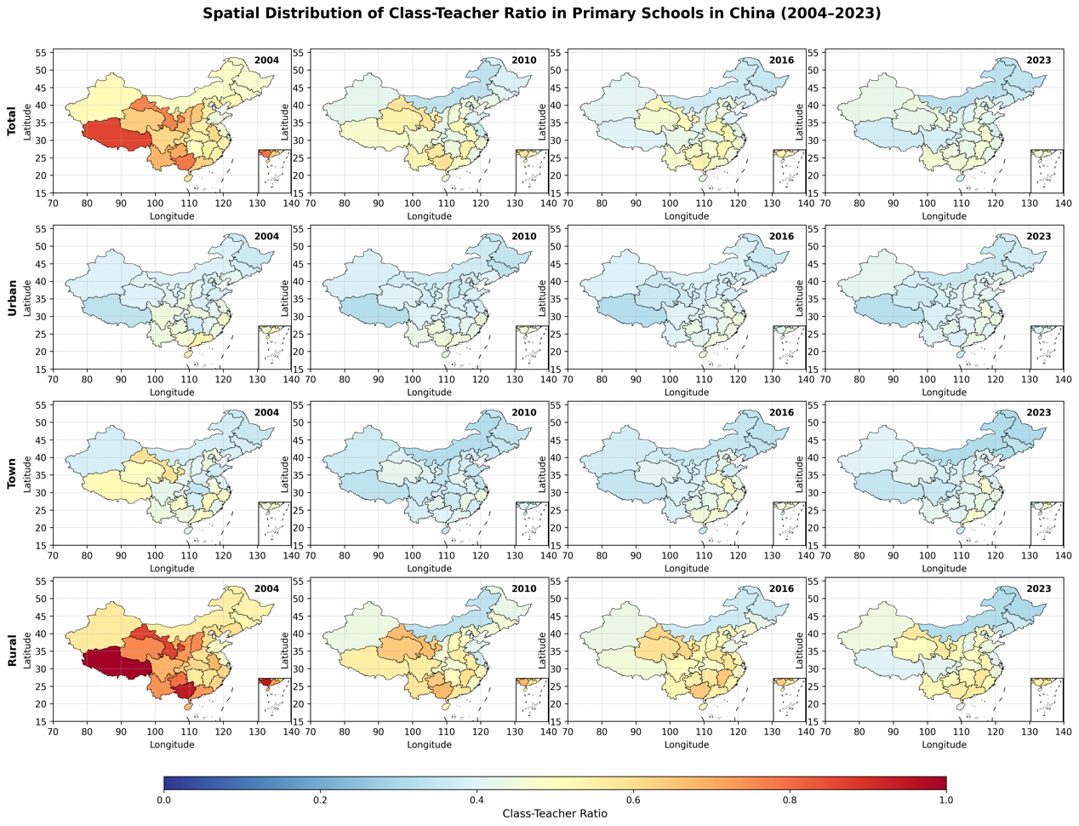
Figure S2. Spatial Distribution Characteristics of Provincial Class-Teacher Ratios in China (2004-2023), stratified by total, urban, town, and rural area.
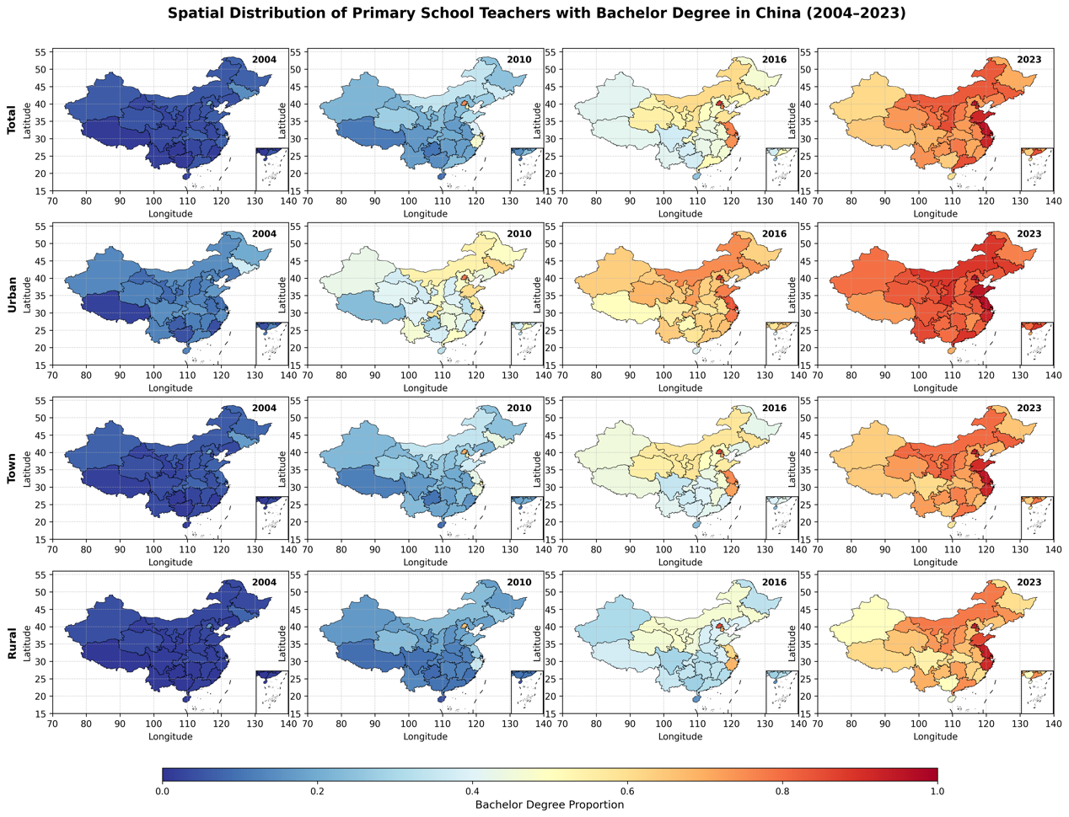
Figure S3. Spatial Distribution Characteristics of Provincial the proportion of bachelor-and-above teachers in China (2004-2023), stratified by total, urban, town, and rural area.
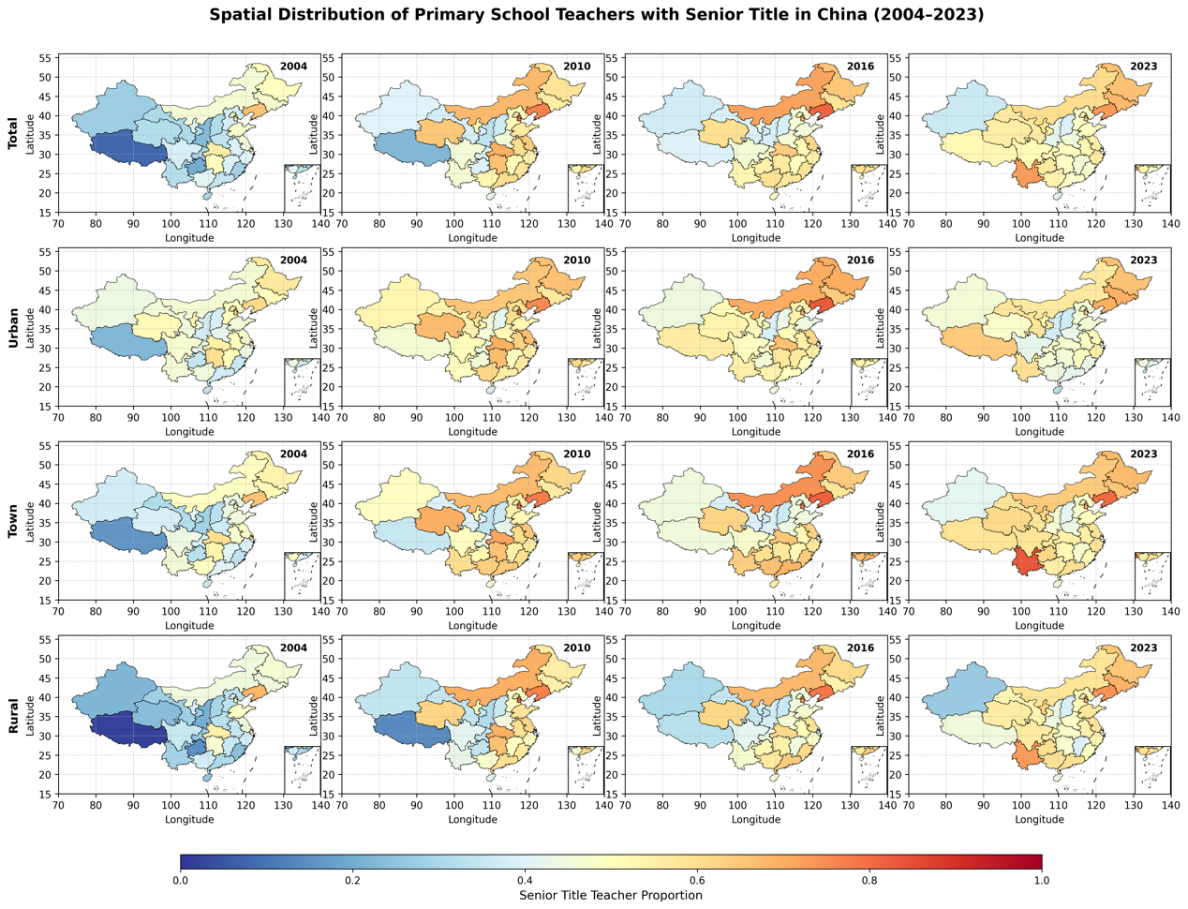
Figure S4. Spatial Distribution Characteristics of Provincial the proportion of mid-to-senior title teachers in China (2004-2023), stratified by total, urban, town, and rural area.

S2. Changes in Standard Deviational Ellipses of Primary School Teacher Allocation Indicator
Figure S5. The Standard Deviational Ellipses for the four teacher-allocation indicators (STR, CTR, PBAT, and PMSTT) across the 2004, 2010, 2016, 2023, stratified by total, urban, town, and rural area.

S3. Spatial autocorrelation analysis of primary school teacher resource allocation using Global Moran’s I and LISA cluster maps.
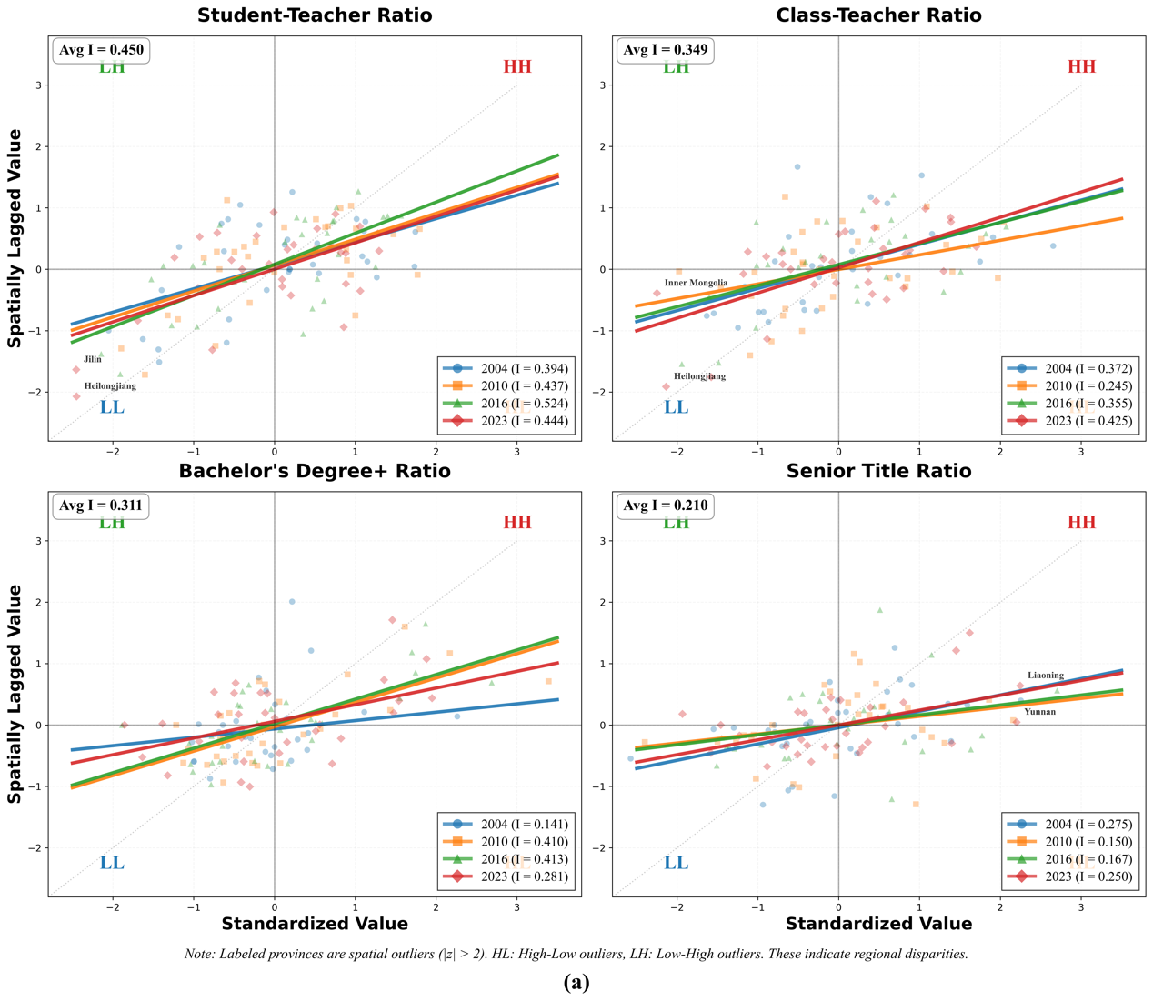
Figure S6. The spatial autocorrelation analysis results for the four teacher-allocation indicators (STR, CTR, PBAT, and PMSTT) across 2004, 2010, 2016, 2023 (Global Moran’s I values)
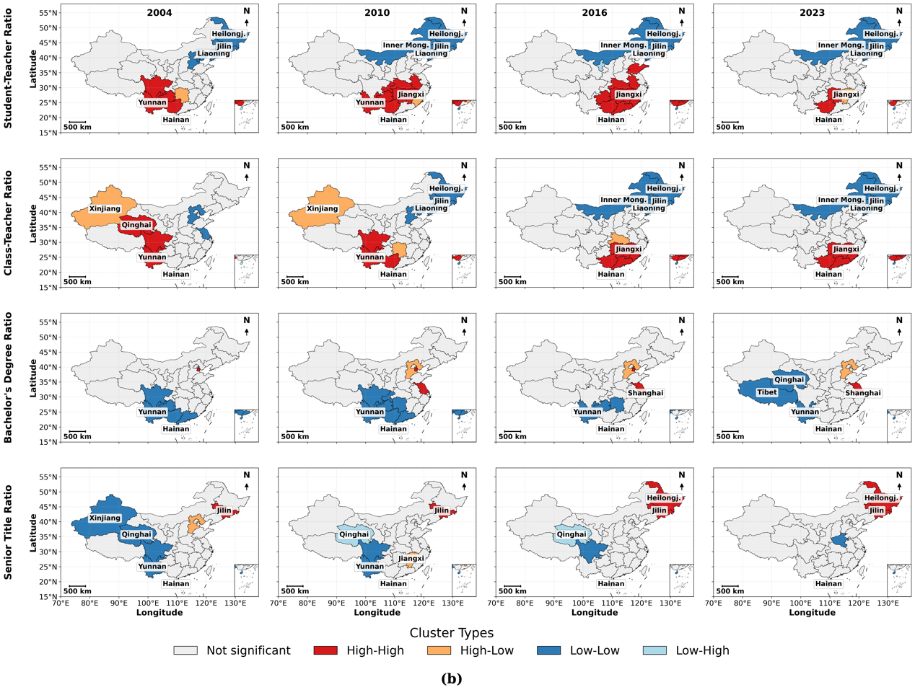
Figure S7. The spatial autocorrelation analysis results for the four teacher-allocation indicators (STR, CTR, PBAT, and PMSTT) across 2004, 2010, 2016, 2023 (LISA cluster maps)

S4. Change Trends in Primary Teacher Allocation Using Theil-Sen Slope (Three Stage)
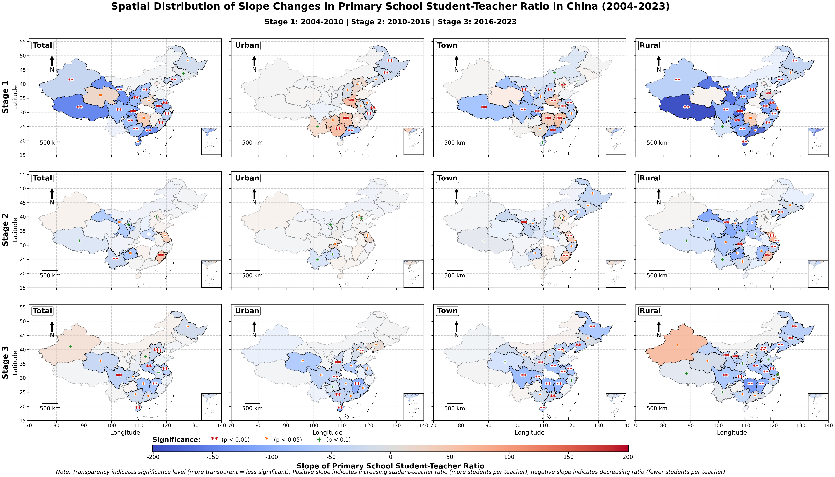
Figure S8. The Theil–Sen trend classification for STR across three sub-periods (2004–2010, 2010–2016, 2016–2023), stratified by total, urban, town, and rural area.

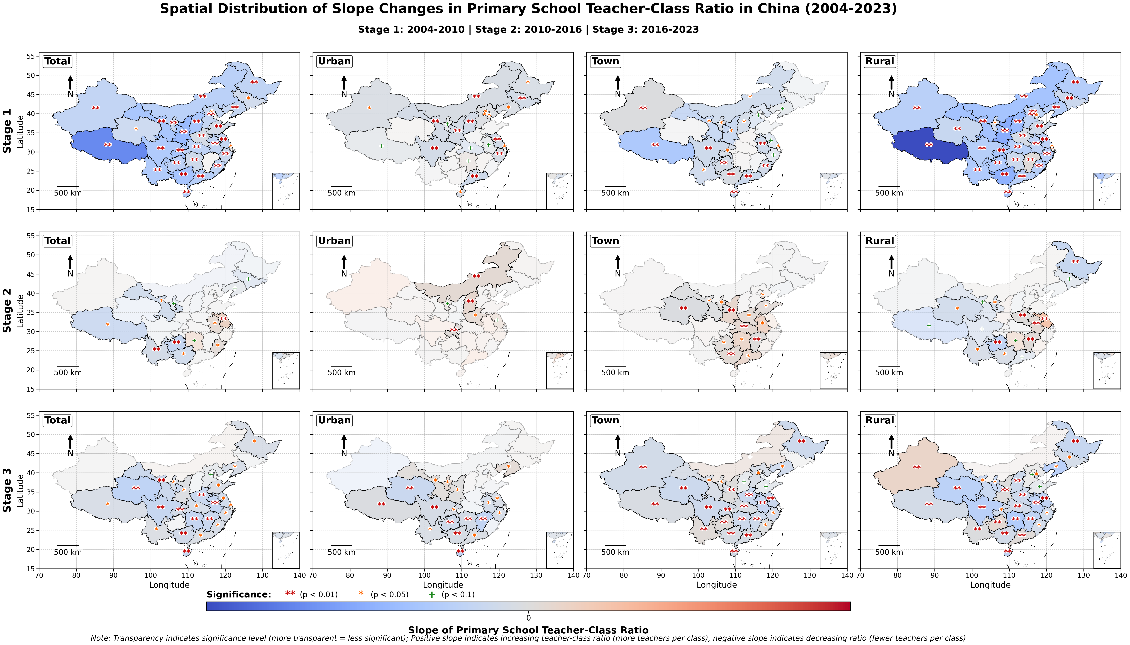
Figure S9. The Theil–Sen trend classification for CTR across three sub-periods (2004–2010, 2010–2016, 2016–2023), stratified by total, urban, town, and rural area.

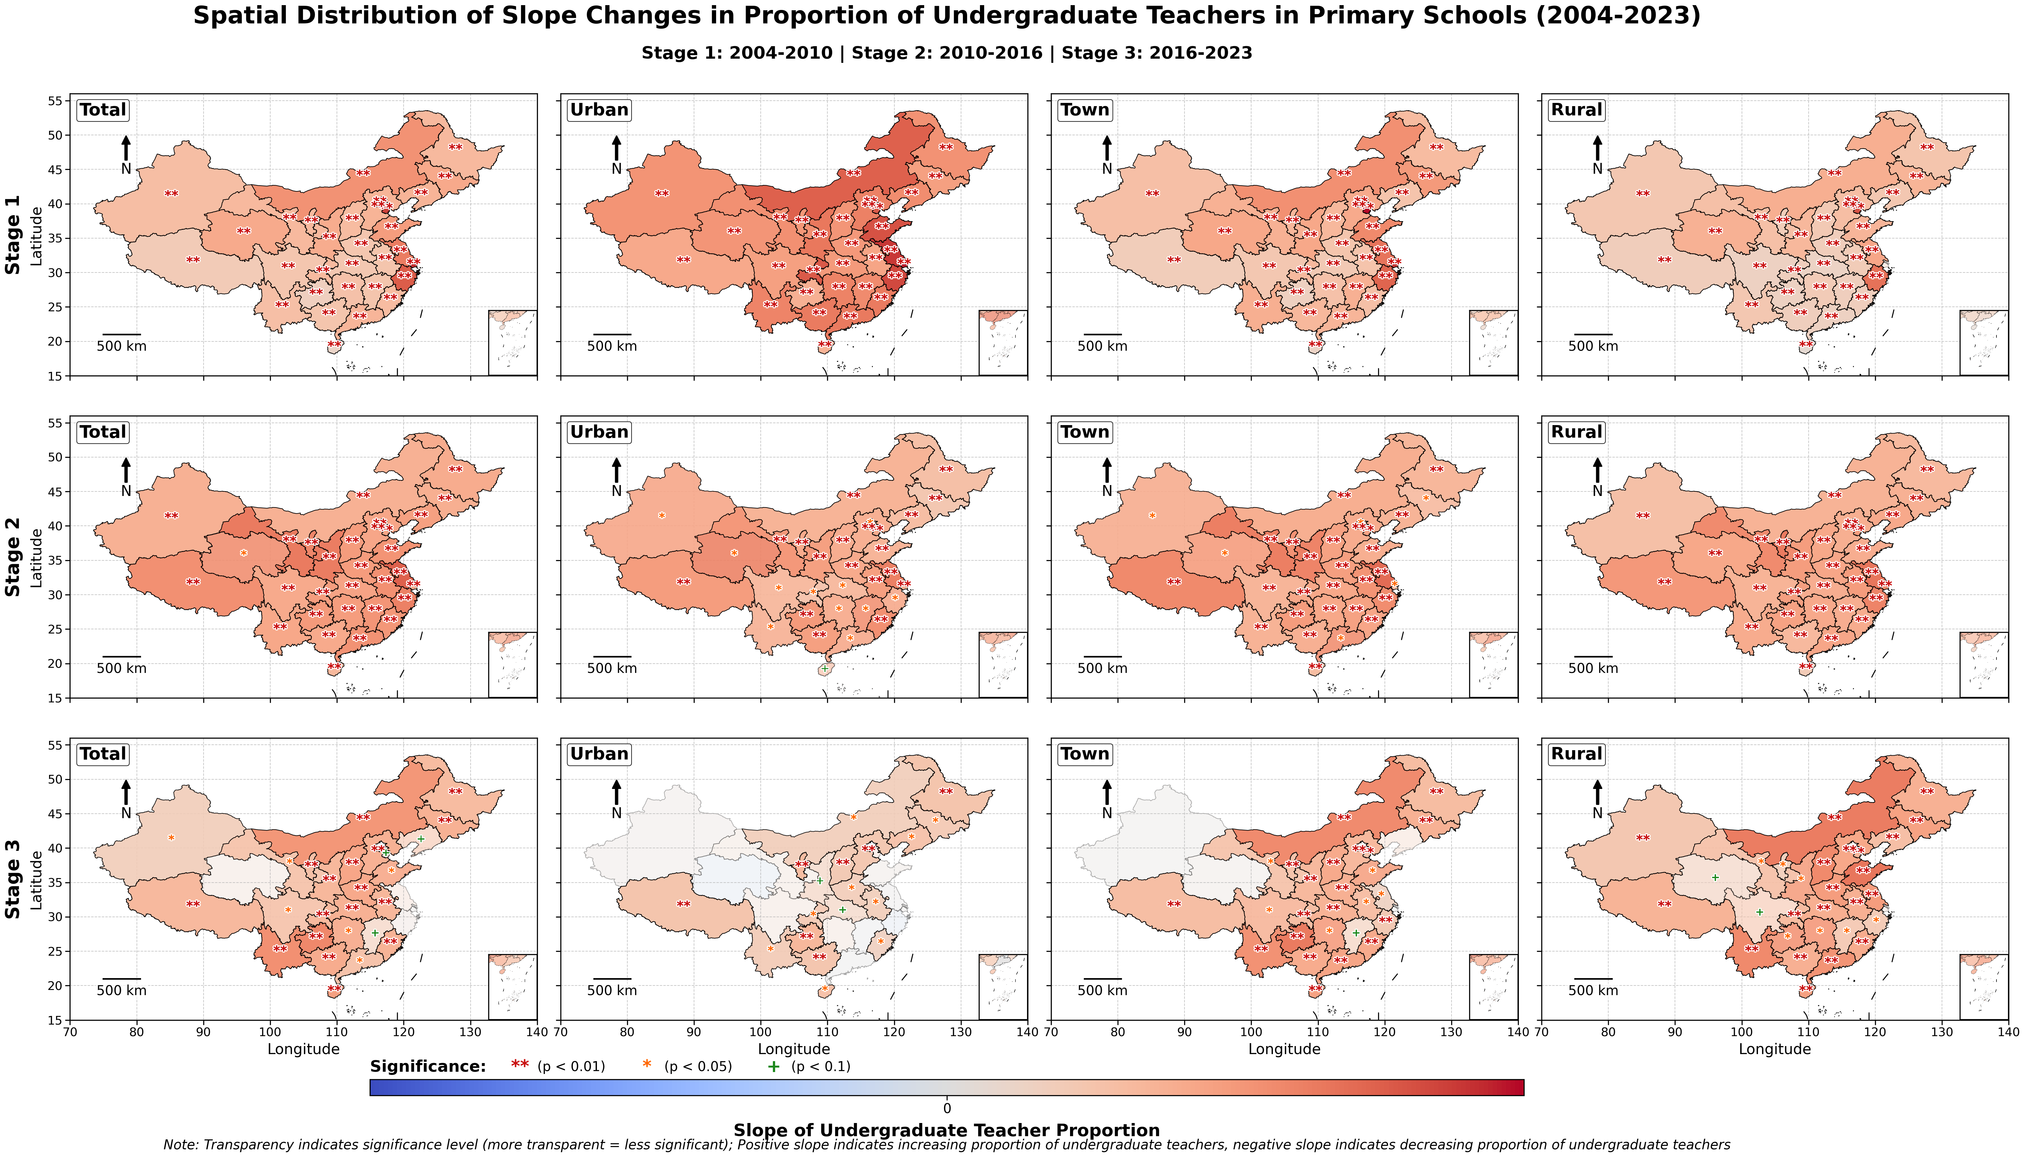
Figure S10. The Theil–Sen trend classification for PBAT across three sub-periods (2004–2010, 2010–2016, 2016–2023), stratified by total, urban, town, and rural area.

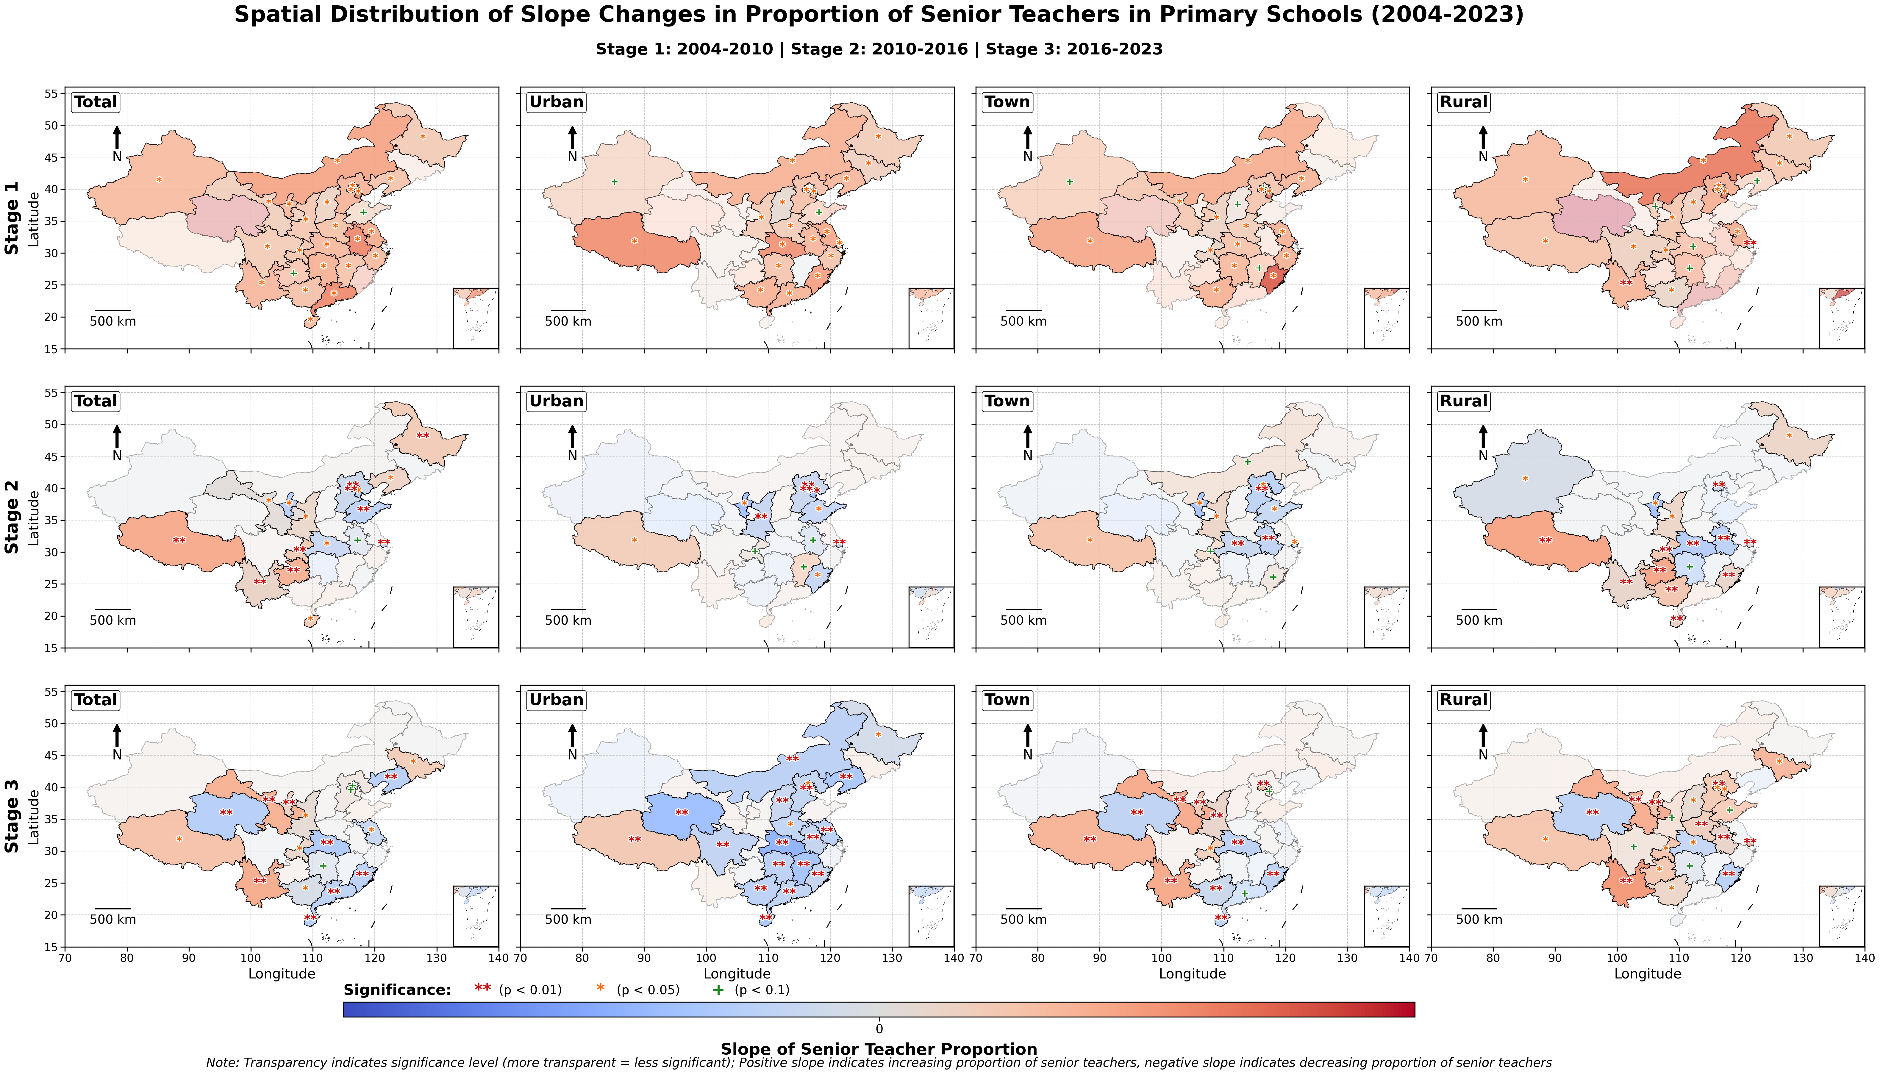
Figure S11. The Theil–Sen trend classification for PBAT across three sub-periods (2004–2010, 2010–2016, 2016–2023), stratified by total, urban, town, and rural area.

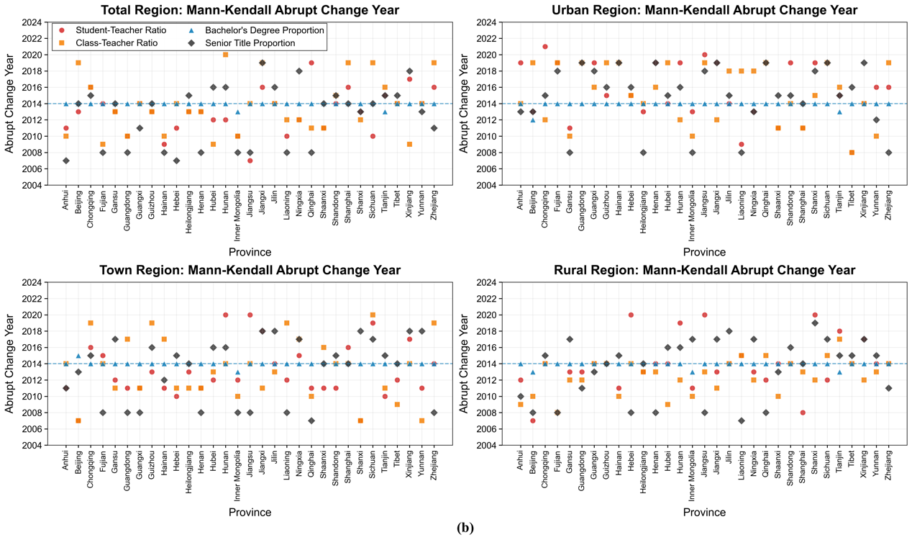
Figure S12. The Mann–Kendall abrupt change test results for all four teacher-allocation indicators (STR, CTR, PBAT, and PMSTT) across each province of China, stratified by total, urban, town, and rural area.

S5. Theil Index and Inequality Decomposition of Primary School Teacher Resources in China
Table S3. Theil index and its decomposition results for the four teacher-allocation indicators (STR, CTR, PBAT, and PMSTT) across China’s primary education at four time points (2004, 2010, 2016, 2022), stratified by urban, town, and rural area.
Year | Urban Theil index | Town Theil index | Rural Theil index
Student-teacher ratio
2004 | 0.0131(38.6) | 0.0148(36.1) | 0.0401(61.3)
2010 | 0.0130(43.1) | 0.0104(37.5) | 0.0304(52.6)
2016 | 0.0071(53.0) | 0.0124(51.9) | 0.0270(53.4)
2022 | 0.0041(41.0) | 0.0137(69.0) | 0.0375(55.8)
Class-teacher ratio
2004 | 0.0055(48.6) | 0.0072(38.0) | 0.0256(49.5)
2010 | 0.0035(40.2) | 0.0030(20.0) | 0.0140(39.0)
2016 | 0.0026(43.5) | 0.0051(45.3) | 0.0104(37.1)
2022 | 0.0017(13.7) | 0.0053(54.7) | 0.0130(49.4)
Proportion of bachelor-and-above teachers
2004 | 0.1070(30.8) | 0.2235(35.9) | 0.3475(36.6)
2010 | 0.0288(25.1) | 0.1108(49.7) | 0.1604(53.9)
2016 | 0.0122(48.2) | 0.0349(51.5) | 0.0552(45.8)
2022 | 0.0022(26.0) | 0.0104(32.0) | 0.0190(31.9)
Proportion of mid-to-senior title teachers
2004 | 0.0191(38.3) | 0.0285(40.4) | 0.0766(48.9)
2010 | 0.0141(34.5) | 0.0214(21.9) | 0.0531(35.3)
2016 | 0.0140(52.0) | 0.0219(28.0) | 0.0288(33.5)
2022 | 0.0174(52.2) | 0.0152(37.8) | 0.0192(29.0)

Table S4. Theil index and its decomposition results for the four teacher-allocation indicators (STR, CTR, PBAT, and PMSTT) across China’s primary education at four time points (2004, 2010, 2016, 2022), decomposed by the four geographic regions (e.g., Eastern, Central, Western, and Northeastern).
Year | East Theil index | Central Theil index | Northeast Theil index | West Theil index
Student-teacher ratio
2004 | 0.0232 | 0.0134 | 0.0087 | 0.0099
2010 | 0.0097 | 0.0174 | 0.0056 | 0.0072
2016 | 0.0043 | 0.0139 | 0.0040 | 0.0060
2022 | 0.0025 | 0.0073 | 0.0067 | 0.0038
Class-teacher ratio
2004 | 0.0105 | 0.0056 | 0.0013 | 0.0094
2010 | 0.0058 | 0.0086 | 0.0008 | 0.0065
2016 | 0.0040 | 0.0056 | 0.0010 | 0.0034
2022 | 0.0029 | 0.0053 | 0.0013 | 0.0024
Proportion of bachelor-and-above teachers
2004 | 0.2640 | 0.0512 | 0.1191 | 0.1545
2010 | 0.1556 | 0.0393 | 0.0159 | 0.0394
2016 | 0.0522 | 0.0095 | 0.0050 | 0.0129
2022 | 0.0122 | 0.0021 | 0.0026 | 0.0054
Proportion of mid-to-senior title teachers
2004 | 0.0229 | 0.0238 | 0.0114 | 0.0542
2010 | 0.0118 | 0.0289 | 0.0104 | 0.0326
2016 | 0.0083 | 0.0241 | 0.0098 | 0.0149
2022 | 0.0084 | 0.0103 | 0.0020 | 0.0139

S6. Lorenz Curves of Primary Teacher Allocation by Years
Figure S13. Lorenz curves for the four teacher-allocation indicators (STR, CTR, PBAT, and PMSTT) in China’s primary education across six time points (2004, 2008, 2012, 2016, 2020, 2023).

