APPENDIX I
Lesson Plan for Building Components (LPBC)

Subject: Basic Technology
Class: JSS 2
Duration: 40 minutes
Topic: Building Components
Sub-topic: Types and Functions of Building Components
Method: Discussion, Demonstration, Inquiry-based learning
Previous Knowledge: Students have seen different buildings and observed construction sites.
Instructional Materials: Charts of building components, video demonstrations, projector, sample building materials (bricks, wood, glass, concrete blocks, nails, etc)
Instructional Objectives: By the end of the lesson, students should be able to:
- Define building components.
- Identify different components of a building.
- Explain the functions of various building components
- Recognize the materials used in constructing different building components.
Rationale: Understanding building components helps students appreciate construction technology and recognize the importance of different building elements in structural safety and functionality.
Introduction:
- Teacher asks students, “What are the main parts of a building?”
- Displays images of buildings and construction processes.
- Engage students in a brief discussion to elicit their prior knowledge.
- Introduce the topic and states the lesson objectives.

Steps | Teacher’s Activities | Student’s Activities | Learning Points | Duration | Comment
Step 1: Definition of Building Components | - Defines building components as essential parts that makes up a structure.  - Gives examples of common building components. | - Listen attentively.  - Take notes and ask questions. | Understand what building components are. | 5 mins
Step 2: Identification of Building Components | - Displays pictures and explains different building components:  1. Foundation  2. Walls  3. Floors  4. Doors  5. Windows  6. Roofs  7. Columns and Beams. | - Observe images and identify the components.  - Participate in discussions. | Recognizing the main components of a building. | 10 mins
Step 3: Functions of Building Components | Explains the purpose of each component.  - Explain Foundation supports of the building.  - Walls provide shelter.  - Doors and window provide access, ventilation, and lighting.  - Roof protects against weather conditions. | - Listen attentively.  - Take notes and ask relevant questions. | Understanding the role of each building component. | 10 mins
Step 4: Materials used for building components | - Displays real building materials and discusses their uses.  - Mentions materials for each component.  - Foundation: Concrete, steel.  - Walls: Bricks, blocks, timber  - Floors: Tiles, wood, concrete.  - Doors & Windows: Wood, aluminium, glass.  - Roofs: Zinc, aluminium sheets, tiles | - Handles and observe sample materials.  - Discuss the importance of different materials. | Learning about construction materials and their uses. | 10 mins
Step 5: Group Work and Demonstration | - Divides students into small groups.  - Gives flashcards for students to match components with their functions and materials.  - Guides students in handling and identifying materials. | - Work in groups to match flashcards.  - Identify and describe materials.  - Participate in practical demonstration. | Applying knowledge through hands-on activities. | 5 mins

Evaluation:
Teacher assesses students by asking:
- What are the main components of a building?
- Why is a foundation important?
- Name two materials used for constructing walls.
- What is the function of a roof?
Assignment:
Draw and label the main components of a building, stating their functions.
Conclusion:
Teacher summarizes the lesson and encourages the students to observe buildings in their surroundings and identify their components.
Reference: Evans Basic Technology for Junior Secondary School Book 1 – 3 by Elekwa

APPENDIX II
Lesson Note for Building Components (LNBC)
Topic: Identification of Parts of a Building

Buildings are structures that provide shelter for people, animals, and valuable materials. They come in different shapes and sizes, depending on their purpose. To understand how buildings function, it is important to identify their different parts. This knowledge helps in construction, maintenance, and repairs.
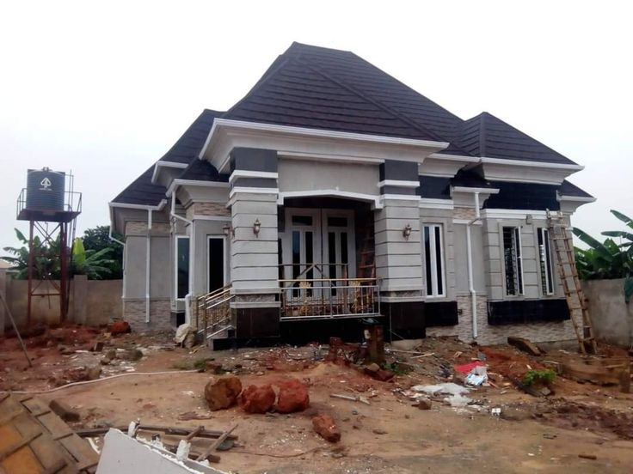 | 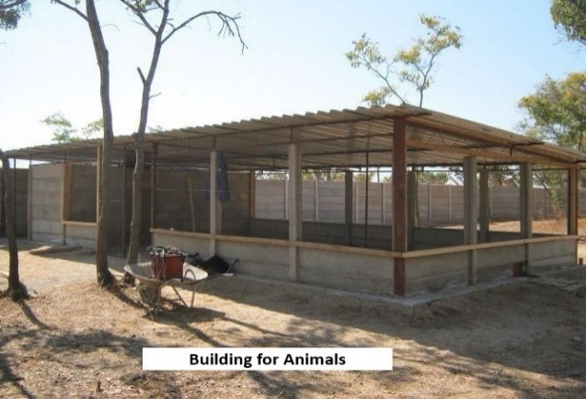
 | 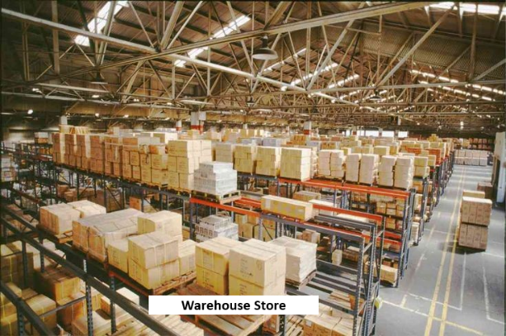
Pictorial View of Buildings

Main Parts of a Building
A building consists of several essential parts, each with a specific function. The major parts include:
- Foundation
- The foundation is the lowest part of a building, usually built underground.
- It supports the entire structure and transfers its weight to the ground.
- Common types include shallow foundations (for small buildings) and deep foundations (for high-rise buildings).
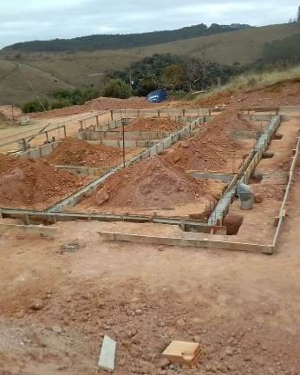 | 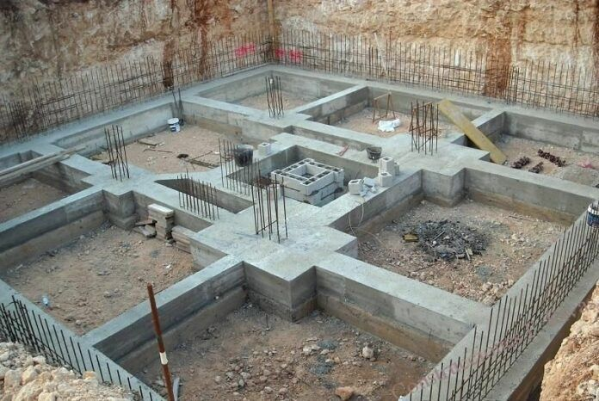
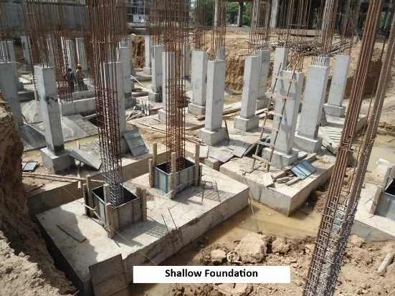 | 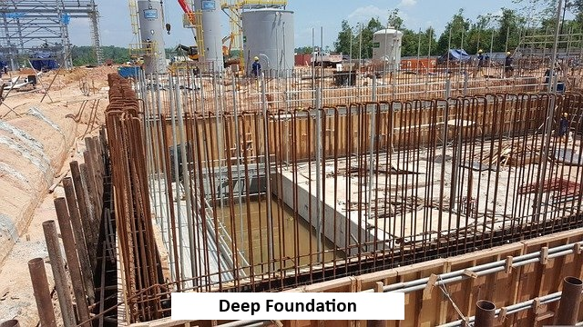
Pictorial View of Foundation

- Walls
- Walls are vertical structures that enclose a space and provide support to the roof.
- They can be made of materials like bricks, concrete, wood, or metal.
- Walls serve as barriers, protect from weather conditions, and provide privacy.

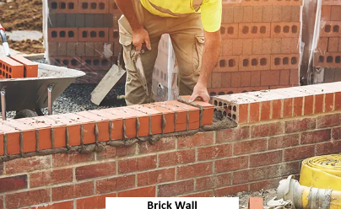 | 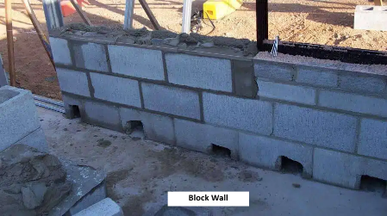 | 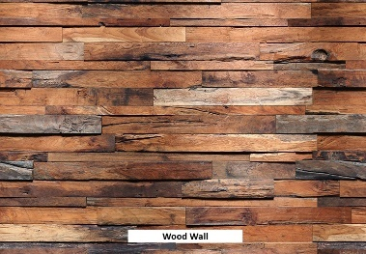
Pictorial View of Walls

- Floors
- The floor is the horizontal surface that people walk on.
- Buildings can have multiple floors, such as ground floor, first floor, and so on.
- Floors are made from materials like concrete, tiles, wood, or ceramics.
 | 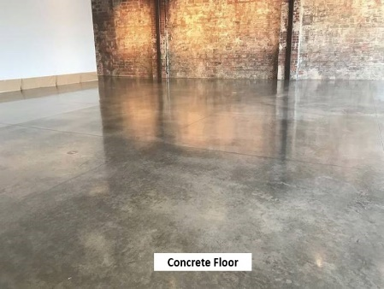 | 
Pictorial View of Floors

- Roof
- The roof covers the top of a building and protects it from sun, rain, and wind.
- Different types of roofs include flat, pitched, and gable roofs.
- Roofing materials include metal sheets, tiles, and asbestos.
 | 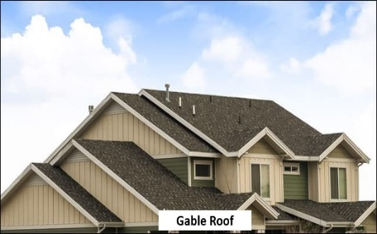 | 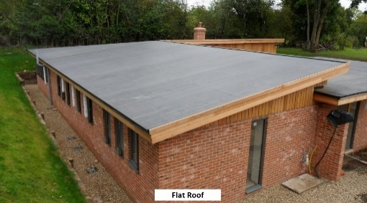
Pictorial View of Roofs

- Doors
- Doors allow entry and exit in a building.
- They can be made of wood, glass, metal, or plastic.
- Types of doors include hinged doors, sliding doors, and revolving doors.
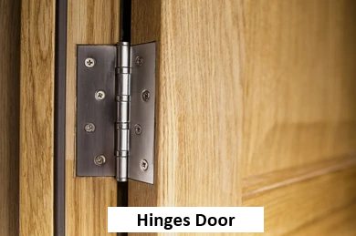 | 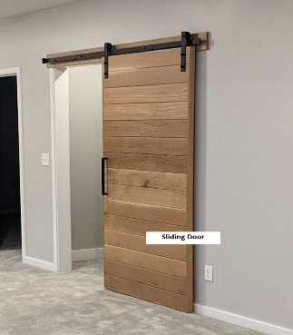
Pictorial View of Doors
- Windows
- Windows provide ventilation, natural light, and a view of the surroundings.
- They are made of glass, wood, or metal.
- Types of windows include casement windows, sliding windows, and louvered windows.
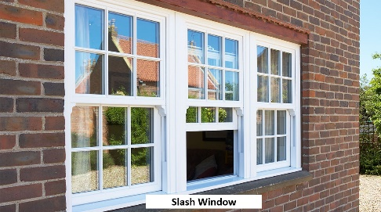 | 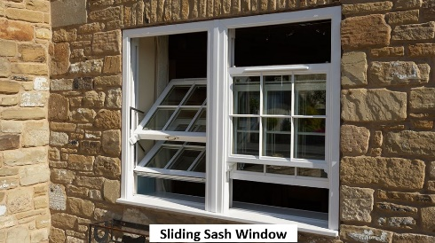 | 
Pictorial View of Windows

APPENDIX III
Students Questionnaire on the Development and Validation of Basic Technology Digital Learning Platform (SQDVBTDLP)

Questionnaire on the Development and Validation of Basic Technology Digital Learning Platform for Instruction in Upper Basic Schools, Ilorin Metropolis

Dear Respondent,
The questionnaire is designed to collect information on the development and validation of Basic Technology digital learning platform for instruction in upper basic schools, Ilorin metropolis. Kindly complete the questionnaire as all responses will be treated with utmost confidentiality.

Thanks for your anticipated cooperation.
SECTION A: Demographic Information

Instruction: Please tick appropriately
√

Name……………………………………

Age: ………………………….

Gender: Male ( ) Female ( )

SECTION B:

Assessment of Digital Learning Platform for Basic Technology Instruction For: Effectiveness, Engagement and Learning Outcomes.
√
Please respond to the statements by ticking to the letters that most closely reflect your level of agreement.

Key: SA= Strongly Agree, A= Agree, D= Disagree, SD= Strongly Disagree

S/N | ITEMS | SA | A | D | SD
1 | Classroom teaching methods help me understand Basic Technology effectively.
2 | The platform helped me develop problem-solving skills.
3 | I would be interested in using a digital learning platform.
4 | The platform helps me retain knowledge effectively.
5 | I feel classroom teaching methods prepare me well for exams.
6 | I would like to explore digital learning as an alternative.
7 | Classroom teaching provides sufficient examples and illustrations.
8. | I feel motivated to learn using the classroom methods.
9 | Classroom teaching methods encourage interaction with my teacher.
10 | I would recommend using digital learning tools in my class.
11 | The lessons on the platform were interactive.
12 | The platform helped me learn at my own pace.
13 | I was able to retain knowledge better using the platform.
14 | The platform made learning fun.
15 | The platform made Basic Technology easier to understand.
16 | The quizzes and exercises helped reinforce my learning.
17 | The platform provided sufficient examples and illustrations.
18 | I would like more subjects to be taught using digital platforms.
19 | The platform helped me develop problem-solving skills.
20 | I would recommend the platform to other students.

APPENDIX IV
BASIC EDUCATION CERTIFICATE EXAMINATION (BECE) PAST QUESTIONS FOR UPPER BASIC SCHOOLS
Examination malpractices may lead to a repeat of the subject or suspensions don’t be involved.
Subject: Basic Technology
Duration: 30 minutes
Class: JSS 2
Total Marks: 40mark

OBJECTIVES
1. ................ receive the weight if the building.
a) roof b) window c) doors d) foundation
2. ................ help to distribute the weight of the building over the surface area.
a) floor b) foundation c) roof d) door
3. We know ................... types of foundation.
a) five b) four c) three d) two
4. The pile foundation is used in constructing.
a) bungalow b) mini-flat c) duplex d) bridges and high-rise building
5. This is used where the load bearing capacity is weak.
a) ceramic b) raft foundation c) clay or mud d) strip foundation
6. ............... is a structural member in building used mainly for the enclosure or division of a space within a building.
a) door b) window c) walls d) foundation
7. ........... this is used to protect the structure against weather
a) door b) window c) floor d) wall
8. ........... is the type of finishing given to the internal wall of a building.
a) plastering b) synthetic c) vulcanization d) later
9. .............. is a tool used to apply mortar (cement and sand) to the surface of the wall.
a) mallet b) trowel c) adhesive d) abrasive
10. A residential building is used for ……….
a) storing goods. b) selling stationery c) office works d) dwelling purposes.
11. One function of a clerk of works is to ……….
a) prepare bills of quantities b) prepare account for clients c) represent architect on site.
d) organize work on site.
12. A potential danger to workers on a construction site is the.............
a) use of unstable scaffold b) proper guarding of equipment
c) provision of ad equate lighting d) stable stacking of materials
13. The eye goggle is worn during …….
a) digging of trenches. b) welding of metals. c) casting of concrete.
d) fixing of scaffold.
14. The tool used to check the vertical alignment of a formwork is ...........
a) boning rod. b) plumb bob. c) ranging pole. d)wooden float
15. An example of earth moving equipment used on a building construction site is …..
a) crane. b) hoist. c) paver d) scraper
16. A contractual agreement for a building project is between the client and the ………
a) contractor b) foreman. C) project officer d) site personnel
17. One instrument used to ensure the horizontal alignment of a wall is …………
a) chalk line b) measuring tape c) plumb bob d) spirit level.
18. The first step in setting out a building is to
a) erect the profile board b) establish the building line c) dig the foundation trench
d) support the foundation trench
19. A scale of 1:100 is interpreted to mean …………..
a) one on plan equal hundred on ground. b) one on ground equals one on plan
c) hundred on ground equals one on ground d) hundred on plan equals one on
ground.
20. A method by which sides of excavation are prevented from collapsing is called
a) hoarding. b) shoring. c) timbering. d) underpinning.
21. The most suitable equipment used for evacuating a foundation trench is a ……
a) Tractor. b) bulldozer c) scraper d) skimmer
22. The choice of a foundation type for a building depends on the …….
a) client’s taste b) experience of contractor c) nature of soil d) type of contract.
23. One functional requirement of a solid ground floor is
a) allowing passage of heat b) resistance to fire c) moisture penetration.
d) passage of sound
24. One material used for hardcore filling is
a) broken bricks. b) clayey soil c) fly ash d) lateritic soil
25. A suitable material used for constructing an upper floor is
a) lateritic soil. b) lime mortar c) mass concrete d) reinforced concrete
26. One function of cement in concrete production is for
a) binding the concrete materials. b) filling the voids in the concrete material
c) coating the concrete materials. d) segregating the concrete
27. A type of concrete made of cement and coarse aggregate is called
a) all-in concrete b) no-fine concrete c) reinforced concrete d) precast concrete
28. The correct sequence of mass concrete production is
a) mixing, batching, transporting and placing
b) batching, mixing, placing and transporting
c) mixing, batching, placing and transporting
d) batching, mixing, transporting and placing
29. A type of bonding in which bricks show alternate header and stretcher in a course is
a) English bonding b) Flemish bonding. c) Header bonding d) Stretcher bonding.
30. Which of the following is NOT a conventional method of building construction?
a) Masonry b) Timber framing c) Reinforced concrete d) Adobe construction
31. What is the primary purpose of a building's foundation?
a) To provide structural support b) To house mechanical systems
c) To store building materials d) To provide natural lighting
32. Which phase of building construction involves enclosing and defining spaces?
a) Foundation b) Walls c) Roof d) Plumbing
33. What is the purpose of the roof in building construction?
a) To provide structural stability b) To enclose the building
c) To support the foundation d) To provide ventilation
34. Which material is commonly used in modern building construction for its strength and durability?
a) Brick b) Stone c) Reinforced concrete d) Adobe
35. Which specialized technique in building construction focuses on minimizing environmental impact?
a) Timber framing b) Green building principles c) Adobe construction d) Masonry
36. What type of training is essential for construction workers to ensure safety on-site?
a) Plumbing techniques b) HVAC system installation
c) Handling hazardous materials d) Landscape design
37. Which phase of building construction involves establishing the building's base and
transferring loads to the ground?
a) Walls b) Roof c) Foundation d) Flooring
38. What role does personal protective equipment (PPE) play in building construction?
a) Enhancing building aesthetics b) Ensuring worker safety
c) Providing structural support d) Improving energy efficiency
39. Which phase of building construction covers the building and protects it from weather elements?
a) Walls b) Roof c) Foundation d) Flooring
40. What is the purpose of using prefabricated components in modern building construction?
a) To increase construction costs b) To reduce construction time
c) To add decorative elements c) To improve building insulation
41. Why is compliance with local building codes and safety standards important in
construction?
a) To increase project costs b) To ensure architectural aesthetics
c) To avoid legal issues d) To improve building durability
42. Which method of building construction uses sustainable practices to harness solar energy?
a) Timber framing b) Passive solar design c) Reinforced concrete d) Masonry
43. What does the term "structural integrity" refer to in building construction?
a) Aesthetic appeal of the building b) Sturdiness of the building
c) Energy efficiency of the building d) Interior layout and functionality
44. Which phase of building construction involves erecting walls to enclose and define
interior spaces?
a) Foundation b) Roof c) Walls d) Flooring
45. Which of the following does NOT constitute a building’s purpose?
a) Offering a place to stay for weather protection
b) Enabling human connections and activities
c) Increasing the aesthetic value of the area
d) Producing money and economic value for the building’s owners or inhabitants
46. To start a building construction work at a site, the document that grants a mandate to
begin work is the............…
a) working drawings b) building permit c) site plan d) bill of quantity
47. Which of the following does NOT constitute a building’s purpose?
a) Offering a place to stay for weather protection
b) Enabling human connections and activities
c) Increasing the aesthetic value of the area
d) Producing money and economic value for the building’s owners or inhabitants
48. Construction is ongoing at a marketing center where business is active. How can we
ensure the marketers’ safety from debris and falling objects?
a) Provision of scaffold b) Provision of hoarding
c) Provision of fence d) Provision of formwork
49. Carpenters argue that wall plates are no longer important. Most carpenters nowadays
fix roof rafters directly on abutment walls. They have forgotten that wall plate ……
a) provides a means of fixing rafters to the wall
b) provides means of support to the foot of rafters
c) helps spread the load evenly from the rafter to the wall
d) helps in arranging rafters evenly on the wall
50. A client has given you the offer to design a stair to link his hall to the master
bedroom but realized there is limited space during the planning. Which of these stairs
will suit the little floor area?
a) Straight flight stair b) Quarter-turn stair c) Half-turn stair d) Helical stair
51. What type of foundation is the diagram below
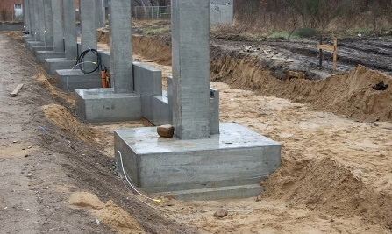
a) Strip Foundation b) Raft Foundation c) Pad Foundation d) Pile Foundation
52. What is the primary function of all the foundation types shown in the image?
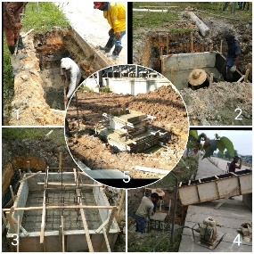
a) To add beauty to the building
b) To transfer the building load safely to the ground
c) To increase the number of floors in a building
d) To provide ventilation under the structure
53. Based on the diagram, which foundation is best suited for a bungalow built on firm soil?
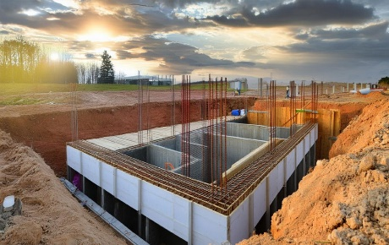
a) Pile Foundation b) Raft Foundation c) Pad Foundation d) Strip Foundation
54. Using the diagram, which foundation type distributes the building load over a large surface area to prevent settlement?
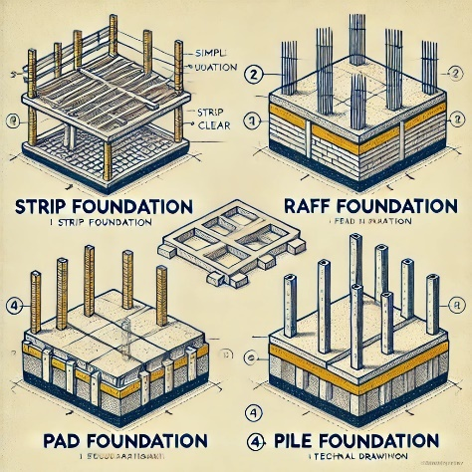
a) Strip Foundation b) Raft Foundation c) Pad Foundation d) Pile Foundation
55. What is the correct sequence for constructing a foundation, based on the image?
a) Digging → Reinforcement → Pouring Concrete → Compaction
b) Pouring Concrete → Digging → Reinforcement → Compaction
c) Reinforcement → Compaction → Digging → Pouring Concrete
d) Compaction → Pouring Concrete → Digging → Reinforcement
Answers:
1 (D), 2 (B), 3 (C), 4 (D), 5 (B), 6 (C), 7 (D), 8 (A), 9 (B), 10 (D), 11 (C), 12 (A), 13 (B), 14 (B), 15 (D), 16 (A), 17 (D), 18 (B), 19 (A), 20 (B), 21 (A), 22 (C), 23 (C), 24 (A), 25 (D), 26 (A), 27 (B), 28 (D), 29 (B), 30 (C), 31 (A), 32 (B), 33 (B), 34 (C), 35 (B), 36 (C), 37 (C), 38 (B), 39 (B), 40 (B), 41 (C), 42 (B), 43 (B), 44 (C), 45 (D), 46 (B), 47 (D), 48 (B), 49 (C), 50 (D), 51 (C), 52 (B), 53 (D), 54 (B), 55 (A)

