Water-induced supramolecular self-assembly of porphyrin integrated with multivalent metal–organic framework for enhanced electrochemiluminescence and ultrasensitive aptasensing of 4-fluoromethamphetamine
Bingxue Fan ^{a,b}, Ding Jiang ª, Yuan Ni ª, Tengfei Meng ª, Zheng Sun ^{c}, Haibo Li ^{c}, Wenchang Wang ª, Zhidong Chen ^{a,b*}
ª Jiangsu Key Laboratory of Advanced Catalytic Materials and Technology, School of Petrochemical Engineering, Changzhou University, Changzhou, Jiangsu, 213164, P. R. China
^{b} Changzhou University Huaide College, Jingjiang 214500, China
^{c} Institute of Forensic Science, Changzhou Municipal Security Bureau, Changzhou
213164, China
*e-mail: zdchen@cczu.edu.cn (Z. Chen)

Catalogue
Reagents .................................................................................................. S3 Apparatus ................................................................................................ S3 Preparation of MMS ............................................................................... S4
Preparation of DNA-Cy7 ........................................................................ S5
ECL Testing Conditions .......................................................................... S5
Measurement of ECL spectra ............................................................... S5 Real sample preparation .......................................................................... S5 ECL and EIS measurement ...................................................................... S6 Figure S1 ................................................................................................. S7 Figure S2.................................................................................................. S8 Figure S3 ............................................................................................... S9 Figure S4 ............................................................................................... S10 Figure S5 ............................................................................................... S11 Figure S6 ............................................................................................... S12 Figure S7 ............................................................................................... S13 Figure S8 ............................................................................................... S14 Figure S9 ............................................................................................... S15 Figure S10 ............................................................................................. S16 Table S1 ................................................................................................. S17 References ............................................................................................. S18

Experimental section

Reagents
Tetrakis(4-carboxyphenyl)porphyrin (TCPP), Iron(III) chloride hexahydrate (FeCl₃·6H₂O), Ammonium molybdate tetrahydrate ((NH₄)₆Mo₇O₂₄·4H₂O), Thiourea (CH₄N₂S), were purchased from Aladdin, Tetrahydrofuran (THF), Terephthalic acid (BDC), N,N-Dimethylformamide (DMF), Potassium persulfate (K₂S₂O₈), sodium dihydrogen phosphate (NaH₂PO₄·2H₂O), Dimethyl sulfoxide (DMSO), Disodium hydrogen phosphate (Na₂HPO₄·12H₂O), anhydrous ethanol(C₂H₆O), were purchased from Sinopharm Chemical Reagent Co.Ltd (Shanghai, China). and. Potassium ferricyanide(K₃[Fe(CN)₆]), potassium ferricyanide (K₄[Fe(CN)₆]) were purchased from Saen Chemical Technology Co., new psychoactive substance (RCS-4: (1-pentyl-1 H-indol-3-yl)(4-methoxyphenyl) methanone(C₂₁H₂₃NO₂), AB-PINACA(C₁₉H₂₆N₄O₂), Furanylfentanyl(C₂₄H₂₆N₂O₂), Alprazolam(C₁₇H₁₃ClN₄), MDPV: 3,4-Methylenedioxypyrovalerone (C₁₆H₂₁NO₃), 4-CEC: 4-Chloroethcathinone(C₁₁H₁₄ClNO) and 4-FMA:4-Fluoromethamphetamine(C₁₀H₁₄FN) were obtained from Shanghai Yuanshi Standard Technology Co.
4-FMA aptamer was synthesised by Shanghai Bio-Bio-Industry Technology Co. The sequence of 4-FMA aptamer was designed as 5'-AGGAATTCAGATCTCCCTGCAGGTGGTGTTTTTTTGTGCTGTGTTTTTGTGATGCATGCTCGAGGAGCTCAGGATCCCG-NH₂-3'. The 0.1 M Tris-HCl buffer (pH = 8.0) containing 0.1 M NaCl, 0.2 M KCl, 5.0 mM MgCl₂, and 1.0 mM ethylenediaminetetraacetic acid (EDTA) as a stock solution for aptamers and cDNA. phosphate buffer solution (PBS) used for ECL measurements contained 0.1 M Na₂HPO₄, 0.1 M NaH₂PO₄, and 0.05 M K₂S₂O₈. The e-cigarettes were purchased from a shopping mall near Changzhou University. All reagents are analytically pure and can be used without further purification, with ultrapure water used throughout the experiment (>18 MΩ).

Apparatus
The scanning electron microscope (SEM) and energy-dispersed spectrum (EDS) were received by a SEM instrument (JSM-6360LA, Japanese) at 15kV. The UV vis absorption spectra were carried out by an UV-2450 spectrophotometer (Shimadzu, Japan) with a 1-cm square quartz cell and the fluorescence and phosphorescence spectrum was detected on a Hitachi F-6500 fluorescence spectrophotometer (Tokyo, Japan). X-ray S4 diffraction (XRD; Rigaku/Max-2000) measurements were performed using a conventional diffractometer employing Ni-filtered Cu Kα radiation, X-ray photoelectron spectroscopy (XPS) were analyzed using AXIS-Ultra DLD (Shimadzu, Japan), respectively. And Fourier transform infrared spectroscopy (FT-IR) characterizations were presented by Nicolet In10 (Thermo Fisher, USA) using a liquid-nitrogen-cooled detector. ECL measurements were performed on MPI-B multifunctional ECL system (Xi'an Ruimai Analytical Instrument Co., Ltd.) with three-electrode system, which chose glassy carbon electrode (GCE) as a working electrode, platinum wire as a counter electrode and Ag/AgCl as a reference electrode for ECL detection. In addition, the ECL signal was tested in a phosphate buffer solution (PBS) (pH 7.4) with 0.05 mol/L K₂S₂O₈. Cyclic voltammetry (CV) was used to scan in the range of -1.0 ~ 0 V. The scanning rate was 0.1 V/s and the photomultiplier was set at 800 V. Cyclic voltammetry (CV) and electrochemical impedance spectroscopy (EIS) tests were performed on the CHI660E electrochemical workstation (Shanghai Chenhua Instrument Co., Ltd., China)., in 5.0 mM Fe(CN)₆^{3-/4-} containing 0.1 M KCl solution with an ac signal amplitude of 20 mV in the frequency range from 0.1 to 105 Hz. To detect the target, a series of 4-FMA standard solutions of different concentrations were added dropwise to the obtained modified electrodes and then incubated for 50 min. Subsequently, the unreacted detector was removed and the electrode was rinsed with ultrapure water for ECL signal strength testing and recording.
Preparation of MMS
MMS was synthesized according to a previously reported method with slight modifications.[1] First, 0.675 g of FeCl₃·6H₂O was dissolved in 30 mL of N,N-dimethylformamide (DMF) to form a homogeneous solution. Next, 0.206 g of terephthalic acid was added to the above solution under stirring for 10 minutes and ultrasonication for 10 minutes. The resulting mixture was transferred to an autoclave and maintained at 110 °C for 20 h, followed by natural cooling. Finally, the product was collected by centrifugation, washed, and dried under vacuum at 60 °C to obtain MIL-101(Fe) for further use. Subsequently, 0.1 g of MIL-101(Fe) was added to 70 mL of ultrapure water and ultrasonicated for 30 minutes to remove MIL-101(Fe) nanoparticles and prepare a homogeneous solution. Then, 1.24 g of ammonium molybdate tetrahydrate and 1.06 g of thiourea were added to the above solution under stirring for 30 min. The resulting homogeneous solution was transferred to an autoclave and heated at 180 °C for 12 h. After centrifugation and washing several times, the product was dried under vacuum for 12 hours to obtain MMS.
Preparation of DNA-Cy7
First, 2 μM of the aptamer was dissolved in Tris buffer solution and incubated at room temperature for 10 minutes to allow aptamer folding. Then, the cyanine dye Cy7 was dissolved in 100% DMSO. Finally, the aptamer solution was added to a centrifuge tube containing the dye, and the mixture was shaken and incubated overnight to form the aptamer–dye conjugate (DNA-Cy7).

ECL Testing Conditions

The ECL test for the fabricated sensor employed a three-electrode system. The working electrode comprised DNA-Cy7/MMST/GCE, with an Ag/AgCl reference electrode and a platinum wire counter electrode. The tri-electrode assembly was immersed in PBS (25 mL, 0.1 M, pH = 7.4) containing 0.05 M K₂S₂O₈. The scan voltage range was −1.0 to 0 V, with a scan rate of 100 mV/s. The photomultiplier tube was set to 800 V high voltage.
Sample Pretreatment
The e-cigarettes were purchased from a shopping mall. First, 5 mL of each e-liquid was placed into a 10 mL centrifuge tube. The tube was then vigorously shaken for 15 min and centrifuged at 6000 rpm for 15 min. Subsequently, the collected supernatant was further filtered through a 0.45 μm membrane, and the filtrate was transferred into a reagent bottle for further use.

ECL and EIS measurement
The three electrodes (Working Electrode, platinum electrode and Ag/AgCl) were placed in a 0.1 M phosphate buffer solution (PBS) containing 0.05 M K₂S₂O₈(pH 7.4) and scanned by a cyclic voltammetry (CV) in the range -1.0 ~ 0 V (vs. Ag/AgCl) at a scanning rate of 100 mV/s. The photomultiplier tube was set to 800 V.
Electrochemical impedance spectroscopy (EIS) were studied by CHI660E electrochemical workstation (Shanghai CH Instrument Co., Ltd., China) in 10.0 mM Fe(CN)₆^{3-/4-} containing 0.1 M KCl solution with an AC signal amplitude of 25 mV in the frequency range from 0.1 to 105 Hz.

Supporting Figures
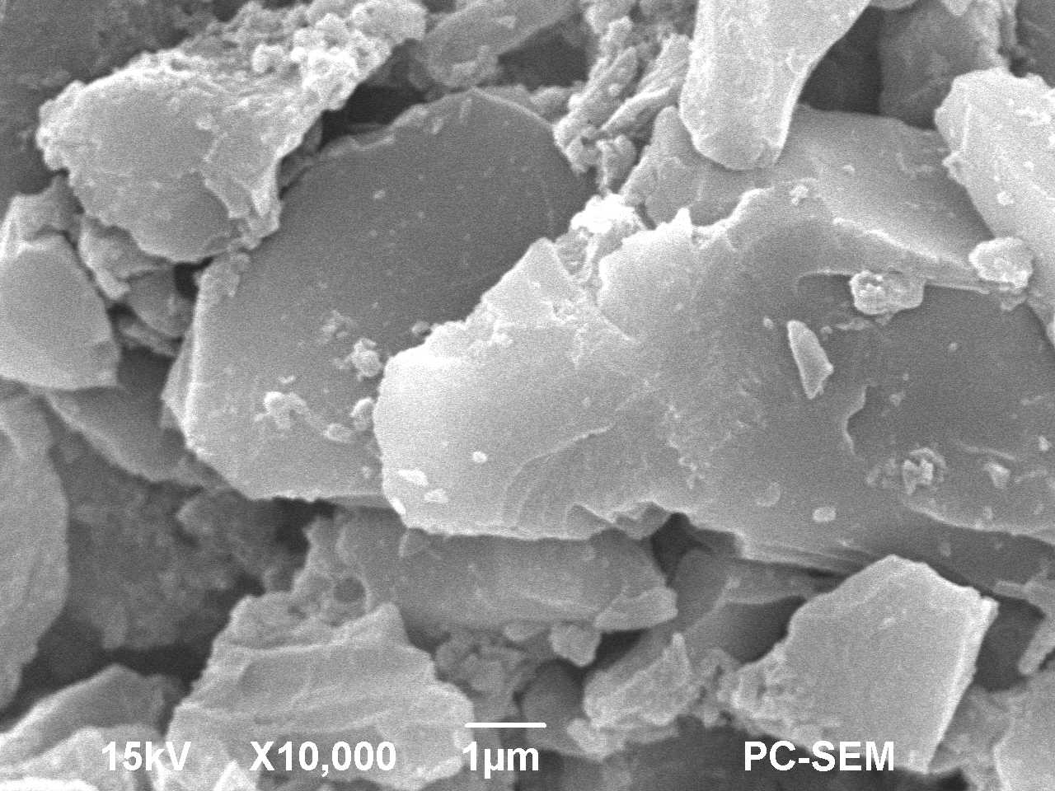
Figure S1. SEM image of TCPP.
Figure S2. FT-IR spectra of TCPP NPs, MMS, and MMST.
Figure S3. UV-Vis spectra of TCPP NPs, MMS, and MMST.
Figure S4. XRD spectra of TCPP and TCPP NPs
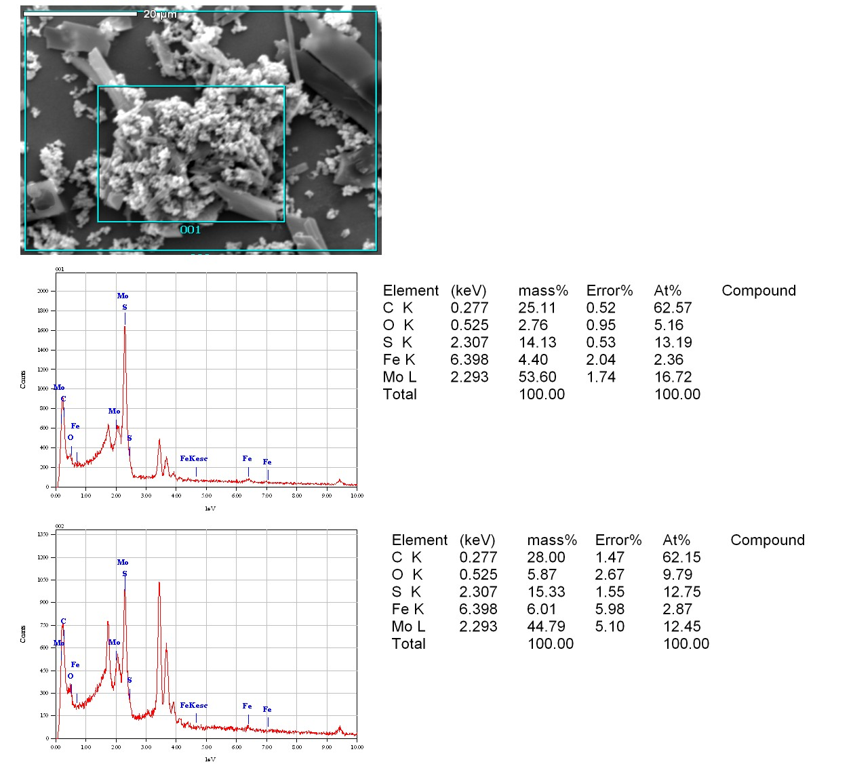
Figure S5. EDS mapping images of MMST.
Figure S6. O1s high resolution spectra of MMST.
The high-resolution O 1s spectrum of MMST was deconvoluted into three peaks at 530.2, 531.3, and 532.5 eV. The peak at 530.2 eV is assigned to metal–oxygen bonds (M–O), originating from Fe–O in MIL-101(Fe) and Mo–O in partially oxidized MoS₂. The peak at 531.3 eV corresponds to oxygen vacancies or surface-adsorbed hydroxyl groups (–OH), which are known to facilitate charge transfer and coreactant activation. The peak at 532.5 eV is attributed to carboxyl oxygen species (C–O) from the organic linkers of TCPP and MIL-101(Fe). These results confirm the coexistence of metal–oxygen coordination, oxygen vacancies, and carboxyl groups in the MMST composite, which collectively contribute to its enhanced ECL performance.
Figure S7. C 1s high resolution spectra of MMST.
The high-resolution C 1s spectrum of MMST was deconvoluted into four peaks at 284.5, 285.6, 286.6, and 288.9 eV. The dominant peak at 284.5 eV is attributed to C–C/C=C species from the aromatic rings of TCPP and the benzene rings of terephthalic acid ligands in MIL-101(Fe). The peak at 285.6 eV corresponds to C–N or C–O bonds, likely arising from the porphyrin core or surface-adsorbed species. The weak peak at 286.6 eV is assigned to carbonyl-type carbon (C=O or O–C–O), possibly due to partial oxidation or defect sites. The peak at 288.9 eV is characteristic of carboxyl carbon (O–C=O), confirming the presence of intact –COOH groups from both TCPP and MIL-101(Fe). These results further confirm the successful integration of TCPP and MIL-101(Fe) in the MMST composite.
Figure S8. EPR spectrum of MMST.

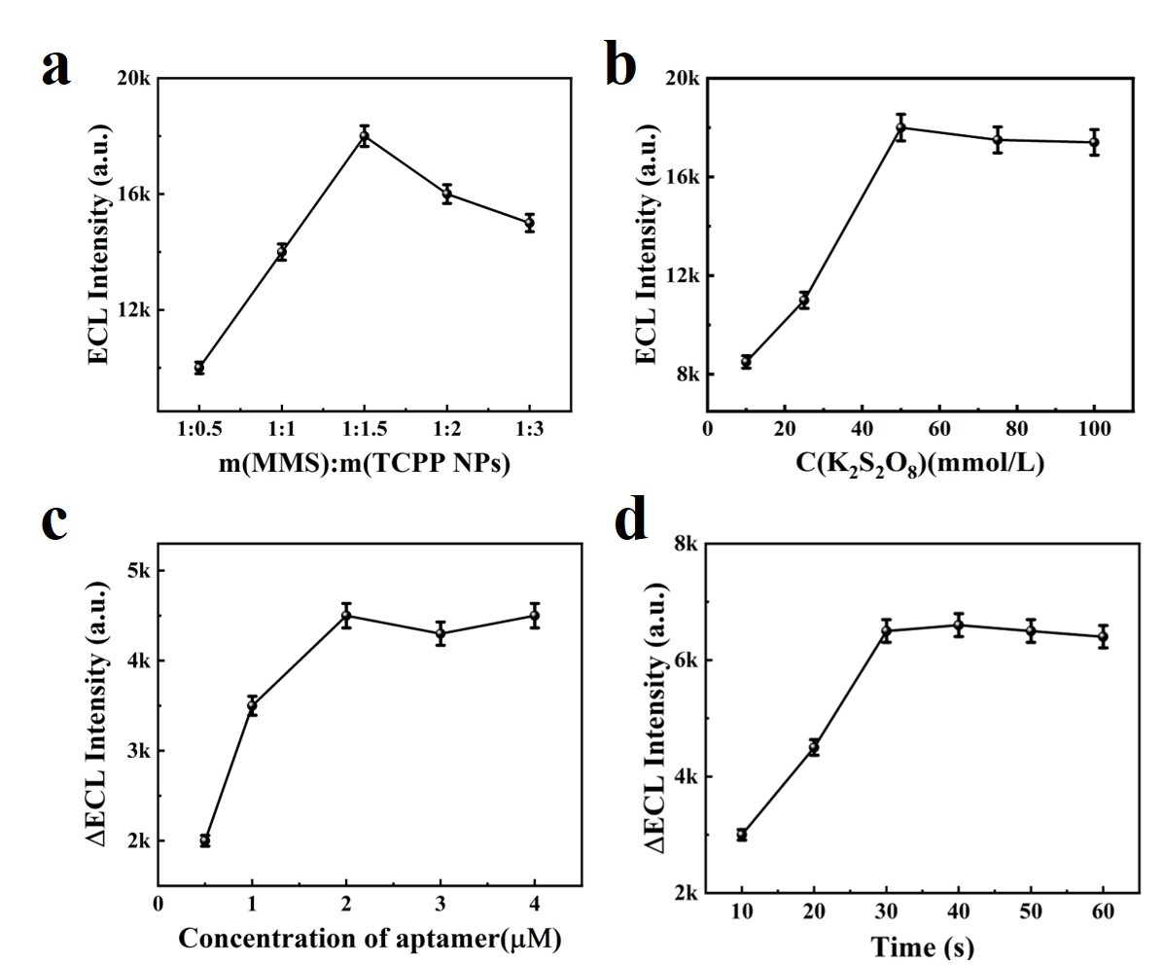
Figure S9. Optimization of the concentration of m(MMS):m(TCPP NPs) (a); K₂S₂O₈ concentration (b); aptamer concentration (c); detector and sensor reaction time (d).
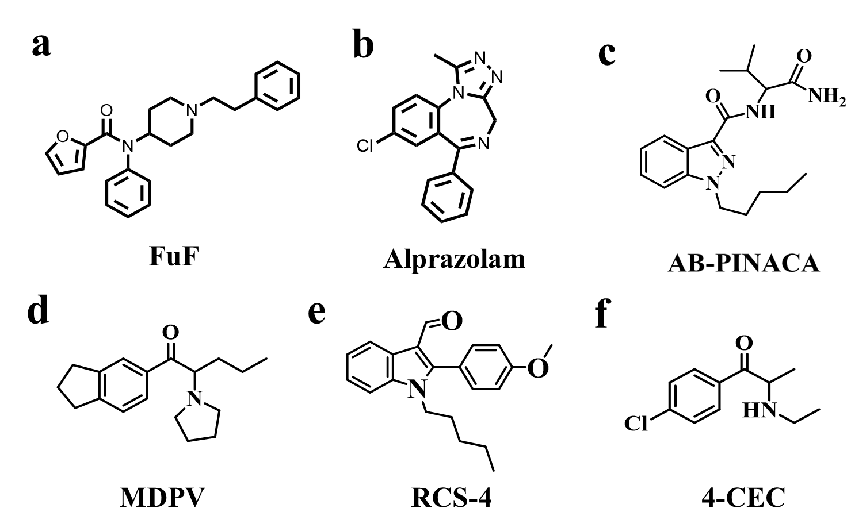
Figure S10. Chemical structure of the interferents.

Table S1. Comparison of different methods for the detection of 4-FMA.
Methods | Linear range (g/L) | LOD (g/L) | Reference
LC-MS/MS | 2.5×10⁻⁷ - 5.0×10⁻⁶ | 5.0×10⁻⁹ | [2]
PS-MS | 1.5×10⁻⁵ - 1.2×10⁻³ | - | [3]
GC-MS | 2.0×10⁻⁶–1.0×10⁻⁴ | 0.6×10⁻⁶ | [4]
SERS | 1.0×10⁻³-1.0 | - | [5]
SALDI-TOF-MS | 3.3×10⁻⁷–2.5×10⁻⁶ | 4.4×10⁻⁹ | [6]
ECL | 1.0 × 10⁻¹⁴ - 1.0 × 10⁻⁶ | 1.87 × 10⁻¹⁵ | This work

References
1. Zhu K, Qin W, Gan Y, et al (2023) Acceleration of Fe3+/Fe2+ cycle in garland-like MIL-101(fe)/MoS2 nanosheets to promote peroxymonosulfate activation for sulfamethoxazole degradation. Chemical Engineering Journal 470:144190. https://doi.org/10.1016/j.cej.2023.144190
2. Lendoiro E, Jiménez-Morigosa C, Cruz A, et al (2017) An LC-MS/MS methodological approach to the analysis of hair for amphetamine-type-stimulant (ATS) drugs, including selected synthetic cathinones and piperazines. Drug Test Anal 9:96–105. https://doi.org/10.1002/dta.1948
3. Yang Y, Wu J, Deng J, et al (2018) Rapid and on-site analysis of amphetamine-type illicit drugs in whole blood and raw urine by slug-flow microextraction coupled with paper spray mass spectrometry. Anal Chim Acta 1032:75–82. https://doi.org/10.1016/j.aca.2018.06.006
4. Weiß JA, Kadkhodaei K, Schmid MG (2017) Indirect chiral separation of 8 novel amphetamine derivatives as potential new psychoactive compounds by GC–MS and HPLC. Sci Justice 57:6–12. https://doi.org/10.1016/j.scijus.2016.08.007
5. Qin Y, Mo F, Yao S, et al (2022) Facile synthesis of porous ag crystals as SERS sensor for detection of five methamphetamine analogs. Molecules 27:3939. https://doi.org/10.3390/molecules27123939
6. Wang S-F, Lin W-Y, Dai J-S, et al (2021) Detection of amphetamine-type stimulants using sample derivatization and SALDI-TOF-MS. J Chin Chem Soc 68:2294–2302. https://doi.org/10.1002/jccs.202100323

