Supplements

Table S1. Baseline differences between Aβ- and Aβ+ participants.
Table S2. Associations between plasma biomarkers, baseline Aβ status and follow-up Aβ conversion.
Table S3. Associations between p-tau217, baseline Aβ status and follow-up Aβ status conversion, with covariates – ANOVA test.
Table S4. Associations between plasma biomarkers, baseline cognition and change in cognition.
Table S5. Association between plasma biomarkers and cognitive change over time stratified by Aβ status (stable negative, converting, stable positive).
Table S6. Association between p-tau217 and memory change over time stratified by each Aβ status group (pair-wise comparison)
Figure S1. Linear relations between within twin-pair difference in baseline concentrations of and changes in plasma biomarkers and within twin pair difference in cognitive change over time.
Table S1. Baseline differences between Aβ- and Aβ+ participants.
 | Aβ- at baseline  (n = 170) | Aβ+ at baseline  (n = 27) | Group difference
Age  Mean, SD | 69.7 (7.31) | 75.9 (7.54) | 0.006*
Sex  Female, % | 97 (57.1%) | 18 (66.67%) | 0.4^{ⱡ}
Year of Education  Mean, SD | 11.5 (2.54) | 11.2 (3.03) | 0.32*
p-tau217 (pg/mL)  Median, IQR | 0.034 [0.025 – 0.043] | 0.08 [0.06 – 0.11] | < 0.001±
Aβ-42/40  Median, IQR | 0.063 [0.056 – 0.068] | 0.05 [0.05 – 0.06] | < 0.001±
NfL (pg/mL)  Median, IQR | 14.3 [10.9 – 18.6] | 16.06 [12.6 – 25.9] | 0.103±
GFAP (pg/mL)  Median, IQR | 92.3 [68.6 – 129] | 166 [128 – 209] | < 0.001±
Memory composite score  Standardized Mean, SD | 0.04 (0.75) | -0.38 (0.6) | 0.003±
Language composite score  Standardized Mean, SD | 0.05 (0.81) | -0.16 (0.81) | 0.23±
Attention composite score  Standardized Mean, SD | 0.05 (0.69) | -0.31 (0.89) | 0.06±
Executive function composite score  Standardized Mean, SD | 0.01 (0.67) | -0.01 (0.56) | 0.89±
* Generalized equation estimation.
^{ⱡ} Fisher’s exact t-test.
± t-test.

Table S2. Associations between plasma biomarkers, baseline Aβ status and follow-up Aβ conversion.
Model | AUC (95% CI) | Sensitivity | Specificity | p | FDRp
Baseline biomarker concentration prediction of baseline Aβ status
p-tau217 | 0.89 (0.80 – 0.97) | 0.85 | 0.86 | < 0.001 | < 0.001***
Aβ-42/40 | 0.75 (0.66 – 0.83) | 0.85 | 0.65 | < 0.001 | < 0.001***
NfL | 0.61 (0.50 – 0.73) | 0.33 | 0.85 | 0.03 | 0.03*
GFAP | 0.80 (0.71 – 0.89) | 0.82 | 0.74 | < 0.001 | < 0.001***
Baseline biomarker concentration prediction of conversion from Aβ- to Aβ+ at follow-up
p-tau217 | 0.68 (0.56 – 0.81) | 0.91 | 0.38 | 0.004 | 0.009**
Aβ-42/40 | 0.56 (0.42 – 0.70) | 0.38 | 0.78 | 0.198 | 0.244
NfL | 0.55 (0.42 – 0.69) | 0.52 | 0.67 | 0.781 | 0.781
GFAP | 0.56 (0.42 – 0.69) | 0.91 | 0.23 | 0.211 | 0.244
Biomarker concentration change over time prediction of conversion from Aβ- to Aβ+ at follow-up
p-tau217 | 0.79 (0.70 – 0.88) | 0.86 | 0.63 | < 0.001 | < 0.001***
Aβ-42/40 | 0.62 (0.47 – 0.76) | 0.67 | 0.66 | 0.048 | 0.065±
NfL | 0.49 (0.35 – 0.62) | 0.48 | 0.64 | 0.436 | 0.436
GFAP | 0.57 (0.44 – 0.70) | 0.71 | 0.50 | 0.152 | 0.163
± p < 0.05, but FDRp non-significant ; * FDRp < 0.05 ; ** FDRp < 0.01 ; *** FDRp < 0.001
Aβ = amyloid beta. Aβ-42/40 = amyloid beta 42/40 ratio. AUC = area under the curve. GFAP = glial fibrillary acidic protein. NfL = neurofilament light. P-tau217 = phosphorylated tau-217. P = p-value. FDRp = FDR-corrected p-value.

Table S3. Associations between p-tau217, baseline Aβ status and follow-up Aβ status conversion, with covariates – ANOVA test.
Model | Predictor | Beta (SE) | p | FDRp
Baseline p-tau217 concentration prediction of baseline Aβ status
p-tau217 + age | p-tau217 | 7.45 (0.77) | 0.77 | 0.77
p-tau217 + age | Age | 0.0008 (0.003) | 0.77 | 0.77
p-tau217 + sex | p-tau217 | 7.61 (0.69) | 0.09 | 0.28
p-tau217 + sex | Sex | 0.07 (0.04) | 0.09 | 0.28
p-tau217 + education | p-tau217 | 7.55 (0.69) | 0.42 | 0.63
p-tau217 + education | Eductation | -0.006 (0.008) | 0.42 | 0.63
Baseline p-tau217 concentration prediction of conversion from Aβ- to Aβ+ at follow-up
p-tau217 + age | p-tau217 | 6.99 (2.13) | 0.15 | 0.37
p-tau217 + age | Age | -0.008 (0.006) | 0.15 | 0.37
p-tau217 + sex | p-tau217 | 5.95 (2.05) | 0.25 | 0.37
p-tau217 + sex | Sex | -0.076 (0.065) | 0.25 | 0.37
p-tau217 + education | p-tau217 | 6.21 (2.09) | 0.74 | 0.74
p-tau217 + education | Eductation | -0.004 (0.013) | 0.74 | 0.74
P-tau217 concentration change over time prediction of conversion from Aβ- to Aβ+ at follow-up
p-tau217 + age | p-tau217 | 229 (45) | 0.03 | 0.08±
p-tau217 + age | Age | -0.012 (0.005) | 0.03 | 0.08±
p-tau217 + sex | p-tau217 | 194 (43) | 0.24 | 0.36
p-tau217 + sex | Sex | -0.073 (0.062) | 0.24 | 0.36
p-tau217 + education | p-tau217 | 200 (43) | 0.63 | 0.63
p-tau217 + education | Eductation | -0.006 (0.013) | 0.63 | 0.63
± p < 0.05, but FDRp non-significant ; * FDRp < 0.05 ; ** FDRp < 0.01 ; *** FDRp < 0.001
All models are compared to the reference model with only baseline p-tau217 as the predictor of baseline Aβ status. The reported p and FDRp are the significance indicators of the ANOVA comparison between the model with covariate and the reference model. A significant FDRp indicates that the model with the covariate is a significantly better fit than the model without.

Table S4. Associations between plasma biomarkers, baseline cognition and change in cognition.
 | Memory |  |  | Language |  |  | Executive function |  |  | Attention
Model | β (SE) | p | FDRp | β (SE) | p | FDRp | β (SE) | p | FDRp | β (SE) | p | FDRp
Baseline biomarker concentration association with baseline cognition
p-tau217 | -0.145 (0.050) | 0.005 | 0.005** | -0.008 (0.041) | 0.844 | 0.844 | -0.010 (0.048) | 0.829 | 0.829 | -0.056 (0.049) | 0.256 | 0.298
Aβ-42/40 | 0.055 (0.039) | 0.160 | 0.218 | -0.031 (0.030) | 0.313 | 0.347 | -0.005 (0.037) | 0.889 | 0.970 | 0.010 (0.037) | 0.778 | 0.908
NfL | -0.121 (0.057) | 0.034 | 0.040* | -0.006 (0.046) | 0.890 | 0.890 | -0.037 (0.052) | 0.474 | 0.553 | -0.042 (0.056) | 0.454 | 0.529
GFAP | -0.021 (0.052) | 0.689 | 0.689 | -0.049 (0.041) | 0.235 | 0.274 | -0.077 (0.049) | 0.115 | 0.201 | -0.031 (0.049) | 0.529 | 0.617
Baseline biomarker concentration association with cognitive change
p-tau217 | -0.072 (0.021) | 0.001 | 0.002** | -0.066 (0.022) | 0.003 | 0.006** | -0.009 (0.024) | 0.711 | 0.826 | -0.031 (0.026) | 0.239 | 0.334
Aβ-42/40 | -0.023 (0.017) | 0.187 | 0.218 | 0.009 (0.018) | 0.609 | 0.852 | -0.001 (0.020) | 0.970 | 0.970 | -0.001 (0.020) | 0.314 | 0.347
NfL | -0.045 (0.021) | 0.038 | 0.053± | -0.030 (0.022) | 0.189 | 0.265 | -0.028 (0.024) | 0.261 | 0.308 | -0.028 (0.024) | < 0.001 | < 0.001***
GFAP | -0.062 (0.021) | 0.003 | 0.005** | -0.032 (-0.022) | 0.147 | 0.205 | -0.032 (0.023) | 0.178 | 0.300 | -0.032 (0.023) | 0.087 | 0.122
Biomarker concentration change association with cognitive change
p-tau217 | -0.131 (0.022) | < 0.001 | < 0.001*** | -0.066 (0.024) | 0.007 | 0.011* | -0.037 (0.027) | 0.169 | 0.295 | -0.011 (0.029) | 0.704 | 0.704
Aβ-42/40 | -0.009 (0.024) | 0.703 | 0.703 | -0.004 (0.026) | 0.891 | 0.891 | -0.022 (0.029) | 0.455 | 0.506 | -0.014 (0.029) | 0.616 | 0.616
NfL | 0.005 (0.035) | 0.896 | 0.910 | -0.066 (0.041) | 0.109 | 0.152 | -0.025 (0.045) | 0.583 | 0.583 | 0.036 (0.033) | 0.607 | 0.607
GFAP | -0.070 (0.027) | 0.009 | 0.013* | -0.057 (0.028) | 0.042 | 0.059± | -0.003 (0.031) | 0.922 | 0.922 | -0.023 (0.045) | 0.283 | 0.396
± p < 0.05, but FDRp non-significant ; * FDRp < 0.05 ; ** FDRp < 0.01 ; *** FDRp < 0.001
Aβ-42/40 = amyloid beta 42/40 ratio. AIC = Akaike information criterion. β = beta coefficient. GFAP = glial fibrillary acidic protein. NfL = neurofilament light. P-tau217 = phosphorylated tau-217. P = p-value. FDRp = FDR-corrected p-value. SE = standard error. Change in cognition was evaluated over a period of minimum 2 years and maximum 6 years.

Table S5. Association between plasma biomarkers and cognitive change over time stratified by Aβ status (stable negative, converting, stable positive).
Model | Beta (SE) | p | FDRp | Model | Beta (SE) | p | FDRp
 | Longitudinal change in memory
Baseline p-tau217*Time* Aβ status | -0.065 (0.025) | 0.010 | 0.021* | Slope of p-tau217*Time* Aβ status | -0.024 (0.030) | 0.415 | 0.571
Baseline GFAP*Time* Aβ status | -0.056 (0.027) | 0.039 | 0.061± | Slope GFAP*Time* Aβ status | -0.021 (0.032) | 0.516 | 0.631
 | Longitudinal change in Attention
Baseline NfL*Time* Aβ status | -0.005 (0.034) | 0.878 | 0.878
 | Longitudinal change in Language
Baseline p-tau217*Time* Aβ status | -0.014 (0.028) | 0.619 | 0.757 | Slope p-tau217*Time* Aβ status | 0.026 (0.034) | 0.437 | 0.480
± p < 0.05, but FDRp non-significant ; * FDRp < 0.05 ; ** FDRp < 0.01 ; *** FDRp < 0.001
Aβ-42/40 = amyloid beta 42/40 ratio. AIC = Akaike information criterion. β = beta coefficient. GFAP = glial fibrillary acidic protein. NfL = neurofilament light. P-tau217 = phosphorylated tau-217. P = p-value. FDRp = FDR-corrected p-value. SE = standard error. Change in cognition was evaluated over a period of minimum 2 years and maximum 6 years.

Table S6. Association between p-tau217 and memory change over time stratified by Aβ status group (pair-wise comparison)
Model | Beta (SE) | p | FDRp
 | Longitudinal change in memory
Baseline p-tau217*Time* Aβ status (Aβ- vs. Aβ+) | -0.125 (0.052) | 0.018 | 0.039*
Baseline p-tau217*Time* Aβ status ( Aβ- vs. Aβconverted) | 0,044 (0.078) | 0.575 | 0.633
Baseline p-tau217*Time* Aβ status ( Aβ+ vs. Aβconverted) | -0.160 (0.110) | 0.153 | 0.420
± p < 0.05, but FDRp non-significant ; * FDRp < 0.05 ; ** FDRp < 0.01 ; *** FDRp < 0.001

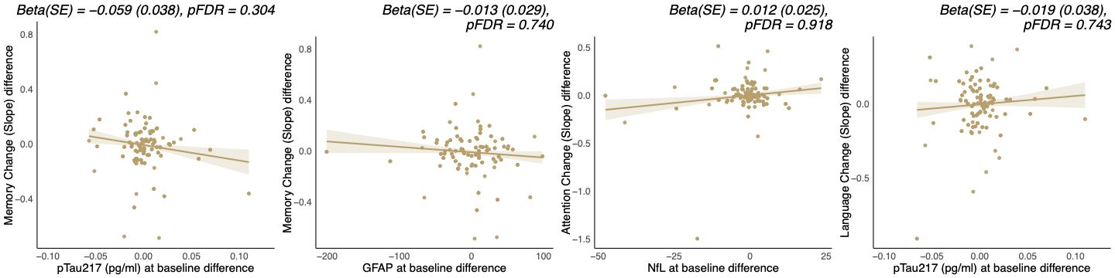

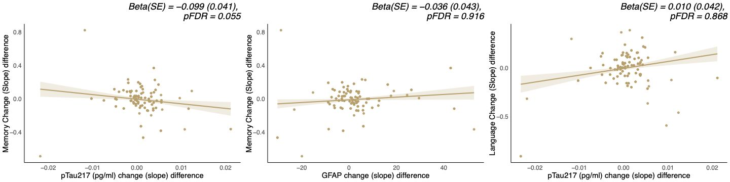

Figure S1. Linear relations between within twin-pair difference in baseline concentrations of (top figure) and changes in (bottom figure) plasma biomarkers and within twin pair difference in cognitive change over time. Results displayed above each scatter plot are derived from a linear mixed model, where the interaction between within twin pair differences in plasma biomarker and time is used as the predictor, and within twin-pair difference scores in the cognitive composite scores as the outcome. For visualization purposes, scatter plots were plotted to illustrate the relationship between the within twin-pair differences of the regressed slopes of cognitive composite scores (obtained from a linear regression corrected for age, gender, and years of education) and within twin-pair differences in plasma biomarkers. Abbreviations: NfL, neurofilament light chain; GFAP, glial fibrillary acidic protein; Aβ, amyloid beta; pTau, 217‐phosphorylated‐tau.

