Supplementary Information
Title: Multi-Omics Profiling Identifies Neuroinflammation-Related Genes and Exosomal miRNA as Robust Diagnostic Signatures for Parkinson's Disease
Author List: Dongdong WU; Xinxin MA; Huimin CHEN; Huijing Liu; Jing HE
Corresponding Author: 1. Dongdong WU; e-mail: lovelywdd@sina.com
Author Affiliations: Department of Basic Innovation Research, Beijing Hospital, National Center for Gerontology; National Clinical Research Center for Gerontology; The Key Laboratory of Geriatrics of NHC; Beijing Key Laboratory of Aging Mechanism and Intervention Research on Aging-Related Diseases; Institute of Geriatric Medicine,Chinese Academy of Medical Sciences, P.R. China
Supplementary Table S1. Primer sequences used for qRT-PCR analysis.
Genes |  | Sequence(5′-3′) | Size（bp）
CNTNAP2 | F | CGACACAGGGAGAAACTGGAAACC | 126
CNTNAP2 | R | CGCACATAGCGGGCAATAATC | 126
RTN3 | F | CCTCCTGTGCGGATTCCTTTG | 222
RTN3 | R | CTTCTTTGGCTAAAATAGGCTGGC | 222
PTGDS | F | AGTGGTGGAGACCGACTACGAC | 177
PTGDS | R | ACAATGGTATCCTCTGTGAAGCC | 177
MAG | F | GTCACCCGAGGATGATGGAGAG | 162
MAG | R | GACTTCACCACGCACAGGCAC | 162
PROK2 | F | CCCCACTCCTGCTCCTCTTGC | 242
PROK2 | R | CCTCTTTCTTCTTTCCTGCCTTCC | 242
GAPDH | F | GAAGGTGAAGGTCGGAGTC | 227
GAPDH | R | GAAGATGGTGATGGGATTTC | 227
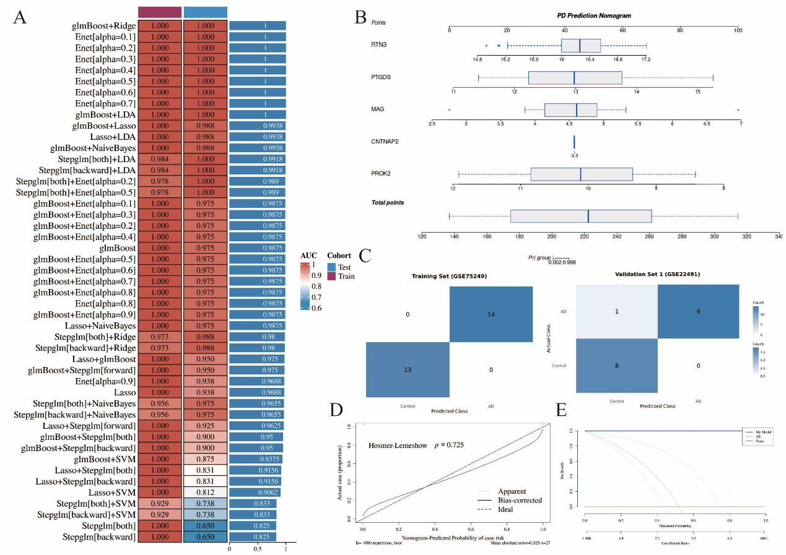
Supplementary Figure 1. Development and preliminary evaluation of a machine learning-based diagnostic model for Parkinson's disease. (A) Performance evaluation of 101 machine learning algorithm combinations, ranked by the Area Under the Curve across training and validation cohorts. (B) A diagnostic nomogram integrating five characteristic neuroinflammation signatures to predict disease probability. (C) Confusion matrices illustrating the classification accuracy of the selected model in the GSE75249 and GSE22491 datasets. (D) Calibration curve assessing the predictive accuracy of the nomogram. (E) Decision curve analysis estimating the clinical net benefit of the predictive model.

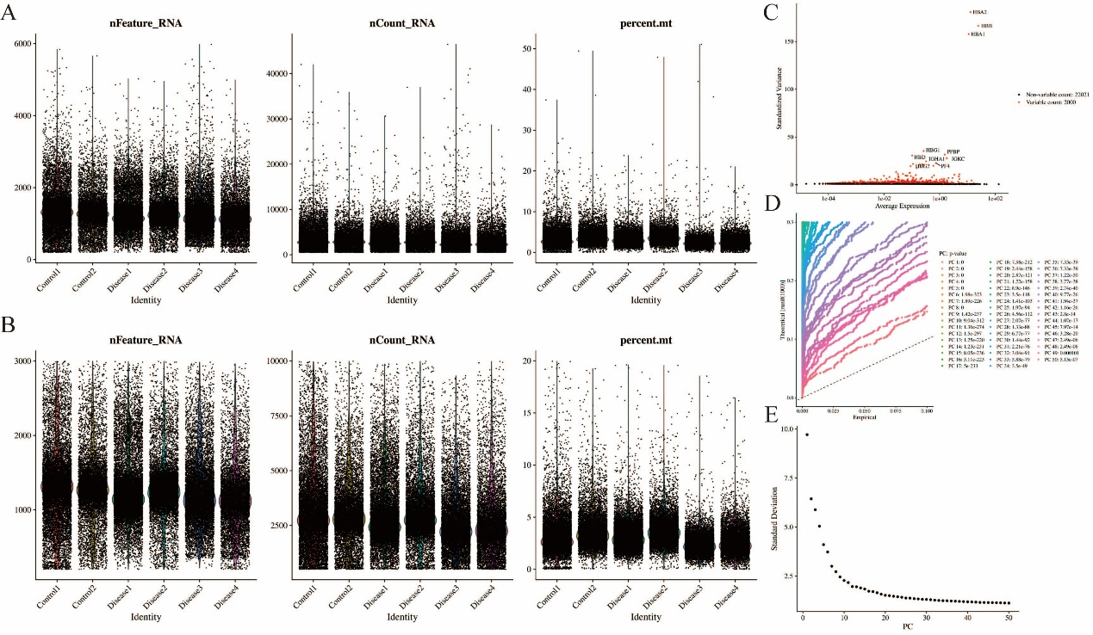
Supplementary Figure 2. Quality control, feature selection, and dimensionality reduction of single-cell RNA sequencing data. (A-B) Violin plots illustrating the distribution of quality control metrics, including the number of detected genes (nFeature_RNA), total unique molecular identifiers (nCount_RNA), and the percentage of mitochondrial gene expression (percent.mt), before (A) and after (B) rigorous filtering across the six clinical samples. (C) Scatter plot identifying 2,000 highly variable genes (highlighted in red) utilized for downstream clustering analysis. (D) JackStraw plot and (E) Elbow plot evaluating the statistical significance and standard deviation of principal components, respectively, to determine the optimal dimensionality (the first 30 principal components) for subsequent manifold approximation.

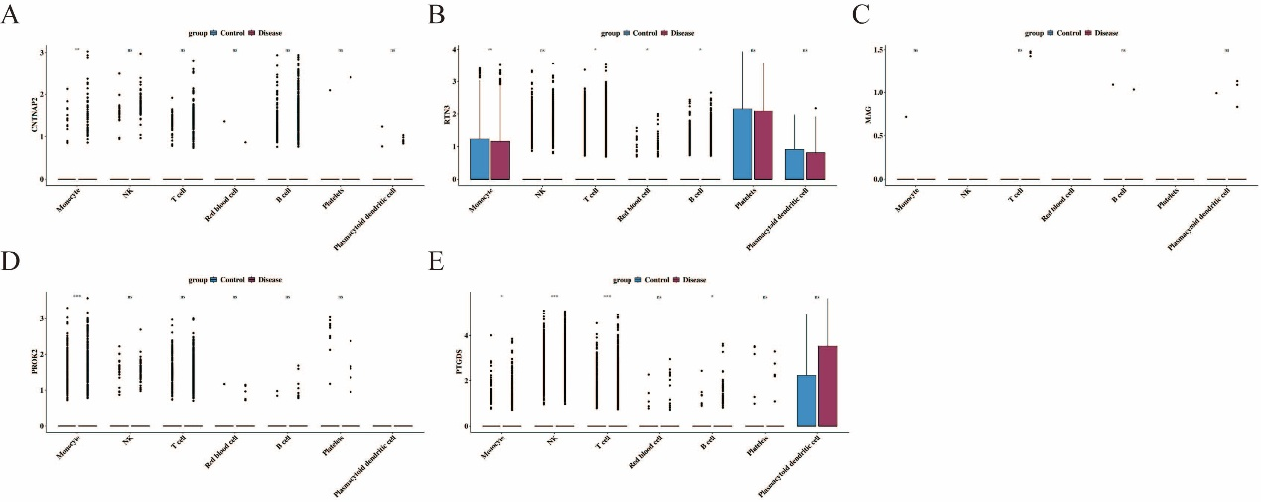
Supplementary Figure 3. Expression profiles of the core biomarkers across annotated single-cell populations. (A-E) Box plots illustrating the differential expression levels of CNTNAP2 (A), RTN3 (B), MAG (C), PROK2 (D), and PTGDS (E) across seven major cell lineages (Monocytes, NK cells, T cells, Red blood cells, B cells, Platelets, and Plasmacytoid dendritic cells) between healthy controls and Parkinson's disease patients.

