Additional file 3
Table S6. Reliability analysis for Likert-type evaluation criteria
Evaluation criterion | Inter-rater T0 κ (%) | Inter-rater T1 κ (%) | Intra-rater Observer 1 κ (%) | Intra-rater Observer 2 κ (%)
Diagnostic accuracy | 0.936 (85%) | 0.846 (60%) | 0.944 (85%) | 0.911 (80%)
Management appropriateness | 0.884 (80%) | 0.762 (50%) | 0.917 (85%) | 0.829 (65%)
Safety | 0.944 (90%) | 0.824 (70%) | 0.944 (90%) | 0.882 (80%)
Completeness/actionability | 0.942 (90%) | 0.872 (75%) | 0.914 (85%) | 0.948 (90%)
Clarity/coherence | 0.826 (75%) | 0.881 (80%) | 0.855 (80%) | 0.914 (85%)
Values are presented as quadratic weighted Cohen’s kappa coefficients, with percent agreement shown in parentheses. T0 indicates the initial evaluation, and T1 indicates the repeated evaluation after one week. According to the Landis and Koch interpretation, κ values of 0.61–0.80 indicate substantial agreement and values >0.80 indicate almost perfect agreement.

Table S7. Reliability analysis for binary safety-related outcomes
Safety-related outcome | Inter-rater T0 κ (%) | Inter-rater T1 κ (%) | Intra-rater Observer 1 κ (%) | Intra-rater Observer 2 κ (%)
Major harmful recommendation | 1.000 (100%) | 1.000 (100%) | 1.000 (100%) | 1.000 (100%)
Missed red flag | 1.000 (100%) | 1.000 (100%) | 1.000 (100%) | 1.000 (100%)
Hallucinated fact or fabricated citation/guideline | 0.857 (95%) | 0.375 (80%) | 0.688 (90%) | 0.571 (85%)
Values are presented as unweighted Cohen’s kappa coefficients, with percent agreement shown in parentheses. Binary variables were coded as 1 = present and 0 = absent. Kappa values should be interpreted cautiously for low-prevalence binary outcomes, as high percent agreement may still yield lower kappa values.

Table S8. Pairwise post-hoc comparisons of overall performance scores stratified by scenario difficulty
Difficulty level | Pairwise comparison | Median score, model 1 | Median score, model 2 | Mean score, model 1 | Mean score, model 2 | Wilcoxon statistic | Raw p-value | Holm-adjusted p-value
Intermediate | ChatGPT 5.4 vs Claude 4.6 | 4 | 4.2 | 4.033 | 4.267 | 4 | 0.219 | 0.875
Intermediate | ChatGPT 5.4 vs DeepSeek V3.2 | 4 | 4 | 4.033 | 4.033 | 9.5 | 0.906 | 1
Intermediate | ChatGPT 5.4 vs Gemini 3.1 | 4 | 4.5 | 4.033 | 4.5 | 1.5 | 0.094 | 0.563
Intermediate | Claude 4.6 vs DeepSeek V3.2 | 4.2 | 4 | 4.267 | 4.033 | 4 | 0.875 | 1
Intermediate | Claude 4.6 vs Gemini 3.1 | 4.2 | 4.5 | 4.267 | 4.5 | 0 | 0.125 | 0.625
Intermediate | DeepSeek V3.2 vs Gemini 3.1 | 4 | 4.5 | 4.033 | 4.5 | 1 | 0.25 | 0.875
Difficult | ChatGPT 5.4 vs Claude 4.6 | 4 | 4.2 | 3.967 | 4.117 | 15.5 | 0.24 | 0.721
Difficult | ChatGPT 5.4 vs DeepSeek V3.2 | 4 | 3.9 | 3.967 | 3.6 | 5 | 0.047 | 0.234
Difficult | ChatGPT 5.4 vs Gemini 3.1 | 4 | 4.3 | 3.967 | 4.25 | 16 | 0.264 | 0.721
Difficult | Claude 4.6 vs DeepSeek V3.2 | 4.2 | 3.9 | 4.117 | 3.6 | 6.5 | 0.059 | 0.234
Difficult | Claude 4.6 vs Gemini 3.1 | 4.2 | 4.3 | 4.117 | 4.25 | 26 | 0.564 | 0.721
Difficult | DeepSeek V3.2 vs Gemini 3.1 | 3.9 | 4.3 | 3.6 | 4.25 | 2 | 0.004 | 0.023
Expert | ChatGPT 5.4 vs Claude 4.6 | 4 | 3.5 | 3.867 | 3.167 | 7 | 0.563 | 1
Expert | ChatGPT 5.4 vs DeepSeek V3.2 | 4 | 3.2 | 3.867 | 3.1 | 1 | 0.125 | 0.75
Expert | ChatGPT 5.4 vs Gemini 3.1 | 4 | 4 | 3.867 | 4.2 | 3.5 | 0.75 | 1
Expert | Claude 4.6 vs DeepSeek V3.2 | 3.5 | 3.2 | 3.167 | 3.1 | 10 | 1 | 1
Expert | Claude 4.6 vs Gemini 3.1 | 3.5 | 4 | 3.167 | 4.2 | 3 | 0.313 | 1
Expert | DeepSeek V3.2 vs Gemini 3.1 | 3.2 | 4 | 3.1 | 4.2 | 1 | 0.125 | 0.75
Pairwise post-hoc comparisons were conducted using Wilcoxon signed-rank tests with Holm correction for multiple comparisons. Overall performance score was calculated as the mean of the five Likert-type evaluation criteria. Median and mean scores are presented according to the order of models in each pairwise comparison. Statistical significance was determined according to Holm-adjusted p-values

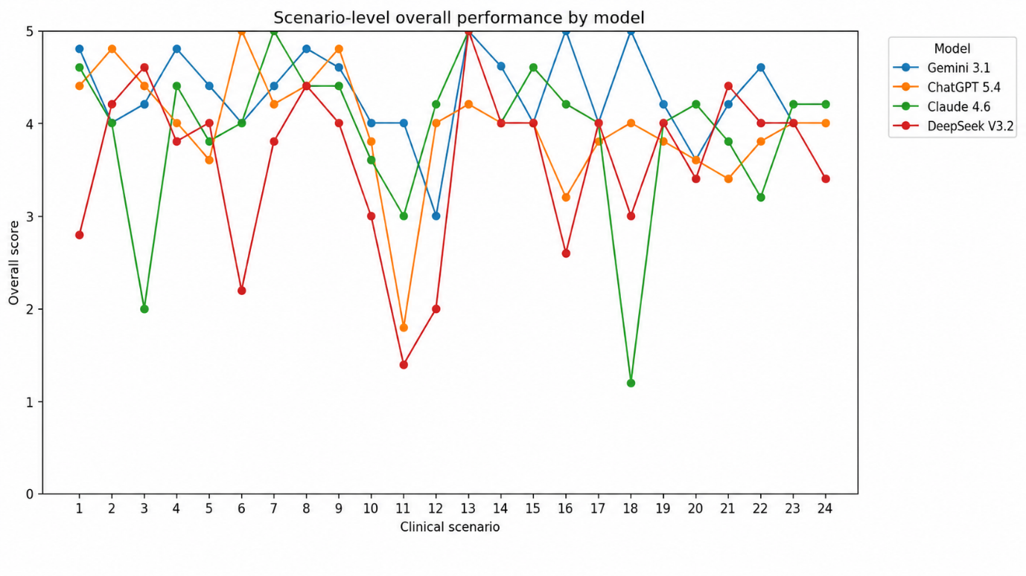
Figure S1. Scenario-level overall performance across clinical scenarios

