SUPPLEMENTARY METHODS

METHYLATION ANALYSIS

DNA DATA PREPROCESSING
Preprocessing DNAm data was performed using minfi (v1.52.1) package [74] from Bioconductor [73], [75] and ENmix (v1.42.0) [76] package. We carried out a rigorous process including background correction, quantile normalization, and probe bias correction, followed by estimation of beta values ​​and their conversion to M-values.
Initially, raw files in .idat format were imported using the minfi package [74]. Then detection values ​​(detectionP) were calculated, filtering out probes that had a p-value greater than 0.000001, ensuring that only those probes that were detected in at least three samples were retained (nbeads > 3). Samples with a methylated/unmethylated ratio of less than 10.2 were also removed to improve data quality. Then, we applied background correction, dye bias correction and quantile normalization using the ENmix package [76].
Subsequently, the beta values ​​of the probes were calculated using the Regression on Correlated Probes (RCP) method [77]. This method is used to correct probe design bias in DNA methylation arrays. Illumina methylation arrays incorporate two distinct probe types—Type I and Type II—each designed to interrogate CpG sites with differing structural and performance characteristics. Type I probes generally offer higher accuracy and reproducibility, although they are fewer in number. In contrast, Type II probes are more abundant but exhibit greater variability in signal intensity and precision due to their simplified design. This bias in probe design can introduce systematic errors into methylation analyses, as type II probes may underestimate, or overestimate methylation compared to type I probes. The PCR method corrects these differences and makes measurements from type II probes comparable to those from type I probes, taking advantage of the spatial correlation of CpGs across the human genome.
Beta-value is the ratio of the methylated probe intensity and the overall intensity (sum of methylated and unmethylated probe intensities). A value of zero indicates that all copies of the CpG site in the sample are completely unmethylated. The beta-value follows a beta distribution [78].
M-value is the log2 ratio of the intensities of methylated probe versus unmethylated probe. A M-value close to 0 indicates a similar intensity between the methylated and the unmethylated probes. Positive values mean that more molecules are methylated than unmethylated, while negative values mean the opposite [78].
Although beta values ​​have a simpler biological interpretation (methylation ratio), M-values ​​have better statistical properties for performing differential analysis [78]. The estimated beta values ​​were then converted to M-values using lumi (v1.1.0) package [79] ​​to provide greater stability in subsequent statistical analyses.
To control data quality, we applied a filter that removed probes with > 5% missing data and samples with >1% missing data. The cellular proportions in the samples were estimated by the Houseman method [80].
This preprocessing and filtering procedure ensures that the data used has high quality and reliability, eliminating artifacts and improving the reproducibility of the results.

DMP DETECTION BY LINEAR MODELS
DMPs (Differentially Methylated Positions) are specific positions in the genome where significant differences in DNA methylation levels are detected between two or more groups of samples. In DNA methylation analysis, DMPs are identified through statistical tests that compare the methylation values ​​(beta or M values) of each CpG position between groups of interest, such as between samples from patients with a disease and healthy controls.
A CpG site is differentially methylated between two samples if its absolute correlation coefficients between titration and methylation profiles are larger than 0.8 (correlation p-value is about 0.05) [78].
We used Limma (v3.60.2) from R. Limma [47], [48], a R Bioconductor package for gene expression analysis, which performs linear models to search for differential gene expressions and differential methylated positions. It allows empirical Bayesian methods to be carried out when the samples are small, which can improve the stability of the estimates. Limma is optimized to process high-dimensional data, such as methylation studies or microarrays, and can process thousands of CpGs very efficiently.

RANDOM EFFECTS AND BATCH EFFECTS
The disadvantage of Limma is that it is not capable of including random effects. This means that unwanted variations, such as differences between patients or technical batches, cannot be modelled, as can be done in mixed models. To overcome this limitation, we applied duplicateCorrelation [81] from Limma, to model intra-subject correlation. However, this approach does not allow more than one random effect to be included and, therefore, the effect of chip or chip position could not be modelled, in addition to within-subject variation.
To control for batches effects, we used ComBat [82], which normalizes non-biological effects such as chip and chip position. ComBat is a package from sva (v3.54.0) library [83] that allows adjusting the batch effect when the batch covariate is known, using the methodology of Johnson et al [82], [83]. It uses parametric or non-parametric empirical Bayes frameworks to adjust the batch effect, returning a matrix with the corrected values. This eliminates technical noise due to batches and chip positions and focuses the analysis on true biological effects. Correcting these technical variations prior to fitting the model with Limma is a solid strategy and powerful technique [84], [85].

SUPPLEMENTARY FIGURES
Supplementary Figure 1
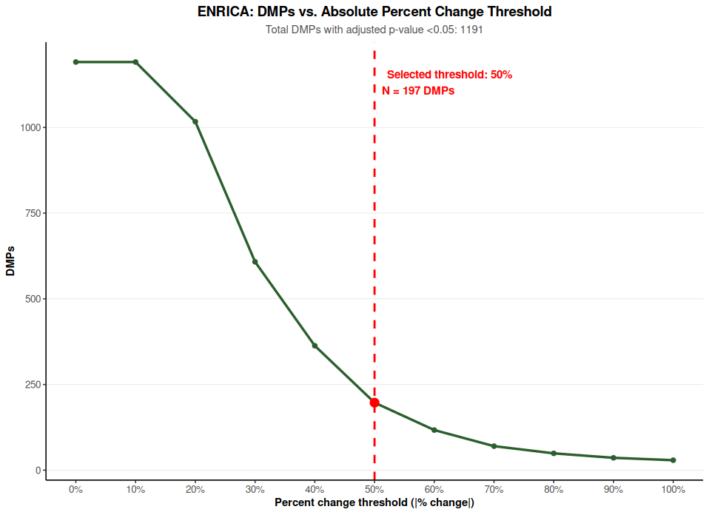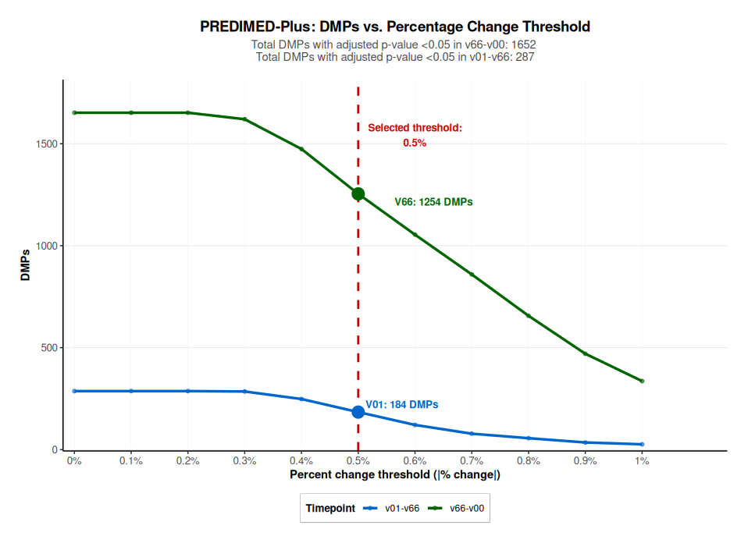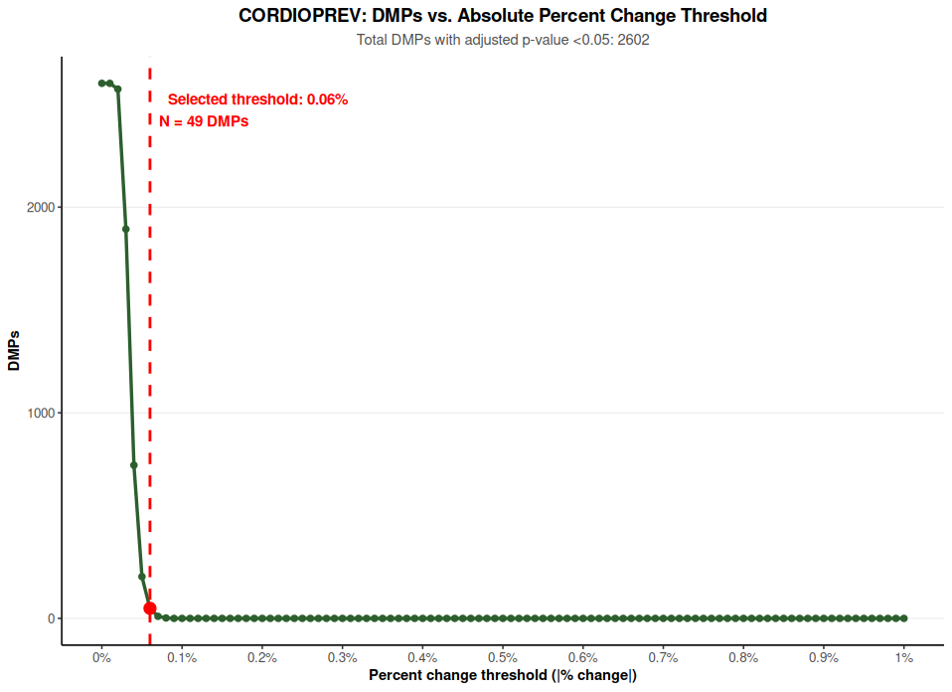
c..
b..
a.
Supplementary Figure 1. Histogram plots showing the number of DMPs (y axis) in relation to the % change (X axis). Dashed red line indicates the cohort-specific knee-point threshold used to prioritize DMPs for functional enrichment analyses. Selected % change and number of selected DPMs in each cohort is indicted (a. ENRICA-Seniors II, b. PREDIMED-Plus, c. CORDIOPREV)

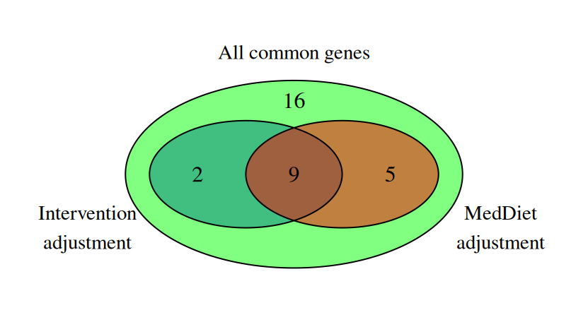
Supplementary Figure 2. Venn diagram illustrating the overlap between genes identified after sensitivity analyses adjusting for Mediterranean diet adherence and intervention group in the PREDIMED-Plus cohort. A total of 9 genes were consistently retained across both models, supporting the robustness of the identified epigenetic signature.

