Table 1: Descriptive Statistics for Child Background, DSM-5, CARS-2, CASD, and Clinical-Report Summary Scores (N = 50)
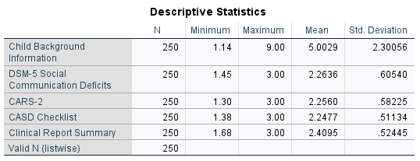

Table 2: Distribution of Autism Severity Classifications for DSM-5 (N = 50)
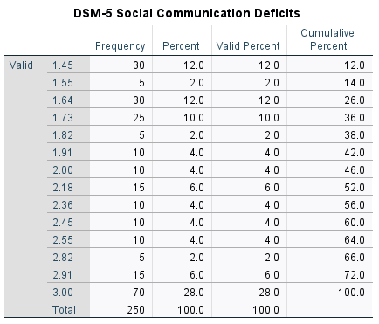
Table 3: Distribution of Autism Severity Classifications for CARS-2 (N = 50)
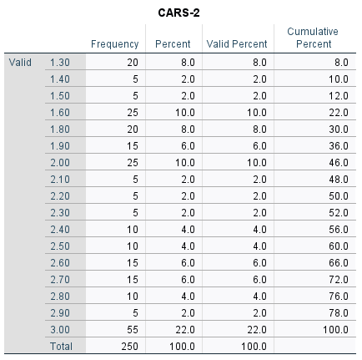
Table 4: Distribution of Autism Severity Classifications for CASD Checklist (N = 50)
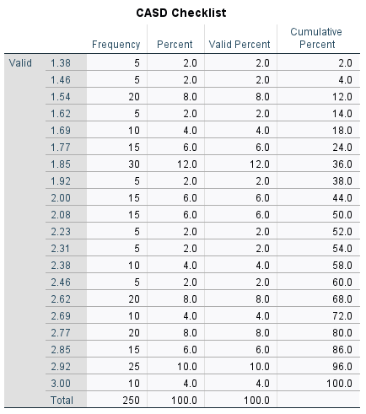

Table 5: Distribution of Autism Severity Classifications for Clinical Report (N = 50)
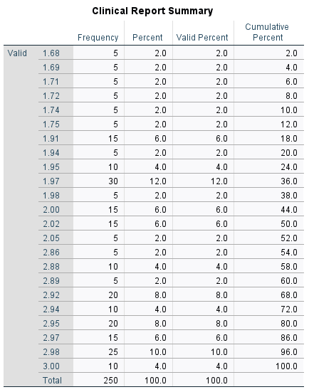
Table 6: Spearman’s Rank Correlation Between Child Background, DSM-5, CARS-2, CASD, and Clinical-Report Summary Scores
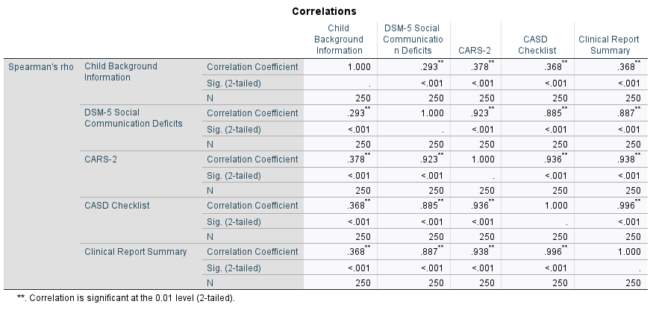

Table 7: Weighted Cohen’s Kappa Agreement Between DSM-5, CARS-2, CASD, and Clinical-Report Autism Severity Classifications
