Supplemental Figures
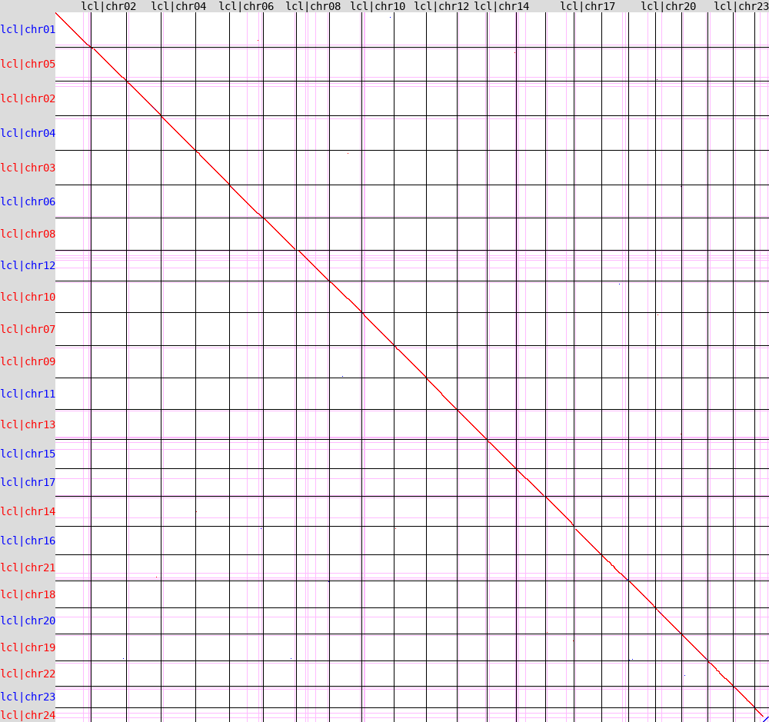
Suppl. Fig. 1 Alignment of the Australian G. holbrooki HAP1 genome against the Australian HAP2 genome.

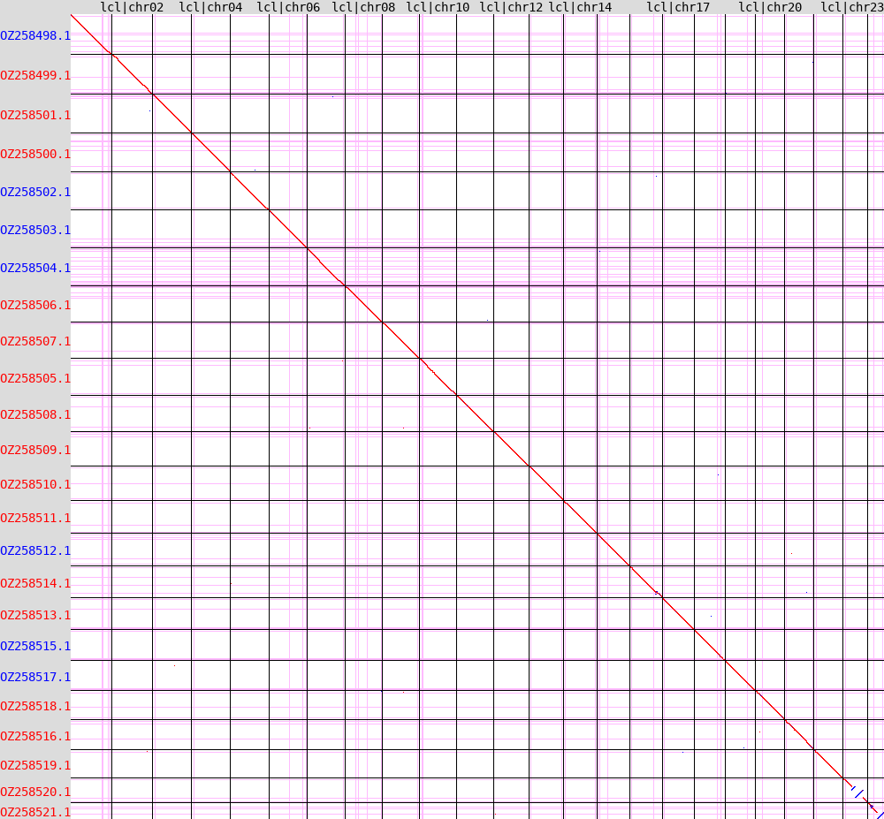
Suppl. Fig. 2 Alignment of the Australian G. holbrooki HAP1 genome against the Italian G. holbrooki genome (GCA_965282415.1, Fraser 2026).
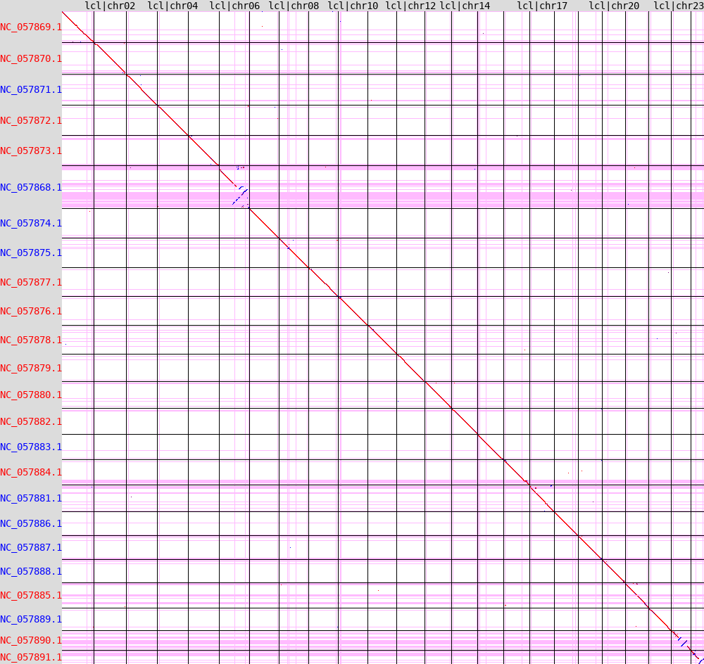
Suppl. Fig. 3 Alignment of the Australian G. holbrooki HAP1 genome against the G. affinis genome (GCF_019740435.1, Shao 2020).

