Extended Data
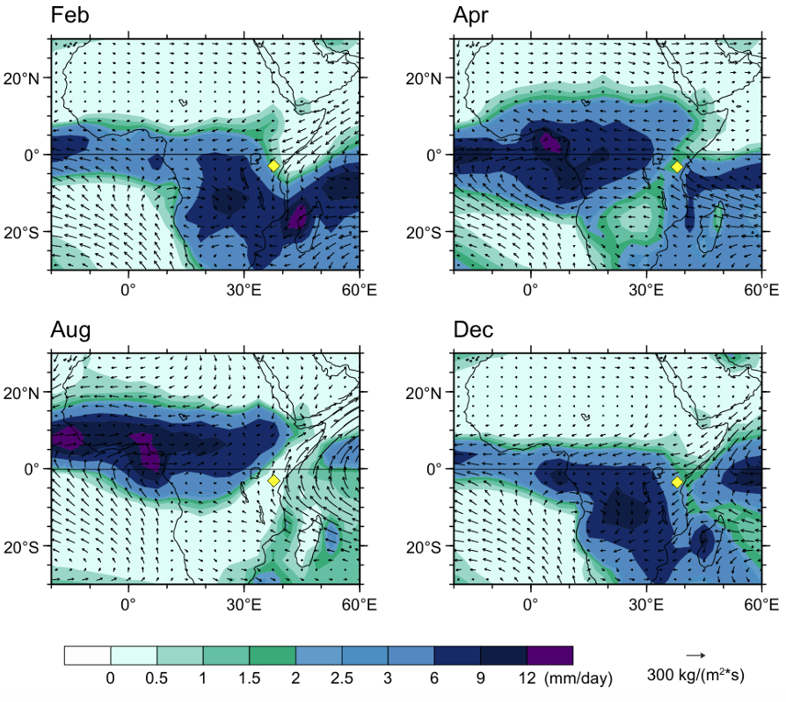Fig. S1. Modern-day seasonality in monsoon winds and precipitation over Africa and adjacent oceans. HadCM3-simulated (29) Pre-Industrial moisture transport during the short dry season in austral summer (Feb), the long rain season (Apr), the long dry season in boreal summer (Aug) and the short rain season (Dec), highlighting the relatively low precipitation in eastern equatorial Africa brought on-land by southeasterly and northeasterly monsoon winds (Fig. 1) even during peak rain seasons in April and December.

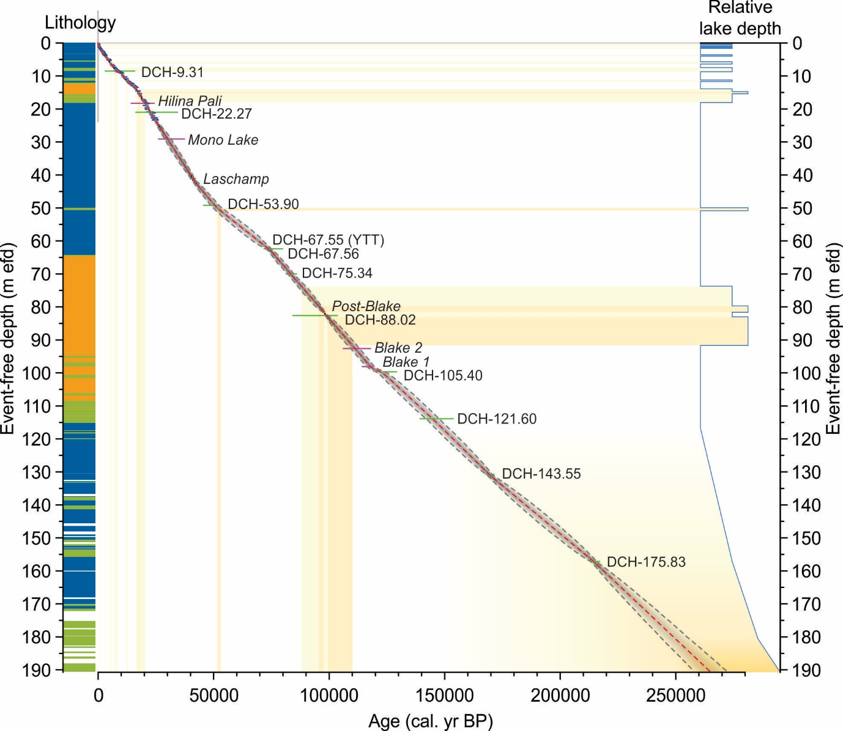Fig. S2. Independent absolute age-depth model for the Lake Chala sediment sequence, based on integration of ²¹⁰Pb and ¹⁴C dating (dark blue; 21), ⁴⁰Ar/³⁹Ar dating of 10 local (DCH-) volcanic tephras (green; 22), sedimentary signatures of 6 geomagnetic intensity excursions (magenta; 23) and the precise time anchor provided by local cryptotephra of the Toba volcanic eruption in Indonesia 73.7 kyr ago (DCH-67.55 YTT; 15). Bayesian age-model integration used a memory strength of 10 over 766 depth sections of 0.25 m each (54). Shown are mean ages (red dashed line) and 2-sigma age uncertainty (grey dashed line). Also shown are the lake-level reconstruction based on seismic stratigraphy (11) and lithology of the DeepCHALLA sediment sequence reflecting the strength of water-column stratification (16), to highlight long-term stability in the rate of sediment accumulation despite marked variation in lake depth and mixing regime. Event-free depth (meter efd) refers to the combined thickness of sediments below the lake floor after excising all turbidite horizons >0.005 m thick.
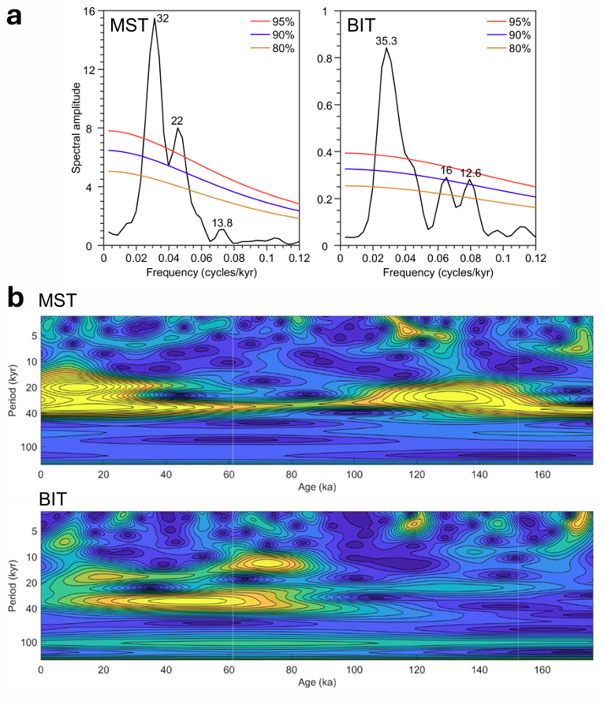
Fig. S3. Periodicity spectra of the 170-kyr Lake Chala temperature (MST) and moisture-balance (BIT-index) reconstructions. a, Lomb-Scargle Fourier transform spectral analysis of 35% detrended MST (left) and BIT-index (right) data series versus time as prescribed by the age-depth model shown in Fig. S2, performed using REDFIT (57) with a rectangular type spectral window, an oversampling factor of 9 and a bandwidth of 6 dB. Also indicated are the 95% (red), 90% (blue) and 85% (yellow) significance levels. b, Continuous wavelet transform of the 35% detrended MST (top) and BIT-index (bottom) data series using a Morlet function, with yellow reflecting locally high values of the power spectrum.
Supplementary text
Introduction (line 47) and MIS5 African megadroughts reflected in lake low-stands (line 290): Northeastern Africa and Arabia enjoyed relatively wet climate conditions during MIS5 (43,45,63), allowing out-of-Africa human migration into Eurasia prior to ~100 kyr ago (64,65), markedly earlier than as constrained by genetic evidence (~65-55 kyr ago; 66,67).
Shifts through time in the relationship between moisture balance and temperature (Line 179): Baxter et al. (ref. 16) advised to limit use of BIT as climate proxy to the last 170 kyr of the Lake Chala record, because correlations between various GDGT-derived proxies in its pre-170-kyr section deviate from expectation based on modern-system understanding (20), suggesting that the water column of Lake Chala at that time had not yet attained its modern-day structure with elevated dissolved-ion content of the lower water column enhancing resistance to complete mixing. In this study we more conservatively interpret the Chala BIT index as moisture balance proxy from ~140 kyr ago (Fig. 3d,g), because the sustained facies transition from mm-scale laminated sediments to predominantly cm-scale banded sediments at that time (Fig. 3f), indicative of mixing-induced turbulence occasionally reaching the profundal lake bottom, implies a prolonged period of lake-level decline that must have entailed evaporative concentration of dissolved salts. It should be noted that despite this reduction in lake depth, the density stratification which developed from that time onwards limits the duration of complete mixing events (68), thence enhancing the steepness and permanence of the oxycline as principal control on the niche availability for different brGDGT-producing aquatic microbiota in Lake Chala (16).
A causal mechanism for MIS5 African megadrought (Line 213): Palaeoceanographic data covering the eastern African megadrought period ~110-97 kyr ago with sufficient resolution are too scarce to map the relative magnitude of local SST anomalies at that time. The Hoffman et al. global synthesis of LIG SSTs (31) considered only the period 130-115 kyr ago and includes a single data point from the Arabian Sea (V3488: 16.5°N, 59.5°E), produced by the CLIMAP project (69) which likewise focused on substage MIS5e. The only pertinent ocean record currently available may be that of site 70KL (17.5°N, 61.5°E), where SST variation has been inferred from sedimentary CaCO₃ content reflecting local upwelling intensity (70), and which does show a pronounced minimum dated to ~113–102 kyr ago (i.e., from around the middle of substage MIS5d to the middle of MIS5c).
MIS5 African megadroughts reflected in lake low-stands (Line 277): This large dating uncertainty is compounded by confirmed or cryptic hiatuses in the sedimentary records from shallow and ephemeral lakes, such as Chew Bahir (4.6°N, 37.0°E) and Magadi (1.5°S, 36.2°E).
Supplementary references
63. Timmermann, A. & Friedrich, T. Late Pleistocene climate drivers of early human migration. Nature 538, 92–95 (2016).
64. Grün, R. et al. U-series and ESR analyses of bones and teeth relating to the human burials from Skhul. J. Hum Evol. 49, 316–334 (2005).
65. Armitage, S.J. et al. The southern route “out of Africa”: Evidence for an early expansion of modern humans into Arabia. Science 331, 453–456 (2011).
66. Mellars, P., Gori, K.C., Carr, M., Soares, P.A. & Richards, M.B. Genetic and archaeological perspectives on the initial modern human colonization of southern Asia. Proc. Nat. Acad. Sci. USA 110, 10699–10704 (2013).
67. Pagani, L. et al. Tracing the route of modern humans out of Africa by using 225 human genome sequences from Ethiopians and Egyptians. Am. J. Hum. Gen. 96, 986–991 (2015).
68. De Crop, W. & Verschuren, D. Determining patterns of stratification and mixing in tropical crater lakes through intermittent water-column profiling: A case study in western Uganda. J. Afr. Earth Sci. 153, 17-30 (2019).
69. CLIMAP Project Members. The Last Interglacial Ocean. Quat. Res. 21, 123-224 (1984).
70. Leuschner, D. C. & Sirocko, F. The low-latitude monsoon climate during Dansgaard-Oeschger cycles and Heinrich Events. Quat. Sci. Rev. 19, 243-254 (2000).

