Supplementary Information 1

Supplementary Information: Conformational Learning, Generative Model Benchmarking, and Experimental Validation Data
This Supplementary Information provides extended computational and experimental results supporting the AI-driven discovery and validation of the CDK2-biased inhibitor CDKCRC-EMBS. It includes ConfGAN training and conformer benchmarking analyses (Figure S1), MD simulation (Figures S2-S4), ADMET properties (Figure S5), synthesis workflow and compound characterization (Figures S6–S7), additional biological validation experiments (Figures S8–S9), and comprehensive supporting tables detailing docking performance, model ablation and benchmarking, interaction profiling, kinome-wide selectivity screening, and additional in silico and experimental results (Tables S1–S9).

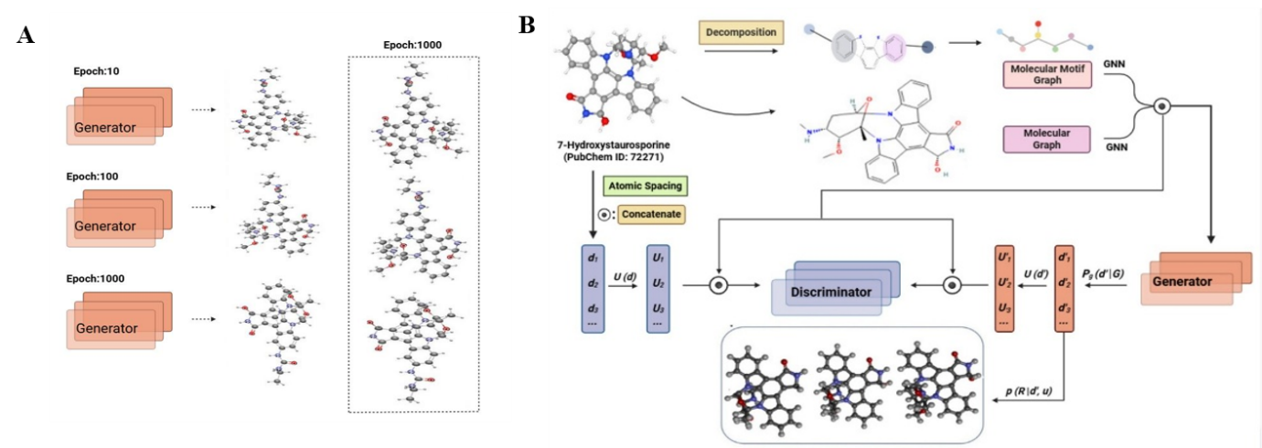
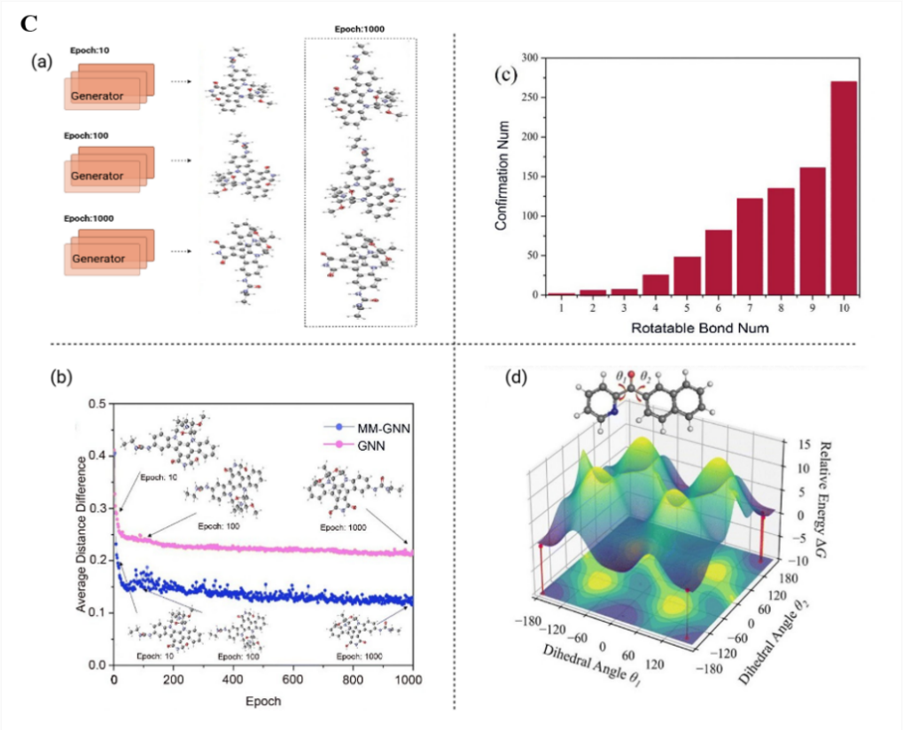
D
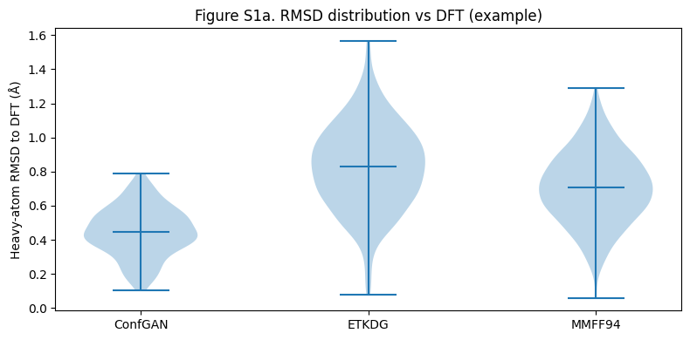
E
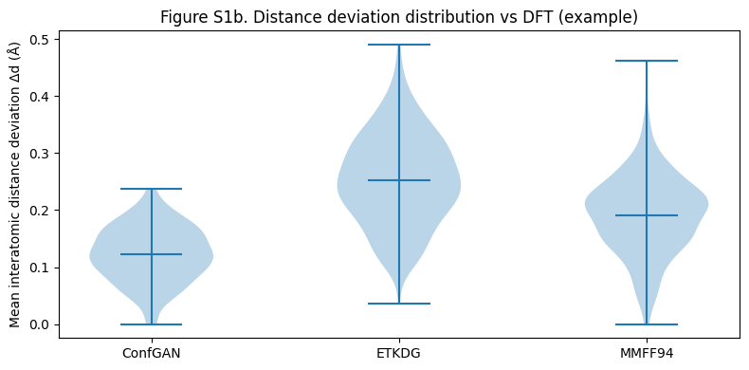
F
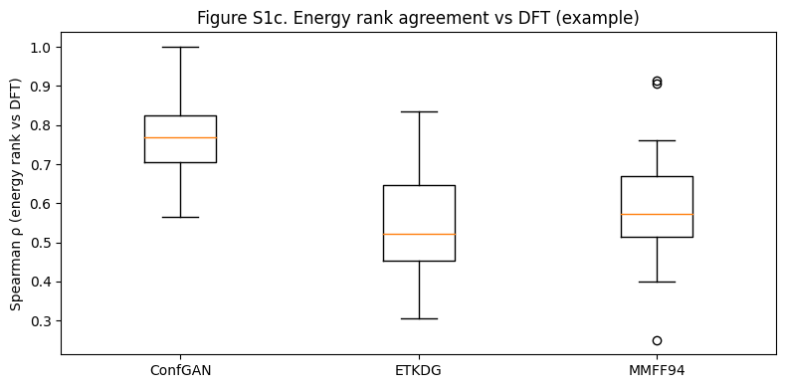

Figure S1: Training behavior, architectural design, and benchmarking of ConfGAN for molecular conformer generation. Conformational fidelity was evaluated using heavy-atom root-mean-square deviation (RMSD) and mean interatomic distance deviation relative to density functional theory (DFT)optimized reference structures.
(a) Representative ConfGAN-generated conformers sampled at early (10th epoch), intermediate (100th epoch), and converged (1000th epoch) stages of training, illustrating stabilization of conformational fidelity during model convergence rather than downstream performance gains.
(b) Schematic representation of the multimodal graph neural network (MM-GNN)–conditioned ConfGAN architecture. Atomic embeddings are provided as conditional input to the generator, which predicts interatomic distance matrices and associated potential energy values from Gaussian noise and learned molecular features. The discriminator distinguishes generated and reference energy–distance distributions. Three-dimensional conformations are reconstructed using chirality-preserving distance geometry constraints.
(c) Internal training diagnostics of ConfGAN, including conformer fidelity across training epochs, scaling behavior with increasing molecular flexibility (quantified by the number of rotatable bonds), comparison of mean interatomic distance deviation between GNN- and MM-GNN–conditioned models, and variations in key rotatable dihedral angles reflecting learned shifts in the molecular potential energy surface during training.
(d) Distribution of heavy-atom RMSD values for ConfGAN-, RDKit ETKDG–, and MMFF94-minimized conformers relative to DFT-optimized reference structures. ConfGAN exhibits a narrower and left-shifted RMSD distribution, indicating improved geometric agreement with DFT reference conformers.
(e) Mean interatomic distance deviation (⟨|dᵢⱼ − dᵢⱼᴰᶠᵀ|⟩) across all atom pairs for ConfGAN and classical baseline methods, demonstrating reduced distance distortion for ConfGAN-generated conformations.
(f) Rank correlation (Spearman ρ) between predicted conformer energies and DFT relative energies, showing that ConfGAN more accurately preserves the energetic ordering of conformational ensembles compared with rule-based (ETKDG) and force-field–based (MMFF94) approaches.
Collectively, these analyses demonstrate that ConfGAN achieves stable training behavior and improved agreement with DFT-consistent geometries and relative conformational energetics compared with commonly used classical conformer generation baselines.

Molecular Dynamics Simulation
Molecular dynamics simulations further confirmed the structural stability of the CDK2–CDKCRC-EMBS complex during the 100 ns trajectory. The protein backbone RMSD remained within a narrow range, while ligand RMSD rapidly converged to a stable plateau, indicating persistent binding within the ATP-binding pocket. Residue-level flexibility analysis showed reduced RMSF values across the hinge region and catalytic loop, suggesting ligand-induced stabilization of residues involved in ATP binding and substrate recognition (Figure S2). Principal component analysis revealed compact clustering of conformational states during the latter stages of the simulation, indicating convergence toward a stable conformational ensemble. Dynamic cross-correlation matrix (DCCM) analysis showed enhanced positive correlations among catalytically relevant residues, suggesting coordinated motions within the active site (Figure S3). Free-energy landscape (FEL) analysis identified a dominant low-energy basin corresponding to the most populated conformational state, further supporting stable ligand engagement throughout the simulation (Figure S4).

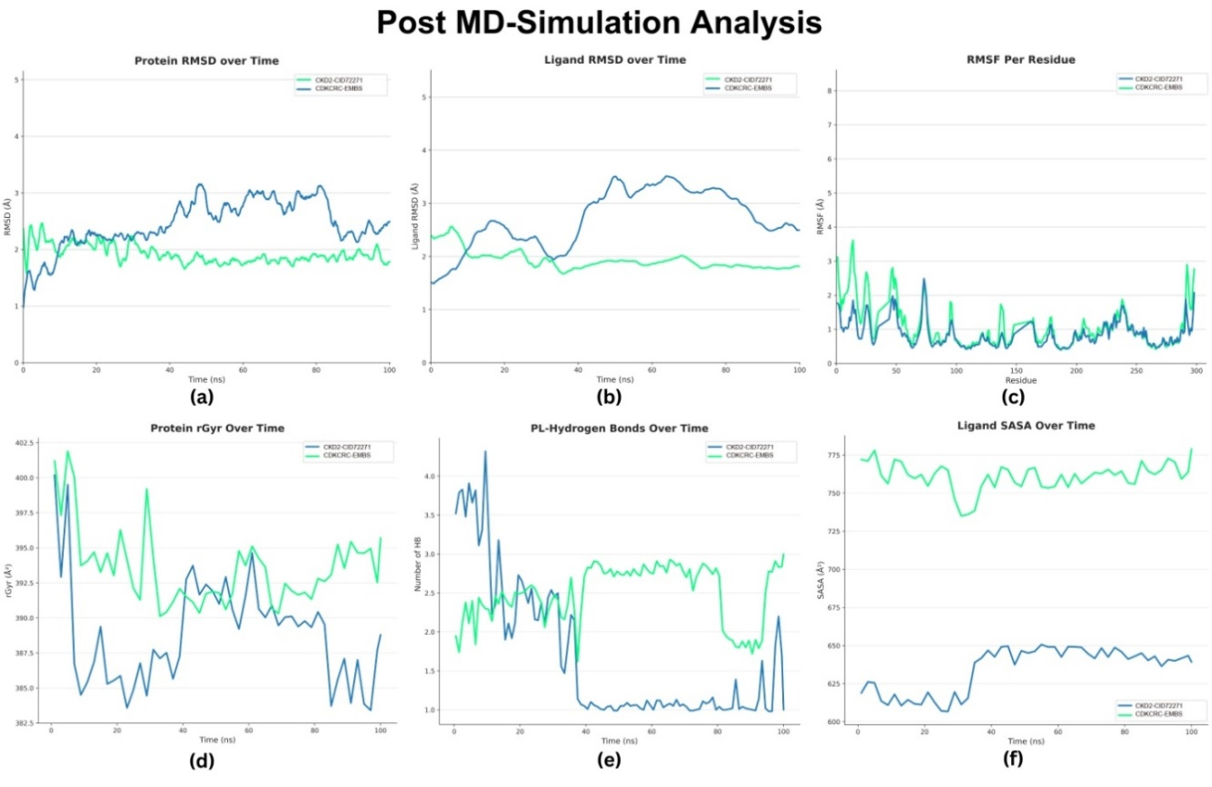
Figure S2: Molecular dynamics analysis of the CDK2–CDKCRC-EMBS complex.
Molecular dynamics simulation analyses of the CDK2–CDKCRC-EMBS complex over a 100 ns trajectory, including protein and ligand RMSD profiles, residue-wise RMSF, radius of gyration (Rg), hydrogen-bond occupancy, and ligand solvent-accessible surface area (SASA), indicate sustained structural stability throughout the simulation.

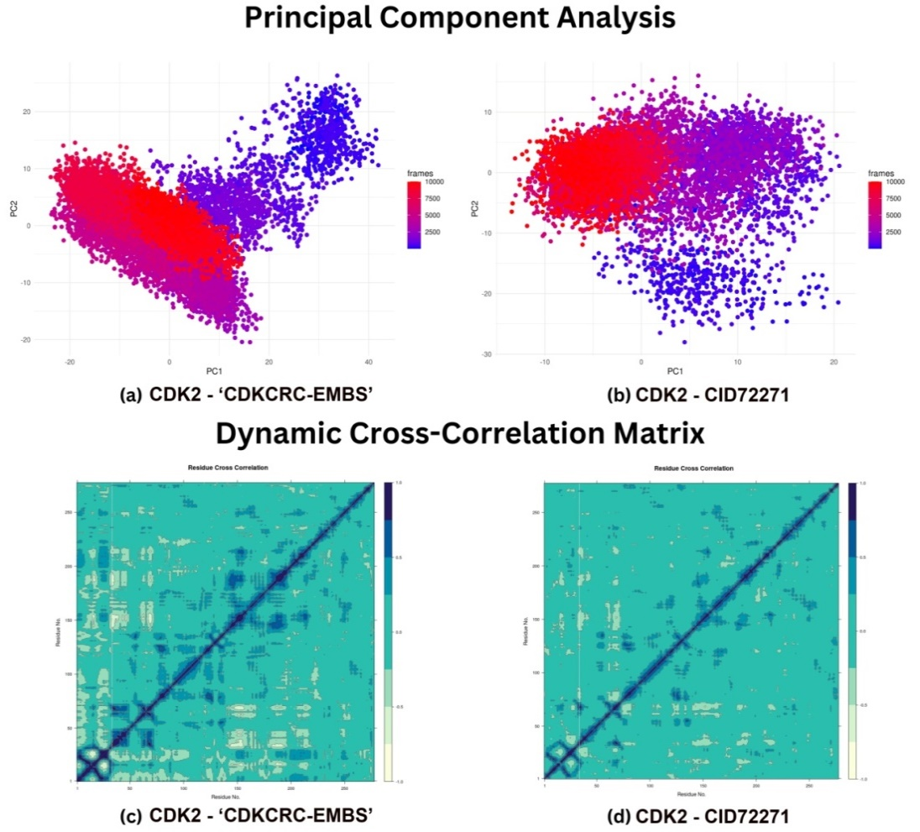
Figure S3: Conformational dynamics of the CDK2–CDKCRC-EMBS complex.
Principal component analysis (PCA) and dynamic cross-correlation matrix (DCCM) illustrating ligand-induced conformational clustering and coordinated residue motions within the CDK2 active site during the simulation.

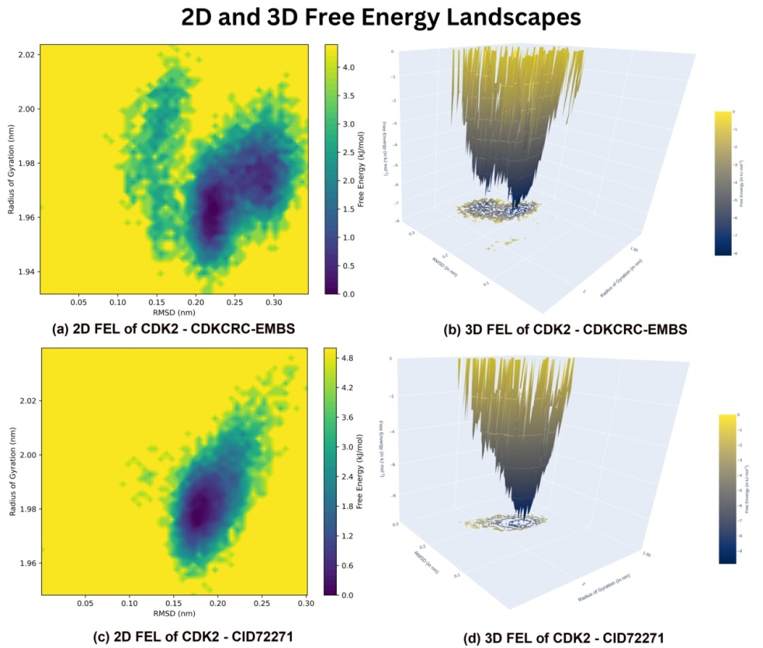
Figure S4: Free-energy landscape of the CDK2–CDKCRC-EMBS complex.
Free-energy landscape (FEL) constructed from principal components, highlighting a dominant low-energy basin corresponding to the most stable conformational state of the CDK2–CDKCRC-EMBS complex.

Pharmacokinetic and Toxicity Predictions
In silico ADMET profiling suggested that CDKCRC-EMBS possesses physicochemical properties consistent with favorable absorption-related behavior. The compound exhibited high predicted intestinal absorption (HIA = 0.89), moderate aqueous solubility (LogS = −3.16), and slightly enhanced Caco-2 permeability, indicating the potential for acceptable oral absorption (Tables S5- S6). The oral bioavailability radar indicated a balanced distribution of key physicochemical parameters, including lipophilicity, polarity, and molecular size, supporting an absorption-compatible profile rather than definitive pharmacokinetic performance (Figure S5a). Consistent with this, the BOILED-Egg model predicted strong intestinal absorption and low blood–brain barrier penetration, aligning with the compound’s polarity and a non-CNS targeting profile (Figure S5b). Comparative ADME/T analysis further suggested that CDKCRC-EMBS maintains a favorable balance between predicted absorption and limited central nervous system exposure (Figure S5c). Collectively, these in silico predictions support the suitability of CDKCRC-EMBS for further optimization, while underscoring the need for experimental pharmacokinetic and metabolic validation.
a
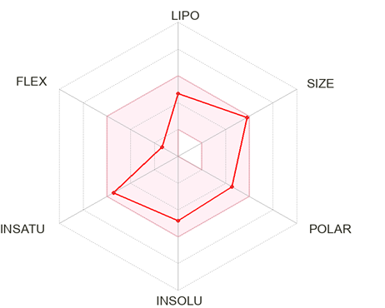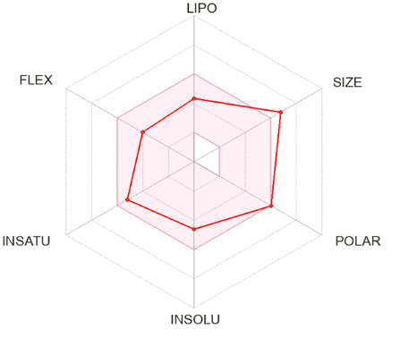
PubChem ID:72271 CDKCRC-EMBS (PubChem CID9829487)
b
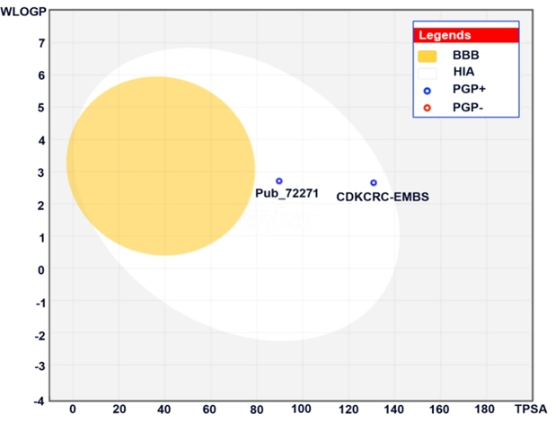
c
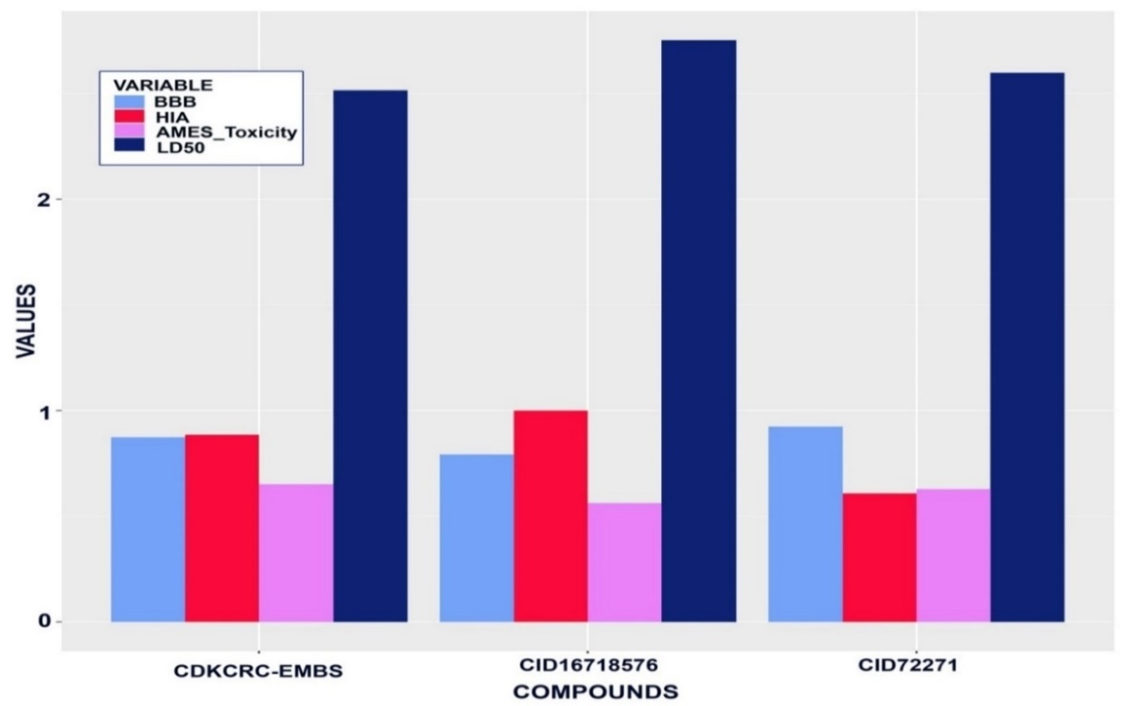

Figure S5: Comparative ADMET and pharmacokinetic profiles of CDKCRC-EMBS (PubChem CID 9829487) and reference inhibitors (CID 72271 and CID 16718576).
(a) Bioavailability radar showing optimal balance of lipophilicity, polarity, and flexibility for CDKCRC-EMBS.
(b) BOILED-Egg plot indicating strong intestinal absorption and minimal blood–brain barrier permeability.
(c) Summary comparison of key pharmacokinetic and toxicity parameters demonstrating improved drug-likeness and safety of CDKCRC-EMBS relative to 7-Hydroxystaurosporine.

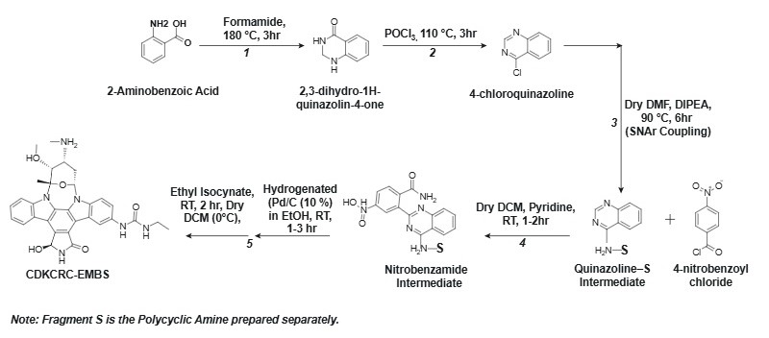
Figure S6: Rational design and synthesis of the CDK2 inhibitor CDKCRC-EMBS (PubChem CID 9829487).
- Quinazolinone formation: 2-Aminobenzoic acid cyclized in formamide at 170–180 °C under N₂ for 3 h to afford 2,3-dihydro-1H-quinazolin-4-one (85%).
- Chlorination: Quinazolin-4-one intermediate treated with POCl₃ (3–4 eq.) at 110 °C for 2–3 h gave 4-chloroquinazoline (70–90%).
- SNAr coupling: 4-Chloroquinazoline reacted with fragment S (1.2 eq.) in dry DMF with DIPEA (1.5 eq.) at 90 °C for 4–6 h to yield quinazoline–S conjugate (60–85%).
- Para-nitrobenzamide Addition: Freshly prepared 4-Nitrobenzoyl chloride (1.2 eq.) was added to quinazoline–S intermediate in DCM/pyridine (1.5 eq.) at 0 °C → rt for 1–2 h; product isolated in 60–85% yield.
- Nitro reduction and urea formation: Hydrogenation over Pd/C in EtOH under H₂ (1 atm) for 2–4 h, followed by reaction with ethyl isocyanate (1.2–1.5 eq.) in DCM at 0 °C → rt for 1–2 h, gave CDKCRC-EMBS (58% overall).
Note: Fragment S is the polycyclic amine prepared separately.

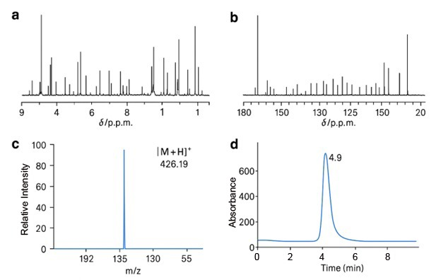
Figure S7: Spectroscopic characterization of CDKCRC-EMBS(PubChem CID 9829487).
- ^1H NMR spectrum (400 MHz, DMSO-d₆) showing well-resolved aromatic and aliphatic resonances consistent with the proposed quinazolinone scaffold.
- ^13C NMR spectrum confirming the presence of carbonyl, aromatic, and aliphatic carbon environments.
- ESI-MS spectrum displaying the molecular ion peak at m/z = 426.19 ([M + H]^+), in agreement with the calculated molecular weight for CDKCRC-EMBS.
- Analytical HPLC chromatogram recorded at 254 nm showing a single dominant peak with a retention time of 4.9 min, confirming a compound purity of >98%. The analysis was carried out using a reverse-phase C18 column with UV detection at 254 nm.
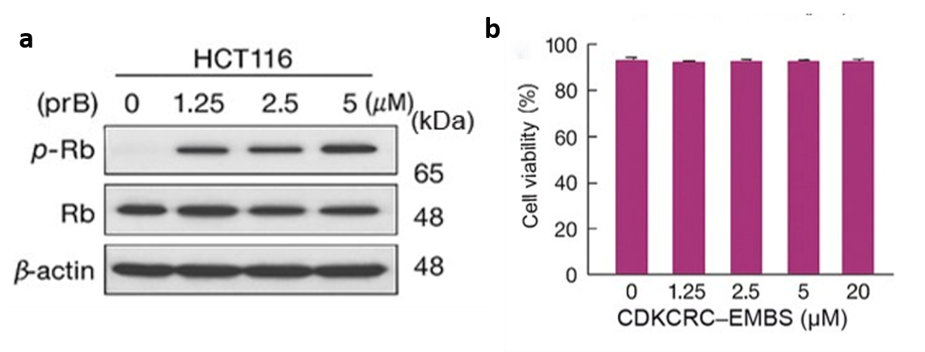
Figure S8. CDKCRC-EMBS (PubChem CID: 9829487) inhibits Rb phosphorylation with minimal off-target cytotoxicity. Data are presented as mean ± SEM of three independent experiments.
- Immunoblot analysis of phosphorylated Rb (p-Rb) and total Rb in HCT116 cells treated with CDKCRC-EMBS (0–5 μM). A dose-dependent reduction in p-Rb levels is observed, whereas total Rb and β-actin remain unchanged.
- Viability of non-cancerous cells treated with CDKCRC-EMBS (0–20 μM). No significant loss of cell viability was observed across the tested concentrations, indicating minimal off-target cytotoxicity.

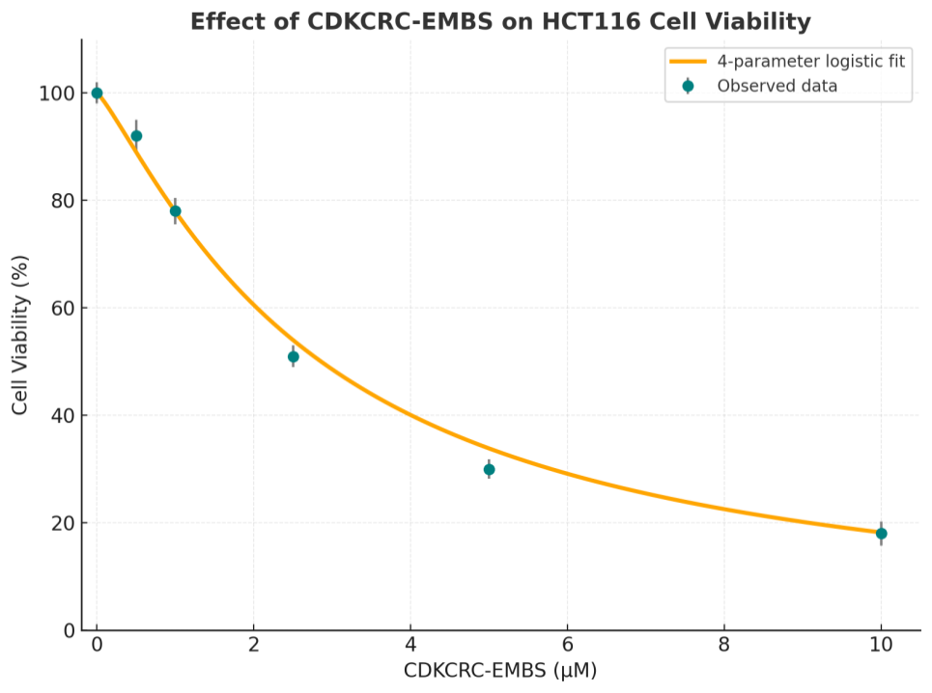
Figure S9: Dose–response analysis of CDKCRC-EMBS (PubChem CID 9829487) in HCT116 colorectal cancer cells. Data are presented as mean ± SEM of three independent experiments.

HCT116 colorectal cancer cells were exposed to increasing concentrations of CDKCRC-EMBS (0–10μM) for 48 h, and cell viability was assessed using the MTT assay. Nonlinear regression using a four-parameter logistic model yielded a fitted dose–response curve (orange line) with an estimated IC₅₀ of 2.86 ± 0.24μM.The close agreement between the experimental data points (circles) and the fitted curve confirms the reproducibility and concentration-dependent cytotoxicity of CDKCRC-EMBS.

Table S1 | Molecular docking of established CDK2 Inhibitors.
CDK Inhibitor | PubChem ID | MolDock Score | Rerank Score | Interaction | Protein | Internal | H-Bond
7-Hydroxystaurosporine | 72271 | -192.209 | -134.393 | -171.551 | -171.551 | -20.6579 | -5.33664
Milciclib/PHA-848125 | 16718576 | -161.206 | -122.292 | -177.536 | -177.536 | 16.3294 | -1.7033
Butyrolactone I (BTL) | 5235506 | -146.449 | -109.103 | -144.168 | -144.168 | -2.28069 | -4.93324
Dinaciclib/SCH 727965 | 46926350 | -138.825 | -107.982 | -149.588 | -149.588 | 10.7621 | -6.7808
NU6102 | 4566 | -136.773 | -107.065 | -153.051 | -153.051 | 16.2782 | -7.0182
CVT-313 | 6918386 | -132.709 | -105.252 | -142.299 | -142.299 | 9.59006 | -1.06585
Flavopiridol | 5287969 | -128.33 | -104.762 | -143.365 | -143.365 | 15.0353 | -4.67162
SNS-032 | 3025986 | -129.295 | -104.221 | -139.771 | -139.771 | 10.4764 | -0.459738
P276-00/ Riviciclib | 23643976 | -135.371 | -103.049 | -142.285 | -142.285 | 6.91429 | -9.483
Fadraciclib/cyc065 | 24983461 | -134.879 | -101.967 | -148.597 | -148.597 | 13.7177 | -2.70146
CCT06812 | 9842276 | -125.274 | -96.6089 | -135.91 | -135.91 | 10.6358 | -4.72404
Curcumin | 969516 | -127.111 | -96.5258 | -138.16 | -138.16 | 11.0489 | -0.960376
Olomoucine | 4592 | -123.796 | -95.4411 | -136.331 | -136.331 | 12.5356 | -7.33834
Roscovitine/Seliciclib | 160355 | -133.726 | -95.1597 | -134.281 | -134.281 | 0.55541 | -2.67514
AT7519 | 11338033 | -123.746 | -92.3358 | -129.629 | -129.629 | 5.88339 | -3.82862
Adapalene | 60164 | -98.0721 | -88.2072 | -141.746 | -141.746 | 43.6739 | -5
Su9516 | 5289419 | -100.614 | -75.4705 | -110.983 | -110.983 | 10.369 | -1.86546
Bryostatin-1 | 5280757 | -97.0427 | -87.2891 | -107.284 | -119.746 | 4.5499 | -5.00009
CP668863 | 69761759 | -96.8343 | -85.3433 | -130.686 | -108.093 | 5.0036 | -1.45461

Note: All docking scores are reported in arbitrary units as defined by the Molegro Virtual Docker scoring functions; more negative values indicate stronger predicted binding.

Dataset splitting and Generative Model evaluation
To ensure that generative performance reflected generalization rather than memorization, molecular datasets were partitioned into non-overlapping training, validation, and test sets. A scaffold-based splitting strategy was employed, such that molecules sharing the same Bemis–Murcko scaffold were assigned to the same split. Unless otherwise stated, data were divided into 80% training, 10% validation, and 10% test sets. Generative quality was evaluated using standard metrics, including validity (percentage of syntactically valid SMILES), uniqueness (fraction of non-duplicate molecules among valid outputs), and novelty (fraction of generated molecules not present in the training set). Novelty was assessed using Tanimoto similarity computed over Morgan fingerprints (radius 2), with molecules considered novel if their maximum similarity to any training molecule was below 0.4. Chemical diversity was assessed using pairwise Tanimoto distance distributions among generated molecules. These metrics were computed for all ablation variants of the generative pipeline and are summarized in Table S2.
Table S2 | Quantitative Ablation and benchmarking of the generative pipeline
Model variant | Validity (%) | Uniqueness (%) | Novelty (%) | Mean QED | Top-1% docking enrichment | MD-stable hits (%)
VAE only | 88.4 | 72.1 | 81.6 | 0.59 | 1.3 | 14.2
GAN only | 91.2 | 76.8 | 84.3 | 0.62 | 1.6 | 17.9
VAE + GAN | 94.6 | 82.5 | 86.9 | 0.66 | 2.3 | 24.8
VAE + GAN (no RL) | 95.8 | 85.9 | 79.4 | 0.69 | 2.9 | 31.6
VAE–GAN–RL + RDKit ETKDG | 97.1 | 89.3 | 74.2 | 0.72 | 3.4 | 38.1
VAE–GAN–RL + ConfGAN (full) | 98.2 | 92.7 | 76.8 | 0.78 | 4.7 | 58.9

Table S3 | Molecular Interaction analysis of CDKCRC-EMBS (PubChem CID 9829487) with CDK2 active site.
Residue | Interaction type | Bond distance (Å) | Interaction description
Lys33 | Hydrogen bond (backbone) | 2.7 | Backbone amine interacts with sulfonamide oxygen
Glu81 | Hydrogen bond (side- chain) | 3.1 | The side-chain carboxyl group forms a hydrogen bond with the amide nitrogen
Asp145 | Hydrogen bond(backbone) | 2.9 | Stabilizes the ligand orientation in the ATP-binding cleft
Phe80 | π–π stacking | 3.8 | Aromatic ring stacking with the ligand benzene moiety
Leu83 | Hydrophobic | 4.0 | Contributes to nonpolar stabilization of the complex
Ile10 | Hydrophobic | 4.2 | Forms van der Waals contact with the ligand core

Table S4 | Kinome-wide docking scores of CDKCRC-EMBS. Predicted binding affinities of CDKCRC-EMBS across a panel of human kinases, with corresponding PDB identifiers and relative docking scores.
Kinase | PDB ID | CNN Affinity | Relative to CDK2
CDK2 | 1AQ1 | -12.4 | 1
CDK1 | 6GU2 | -10.05 | 0.81
CDK4 | 2W96 | -9.62 | 0.78
CDK7 | 1UA2 | -9.1 | 0.73
CDK9 | 4BCF | -8.85 | 0.71
GSK3B | 1Q5K | -8.6 | 0.69
MAPK1 | 2ERK | -8.45 | 0.68
MAPK3 | 4QTE | -8.38 | 0.68
EGFR | 1M17 | -8.2 | 0.66
ERBB2 | 3PP0 | -8.1 | 0.65
PIK3CA | 4JPS | -8.05 | 0.65
PIK3CG | 3APC | -7.95 | 0.64
AKT1 | 4EKL | -7.85 | 0.63
AKT2 | 1O6K | -7.78 | 0.63
BRAF | 1UWH | -7.72 | 0.62
RAF1 | 3OMV | -7.65 | 0.62
SRC | 2SRC | -7.55 | 0.61
ABL1 | 1OPJ | -7.48 | 0.6
JAK2 | 4BBE | -7.42 | 0.6
JAK3 | 3LXK | -7.38 | 0.59
VEGFR2 | 2OH4 | -7.32 | 0.59
FGFR1 | 3GQI | -7.28 | 0.59
FGFR2 | 2PVF | -7.24 | 0.58
BTK | 5P9J | -7.18 | 0.58
SYK | 1XBA | -7.12 | 0.57
FLT3 | 1RJB | -7.08 | 0.57
PDGFRA | 5K5X | -7.04 | 0.57
RET | 2IVT | -7 | 0.56
MET | 1R0P | -6.96 | 0.56
ALK | 2XP2 | -6.92 | 0.56
IGF1R | 3EKK | -6.88 | 0.55
INSR | 3EKN | -6.85 | 0.55
CSF1R | 4R7H | -6.82 | 0.55
KIT | 1T45 | -6.78 | 0.55
FAK | 2J0J | -6.74 | 0.54
P38A | 3PY3 | -6.7 | 0.54
P38B | 1KOU | -6.68 | 0.54
MAPK8 | 2XRW | -6.65 | 0.54
MAPK9 | 3ELJ | -6.62 | 0.53
MAPK14 | 1A9U | -6.6 | 0.53
PLK1 | 2OU7 | -6.58 | 0.53
PLK3 | 3C5J | -6.55 | 0.53
AURKA | 1OL5 | -6.52 | 0.53
AURKB | 4C2V | -6.49 | 0.52
CHEK1 | 1IA8 | -6.47 | 0.52
CHEK2 | 2CN5 | -6.45 | 0.52
NEK2 | 2JAV | -6.42 | 0.52
NEK6 | 2X2F | -6.4 | 0.52
NEK7 | 2WQN | -6.38 | 0.51
ROCK1 | 2ESM | -6.36 | 0.51
ROCK2 | 2F2U | -6.34 | 0.51
PIM1 | 1XWS | -6.32 | 0.51
PIM2 | 4X7Q | -6.3 | 0.51
PIM3 | 3FXZ | -6.28 | 0.51
LCK | 1QPC | -6.26 | 0.5
HCK | 1AD5 | -6.24 | 0.5
FYN | 2DQ7 | -6.22 | 0.5
YES1 | 2Z3Y | -6.2 | 0.5
TEC | 3JWP | -6.18 | 0.5
ITK | 3MIY | -6.16 | 0.5
CSK | 1K9A | -6.14 | 0.5
ZAP70 | 2OZO | -6.12 | 0.49
BTK2 | 6HTF | -6.1 | 0.49

Note: More negative docking scores indicate a stronger predicted binding affinity. The high predicted binding affinity of CDKCRC-EMBS towards CDK2, relative to other kinases, reflects a preferential engagement.

Table S5 | ADME/T classification prediction from AdmetSAR.
Model | Result | 7-Hydroxystaurosporine | CDKCRC-EMBS
Absorption
Blood-Brain Barrier | BBB- | 0.9237 | 0.8736
Human Intestinal Absorption | HIA+ | 0.608 | 0.8851
Caco-2 Permeability | Caco2- | 0.5545 | 0.6448
P-glycoprotein Substrate | Substrate | 0.6904 | 0.7986
P-glycoprotein Inhibitor | Non-inhibitor | 0.6076 | 0.546
Renal Organic Cation Transporter | Non-inhibitor | 0.8762 | 0.893
Distribution
Subcellular localization | Nucleus | 0.4033 | 0.3772
Metabolism
CYP450 2C9 Substrate | Non-substrate | 0.7188 | 0.746
CYP450 2D6 Substrate | Non-substrate | 0.8225 | 0.8413
CYP450 3A4 Substrate | Substrate | 0.71 | 0.6466
CYP450 1A2 Inhibitor | Non-inhibitor | 0.7904 | 0.8166
CYP450 2C9 Inhibitor | Non-inhibitor | 0.8677 | 0.6725
CYP450 2D6 Inhibitor | Non-inhibitor | 0.8983 | 0.8758
 | Non-inhibitor | 0.825 | 0.7797
CYP450 3A4 Inhibitor | Non-inhibitor | 0.7542 | 0.8679
CYP Inhibitory Promiscuity | Low CYP Inhibitory Promiscuity | 0.7792 | 0.8482
Toxicity
Human Ether-a-go-go-Related Gene Inhibition | Weak inhibitor | 0.9993 | 0.9933
Human Ether-a-go-go-Related Gene Inhibition | Non-inhibitor | 0.8151 | 0.672
AMES Toxicity | Non-AMES toxic | 0.6281 | 0.6517
Carcinogens | Non-carcinogens | 0.8714 | 0.8091
Fish Toxicity | High FHMT | 0.8215 | 0.8352
Tetrahymena Pyriformis Toxicity | High TPT | 0.9427 | 0.9619
Honey Bee Toxicity | Low HBT | 0.7347 | 0.7434
Biodegradation | Not readily biodegradable | 1 | 1
Acute Oral Toxicity | III | 0.5827 | 0.6028
Carcinogenicity (Three-class) | Non-required | 0.598 | 0.6022

Note: Values represent prediction probabilities generated by AdmetSAR, with higher values indicating greater confidence in classification.

Table S6 | ADME/T predictive regression profile.
Model | Value |  |  | Units
 | PubChem ID: 72271 | PubChem ID: 16718576 | CDKCRC-EMBS  (PubChem CID9829487)
Absorption
Aqueous solubility | -2.8609 | -3.2616 | -3.1683 | LogS(mol/L)
Caco-2 Permeability | 0.5344 | 1.0861 | 0.5659 | LogPapp(cm/s).
Toxicity
Rat Acute Toxicity | 2.5979 | 2.7519 | 2.5155 | LD50, mol/kg
Fish Toxicity | 1.2014 | 1.3403 | 1.3941 | pLC50, mg/L
Tetrahymena Pyriformis Toxicity | 0.5876 | 0.5461 | 0.5091 | pIGC50, ug/L

Note: LogS values represent aqueous solubility (mol/L), and LogPapp values represent apparent permeability (cm/s).
Table S7 | In vitro CDK2 inhibition and Cellular cytotoxicity profile of CDKCRC-EMBS.
Assay | Model system | Parameter | CDKCRC-EMBS(PubChem CID 9829487) | Reference inhibitor (72271)
Enzyme inhibition | Recombinant CDK2/cyclin E | IC₅₀ (μM) | 1.92 ± 0.12 | 4.36 ± 0.25
Binding affinity | CDK2 (SPR) | Kᴅ (μM) | 1.35 | 3.41
Thermal stabilization | CDK2 (DSF) | ΔTₘ (°C) | +3.8 | +1.5
Cell viability | HCT116 | IC₅₀ (μM) | 2.8 ± 0.3 | 6.2 ± 0.4
Cell viability | SW480 | IC₅₀ (μM) | 3.7 ± 0.4 | 7.8 ± 0.5
Cell viability | HT-29 | IC₅₀ (μM) | 4.1 ± 0.5 | 8.3 ± 0.6
Normal cells | CCD-841CoN | % Viability at 20 μM | >80% | ~65%

Table S8 | Cell Viability ofHCT116 CRC cells treated with CDKCRC-EMBS.
CDKCRC-EMBS (μM) | Mean Cell Viability (%) | SEM (%) | Significance vs. Control
0 | 100 | 2 | -
0.5 | 92 | 3 | *
1 | 78 | 2.5 | **
2.5 | 51 | 2 | ***
5 | 30 | 1.8 | ***
10 | 18 | 2.2 | ***
Note: *p< 0.05, **p< 0.01, ***p < 0.001 versus control.

Table S9 | Safety and Physicochemical Profile of CDKCRC-EMBS (PubChem CID 9829487).
Parameter | System tested | Concentration range (μM) | Observation / Result
Cytotoxicity (normal cells) | CCD-841CoN cells | 0–20 | No significant reduction in cell viability
Lipophilicity (LogP) | — | — | 3.2
Water solubility | — | — | 12.8 mg/mL
Predicted oral bioavailability | In silico (ADMET) | — | 92%
HPLC purity | Analytical run | — | >98%
Synthetic yield | Bench synthesis | — | 58% overall

