Supplementary Methods
Supplementary Methods: Computational Modeling, Molecular Simulations, Synthesis, and Biological Assays
This Supplementary Methods document provides detailed protocols and parameters for the computational and experimental procedures used in this study. It includes protein and ligand preparation, docking setup and scoring settings, molecular dynamics simulation configuration, and detailed laboratory methods for chemical synthesis and compound characterization. It further describes biochemical and biophysical assays (ADP-Glo kinase assay, SPR, DSF), cell-based assays, western blotting procedures, statistical analysis, and reproducibility details supporting the discovery and validation of the CDK2-biased inhibitor CDKCRC-EMBS.
- Computational screening of CDK2 Inhibitors
The crystal structure of human cyclin-dependent kinase 2 (CDK2) complexed with staurosporine (PDB ID: 1AQ1, resolution 2.0 Å) was used as the target for molecular docking [79]. Protein preparation involved the addition of hydrogen atoms, assignment of bond orders, and optimization of hydrogen-bonding networks at physiological pH (7.4). Disulfide bonds were retained as observed in the crystal structure. All co-crystallized ligands were removed except staurosporine, which was retained solely to define the ATP-binding pocket and removed prior to final pose scoring to avoid bias in ligand ranking.Ligand structures were prepared using RDKit, preserving stereochemistry and relevant ionization states [80]. For ligands containing chiral centers or flexible moieties, an initial conformational search was performed prior to energy minimization. Prepared ligands were saved in .sdf format for docking[81-83].All CDK2 inhibitors evaluated in this study are listed in Table 1.
Molecular docking was conducted using Molegro Virtual Docker (MVD) [24]. The docking grid was centered on the ATP-binding site defined by the staurosporine binding pose. Docking parameters included a maximum population size of 50, a maximum of 1,500 iterations, and a grid resolution of 0.3 Å. Post-docking refinement involved hydrogen-bond optimization using the MolDock Simplex Evolution algorithm (300 steps, with a neighbor distance factor of 1.0) [53, 84-85].
Table SM1: List of Selected CDK2 Inhibitors
S. No. | Inhibitors | PubChem ID | MW (g/mol) | HBD | HBA | LogP | Sructure | IC₅₀ | Ref.
 | SU9516 | 5289419 | 241.24 | 2 | 3 | 1 | 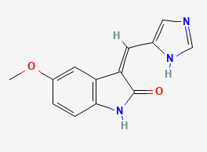 | ~22 nM | [86-87]
 | Curcumin | 969516 | 368.4 | 2 | 6 | 3.2 | 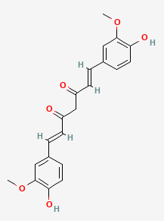 | ~10-50 µM | [88-89]
- ` | Adapalene | 60164 | 412.5 | 1 | 3 | 7.7 | 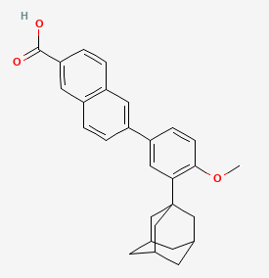 | ~10 µM | [90]
 | Butyrolactone I (BTL) | 5235506 | 424.4 | 3 | 7 | 4.4 | 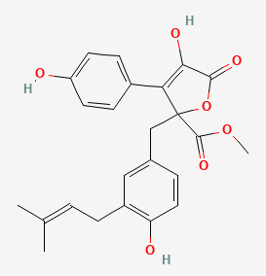 | ~0.5–1 µM | [91-92]
 | NU6102 | 4566 | 402.5 | 3 | 8 | 3.2 | 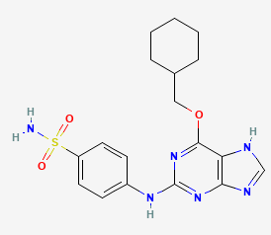 | ~5.4 nM | [93-94]
 | CCT068127 | 9842276 | 369.5 | 3 | 7 | 2.5 | 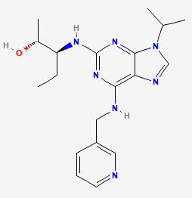 | ~15–20 nM | [95]
 | Flavopiridol | 5287969 | 401.8 | 3 | 6 | 3.3 | 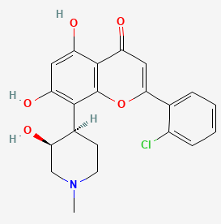 | ~40–100 nM | [96-98]
 | SNS-032 | 3025986 | 380.5 | 2 | 7 | 3 | 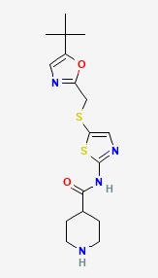 | ~38 nM | [99-101]
 | Roscovitine | 160355 | 354.4 | 3 | 6 | 3.2 | 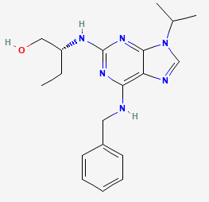 | ~0.65–0.7 µM | [13, 102]
 | Olomoucine | 4592 | 298.34 | 3 | 6 | 1.5 | 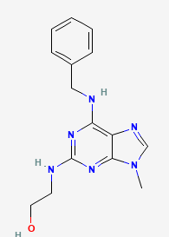 | ~7 µM | [103-105]
 | CVT-313 | 6918386 | 400.5 | 3 | 8 | 1.6 | 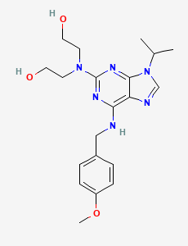 | ~0.5 µM | [106-107]
 | AT7519 | 11338033 | 382.2 | 4 | 4 | 2.6 | 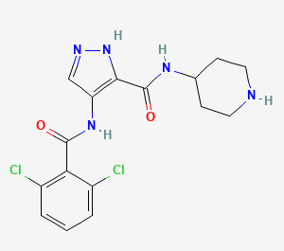 | ~47 nM | [108-110]
 | CP668863 | 69761759 | 305.4 | 2 | 2 | 3.7 | 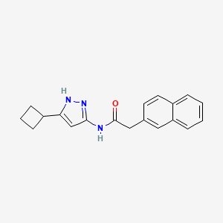 | ~6-8 nM | [111]
 | Dinaciclib/SCH 727965 | 46926350 | 396.5 | 2 | 6 | 1.9 | 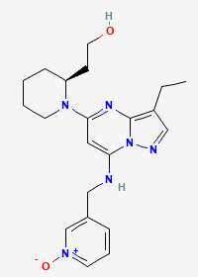 | ~1–4 nM | [10,112]
 | P276-00/ Riviciclib | 23643976 | 401.8 | 6 | 3 | 3.3 | 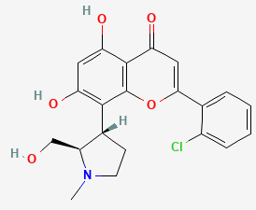 | ~20 nM | [98, 113-114]
 | Milciclib/PHA-848125 | 16718576 | 460.6 | 2 | 7 | 2.8 | 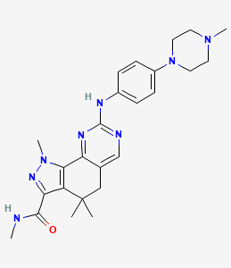 | ~45 nM | [98,115]
 | Fadraciclib/cyc065 | 24983461 | 397.5 | 3 | 7 | 3.3 | 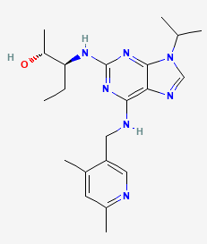 | ~5–10 nM | [116-117]
 | 7-Hydroxystaurosporine Acid | 72271 | 482.5 | 3 | 5 | 2.7 | 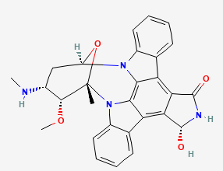 | ~30–50 nM | [118-120]

- Molecular Dynamics Simulations
Molecular dynamics (MD) simulations were performed using GROMACS (2024) automated through the CHAPERONg workflow. Protein parameters were assigned using an OPLS-AA–compatible force field, while ligand parameters were generated using LigParGen [121] to ensure consistency with OPLS-AA atom types and partial charges. Each protein–ligand complex was placed in a cubic simulation box with a minimum solute–box distance of 10 Å and solvated using SPC/E water molecules. Periodic boundary conditions were applied in all three dimensions. Systems were neutralized with Na⁺ ions and supplemented with Na⁺/Cl⁻ ions to achieve a final ionic strength of 0.15 M. Energy minimization was performed using the steepest-descent algorithm.
The minimized systems were equilibrated in two stages, NVT equilibration for 100 ps at 300 K using the Nosé–Hoover thermostat, followed by NPT equilibration for 100 ps at 300 K and 1 atm using the Parrinello–Rahman barostat. The thermostat coupling constant (τ<sub>T</sub>) was set to 1.0 ps, while the barostat coupling constant (τ<sub>P</sub>) was set to 5.0 ps with a compressibility of 4.5 × 10⁻⁵ bar⁻¹. Long-range electrostatic interactions were calculated using the Particle Mesh Ewald (PME) method with a real-space cutoff of 1.0 nm and a Fourier grid spacing of 0.12 nm. Van der Waals interactions used a cutoff of 1.0 nm with a force-switching function applied between 0.9 and 1.0 nm. Covalent bonds involving hydrogen atoms were constrained using the LINCS algorithm, allowing a 2 fs integration time step [34, 60-61].
After equilibration, positional restraints were removed, and production MD simulations were carried out for 100 ns with a 2 fs time step. Atomic coordinates were recorded every 10 ps and energy values every 1 ps. Center-of-mass motion was removed every 100 integration steps to prevent translational drift. Systems were visually inspected before production runs to confirm stability and absence of structural artifacts. Trajectory analyses were performed using the Bio3D package in R. Simulation trajectories (.xtc) were converted to (.dcd) format for compatibility with Bio3D, and analyses were performed using Cα atoms [62-63].
Root-mean-square deviation (RMSD), root-mean-square fluctuation (RMSF), radius of gyration, and hydrogen-bond persistence were calculated to assess structural stability and residue flexibility during the simulations.Principal component analysis (PCA) was conducted using singular value decomposition (SVD) to identify dominant collective motions. Dynamic cross-correlation matrix (DCCM) analysis was used to evaluate correlated and anti-correlated residue motions. Free-energy landscape (FEL) analysis was constructed using RMSD and radius of gyration as reaction coordinates to characterize conformational stability and dominant conformational states sampled during the simulations [64-67].
- Chemical synthesis of CDKCRC-EMBS
The novel CDK2 inhibitor CDKCRC-EMBS was synthesized via a concise five-step route starting from commercially available precursors, with a representative literature referenceincluded [122-123].The synthetic strategy involved the construction of a quinazolinone core, functionalization at the C-4 position, and introduction of pharmacophoric substituents essential for CDK2 binding andselectivity (Figure S6, Supplementary Information 1). A stereochemically defined bicyclic/polycyclic amine fragment (Fragment S) was synthesized independently and incorporated through nucleophilic aromatic substitution (SNAr) with a 4-chloroquinazoline intermediate. CDKCRC-EMBS has been deposited in the NCBI PubChem database (CID 9829487, SID 522761491).
Formation of Quinazolinone Core
2-Aminobenzoic acid was cyclized in formamide at 170–180 °C under nitrogen for 3 h to afford 2,3-dihydro-1H-quinazolin-4-one in 85% yield.
Chlorination
The quinazolinone intermediate was treated with POCl₃ (3–4 equivalents) at 110 °C for 2–3 h to yield 4-chloroquinazoline in 70–90% yield.
SNAr Coupling
4-Chloroquinazoline was reacted with Fragment S (1.2 equivalents) in dry DMF with DIPEA (1.5 equivalents) at 90 °C for 4–6 h, affording the quinazoline–S conjugate in 60–85% yield.
Installation of para-Nitrobenzamide
Freshly prepared 4-nitrobenzoyl chloride was added to the quinazoline–S intermediate in dry DCM/pyridine at 0 °C to room temperature, yielding the nitrobenzamide intermediate in 60–85% yield.
Nitro Reduction and Urea Formation
Catalytic hydrogenation over Pd/C followed by reaction with ethyl isocyanate afforded CDKCRC-EMBS as a pale-yellow solid in 58% overall yield.
Synthesis of Side-Chain Fragment S
Fragment S was synthesized via N-Boc protection, intramolecular Mitsunobu cyclization, Boc deprotection, and N-alkylation steps, yielding a stereochemically defined polycyclic amine suitable for SNAr coupling.
Structural identity and purity of the final compound were confirmed through a combination of ^1H and ^13C NMR spectroscopy, high-resolution mass spectrometry (HRMS), and HPLC [124].
- Experimental Validation of CDKCRC-EMBS
  - Cell lines and Culture Conditions
The human colorectal cancer cell lines HCT116, SW480, and HT-29 were procured from the American Type Culture Collection (ATCC, Manassas, VA, USA) through its authorized Indian distributor, HiMedia Laboratories Pvt. Ltd. (Mumbai, India).
HCT116 (ATCC CCL-247) and HT-29 (ATCC HTB-38) cells were cultured in modified McCoy's 5A medium (HiMedia, Cat. No. AT057) supplemented with 10% (v/v) heat-inactivated fetal bovine serum (FBS; HiMedia, Cat. No. RM1112) and 1% (v/v) penicillin–streptomycin solution. Cells were maintained at 37 °C in a humidified incubator with 5% CO₂.
SW480 (ATCC CCL-228) cells were cultured in Leibovitz's L-15 medium (HiMedia, Cat. No. AT011) supplemented with 10% (v/v) heat-inactivated FBS and 1% (v/v) penicillin–streptomycin solution. In accordance with the manufacturer's recommendations for L-15 medium, SW480 cells were maintained at 37 °C in a humidified incubator with free gas exchange under atmospheric air, without CO₂ supplementation.
Cell Maintenance and Passaging
For routine maintenance, the culture medium was replaced every 2–3 days. Upon reaching 80–90% confluence, cells were washed with sterile phosphate-buffered saline (PBS; pH 7.4) and detached using 0.25% trypsin–EDTA solution (HiMedia, Cat. No. TCL007) for 3–5 min at 37 °C. Detached cells were resuspended in complete growth medium, centrifuged at 1,000 × g for 5 min, and subcultured at split ratios ranging from 1:3 to 1:6, depending on their growth characteristics. All cell lines were routinely monitored for mycoplasma contamination and were used within 10–15 passages after thawing to minimize phenotypic and genetic drift.
  - CDK2 Kinase Inhibition Assay
CDK2/cyclin E inhibition was measured using the ADP-Glo™ Kinase Assay. Recombinant CDK2/cyclin E (50 ng per reaction) was incubated with CDKCRC-EMBS (0.01–100 µM) in the presence of 100 µM ATP and histone H1 substrate. Luminescence was measured at 560 nm, and IC₅₀ values were calculated by nonlinear regression using GraphPad Prism 9.
  - Surface Plasmon Resonance (SPR) and Thermal Shift Assays
SPR experiments were conducted on a Biacore T200 using CDK2 immobilized on a CM5 chip. Binding kinetics were analyzed using a 1:1 Langmuir model. Thermal stability was assessed by differential scanning fluorimetry using SYPRO Orange dye, and melting temperatures (ΔTₘ) were determined from first-derivative curves.
  - Cell Culture and Cellular Assays
Human colorectal cancer cell lines (HCT116, SW480, and HT-29) and the normal human colon epithelial cell line CCD-841CoN (ATCC CRL-1790) were used for cellular assays. CCD-841CoN cells were obtained from the American Type Culture Collection (ATCC, Manassas, VA, USA) through its authorized Indian distributor, HiMedia Laboratories Pvt. Ltd. (Mumbai, India). All cell lines were cultured in DMEM supplemented with 10% FBS and 1% penicillin–streptomycin at 37 °C in a humidified atmosphere containing 5% CO₂. Cells between passages 5 and 20 were used. Cell viability was assessed using the CellTiter-Glo® luminescent cell viability assay after 48 h of treatment in both colorectal cancer and CCD-841CoN cells. Cell-cycle distribution and apoptosis were analyzed by flow cytometry using propidium iodide and Annexin V–FITC/PI staining, respectively.
  - Western Blot Analysis
HCT116 cells were treated with CDKCRC-EMBS (0, 2.5, 5, and 10 µM) for 24 h, harvested, and lysed in RIPA buffer supplemented with protease and phosphatase inhibitors. Cell lysates were clarified by centrifugation at 12,000 × g for 10 min at 4 °C. Protein concentrations were determined using the BCA assay. Equal amounts of protein (30 µg) were separated by SDS–PAGE, transferred onto PVDF membranes, and immunoblotted with antibodies against phospho-Rb (Ser807/811), total Rb, and β-actin (Cell Signaling Technology). Bound antibodies were detected using HRP-conjugated secondary antibodies.
Statistical Analysis
All experiments were performed with n ≥ 3 biological replicates. Statistical analyses were conducted using R v4.4.2 with the tidyverse, rstatix, and drc packages. Data are presented as mean ± SEM. Normality and variance homogeneity were assessed prior to ANOVA, with appropriate post hoc corrections. Statistical significance was defined as p < 0.05.

References
- Lawrie, A. M., Noble, M. E., Tunnah, P., Brown, N. R., Johnson, L. N., & Endicott, J. A. (1997). Protein kinase inhibition by staurosporine revealed in details of the molecular interaction with CDK2. Nature structural biology, 4(10), 796-801.
- Bento, A. P., Hersey, A., Félix, E., Landrum, G., Gaulton, A., Atkinson, F., ... & Leach, A. R. (2020). An open source chemical structure curation pipeline using RDKit. Journal of Cheminformatics, 12, 1-16.
- Patidar, K., Panwar, U., Vuree, S., Sweta, J., Sandhu, M. K., Nayarisseri, A., & Singh, S. K. (2019). An in silico approach to identify high affinity small molecule targeting m-TOR inhibitors for the clinical treatment of breast cancer. Asian Pacific journal of cancer prevention: APJCP, 20(4), 1229.
- Gokhale, P., Chauhan, A. P. S., Arora, A., Khandekar, N., Nayarisseri, A., & Singh, S. K. (2019). FLT3 inhibitor design using molecular docking based virtual screening for acute myeloid leukemia. Bioinformation, 15(2), 104.
- Sharma, K., Patidar, K., Ali, M. A., Patil, P., Goud, H., Hussain, T., ... & Singh, S. K. (2018). Structure-based virtual screening for the identification of high affinity compounds as potent VEGFR2 inhibitors for the treatment of renal cell carcinoma. Current topics in medicinal chemistry, 18(25), 2174-2185.
- Sinha, C., Nischal, A., Pant, K. K., Bandaru, S., Nayarisseri, A., &Khattri, S. (2014). Molecular docking analysis of RN18 and VEC5 in A3G-Vif inhibition. Bioinformation, 10(10), 611.
- Tabassum, A., Rajeshwari, T., Soni, N., Raju, D. S. B., Yadav, M., Nayarisseri, A., & Jahan, P. (2014). Structural characterization and mutational assessment of podocin—A novel drug target to nephrotic syndrome—An in silico approach. Interdisciplinary Sciences: Computational Life Sciences, 6, 32-39.
- Lane, M. E., Yu, B., Rice, A., Lipson, K. E., Liang, C., Sun, L., ... & Wadler, S. (2001). A novel cdk2-selective inhibitor, SU9516, induces apoptosis in colon carcinoma cells. Cancer research, 61(16), 6170-6177.
- Moshinsky, D. J., Bellamacina, C. R., Boisvert, D. C., Huang, P., Hui, T., Jancarik, J., ... & Rice, A. G. (2003). SU9516: biochemical analysis of cdk inhibition and crystal structure in complex with cdk2. Biochemical and biophysical research communications, 310(3), 1026-1031.
- Lim, T. G., Lee, S. Y., Huang, Z., Lim, D. Y., Chen, H., Jung, S. K., ... & Dong, Z. (2014). Curcumin suppresses the proliferation of colon cancer cells by targeting CDK2. Cancer Prevention Research, 7(4), 466-474.
- Flint, A. L., Hansen, D. W., Brown, L. D., Stewart, L. E., Ortiz, E., & Panda, S. S. (2022). Modified curcumins as potential drug candidates for breast cancer: An overview. Molecules, 27(24), 8891.
- Shi, X. N., Li, H., Yao, H., Liu, X., Li, L., Leung, K. S., ... & Lin, M. C. M. (2015). Adapalene inhibits the activity of cyclin-dependent kinase 2 in colorectal carcinoma. Molecular medicine reports, 12(5), 6501-6508.
- Yamamoto, H., Monden, T., Miyoshi, H., Izawa, H., Ikeda, K., Tsujie, M., ... & Monden, M. (1998). Cdk2/cdc2 expression in colon carcinogenesis and effects of cdk2/cdc2 inhibitor in colon cancer cells. International journal of oncology, 13(2), 233-242.
- Kitagawa, M., Okabe, T., Ogino, H., Matsumoto, H., Suzuki-Takahashi, I., Kokubo, T., ... & Yasuda, H. (1993). Butyrolactone I, a selective inhibitor of cdk2 and cdc2 kinase. Oncogene, 8(9), 2425-2432.
- Beale, G., Haagensen, E. J., Thomas, H. D., Wang, L. Z., Revill, C. H., Payne, S. L., ... &Cano, C. (2016). Combined PI3K and CDK2 inhibition induces cell death and enhances in vivo antitumour activity in colorectal cancer. British journal of cancer, 115(6), 682-690.
- Johnson, N., Bentley, J., Wang, L. Z., Newell, D. R., Robson, C. N., Shapiro, G. I., & Curtin, N. J. (2010). Pre-clinical evaluation of cyclin-dependent kinase 2 and 1 inhibition in anti-estrogen-sensitive and resistant breast cancer cells. British journal of cancer, 102(2), 342-350
- Whittaker, S. R., Barlow, C., Martin, M. P., Mancusi, C., Wagner, S., Self, A., ... & Workman, P. (2018). Molecular profiling and combinatorial activity of CCT 068127: a potent CDK 2 and CDK 9 inhibitor. Molecular Oncology, 12(3), 287-304.
- Rathkopf, D., Dickson, M. A., Feldman, D. R., Carvajal, R. D., Shah, M. A., Wu, N., ... & Schwartz, G. K. (2009). Phase I study of flavopiridol with oxaliplatin and fluorouracil/leucovorin in advanced solid tumors. Clinical Cancer Research, 15(23), 7405-7411.
- Smith, V., Raynaud, F., Workman, P., & Kelland, L. R. (2001). Characterization of a human colorectal carcinoma cell line with acquired resistance to flavopiridol. Molecular pharmacology, 60(5), 885-893.
- Zhang, M., Zhang, L., Hei, R., Li, X., Cai, H., Wu, X., ... & Cai, C. (2021). CDK inhibitors in cancer therapy, an overview of recent development. American journal of cancer research, 11(5), 1913.
- Heath, E. I., Bible, K., Martell, R. E., Adelman, D. C., & LoRusso, P. M. (2008). A phase 1 study of SNS-032 (formerly BMS-387032), a potent inhibitor of cyclin-dependent kinases 2, 7 and 9 administered as a single oral dose and weekly infusion in patients with metastatic refractory solid tumors. Investigational new drugs, 26, 59-65.
- Boquoi, A., Chen, T., & Enders, G. H. (2009). Chemoprevention of mouse intestinal tumorigenesis by the cyclin-dependent kinase inhibitor SNS-032. Cancer Prevention Research, 2(9), 800-806.
- Chen, R., Wierda, W. G., Chubb, S., Hawtin, R. E., Fox, J. A., Keating, M. J., ... & Plunkett, W. (2009). Mechanism of action of SNS-032, a novel cyclin-dependent kinase inhibitor, in chronic lymphocytic leukemia. Blood, The Journal of the American Society of Hematology, 113(19), 4637-4645.
- Wells, C. I., Vasta, J. D., Corona, C. R., Wilkinson, J., Zimprich, C. A., Ingold, M. R., ... & Robers, M. B. (2020). Quantifying CDK inhibitor selectivity in live cells. Nature communications, 11(1), 2743.
- Glab, N., Labidi, B., Qin, L. X., Trehin, C., Bergounioux, C., & Meijer, L. (1994). Olomoucine, an inhibitor of the cdc2/cdk2 kinases activity, blocks plant cells at the G1 to S and G2 to M cell cycle transitions. FEBS letters, 353(2), 207-211.
- Raynaud, F. I., Whittaker, S. R., Fischer, P. M., McClue, S., Walton, M. I., Barrie, S. E., ... & Workman, P. (2005). In vitro and in vivo pharmacokinetic-pharmacodynamic relationships for the trisubstituted aminopurine cyclin-dependent kinase inhibitors olomoucine, bohemine and CYC202. Clinical cancer research, 11(13), 4875-4887.
- Veselý, J., Havliček, L., Strnad, M., Blow, J. J., Donella‐Deana, A., Pinna, L., ... & Meijer, L. (1994). Inhibition of cyclin‐dependent kinases by purine analogues. European journal of biochemistry, 224(2), 771-786.
- Brooks, E. E., Gray, N. S., Joly, A., Kerwar, S. S., Lum, R., Mackman, R. L., ... & Shiffman, D. (1997). CVT-313, a specific and potent inhibitor of CDK2 that prevents neointimal proliferation. Journal of Biological Chemistry, 272(46), 29207-29211.
- Singh, R., Bhardwaj, V. K., Sharma, J., Das, P., & Purohit, R. (2022). Identification of selective cyclin-dependent kinase 2 inhibitor from the library of pyrrolone-fused benzosuberene compounds: an in silico exploration. Journal of Biomolecular Structure and Dynamics, 40(17), 7693-7701.
- Tadesse, S., Caldon, E. C., Tilley, W., & Wang, S. (2018). Cyclin-dependent kinase 2 inhibitors in cancer therapy: an update. Journal of medicinal chemistry, 62(9), 4233-4251.
- Cicenas, J., & Valius, M. (2011). The CDK inhibitors in cancer research and therapy. Journal of cancer research and clinical oncology, 137(10), 1409-1418.
- Squires, M. S., Feltell, R. E., Wallis, N. G., Lewis, E. J., Smith, D. M., Cross, D. M., ... & Thompson, N. T. (2009). Biological characterization of AT7519, a small-molecule inhibitor of cyclin-dependent kinases, in human tumor cell lines. Molecular cancer therapeutics, 8(2), 324-332.
- Robb, C. M., Kour, S., Contreras, J. I., Agarwal, E., Barger, C. J., Rana, S., ... & Natarajan, A. (2017). Characterization of CDK (5) inhibitor, 20-223 (aka CP668863) for colorectal cancer therapy. Oncotarget, 9(4), 5216.
- Parry, D., Guzi, T., Shanahan, F., Davis, N., Prabhavalkar, D., Wiswell, D., ... & Lees, E. M. (2010). Dinaciclib (SCH 727965), a novel and potent cyclin-dependent kinase inhibitor. Molecular cancer therapeutics, 9(8), 2344-2353.
- Joshi, K. S., Rathos, M. J., Mahajan, P., Wagh, V., Shenoy, S., Bhatia, D., ... & Sharma, S. (2007). P276-00, a novel cyclin-dependent inhibitor induces G1-G2 arrest, shows antitumor activity on cisplatin-resistant cells and significant in vivo efficacy in tumor models. Molecular cancer therapeutics, 6(3), 926-934.
- Mikhail, S., Albanese, C., &Pishvaian, M. J. (2015). Cyclin-dependent kinase inhibitors and the treatment of gastrointestinal cancers. The American Journal of Pathology, 185(5), 1185-1197.
- Albanese, C., Alzani, R., Amboldi, N., Avanzi, N., Ballinari, D., Brasca, M. G., ... &Ciomei, M. (2010). Dual targeting of CDK and tropomyosin receptor kinase families by the oral inhibitor PHA-848125, an agent with broad-spectrum antitumor efficacy. Molecular cancer therapeutics, 9(8), 2243-2254.
- Frame, S., Saladino, C., MacKay, C., Atrash, B., Sheldrake, P., McDonald, E., ... &Zheleva, D. (2020). Fadraciclib (CYC065), a novel CDK inhibitor, targets key pro-survival and oncogenic pathways in cancer. Plos one, 15(7), e0234103.
- Coxon, C. R., Anscombe, E., Harnor, S. J., Martin, M. P., Carbain, B., Golding, B. T., ... & Cano, C. (2017). Cyclin-dependent kinase (CDK) inhibitors: structure–activity relationships and insights into the CDK-2 selectivity of 6-substituted 2-arylaminopurines. Journal of Medicinal Chemistry, 60(5), 1746-1767.
- Komander, D., Kular, G. S., Bain, J., Elliott, M., Alessi, D. R., & Van Aalten, D. M. (2003). Structural basis for UCN-01 (7-hydroxystaurosporine) specificity and PDK1 (3-phosphoinositide-dependent protein kinase-1) inhibition. Biochemical Journal, 375(2), 255-262.
- Akinaga, S., Sugiyama, K., & Akiyama, T. (2000). UCN-01 (7-hydroxystaurosporine) and other indolocarbazole compounds: a new generation of anti-cancer agents for the new century?. Anti-cancer drug design, 15(1), 43-52.
- Akiyama, T., Yoshida, T., Tsujita, T., Shimizu, M., Mizukami, T., Okabe, M., & Akinaga, S. (1997). G1 phase accumulation induced by UCN-01 is associated with dephosphorylation of Rb and CDK2 proteins as well as induction of CDK inhibitor p21/Cip1/WAF1/Sdi1 in p53-mutated human epidermoid carcinoma A431 cells. Cancer research, 57(8), 1495-1501.
- Dodda, L. S., Cabeza de Vaca, I., Tirado-Rives, J., & Jorgensen, W. L. (2017). LigParGen web server: an automatic OPLS-AA parameter generator for organic ligands. Nucleic acids research, 45(W1), W331-W336.
- Connolly, D. J., Cusack, D., O'Sullivan, T. P., & Guiry, P. J. (2005). Synthesis of quinazolinones and quinazolines. Tetrahedron, 61(43), 10153-10202.
- Arnott, E. A., Chan, L. C., Cox, B. G., Meyrick, B., & Phillips, A. (2011). POCl3 chlorination of 4-quinazolones. The Journal of Organic Chemistry, 76(6), 1653-1661.
- Sturm, R. M., Jones, B. R., Mulvana, D. E., & Lowes, S. (2016). HRMS using a Q-Exactive series mass spectrometer for regulated quantitative bioanalysis: how, when, and why to implement. Bioanalysis, 8(16), 1709-1721.

