Supplementary Table S1
Descriptive Statistics of Numerical Predictors
statistic | value
goals_scored_last_4y_mean | 84.58333333
goals_scored_last_4y_sd | 23.73177633
goals_scored_last_4y_median | 83.5
goals_scored_last_4y_min | 28
goals_scored_last_4y_max | 156
goals_received_last_4y_mean | 44.57291667
goals_received_last_4y_sd | 13.60800872
goals_received_last_4y_median | 42.5
goals_received_last_4y_min | 19
goals_received_last_4y_max | 95
wins_last_4y_mean | 26.046875
wins_last_4y_sd | 6.912534379
wins_last_4y_median | 25
wins_last_4y_min | 8
wins_last_4y_max | 48
losses_last_4y_mean | 11.05208333
losses_last_4y_sd | 4.745612008
losses_last_4y_median | 10.5
losses_last_4y_min | 2
losses_last_4y_max | 30
draws_last_4y_mean | 11.80208333
draws_last_4y_sd | 3.496055494
draws_last_4y_median | 12
draws_last_4y_min | 4
draws_last_4y_max | 23
world_cup_titles_before_mean | 0.427083333
world_cup_titles_before_sd | 1.085311659
world_cup_titles_before_median | 0
world_cup_titles_before_min | 0
world_cup_titles_before_max | 5
squad_total_market_value_eur_mean | 322411093.8
squad_total_market_value_eur_sd | 321764770.8
squad_total_market_value_eur_median | 217940000
squad_total_market_value_eur_min | 6270000
squad_total_market_value_eur_max | 1.62E+09
fifa_rank_pre_tournament_mean | 23.54166667
fifa_rank_pre_tournament_sd | 18.21449665
fifa_rank_pre_tournament_median | 20
fifa_rank_pre_tournament_min | 1
fifa_rank_pre_tournament_max | 105
fifa_points_pre_tournament_mean | 954.1654688
fifa_points_pre_tournament_sd | 367.5446094
fifa_points_pre_tournament_median | 824
fifa_points_pre_tournament_min | 285
fifa_points_pre_tournament_max | 1841.3
squad_avg_age_mean | 27.24963542
squad_avg_age_sd | 1.092350543
squad_avg_age_median | 27.225
squad_avg_age_min | 23.92
squad_avg_age_max | 29.78
world_cup_participations_before_mean | 5.625
world_cup_participations_before_sd | 5.548925654
world_cup_participations_before_median | 4
world_cup_participations_before_min | 0
world_cup_participations_before_max | 21
groups_passed_before_mean | 3.572916667
groups_passed_before_sd | 4.584848234
groups_passed_before_median | 1
groups_passed_before_min | 0
groups_passed_before_max | 19
round16_before_mean | 2.244791667
round16_before_sd | 2.701070945
round16_before_median | 1
round16_before_min | 0
round16_before_max | 11
quarterfinals_before_mean | 2.223958333
quarterfinals_before_sd | 3.525056007
quarterfinals_before_median | 1
quarterfinals_before_min | 0
quarterfinals_before_max | 16
semifinals_before_mean | 1.348958333
semifinals_before_sd | 2.618520216
semifinals_before_median | 0
semifinals_before_min | 0
semifinals_before_max | 13
finals_before_mean | 0.697916667
finals_before_sd | 1.731263447
finals_before_median | 0
finals_before_min | 0
finals_before_max | 8

Supplementary Table S2
Full Predictive Performance of Competing Models Using the Youden Optimal Classification Threshold

Supplementary Table S2
Predictive Performance of Competing Models Using a Fixed 0.50 Classification Threshold

Supplementary Table S3
Combined Model Performance Across Classification Thresholds
Supplementary Table S4
Penalized Logistic Regression Coefficient Estimates
predictor | coefficient | outcome | model
semifinals_before | 0.000869 | finalist | elastic_net
squad_total_market_value_eur | 4.68E-10 | finalist | elastic_net
continentSouth America | 0 | finalist | elastic_net
continentOceania | 0 | finalist | elastic_net
continentNorth America | 0 | finalist | elastic_net
continentEurope | 0 | finalist | elastic_net
continentAsia | 0 | finalist | elastic_net
is_host1 | 0 | finalist | elastic_net
goals_scored_last_4y | 0 | finalist | elastic_net
goals_received_last_4y | 0 | finalist | elastic_net
wins_last_4y | 0 | finalist | elastic_net
losses_last_4y | 0 | finalist | elastic_net
draws_last_4y | 0 | finalist | elastic_net
world_cup_titles_before | 0 | finalist | elastic_net
fifa_rank_pre_tournament | 0 | finalist | elastic_net
fifa_points_pre_tournament | 0 | finalist | elastic_net
squad_avg_age | 0 | finalist | elastic_net
world_cup_participations_before | 0 | finalist | elastic_net
groups_passed_before | 0 | finalist | elastic_net
round16_before | 0 | finalist | elastic_net
quarterfinals_before | 0 | finalist | elastic_net
finals_before | 0 | finalist | elastic_net
finals_before | 0.008563 | finalist | lasso
squad_total_market_value_eur | 1.15E-09 | finalist | lasso
continentSouth America | 0 | finalist | lasso
continentOceania | 0 | finalist | lasso
continentNorth America | 0 | finalist | lasso
continentEurope | 0 | finalist | lasso
continentAsia | 0 | finalist | lasso
is_host1 | 0 | finalist | lasso
goals_scored_last_4y | 0 | finalist | lasso
goals_received_last_4y | 0 | finalist | lasso
wins_last_4y | 0 | finalist | lasso
losses_last_4y | 0 | finalist | lasso
draws_last_4y | 0 | finalist | lasso
world_cup_titles_before | 0 | finalist | lasso
fifa_rank_pre_tournament | 0 | finalist | lasso
fifa_points_pre_tournament | 0 | finalist | lasso
squad_avg_age | 0 | finalist | lasso
world_cup_participations_before | 0 | finalist | lasso
groups_passed_before | 0 | finalist | lasso
round16_before | 0 | finalist | lasso
quarterfinals_before | 0 | finalist | lasso
semifinals_before | 0 | finalist | lasso
continentEurope | 8.33E-38 | finalist | ridge
continentAsia | -7.17E-38 | finalist | ridge
continentNorth America | -7.09E-38 | finalist | ridge
is_host1 | -6.55E-38 | finalist | ridge
continentOceania | -6.52E-38 | finalist | ridge
world_cup_titles_before | 4.88E-38 | finalist | ridge
continentSouth America | 4.87E-38 | finalist | ridge
finals_before | 3.64E-38 | finalist | ridge
semifinals_before | 2.45E-38 | finalist | ridge
round16_before | 2.25E-38 | finalist | ridge
quarterfinals_before | 1.76E-38 | finalist | ridge
groups_passed_before | 1.24E-38 | finalist | ridge
losses_last_4y | -1.19E-38 | finalist | ridge
world_cup_participations_before | 1.00E-38 | finalist | ridge
wins_last_4y | 7.69E-39 | finalist | ridge
squad_avg_age | -7.12E-39 | finalist | ridge
draws_last_4y | -3.73E-39 | finalist | ridge
fifa_rank_pre_tournament | -3.21E-39 | finalist | ridge
goals_scored_last_4y | 2.01E-39 | finalist | ridge
goals_received_last_4y | -1.68E-39 | finalist | ridge
fifa_points_pre_tournament | 9.61E-41 | finalist | ridge
squad_total_market_value_eur | 2.40E-46 | finalist | ridge
world_cup_titles_before | 0.061448 | quarter_finalist | elastic_net
finals_before | 0.022984 | quarter_finalist | elastic_net
semifinals_before | 0.01639 | quarter_finalist | elastic_net
quarterfinals_before | 0.007114 | quarter_finalist | elastic_net
groups_passed_before | 0.002446 | quarter_finalist | elastic_net
fifa_rank_pre_tournament | -0.00027 | quarter_finalist | elastic_net
squad_total_market_value_eur | 9.40E-10 | quarter_finalist | elastic_net
continentSouth America | 0 | quarter_finalist | elastic_net
continentOceania | 0 | quarter_finalist | elastic_net
continentNorth America | 0 | quarter_finalist | elastic_net
continentEurope | 0 | quarter_finalist | elastic_net
continentAsia | 0 | quarter_finalist | elastic_net
is_host1 | 0 | quarter_finalist | elastic_net
goals_scored_last_4y | 0 | quarter_finalist | elastic_net
goals_received_last_4y | 0 | quarter_finalist | elastic_net
wins_last_4y | 0 | quarter_finalist | elastic_net
losses_last_4y | 0 | quarter_finalist | elastic_net
draws_last_4y | 0 | quarter_finalist | elastic_net
fifa_points_pre_tournament | 0 | quarter_finalist | elastic_net
squad_avg_age | 0 | quarter_finalist | elastic_net
world_cup_participations_before | 0 | quarter_finalist | elastic_net
round16_before | 0 | quarter_finalist | elastic_net
world_cup_titles_before | 0.006833 | quarter_finalist | lasso
squad_total_market_value_eur | 1.08E-09 | quarter_finalist | lasso
continentSouth America | 0 | quarter_finalist | lasso
continentOceania | 0 | quarter_finalist | lasso
continentNorth America | 0 | quarter_finalist | lasso
continentEurope | 0 | quarter_finalist | lasso
continentAsia | 0 | quarter_finalist | lasso
is_host1 | 0 | quarter_finalist | lasso
goals_scored_last_4y | 0 | quarter_finalist | lasso
goals_received_last_4y | 0 | quarter_finalist | lasso
wins_last_4y | 0 | quarter_finalist | lasso
losses_last_4y | 0 | quarter_finalist | lasso
draws_last_4y | 0 | quarter_finalist | lasso
fifa_rank_pre_tournament | 0 | quarter_finalist | lasso
fifa_points_pre_tournament | 0 | quarter_finalist | lasso
squad_avg_age | 0 | quarter_finalist | lasso
world_cup_participations_before | 0 | quarter_finalist | lasso
groups_passed_before | 0 | quarter_finalist | lasso
round16_before | 0 | quarter_finalist | lasso
quarterfinals_before | 0 | quarter_finalist | lasso
semifinals_before | 0 | quarter_finalist | lasso
finals_before | 0 | quarter_finalist | lasso
is_host1 | 0.161145 | quarter_finalist | ridge
continentSouth America | 0.099539 | quarter_finalist | ridge
continentOceania | -0.08983 | quarter_finalist | ridge
continentAsia | -0.08272 | quarter_finalist | ridge
continentNorth America | -0.0588 | quarter_finalist | ridge
continentEurope | 0.052309 | quarter_finalist | ridge
world_cup_titles_before | 0.040561 | quarter_finalist | ridge
finals_before | 0.02444 | quarter_finalist | ridge
semifinals_before | 0.016463 | quarter_finalist | ridge
quarterfinals_before | 0.012308 | quarter_finalist | ridge
round16_before | 0.011975 | quarter_finalist | ridge
groups_passed_before | 0.009083 | quarter_finalist | ridge
losses_last_4y | -0.00673 | quarter_finalist | ridge
world_cup_participations_before | 0.006197 | quarter_finalist | ridge
squad_avg_age | -0.0061 | quarter_finalist | ridge
wins_last_4y | 0.002799 | quarter_finalist | ridge
fifa_rank_pre_tournament | -0.00223 | quarter_finalist | ridge
goals_received_last_4y | -0.00148 | quarter_finalist | ridge
goals_scored_last_4y | 0.000994 | quarter_finalist | ridge
draws_last_4y | 0.000814 | quarter_finalist | ridge
fifa_points_pre_tournament | 4.68E-05 | quarter_finalist | ridge
squad_total_market_value_eur | 1.98E-10 | quarter_finalist | ridge
semifinals_before | 0.007354 | semi_finalist | elastic_net
finals_before | 0.001564 | semi_finalist | elastic_net
fifa_rank_pre_tournament | -0.00056 | semi_finalist | elastic_net
squad_total_market_value_eur | 6.44E-10 | semi_finalist | elastic_net
continentSouth America | 0 | semi_finalist | elastic_net
continentOceania | 0 | semi_finalist | elastic_net
continentNorth America | 0 | semi_finalist | elastic_net
continentEurope | 0 | semi_finalist | elastic_net
continentAsia | 0 | semi_finalist | elastic_net
is_host1 | 0 | semi_finalist | elastic_net
goals_scored_last_4y | 0 | semi_finalist | elastic_net
goals_received_last_4y | 0 | semi_finalist | elastic_net
wins_last_4y | 0 | semi_finalist | elastic_net
losses_last_4y | 0 | semi_finalist | elastic_net
draws_last_4y | 0 | semi_finalist | elastic_net
world_cup_titles_before | 0 | semi_finalist | elastic_net
fifa_points_pre_tournament | 0 | semi_finalist | elastic_net
squad_avg_age | 0 | semi_finalist | elastic_net
world_cup_participations_before | 0 | semi_finalist | elastic_net
groups_passed_before | 0 | semi_finalist | elastic_net
round16_before | 0 | semi_finalist | elastic_net
quarterfinals_before | 0 | semi_finalist | elastic_net
squad_total_market_value_eur | 8.68E-10 | semi_finalist | lasso
continentSouth America | 0 | semi_finalist | lasso
continentOceania | 0 | semi_finalist | lasso
continentNorth America | 0 | semi_finalist | lasso
continentEurope | 0 | semi_finalist | lasso
continentAsia | 0 | semi_finalist | lasso
is_host1 | 0 | semi_finalist | lasso
goals_scored_last_4y | 0 | semi_finalist | lasso
goals_received_last_4y | 0 | semi_finalist | lasso
wins_last_4y | 0 | semi_finalist | lasso
losses_last_4y | 0 | semi_finalist | lasso
draws_last_4y | 0 | semi_finalist | lasso
world_cup_titles_before | 0 | semi_finalist | lasso
fifa_rank_pre_tournament | 0 | semi_finalist | lasso
fifa_points_pre_tournament | 0 | semi_finalist | lasso
squad_avg_age | 0 | semi_finalist | lasso
world_cup_participations_before | 0 | semi_finalist | lasso
groups_passed_before | 0 | semi_finalist | lasso
round16_before | 0 | semi_finalist | lasso
quarterfinals_before | 0 | semi_finalist | lasso
semifinals_before | 0 | semi_finalist | lasso
finals_before | 0 | semi_finalist | lasso
is_host1 | 0.053639 | semi_finalist | ridge
continentEurope | 0.022727 | semi_finalist | ridge
continentNorth America | -0.02237 | semi_finalist | ridge
continentOceania | -0.01981 | semi_finalist | ridge
continentAsia | -0.01417 | semi_finalist | ridge
world_cup_titles_before | 0.009397 | semi_finalist | ridge
continentSouth America | 0.00809 | semi_finalist | ridge
finals_before | 0.007569 | semi_finalist | ridge
semifinals_before | 0.005152 | semi_finalist | ridge
round16_before | 0.003778 | semi_finalist | ridge
quarterfinals_before | 0.003591 | semi_finalist | ridge
losses_last_4y | -0.00282 | semi_finalist | ridge
squad_avg_age | -0.0026 | semi_finalist | ridge
groups_passed_before | 0.002385 | semi_finalist | ridge
world_cup_participations_before | 0.001875 | semi_finalist | ridge
wins_last_4y | 0.001495 | semi_finalist | ridge
fifa_rank_pre_tournament | -0.00074 | semi_finalist | ridge
goals_scored_last_4y | 0.000495 | semi_finalist | ridge
draws_last_4y | -0.00043 | semi_finalist | ridge
goals_received_last_4y | -0.00033 | semi_finalist | ridge
fifa_points_pre_tournament | 1.97E-05 | semi_finalist | ridge
squad_total_market_value_eur | 5.51E-11 | semi_finalist | ridge
continentSouth America | 0 | winner | elastic_net
continentOceania | 0 | winner | elastic_net
continentNorth America | 0 | winner | elastic_net
continentEurope | 0 | winner | elastic_net
continentAsia | 0 | winner | elastic_net
is_host1 | 0 | winner | elastic_net
goals_scored_last_4y | 0 | winner | elastic_net
goals_received_last_4y | 0 | winner | elastic_net
wins_last_4y | 0 | winner | elastic_net
losses_last_4y | 0 | winner | elastic_net
draws_last_4y | 0 | winner | elastic_net
world_cup_titles_before | 0 | winner | elastic_net
squad_total_market_value_eur | 0 | winner | elastic_net
fifa_rank_pre_tournament | 0 | winner | elastic_net
fifa_points_pre_tournament | 0 | winner | elastic_net
squad_avg_age | 0 | winner | elastic_net
world_cup_participations_before | 0 | winner | elastic_net
groups_passed_before | 0 | winner | elastic_net
round16_before | 0 | winner | elastic_net
quarterfinals_before | 0 | winner | elastic_net
semifinals_before | 0 | winner | elastic_net
finals_before | 0 | winner | elastic_net
continentSouth America | 0 | winner | lasso
continentOceania | 0 | winner | lasso
continentNorth America | 0 | winner | lasso
continentEurope | 0 | winner | lasso
continentAsia | 0 | winner | lasso
is_host1 | 0 | winner | lasso
goals_scored_last_4y | 0 | winner | lasso
goals_received_last_4y | 0 | winner | lasso
wins_last_4y | 0 | winner | lasso
losses_last_4y | 0 | winner | lasso
draws_last_4y | 0 | winner | lasso
world_cup_titles_before | 0 | winner | lasso
squad_total_market_value_eur | 0 | winner | lasso
fifa_rank_pre_tournament | 0 | winner | lasso
fifa_points_pre_tournament | 0 | winner | lasso
squad_avg_age | 0 | winner | lasso
world_cup_participations_before | 0 | winner | lasso
groups_passed_before | 0 | winner | lasso
round16_before | 0 | winner | lasso
quarterfinals_before | 0 | winner | lasso
semifinals_before | 0 | winner | lasso
finals_before | 0 | winner | lasso
continentSouth America | 4.49E-38 | winner | ridge
continentAsia | -3.59E-38 | winner | ridge
continentNorth America | -3.54E-38 | winner | ridge
world_cup_titles_before | 3.34E-38 | winner | ridge
is_host1 | -3.28E-38 | winner | ridge
continentOceania | -3.26E-38 | winner | ridge
continentEurope | 3.09E-38 | winner | ridge
finals_before | 2.26E-38 | winner | ridge
round16_before | 1.49E-38 | winner | ridge
squad_avg_age | -1.36E-38 | winner | ridge
semifinals_before | 1.30E-38 | winner | ridge
quarterfinals_before | 1.05E-38 | winner | ridge
groups_passed_before | 8.19E-39 | winner | ridge
world_cup_participations_before | 6.91E-39 | winner | ridge
losses_last_4y | -6.18E-39 | winner | ridge
wins_last_4y | 5.61E-39 | winner | ridge
draws_last_4y | -3.38E-39 | winner | ridge
fifa_rank_pre_tournament | -1.79E-39 | winner | ridge
goals_scored_last_4y | 1.40E-39 | winner | ridge
goals_received_last_4y | -5.27E-40 | winner | ridge
fifa_points_pre_tournament | 6.36E-41 | winner | ridge
squad_total_market_value_eur | 1.26E-46 | winner | ridge

Supplementary Table S5
Bootstrap Stability Selection Frequencies for All Predictors
predictor | selection_frequency | stability_class | outcome | model
squad_total_market_value_eur | 0.594 | Moderate | finalist | elastic_net
losses_last_4y | 0.492 | Weak | finalist | elastic_net
wins_last_4y | 0.478 | Weak | finalist | elastic_net
fifa_rank_pre_tournament | 0.37 | Weak | finalist | elastic_net
semifinals_before | 0.366 | Weak | finalist | elastic_net
finals_before | 0.358 | Weak | finalist | elastic_net
continentEurope | 0.312 | Weak | finalist | elastic_net
goals_scored_last_4y | 0.258 | Weak | finalist | elastic_net
round16_before | 0.194 | Weak | finalist | elastic_net
fifa_points_pre_tournament | 0.178 | Weak | finalist | elastic_net
continentSouth America | 0.172 | Weak | finalist | elastic_net
world_cup_titles_before | 0.154 | Weak | finalist | elastic_net
quarterfinals_before | 0.138 | Weak | finalist | elastic_net
squad_avg_age | 0.128 | Weak | finalist | elastic_net
world_cup_participations_before | 0.112 | Weak | finalist | elastic_net
draws_last_4y | 0.104 | Weak | finalist | elastic_net
groups_passed_before | 0.098 | Weak | finalist | elastic_net
goals_received_last_4y | 0.096 | Weak | finalist | elastic_net
continentNorth America | 0.094 | Weak | finalist | elastic_net
is_host1 | 0.08 | Weak | finalist | elastic_net
continentAsia | 0.078 | Weak | finalist | elastic_net
continentOceania | 0.002 | Weak | finalist | elastic_net
squad_total_market_value_eur | 0.486 | Weak | finalist | lasso
wins_last_4y | 0.31 | Weak | finalist | lasso
losses_last_4y | 0.288 | Weak | finalist | lasso
finals_before | 0.218 | Weak | finalist | lasso
continentEurope | 0.216 | Weak | finalist | lasso
fifa_rank_pre_tournament | 0.186 | Weak | finalist | lasso
semifinals_before | 0.184 | Weak | finalist | lasso
goals_scored_last_4y | 0.164 | Weak | finalist | lasso
continentSouth America | 0.116 | Weak | finalist | lasso
fifa_points_pre_tournament | 0.102 | Weak | finalist | lasso
squad_avg_age | 0.102 | Weak | finalist | lasso
world_cup_titles_before | 0.076 | Weak | finalist | lasso
groups_passed_before | 0.062 | Weak | finalist | lasso
round16_before | 0.062 | Weak | finalist | lasso
is_host1 | 0.054 | Weak | finalist | lasso
draws_last_4y | 0.054 | Weak | finalist | lasso
goals_received_last_4y | 0.04 | Weak | finalist | lasso
world_cup_participations_before | 0.038 | Weak | finalist | lasso
continentAsia | 0.03 | Weak | finalist | lasso
continentNorth America | 0.026 | Weak | finalist | lasso
quarterfinals_before | 0.022 | Weak | finalist | lasso
continentOceania | 0 | Not selected | finalist | lasso
squad_total_market_value_eur | 0.98 | Very strong | quarter_finalist | elastic_net
continentSouth America | 0.606 | Moderate | quarter_finalist | elastic_net
world_cup_titles_before | 0.582 | Moderate | quarter_finalist | elastic_net
fifa_rank_pre_tournament | 0.56 | Moderate | quarter_finalist | elastic_net
is_host1 | 0.558 | Moderate | quarter_finalist | elastic_net
semifinals_before | 0.552 | Moderate | quarter_finalist | elastic_net
finals_before | 0.534 | Moderate | quarter_finalist | elastic_net
groups_passed_before | 0.378 | Weak | quarter_finalist | elastic_net
quarterfinals_before | 0.37 | Weak | quarter_finalist | elastic_net
losses_last_4y | 0.312 | Weak | quarter_finalist | elastic_net
continentEurope | 0.306 | Weak | quarter_finalist | elastic_net
continentAsia | 0.296 | Weak | quarter_finalist | elastic_net
goals_scored_last_4y | 0.194 | Weak | quarter_finalist | elastic_net
goals_received_last_4y | 0.16 | Weak | quarter_finalist | elastic_net
squad_avg_age | 0.136 | Weak | quarter_finalist | elastic_net
draws_last_4y | 0.134 | Weak | quarter_finalist | elastic_net
world_cup_participations_before | 0.132 | Weak | quarter_finalist | elastic_net
fifa_points_pre_tournament | 0.124 | Weak | quarter_finalist | elastic_net
continentNorth America | 0.106 | Weak | quarter_finalist | elastic_net
wins_last_4y | 0.07 | Weak | quarter_finalist | elastic_net
round16_before | 0.068 | Weak | quarter_finalist | elastic_net
continentOceania | 0.038 | Weak | quarter_finalist | elastic_net
squad_total_market_value_eur | 0.944 | Very strong | quarter_finalist | lasso
continentSouth America | 0.516 | Moderate | quarter_finalist | lasso
is_host1 | 0.43 | Weak | quarter_finalist | lasso
fifa_rank_pre_tournament | 0.31 | Weak | quarter_finalist | lasso
world_cup_titles_before | 0.288 | Weak | quarter_finalist | lasso
finals_before | 0.262 | Weak | quarter_finalist | lasso
semifinals_before | 0.244 | Weak | quarter_finalist | lasso
continentEurope | 0.16 | Weak | quarter_finalist | lasso
continentAsia | 0.148 | Weak | quarter_finalist | lasso
losses_last_4y | 0.138 | Weak | quarter_finalist | lasso
groups_passed_before | 0.134 | Weak | quarter_finalist | lasso
goals_scored_last_4y | 0.124 | Weak | quarter_finalist | lasso
squad_avg_age | 0.088 | Weak | quarter_finalist | lasso
goals_received_last_4y | 0.084 | Weak | quarter_finalist | lasso
draws_last_4y | 0.078 | Weak | quarter_finalist | lasso
quarterfinals_before | 0.07 | Weak | quarter_finalist | lasso
fifa_points_pre_tournament | 0.046 | Weak | quarter_finalist | lasso
world_cup_participations_before | 0.044 | Weak | quarter_finalist | lasso
continentNorth America | 0.038 | Weak | quarter_finalist | lasso
wins_last_4y | 0.038 | Weak | quarter_finalist | lasso
round16_before | 0.016 | Weak | quarter_finalist | lasso
continentOceania | 0.012 | Weak | quarter_finalist | lasso
squad_total_market_value_eur | 0.838 | Strong | semi_finalist | elastic_net
losses_last_4y | 0.696 | Moderate | semi_finalist | elastic_net
fifa_rank_pre_tournament | 0.638 | Moderate | semi_finalist | elastic_net
is_host1 | 0.584 | Moderate | semi_finalist | elastic_net
continentEurope | 0.538 | Moderate | semi_finalist | elastic_net
goals_scored_last_4y | 0.504 | Moderate | semi_finalist | elastic_net
semifinals_before | 0.45 | Weak | semi_finalist | elastic_net
finals_before | 0.418 | Weak | semi_finalist | elastic_net
wins_last_4y | 0.308 | Weak | semi_finalist | elastic_net
fifa_points_pre_tournament | 0.208 | Weak | semi_finalist | elastic_net
squad_avg_age | 0.19 | Weak | semi_finalist | elastic_net
continentSouth America | 0.158 | Weak | semi_finalist | elastic_net
quarterfinals_before | 0.156 | Weak | semi_finalist | elastic_net
continentNorth America | 0.138 | Weak | semi_finalist | elastic_net
world_cup_titles_before | 0.118 | Weak | semi_finalist | elastic_net
round16_before | 0.104 | Weak | semi_finalist | elastic_net
continentAsia | 0.102 | Weak | semi_finalist | elastic_net
draws_last_4y | 0.1 | Weak | semi_finalist | elastic_net
world_cup_participations_before | 0.096 | Weak | semi_finalist | elastic_net
groups_passed_before | 0.078 | Weak | semi_finalist | elastic_net
goals_received_last_4y | 0.058 | Weak | semi_finalist | elastic_net
continentOceania | 0.004 | Weak | semi_finalist | elastic_net
squad_total_market_value_eur | 0.694 | Moderate | semi_finalist | lasso
is_host1 | 0.546 | Moderate | semi_finalist | lasso
losses_last_4y | 0.524 | Moderate | semi_finalist | lasso
goals_scored_last_4y | 0.42 | Weak | semi_finalist | lasso
fifa_rank_pre_tournament | 0.414 | Weak | semi_finalist | lasso
continentEurope | 0.382 | Weak | semi_finalist | lasso
finals_before | 0.284 | Weak | semi_finalist | lasso
semifinals_before | 0.226 | Weak | semi_finalist | lasso
wins_last_4y | 0.176 | Weak | semi_finalist | lasso
squad_avg_age | 0.14 | Weak | semi_finalist | lasso
fifa_points_pre_tournament | 0.136 | Weak | semi_finalist | lasso
continentSouth America | 0.11 | Weak | semi_finalist | lasso
continentNorth America | 0.068 | Weak | semi_finalist | lasso
draws_last_4y | 0.066 | Weak | semi_finalist | lasso
round16_before | 0.054 | Weak | semi_finalist | lasso
world_cup_titles_before | 0.044 | Weak | semi_finalist | lasso
quarterfinals_before | 0.042 | Weak | semi_finalist | lasso
continentAsia | 0.038 | Weak | semi_finalist | lasso
goals_received_last_4y | 0.034 | Weak | semi_finalist | lasso
groups_passed_before | 0.034 | Weak | semi_finalist | lasso
world_cup_participations_before | 0.032 | Weak | semi_finalist | lasso
continentOceania | 0.004 | Weak | semi_finalist | lasso
wins_last_4y | 0.432 | Weak | winner | elastic_net
squad_total_market_value_eur | 0.36 | Weak | winner | elastic_net
losses_last_4y | 0.306 | Weak | winner | elastic_net
finals_before | 0.292 | Weak | winner | elastic_net
goals_scored_last_4y | 0.284 | Weak | winner | elastic_net
squad_avg_age | 0.27 | Weak | winner | elastic_net
world_cup_participations_before | 0.262 | Weak | winner | elastic_net
round16_before | 0.254 | Weak | winner | elastic_net
world_cup_titles_before | 0.232 | Weak | winner | elastic_net
fifa_rank_pre_tournament | 0.222 | Weak | winner | elastic_net
fifa_points_pre_tournament | 0.216 | Weak | winner | elastic_net
continentEurope | 0.198 | Weak | winner | elastic_net
continentSouth America | 0.182 | Weak | winner | elastic_net
draws_last_4y | 0.182 | Weak | winner | elastic_net
groups_passed_before | 0.148 | Weak | winner | elastic_net
semifinals_before | 0.14 | Weak | winner | elastic_net
goals_received_last_4y | 0.132 | Weak | winner | elastic_net
continentNorth America | 0.116 | Weak | winner | elastic_net
quarterfinals_before | 0.108 | Weak | winner | elastic_net
continentAsia | 0.05 | Weak | winner | elastic_net
is_host1 | 0.05 | Weak | winner | elastic_net
continentOceania | 0 | Not selected | winner | elastic_net
wins_last_4y | 0.324 | Weak | winner | lasso
squad_total_market_value_eur | 0.224 | Weak | winner | lasso
squad_avg_age | 0.194 | Weak | winner | lasso
losses_last_4y | 0.192 | Weak | winner | lasso
goals_scored_last_4y | 0.164 | Weak | winner | lasso
finals_before | 0.146 | Weak | winner | lasso
world_cup_titles_before | 0.122 | Weak | winner | lasso
continentEurope | 0.106 | Weak | winner | lasso
fifa_points_pre_tournament | 0.102 | Weak | winner | lasso
world_cup_participations_before | 0.1 | Weak | winner | lasso
continentSouth America | 0.094 | Weak | winner | lasso
fifa_rank_pre_tournament | 0.094 | Weak | winner | lasso
round16_before | 0.088 | Weak | winner | lasso
draws_last_4y | 0.076 | Weak | winner | lasso
goals_received_last_4y | 0.07 | Weak | winner | lasso
continentNorth America | 0.064 | Weak | winner | lasso
semifinals_before | 0.05 | Weak | winner | lasso
groups_passed_before | 0.038 | Weak | winner | lasso
quarterfinals_before | 0.018 | Weak | winner | lasso
is_host1 | 0.016 | Weak | winner | lasso
continentAsia | 0.012 | Weak | winner | lasso
continentOceania | 0 | Not selected | winner | lasso

Supplementary Table S6
Predictors with Stability Selection Frequency ≥ 0.50
predictor | selection_frequency | stability_class | outcome | model
squad_total_market_value_eur | 0.594 | Moderate | finalist | elastic_net
squad_total_market_value_eur | 0.98 | Very strong | quarter_finalist | elastic_net
continentSouth America | 0.606 | Moderate | quarter_finalist | elastic_net
world_cup_titles_before | 0.582 | Moderate | quarter_finalist | elastic_net
fifa_rank_pre_tournament | 0.56 | Moderate | quarter_finalist | elastic_net
is_host1 | 0.558 | Moderate | quarter_finalist | elastic_net
semifinals_before | 0.552 | Moderate | quarter_finalist | elastic_net
finals_before | 0.534 | Moderate | quarter_finalist | elastic_net
squad_total_market_value_eur | 0.944 | Very strong | quarter_finalist | lasso
continentSouth America | 0.516 | Moderate | quarter_finalist | lasso
squad_total_market_value_eur | 0.838 | Strong | semi_finalist | elastic_net
losses_last_4y | 0.696 | Moderate | semi_finalist | elastic_net
fifa_rank_pre_tournament | 0.638 | Moderate | semi_finalist | elastic_net
is_host1 | 0.584 | Moderate | semi_finalist | elastic_net
continentEurope | 0.538 | Moderate | semi_finalist | elastic_net
goals_scored_last_4y | 0.504 | Moderate | semi_finalist | elastic_net
squad_total_market_value_eur | 0.694 | Moderate | semi_finalist | lasso
is_host1 | 0.546 | Moderate | semi_finalist | lasso
losses_last_4y | 0.524 | Moderate | semi_finalist | lasso

Supplementary Table S7
Predictors with Stability Selection Frequency ≥ 0.75
predictor | selection_frequency | stability_class | outcome | model
squad_total_market_value_eur | 0.98 | Very strong | quarter_finalist | elastic_net
squad_total_market_value_eur | 0.944 | Very strong | quarter_finalist | lasso
squad_total_market_value_eur | 0.838 | Strong | semi_finalist | elastic_net

Supplementary Table S8
Predicted Probabilities of FIFA World Cup 2026 Tournament Progression for All Teams Using Baseline Logistic Regression
version | team | continent | outcome | model | Predicted probability
2026 | Brazil | South America | quarter_finalist | baseline_logistic | 0.839348251
2026 | France | Europe | quarter_finalist | baseline_logistic | 0.828452749
2026 | England | Europe | quarter_finalist | baseline_logistic | 0.763672826
2026 | Germany | Europe | quarter_finalist | baseline_logistic | 0.753724738
2026 | Spain | Europe | quarter_finalist | baseline_logistic | 0.723758096
2026 | Argentina | South America | quarter_finalist | baseline_logistic | 0.65316684
2026 | Portugal | Europe | quarter_finalist | baseline_logistic | 0.469387765
2026 | Netherlands | Europe | quarter_finalist | baseline_logistic | 0.468446948
2026 | Uruguay | South America | quarter_finalist | baseline_logistic | 0.340819374
2026 | Morocco | Africa | quarter_finalist | baseline_logistic | 0.279289415
2026 | Belgium | Europe | quarter_finalist | baseline_logistic | 0.267336321
2026 | Senegal | Africa | quarter_finalist | baseline_logistic | 0.254786313
2026 | Turkey | Europe | quarter_finalist | baseline_logistic | 0.253689338
2026 | Norway | Europe | quarter_finalist | baseline_logistic | 0.228885389
2026 | Colombia | South America | quarter_finalist | baseline_logistic | 0.214570372
2026 | Ecuador | South America | quarter_finalist | baseline_logistic | 0.203307384
2026 | Croatia | Europe | quarter_finalist | baseline_logistic | 0.200204079
2026 | Switzerland | Europe | quarter_finalist | baseline_logistic | 0.18457879
2026 | Sweden | Europe | quarter_finalist | baseline_logistic | 0.183218147
2026 | Japan | Asia | quarter_finalist | baseline_logistic | 0.179259957
2026 | Ivory Coast | Africa | quarter_finalist | baseline_logistic | 0.176359844
2026 | Mexico | North America | quarter_finalist | baseline_logistic | 0.164328407
2026 | United States | North America | quarter_finalist | baseline_logistic | 0.161893226
2026 | Algeria | Africa | quarter_finalist | baseline_logistic | 0.153351581
2026 | Austria | Europe | quarter_finalist | baseline_logistic | 0.150452492
2026 | Egypt | Africa | quarter_finalist | baseline_logistic | 0.128285877
2026 | South Korea | Asia | quarter_finalist | baseline_logistic | 0.127221068
2026 | Iran | Asia | quarter_finalist | baseline_logistic | 0.123089849
2026 | Scotland | Europe | quarter_finalist | baseline_logistic | 0.114864571
2026 | Australia | Oceania | quarter_finalist | baseline_logistic | 0.110521813
2026 | Czech Republic | Europe | quarter_finalist | baseline_logistic | 0.106498296
2026 | Paraguay | South America | quarter_finalist | baseline_logistic | 0.103463749
2026 | Canada | North America | quarter_finalist | baseline_logistic | 0.102739555
2026 | DR Congo | Africa | quarter_finalist | baseline_logistic | 0.094661439
2026 | Panama | North America | quarter_finalist | baseline_logistic | 0.094471846
2026 | Tunisia | Africa | quarter_finalist | baseline_logistic | 0.086993292
2026 | Uzbekistan | Asia | quarter_finalist | baseline_logistic | 0.070543739
2026 | Bosnia and Herzegovina | Europe | quarter_finalist | baseline_logistic | 0.064887731
2026 | Qatar | Asia | quarter_finalist | baseline_logistic | 0.064691249
2026 | South Africa | Africa | quarter_finalist | baseline_logistic | 0.06197569
2026 | Iraq | Asia | quarter_finalist | baseline_logistic | 0.061473298
2026 | Ghana | Africa | quarter_finalist | baseline_logistic | 0.060004913
2026 | Saudi Arabia | Asia | quarter_finalist | baseline_logistic | 0.058267815
2026 | Jordan | Asia | quarter_finalist | baseline_logistic | 0.054803411
2026 | Cape Verde | Africa | quarter_finalist | baseline_logistic | 0.051115562
2026 | Haiti | North America | quarter_finalist | baseline_logistic | 0.039729772
2026 | Cura?o | North America | quarter_finalist | baseline_logistic | 0.039456856
2026 | New Zealand | Oceania | quarter_finalist | baseline_logistic | 0.036617138
2026 | France | Europe | semi_finalist | baseline_logistic | 0.628169555
2026 | Netherlands | Europe | semi_finalist | baseline_logistic | 0.573424923
2026 | Germany | Europe | semi_finalist | baseline_logistic | 0.487115944
2026 | England | Europe | semi_finalist | baseline_logistic | 0.429604066
2026 | Spain | Europe | semi_finalist | baseline_logistic | 0.388979767
2026 | Argentina | South America | semi_finalist | baseline_logistic | 0.36374644
2026 | Portugal | Europe | semi_finalist | baseline_logistic | 0.31731939
2026 | Brazil | South America | semi_finalist | baseline_logistic | 0.246751906
2026 | Croatia | Europe | semi_finalist | baseline_logistic | 0.185800965
2026 | Belgium | Europe | semi_finalist | baseline_logistic | 0.178886429
2026 | Morocco | Africa | semi_finalist | baseline_logistic | 0.175766453
2026 | Senegal | Africa | semi_finalist | baseline_logistic | 0.123545808
2026 | Colombia | South America | semi_finalist | baseline_logistic | 0.111567499
2026 | Turkey | Europe | semi_finalist | baseline_logistic | 0.102813168
2026 | United States | North America | semi_finalist | baseline_logistic | 0.089045637
2026 | Mexico | North America | semi_finalist | baseline_logistic | 0.085043771
2026 | Japan | Asia | semi_finalist | baseline_logistic | 0.081830555
2026 | Switzerland | Europe | semi_finalist | baseline_logistic | 0.080821962
2026 | Sweden | Europe | semi_finalist | baseline_logistic | 0.077496333
2026 | Ecuador | South America | semi_finalist | baseline_logistic | 0.07578621
2026 | Austria | Europe | semi_finalist | baseline_logistic | 0.06992188
2026 | Uruguay | South America | semi_finalist | baseline_logistic | 0.065882432
2026 | Norway | Europe | semi_finalist | baseline_logistic | 0.06289903
2026 | Iran | Asia | semi_finalist | baseline_logistic | 0.055507673
2026 | South Korea | Asia | semi_finalist | baseline_logistic | 0.054187132
2026 | Algeria | Africa | semi_finalist | baseline_logistic | 0.050913366
2026 | Czech Republic | Europe | semi_finalist | baseline_logistic | 0.049980833
2026 | Ivory Coast | Africa | semi_finalist | baseline_logistic | 0.045712065
2026 | Egypt | Africa | semi_finalist | baseline_logistic | 0.042884379
2026 | Australia | Oceania | semi_finalist | baseline_logistic | 0.041277008
2026 | Canada | North America | semi_finalist | baseline_logistic | 0.035057209
2026 | Panama | North America | semi_finalist | baseline_logistic | 0.029522415
2026 | Paraguay | South America | semi_finalist | baseline_logistic | 0.024380484
2026 | Scotland | Europe | semi_finalist | baseline_logistic | 0.023594299
2026 | Tunisia | Africa | semi_finalist | baseline_logistic | 0.018483591
2026 | DR Congo | Africa | semi_finalist | baseline_logistic | 0.018261093
2026 | Uzbekistan | Asia | semi_finalist | baseline_logistic | 0.01267221
2026 | Qatar | Asia | semi_finalist | baseline_logistic | 0.009864218
2026 | Iraq | Asia | semi_finalist | baseline_logistic | 0.008817994
2026 | South Africa | Africa | semi_finalist | baseline_logistic | 0.007922957
2026 | Saudi Arabia | Asia | semi_finalist | baseline_logistic | 0.007297453
2026 | Bosnia and Herzegovina | Europe | semi_finalist | baseline_logistic | 0.006784747
2026 | Jordan | Asia | semi_finalist | baseline_logistic | 0.006475235
2026 | Cape Verde | Africa | semi_finalist | baseline_logistic | 0.004911055
2026 | Ghana | Africa | semi_finalist | baseline_logistic | 0.00456405
2026 | Cura?o | North America | semi_finalist | baseline_logistic | 0.002496735
2026 | Haiti | North America | semi_finalist | baseline_logistic | 0.002415774
2026 | New Zealand | Oceania | semi_finalist | baseline_logistic | 0.002113554
2026 | France | Europe | finalist | baseline_logistic | 0.521672363
2026 | Netherlands | Europe | finalist | baseline_logistic | 0.360614834
2026 | England | Europe | finalist | baseline_logistic | 0.289707779
2026 | Spain | Europe | finalist | baseline_logistic | 0.288858261
2026 | Argentina | South America | finalist | baseline_logistic | 0.265387953
2026 | Germany | Europe | finalist | baseline_logistic | 0.256722608
2026 | Portugal | Europe | finalist | baseline_logistic | 0.193975183
2026 | Brazil | South America | finalist | baseline_logistic | 0.146955903
2026 | Morocco | Africa | finalist | baseline_logistic | 0.086863889
2026 | Belgium | Europe | finalist | baseline_logistic | 0.082417062
2026 | Croatia | Europe | finalist | baseline_logistic | 0.075511273
2026 | Senegal | Africa | finalist | baseline_logistic | 0.040511555
2026 | Colombia | South America | finalist | baseline_logistic | 0.039249228
2026 | Mexico | North America | finalist | baseline_logistic | 0.02610668
2026 | United States | North America | finalist | baseline_logistic | 0.025333297
2026 | Japan | Asia | finalist | baseline_logistic | 0.020308227
2026 | Turkey | Europe | finalist | baseline_logistic | 0.019047724
2026 | Switzerland | Europe | finalist | baseline_logistic | 0.018679951
2026 | Uruguay | South America | finalist | baseline_logistic | 0.017685755
2026 | Ecuador | South America | finalist | baseline_logistic | 0.013166053
2026 | Iran | Asia | finalist | baseline_logistic | 0.011248453
2026 | Austria | Europe | finalist | baseline_logistic | 0.011233657
2026 | South Korea | Asia | finalist | baseline_logistic | 0.008201881
2026 | Algeria | Africa | finalist | baseline_logistic | 0.006243902
2026 | Norway | Europe | finalist | baseline_logistic | 0.006161666
2026 | Australia | Oceania | finalist | baseline_logistic | 0.005494774
2026 | Egypt | Africa | finalist | baseline_logistic | 0.004929074
2026 | Sweden | Europe | finalist | baseline_logistic | 0.004532593
2026 | Canada | North America | finalist | baseline_logistic | 0.003786282
2026 | Ivory Coast | Africa | finalist | baseline_logistic | 0.003644729
2026 | Panama | North America | finalist | baseline_logistic | 0.002589199
2026 | Czech Republic | Europe | finalist | baseline_logistic | 0.002427318
2026 | Paraguay | South America | finalist | baseline_logistic | 0.001300079
2026 | Scotland | Europe | finalist | baseline_logistic | 0.001013428
2026 | Tunisia | Africa | finalist | baseline_logistic | 0.000750026
2026 | DR Congo | Africa | finalist | baseline_logistic | 0.000641093
2026 | Uzbekistan | Asia | finalist | baseline_logistic | 0.00034109
2026 | Qatar | Asia | finalist | baseline_logistic | 0.000187899
2026 | Iraq | Asia | finalist | baseline_logistic | 0.00014643
2026 | South Africa | Africa | finalist | baseline_logistic | 0.000106603
2026 | Saudi Arabia | Asia | finalist | baseline_logistic | 9.19E-05
2026 | Jordan | Asia | finalist | baseline_logistic | 7.11E-05
2026 | Bosnia and Herzegovina | Europe | finalist | baseline_logistic | 6.42E-05
2026 | Cape Verde | Africa | finalist | baseline_logistic | 3.56E-05
2026 | Ghana | Africa | finalist | baseline_logistic | 2.31E-05
2026 | Cura?o | North America | finalist | baseline_logistic | 7.41E-06
2026 | Haiti | North America | finalist | baseline_logistic | 6.69E-06
2026 | New Zealand | Oceania | finalist | baseline_logistic | 5.11E-06
2026 | Argentina | South America | winner | baseline_logistic | 0.379709703
2026 | France | Europe | winner | baseline_logistic | 0.289003004
2026 | Spain | Europe | winner | baseline_logistic | 0.211267507
2026 | England | Europe | winner | baseline_logistic | 0.127605733
2026 | Netherlands | Europe | winner | baseline_logistic | 0.089534818
2026 | Portugal | Europe | winner | baseline_logistic | 0.052107029
2026 | Brazil | South America | winner | baseline_logistic | 0.048162769
2026 | Germany | Europe | winner | baseline_logistic | 0.044548653
2026 | Morocco | Africa | winner | baseline_logistic | 0.02619978
2026 | Belgium | Europe | winner | baseline_logistic | 0.014585924
2026 | Colombia | South America | winner | baseline_logistic | 0.012289216
2026 | Senegal | Africa | winner | baseline_logistic | 0.011845929
2026 | Croatia | Europe | winner | baseline_logistic | 0.010890237
2026 | Mexico | North America | winner | baseline_logistic | 0.006906852
2026 | Japan | Asia | winner | baseline_logistic | 0.004275813
2026 | United States | North America | winner | baseline_logistic | 0.003918078
2026 | Switzerland | Europe | winner | baseline_logistic | 0.003645022
2026 | Ecuador | South America | winner | baseline_logistic | 0.001894728
2026 | Turkey | Europe | winner | baseline_logistic | 0.001887035
2026 | Iran | Asia | winner | baseline_logistic | 0.001851961
2026 | Uruguay | South America | winner | baseline_logistic | 0.001330312
2026 | South Korea | Asia | winner | baseline_logistic | 0.000626955
2026 | Algeria | Africa | winner | baseline_logistic | 0.00060585
2026 | Austria | Europe | winner | baseline_logistic | 0.000588042
2026 | Australia | Oceania | winner | baseline_logistic | 0.000569262
2026 | Norway | Europe | winner | baseline_logistic | 0.00048219
2026 | Egypt | Africa | winner | baseline_logistic | 0.00044043
2026 | Canada | North America | winner | baseline_logistic | 0.000311245
2026 | Ivory Coast | Africa | winner | baseline_logistic | 0.00022471
2026 | Panama | North America | winner | baseline_logistic | 0.0001689
2026 | Czech Republic | Europe | winner | baseline_logistic | 8.00E-05
2026 | Paraguay | South America | winner | baseline_logistic | 4.99E-05
2026 | Sweden | Europe | winner | baseline_logistic | 4.96E-05
2026 | Scotland | Europe | winner | baseline_logistic | 3.11E-05
2026 | Tunisia | Africa | winner | baseline_logistic | 2.11E-05
2026 | DR Congo | Africa | winner | baseline_logistic | 1.56E-05
2026 | Uzbekistan | Asia | winner | baseline_logistic | 6.06E-06
2026 | Qatar | Asia | winner | baseline_logistic | 2.28E-06
2026 | Iraq | Asia | winner | baseline_logistic | 1.52E-06
2026 | South Africa | Africa | winner | baseline_logistic | 8.83E-07
2026 | Saudi Arabia | Asia | winner | baseline_logistic | 7.04E-07
2026 | Jordan | Asia | winner | baseline_logistic | 4.67E-07
2026 | Bosnia and Herzegovina | Europe | winner | baseline_logistic | 3.64E-07
2026 | Cape Verde | Africa | winner | baseline_logistic | 1.48E-07
2026 | Ghana | Africa | winner | baseline_logistic | 6.61E-08
2026 | Cura?o | North America | winner | baseline_logistic | 1.14E-08
2026 | Haiti | North America | winner | baseline_logistic | 9.54E-09
2026 | New Zealand | Oceania | winner | baseline_logistic | 6.25E-09

Supplementary Table S9
Predicted Probabilities of FIFA World Cup 2026 Tournament Progression for All Teams Using Elastic Net Regression
version | team | continent | outcome | model | predicted_probability
2026 | England | Europe | finalist | elastic_net | 0.094524812
2026 | France | Europe | finalist | elastic_net | 0.094421537
2026 | Spain | Europe | finalist | elastic_net | 0.088612543
2026 | Brazil | South America | finalist | elastic_net | 0.081290402
2026 | Germany | Europe | finalist | elastic_net | 0.07785197
2026 | Portugal | Europe | finalist | elastic_net | 0.077603299
2026 | Netherlands | Europe | finalist | elastic_net | 0.076688867
2026 | Argentina | South America | finalist | elastic_net | 0.069368575
2026 | Turkey | Europe | finalist | elastic_net | 0.067104143
2026 | Sweden | Europe | finalist | elastic_net | 0.066909385
2026 | Norway | Europe | finalist | elastic_net | 0.066894728
2026 | Belgium | Europe | finalist | elastic_net | 0.065248377
2026 | Morocco | Africa | finalist | elastic_net | 0.065005923
2026 | Uruguay | South America | finalist | elastic_net | 0.064752309
2026 | Senegal | Africa | finalist | elastic_net | 0.064115117
2026 | Ivory Coast | Africa | finalist | elastic_net | 0.063136072
2026 | Ecuador | South America | finalist | elastic_net | 0.062550962
2026 | Colombia | South America | finalist | elastic_net | 0.060803939
2026 | Croatia | Europe | finalist | elastic_net | 0.060243986
2026 | Switzerland | Europe | finalist | elastic_net | 0.05989858
2026 | Austria | Europe | finalist | elastic_net | 0.05949414
2026 | Algeria | Africa | finalist | elastic_net | 0.059323804
2026 | Japan | Asia | finalist | elastic_net | 0.059177661
2026 | Scotland | Europe | finalist | elastic_net | 0.058864336
2026 | United States | North America | finalist | elastic_net | 0.057838059
2026 | Ghana | Africa | finalist | elastic_net | 0.057668494
2026 | Mexico | North America | finalist | elastic_net | 0.05709113
2026 | Egypt | Africa | finalist | elastic_net | 0.056942612
2026 | DR Congo | Africa | finalist | elastic_net | 0.056888581
2026 | Paraguay | South America | finalist | elastic_net | 0.056635405
2026 | South Korea | Asia | finalist | elastic_net | 0.056553048
2026 | Czech Republic | Europe | finalist | elastic_net | 0.056526959
2026 | Bosnia and Herzegovina | Europe | finalist | elastic_net | 0.056481763
2026 | Tunisia | Africa | finalist | elastic_net | 0.055262995
2026 | South Africa | Africa | finalist | elastic_net | 0.054679268
2026 | Haiti | North America | finalist | elastic_net | 0.054541489
2026 | Iran | Asia | finalist | elastic_net | 0.054432948
2026 | Australia | Oceania | finalist | elastic_net | 0.054399221
2026 | Cape Verde | Africa | finalist | elastic_net | 0.054374661
2026 | Cura?o | North America | finalist | elastic_net | 0.054219596
2026 | Canada | North America | finalist | elastic_net | 0.054135627
2026 | Saudi Arabia | Asia | finalist | elastic_net | 0.054133709
2026 | Qatar | Asia | finalist | elastic_net | 0.054042684
2026 | New Zealand | Oceania | finalist | elastic_net | 0.054005119
2026 | Uzbekistan | Asia | finalist | elastic_net | 0.053967339
2026 | Iraq | Asia | finalist | elastic_net | 0.053868226
2026 | Jordan | Asia | finalist | elastic_net | 0.053834829
2026 | Panama | North America | finalist | elastic_net | 0.053739516
2026 | France | Europe | finalist | lasso | 0.162777845
2026 | England | Europe | finalist | lasso | 0.160854423
2026 | Spain | Europe | finalist | lasso | 0.138896585
2026 | Brazil | South America | finalist | lasso | 0.115830839
2026 | Germany | Europe | finalist | lasso | 0.105735408
2026 | Portugal | Europe | finalist | lasso | 0.100778473
2026 | Netherlands | Europe | finalist | lasso | 0.099670712
2026 | Argentina | South America | finalist | lasso | 0.079929394
2026 | Turkey | Europe | finalist | lasso | 0.070992168
2026 | Sweden | Europe | finalist | lasso | 0.070630384
2026 | Norway | Europe | finalist | lasso | 0.070591006
2026 | Belgium | Europe | finalist | lasso | 0.066143768
2026 | Morocco | Africa | finalist | lasso | 0.065672683
2026 | Uruguay | South America | finalist | lasso | 0.065046491
2026 | Senegal | Africa | finalist | lasso | 0.063610013
2026 | Ivory Coast | Africa | finalist | lasso | 0.061246303
2026 | Ecuador | South America | finalist | lasso | 0.059857379
2026 | Colombia | South America | finalist | lasso | 0.055815917
2026 | Croatia | Europe | finalist | lasso | 0.05466544
2026 | Switzerland | Europe | finalist | lasso | 0.053783742
2026 | Austria | Europe | finalist | lasso | 0.052676175
2026 | Algeria | Africa | finalist | lasso | 0.052515631
2026 | Japan | Asia | finalist | lasso | 0.052195927
2026 | Scotland | Europe | finalist | lasso | 0.05151422
2026 | United States | North America | finalist | lasso | 0.049216877
2026 | Ghana | Africa | finalist | lasso | 0.048959063
2026 | Mexico | North America | finalist | lasso | 0.047751849
2026 | Egypt | Africa | finalist | lasso | 0.047444091
2026 | DR Congo | Africa | finalist | lasso | 0.047332411
2026 | Czech Republic | Europe | finalist | lasso | 0.047163185
2026 | Paraguay | South America | finalist | lasso | 0.04681111
2026 | South Korea | Asia | finalist | lasso | 0.046547404
2026 | Bosnia and Herzegovina | Europe | finalist | lasso | 0.046496363
2026 | Tunisia | Africa | finalist | lasso | 0.044042654
2026 | South Africa | Africa | finalist | lasso | 0.042894468
2026 | Haiti | North America | finalist | lasso | 0.042626005
2026 | Iran | Asia | finalist | lasso | 0.042415195
2026 | Australia | Oceania | finalist | lasso | 0.042349813
2026 | Cape Verde | Africa | finalist | lasso | 0.042302238
2026 | Cura?o | North America | finalist | lasso | 0.042002579
2026 | Canada | North America | finalist | lasso | 0.041840824
2026 | Saudi Arabia | Asia | finalist | lasso | 0.041837133
2026 | Qatar | Asia | finalist | lasso | 0.041662203
2026 | New Zealand | Oceania | finalist | lasso | 0.041590133
2026 | Uzbekistan | Asia | finalist | lasso | 0.041517725
2026 | Iraq | Asia | finalist | lasso | 0.041328113
2026 | Jordan | Asia | finalist | lasso | 0.041264335
2026 | Panama | North America | finalist | lasso | 0.041082629
2026 | France | Europe | finalist | ridge | 0.0625
2026 | Spain | Europe | finalist | ridge | 0.0625
2026 | Argentina | South America | finalist | ridge | 0.0625
2026 | England | Europe | finalist | ridge | 0.0625
2026 | Portugal | Europe | finalist | ridge | 0.0625
2026 | Brazil | South America | finalist | ridge | 0.0625
2026 | Netherlands | Europe | finalist | ridge | 0.0625
2026 | Morocco | Africa | finalist | ridge | 0.0625
2026 | Belgium | Europe | finalist | ridge | 0.0625
2026 | Germany | Europe | finalist | ridge | 0.0625
2026 | Croatia | Europe | finalist | ridge | 0.0625
2026 | Colombia | South America | finalist | ridge | 0.0625
2026 | Senegal | Africa | finalist | ridge | 0.0625
2026 | Mexico | North America | finalist | ridge | 0.0625
2026 | United States | North America | finalist | ridge | 0.0625
2026 | Uruguay | South America | finalist | ridge | 0.0625
2026 | Japan | Asia | finalist | ridge | 0.0625
2026 | Switzerland | Europe | finalist | ridge | 0.0625
2026 | Iran | Asia | finalist | ridge | 0.0625
2026 | Turkey | Europe | finalist | ridge | 0.0625
2026 | Ecuador | South America | finalist | ridge | 0.0625
2026 | Austria | Europe | finalist | ridge | 0.0625
2026 | South Korea | Asia | finalist | ridge | 0.0625
2026 | Australia | Oceania | finalist | ridge | 0.0625
2026 | Algeria | Africa | finalist | ridge | 0.0625
2026 | Egypt | Africa | finalist | ridge | 0.0625
2026 | Canada | North America | finalist | ridge | 0.0625
2026 | Norway | Europe | finalist | ridge | 0.0625
2026 | Panama | North America | finalist | ridge | 0.0625
2026 | Ivory Coast | Africa | finalist | ridge | 0.0625
2026 | Sweden | Europe | finalist | ridge | 0.0625
2026 | Paraguay | South America | finalist | ridge | 0.0625
2026 | Czech Republic | Europe | finalist | ridge | 0.0625
2026 | Scotland | Europe | finalist | ridge | 0.0625
2026 | Tunisia | Africa | finalist | ridge | 0.0625
2026 | DR Congo | Africa | finalist | ridge | 0.0625
2026 | Uzbekistan | Asia | finalist | ridge | 0.0625
2026 | Qatar | Asia | finalist | ridge | 0.0625
2026 | Iraq | Asia | finalist | ridge | 0.0625
2026 | South Africa | Africa | finalist | ridge | 0.0625
2026 | Saudi Arabia | Asia | finalist | ridge | 0.0625
2026 | Jordan | Asia | finalist | ridge | 0.0625
2026 | Bosnia and Herzegovina | Europe | finalist | ridge | 0.0625
2026 | Cape Verde | Africa | finalist | ridge | 0.0625
2026 | Ghana | Africa | finalist | ridge | 0.0625
2026 | Cura?o | North America | finalist | ridge | 0.0625
2026 | Haiti | North America | finalist | ridge | 0.0625
2026 | New Zealand | Oceania | finalist | ridge | 0.0625
2026 | Brazil | South America | quarter_finalist | elastic_net | 0.536041403
2026 | France | Europe | quarter_finalist | elastic_net | 0.526260751
2026 | Germany | Europe | quarter_finalist | elastic_net | 0.51270838
2026 | England | Europe | quarter_finalist | elastic_net | 0.483064202
2026 | Spain | Europe | quarter_finalist | elastic_net | 0.435851339
2026 | Argentina | South America | quarter_finalist | elastic_net | 0.387616516
2026 | Netherlands | Europe | quarter_finalist | elastic_net | 0.36815561
2026 | Portugal | Europe | quarter_finalist | elastic_net | 0.338536273
2026 | Uruguay | South America | quarter_finalist | elastic_net | 0.302815765
2026 | Sweden | Europe | quarter_finalist | elastic_net | 0.285730807
2026 | Turkey | Europe | quarter_finalist | elastic_net | 0.263526651
2026 | Belgium | Europe | quarter_finalist | elastic_net | 0.26190218
2026 | Norway | Europe | quarter_finalist | elastic_net | 0.258041044
2026 | Morocco | Africa | quarter_finalist | elastic_net | 0.251650398
2026 | Senegal | Africa | quarter_finalist | elastic_net | 0.243109058
2026 | Croatia | Europe | quarter_finalist | elastic_net | 0.234212425
2026 | Ivory Coast | Africa | quarter_finalist | elastic_net | 0.233959797
2026 | Ecuador | South America | quarter_finalist | elastic_net | 0.231361115
2026 | Colombia | South America | quarter_finalist | elastic_net | 0.223292177
2026 | Switzerland | Europe | quarter_finalist | elastic_net | 0.222043164
2026 | Austria | Europe | quarter_finalist | elastic_net | 0.22145315
2026 | Japan | Asia | quarter_finalist | elastic_net | 0.212400581
2026 | Czech Republic | Europe | quarter_finalist | elastic_net | 0.21237676
2026 | Algeria | Africa | quarter_finalist | elastic_net | 0.211606275
2026 | United States | North America | quarter_finalist | elastic_net | 0.210384227
2026 | Scotland | Europe | quarter_finalist | elastic_net | 0.207783718
2026 | Mexico | North America | quarter_finalist | elastic_net | 0.204273903
2026 | Ghana | Africa | quarter_finalist | elastic_net | 0.201263093
2026 | South Korea | Asia | quarter_finalist | elastic_net | 0.199442169
2026 | Egypt | Africa | quarter_finalist | elastic_net | 0.197357534
2026 | Paraguay | South America | quarter_finalist | elastic_net | 0.197354678
2026 | DR Congo | Africa | quarter_finalist | elastic_net | 0.195931276
2026 | Bosnia and Herzegovina | Europe | quarter_finalist | elastic_net | 0.192740858
2026 | Tunisia | Africa | quarter_finalist | elastic_net | 0.186476763
2026 | Australia | Oceania | quarter_finalist | elastic_net | 0.182859948
2026 | Iran | Asia | quarter_finalist | elastic_net | 0.182566445
2026 | South Africa | Africa | quarter_finalist | elastic_net | 0.18243631
2026 | Haiti | North America | quarter_finalist | elastic_net | 0.18072281
2026 | Canada | North America | quarter_finalist | elastic_net | 0.180479598
2026 | Cape Verde | Africa | quarter_finalist | elastic_net | 0.180315876
2026 | Saudi Arabia | Asia | quarter_finalist | elastic_net | 0.179601758
2026 | Qatar | Asia | quarter_finalist | elastic_net | 0.178952999
2026 | Cura?o | North America | quarter_finalist | elastic_net | 0.178908276
2026 | Uzbekistan | Asia | quarter_finalist | elastic_net | 0.178715026
2026 | Panama | North America | quarter_finalist | elastic_net | 0.178067353
2026 | Iraq | Asia | quarter_finalist | elastic_net | 0.177868196
2026 | New Zealand | Oceania | quarter_finalist | elastic_net | 0.177557784
2026 | Jordan | Asia | quarter_finalist | elastic_net | 0.177440703
2026 | England | Europe | quarter_finalist | lasso | 0.483248085
2026 | France | Europe | quarter_finalist | lasso | 0.48225869
2026 | Spain | Europe | quarter_finalist | lasso | 0.44300937
2026 | Brazil | South America | quarter_finalist | lasso | 0.392466206
2026 | Germany | Europe | quarter_finalist | lasso | 0.36446008
2026 | Portugal | Europe | quarter_finalist | lasso | 0.361385631
2026 | Netherlands | Europe | quarter_finalist | lasso | 0.353205495
2026 | Argentina | South America | quarter_finalist | lasso | 0.30237713
2026 | Turkey | Europe | quarter_finalist | lasso | 0.283206355
2026 | Norway | Europe | quarter_finalist | lasso | 0.282046361
2026 | Sweden | Europe | quarter_finalist | lasso | 0.280536155
2026 | Belgium | Europe | quarter_finalist | lasso | 0.268969128
2026 | Morocco | Africa | quarter_finalist | lasso | 0.267559968
2026 | Uruguay | South America | quarter_finalist | lasso | 0.266779859
2026 | Senegal | Africa | quarter_finalist | lasso | 0.261334328
2026 | Ivory Coast | Africa | quarter_finalist | lasso | 0.254086428
2026 | Ecuador | South America | quarter_finalist | lasso | 0.249769459
2026 | Colombia | South America | quarter_finalist | lasso | 0.236954727
2026 | Croatia | Europe | quarter_finalist | lasso | 0.231802184
2026 | Switzerland | Europe | quarter_finalist | lasso | 0.230363619
2026 | Austria | Europe | quarter_finalist | lasso | 0.22672839
2026 | Algeria | Africa | quarter_finalist | lasso | 0.226198898
2026 | Japan | Asia | quarter_finalist | lasso | 0.225142542
2026 | Scotland | Europe | quarter_finalist | lasso | 0.222881377
2026 | United States | North America | quarter_finalist | lasso | 0.215172761
2026 | Ghana | Africa | quarter_finalist | lasso | 0.214299019
2026 | Mexico | North America | quarter_finalist | lasso | 0.210184024
2026 | Egypt | Africa | quarter_finalist | lasso | 0.209128672
2026 | DR Congo | Africa | quarter_finalist | lasso | 0.208745065
2026 | Paraguay | South America | quarter_finalist | lasso | 0.20694994
2026 | South Korea | Asia | quarter_finalist | lasso | 0.206039006
2026 | Bosnia and Herzegovina | Europe | quarter_finalist | lasso | 0.20586247
2026 | Czech Republic | Europe | quarter_finalist | lasso | 0.205527361
2026 | Tunisia | Africa | quarter_finalist | lasso | 0.197289557
2026 | South Africa | Africa | quarter_finalist | lasso | 0.19321876
2026 | Haiti | North America | quarter_finalist | lasso | 0.192261386
2026 | Iran | Asia | quarter_finalist | lasso | 0.191508121
2026 | Australia | Oceania | quarter_finalist | lasso | 0.191274232
2026 | Cape Verde | Africa | quarter_finalist | lasso | 0.191103964
2026 | Cura?o | North America | quarter_finalist | lasso | 0.190029952
2026 | Canada | North America | quarter_finalist | lasso | 0.189449091
2026 | Saudi Arabia | Asia | quarter_finalist | lasso | 0.18943583
2026 | Qatar | Asia | quarter_finalist | lasso | 0.188806757
2026 | New Zealand | Oceania | quarter_finalist | lasso | 0.188547318
2026 | Uzbekistan | Asia | quarter_finalist | lasso | 0.188286503
2026 | Iraq | Asia | quarter_finalist | lasso | 0.187602773
2026 | Jordan | Asia | quarter_finalist | lasso | 0.187372547
2026 | Panama | North America | quarter_finalist | lasso | 0.18671596
2026 | Brazil | South America | quarter_finalist | ridge | 0.528745358
2026 | Germany | Europe | quarter_finalist | ridge | 0.510760768
2026 | Argentina | South America | quarter_finalist | ridge | 0.461918083
2026 | France | Europe | quarter_finalist | ridge | 0.435623355
2026 | England | Europe | quarter_finalist | ridge | 0.402818429
2026 | Spain | Europe | quarter_finalist | ridge | 0.390241545
2026 | Netherlands | Europe | quarter_finalist | ridge | 0.36001269
2026 | Uruguay | South America | quarter_finalist | ridge | 0.340571799
2026 | Portugal | Europe | quarter_finalist | ridge | 0.306040088
2026 | Belgium | Europe | quarter_finalist | ridge | 0.302237167
2026 | Mexico | North America | quarter_finalist | ridge | 0.285721019
2026 | Sweden | Europe | quarter_finalist | ridge | 0.283121954
2026 | Switzerland | Europe | quarter_finalist | ridge | 0.270901081
2026 | Morocco | Africa | quarter_finalist | ridge | 0.270669871
2026 | United States | North America | quarter_finalist | ridge | 0.266803812
2026 | Croatia | Europe | quarter_finalist | ridge | 0.264595534
2026 | Colombia | South America | quarter_finalist | ridge | 0.255677271
2026 | Czech Republic | Europe | quarter_finalist | ridge | 0.254112204
2026 | Austria | Europe | quarter_finalist | ridge | 0.25172481
2026 | Senegal | Africa | quarter_finalist | ridge | 0.251612593
2026 | Ecuador | South America | quarter_finalist | ridge | 0.240969955
2026 | Norway | Europe | quarter_finalist | ridge | 0.24035022
2026 | Japan | Asia | quarter_finalist | ridge | 0.236775978
2026 | Algeria | Africa | quarter_finalist | ridge | 0.233735387
2026 | Turkey | Europe | quarter_finalist | ridge | 0.233074015
2026 | Paraguay | South America | quarter_finalist | ridge | 0.224975938
2026 | South Korea | Asia | quarter_finalist | ridge | 0.22256442
2026 | Ivory Coast | Africa | quarter_finalist | ridge | 0.220396225
2026 | Canada | North America | quarter_finalist | ridge | 0.219284226
2026 | Egypt | Africa | quarter_finalist | ridge | 0.217564453
2026 | Iran | Asia | quarter_finalist | ridge | 0.205784469
2026 | Australia | Oceania | quarter_finalist | ridge | 0.202891955
2026 | Tunisia | Africa | quarter_finalist | ridge | 0.202732141
2026 | DR Congo | Africa | quarter_finalist | ridge | 0.199791913
2026 | Scotland | Europe | quarter_finalist | ridge | 0.198527387
2026 | South Africa | Africa | quarter_finalist | ridge | 0.194686751
2026 | Ghana | Africa | quarter_finalist | ridge | 0.188593733
2026 | Uzbekistan | Asia | quarter_finalist | ridge | 0.187680411
2026 | Panama | North America | quarter_finalist | ridge | 0.185813257
2026 | Bosnia and Herzegovina | Europe | quarter_finalist | ridge | 0.177051094
2026 | Cape Verde | Africa | quarter_finalist | ridge | 0.176611834
2026 | Iraq | Asia | quarter_finalist | ridge | 0.175480012
2026 | Haiti | North America | quarter_finalist | ridge | 0.171130244
2026 | Saudi Arabia | Asia | quarter_finalist | ridge | 0.168707895
2026 | Cura?o | North America | quarter_finalist | ridge | 0.165302472
2026 | Jordan | Asia | quarter_finalist | ridge | 0.165021654
2026 | Qatar | Asia | quarter_finalist | ridge | 0.164666377
2026 | New Zealand | Oceania | quarter_finalist | ridge | 0.161034979
2026 | France | Europe | semi_finalist | elastic_net | 0.216931848
2026 | England | Europe | semi_finalist | elastic_net | 0.211990002
2026 | Spain | Europe | semi_finalist | elastic_net | 0.195323115
2026 | Brazil | South America | semi_finalist | elastic_net | 0.184770474
2026 | Germany | Europe | semi_finalist | elastic_net | 0.17716143
2026 | Netherlands | Europe | semi_finalist | elastic_net | 0.166095314
2026 | Portugal | Europe | semi_finalist | elastic_net | 0.165487351
2026 | Argentina | South America | semi_finalist | elastic_net | 0.148135849
2026 | Sweden | Europe | semi_finalist | elastic_net | 0.136798018
2026 | Turkey | Europe | semi_finalist | elastic_net | 0.135988992
2026 | Norway | Europe | semi_finalist | elastic_net | 0.134147126
2026 | Uruguay | South America | semi_finalist | elastic_net | 0.133246516
2026 | Belgium | Europe | semi_finalist | elastic_net | 0.132742299
2026 | Morocco | Africa | semi_finalist | elastic_net | 0.131471986
2026 | Senegal | Africa | semi_finalist | elastic_net | 0.128109072
2026 | Ivory Coast | Africa | semi_finalist | elastic_net | 0.124390786
2026 | Ecuador | South America | semi_finalist | elastic_net | 0.12357077
2026 | Croatia | Europe | semi_finalist | elastic_net | 0.120533491
2026 | Colombia | South America | semi_finalist | elastic_net | 0.119729012
2026 | Switzerland | Europe | semi_finalist | elastic_net | 0.117089394
2026 | Austria | Europe | semi_finalist | elastic_net | 0.117051447
2026 | Japan | Asia | semi_finalist | elastic_net | 0.115328132
2026 | Algeria | Africa | semi_finalist | elastic_net | 0.11512927
2026 | Scotland | Europe | semi_finalist | elastic_net | 0.113137803
2026 | United States | North America | semi_finalist | elastic_net | 0.112684636
2026 | Mexico | North America | semi_finalist | elastic_net | 0.110251502
2026 | Egypt | Africa | semi_finalist | elastic_net | 0.109120984
2026 | South Korea | Asia | semi_finalist | elastic_net | 0.108963003
2026 | Czech Republic | Europe | semi_finalist | elastic_net | 0.108936294
2026 | Ghana | Africa | semi_finalist | elastic_net | 0.10848836
2026 | DR Congo | Africa | semi_finalist | elastic_net | 0.108072686
2026 | Paraguay | South America | semi_finalist | elastic_net | 0.107767602
2026 | Bosnia and Herzegovina | Europe | semi_finalist | elastic_net | 0.106063316
2026 | Tunisia | Africa | semi_finalist | elastic_net | 0.104172162
2026 | Iran | Asia | semi_finalist | elastic_net | 0.103313057
2026 | Australia | Oceania | semi_finalist | elastic_net | 0.102921399
2026 | Canada | North America | semi_finalist | elastic_net | 0.10211822
2026 | South Africa | Africa | semi_finalist | elastic_net | 0.101922454
2026 | Panama | North America | semi_finalist | elastic_net | 0.100992205
2026 | Cape Verde | Africa | semi_finalist | elastic_net | 0.100727313
2026 | Uzbekistan | Asia | semi_finalist | elastic_net | 0.100693287
2026 | Qatar | Asia | semi_finalist | elastic_net | 0.100625397
2026 | Saudi Arabia | Asia | semi_finalist | elastic_net | 0.100545147
2026 | Haiti | North America | semi_finalist | elastic_net | 0.100426702
2026 | Iraq | Asia | semi_finalist | elastic_net | 0.100100723
2026 | Jordan | Asia | semi_finalist | elastic_net | 0.099719889
2026 | Cura?o | North America | semi_finalist | elastic_net | 0.099701599
2026 | New Zealand | Oceania | semi_finalist | elastic_net | 0.099036756
2026 | England | Europe | semi_finalist | lasso | 0.244540252
2026 | France | Europe | semi_finalist | lasso | 0.242940036
2026 | Spain | Europe | semi_finalist | lasso | 0.221289913
2026 | Brazil | South America | semi_finalist | lasso | 0.190399542
2026 | Portugal | Europe | semi_finalist | lasso | 0.178518759
2026 | Germany | Europe | semi_finalist | lasso | 0.176869726
2026 | Netherlands | Europe | semi_finalist | lasso | 0.174356144
2026 | Argentina | South America | semi_finalist | lasso | 0.147124256
2026 | Turkey | Europe | semi_finalist | lasso | 0.139995538
2026 | Norway | Europe | semi_finalist | lasso | 0.139442502
2026 | Sweden | Europe | semi_finalist | lasso | 0.138723183
2026 | Belgium | Europe | semi_finalist | lasso | 0.133238488
2026 | Morocco | Africa | semi_finalist | lasso | 0.132573195
2026 | Uruguay | South America | semi_finalist | lasso | 0.130949435
2026 | Senegal | Africa | semi_finalist | lasso | 0.129641065
2026 | Ivory Coast | Africa | semi_finalist | lasso | 0.126241504
2026 | Ecuador | South America | semi_finalist | lasso | 0.12422347
2026 | Colombia | South America | semi_finalist | lasso | 0.118260644
2026 | Croatia | Europe | semi_finalist | lasso | 0.115873861
2026 | Switzerland | Europe | semi_finalist | lasso | 0.115208501
2026 | Austria | Europe | semi_finalist | lasso | 0.113529046
2026 | Algeria | Africa | semi_finalist | lasso | 0.113284645
2026 | Japan | Asia | semi_finalist | lasso | 0.112797219
2026 | Scotland | Europe | semi_finalist | lasso | 0.111754588
2026 | United States | North America | semi_finalist | lasso | 0.1082071
2026 | Ghana | Africa | semi_finalist | lasso | 0.107805648
2026 | Mexico | North America | semi_finalist | lasso | 0.105916591
2026 | Egypt | Africa | semi_finalist | lasso | 0.105432531
2026 | DR Congo | Africa | semi_finalist | lasso | 0.105256622
2026 | Paraguay | South America | semi_finalist | lasso | 0.104433721
2026 | South Korea | Asia | semi_finalist | lasso | 0.104016314
2026 | Bosnia and Herzegovina | Europe | semi_finalist | lasso | 0.103935436
2026 | Czech Republic | Europe | semi_finalist | lasso | 0.103781919
2026 | Tunisia | Africa | semi_finalist | lasso | 0.100012609
2026 | South Africa | Africa | semi_finalist | lasso | 0.098152818
2026 | Haiti | North America | semi_finalist | lasso | 0.097715669
2026 | Iran | Asia | semi_finalist | lasso | 0.09737178
2026 | Australia | Oceania | semi_finalist | lasso | 0.097265012
2026 | Cape Verde | Africa | semi_finalist | lasso | 0.09718729
2026 | Cura?o | North America | semi_finalist | lasso | 0.096697095
2026 | Canada | North America | semi_finalist | lasso | 0.096432023
2026 | Saudi Arabia | Asia | semi_finalist | lasso | 0.096425971
2026 | Qatar | Asia | semi_finalist | lasso | 0.09613893
2026 | New Zealand | Oceania | semi_finalist | lasso | 0.096020559
2026 | Uzbekistan | Asia | semi_finalist | lasso | 0.095901567
2026 | Iraq | Asia | semi_finalist | lasso | 0.09558965
2026 | Jordan | Asia | semi_finalist | lasso | 0.095484629
2026 | Panama | North America | semi_finalist | lasso | 0.09518514
2026 | Germany | Europe | semi_finalist | ridge | 0.168171121
2026 | Brazil | South America | semi_finalist | ridge | 0.164936596
2026 | Argentina | South America | semi_finalist | ridge | 0.15809166
2026 | France | Europe | semi_finalist | ridge | 0.157309741
2026 | England | Europe | semi_finalist | ridge | 0.151835633
2026 | Spain | Europe | semi_finalist | ridge | 0.151303902
2026 | Netherlands | Europe | semi_finalist | ridge | 0.145471045
2026 | Portugal | Europe | semi_finalist | ridge | 0.137441033
2026 | Uruguay | South America | semi_finalist | ridge | 0.136255572
2026 | Belgium | Europe | semi_finalist | ridge | 0.135526257
2026 | Mexico | North America | semi_finalist | ridge | 0.132183469
2026 | Sweden | Europe | semi_finalist | ridge | 0.131895341
2026 | Morocco | Africa | semi_finalist | ridge | 0.131660318
2026 | United States | North America | semi_finalist | ridge | 0.129440505
2026 | Switzerland | Europe | semi_finalist | ridge | 0.129348199
2026 | Croatia | Europe | semi_finalist | ridge | 0.129209856
2026 | Senegal | Africa | semi_finalist | ridge | 0.12745887
2026 | Austria | Europe | semi_finalist | ridge | 0.127342995
2026 | Czech Republic | Europe | semi_finalist | ridge | 0.12688083
2026 | Japan | Asia | semi_finalist | ridge | 0.126433349
2026 | Norway | Europe | semi_finalist | ridge | 0.125107999
2026 | Algeria | Africa | semi_finalist | ridge | 0.124578869
2026 | Colombia | South America | semi_finalist | ridge | 0.124349334
2026 | Turkey | Europe | semi_finalist | ridge | 0.123543609
2026 | South Korea | Asia | semi_finalist | ridge | 0.12206612
2026 | Ivory Coast | Africa | semi_finalist | ridge | 0.120919534
2026 | Ecuador | South America | semi_finalist | ridge | 0.120534892
2026 | Egypt | Africa | semi_finalist | ridge | 0.11993425
2026 | Canada | North America | semi_finalist | ridge | 0.119729828
2026 | Iran | Asia | semi_finalist | ridge | 0.119651657
2026 | Australia | Oceania | semi_finalist | ridge | 0.118052846
2026 | Paraguay | South America | semi_finalist | ridge | 0.116827524
2026 | Tunisia | Africa | semi_finalist | ridge | 0.116373554
2026 | DR Congo | Africa | semi_finalist | ridge | 0.115746728
2026 | Scotland | Europe | semi_finalist | ridge | 0.115662577
2026 | Uzbekistan | Asia | semi_finalist | ridge | 0.115068124
2026 | South Africa | Africa | semi_finalist | ridge | 0.11465334
2026 | Panama | North America | semi_finalist | ridge | 0.113760384
2026 | Ghana | Africa | semi_finalist | ridge | 0.112602703
2026 | Iraq | Asia | semi_finalist | ridge | 0.112583166
2026 | Bosnia and Herzegovina | Europe | semi_finalist | ridge | 0.110758152
2026 | Cape Verde | Africa | semi_finalist | ridge | 0.11030819
2026 | Saudi Arabia | Asia | semi_finalist | ridge | 0.110134773
2026 | Jordan | Asia | semi_finalist | ridge | 0.110067417
2026 | Qatar | Asia | semi_finalist | ridge | 0.109661623
2026 | Haiti | North America | semi_finalist | ridge | 0.109581563
2026 | New Zealand | Oceania | semi_finalist | ridge | 0.108013171
2026 | Cura?o | North America | semi_finalist | ridge | 0.107644254
2026 | France | Europe | winner | elastic_net | 0.03125
2026 | Spain | Europe | winner | elastic_net | 0.03125
2026 | Argentina | South America | winner | elastic_net | 0.03125
2026 | England | Europe | winner | elastic_net | 0.03125
2026 | Portugal | Europe | winner | elastic_net | 0.03125
2026 | Brazil | South America | winner | elastic_net | 0.03125
2026 | Netherlands | Europe | winner | elastic_net | 0.03125
2026 | Morocco | Africa | winner | elastic_net | 0.03125
2026 | Belgium | Europe | winner | elastic_net | 0.03125
2026 | Germany | Europe | winner | elastic_net | 0.03125
2026 | Croatia | Europe | winner | elastic_net | 0.03125
2026 | Colombia | South America | winner | elastic_net | 0.03125
2026 | Senegal | Africa | winner | elastic_net | 0.03125
2026 | Mexico | North America | winner | elastic_net | 0.03125
2026 | United States | North America | winner | elastic_net | 0.03125
2026 | Uruguay | South America | winner | elastic_net | 0.03125
2026 | Japan | Asia | winner | elastic_net | 0.03125
2026 | Switzerland | Europe | winner | elastic_net | 0.03125
2026 | Iran | Asia | winner | elastic_net | 0.03125
2026 | Turkey | Europe | winner | elastic_net | 0.03125
2026 | Ecuador | South America | winner | elastic_net | 0.03125
2026 | Austria | Europe | winner | elastic_net | 0.03125
2026 | South Korea | Asia | winner | elastic_net | 0.03125
2026 | Australia | Oceania | winner | elastic_net | 0.03125
2026 | Algeria | Africa | winner | elastic_net | 0.03125
2026 | Egypt | Africa | winner | elastic_net | 0.03125
2026 | Canada | North America | winner | elastic_net | 0.03125
2026 | Norway | Europe | winner | elastic_net | 0.03125
2026 | Panama | North America | winner | elastic_net | 0.03125
2026 | Ivory Coast | Africa | winner | elastic_net | 0.03125
2026 | Sweden | Europe | winner | elastic_net | 0.03125
2026 | Paraguay | South America | winner | elastic_net | 0.03125
2026 | Czech Republic | Europe | winner | elastic_net | 0.03125
2026 | Scotland | Europe | winner | elastic_net | 0.03125
2026 | Tunisia | Africa | winner | elastic_net | 0.03125
2026 | DR Congo | Africa | winner | elastic_net | 0.03125
2026 | Uzbekistan | Asia | winner | elastic_net | 0.03125
2026 | Qatar | Asia | winner | elastic_net | 0.03125
2026 | Iraq | Asia | winner | elastic_net | 0.03125
2026 | South Africa | Africa | winner | elastic_net | 0.03125
2026 | Saudi Arabia | Asia | winner | elastic_net | 0.03125
2026 | Jordan | Asia | winner | elastic_net | 0.03125
2026 | Bosnia and Herzegovina | Europe | winner | elastic_net | 0.03125
2026 | Cape Verde | Africa | winner | elastic_net | 0.03125
2026 | Ghana | Africa | winner | elastic_net | 0.03125
2026 | Cura?o | North America | winner | elastic_net | 0.03125
2026 | Haiti | North America | winner | elastic_net | 0.03125
2026 | New Zealand | Oceania | winner | elastic_net | 0.03125
2026 | France | Europe | winner | lasso | 0.03125
2026 | Spain | Europe | winner | lasso | 0.03125
2026 | Argentina | South America | winner | lasso | 0.03125
2026 | England | Europe | winner | lasso | 0.03125
2026 | Portugal | Europe | winner | lasso | 0.03125
2026 | Brazil | South America | winner | lasso | 0.03125
2026 | Netherlands | Europe | winner | lasso | 0.03125
2026 | Morocco | Africa | winner | lasso | 0.03125
2026 | Belgium | Europe | winner | lasso | 0.03125
2026 | Germany | Europe | winner | lasso | 0.03125
2026 | Croatia | Europe | winner | lasso | 0.03125
2026 | Colombia | South America | winner | lasso | 0.03125
2026 | Senegal | Africa | winner | lasso | 0.03125
2026 | Mexico | North America | winner | lasso | 0.03125
2026 | United States | North America | winner | lasso | 0.03125
2026 | Uruguay | South America | winner | lasso | 0.03125
2026 | Japan | Asia | winner | lasso | 0.03125
2026 | Switzerland | Europe | winner | lasso | 0.03125
2026 | Iran | Asia | winner | lasso | 0.03125
2026 | Turkey | Europe | winner | lasso | 0.03125
2026 | Ecuador | South America | winner | lasso | 0.03125
2026 | Austria | Europe | winner | lasso | 0.03125
2026 | South Korea | Asia | winner | lasso | 0.03125
2026 | Australia | Oceania | winner | lasso | 0.03125
2026 | Algeria | Africa | winner | lasso | 0.03125
2026 | Egypt | Africa | winner | lasso | 0.03125
2026 | Canada | North America | winner | lasso | 0.03125
2026 | Norway | Europe | winner | lasso | 0.03125
2026 | Panama | North America | winner | lasso | 0.03125
2026 | Ivory Coast | Africa | winner | lasso | 0.03125
2026 | Sweden | Europe | winner | lasso | 0.03125
2026 | Paraguay | South America | winner | lasso | 0.03125
2026 | Czech Republic | Europe | winner | lasso | 0.03125
2026 | Scotland | Europe | winner | lasso | 0.03125
2026 | Tunisia | Africa | winner | lasso | 0.03125
2026 | DR Congo | Africa | winner | lasso | 0.03125
2026 | Uzbekistan | Asia | winner | lasso | 0.03125
2026 | Qatar | Asia | winner | lasso | 0.03125
2026 | Iraq | Asia | winner | lasso | 0.03125
2026 | South Africa | Africa | winner | lasso | 0.03125
2026 | Saudi Arabia | Asia | winner | lasso | 0.03125
2026 | Jordan | Asia | winner | lasso | 0.03125
2026 | Bosnia and Herzegovina | Europe | winner | lasso | 0.03125
2026 | Cape Verde | Africa | winner | lasso | 0.03125
2026 | Ghana | Africa | winner | lasso | 0.03125
2026 | Cura?o | North America | winner | lasso | 0.03125
2026 | Haiti | North America | winner | lasso | 0.03125
2026 | New Zealand | Oceania | winner | lasso | 0.03125
2026 | France | Europe | winner | ridge | 0.03125
2026 | Spain | Europe | winner | ridge | 0.03125
2026 | Argentina | South America | winner | ridge | 0.03125
2026 | England | Europe | winner | ridge | 0.03125
2026 | Portugal | Europe | winner | ridge | 0.03125
2026 | Brazil | South America | winner | ridge | 0.03125
2026 | Netherlands | Europe | winner | ridge | 0.03125
2026 | Morocco | Africa | winner | ridge | 0.03125
2026 | Belgium | Europe | winner | ridge | 0.03125
2026 | Germany | Europe | winner | ridge | 0.03125
2026 | Croatia | Europe | winner | ridge | 0.03125
2026 | Colombia | South America | winner | ridge | 0.03125
2026 | Senegal | Africa | winner | ridge | 0.03125
2026 | Mexico | North America | winner | ridge | 0.03125
2026 | United States | North America | winner | ridge | 0.03125
2026 | Uruguay | South America | winner | ridge | 0.03125
2026 | Japan | Asia | winner | ridge | 0.03125
2026 | Switzerland | Europe | winner | ridge | 0.03125
2026 | Iran | Asia | winner | ridge | 0.03125
2026 | Turkey | Europe | winner | ridge | 0.03125
2026 | Ecuador | South America | winner | ridge | 0.03125
2026 | Austria | Europe | winner | ridge | 0.03125
2026 | South Korea | Asia | winner | ridge | 0.03125
2026 | Australia | Oceania | winner | ridge | 0.03125
2026 | Algeria | Africa | winner | ridge | 0.03125
2026 | Egypt | Africa | winner | ridge | 0.03125
2026 | Canada | North America | winner | ridge | 0.03125
2026 | Norway | Europe | winner | ridge | 0.03125
2026 | Panama | North America | winner | ridge | 0.03125
2026 | Ivory Coast | Africa | winner | ridge | 0.03125
2026 | Sweden | Europe | winner | ridge | 0.03125
2026 | Paraguay | South America | winner | ridge | 0.03125
2026 | Czech Republic | Europe | winner | ridge | 0.03125
2026 | Scotland | Europe | winner | ridge | 0.03125
2026 | Tunisia | Africa | winner | ridge | 0.03125
2026 | DR Congo | Africa | winner | ridge | 0.03125
2026 | Uzbekistan | Asia | winner | ridge | 0.03125
2026 | Qatar | Asia | winner | ridge | 0.03125
2026 | Iraq | Asia | winner | ridge | 0.03125
2026 | South Africa | Africa | winner | ridge | 0.03125
2026 | Saudi Arabia | Asia | winner | ridge | 0.03125
2026 | Jordan | Asia | winner | ridge | 0.03125
2026 | Bosnia and Herzegovina | Europe | winner | ridge | 0.03125
2026 | Cape Verde | Africa | winner | ridge | 0.03125
2026 | Ghana | Africa | winner | ridge | 0.03125
2026 | Cura?o | North America | winner | ridge | 0.03125
2026 | Haiti | North America | winner | ridge | 0.03125
2026 | New Zealand | Oceania | winner | ridge | 0.03125

Supplementary Table S10
Optimal Classification Thresholds Based on the Youden Index
outcome | model | optimal_threshold
quarter_finalist | ridge | 0.234002368
quarter_finalist | lasso | 0.248040594
quarter_finalist | elastic_net | 0.236055683
semi_finalist | ridge | 0.122798953
semi_finalist | lasso | 0.125360434
semi_finalist | elastic_net | 0.122719507
finalist | ridge | 0.5
finalist | lasso | 0.054013974
finalist | elastic_net | 0.059395839
winner | ridge | 0.5
winner | lasso | 0.5
winner | elastic_net | 0.5

Supplementary Table S11
DeLong ROC Comparisons

Supplementary Table S11
Baseline Logistic Regression Odds Ratios

Supplementary Table S12
Predicted Probabilities of FIFA World Cup 2026 Tournament Progression Using Baseline Logistic Regression
Version | Team | Continent | Outcome | Model | Predicted Probability
2026 | France | Europe | finalist | baseline_logistic | 0.5217
2026 | Netherlands | Europe | finalist | baseline_logistic | 0.3606
2026 | England | Europe | finalist | baseline_logistic | 0.2897
2026 | Spain | Europe | finalist | baseline_logistic | 0.2889
2026 | Argentina | South America | finalist | baseline_logistic | 0.2654
2026 | Brazil | South America | quarter_finalist | baseline_logistic | 0.8393
2026 | France | Europe | quarter_finalist | baseline_logistic | 0.8285
2026 | England | Europe | quarter_finalist | baseline_logistic | 0.7637
2026 | Germany | Europe | quarter_finalist | baseline_logistic | 0.7537
2026 | Spain | Europe | quarter_finalist | baseline_logistic | 0.7238
2026 | France | Europe | semi_finalist | baseline_logistic | 0.6282
2026 | Netherlands | Europe | semi_finalist | baseline_logistic | 0.5734
2026 | Germany | Europe | semi_finalist | baseline_logistic | 0.4871
2026 | England | Europe | semi_finalist | baseline_logistic | 0.4296
2026 | Spain | Europe | semi_finalist | baseline_logistic | 0.3890
2026 | Argentina | South America | winner | baseline_logistic | 0.3797
2026 | France | Europe | winner | baseline_logistic | 0.2890
2026 | Spain | Europe | winner | baseline_logistic | 0.2113
2026 | England | Europe | winner | baseline_logistic | 0.1276
2026 | Netherlands | Europe | winner | baseline_logistic | 0.0895

Supplementary Figure S1
Cross-Validation Curves for Penalized Logistic Regression Models
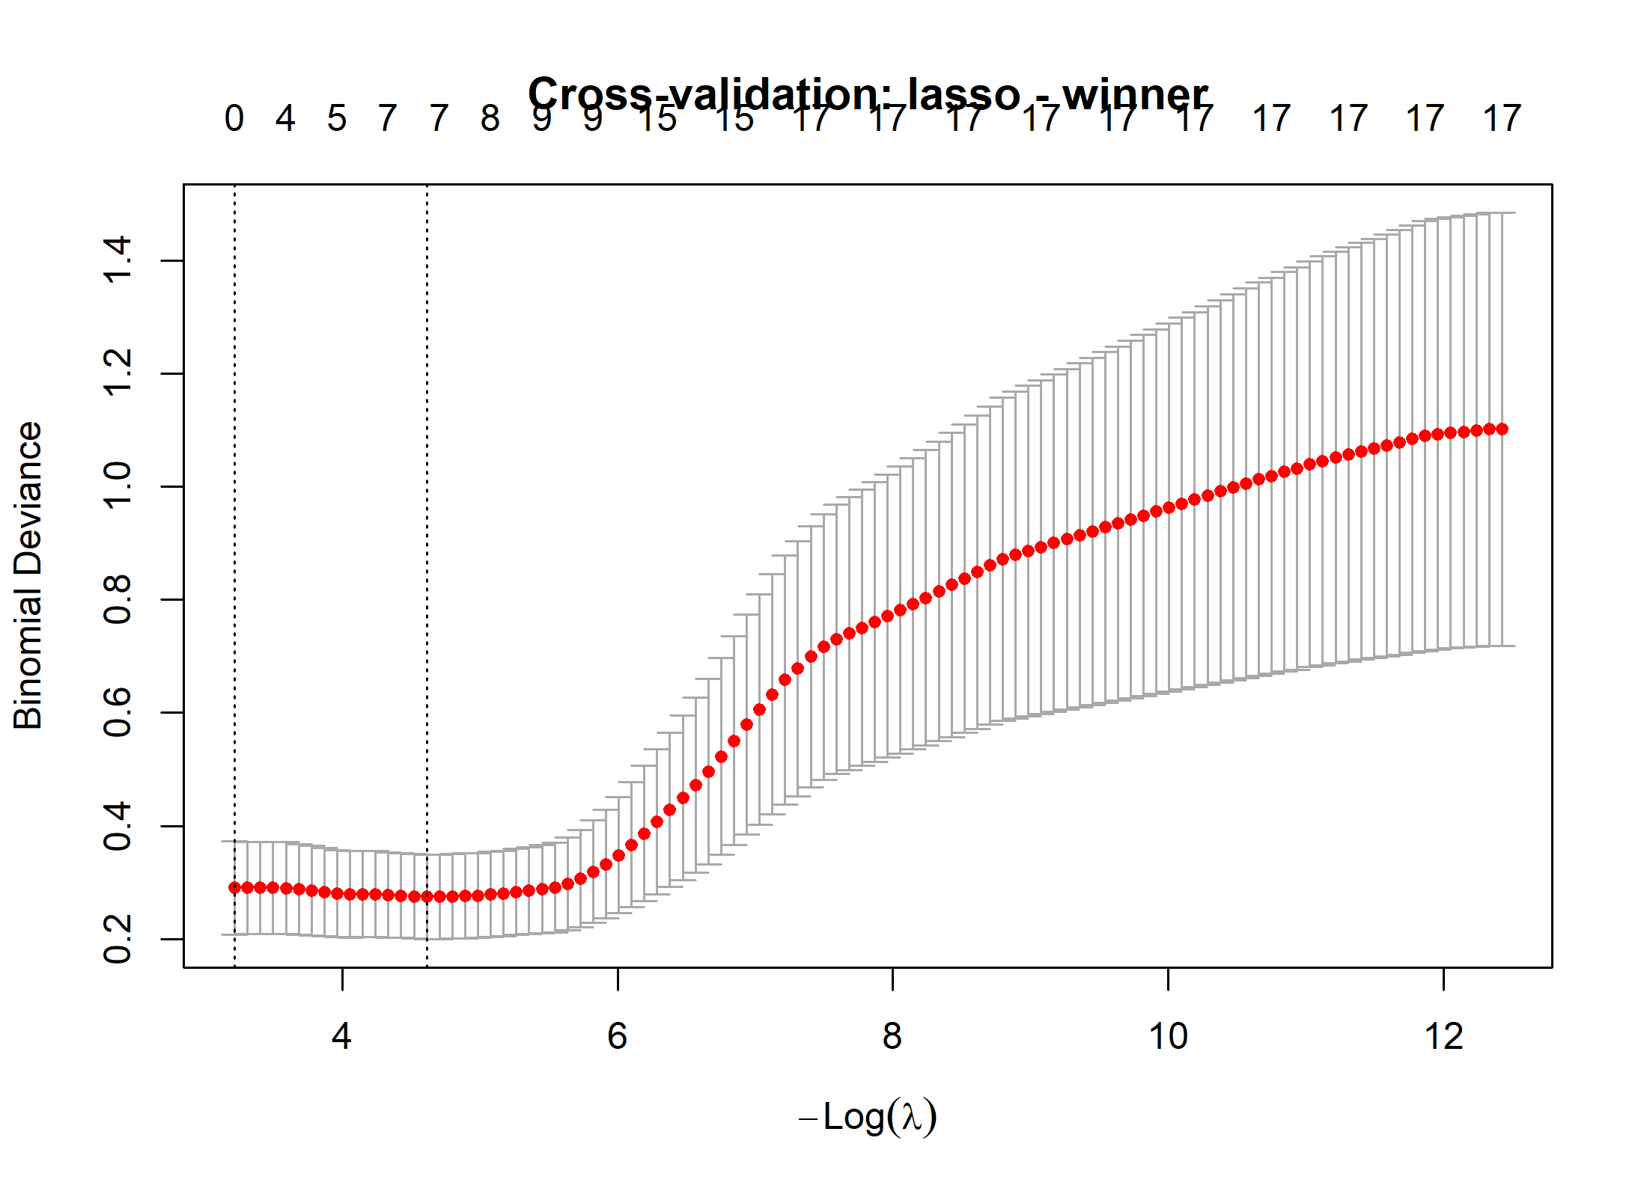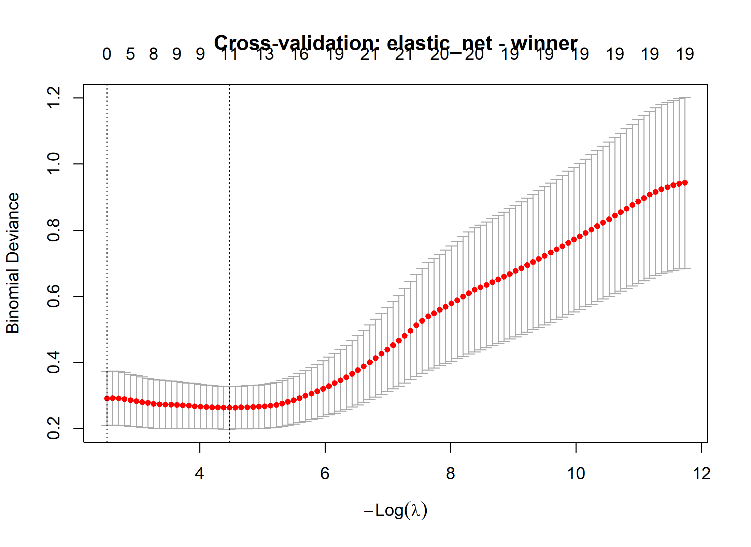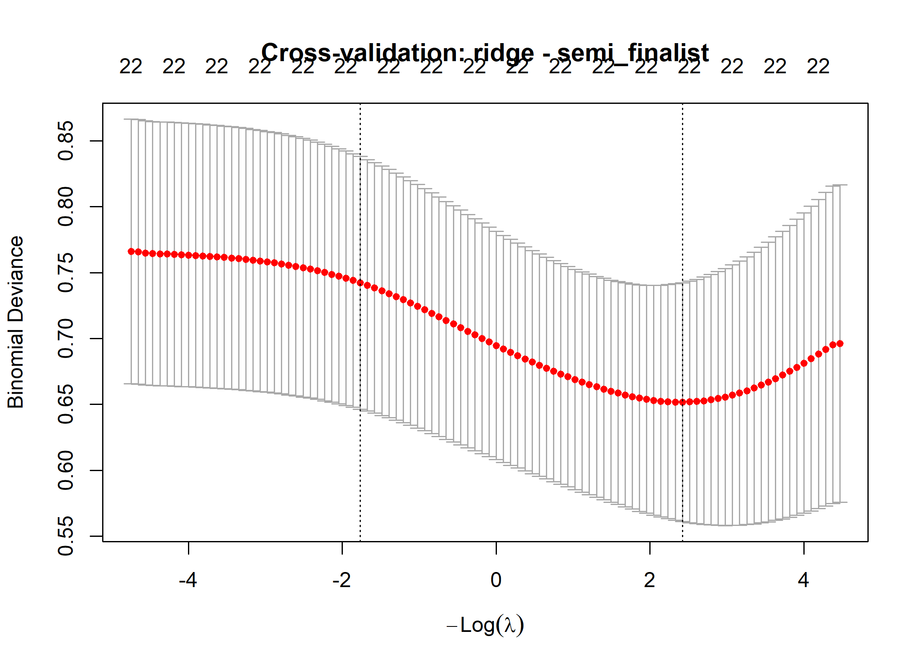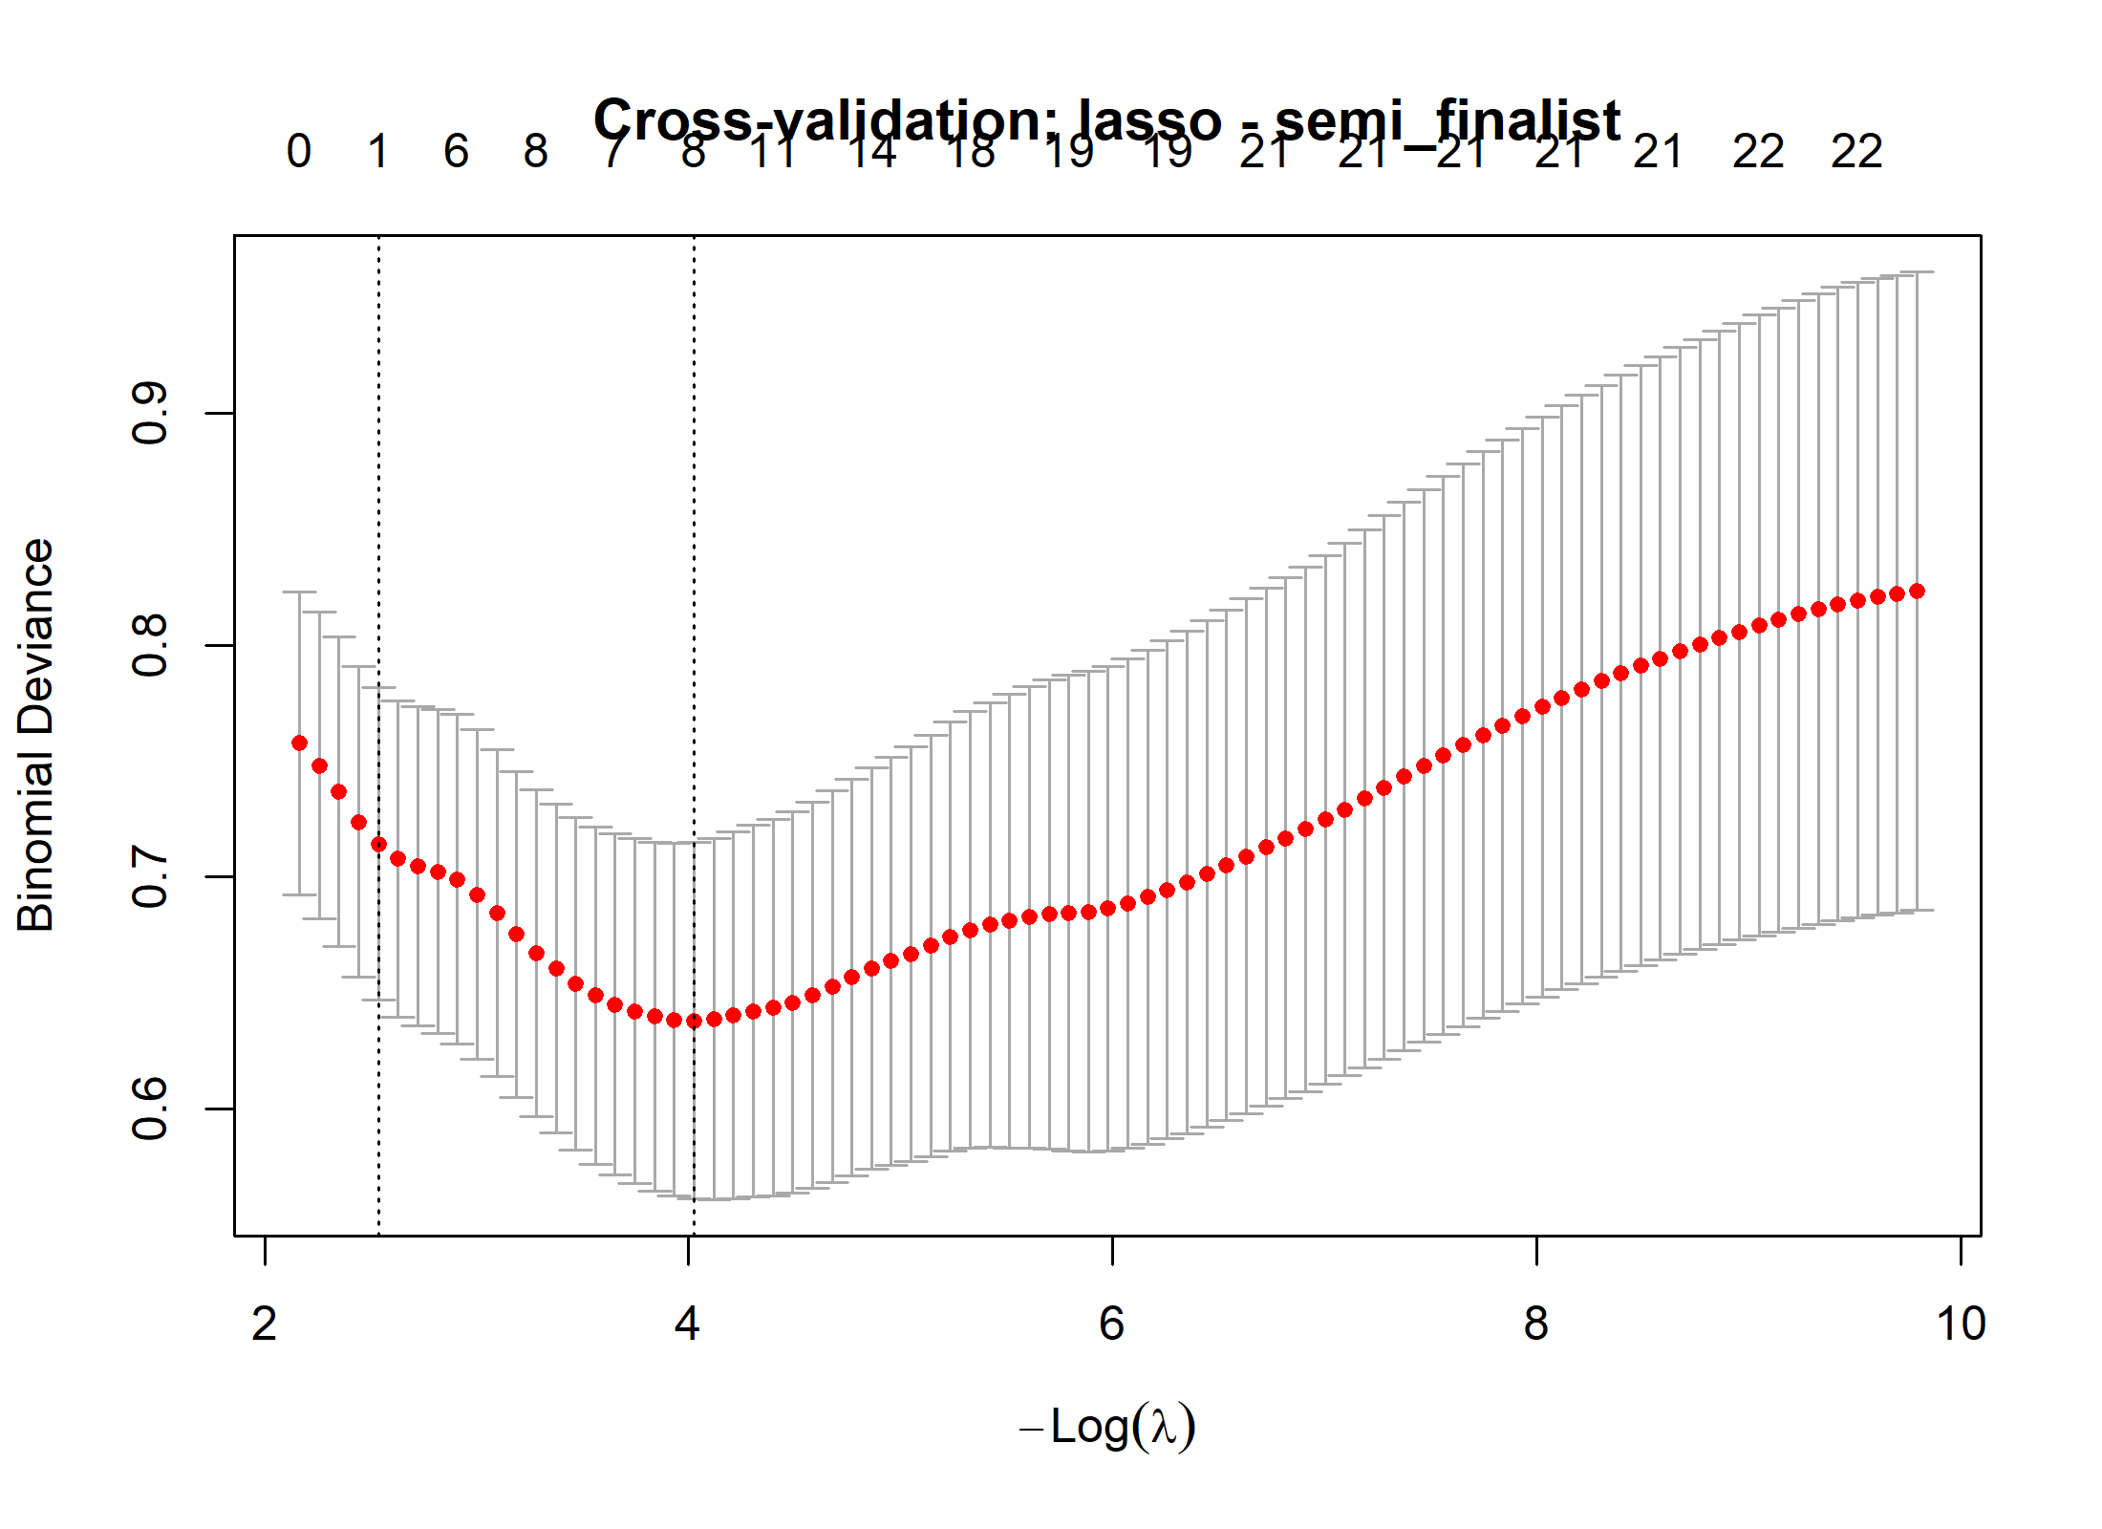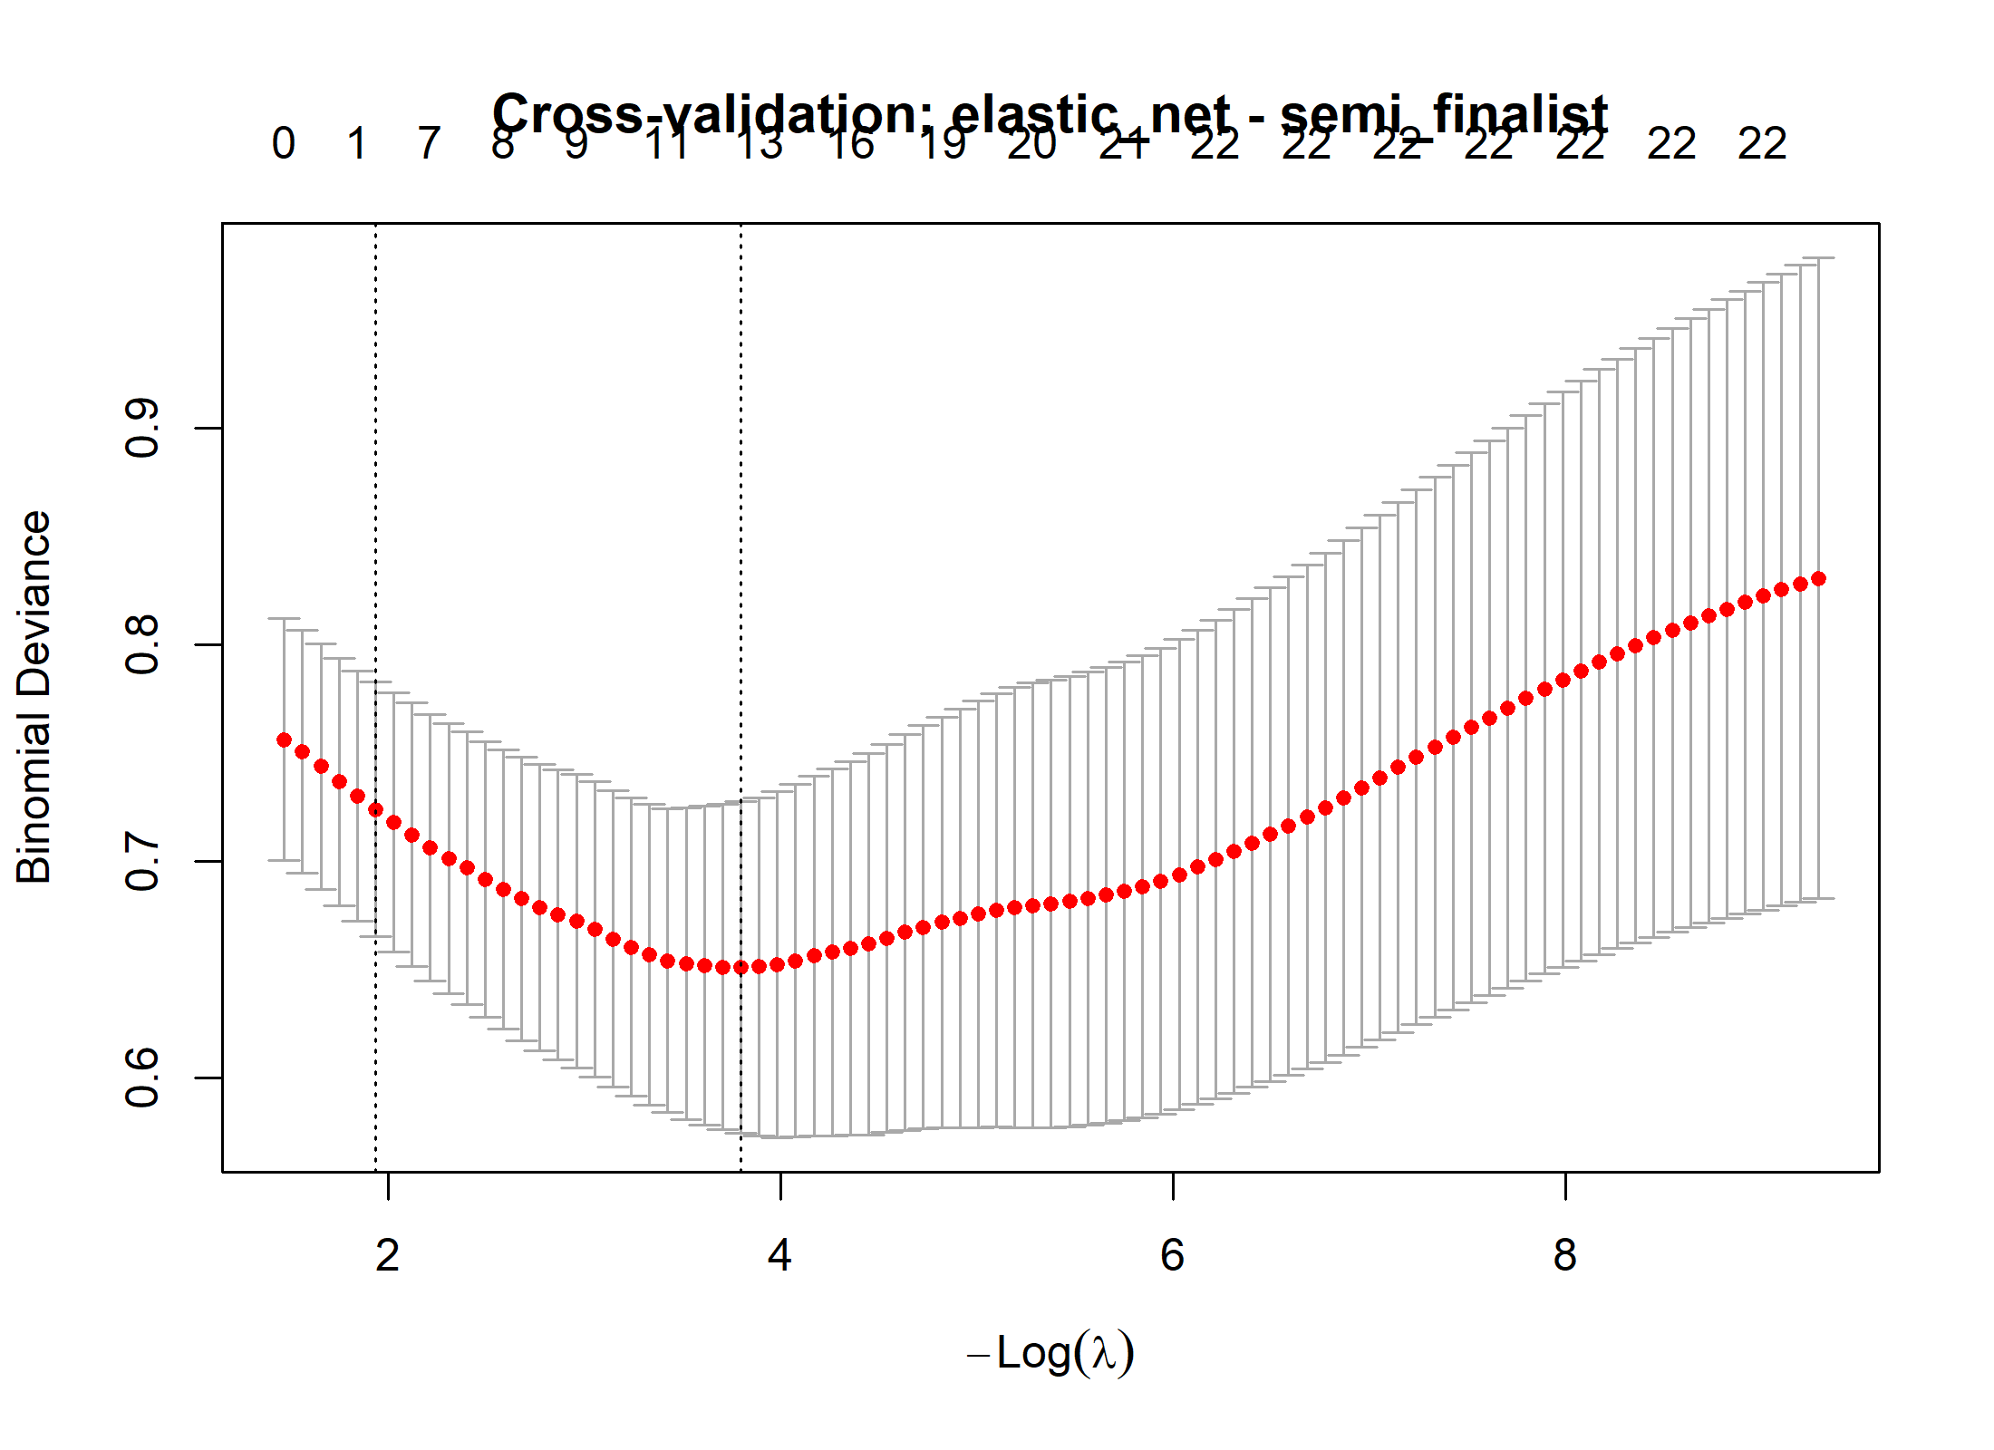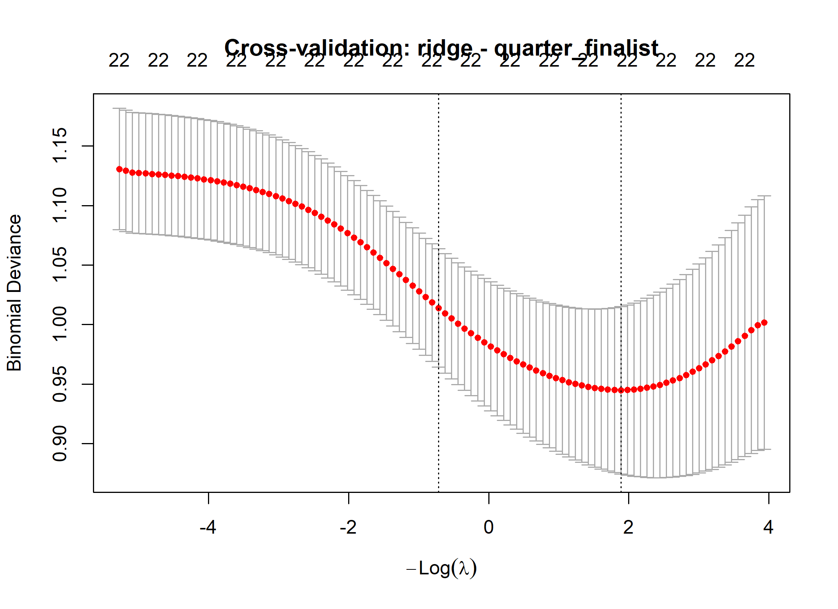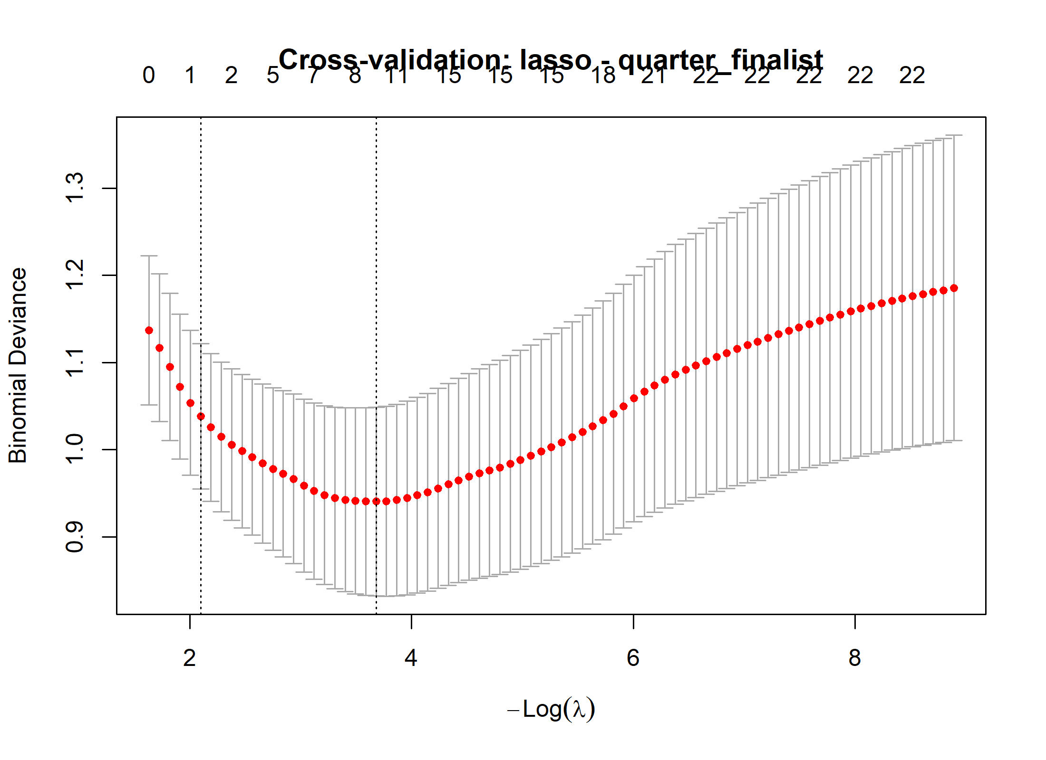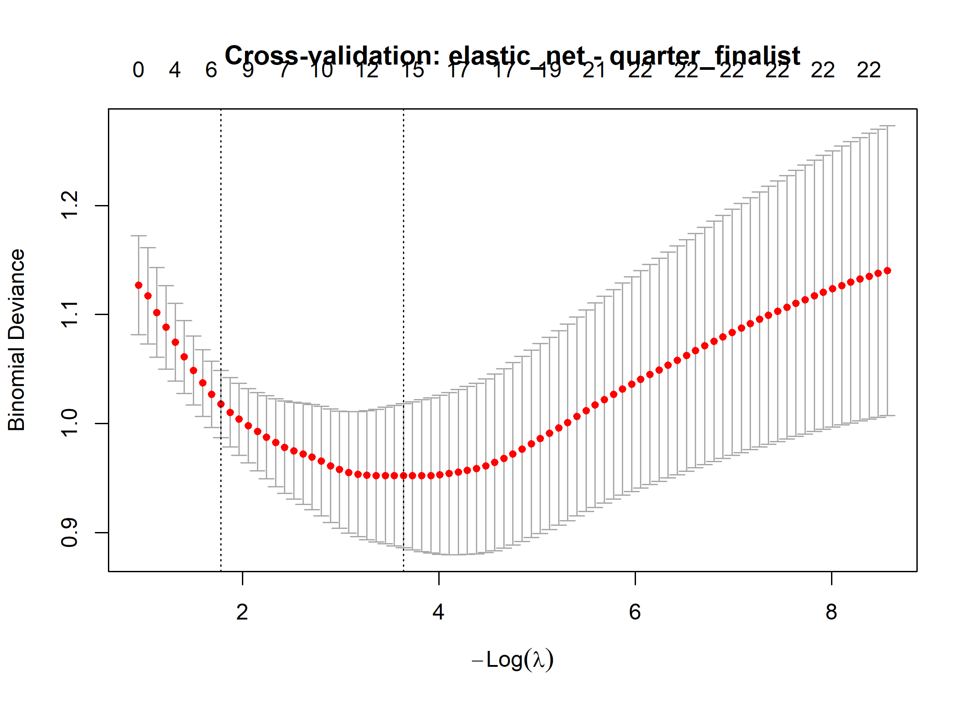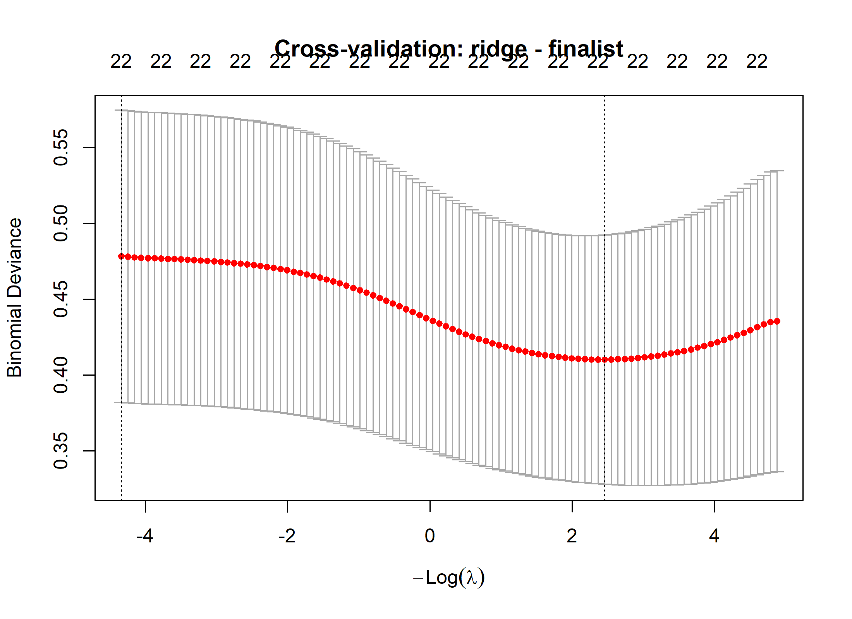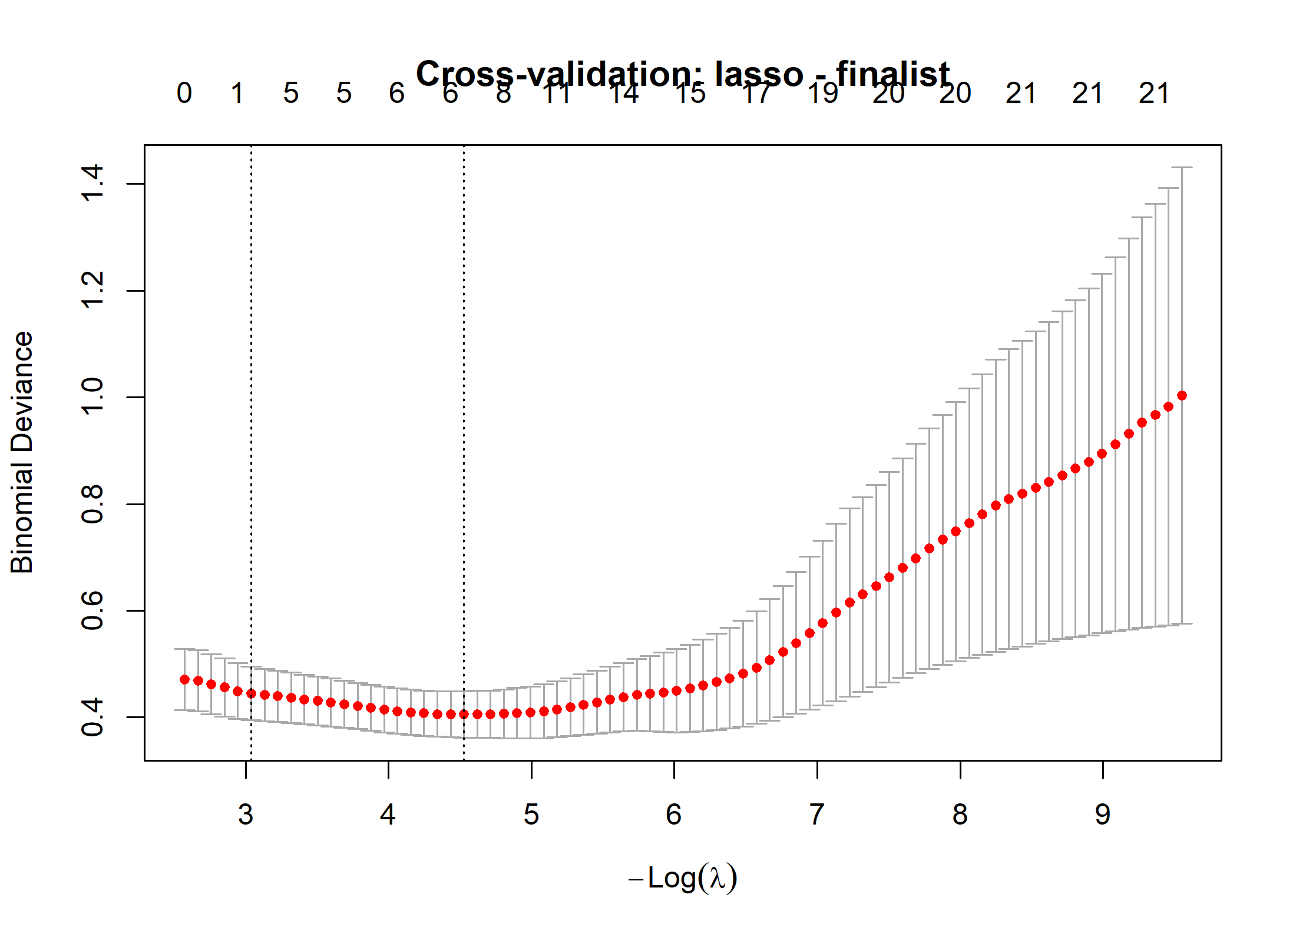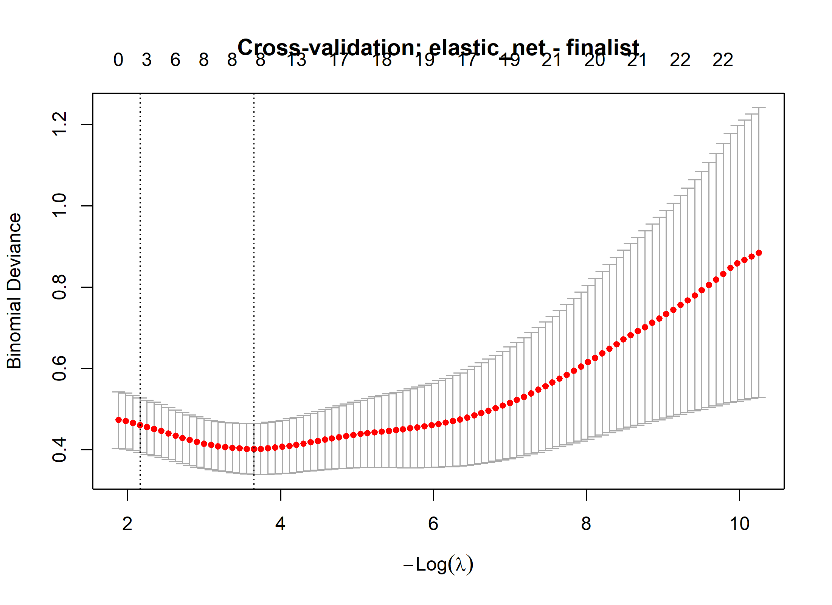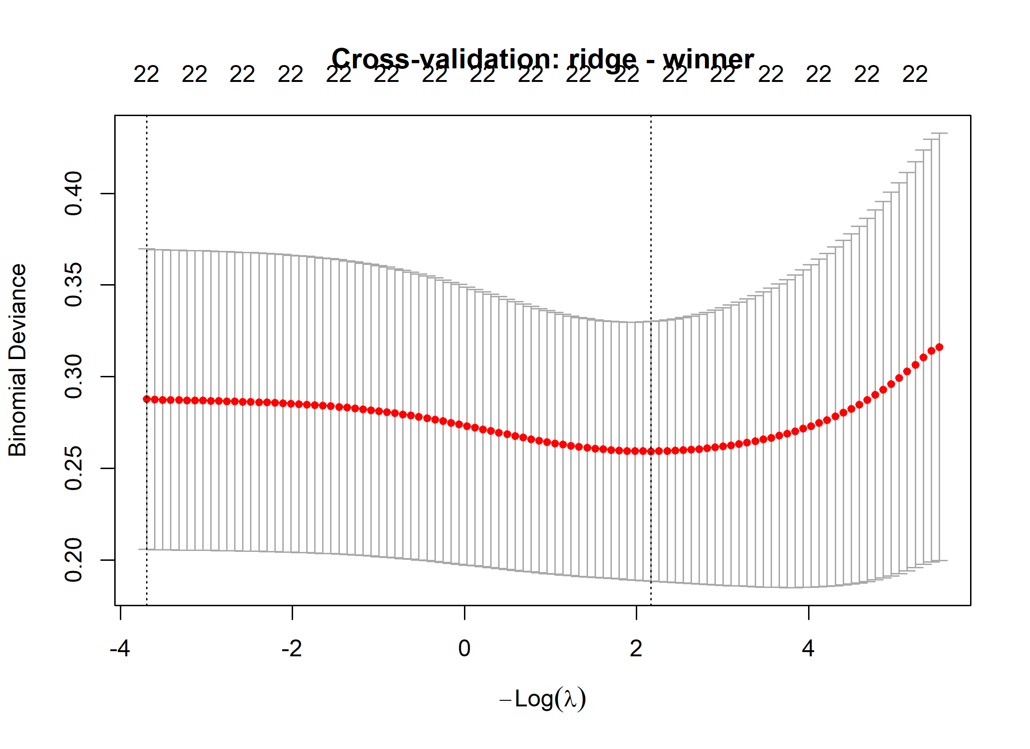

Supplementary Figure S2.
Calibration Curves for FIFA World Cup Tournament Progression Models
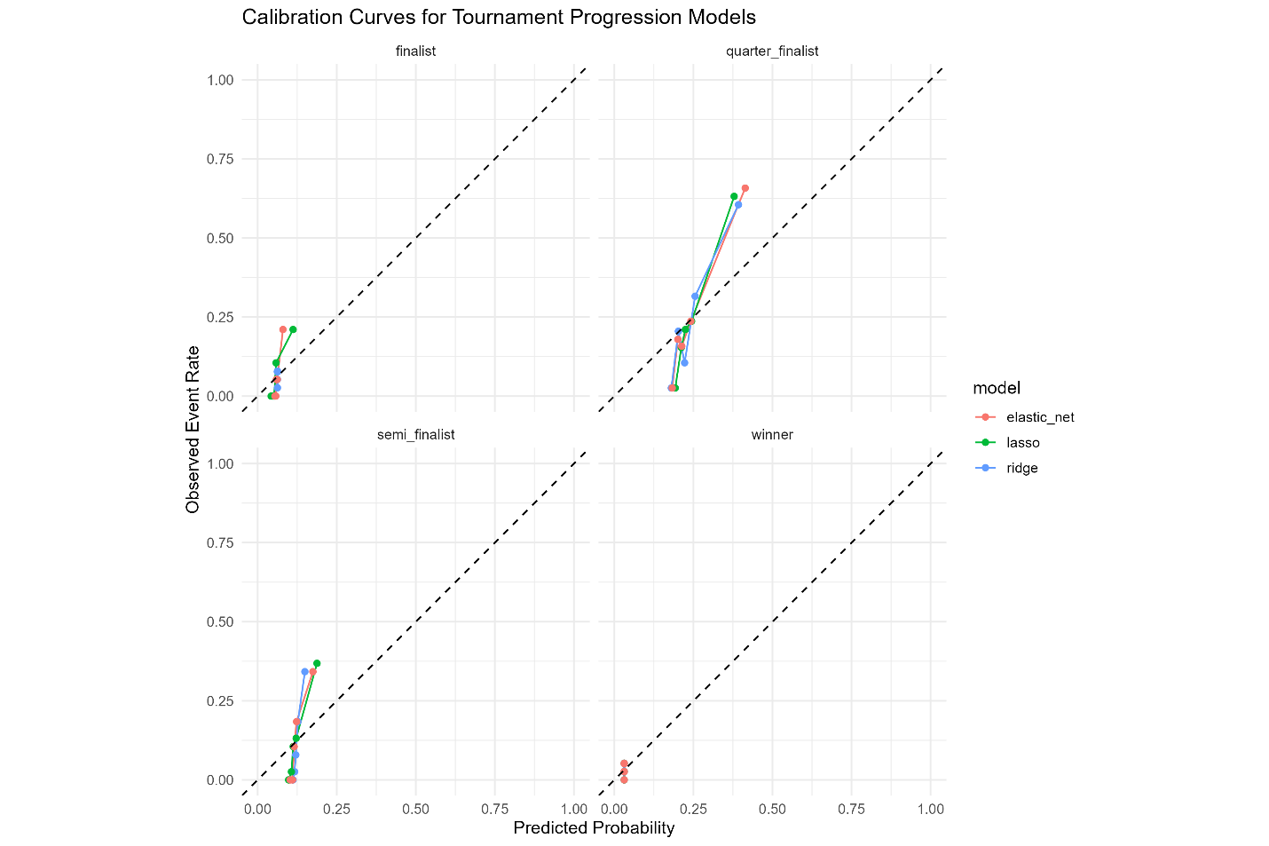
Supplementary Figure S2
Coefficient Paths for Lasso and Elastic Net Models
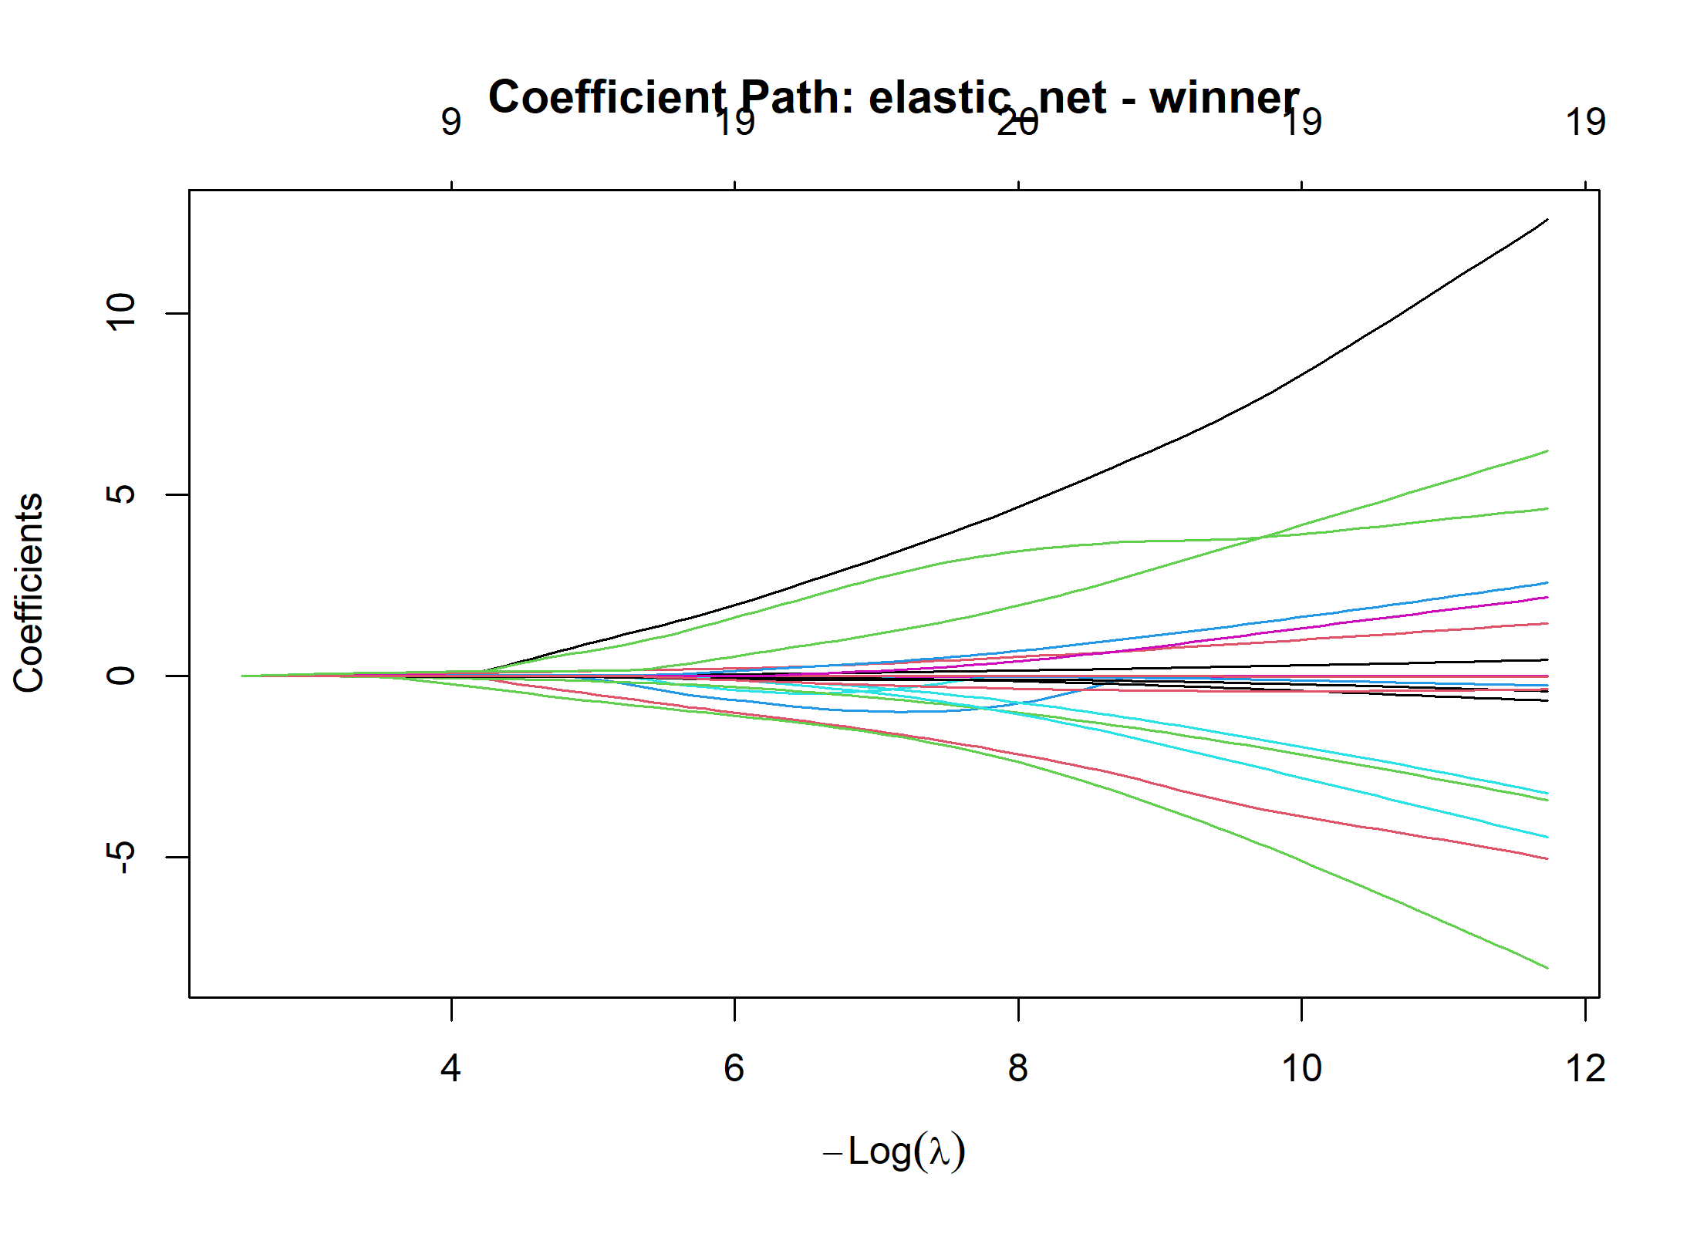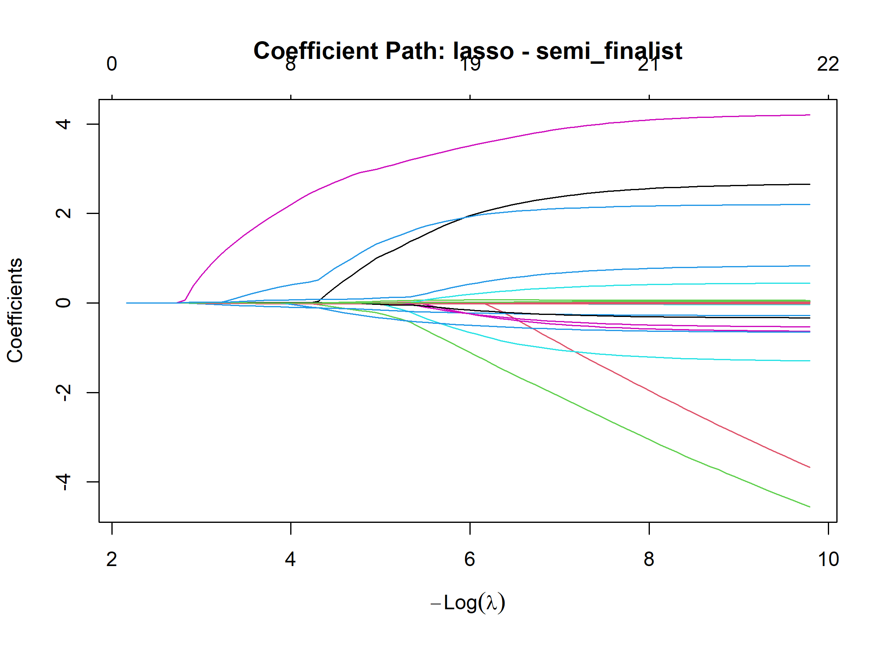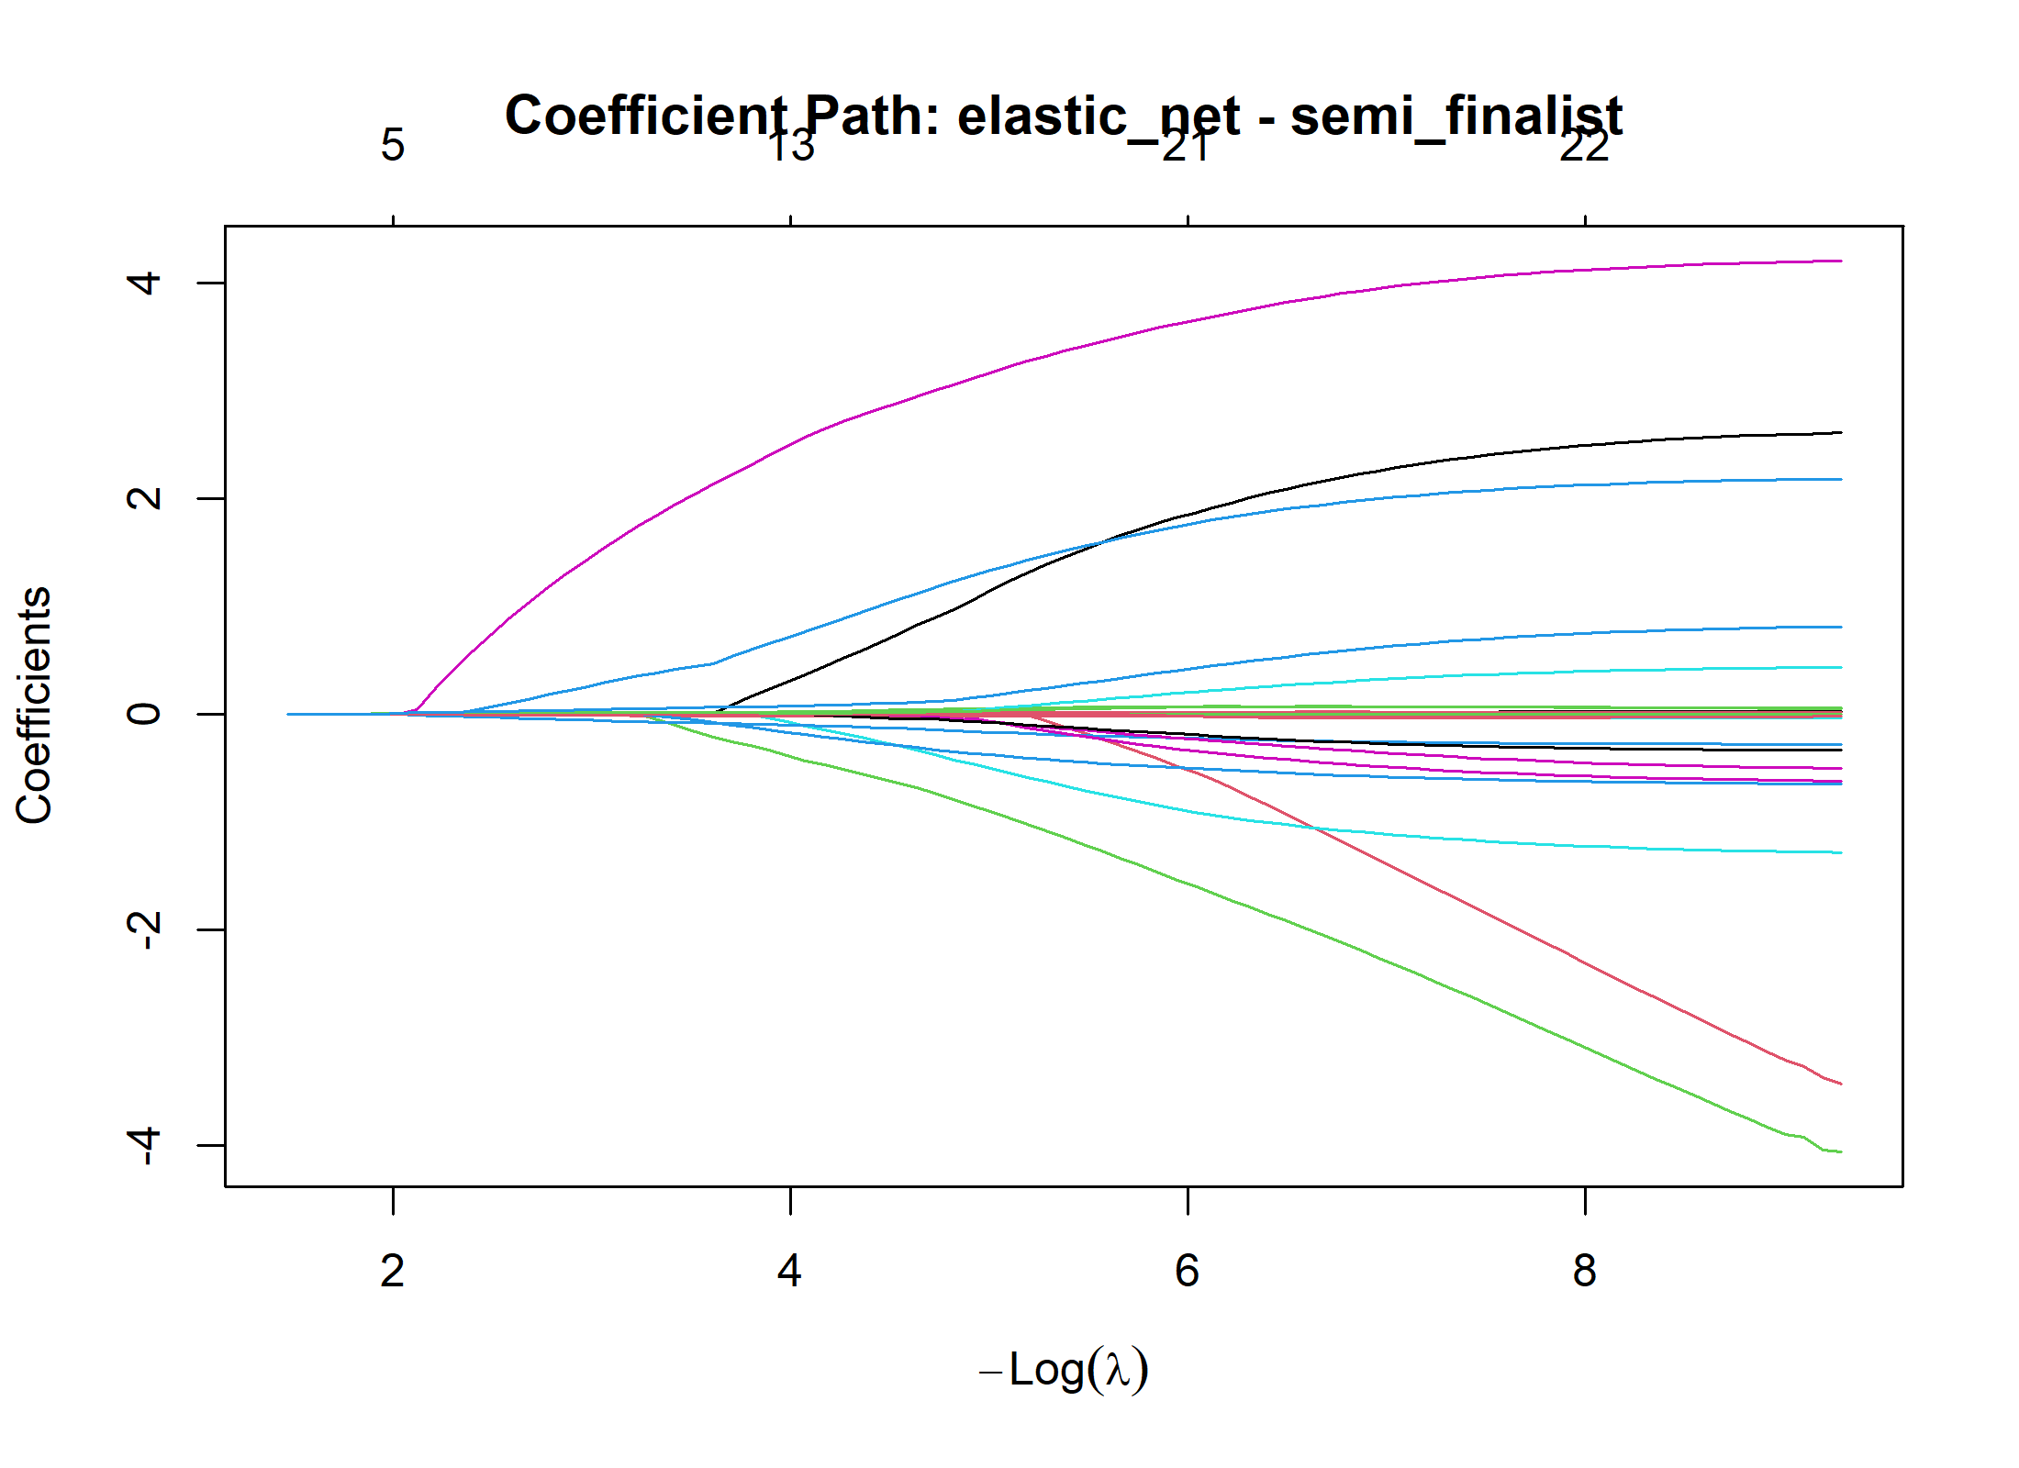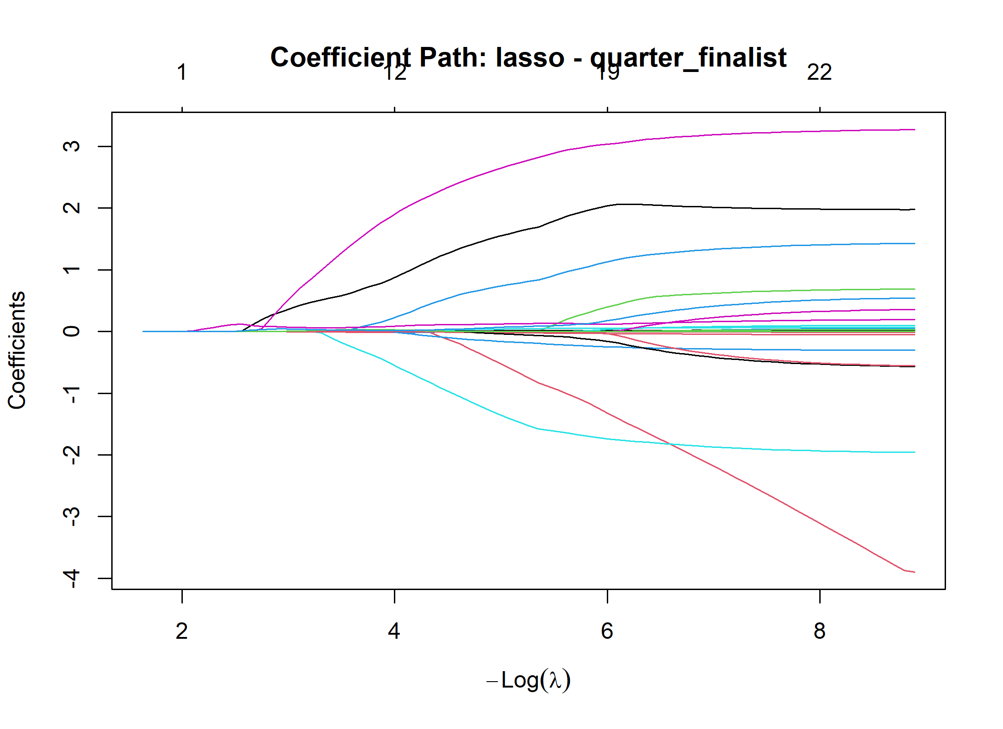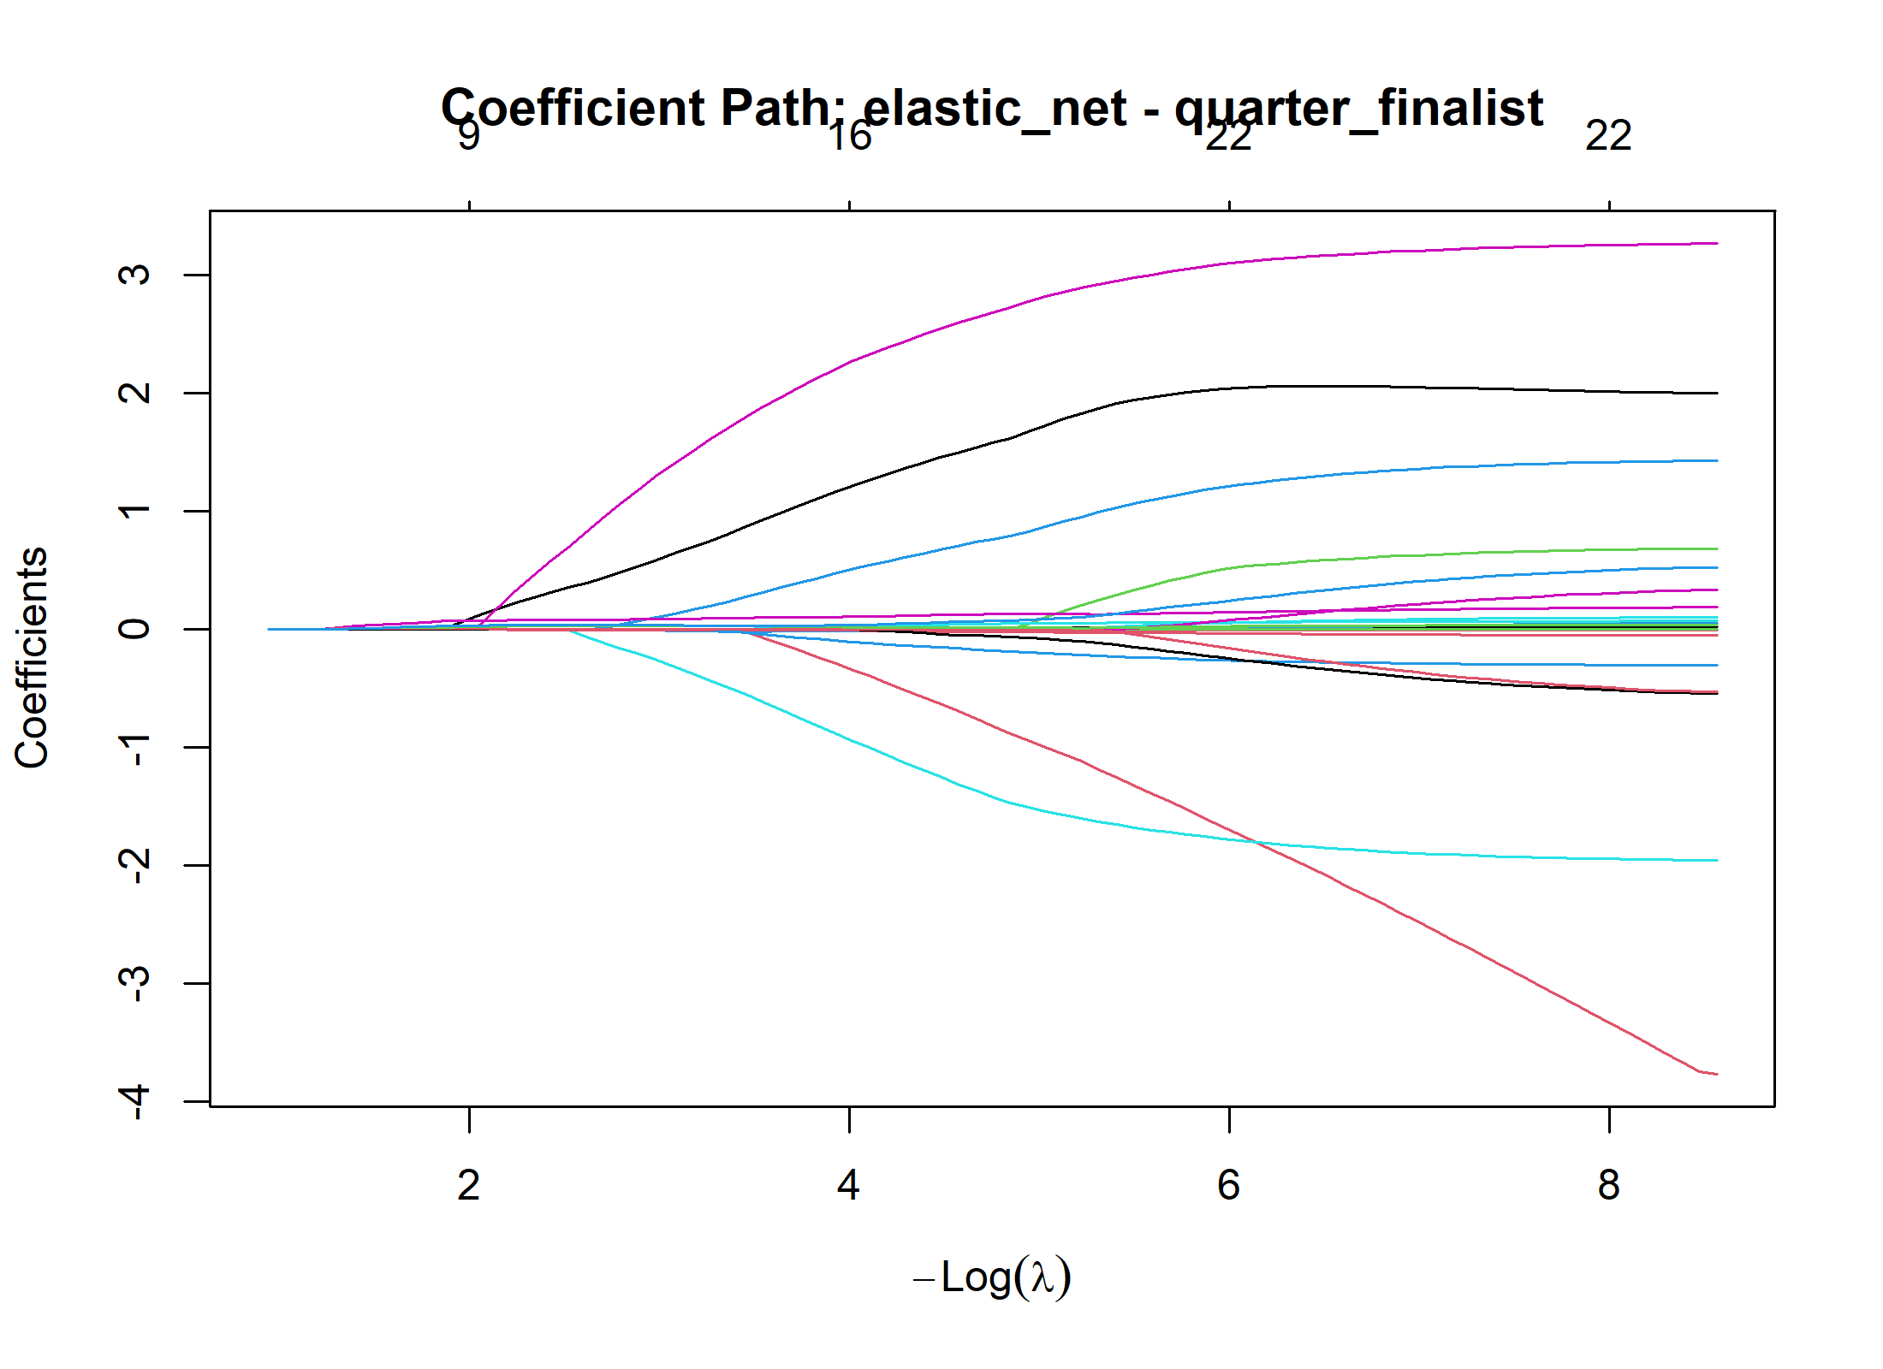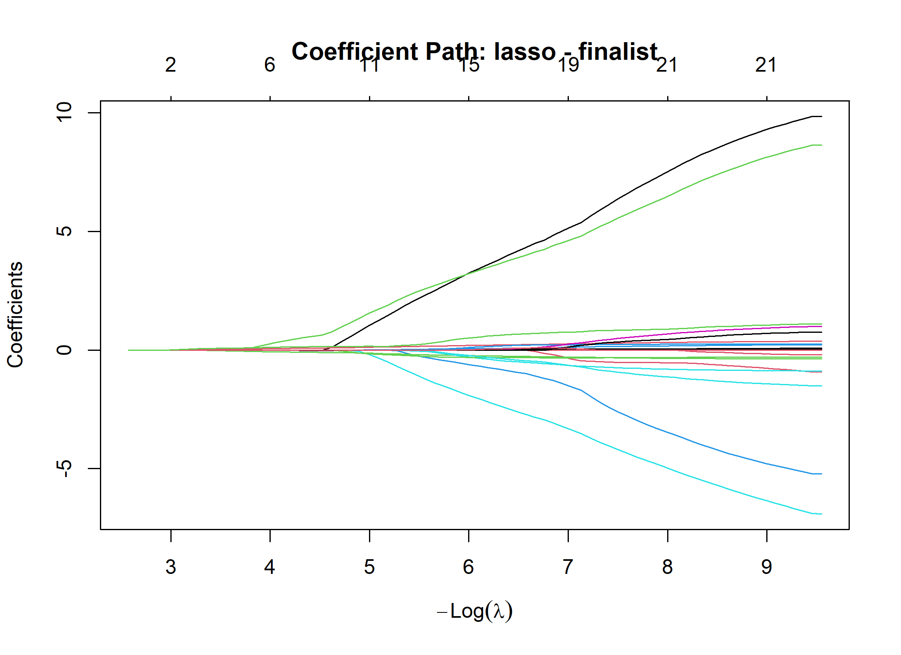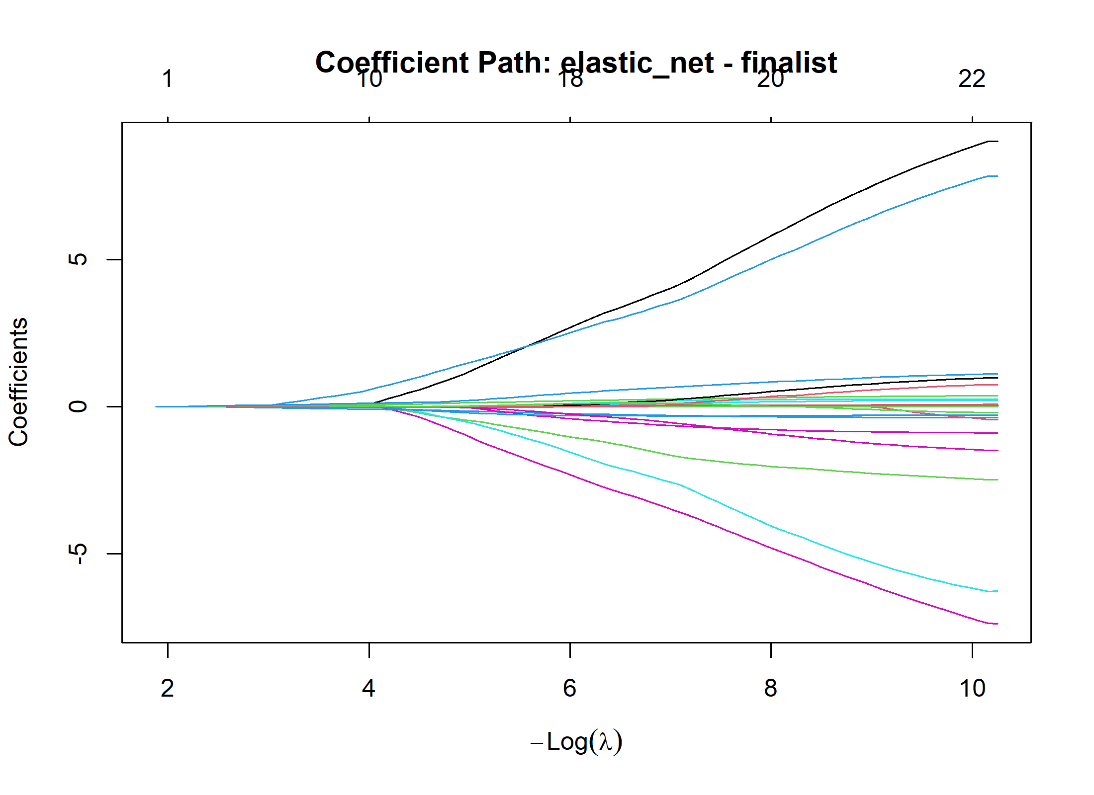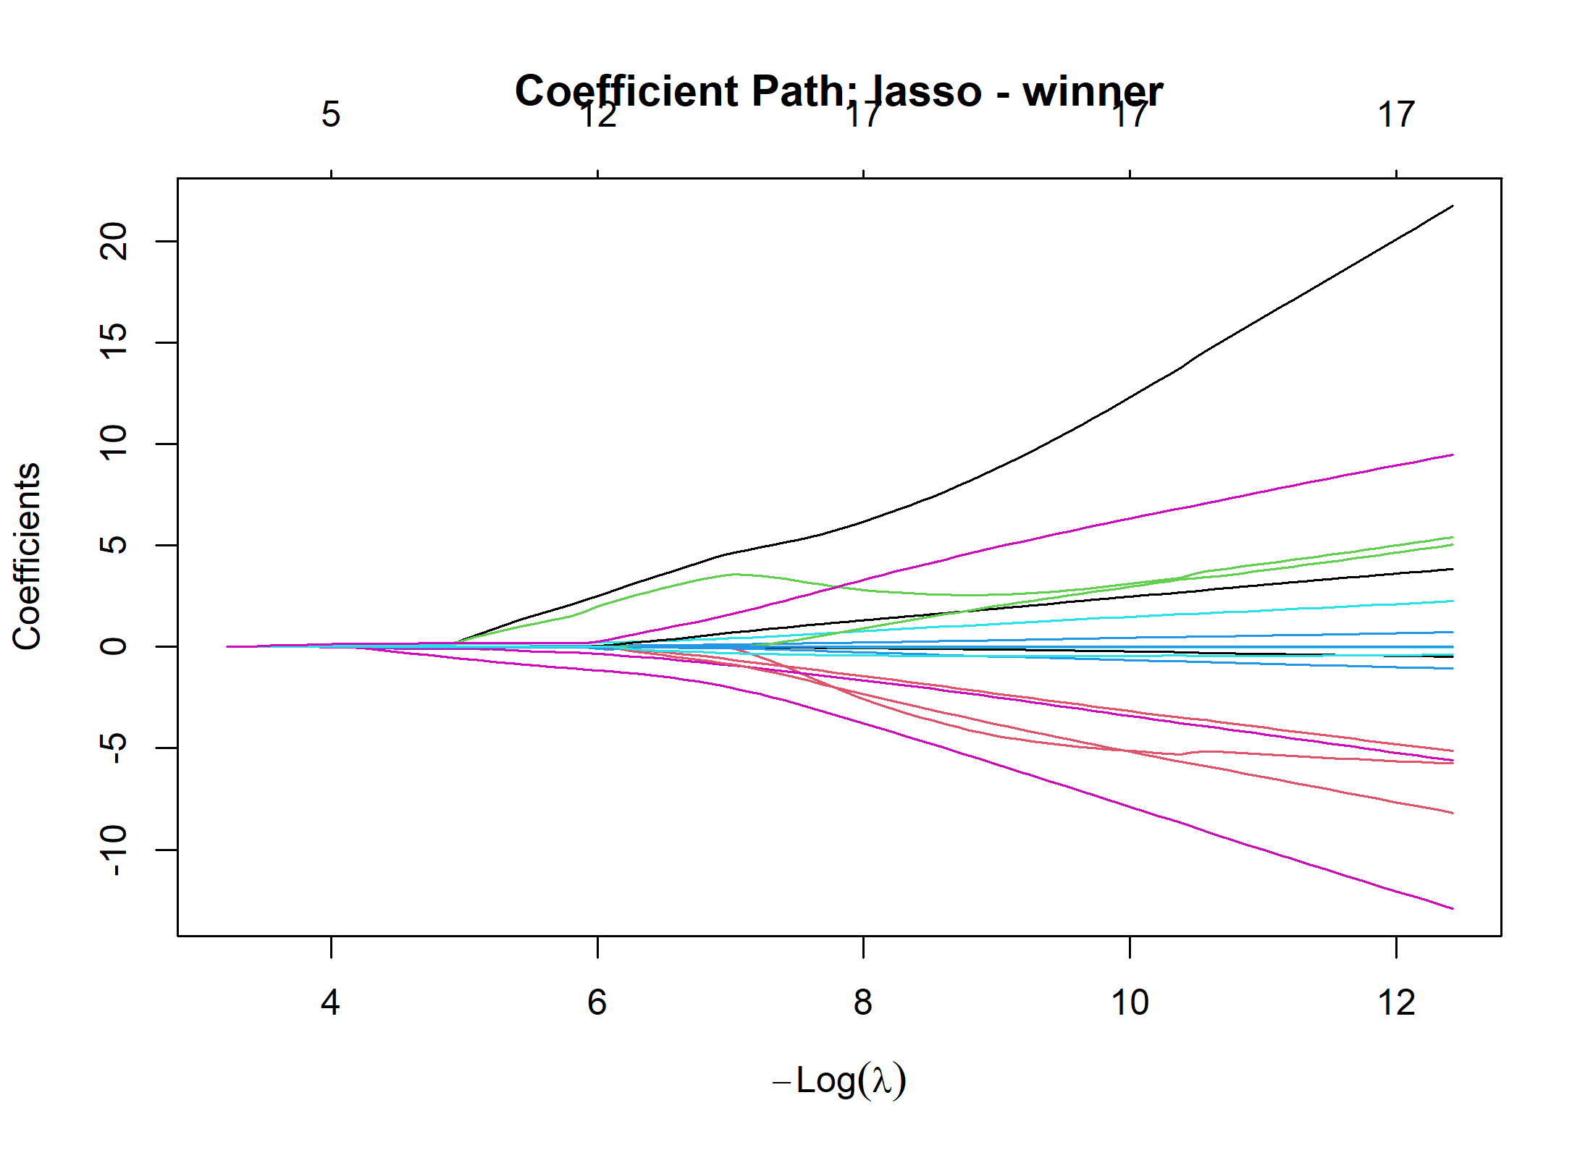

Supplementary Figure S3
Predicted Probabilities of FIFA World Cup 2026 Tournament Progression Using Elastic Net Regression
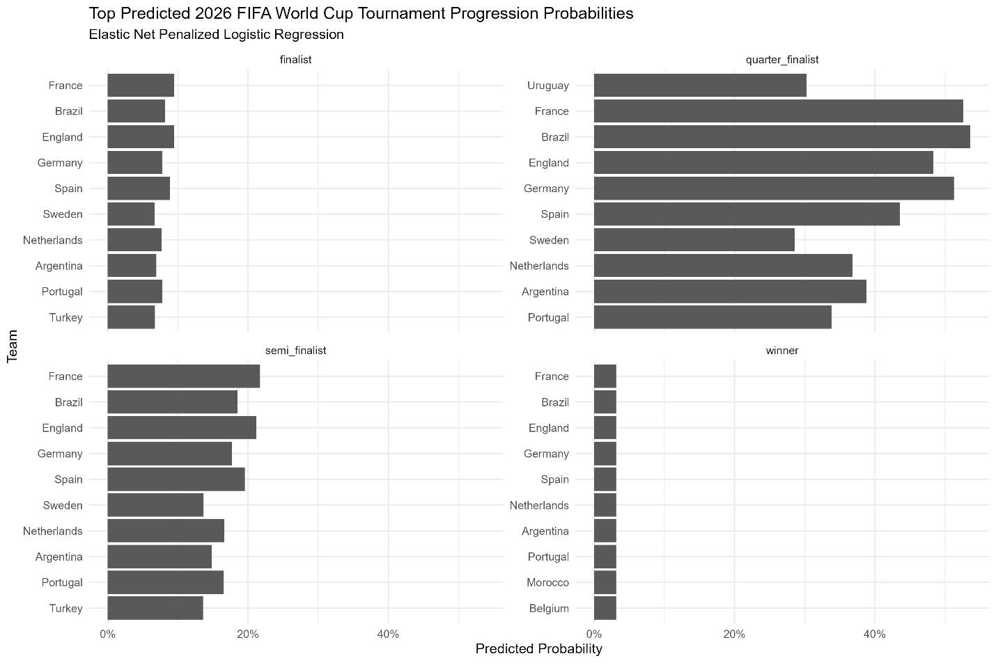

Supplementary Material
Figure S4. Forest Plot of Baseline Logistic Regression Odds Ratios
