Supplementary Figure 1 - Associations of environmental exposures with PD (Argentina)
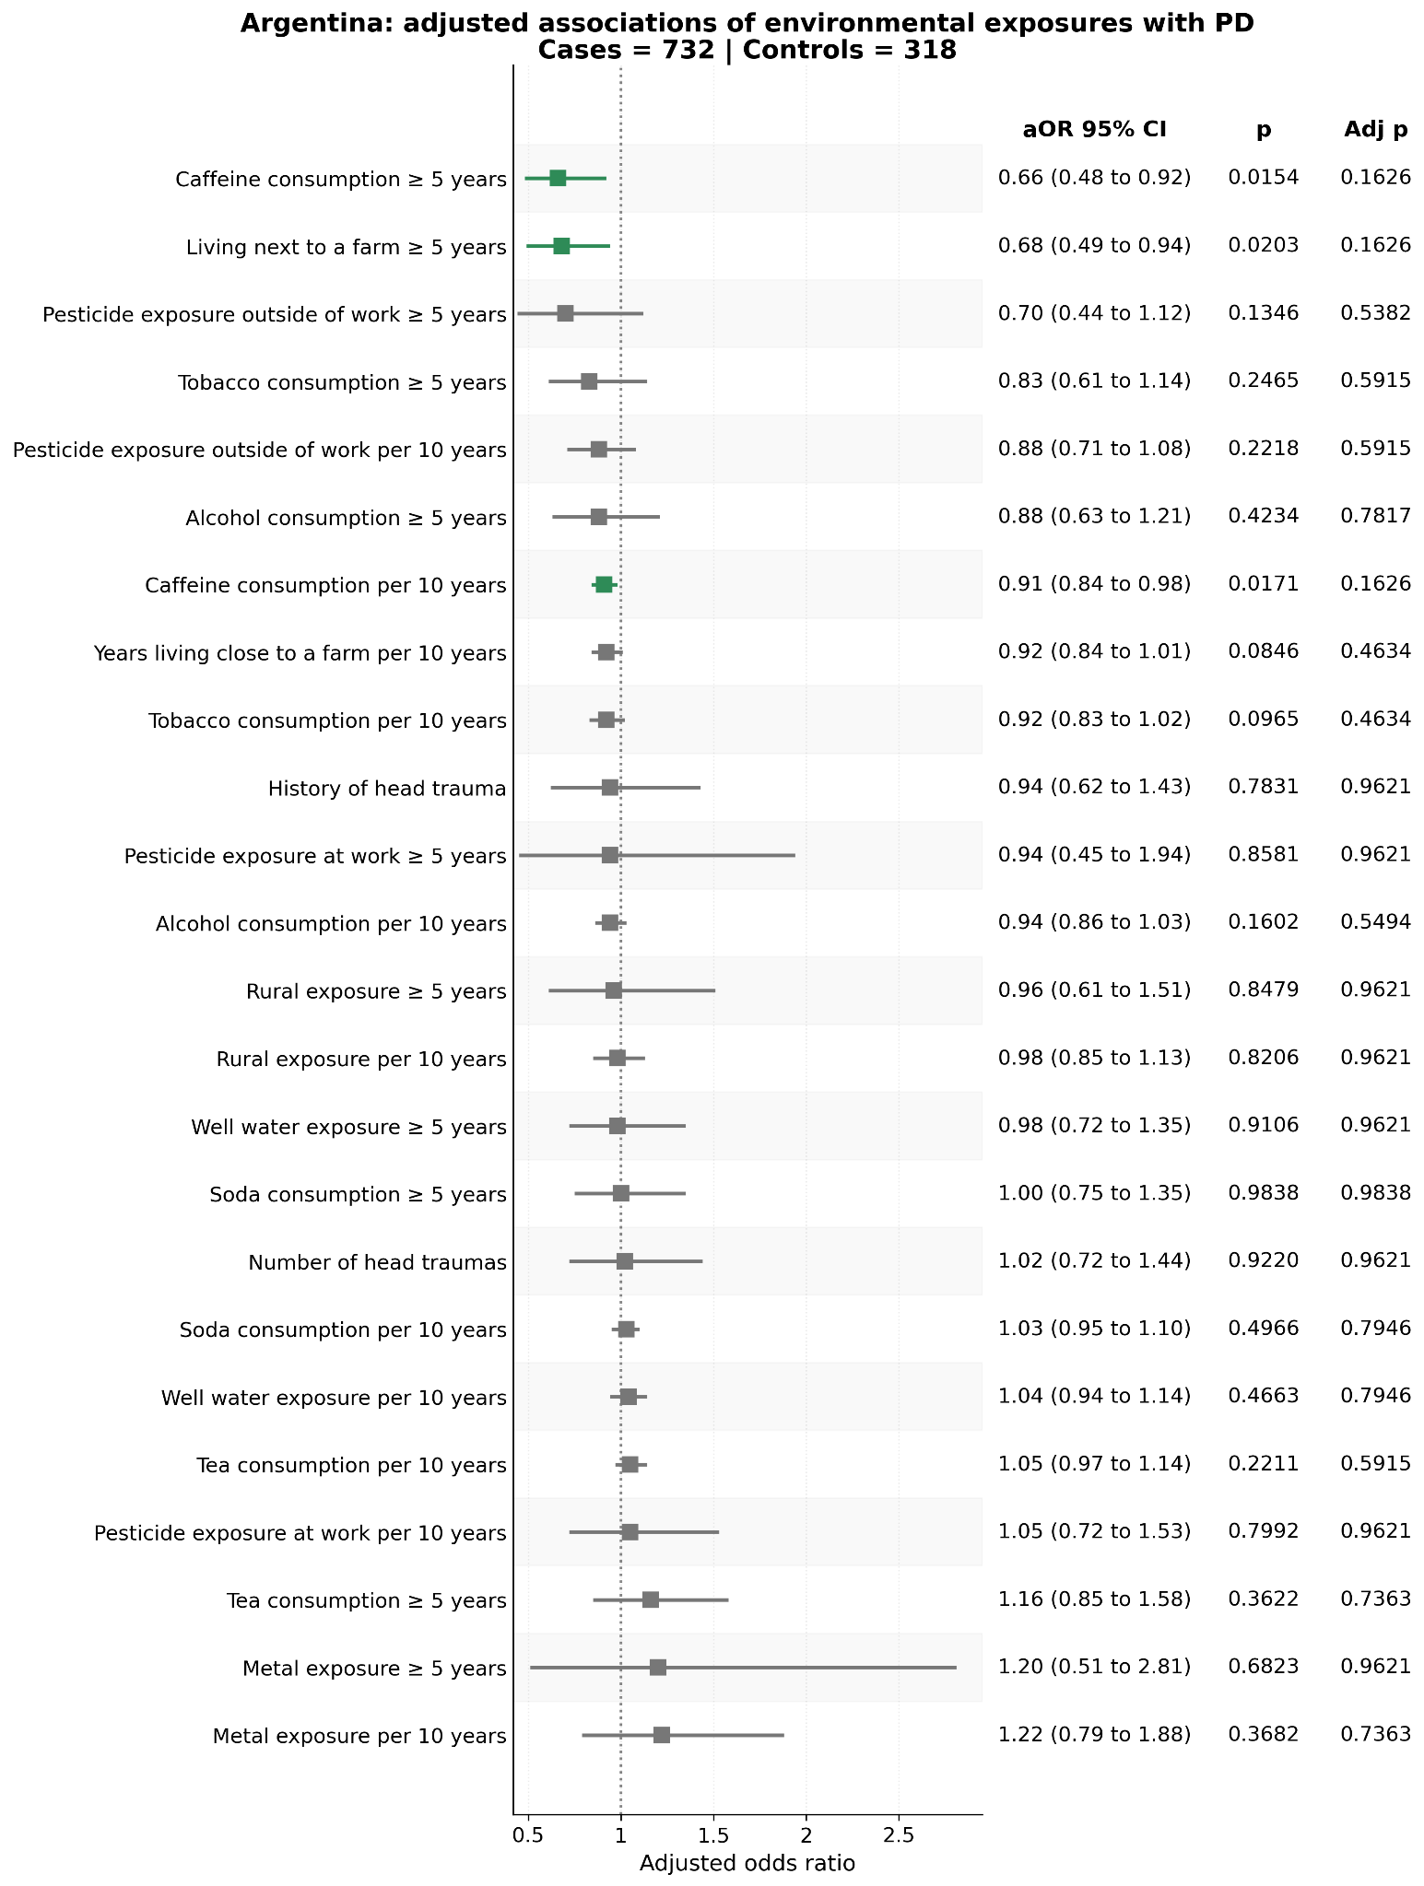

Supplementary Figure 2 - Associations of environmental exposures with PD (Brazil)
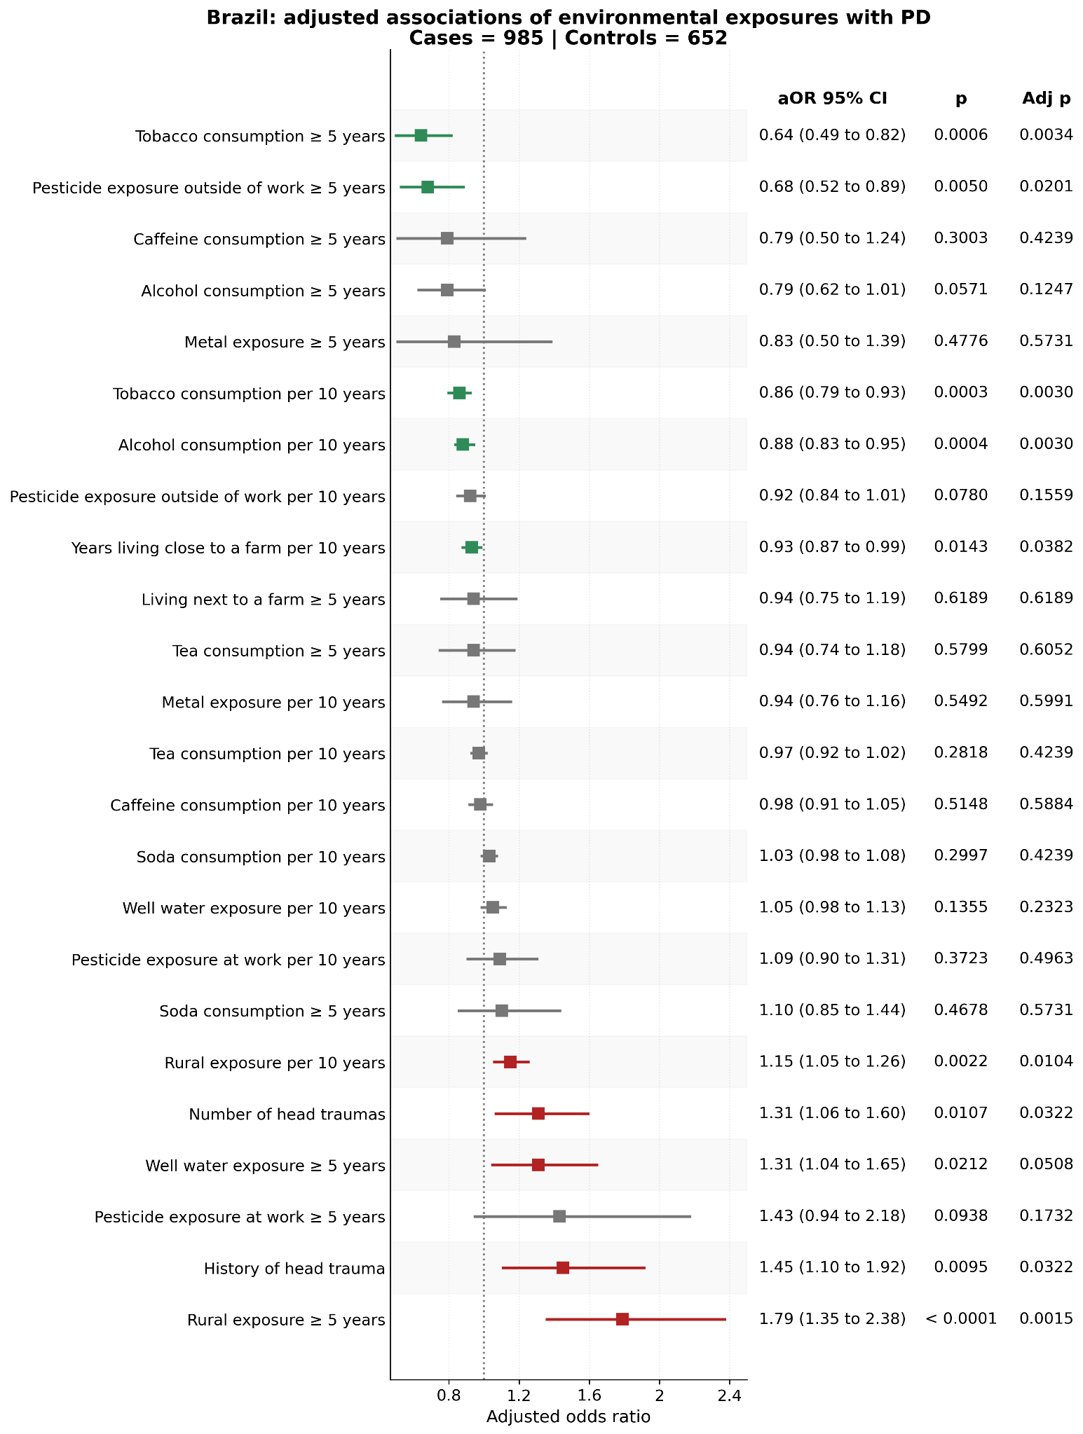

Supplementary Figure 3 - Associations of environmental exposures with PD (Chile)
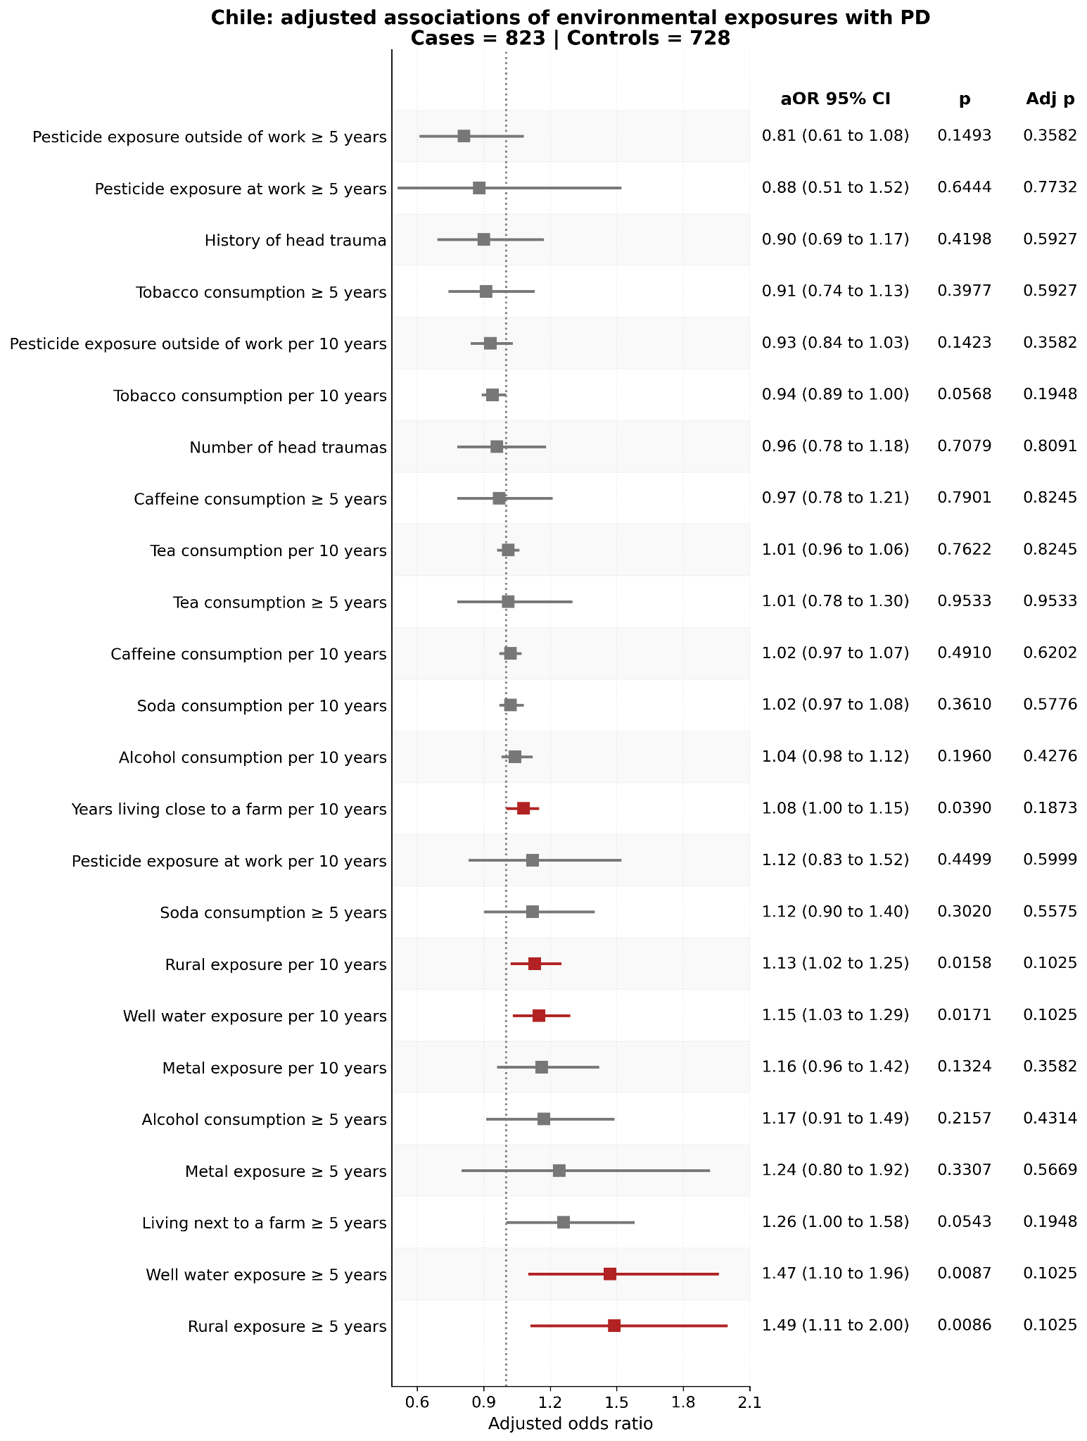

Supplementary Figure 4 - Associations of environmental exposures with PD (Colombia)
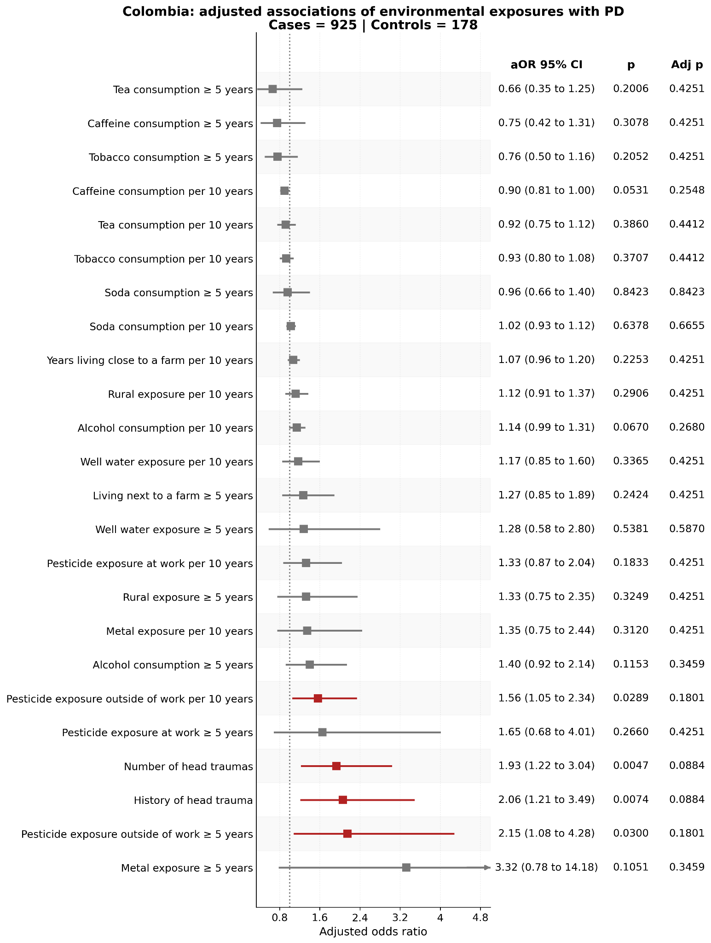

Supplementary Figure 5 - Associations of environmental exposures with PD (El Salvador)
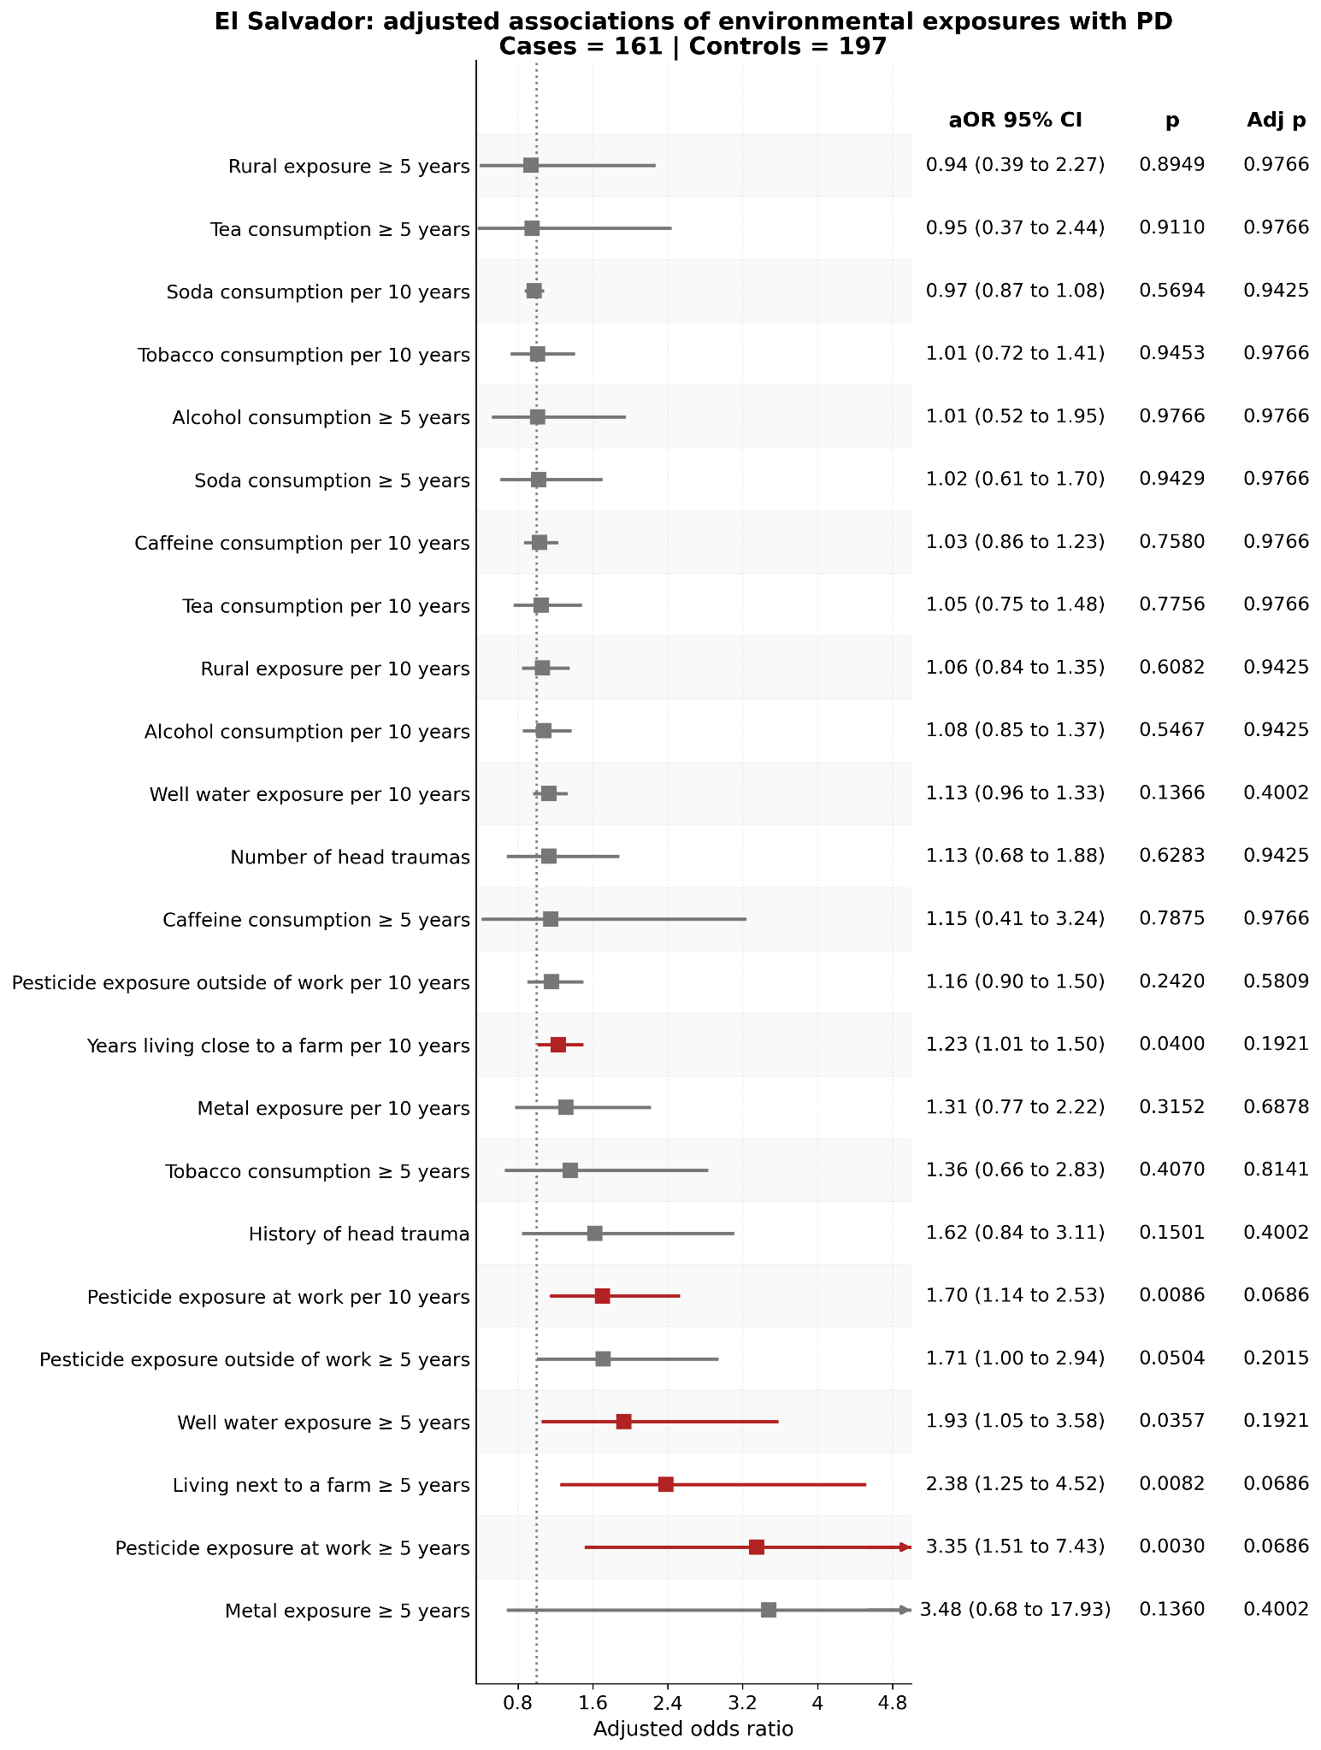

Supplementary Figure 6 - Associations of environmental exposures with PD (Honduras)
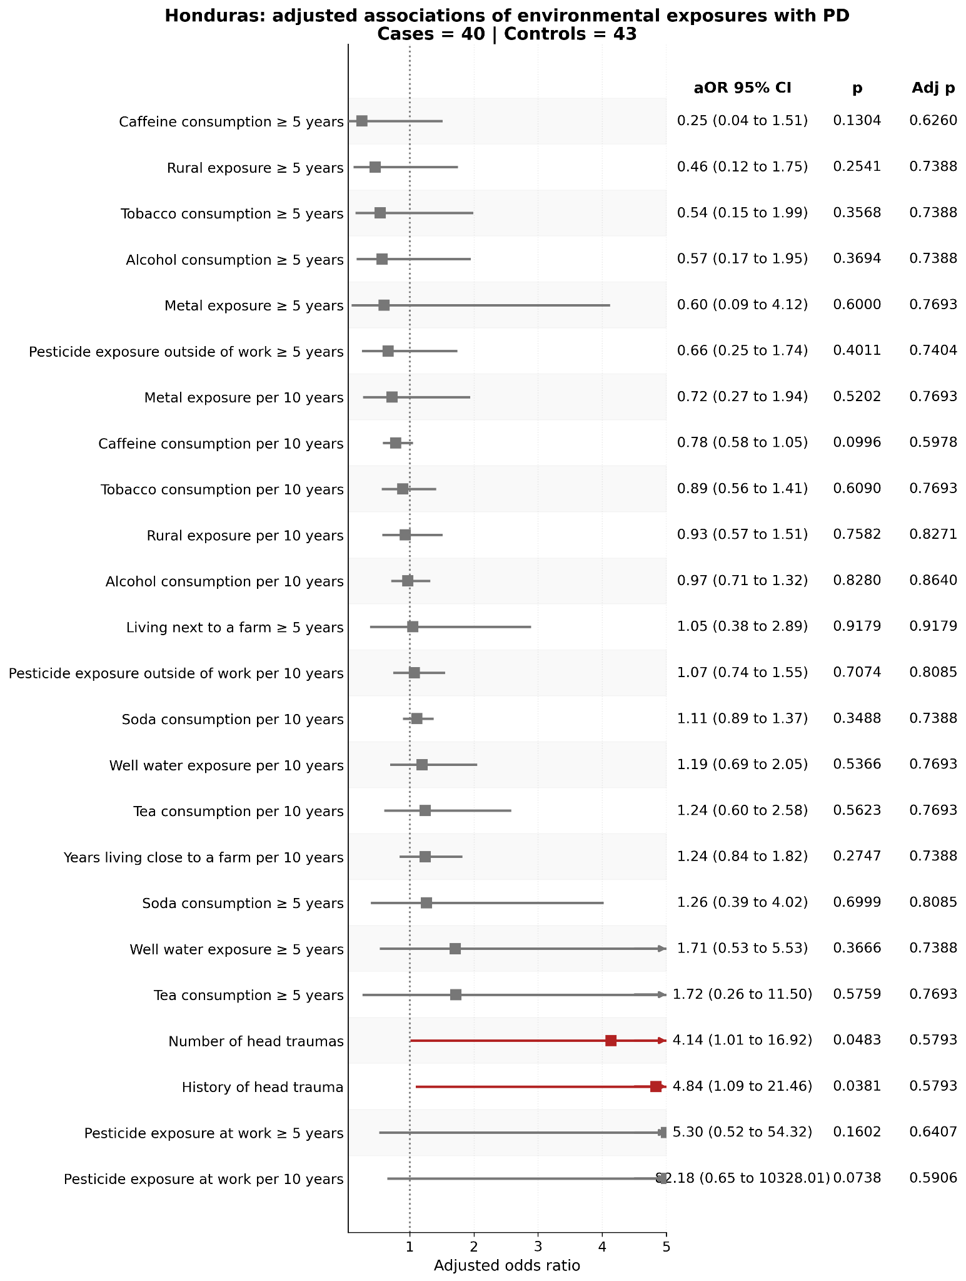

Supplementary Figure 7 - Associations of environmental exposures with PD (Mexico)
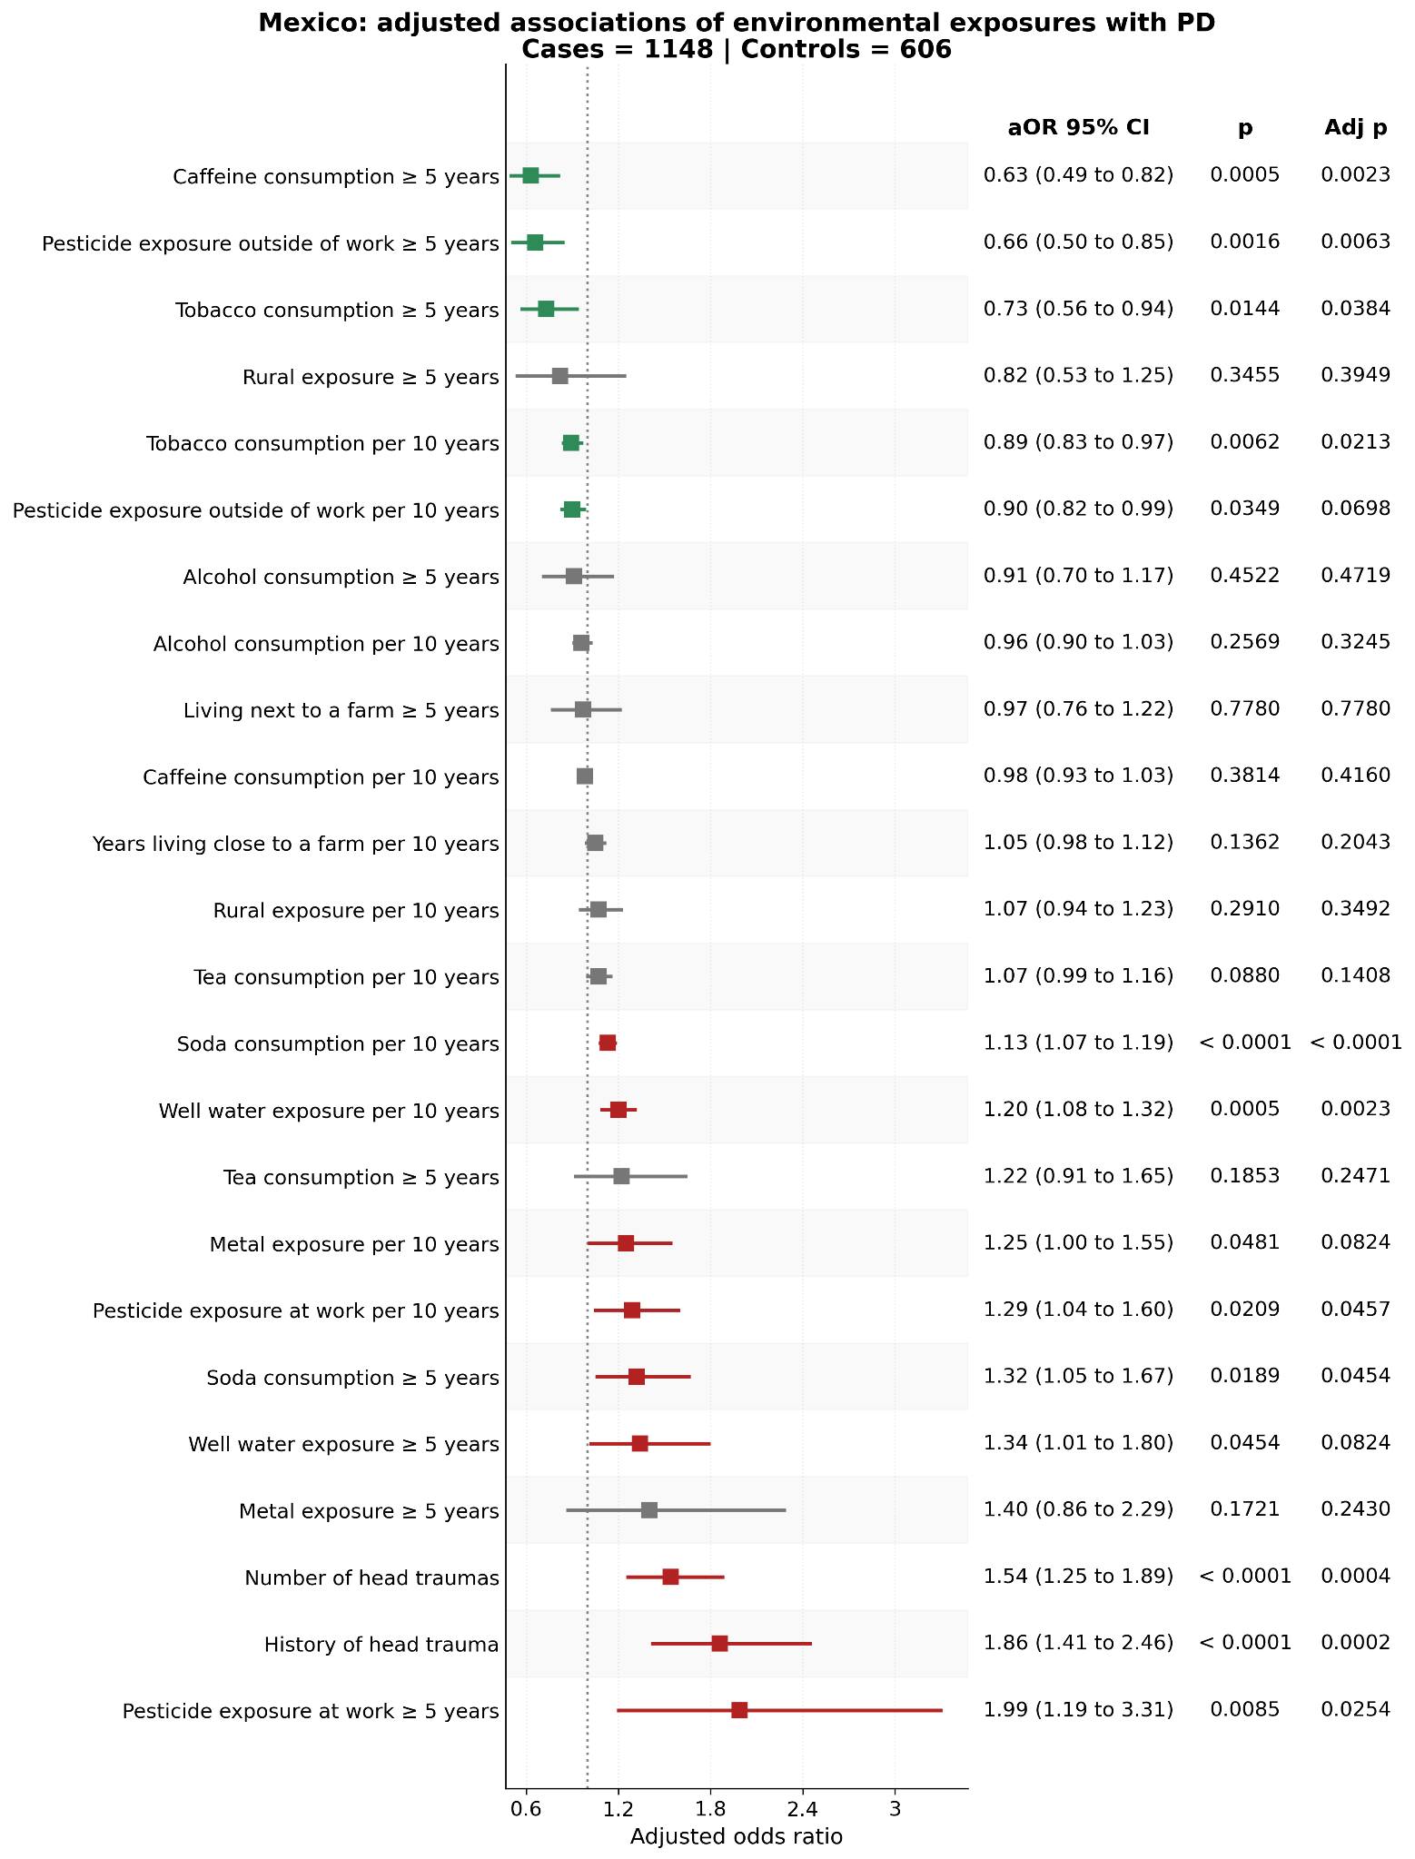

Supplementary Figure 8 - Associations of environmental exposures with PD (Peru)
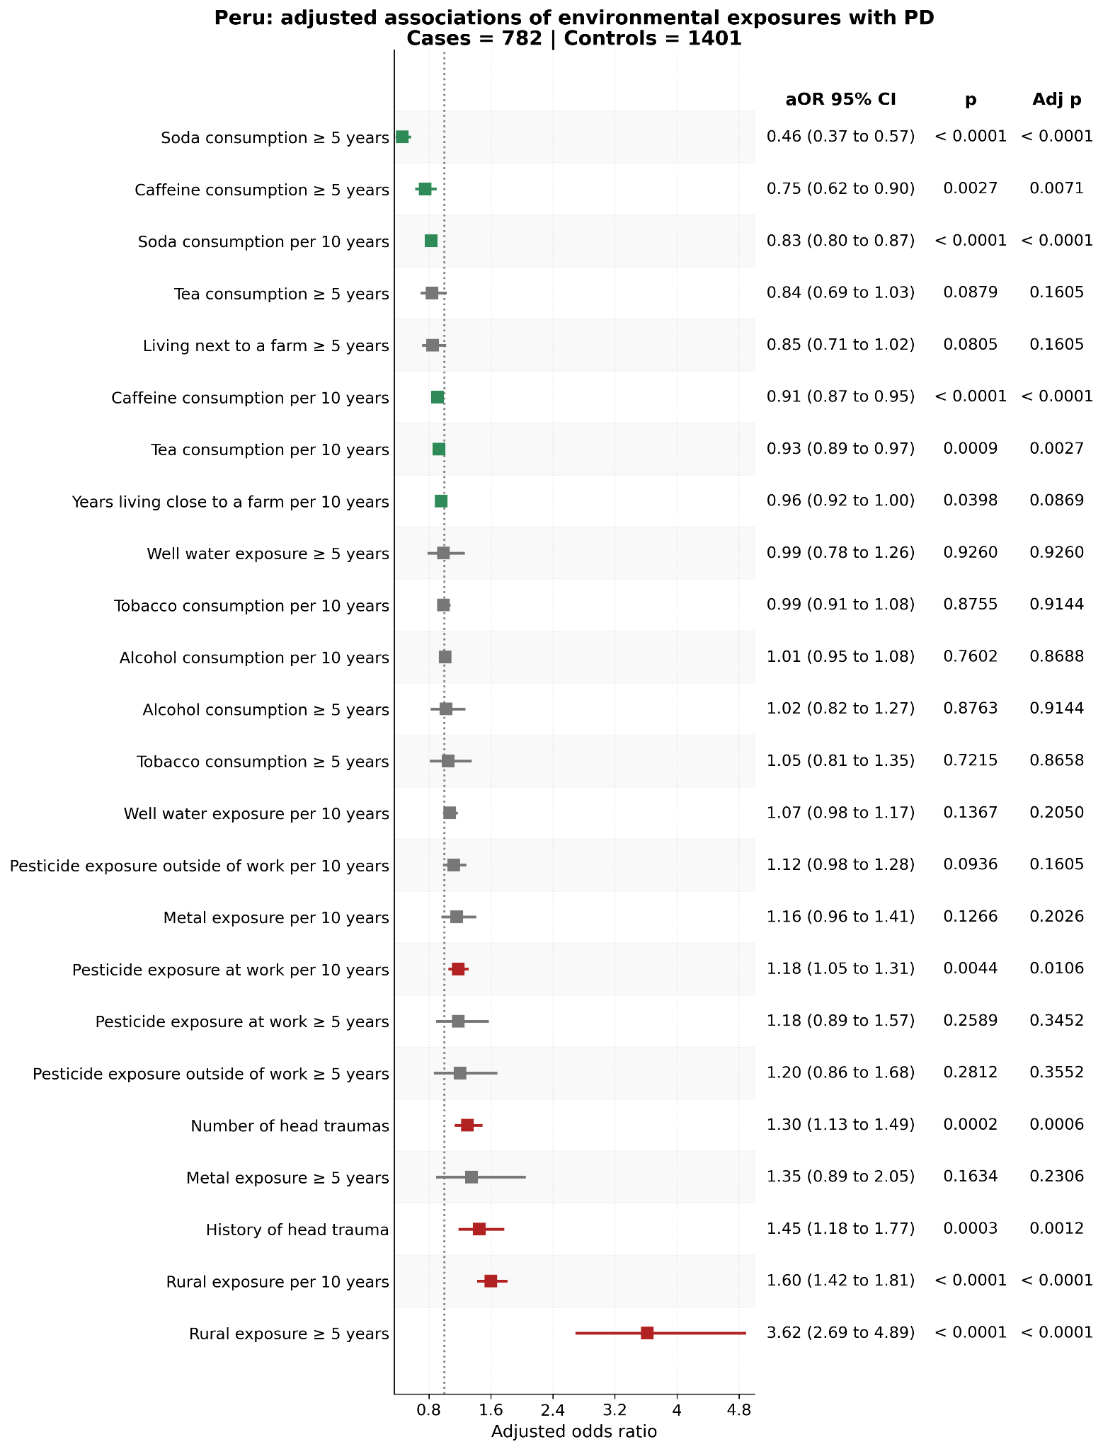

Supplementary Figure 9 - Associations of environmental exposures with PD (Puerto Rico)
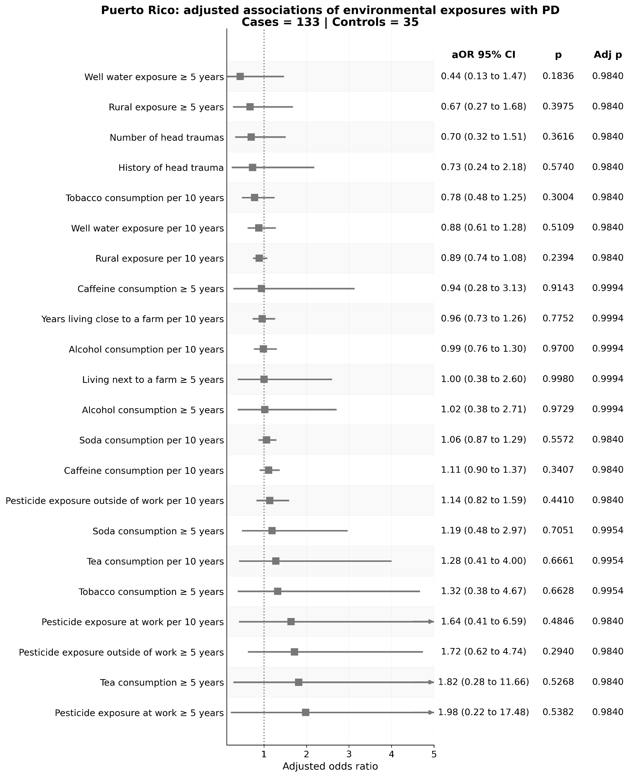

Supplementary Figure 10 - Comparison of environmental risk factors between countries
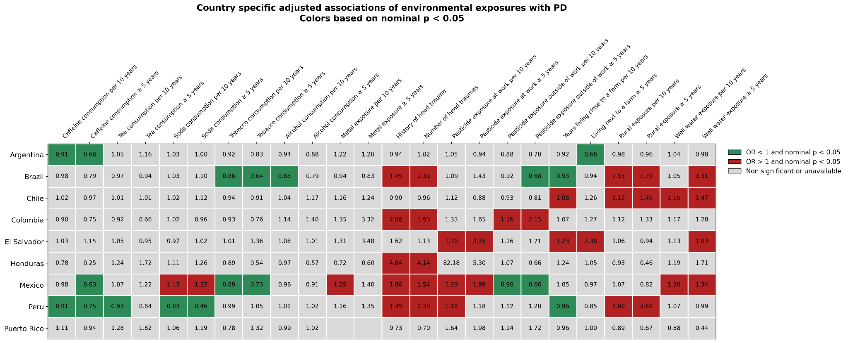

Supplementary Figure 11 - Country-specific PAFs using lifetime ever exposure definitions
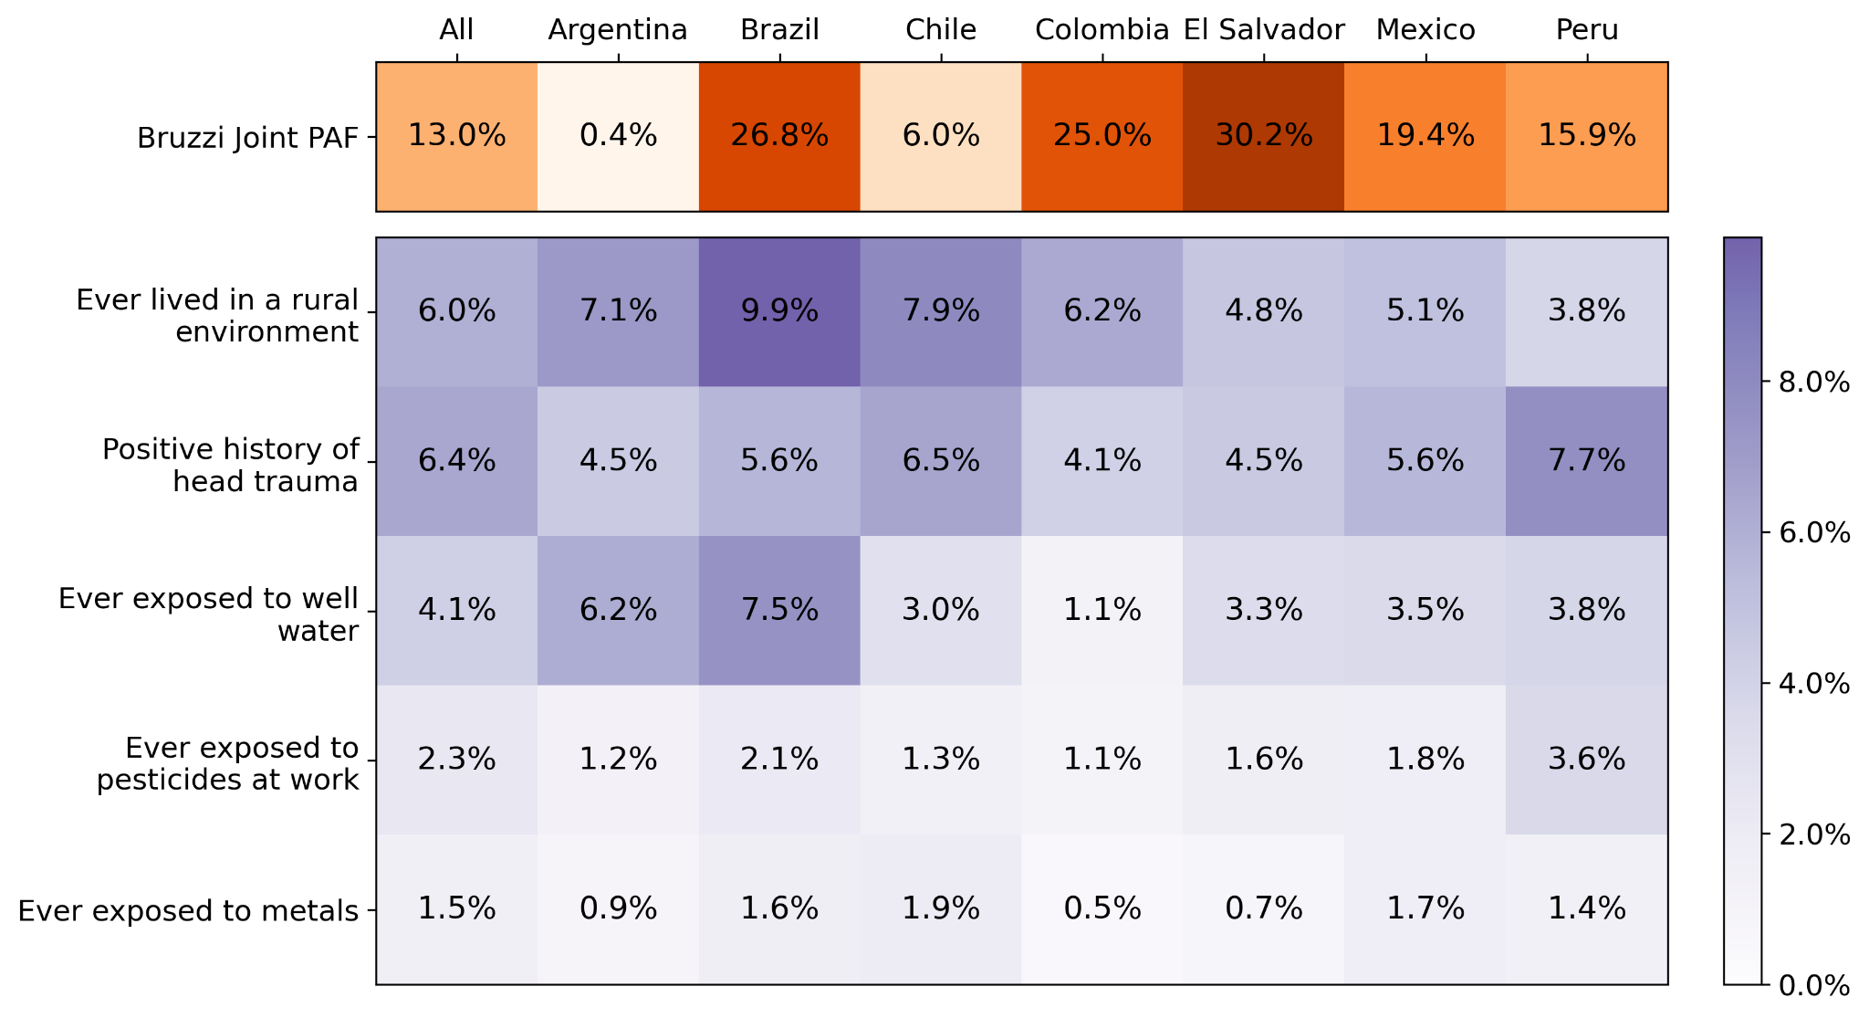

Supplementary Figure 12 - Sex-stratified PAFs using lifetime ever exposure definitions
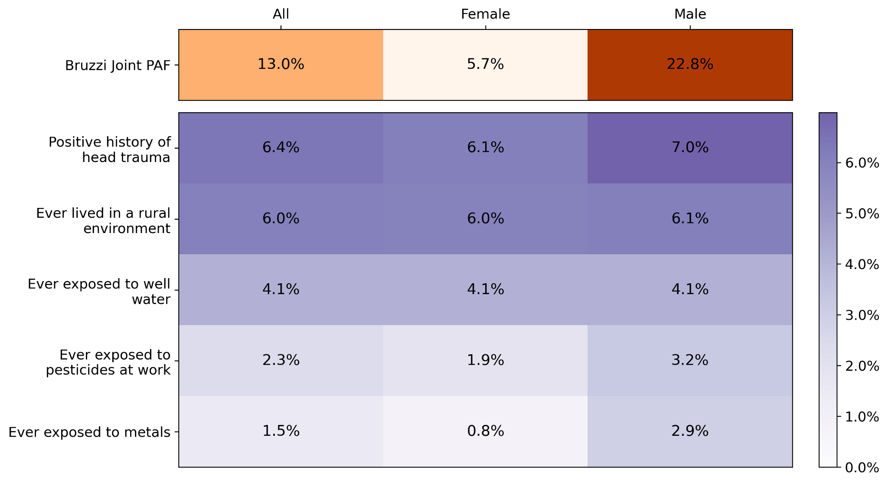

Supplementary Figure 13 - Age-stratified PAFs using lifetime ever exposure definitions
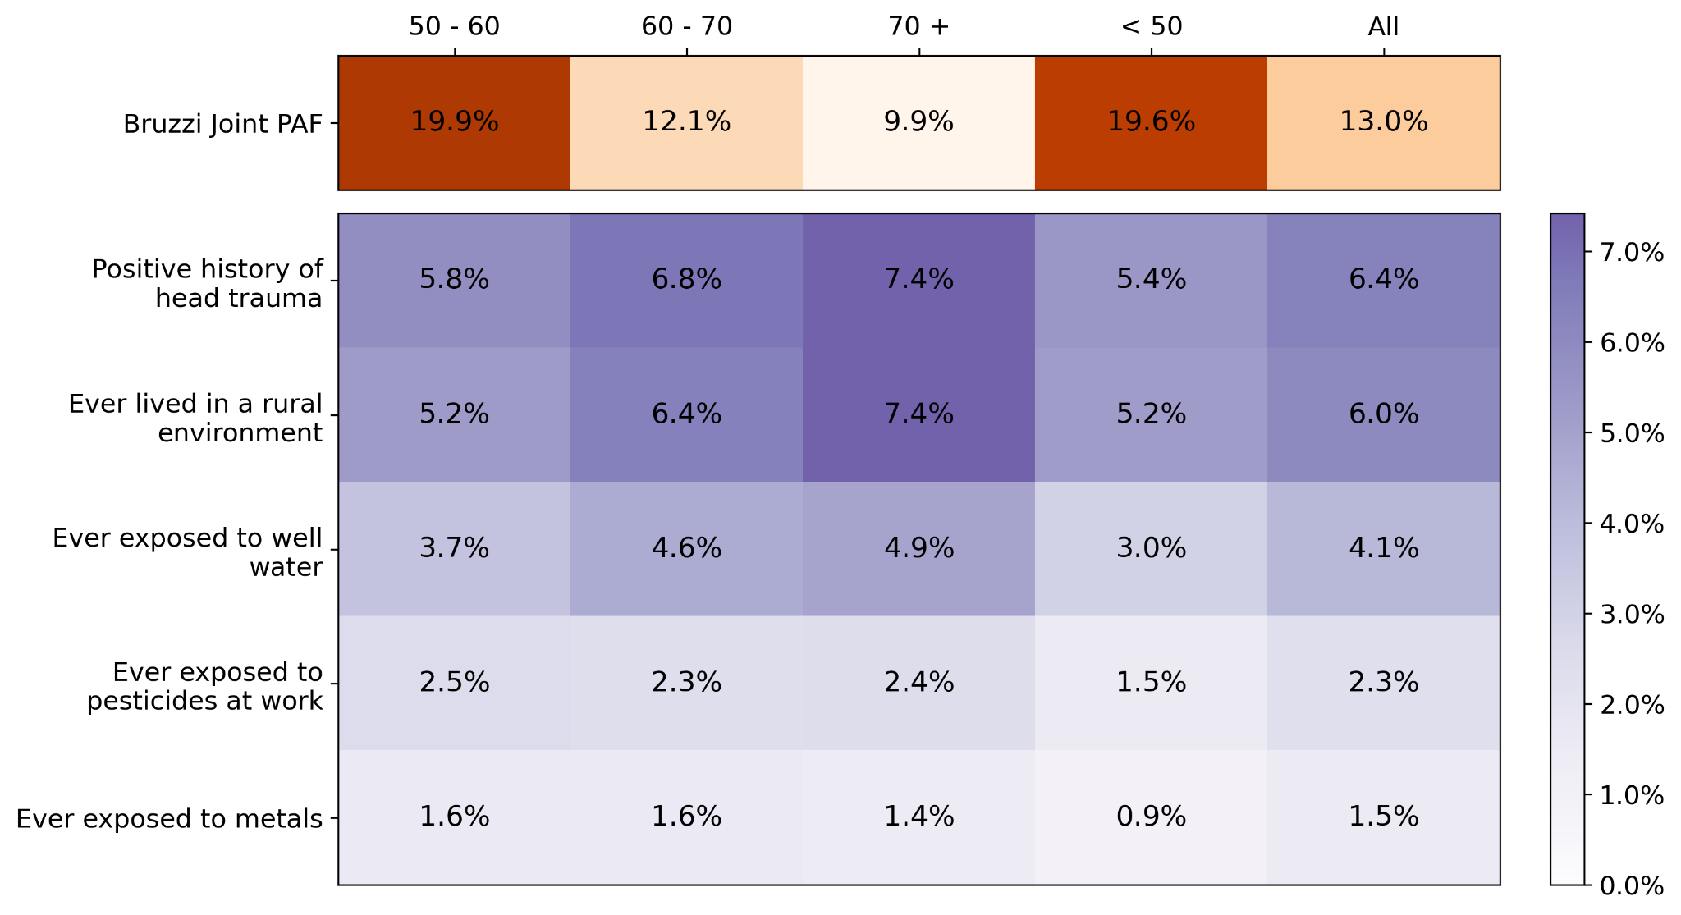

Supplementary Figure 14 - Country-specific PAFs additionally adjusted for education
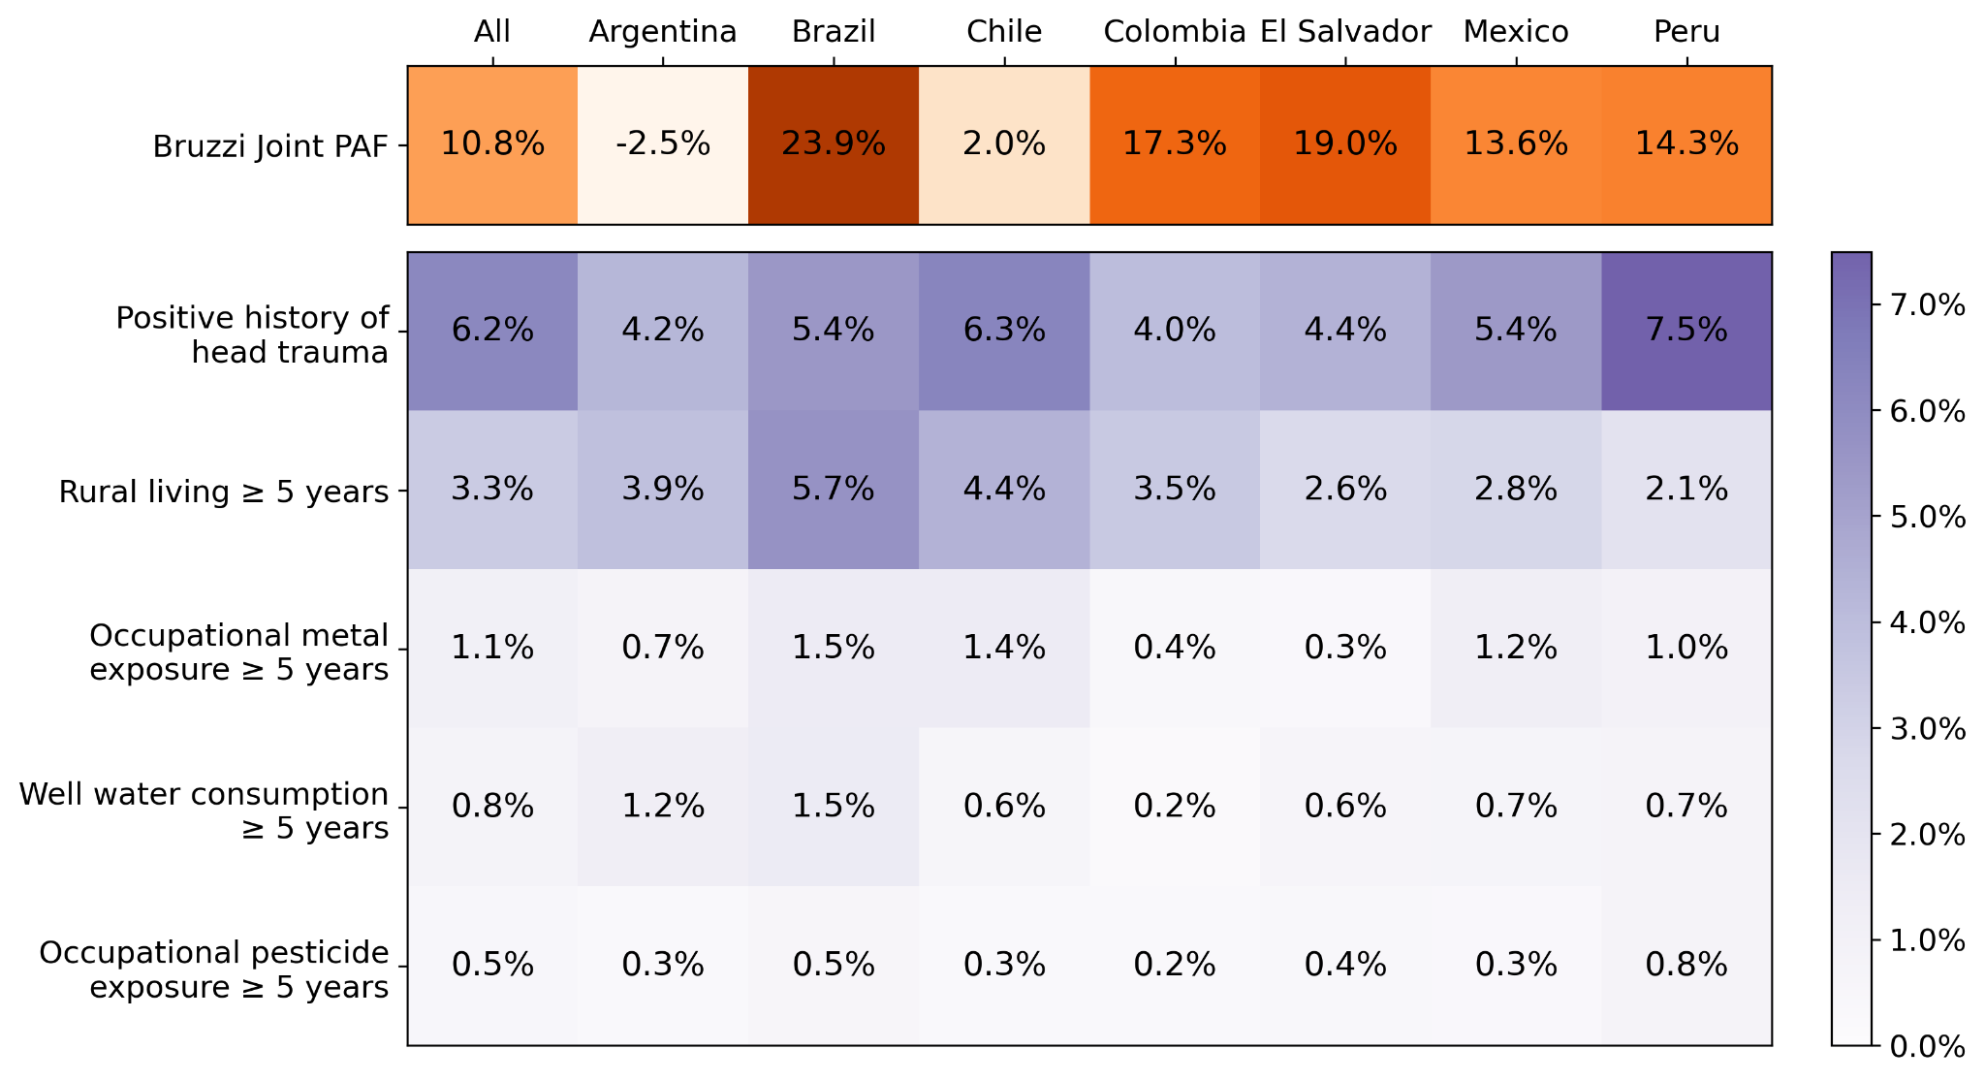

Supplementary Figure 15 - Sex-stratified PAFs additionally adjusted for education
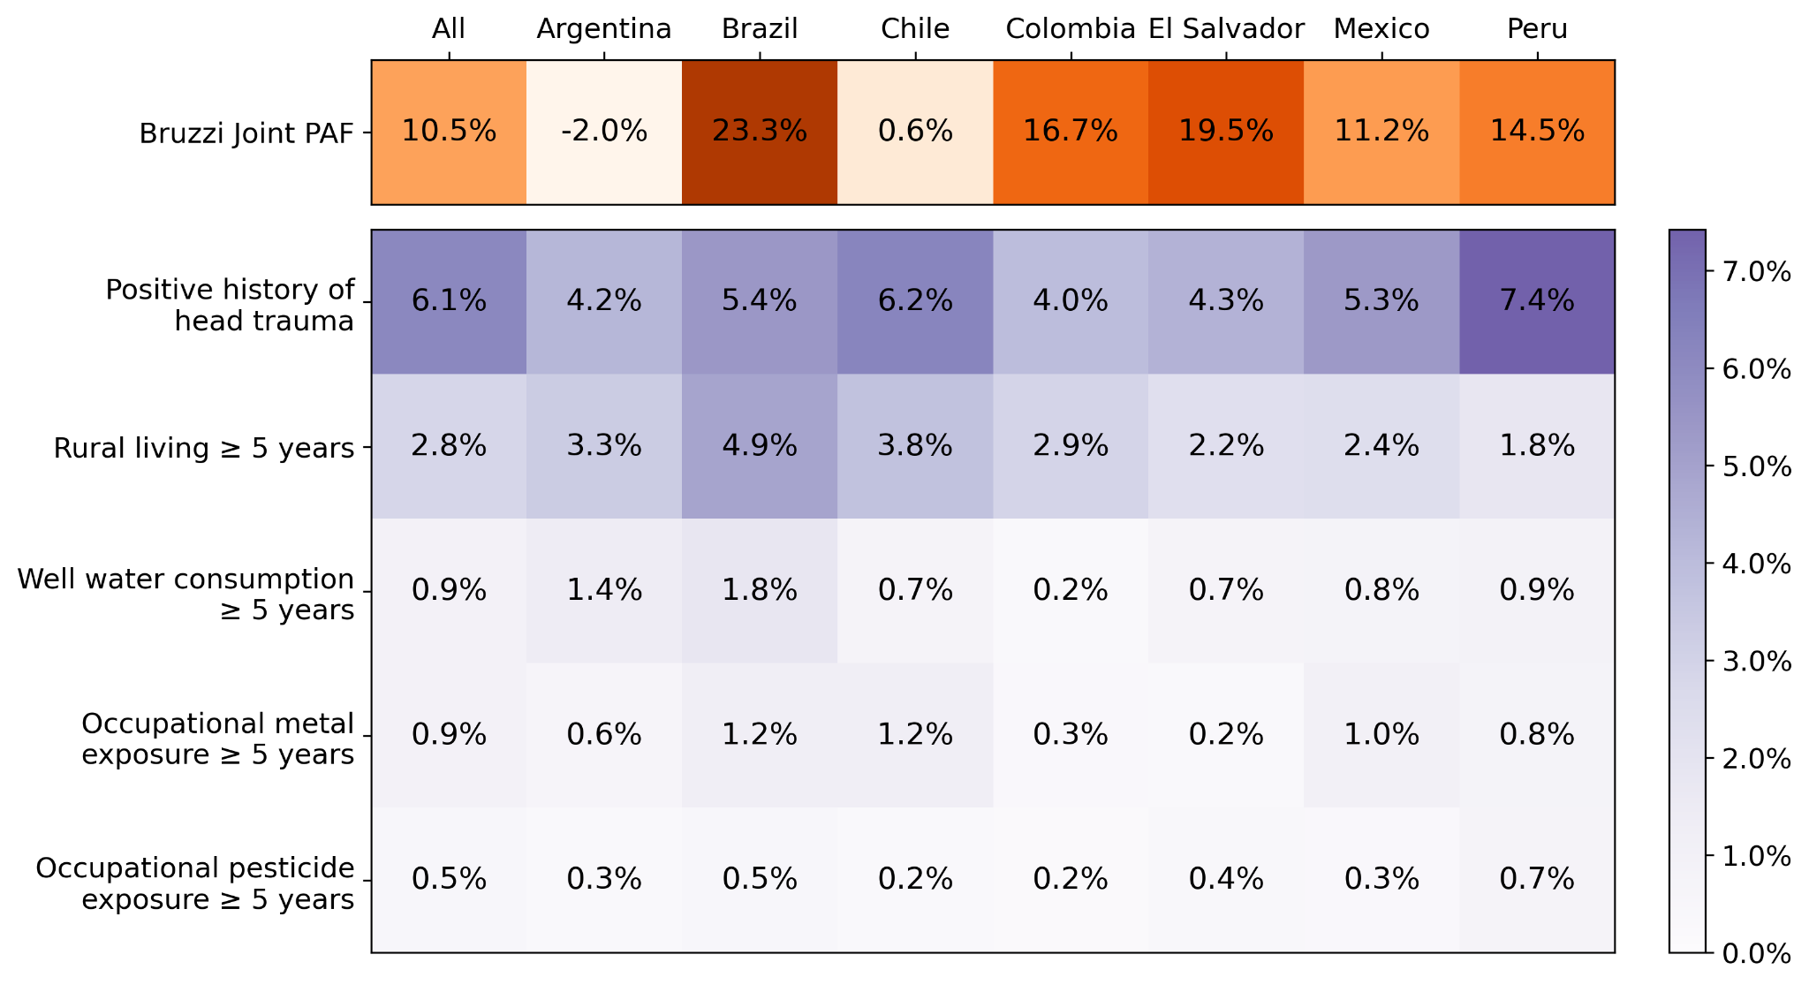

Supplementary Figure 16 - Age-stratified PAFs additionally adjusted for education
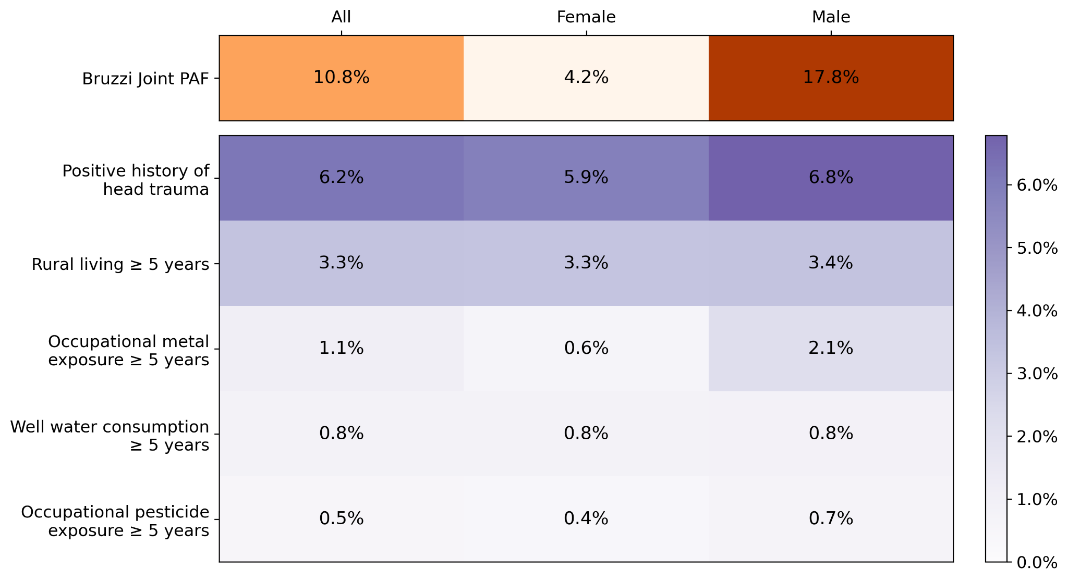

Supplementary Figure 17 - Country-specific PAFs additionally adjusted for education, PD family history, and tobacco use
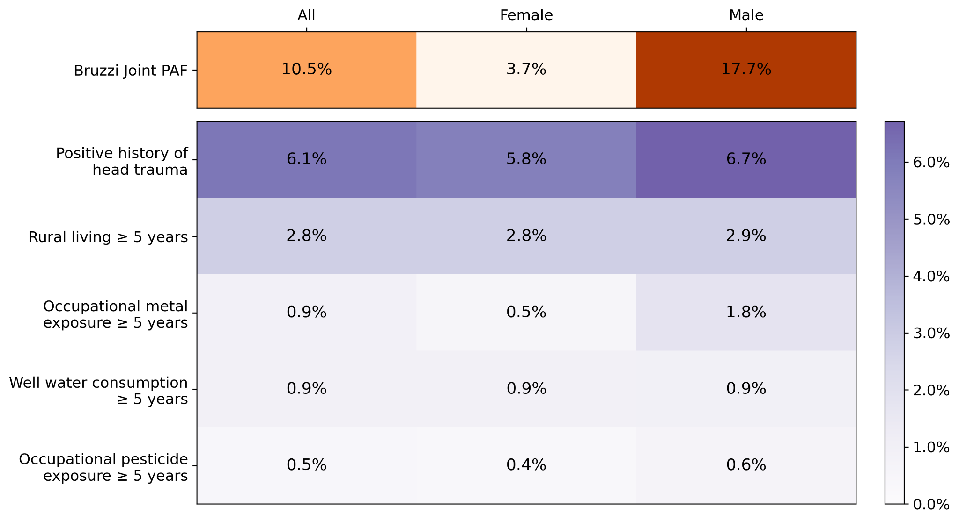

Supplementary Figure 18 - Sex-stratified PAFs additionally adjusted for education, PD family history, and tobacco use
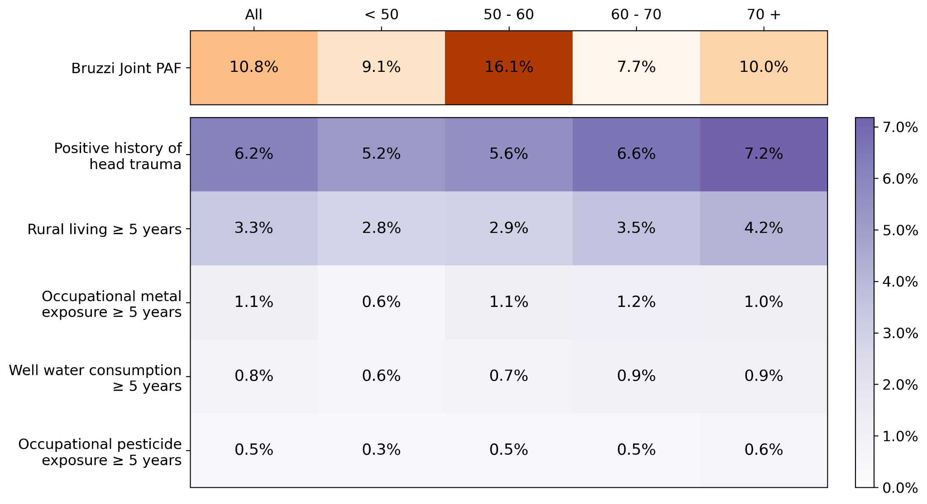

Supplementary Figure 19 - Age-stratified PAFs additionally adjusted for education, PD family history, and tobacco use
