SUPPLEMENTARY INFORMATION

Disease-Associated Loss of an MHC Locus in the Tasmanian Devil: Evolutionary Consequences for Devil Facial Tumour Disease Resistance

Kimberley C. Batley^{1†}, Ruth J. Pye^{2†}, Luke W. Silver^{1,3}, Katherine A. Farquharson^{1,3}, Yuanyuan Cheng¹ Andrew S. Flies^{2†,} Carolyn J. Hogg^{1,3†*}, Katherine Belov^{1,3†}

¹ School of Life and Environmental Sciences, The University of Sydney, Sydney, NSW, 2006, Australia.
² Menzies Institute for Medical Research, University of Tasmania, Hobart, TAS, 7000, Australia.
³ ARC Centre of Excellence for Innovations in Peptide and Protein Science, The University of Sydney, Sydney, NSW, 2006, Australia.

Table S1: Metadata for the 116 Tasmanian devils with known antibody status and MHC-I alleles. The first number in the allele nomenclature refers to the supertype. Shaded rows indicate the 61 included in the GLM analysis. See Excel spreadsheet.

Table S2: Variables included in the top model for the non-genetic model and four separate genetic models, where the response variable is the antibody response. Relative importance is given where multiple top models (<2 AICc) described the data. Where only one top model described the data, the P-value of each variable is given. Hs is standardised heterozygosity.
Non-genetic variables
Predictor | Estimate (SE) | RI
Intercept | -1.70 (0.30)
Age | 1.87 (0.55) | 1
Health status | 1.2 (0.61) | 1
Sex | -0.26 (0.56) | 0.27
Genetic variables
Predictor | Estimate (SE) | P
Intercept | -1.96 (0.36) | <0.001
Age | 1.68 (0.57) | 0.00293
Hs | -1.42 (0.55) | 0.0096
Number of MHC-I alleles | -1.51 (0.58) | 0.00874
Health status | 1.20 (0.60) | 0.04444
Predictor | Estimate (SE) | P
Intercept | -1.86 (0.34) | <0.001
Age | 1.94 (0.60) | 0.00113
UA heterozygosity | -2.17 (0.74) | 0.00343
Health status | 1.21 (0.59) | 0.04164
Predictor | Estimate (SE) | P
Intercept | -1.82 (0.34) | <0.001
Age | 1.81 (0.58) | 0.00191
Genetic similarity (all supertypes) | -2.06 (0.84) | 0.02
Health status | 0.99 (0.55) | 0.07192
Predictor | Estimate (SE) | P
Intercept | -2.17 (0.44) | 1.85E-03
Age | 1.74 (0.60) | 0.00401
Genetic similarity (UA supertype) | -3.06 (0.65) | 0.00165
Health status | 1.31 (0.60) | 0.02839

Table S3: Generalized linear models and the relationship between alleles and supertypes and the response variable (antibody response) of Tasmanian devils against DFT1.

Level | predictor | estimate | se | z | p | p_adj_BH
Allele | UA_delete_full | 2.254 | 0.717 | 3.142 | 0.002 | 0.028
Allele | UC.04.02.01.01 | -3.320 | 1.133 | -2.931 | 0.003 | 0.029
Allele | UA_deletion | 1.088 | 0.444 | 2.450 | 0.014 | 0.081
Allele | UB_delete | 2.070 | 0.907 | 2.281 | 0.023 | 0.096
Allele | UA.02.01.01.01 | -1.745 | 1.070 | -1.631 | 0.103 | 0.273
Allele | UA.02.03.01.01 | -1.714 | 1.132 | -1.514 | 0.130 | 0.273
Allele | UB.06.01.01.01 | -1.714 | 1.132 | -1.514 | 0.130 | 0.273
Allele | UC.04.01.01.01 | 0.614 | 0.415 | 1.479 | 0.139 | 0.273
Allele | UC.01.01.01.01 | 0.726 | 0.498 | 1.459 | 0.144 | 0.273
Allele | UB.10.01.01.01 | 0.460 | 0.433 | 1.063 | 0.288 | 0.456
Allele | UA.07.01.01.01 | 0.665 | 0.635 | 1.047 | 0.295 | 0.456
Allele | UB.03.02.01.01 | 0.544 | 0.599 | 0.908 | 0.364 | 0.516
Allele | UB.09.01.01.01 | 0.183 | 0.659 | 0.277 | 0.782 | 0.992
Allele | UB.10.02.01.01 | -0.113 | 0.820 | -0.137 | 0.891 | 0.992
Allele | UB.03.01.01.01 | -16.366 | 1421.023 | -0.012 | 0.991 | 0.992
Allele | UA.02.02.01.01 | -18.604 | 1688.160 | -0.011 | 0.991 | 0.992
Allele | UB.12.01.01.01 | -18.686 | 1929.351 | -0.010 | 0.992 | 0.992
Supertype | Supertype_2 | -2.310 | 0.700 | -3.302 | 0.001 | 0.009
Supertype | Supertype_7 | 0.665 | 0.635 | 1.047 | 0.295 | 0.732
Supertype | Supertype_10 | 0.367 | 0.428 | 0.857 | 0.392 | 0.732
Supertype | Supertype_1 | 0.313 | 0.376 | 0.834 | 0.404 | 0.732
Supertype | Supertype_6 | -0.646 | 0.778 | -0.830 | 0.406 | 0.732
Supertype | Supertype_3 | -0.236 | 0.431 | -0.548 | 0.584 | 0.822
Supertype | Supertype_9 | 0.317 | 0.677 | 0.468 | 0.639 | 0.822
Supertype | Supertype_4 | -0.126 | 0.406 | -0.310 | 0.757 | 0.851
Supertype | Supertype_12 | -18.658 | 2031.776 | -0.009 | 0.993 | 0.993

Table S4: MHC genotypes for the three devils with tumour regressions and positive antibody responses following immunotherapy with live MHC-I+ DFT1 cells (Tovar et al., 2017).

Name | UA1 | UA2 | UB1 | UB2 | UC1 | UC2
DFT1 cell line | UA*02:01:01:01 | UA*02:03:01:01 | UB*03:03:01:01 | UB*06:01:01:01 | UC*01:01:01:01 | UC*04:02:01:01
Stinky | UA*07:01:01:01 | UA*07:01:01:01 | UB*03:02:01:01 | UB*03:02:01:01 | UC*01:01:01:01 | UC*01:01:01:01
Missy | x | x | UB*10:01:01:01 | UB*10:01:01:01 | UC*04:01:01:01 | UC*04:01:01:01
Tip | UA*07:01:01:01 | UA*07:01:01:01 | UB*03:02:01:01 | UB*03:02:01:01 | UC*01:01:01:01 | UC*01:01:01:01

Table S5: dS ratios between devil MHC class I genes (below diagonal) and divergence times (above diagonal) with divergence times calculated using t = d/2µ with the average 1.98x10⁻⁹ mutations/bp/year as well as upper and lower 95% CI values (1.92x10⁻⁹-3.98x10⁻⁹).
 | Saha-UA | Saha-UB | Saha-UC | Saha-UD | Saha-UK | Saha-UM
Saha-UA |  | 664,075.34 (476,979.98 - 989,108.78) | 2,009,701.67 (1,443,492.05 - 2,993,355.52) | 28,887,277.11 (20,748,629.19 - 43,026,231.90) | 86,137,561.32 (61,869,324.43 - 128,297,820.35) | 192,774,079.73 (138,462,267.75 - 287,127,866.96)
Saha-UB | 0.0038 |  | 1,328,150.67 (953,959.96 - 1,978,217.56) | 29,691,157.78 (21,326,026.01 - 44,223,574.11) | 86,696,782.66 (62,270,991.78 - 129,130,754.05) | 193,455,630.73 (138,951,799.84 - 288,143,004.92)
Saha-UC | 0.0115 | 0.0076 |  | 28,922,228.44 (20,773,733.40 - 43,078,290.26) | 88,916,192.33 (63,865,109.09 - 132,436,459.71) | 194,032,327.73 (139,366,019.29 - 289,001,967.80)
Saha-UD | 0.1653 | 0.1699 | 0.1655 |  | 82,729,806.31 (59,421,664.00 - 123,222,130.56) | 156,739,254.92 (112,579,827.71 - 233,455,701.09)
Saha-UK | 0.4929 | 0.4961 | 0.5088 | 0.4734 |  | 154,502,369.58 (110,973,158.30 - 230,123,966.26)
Saha-UM | 1.1031 | 1.107 | 1.1103 | 0.8969 | 0.8841

A)

B)

Supplementary Fig. S1: Devils with higher supertype transplant scores are more likely to have serum anti-DFT1 antibodies. Supertype transplant scores against antibody positive and antibody negative groups for A) the full set of 116 devils that have serum antibody data, and B) the subset of 61 devils that were anti-DFT1 antibody positive (N = 25) and/or DFT1 positive. The fitted binomial regression curve with 95% confidence intervals is presented. The sample sizes and p-value are shown for reference.
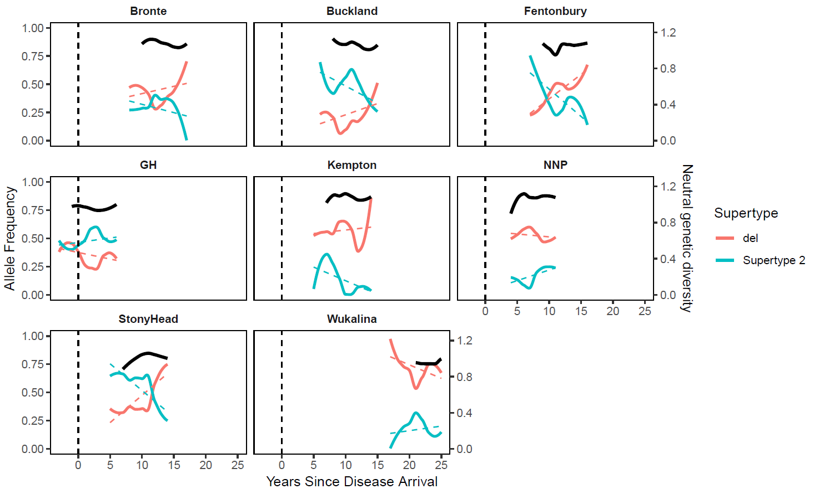
A)

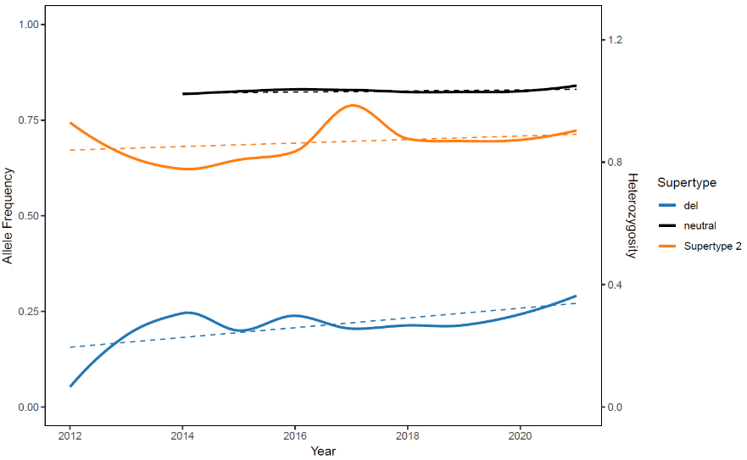
B)

Supplementary Fig. 2. A) Temporal changes in the frequency of the non-functional UA allele (not shared with DFT1; red) and supertype 2 (shared with DFT1; blue), with neutral diversity for comparison (black) across all diseased sites. Vertical dashed lines indicate the year that DFT1 arrived at each sampling site, with the x-axis representing the number of years between disease arriving and sampling collection. B) Temporal changes in the frequency of the non-functional UA allele (not shared with DFT1; blue) and supertype 2 (shared with DFT1; orange), with neutral diversity for comparison (black) at Woolnorth. Dotted coloured lines represent the trend.
w

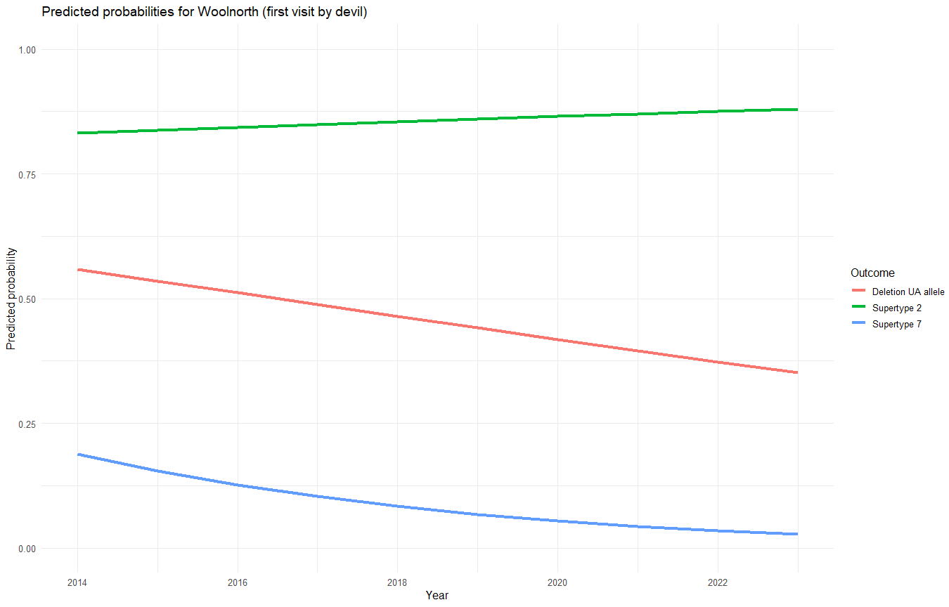
Supplementary Fig. 3. Predicted probabilities of the UA deletion, supertype 2 and supertype 7 (first visit by devil) at Woolnorth across years of the study.

