Supplementary Information for…
Nephelometer-based air sensor networks systematically underestimate PM_{2.5} in dust-influenced West Africa
Daniel M. Westervelt^{1*}, Abhishek Anand¹, Selina Amoah², Benjamin Essien², Kingsley Mawuli Amegah², Clement Mensah Ackaah², Esi Nerquaye Tetteh², Nana Ama Browne Klutse²
- Lamont-Doherty Earth Observatory of Columbia University, Palisades, NY, USA, 10964
- Environmental Protection Authority, Accra, Ghana

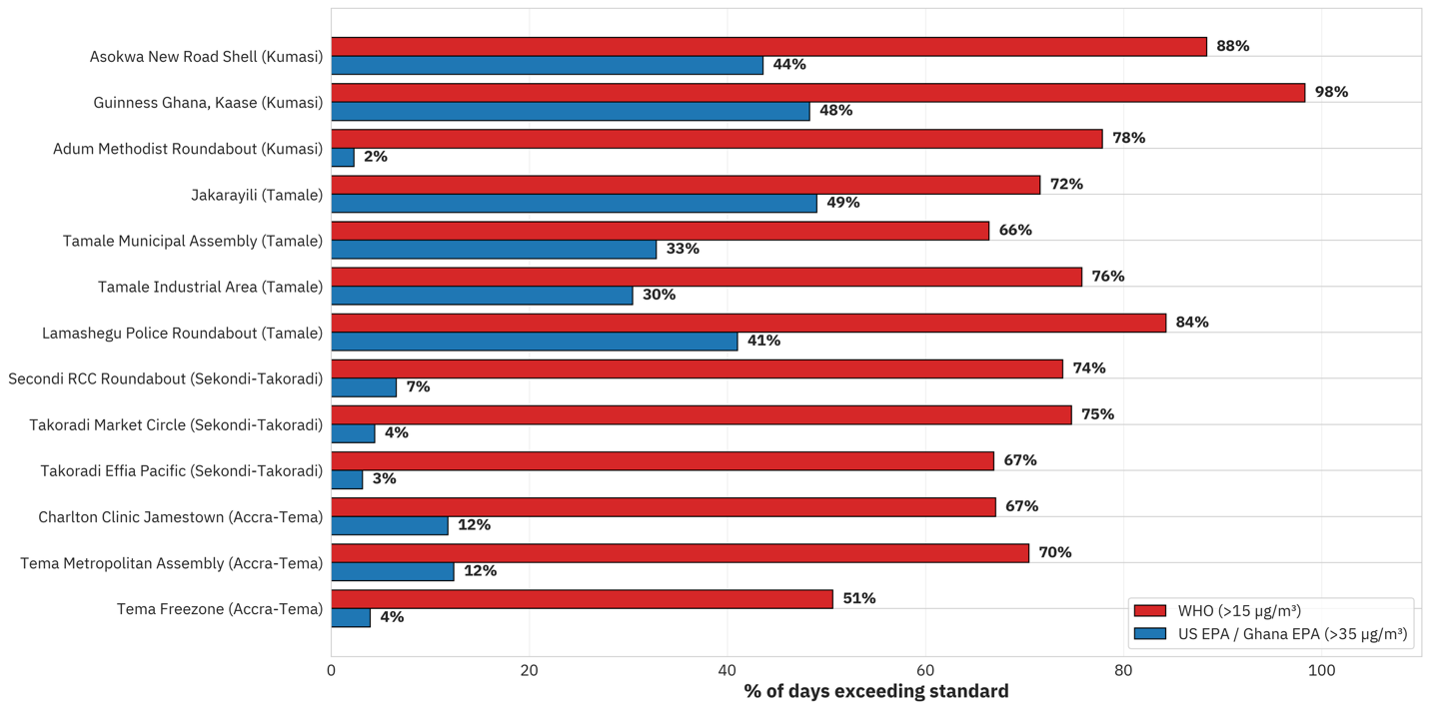
Figure S1: Percentage of days exceeding the 24-hour Ghana EPA PM_{2.5} standard and WHO Air Quality Guideline across the national network

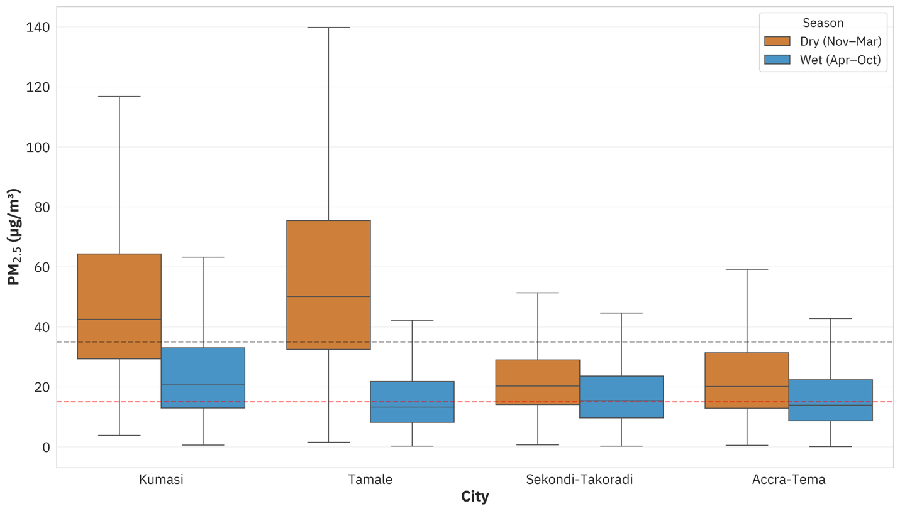
Figure S2: Box plots for dry and wet season daily mean PM_{2.5} at each city. Dashed-lines indicate

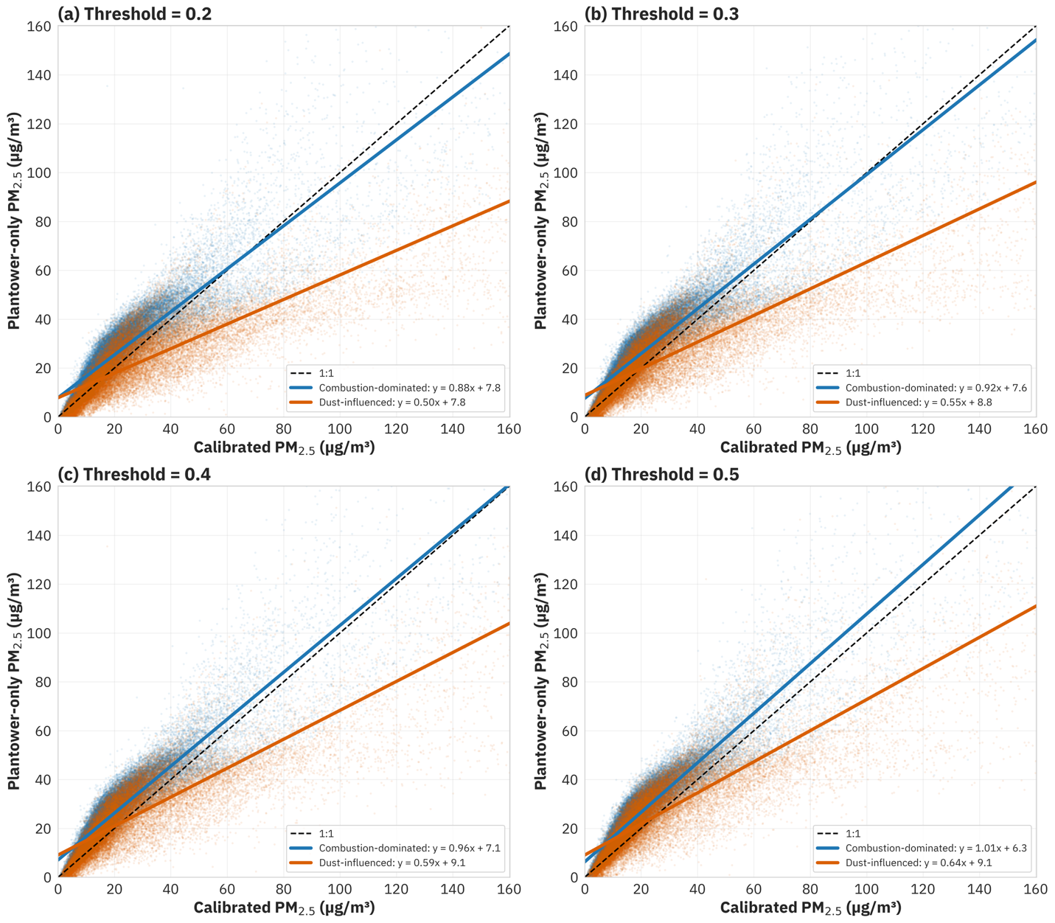
Figure S3: Scatterplots of Plantower-only PM_{2.5} versus MOD-PM calibrated PM_{2.5} using 4 alternative PM₁:PM₁₀ ratio thresholds: (a) 0.2, (b) 0.3, (c) 0.4, (d) 0.5

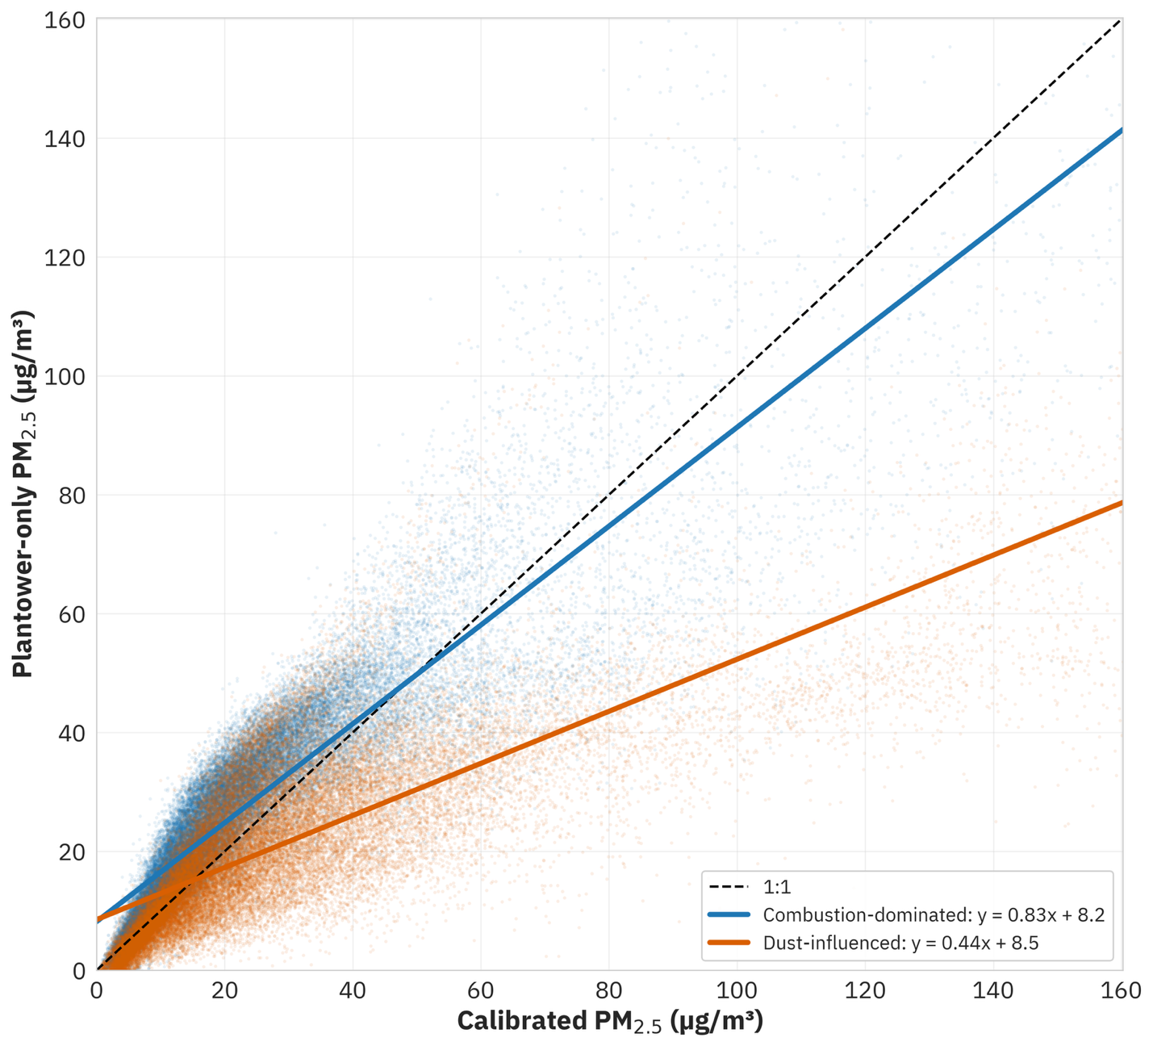
Figure S4: Scatterplots of Plantower-only PM_{2.5} versus MOD-PM calibrated PM_{2.5} using the PM_{2.5}:PM₁₀ ratio threshold of 0.1

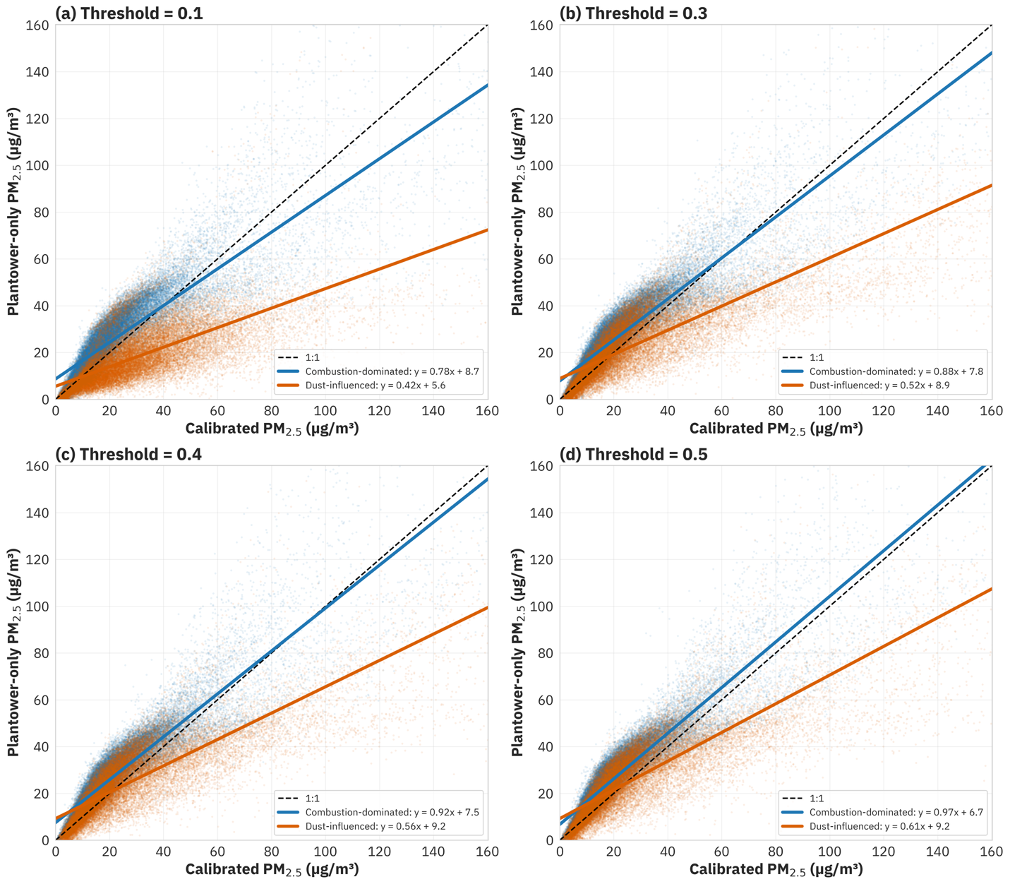
Figure S5: Scatterplots of Plantower-only PM_{2.5} versus MOD-PM calibrated PM_{2.5} using 4 alternative PM_{2.5}:PM₁₀ ratio thresholds: (a) 0.1, (b) 0.3, (c) 0.4, (d) 0.5

