Hypermethylation of TMEM240 Involved in Expression Deficiency Predicts Poor Hormone Therapy Response and Disease Progression in Breast Cancer
Ruo-Kai Lin^{#1,2,3,4,5}, Chih-Ming Su^{#6,7}, Shih-Yun Lin^{1,} Le Thi Anh Thu^{1,8},
Phui-Ly Liew^{9,10}, Jian-Yu Chen¹¹, Huey-En Tzeng¹², Chin-Sheng Hung *^{6,7,14}

Table S1 List of primers sequences and their reaction conditions used in the present study
Gene | primer | 5’→3’sequences | Application | Size  (bp) | Tm ($℃$)
GAPDH | Forward  Reverse | AGCCACATCGCTCAGACAC  GCCCAATACGACCAAATCC | RT-PCR  Real-time | 66 | 60
TMEM240 | Forward  Reverse | ATCGCGTGCTTGATGGAC  GGATCACGTAGTGGATATGGTG | RT-PCR  Real-time | 125 | 60
BACTIN | Forward  Reverse  Probe | TGGTGATGGAGGAGGTTTAGTAAGT  AACCAATAAAACCTACTCCTCCCTTAA  ACCACCACCCAACACACAATAACAAACACA | MSP-M | 132 | 60
TMEM240 | Forward  Reverse  Probe | TTTTTCGTTTATTATTACGATCGAC  CGACCCCGCCCGATATCCATAA  TTTAGAATTATGAAGATTATGGTGTTC | MSP-M | 81 | 60

Table S2 List of antibodies used in the present study
Target | K.D. | Raised In | Application | Dilution | Source | Catalog No.
β-actin | 42 | Mouse | Western blot | 1:5000 | GeneTex  Irvine,  USA | GTX26276
DDK  Clone: 4C5 | 20 | Mouse | Western blot  Immunofluorescence | 1:3000 | OriGene Rockville,  USA | TA50011-100
c-Myc | 20 | Rabbit recombinant oligoclonal Ab | Western blot  Immunofluorescence | 1:50 | Invitrogen  Grand Island, USA | 710007
Mouse IgG-HRP conjugate |  | Goat | Western blot | 1:5000 | GeneTex  Irvine,  USA | GTX213111-01
Rabbit IgG- HRP conjugate |  | Goat | Western blot | 1:5000 | GeneTex  Irvine,  USA | GTX213110-01
Mouse IgG-FITC conjugate |  | Goat | Immunofluorescence | 1:250 | Sigma-aldrich  Taiwan, R.O.C | F0257
Rabbit IgG-TRITC conjugate |  | Goat | Immunofluorescence | 1:250 | Sigma-aldrich  Taiwan, R.O.C | T6778

Figure S1. Representative standard sequencing diagram for bisulfite direct sequencing of the TMEM240 gene.

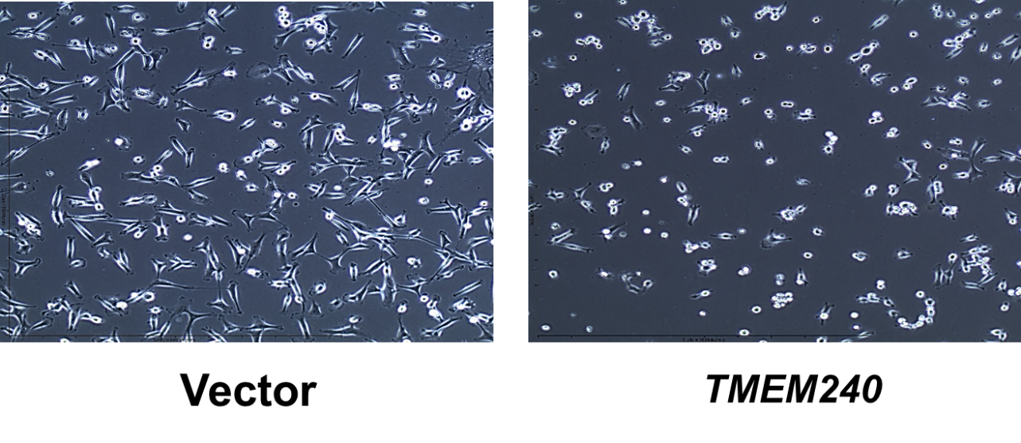
Figure S2. The cell morphology was determined by microscopy in MDA-MB-231 cells (original magnification, ×100).
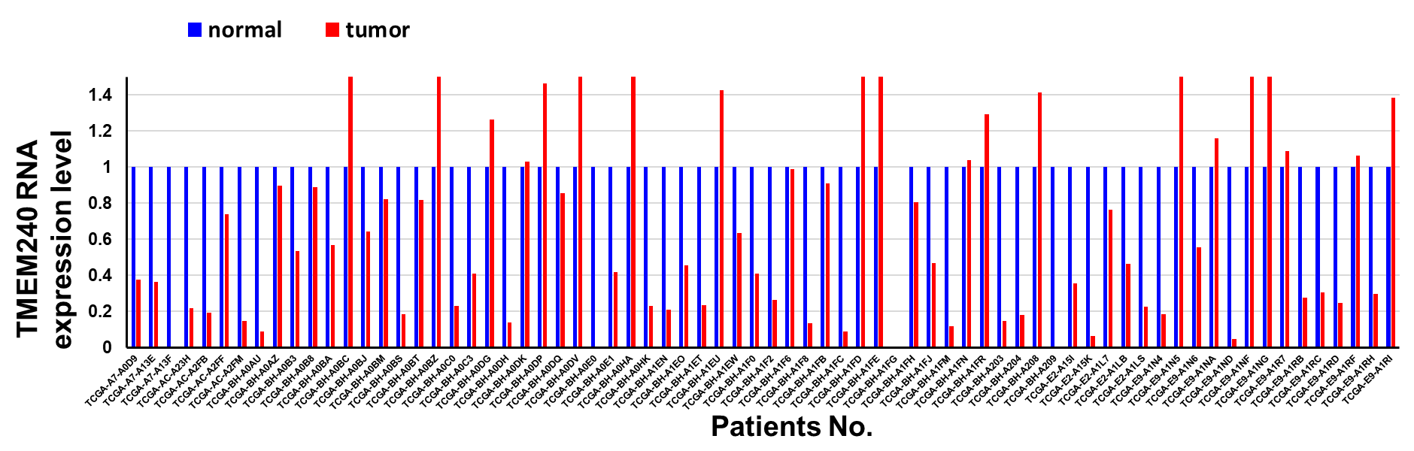
Figure S3. Representative figures showing the TMEM240 mRNA expression by RNA sequencing in breast cancer patients from TCGA.

