Supplementary materials
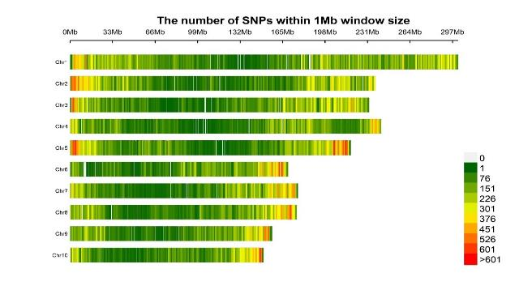
Supplementary Figure S1. Density plot showing the number SNPs within 1 Mb window size from the studied 259,798 markers. The number of SNPs is displayed on a scale from green to red.

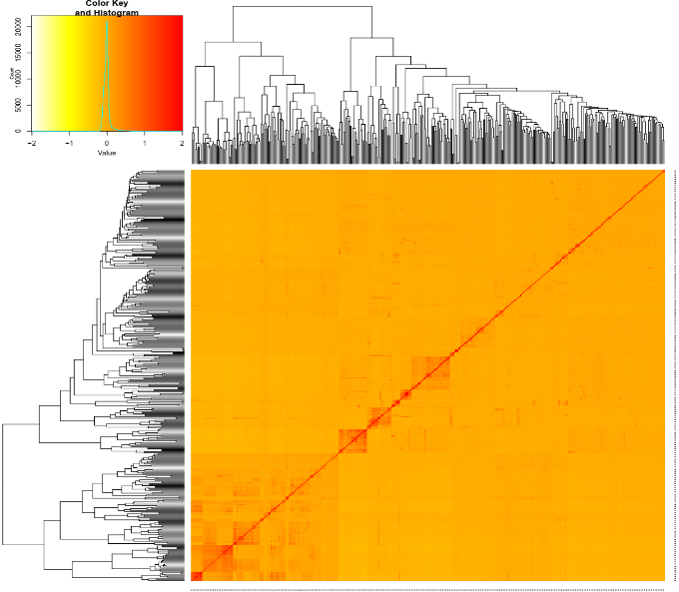
Supplementary Figure S2. Kinship Analysis of the IMAS panel. The heat map shows the pairwise kinship matrix based on 259,798 filtered SNPs.

A B
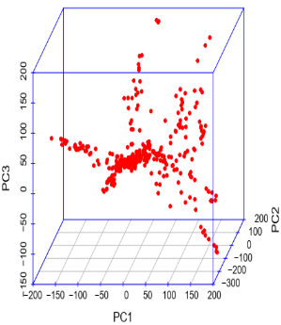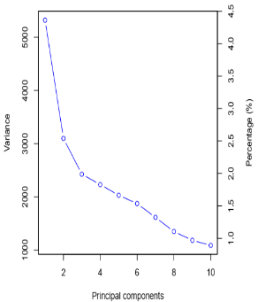
Supplementary Figure S3. (A) Population structure representation based on the first three principal components (PC). (B) Scree plot of the estimated eigen values of each PC. The PCA plots of the IMAS panel were computed using 259,798 SNPs of the IMAS panel.

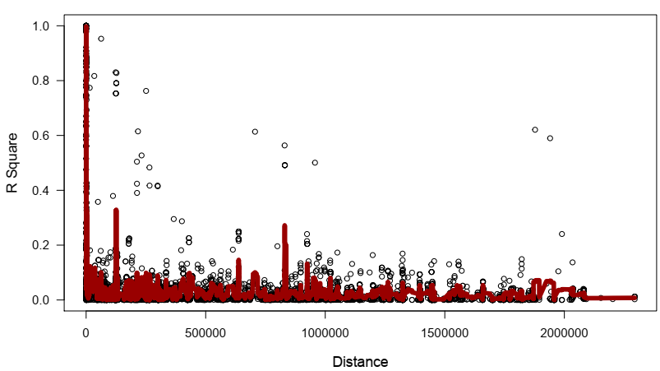
Supplementary Figure S4 LD decay plot for the whole genome-based on 259,798 SNPs. The x-axis values represent the physical distance (kb), while the y-axis values represent the squared correlation coefficient (r²).

Supplementary Table S1. SNP distribution, proportion of missing markers and heterozygous markers, and minor allele frequency across the chromosome architecture of diverse tropical lines of maize.
Chromosome | Number of Sites |  | Proportion Missing (%) |  |  | Proportion Heterozygosity |  |  | Mean
Chromosome | Raw Data | Filtered | Min | Max | Mean | Min | Max | Mean | Mean
1 | 52,977 | 40,910 | 0 | 0.99 | 0.003 | 0 | 0.31 | 0.095 | 0.22
2 | 41,550 | 32,083 | 0 | 0.99 | 0.003 | 0 | 0.31 | 0.096 | 0.22
3 | 38,701 | 29,694 | 0 | 0.99 | 0.003 | 0 | 0.31 | 0.093 | 0.22
4 | 31,020 | 23,849 | 0 | 0.99 | 0.003 | 0 | 0.30 | 0.092 | 0.22
5 | 39,463 | 30,411 | 0 | 0.99 | 0.003 | 0 | 0.31 | 0.095 | 0.22
6 | 27,130 | 21,053 | 0 | 0.99 | 0.003 | 0 | 0.31 | 0.093 | 0.22
7 | 28,593 | 21,991 | 0 | 0.99 | 0.003 | 0 | 0.30 | 0.091 | 0.22
8 | 28,816 | 22,192 | 0 | 0.99 | 0.003 | 0 | 0.31 | 0.094 | 0.23
9 | 25,290 | 19,500 | 0 | 0.99 | 0.003 | 0 | 0.28 | 0.094 | 0.22
10 | 23,573 | 18,115 | 0 | 0.99 | 0.003 | 0 | 0.29 | 0.092 | 0.22
TOTAL | 337,113 | 259,798
*Min, minimum; max, maximum. The recorded parameters are presented for SNPs after filtering using the 5% MAF and 10% missing criterion

Supplementary Table S2. Genome-wide prediction accuracies for grain yield and quality traits
 | IMAS Panel | DH pop1 | DH pop2 | DH pop3 | DH pop4
Optimum
Grain yield | 0.41 | - | 0.33 | 0.14 | -
Protein content | 0.38 | - | 0.38 | 0.66 | -
Starch content | 0.39 | - | 0.16 | 0.53 | -
Oil content | 0.44 | - | 0.11 | 0.35 | -
Low N
Grain yield | 0.35 | 0.31 | 0.08 | 0.41 | 0.28
Protein content | 0.35 | 0.69 | 0.17 | 0.69 | 0.60
Starch content | 0.41 | 0.70 | 0.26 | 0.23 | 0.56
Oil content | 0.56 | 0.73 | 0.36 | 0.71 | 0.78

Supplementary Table S3. Percentage change between optimum and Low N stress conditions
Genotype | Grain yield (%) | Protein content (%) | Starch content (%) | Oil content (%)
IMAS | -58.81 | -23.41 | 2.57 | -4.42
DH pop1 | -51.36 | -23.13 | 2.61 | 2.24
DH pop2 | -47.58 | -27.19 | 2.25 | -6.87
DH pop3 | -46.89 | -8.43 | 1.02 | 3.84
DH pop4 | -55.32 | -27.71 | 3.49 | 0.09
*A negative value indicates that the percentage change is decreasing, whereas a positive number indicates the opposite. DH pop1= CML550/CML504; DH pop2= CML550/CML511; DH pop3= CML505/LaPostaSeqC7-F64-2-6-2-2; and DH pop4= CML536/LaPostaSeqC7-F64-2-6-2-2

