Supplementary Material
Bayesian small-area modelling of COVID-19 cases and deaths in England and association with key risk factors: a combined space–time Susceptible-Exposed-Infected-Removed (SEIR) model
Sartorius B, Lawson AB, Pullan RL

Section 1. Gather checklist of information that should be included in new reports of global health estimates

Item # | Checklist item | Reported on page #
Objectives and funding
1 | Define the indicator(s), populations (including age, sex, and geographic entities), and time period(s) for which estimates were made. | 1
2 | List the funding sources for the work. | 2
Data Inputs
For all data inputs from multiple sources that are synthesized as part of the study:
3 | Describe how the data were identified and how the data were accessed. | 3,4,Table 1
4 | Specify the inclusion and exclusion criteria. Identify all ad-hoc exclusions. | 3
5 | Provide information on all included data sources and their main characteristics. For each data source used, report reference information or contact name/institution, population represented, data collection method, year(s) of data collection, sex and age range, diagnostic criteria or measurement method, and sample size, as relevant. | 3,4,Table 1
6 | Identify and describe any categories of input data that have potentially important biases (e.g., based on characteristics listed in item 5). | N/A
7 | Describe and give sources for any other data inputs. | 3,4,Table 1
For all data inputs:
8 | Provide all data inputs in a file format from which data can be efficiently extracted (e.g., a spreadsheet rather than a PDF), including all relevant meta-data listed in item 5. For any data inputs that cannot be shared because of ethical or legal reasons, such as third-party ownership, provide a contact name or the name of the institution that retains the right to the data. | Table 1
Data analysis
9 | Provide a conceptual overview of the data analysis method. A diagram may be helpful. | 3
10 | Provide a detailed description of all steps of the analysis, including mathematical formulae. This description should cover, as relevant, data cleaning, data pre-processing, data adjustments and weighting of data sources, and mathematical or statistical model(s). | 7-9
11 | Describe how candidate models were evaluated and how the final model(s) were selected. | 6-8
12 | Provide the results of an evaluation of model performance, if done, as well as the results of any relevant sensitivity analysis. | Supplementary 3  8
13 | Describe methods for calculating uncertainty of the estimates. State which sources of uncertainty were, and were not, accounted for in the uncertainty analysis. | 9
14 | State how analytic or statistical source code used to generate estimates can be accessed. | 5, Supplementary 2
Results and Discussion
15 | Provide published estimates in a file format from which data can be efficiently extracted. | Supplementary 5
16 | Report a quantitative measure of the uncertainty of the estimates (e.g. uncertainty intervals). | 9-13
17 | Interpret results in light of existing evidence. If updating a previous set of estimates, describe the reasons for changes in estimates. | 13-15
18 | Discuss limitations of the estimates. Include a discussion of any modelling assumptions or data limitations that affect interpretation of the estimates. | 15

Section 2: WinBUGS code for full space-time SEIR model

model{

for (i in 1:N){
b1.ut[i]~dnorm(alpha[1],tau.bu[1])
b2.ut[i]~dnorm(alpha[2],tau.bu[2])

deaths_mod[i,1]~dpois(mu.d[i,1])
mu.d[i,1]<-0
susc[i,1]<-Pop_AllAges[i]
cases_mod[i,1]~dpois(mu.c[i,1])
mu.c[i,1]<-0
asym.cases[i,1]<-cases_mod[i,1]*asym

deaths_mod[i,2]~dpois(mu.d[i,2])
mu.d[i,2]<-0
susc[i,2]<-susc[i,1]-cases_mod[i,1]-inf[i,1]-deaths_mod[i,1]
cases_mod[i,2]~dpois(mu.c[i,2])
log(mu.c[i,2])<-b1[i]+b1.ut[i]+beta[1]*cum_gyration[i,2]
asym.cases[i,2]<-cases_mod[i,1]*asym

for (j in 3:T){
deaths_mod[i,j]~dpois(mu.d[i,j])
log(mu.d[i,j])<-b2[i]+b2.ut[i]+log(cases_mod[i,j-1]+0.001)+beta[3]*prop_70plus[i]+beta[4]*imd19_inv[i]
susc[i,j]<-susc[i,j-1]- asym.cases[i,j-1]-cases_mod[i,j-1]-deaths_mod[i,j-1]
cases_mod[i,j]~dpois(mu.c[i,j])
log(mu.c[i,j])<-b1[i]+b1.ut[i]+log(susc[i,j]+0.001)+beta0[1]*log(cases_mod[i,j-1]+0.001)+beta[1]*cum_gyration[i,j-1]+beta[2]*imd19_inv[i]
asym.cases[i,j]<-cases_mod[i,j]*asym
}
}

b1[1:N] ~ car.normal(adj[], weights[], num[], tau.b[1])
b2[1:N] ~ car.normal(adj[], weights[], num[], tau.b[2])

for(k in 1:sumNumNeigh) {
weights[k] <- 1
}

alpha[1]~dflat()
alpha[2]~dflat()

beta0[1]~dunif(0,1)

beta[1]~dnorm(0,1)
beta[2]~dnorm(0,1)
beta[3]~dnorm(0,1)
beta[4]~dnorm(0,1)

for (k in 1:2){
tau.b[k]~dgamma(0.5,0.0005)
}

for (k in 1:2){
tau.bu[k]~dgamma(0.5,0.0005)
}

asym~dunif(0.05,0.4)

for (i in 1:N){
gyration.baseline[i]<-cum_gyration[i,1]
mu.counter[i,1]<-0
mu.counter[i,2]<-mu.c[i,2]
for (j in 3:T){
log(mu.counter[i,j])<-b1[i]+b1.ut[i]+log(susc[i,j]+0.001)+beta0[1]*log(cases_mod[i,j-1]+0.001)+beta[1]*gyration.baseline[i]
}
}

for (j in 1:T){
cases.fitted[j] <- sum(mu.c[,j])
asym.fitted[j] <- sum(asym.cases [,j])
cases.fitted.counter[j] <- sum(mu.counter[,j])
deaths.fitted[j] <- sum(mu.d[,j])
}

}
Section 3: Model fit and out of sample validation/performance

The model appears to adequately fit the observed number of cases by MSOA for the period of week 9 to week 34 of 2020 which corresponds to observed data input period for the model (Figure 3.1, Spearman rank correlation coefficient=+0.966, p<0.001. A comparison of model fitted cases for a 20% randomly withheld sample of observed data points for the period of week 9 to 34 against total observed cases by MSOA appears to suggest a high degree of correlation (Spearman rank correlation coefficient = +0.867, p<0.001) (Figure 3.2). Thus we believe that the model has demonstrated good out of sample predictive capabilities.
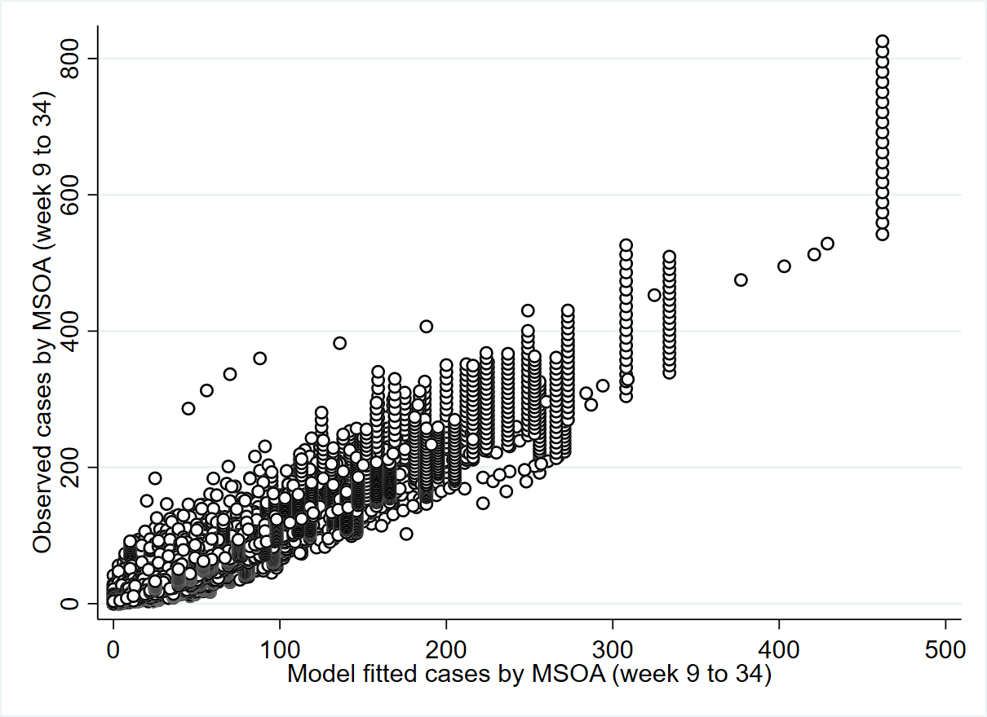
Figure 3.1. Scatter plot of observed cases versus model fitted cases for week 9 to week 34 of 2020.

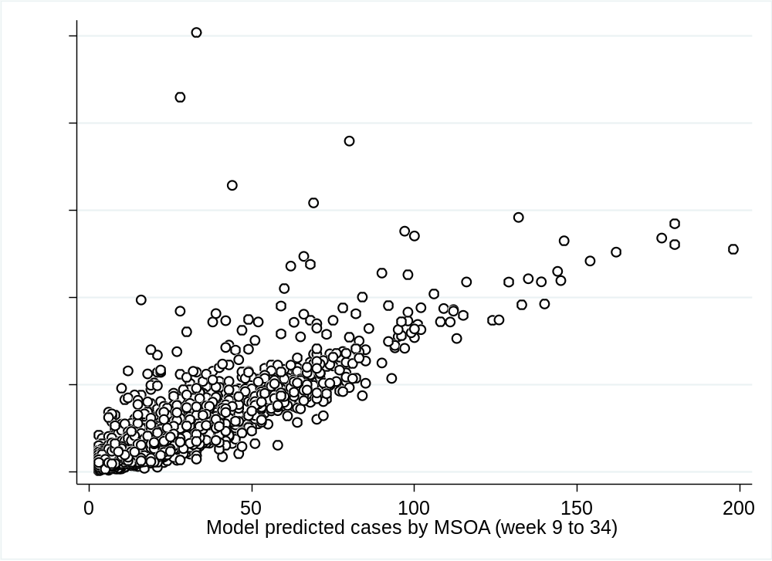
Figure 3.2. Scatter plot of observed cases versus model fitted cases for the 20% withheld sample for week 9 to week 34 of 2020.

Supplementary 4: Poisson multivariable regression (non space-time, non SEIR) results for case component run in Stata 16 using observed daily reported cases by MSOA from 1 March to 18 April 2020 with population offset.

Number of obs = 162,984; (*Std. Err. adjusted for 6791 clusters in MSOA)

Compartment | Covariate | Coef. (β) | Robust Std. Err. * | 95% CI for β |  |  | p-value
Cases ^{i} | Cumulative mobility loss ^{TV} | +1.433 | 0.264 | +0.914 | +1.951 | <0.001
Cases ^{i} | ln (population density) ^{nTV} | +0.099 | 0.026 | +0.048 | +0.150 | <0.001
Cases ^{i} | Cumulative mobility loss ^{TV} x ln (population density) ^{nTV} | +0.113 | 0.035 | +0.044 | +0.181 | 0.001
Cases ^{i} | Constant ^{nTV} | -9.371 | 0.195 | -9.754 | -8.989 | <0.001
Cases ^{i} | ln(Population 2020) | 1 | (exposure)
Deaths ^{ii} | Proportion of population aged 70 years or older ^{nTV} | +3.673 | 0.225 | +3.232 | +4.115 | <0.001
Deaths ^{ii} | Elderly population proportion living in deprivation ^{nTV} | +1.709 | 0.113 | +1.488 | +1.930 | <0.001
Deaths ^{ii} | Constant ^{nTV} | -11.101 | 0.049 | -11.200 | -11.006 | <0.001
Deaths ^{ii} | ln(Population 2020) | 1 | (exposure)
TV: Time varying; nTV: not time varying; i: Variances and covariances of unstructured random effect (MSOA): .39026343 (.00471932); ii: Variances and covariances of unstructured random effect (MSOA): .55440246 (.0134037)

