Additional file 1. Supplementary figures and tables
Supplementary Figure S1. Restricted cubic spline analysis of delta NLR and DFS. The model was adjusted for age, molecular subtype, pT stage, pN stage, histological grade, tumor necrosis, radiotherapy, postoperative infection/fever/antibiotic exposure, and surgery-to-T1 sampling interval.
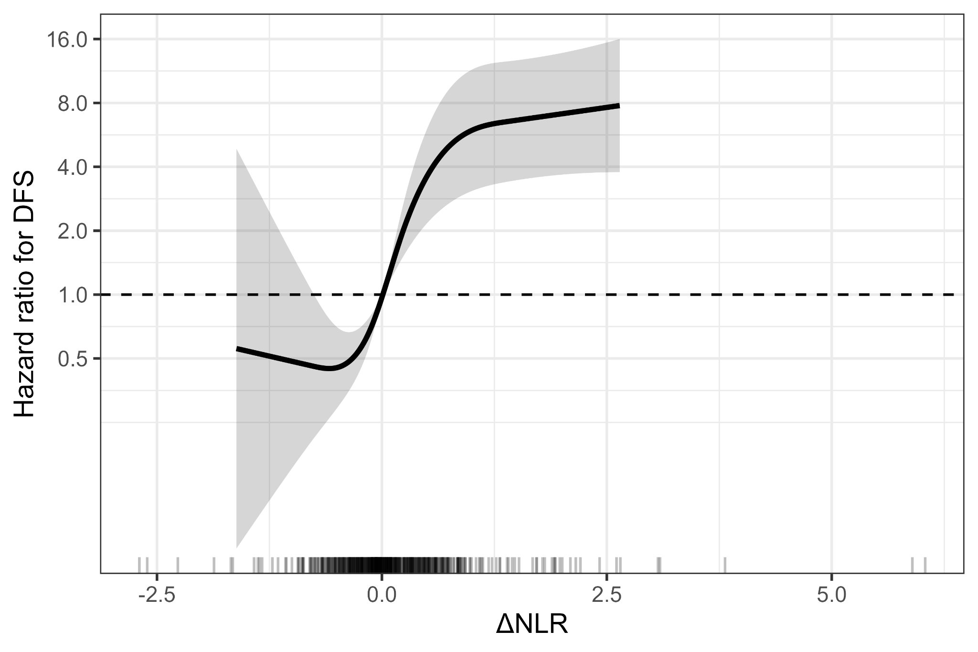
Supplementary Figure S2. Treatment-related sensitivity analyses. Hazard ratios for delta NLR are shown in the full cohort, after excluding infection/fever/antibiotic exposure, after excluding immunotherapy, and among adjuvant chemotherapy recipients only.
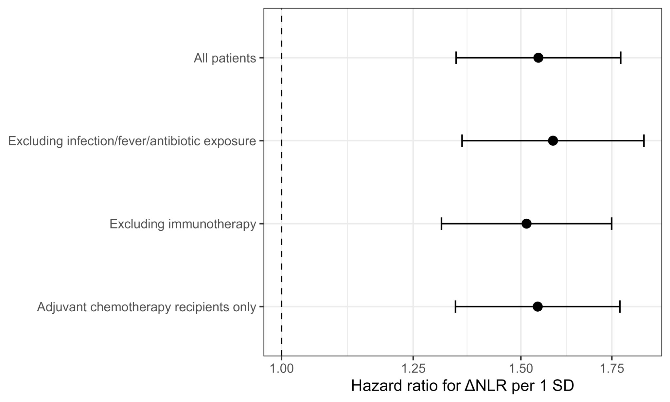
Supplementary Figure S3. Landmark sensitivity analyses. Because no DFS events occurred during the first 6 months after surgery, the 1-, 3-, and 6-month landmark analyses yielded identical estimates.
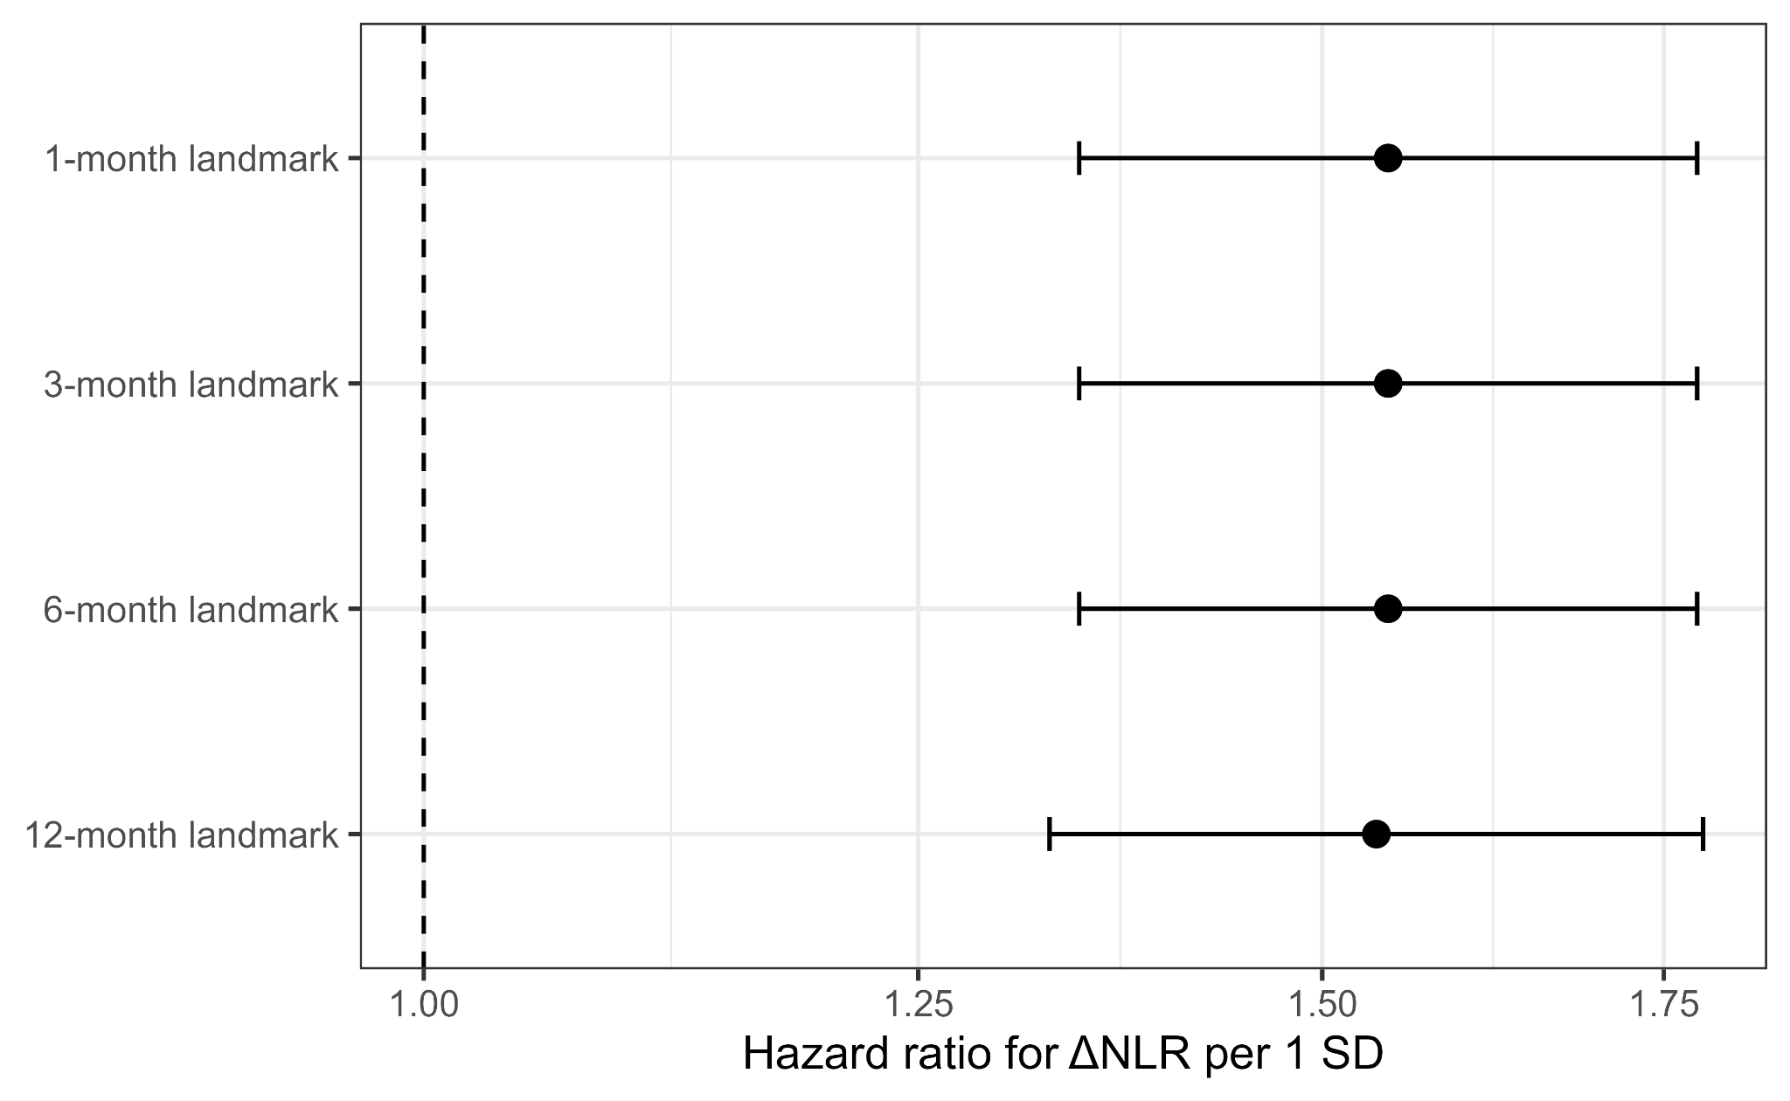
Supplementary Table S1. Full baseline, hematologic, treatment, and outcome variables by delta NLR status.
Characteristic | Overall (N = 518) | Delta NLR <= 0 (N = 253) | Delta NLR > 0 (N = 265) | P value
Age, years | 53 (45, 60) | 52 (45, 60) | 54 (45, 60) | 0.408
Ki-67 index, % | 50 (35, 70) | 50 (35, 65) | 50 (30, 70) | 0.681
Menopausal status |  |  |  | 0.359
Premenopausal | 182 (35.1%) | 94 (37.2%) | 88 (33.2%)
Postmenopausal | 336 (64.9%) | 159 (62.8%) | 177 (66.8%)
ER status |  |  |  | 0.378
Negative | 239 (46.1%) | 122 (48.2%) | 117 (44.2%)
Positive | 279 (53.9%) | 131 (51.8%) | 148 (55.8%)
PR status |  |  |  | 0.323
Negative | 314 (60.6%) | 159 (62.8%) | 155 (58.5%)
Positive | 204 (39.4%) | 94 (37.2%) | 110 (41.5%)
HER2 status |  |  |  | 0.401
Negative | 349 (67.4%) | 175 (69.2%) | 174 (65.7%)
Positive | 169 (32.6%) | 78 (30.8%) | 91 (34.3%)
Molecular subtype |  |  |  | 0.582
Luminal | 191 (36.9%) | 93 (36.8%) | 98 (37.0%)
HER2-positive | 169 (32.6%) | 78 (30.8%) | 91 (34.3%)
TNBC | 158 (30.5%) | 82 (32.4%) | 76 (28.7%)
Histological grade |  |  |  | 0.861
Grade 2 | 260 (50.2%) | 128 (50.6%) | 132 (49.8%)
Grade 3 | 258 (49.8%) | 125 (49.4%) | 133 (50.2%)
Pathological T stage |  |  |  | 0.776
T1 | 212 (40.9%) | 101 (39.9%) | 111 (41.9%)
T2 | 252 (48.6%) | 127 (50.2%) | 125 (47.2%)
T3 | 54 (10.4%) | 25 (9.9%) | 29 (10.9%)
Pathological N stage |  |  |  | 0.872
pN0 | 269 (51.9%) | 127 (50.2%) | 142 (53.6%)
pN1 | 138 (26.6%) | 70 (27.7%) | 68 (25.7%)
pN2 | 73 (14.1%) | 36 (14.2%) | 37 (14.0%)
pN3 | 38 (7.3%) | 20 (7.9%) | 18 (6.8%)
Pathological nodal status |  |  |  | 0.482
pN0 | 269 (51.9%) | 127 (50.2%) | 142 (53.6%)
pN+ | 249 (48.1%) | 126 (49.8%) | 123 (46.4%)
Tumor necrosis |  |  |  | 0.551
Absent | 381 (73.6%) | 183 (72.3%) | 198 (74.7%)
Present | 137 (26.4%) | 70 (27.7%) | 67 (25.3%)
Surgery-to-T1 interval, days | 25 (23, 28) | 25 (23, 28) | 25 (23, 28) | >0.9
Neoadjuvant therapy | 0 (0.0%) | 0 (0.0%) | 0 (0.0%) | NA
Adjuvant chemotherapy | 501 (96.7%) | 245 (96.8%) | 256 (96.6%) | >0.9
Radiotherapy | 198 (38.2%) | 93 (36.8%) | 105 (39.6%) | 0.527
Endocrine therapy | 279 (53.9%) | 131 (51.8%) | 148 (55.8%) | 0.378
Anti-HER2 therapy | 169 (32.6%) | 78 (30.8%) | 91 (34.3%) | 0.401
Immunotherapy before recurrence/metastasis | 8 (1.5%) | 2 (0.8%) | 6 (2.3%) | 0.286
G-CSF use | 0 (0.0%) | 0 (0.0%) | 0 (0.0%) | NA
Postoperative infection/fever/antibiotic exposure | 85 (16.4%) | 37 (14.6%) | 48 (18.1%) | 0.289
Preoperative ANC | 3.39 (2.82, 4.01) | 3.49 (2.95, 4.02) | 3.29 (2.69, 3.98) | 0.116
Preoperative ALC | 1.81 (1.53, 2.13) | 1.75 (1.41, 2.07) | 1.86 (1.61, 2.19) | <0.001
Preoperative NLR | 1.88 (1.49, 2.36) | 2.00 (1.57, 2.59) | 1.78 (1.38, 2.19) | <0.001
Postoperative ANC | 3.54 (2.80, 4.27) | 3.22 (2.54, 3.80) | 3.91 (3.08, 4.77) | <0.001
Postoperative ALC | 1.80 (1.49, 2.16) | 1.93 (1.61, 2.27) | 1.69 (1.38, 2.03) | <0.001
Postoperative NLR | 1.92 (1.50, 2.59) | 1.66 (1.30, 2.11) | 2.28 (1.75, 2.88) | <0.001
Delta NLR | 0.01 (-0.26, 0.41) | -0.27 (-0.52, -0.11) | 0.41 (0.16, 0.72) | <0.001
DFS event | 53 (10.2%) | 13 (5.1%) | 40 (15.1%) | <0.001
Values are median (IQR) or n (%). P values were calculated using Wilcoxon rank-sum, chi-square, or Fisher exact tests, as appropriate. Constant variables are marked as NA. NLR values were uniformly recalculated from ANC/ALC.
Supplementary Table S2. Firth penalized Cox regression for binary delta NLR classification.
Model | Variable | HR (95% CI) | P value
Model 3: clinicopathological model | Delta NLR > 0 vs <= 0 | 3.71 (2.04-7.19) | <0.001
Model 3: clinicopathological model | Age, per year | 1.02 (0.99-1.04) | 0.188
Model 3: clinicopathological model | HER2-positive vs Luminal | 1.55 (0.78-3.13) | 0.209
Model 3: clinicopathological model | TNBC vs Luminal | 1.50 (0.74-3.11) | 0.266
Model 3: clinicopathological model | pT stage, per category | 1.48 (1.00-2.18) | 0.049
Model 3: clinicopathological model | pN stage, per category | 2.28 (1.76-2.95) | <0.001
Model 3: clinicopathological model | Grade 3 vs Grade 2 | 6.72 (3.16-16.94) | <0.001
Model 3: clinicopathological model | Tumor necrosis present | 1.95 (1.09-3.46) | 0.025
Model 4: treatment-adjusted model | Delta NLR > 0 vs <= 0 | 3.72 (2.04-7.23) | <0.001
Model 4: treatment-adjusted model | Age, per year | 1.01 (0.99-1.04) | 0.319
Model 4: treatment-adjusted model | HER2-positive vs Luminal | 1.50 (0.75-3.03) | 0.249
Model 4: treatment-adjusted model | TNBC vs Luminal | 1.47 (0.72-3.04) | 0.292
Model 4: treatment-adjusted model | pT stage, per category | 1.44 (0.96-2.15) | 0.076
Model 4: treatment-adjusted model | pN stage, per category | 1.96 (1.42-2.77) | <0.001
Model 4: treatment-adjusted model | Grade 3 vs Grade 2 | 6.65 (3.12-16.78) | <0.001
Model 4: treatment-adjusted model | Tumor necrosis present | 2.07 (1.16-3.67) | 0.015
Model 4: treatment-adjusted model | Radiotherapy | 1.62 (0.73-3.54) | 0.232
Model 4: treatment-adjusted model | Postoperative infection/fever/antibiotic exposure | 0.73 (0.27-1.66) | 0.472
Model 4: treatment-adjusted model | Surgery-to-T1 interval, per day | 1.04 (0.94-1.15) | 0.448
Model 3 adjusted for age, molecular subtype, pT stage, pN stage, histological grade, and tumor necrosis. Model 4 further adjusted for radiotherapy, postoperative infection/fever/antibiotic exposure, and surgery-to-T1 interval.
Supplementary Table S3. Firth penalized Cox model additionally including immunotherapy before recurrence/metastasis.
Variable | HR (95% CI) | P value
Delta NLR > 0 vs <= 0 | 3.69 (2.02-7.18) | <0.001
Age, per year | 1.02 (0.99-1.05) | 0.261
HER2-positive vs Luminal | 1.49 (0.75-3.01) | 0.256
TNBC vs Luminal | 1.37 (0.64-2.97) | NA
pT stage, per category | 1.44 (0.96-2.15) | 0.077
pN stage, per category | 1.90 (1.35-2.73) | NA
Grade 3 vs Grade 2 | 6.64 (3.12-16.77) | <0.001
Tumor necrosis present | 2.06 (1.15-3.67) | 0.015
Radiotherapy | 1.65 (0.74-3.59) | 0.216
Postoperative infection/fever/antibiotic exposure | 0.78 (0.29-1.81) | 0.577
Surgery-to-T1 interval, per day | 1.05 (0.94-1.16) | 0.395
Immunotherapy before recurrence/metastasis | 1.47 (0.43-4.49) | 0.527
This supplementary model additionally included immunotherapy before recurrence/metastasis; exposure was sparse (n = 8), so this model was not used as the primary multivariable model. NA indicates that a profile-likelihood P value was not returned for that covariate in the coxphf output.
Supplementary Table S4. Proportional hazards assumption for the treatment-adjusted Cox model.
Variable | Chi-square | df | P value
Delta NLR, per 1 SD | 1.0082 | 1 | 0.32
Age | 0.3464 | 1 | 0.56
Molecular subtype | 0.2683 | 2 | 0.87
pT stage | 1.2788 | 1 | 0.26
pN stage | 0.0149 | 1 | 0.90
Histological grade | 0.1481 | 1 | 0.70
Tumor necrosis | 0.7982 | 1 | 0.37
Radiotherapy | 0.4050 | 1 | 0.52
Postoperative infection/fever/antibiotic exposure | 1.4075 | 1 | 0.24
Surgery-to-T1 interval | 0.4411 | 1 | 0.51
Global | 6.4441 | 11 | 0.84
The global test did not suggest a meaningful violation of the proportional hazards assumption (global P = 0.84).
Supplementary Table S5. Restricted cubic spline ANOVA for delta NLR and DFS.
Factor | Chi-square | df | P value
Delta NLR | 39.61 | 3 | <0.0001
Nonlinear component of Delta NLR | 17.03 | 2 | 0.0002
Age | 1.25 | 1 | 0.2630
Molecular subtype | 0.87 | 2 | 0.6472
pT stage | 2.46 | 1 | 0.1168
pN stage | 12.29 | 1 | 0.0005
Histological grade | 16.90 | 1 | <0.0001
Tumor necrosis | 6.77 | 1 | 0.0093
Radiotherapy | 1.39 | 1 | 0.2388
Postoperative infection/fever/antibiotic exposure | 0.07 | 1 | 0.7956
Surgery-to-T1 interval | 0.09 | 1 | 0.7608
Total model | 121.73 | 13 | <0.0001
The model was adjusted for age, molecular subtype, pT stage, pN stage, histological grade, tumor necrosis, radiotherapy, postoperative infection/fever/antibiotic exposure, and surgery-to-T1 interval.

